**Supplementary materials**

**Supplementary methods – Systematic map**

Initial searches and screening were done as part of systematic map (Martin et al., 2021) and these were updated in February 2024. Below we describe briefly the methods that we used to search and screen papers for the systematic map.

The topic and research questions were developed as part of the HoliSoils project ([holisoils.eu](http://holisoils.eu)), which focuses on holistic management practices, modelling, and monitoring for European forest soils. The topic was defined in a series of meetings with researchers who form the Holisoils consortium and feedback via email on proposed topics. Following this, a series of questions were proposed and feedback from consortium members was included. As a result of these meetings a review team (the authors of this study) was defined who to guide the development of synthesis during the project. During scoping of the project searches that included soil microbes as a population of interest indicated that their inclusion would produce a very large literature that would have taken a large amount of time to screen (Haddaway & Westgate, 2019). As a result of this and because there have already been a large number of syntheses on the impacts of natural disturbances on soil microbes, the review team decided to exclude soil microbes from the study. We also excluded ants because we found that including them massively increased the number of papers we found in searches, which would have led to an unfeasible workload.

To identify the search terms, we used the methodology suggested by Grames et al. (2019). This involved the identification of ‘naive’ search terms based on the different PECO elements of our questions and scoping of these terms using the Web of Science and Scopus platforms. We decided to restrict our search terms to those related to the population and exposure elements of our PECO because we were concerned that articles may not give details of the outcome and comparison elements in their titles or abstracts. Once our search terms returned all our benchmark studies (see below) all references were downloaded and duplicates removed using the R package revtools (M. J. Westgate, 2019). We then used the R package litsearchr to identify potentially useful additional keywords based on those found in the articles during the literature search (Grames et al., 2019). PM manually reviewed suggested keywords and those considered to be useful were added. Table S2 gives details of the different keywords and associated PECO elements for this study. We then followed the recommendations of Foo et al. (2021) to estimate the number of relevant studies returned by our searches. To do this searched the Web of Science and Scopus platforms and randomly selected 500 of the returned references. We screened the references against our inclusion criteria to determine the percentage that met our inclusion criteria. Further details of this process can be found in Supplementary file 2. Since different bibliographic platforms and databases have different rules for the formatting of searches, we developed specific searches for each search system. Details of these search terms for each of the four bibliographic platforms can be found in Supplementary file 2.

To estimate the comprehensiveness of our search the review team developed a benchmark list of articles. These represent articles that we feel our searches needed to capture in order to be considered comprehensive - as recommended by guidelines for environmental evidence synthesis (Collaboration for Environmental Evidence, 2018). We supplemented this list with relevant English-language articles mentioned by reviews and meta-analysis of the impacts of disturbances on belowground organisms and soil conditions (Blankinship et al., 2011; Bouget & Duelli, 2004; Certini et al., 2021; Kristensen et al., 2020; Neary et al., 1999; Pressler et al., 2019; Zhou et al., 2020). Table S4 gives a summary of the benchmark studies.

Once search terms were identified, we searched four bibliographic platforms: Web of Science, Scopus, Google Scholar, and Open Access Theses and Dissertations. Since different bibliographic platforms and databases have different rules for the formatting of searches, we developed platform-specific searches (see Table S2). When searching Google Scholar, we used the R package gsscraper (Haddaway, 2020) to download the first 1000 relevant references we found. In addition to formal searches, we contacted expert researchers to help identify potentially relevant studies and included references from primary studies that met our inclusion criteria using the R package citationchaser (Haddaway, Grainger & Gray 2021).

Once searches were complete, we downloaded all references found as .bib or .ris files and used the R package synthesisr to remove duplicate articles (M. Westgate & Grames, 2020). The bibfix package (Haddaway et al., 2021) was used to repair bibliographic files with incomplete data. Files were then uploaded to sysrev (Bozada et al., 2021) - an online tool that allows for screening and data extraction by review teams (see Martin, 2021). Article titles and abstracts were screened for relevance, and articles that met inclusion criteria were retained and their full text reviewed. To meet our eligibility criteria studies needed to: (1) Relate to soil and litter fauna in forests; (2) Address the impact of a natural disturbance (precipitation change, fire, windthrow, inspect pests, plant pathogens) ; (3) Be field-based (i.e. not be carried out in greenhouses or mesocosms); (4) Quantitatively assess soil fauna biomass, abundance, or diversity; (5) Have a comparison between sites that vary in the intensity or frequency of the precipitation that they were exposed to; (6) Be written in English. At the title and abstract screening stage, in order to be retained, articles needed to be likely to meet criteria 1-3 and criterion 5. At the full-text stage criteria 1-6 needed to be met in order for an article to be retained.

To ensure consistency, a random sample of 10% of titles and abstracts were screened by two team members, using our inclusion criteria. Any disagreements between the two people were discussed, and eligibility criteria were revised where appropriate. Cohen’s Kappa scores were calculated to test the agreement between the two people (Cohen, 1960). If Kappa scores were below 0.6, another 10% of titles and abstracts were screened by the same two team members with the process repeated until Kappa scores were >0.6. The same process was repeated for the full texts of publications that met inclusion criteria. After screening of titles and abstracts, inter-reviewer agreement was 96.6% and the Kappa score was 0.84. For full text screening agreement was 96.6% and the Kappa score was 0.92. We found 19296 papers during searches, 1020 of which were retained after screening of titles and abstracts, and 30 of which were used for critical appraisal and data extraction. We used 352 comparisons between control and treatment groups extracted from these studies. This process is summarised in more detail in Figure S1.

**Primary studies used in meta-analysis**

Ashton, L. A., Griffiths, H. M., Parr, C. L., Evans, T. A., Didham, R. K., Hasan, F., Teh, Y. A., Tin, H. S., Vairappan, C. S., & Eggleton, P. (2019). Termites mitigate the effects of drought in tropical rainforest. *Science*, *363*(6423), 174–177. https://doi.org/10.1126/science.aau9565  
  
Aslam, T. J., Benton, T. G., Nielsen, U. N., & Johnson, S. N. (2015). Impacts of eucalypt plantation management on soil faunal communities and nutrient bioavailability: trading function for dependence? *Biology and Fertility of Soils*, *51*(5), 637–644. https://doi.org/10.1007/s00374-015-1003-6  
  
Aupic-Samain, A., Santonja, M., Chomel, M., Pereira, S., Quer, E., Lecareux, C., Limousin, J.-M., Ourcival, J.-M., Simioni, G., Gauquelin, T., Fernandez, C., & Baldy, V. (2021). Soil biota response to experimental rainfall reduction depends on the dominant tree species in mature northern Mediterranean forests. *Soil Biology & Biochemistry*, *154*, 108122. https://doi.org/10.1016/j.soilbio.2020.108122  
  
Bakonyi, G., Nagy, P., Kovács-Láng, E., Kovács, E., Barabás, S., Répási, V., & Seres, A. (2007). Soil nematode community structure as affected by temperature and moisture in a temperate semiarid shrubland. *Applied Soil Ecology: A Section of Agriculture, Ecosystems & Environment*, *37*(1), 31–40. https://doi.org/10.1016/j.apsoil.2007.03.008  
  
Chikoski, J. M., Ferguson, S. H., & Meyer, L. (2006). Effects of water addition on soil arthropods and soil characteristics in a precipitation-limited environment. *Acta Oecologica*, *30*(2), 203–211. https://doi.org/10.1016/j.actao.2006.04.005  
  
Delph, R. J., Clifford, M. J., Cobb, N. S., Ford, P. L., & Brantley, S. L. (2014). Pinyon Pine Mortality Alters Communities of Ground-Dwelling Arthropods. *Western North American Naturalist / Brigham Young University*, *74*(2), 162–184. https://doi.org/10.3398/064.074.0203  
  
Ferguson, S. H., & Joly, D. O. (2002). Dynamics of springtail and mite populations: the role of density dependence, predation, and weather. *Ecological Entomology*, *27*(5), 565–573. https://doi.org/10.1046/j.1365-2311.2002.00441.x  
  
Frew, A., Nielsen, U. N., Riegler, M., & Johnson, S. N. (2013). Do eucalypt plantation management practices create understory reservoirs of scarab beetle pests in the soil? *Forest Ecology and Management*, *306*, 275–280. https://doi.org/10.1016/j.foreco.2013.06.051  
  
Guidi, C., Frey, B., Brunner, I., Meusburger, K., Vogel, M. E., Chen, X., Stucky, T., Gwiazdowicz, D. J., Skubała, P., Bose, A. K., Schaub, M., Rigling, A., & Hagedorn, F. (2022). Soil fauna drives vertical redistribution of soil organic carbon in a long-term irrigated dry pine forest. *Global Change Biology*, *28*(9), 3145–3160. https://doi.org/10.1111/gcb.16122  
  
Homet, P., Gómez-Aparicio, L., Matías, L., & Godoy, O. (2021). Soil fauna modulates the effect of experimental drought on litter decomposition in forests invaded by an exotic pathogen. *The Journal of Ecology*, *109*(8), 2963–2980. https://doi.org/10.1111/1365-2745.13711  
  
Homet, P., Ourcival, J.-M., Gutiérrez, E., Domínguez-Begines, J., Matías, L., Godoy, O., & Gómez-Aparicio, L. (2023). Short- and long-term responses of nematode communities to predicted rainfall reduction in Mediterranean forests. *Soil Biology & Biochemistry*, *179*, 108974. https://doi.org/10.1016/j.soilbio.2023.108974  
  
Johnson, S. N., Lopaticki, G., Aslam, T. J., Barnett, K., Frew, A., Hartley, S. E., Hiltpold, I., Nielsen, U. N., & Ryalls, J. M. W. (2018). Dryland management regimes alter forest habitats and understory arthropod communities. *The Annals of Applied Biology*, *172*(3), 282–294. https://doi.org/10.1111/aab.12419  
  
Krashevska, V., Sandmann, D., Maraun, M., & Scheu, S. (2012). Consequences of exclusion of precipitation on microorganisms and microbial consumers in montane tropical rainforests. *Oecologia*, *170*(4), 1067–1076. https://doi.org/10.1007/s00442-012-2360-6  
  
Kuperman, R. G., Potapov, M. B., & Sinitzina, E. A. (2002). Precipitation and pollution interaction effect on the abundance of Collembola in hardwood forests in the lower Midwestern United States. *European Journal of Soil Biology*, *38*(3), 277–280. https://doi.org/10.1016/S1164-5563(02)01159-7  
  
Landesman, W. J., Treonis, A. M., & Dighton, J. (2011). Effects of a one-year rainfall manipulation on soil nematode abundances and community composition. *Pedobiologia*, *54*(2), 87–91. https://doi.org/10.1016/j.pedobi.2010.10.002  
  
Lensing, J. R., Todd, S., & Wise, D. H. (2005). The impact of altered precipitation on spatial stratification and activity-densities of springtails (Collembola) and spiders (Araneae). *Ecological Entomology*, *30*(2), 194–200. https://doi.org/10.1111/j.0307-6946.2005.00669.x  
  
Levings, S. C., & Windsor, D. M. (1984). Litter Moisture Content as a Determinant of Litter Arthropod Distribution and Abundance During the Dry Season on Barro Colorado Island, Panama. *Biotropica*, *16*(2), 125–131. https://doi.org/10.2307/2387844  
  
Lindberg, N., & Bengtsson, J. (2006). Recovery of forest soil fauna diversity and composition after repeated summer droughts. *Oikos* , *114*(3), 494–506. https://doi.org/10.1111/j.2006.0030-1299.14396.x  
  
Lindberg, N., Engtsson, J. B., & Persson, T. (2002). Effects of experimental irrigation and drought on the composition and diversity of soil fauna in a coniferous stand. *The Journal of Applied Ecology*, *39*(6), 924–936. https://doi.org/10.1046/j.1365-2664.2002.00769.x  
  
Lindberg, N., & Persson, T. (2004). Effects of long-term nutrient fertilisation and irrigation on the microarthropod community in a boreal Norway spruce stand. *Forest Ecology and Management*, *188*(1), 125–135. https://doi.org/10.1016/j.foreco.2003.07.012  
  
Liu, T., Mao, P., Shi, L., Wang, Z., Wang, X., He, X., Tao, L., Liu, Z., Zhou, L., Shao, Y., & Fu, S. (2020). Contrasting effects of nitrogen deposition and increased precipitation on soil nematode communities in a temperate forest. *Soil Biology & Biochemistry*, *148*, 107869. https://doi.org/10.1016/j.soilbio.2020.107869  
  
Peguero, G., Folch, E., Liu, L., Ogaya, R., & Peñuelas, J. (2021). Divergent effects of drought and nitrogen deposition on microbial and arthropod soil communities in a Mediterranean forest. *European Journal of Soil Biology*, *103*, 103275. https://doi.org/10.1016/j.ejsobi.2020.103275  
  
Pflug, A., & Wolters, V. (2001). Influence of drought and litter age on Collembola communities. *European Journal of Soil Biology*, *37*(4), 305–308. https://doi.org/10.1016/S1164-5563(01)01101-3  
  
Riutta, T., Slade, E. M., Bebber, D. P., Taylor, M. E., Malhi, Y., Riordan, P., Macdonald, D. W., & Morecroft, M. D. (2012). Experimental evidence for the interacting effects of forest edge, moisture and soil macrofauna on leaf litter decomposition. *Soil Biology & Biochemistry*, *49*, 124–131. https://doi.org/10.1016/j.soilbio.2012.02.028  
  
Santonja, M., Fernandez, C., Proffit, M., Gers, C., Gauquelin, T., Reiter, I. M., Cramer, W., & Baldy, V. (2017). Plant litter mixture partly mitigates the negative effects of extended drought on soil biota and litter decomposition in a Mediterranean oak forest. *The Journal of Ecology*, *105*(3), 801–815. https://doi.org/10.1111/1365-2745.12711  
  
Sohlenius, B., & Wasilewska, L. (1984). Influence of Irrigation and Fertilization on the Nematode Community in a Swedish Pine Forest Soil. *The Journal of Applied Ecology*, *21*(1), 327–342. https://doi.org/10.2307/2403057  
  
Sun, F., Song, C., Wang, M., Lai, D. Y. F., Tariq, A., Zeng, F., Zhong, Q., Wang, F., Li, Z., & Peng, C. (2020). Long-term increase in rainfall decreases soil organic phosphorus decomposition in tropical forests. *Soil Biology & Biochemistry*, *151*, 108056. https://doi.org/10.1016/j.soilbio.2020.108056  
  
Sun, X., Zhang, X., Zhang, S., Dai, G., Han, S., & Liang, W. (12 2013). Soil Nematode Responses to Increases in Nitrogen Deposition and Precipitation in a Temperate Forest. *PloS One*, *8*(12), null. https://doi.org/10.1371/journal.pone.0082468  
  
Šustek, Z., Vido, J., Škvareninová, J., Škvarenina, J., & Šurda, P. (2017). Drought impact on ground beetle assemblages (Coleoptera, Carabidae) in Norway spruce forests with different management after windstorm damage – a case study from Tatra Mts. (Slovakia). *Journal of Hydrology and Hydromechanics/Vodohospodarsky Casopis*, *65*(4), 333–342. https://doi.org/10.1515/johh-2017-0048  
  
Taylor, A. R., Schröter, D., Pflug, A., & Wolters, V. (2004). Response of different decomposer communities to the manipulation of moisture availability: potential effects of changing precipitation patterns. *Global Change Biology*, *10*(8), 1313–1324. https://doi.org/10.1111/j.1365-2486.2004.00801.x  
  
Taylor, A. R., & Wolters, V. (2005). Responses of oribatid mite communities to summer drought: The influence of litter type and quality. *Soil Biology & Biochemistry*, *37*(11), 2117–2130. https://doi.org/10.1016/j.soilbio.2005.03.015  
  
Tsiafouli, M. A., Kallimanis, A. S., Katana, E., Stamou, G. P., & Sgardelis, S. P. (2005). Responses of soil microarthropods to experimental short-term manipulations of soil moisture. *Applied Soil Ecology: A Section of Agriculture, Ecosystems & Environment*, *29*(1), 17–26. https://doi.org/10.1016/j.apsoil.2004.10.002  
  
Tsiafouli, M. A., Monokrousos, N., & Sgardelis, S. P. (2018). Drought in spring increases microbial carbon loss through respiration in a Mediterranean pine forest. *Soil Biology & Biochemistry*, *119*, 59–62. https://doi.org/10.1016/j.soilbio.2018.01.010  
  
Wang, H., Liu, G., Huang, B., Wang, X., Xing, Y., & Wang, Q. (2021). Long-term nitrogen addition and precipitation reduction decrease soil nematode community diversity in a temperate forest. *Applied Soil Ecology: A Section of Agriculture, Ecosystems & Environment*, *162*, 103895. https://doi.org/10.1016/j.apsoil.2021.103895  
  
Wang, Q. (2023). Neutral effect of nitrogen addition and negative effect of precipitation reduction on the soil faunal community in a temperate forest. *Scandinavian Journal of Forest Research / Issued Bimonthly by the Nordic Forest Research Cooperation Committee* , *38*(7-8), 465–474. https://doi.org/10.1080/02827581.2023.2263367  
  
Williams, R. S., Marbert, B. S., Fisk, M. C., & Hanson, P. J. (2014). Ground-Dwelling Beetle Responses to Long-Term Precipitation Alterations in a Hardwood Forest. *Southeastern Naturalist* , *13*(1), 138–155. https://doi.org/10.1656/058.013.0114  
  
Wise, D. H., & Lensing, J. R. (2019). Impacts of rainfall extremes predicted by climate-change models on major trophic groups in the leaf litter arthropod community. *The Journal of Animal Ecology*, *88*(10), 1486–1497. https://doi.org/10.1111/1365-2656.13046  
  
Zhou, S., Hu, J., Liu, X., Zou, X., Xiao, L., Cao, D., Tu, L., Cui, X., & Huang, C. (2023). The Response of Mesofauna to Nitrogen Deposition and Reduced Precipitation during Litter Decomposition. *Forests, Trees and Livelihoods*, *14*(6). https://doi.org/10.3390/f14061112

**Table S1** - Taxonomic groups of soil fauna which we included in our study. Size classification is based on Nielsen (2019).

| **Taxonomic group** | **Common name** | **Size classification** |
| --- | --- | --- |
| Nematoda | Nematodes | Microfauna |
| Protozoa | Protozoans | Microfauna |
| Protista | Protists | Microfauna |
| Tardigrada | Tardigrades | Microfauna |
| Rotifera | Rotifers | Microfauna |
| Acari | Mites | Mesofauna |
| Collembola | Springtails | Mesofauna |
| Protura | Proturans | Mesofauna |
| Diplura | Diplurans | Mesofauna |
| Symphyla | Pseudocentipedes | Mesofauna |
| Enchytraeidae | Potworms | Mesofauna |
| Chelonethi | Pseudoscorpions | Mesofauna |
| Isoptera | Termites | Macrofauna |
| Isopoda | Isopods | Macrofauna |
| Opiliones | Harvestman | Macrofauna |
| Amphipoda | Amphipods | Macrofauna |
| Chilipoda | Centipedes | Macrofauna |
| Diplopoda | Millipedes | Macrofauna |
| Megadrilacea | Earthworms | Macrofauna |
| Coleoptera | Beetles | Macrofauna |
| Araneida | Spiders | Macrofauna |
| Mollusca | Molluscs | Macrofauna |

**Table S2 -** Terms associated with different PECO elements. Note that the search was broader than solely precipitation changes as it was performed as part of a systematic map on the impacts of natural forest disturbances.

| **PECO element** | **PECO elements for this study** | **Search terms related to PECO element** |
| --- | --- | --- |
| Population | Forest soil fauna | Forest synonyms = Forest, Woodland, Plantation  Soil synonyms= Soil, Belowground, Root  Soil fauna terms = Soil biodiversity, Belowground biodiversity, Soil diversity, Belowground diversity, Biodiversity, Biota, Fauna, Microfauna, Mesofauna, Macrofauna, Animal, Arthropod, Invertebrate, Detritivore, Macroarthropod, Microarthropod, Protozoa, Ciliate, Nematode, Nematoda, Protist, Rotifer, Rotifera, Tardigrade, Acari, Oribatid, Mite, Collembola, Springtail, Protura, Diplura, Symphyla, Chelonethi, Opiliones, Harvestmen, Ispotera, Termite, Isopoda, Woodlice, Amphipoda, Megadrilacea, Oligochaete, Annelid, Enchytraeus, Enchytraeidae, Potworm, Lumbricidae, Earthworm, Chilopoda, Centipedes, Diplopoda, Millipedes, Coleoptera, Beetles, Araneida, Spiders, Mollusca, Snails, Slugs |
| Exposures | Drought, Windthrow, Fire, Extreme rainfall, Insect pests, Tree pathogens | Drought, Fire, Wind, Typhoon, Cyclone, Hurricane, Storm, Rain, Precipitation, Disturbance, Global change, Bark beetle, Pest, Insect herbivore, Pathogen |

**Table S3 - Searches for different platforms.**  Note that searches included a wide range of natural forest disturbances as they were performed as part of a broad systematic map.

| **Platform** | **Search string** |
| --- | --- |
| Open Access Theses and Dissertations | all of these words= forest, any of these words=soil belowground, any of these words=drought fire burn wind typhoon cyclone hurricane storm rain precipitation irrigation disturbance pest pathogen, all of these words= soil fauna. Searched at abstract level |
| Google Scolar | Google Scholar queried using gscraper R package; save_and_scrapeGS(and_terms = c('forest', 'soil', 'fauna'),or_terms=c('drought', 'fire','wind','storm','precipitation','bark beetle','pathogen'), pages = 100,backoff=TRUE,incl_cit=FALSE,incl_pat=FALSE) |
| Web of Science Core Collection | TS=((forest* OR woodland* OR plantation* OR clearcut OR logg* OR timber) AND (soil* OR below$ground OR root*) AND (drought* OR *fire* OR burn* OR wind* OR typhoon* OR cyclone* OR hurricane* OR *storm* OR "canopy gap*" OR rain* OR precipitation OR irrigat* OR disturb* OR “bark beetle*” OR pest OR “insect herbivore*” OR "insect infestation" OR "insect outbreak" OR "beetle outbreak" OR “pathogen*”) AND (“soil biodiversity” OR “below$ground biodiversity” OR “soil divers*” OR “below$ground divers*” OR biodiversity OR biota OR fauna OR organism* OR micro$fauna OR macro$fauna OR meso$fauna OR animal* OR arthropod* OR invert* OR insect OR detritivore* OR macroarthropod* OR micro-arthropod* OR microarthropod* OR protozoa* OR ciliat*OR protist* OR rotifer* OR tardigade OR mite* OR orbatid* OR acari* OR nematod* OR mesostigmata* OR prostigmata*OR protura* OR diplura* OR symphyla OR enchytrae* OR potworm OR oligochaet* OR annelid* OR collembol* OR springtail* OR earthworm* OR lumbricid* OR woodlice OR woodlouse OR isopod* OR termite* OR isoptera* OR millipede* OR diplopoda* OR centipede* OR chilopoda* OR beetle* Or coleoptera* OR araneida OR archnid* OR spider* OR mollusc* OR snail* OR slug OR chelonethi OR opilones OR harvestmen OR amphipod*) |
| Scopus | TITLE-ABS-KEY((forest* OR woodland* OR plantation* OR clearcut OR logg* OR timber) AND (soil* OR below?ground OR root*) AND (drought* OR *fire* OR burn* OR wind* OR typhoon* OR cyclone* OR hurricane* OR *storm* OR "canopy gap*" OR rain* OR precipitation OR irrigat* OR disturb* OR “bark beetle*” OR pest OR “insect herbivore*” OR "insect infestation" OR "insect outbreak" OR "beetle outbreak" OR “pathogen*”) AND (“soil biodiversity” OR “below?ground biodiversity” OR “soil divers*” OR “below?ground divers*” OR biodiversity OR biota OR fauna OR organism* OR micro?fauna OR macro?fauna OR meso?fauna OR animal* OR arthropod* OR invert* OR insect OR detritivore* OR macroarthropod* OR micro-arthropod* OR microarthropod* OR protozoa* OR ciliat* OR protist* OR rotifer* OR tardigade OR mite* OR oribatid* OR acari* OR nematod* OR mesostigmata* OR prostigmata* OR protura* OR diplura* OR symphyla OR enchytrae* OR potworm OR oligochaet* OR annelid* OR collembol* OR springtail* OR earthworm* OR lumbricid* OR woodlice OR woodlouse OR isopod* OR termite* OR isoptera* OR millipede* OR diplopoda* OR centipede* OR chilopoda* OR beetle* Or coleoptera* OR araneida OR archnid* OR spider* OR mollusc* OR snail* OR slug OR chelonethi OR opilones OR harvestmen OR amphipod*)) |

**Table S4 -** Details of benchmark studies used to assess the comprehensiveness of our search strategy.

| **Reference** | **Focal taxa** | **Disturbance(s)** |
| --- | --- | --- |
| Landesman, Treonis, & Dighton (2011) | Mesofauna | Precipitation reduction |
| Lindberg et al. (2002) | Oribatida, Mesostigmata, Collembola, Macroarthropod predators, Enchytraeidae | Precipitation reduction, Precipitation increases |
| Sohlenius and Wasilewska(1984) | Nematoda | Precipitation increases |
| Santonja et al. (2017) | Mesofauna | Precipitation reduction |
| Xu et al. (2012) | Mesofauna | Precipitation reduction |
| Lindberg & Bengtsson  (2006) | Mesofauna | Precipitation reduction |
| Homet et al.  (2021) | Mesofauna | Precipitation reduction |
| Wehne et al. (2021) | Oribatida | Precipitation reduction |
| Sun et al. (2013) | Nematoda | Precipitation increases |

**Table S5 -** Criteria for study validity assessment (Martin et al., 2020). Any studies for which the answer to any of the questions is ‘no’ or ‘unclear’ were assigned as having low validity; remaining studies will be assigned as having medium validity if any of the answers are ‘partially’ and high validity if all the answers are ‘yes’.

| **Question/criterion** | **Response to question** |  |  |  | **Type of bias** |
| --- | --- | --- | --- | --- | --- |
|  | **Yes** | **Partially** | **No** | **Unclear** |
| Did the study consist of both temporal and spatial comparisons? | Before-after-control-impact study | Before-and-after study or Controlled study | N/A as study is not eligible for inclusion based on inclusion criteria | Lacking sufficient information to judge | Selection bias |
| Did the study use randomization? | Study accounts for spatial heterogeneity by using appropriate randomisation of samples | N/A as study was either randomized with respect to precipitation change or not (e.g. random site selection but not random allocation of treatments/controls) | Study does not attempt to randomize sampling | Lacking sufficient information to judge | Selection bias |
| Did the study avoid confounding factors? | Confounding factors were likely to be minimal as a result of blocking/pairing or stated attempts to match samples | Some confounding factors present, likely to have a moderate impact on outcome | Study was subject to confounding factors that could have a major impact on the outcome | Lacking sufficient information to judge | Selection bias and performance bias |
| Can study determine causality? | Experimental study in which comparator samples were selected prior to the management intervention being used | Correlative study in which comparators are selected after the management intervention has already been implemented, thereby limiting the ability of researchers to determine the similarity of comparators prior to management intervention use. | N/A - Studies with no comparator will be excluded | Lacking sufficient information to judge | Selection bias and performance bias |

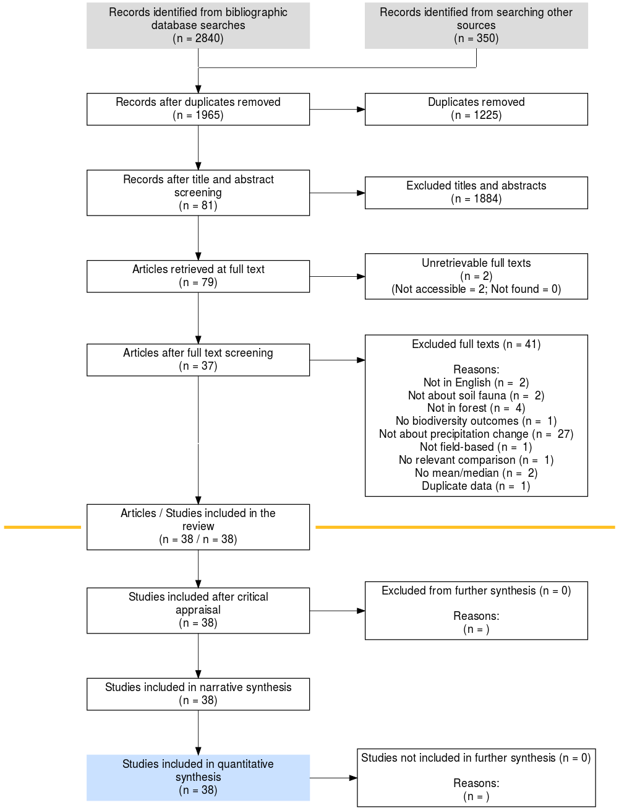

**Figure S1 -** ROSES flow diagram showing the process of selection and synthesis of studies used in the meta-analysis

**Table S6 -** Statistics from summary meta-analyses and sensitivity analyses

| **Disturbance** | **Outcome** | **Model type** | **Coeff** | **SE** | **p-value** | **Q** | **Q p-value** | **I2** |
| --- | --- | --- | --- | --- | --- | --- | --- | --- |
| Precipitation reduction | Abundance | Null model | -0.44 | 0.14 | 0.001 | 2767 | <0.001 | 98 |
| Precipitation reduction | Abundance | Failed Geary test | -0.38 | 0.14 | 0.007 | 2735 | <0.001 | 98 |
| Precipitation reduction | Abundance | Low validity removed | -0.56 | 0.20 | 0.005 | 2391 | <0.001 | 99 |
| Precipitation increase | Abundance | Null model | 0.33 | 0.14 | 0.016 | 1637 | <0.001 | 78 |
| Precipitation increase | Abundance | Failed Geary test | 0.32 | 0.14 | 0.018 | 1605 | <0.001 | 81 |
| Precipitation increase | Abundance | Low validity removed | 0.30 | 0.18 | 0.099 | 1502 | <0.001 | 79 |
| Precipitation reduction | Taxonomic richness | Null model | -0.03 | 0.04 | 0.345 | 96 | <0.001 | 41 |
| Precipitation reduction | Taxonomic richness | Failed Geary test | -0.03 | 0.04 | 0.345 | 96 | <0.001 | 41 |
| Precipitation reduction | Taxonomic richness | Low validity removed | -0.13 | 0.02 | 0.000 | 59 | <0.001 | 5 |
| Precipitation increase | Taxonomic richness | Null model | -0.02 | 0.09 | 0.869 | 17 | 0.279 | 58 |
| Precipitation increase | Taxonomic richness | Failed Geary test | -0.02 | 0.09 | 0.869 | 17 | 0.279 | 58 |
| Precipitation increase | Taxonomic richness | Low validity removed | -0.08 | 0.04 | 0.066 | 8 | 0.584 | 12 |
| Precipitation reduction | Shannon-Wiener | Null model | -0.07 | 0.04 | 0.036 | 201 | <0.001 | 68 |
| Precipitation reduction | Shannon-Wiener | Failed Geary test | -0.07 | 0.04 | 0.036 | 201 | <0.001 | 68 |
| Precipitation reduction | Shannon-Wiener | Low validity removed | -0.14 | 0.03 | 0.000 | 72 | <0.001 | 26 |
| Precipitation increase | Shannon-Wiener | Null model | -0.08 | 0.03 | 0.005 | 4 | 0.987 | 0 |
| Precipitation increase | Shannon-Wiener | Failed Geary test | -0.08 | 0.03 | 0.005 | 4 | 0.987 | 0 |
| Precipitation increase | Shannon-Wiener | Low validity removed | -0.07 | 0.03 | 0.012 | 3 | 0.986 | 0 |

**Table S7 -** Model selection for models of change in the abundance of soil and litter fauna in forests as a result of precipitation changes. In the variables column ‘Precipitation change’ refers to the magnitude of precipitation change relative to baseline conditions, Body Size refers to the classification of taxonomic groups as either micro-, meso-, or macrofauna, ‘Decline effect’ the year in which a study was published to assess whether observed effect sizes change over time as seen in other literatures, ‘Small study effect’ a variable to assess whether smaller studies vary in their reported effect size.

| **Variables** | **df** | **logLik** | **AICc** | **delta** |
| --- | --- | --- | --- | --- |
| Precipitation change *Body size + Decline effect + Small study effect- | 11 | -398.66 | 820.22 | 0.00 |
| Precipitation change *Body size + Decline effect | 10 | -400.11 | 820.96 | 0.74 |
| Precipitation change *Body size + Small study effect- | 10 | -400.64 | 822.03 | 1.81 |
| Precipitation change *Body size | 9 | -402.07 | 822.75 | 2.53 |
| Precipitation change *Above/belowground +Decline effect + Small study effect- | 9 | -403.29 | 825.19 | 4.97 |
| Precipitation change *Above/belowground +Decline effect | 8 | -404.64 | 825.78 | 5.55 |
| Precipitation change *Above/belowground +Small study effect | 8 | -404.95 | 826.39 | 6.17 |
| Precipitation change *Above/belowground | 7 | -406.28 | 826.94 | 6.72 |
| Precipitation change *Aridity + Decline effect + Small study effect- | 9 | -404.31 | 827.23 | 7.01 |
| Precipitation change *Exoskeleton +Decline effect + Small study effect- | 9 | -404.40 | 827.42 | 7.20 |
| Precipitation change *Aridity + Decline effect | 8 | -405.49 | 827.48 | 7.25 |
| Precipitation change *Exoskeleton + Decline effect | 8 | -405.85 | 828.18 | 7.96 |
| Precipitation change + Decline effect + Small study effect | 7 | -406.91 | 828.20 | 7.98 |
| Precipitation change *Aridity + Small study effect | 8 | -405.95 | 828.38 | 8.16 |
| Precipitation change *Aridity | 7 | -407.13 | 828.64 | 8.41 |
| Precipitation change *Exoskeleton + Small study effect | 8 | -406.18 | 828.84 | 8.62 |
| Precipitation change + Decline effect | 6 | -408.32 | 828.91 | 8.69 |
| Precipitation change + Small study effect | 6 | -408.60 | 829.47 | 9.25 |
| Precipitation change *Exoskeleton | 7 | -407.61 | 829.61 | 9.39 |
| Precipitation change | 5 | -410.03 | 830.25 | 10.03 |

**Table S8** - Model averaged coefficients for models of changes in faunal abundance with an AICc delta <2

| **Variable** | **Estimate** | **SE** | **z value** | **p value** |
| --- | --- | --- | --- | --- |
| Precipitation change | -0.0011 | 0.0020 | 0.5359 | 0.5921 |
| Macrofauna | -0.0477 | 0.2380 | 0.2002 | 0.8413 |
| Mesofauna | -0.1025 | 0.2020 | 0.5073 | 0.6120 |
| Microfauna | -0.2535 | 0.3366 | 0.7531 | 0.4514 |
| Decline effect | 0.0104 | 0.0110 | 0.9392 | 0.3476 |
| Small study size | 0.0746 | 0.4029 | 0.1850 | 0.8532 |
| Mesofauna:Precipitation change | 0.0052 | 0.0020 | 2.5687 | 0.0102 |
| Microfauna:Precipitation change | 0.0032 | 0.0040 | 0.8062 | 0.4201 |

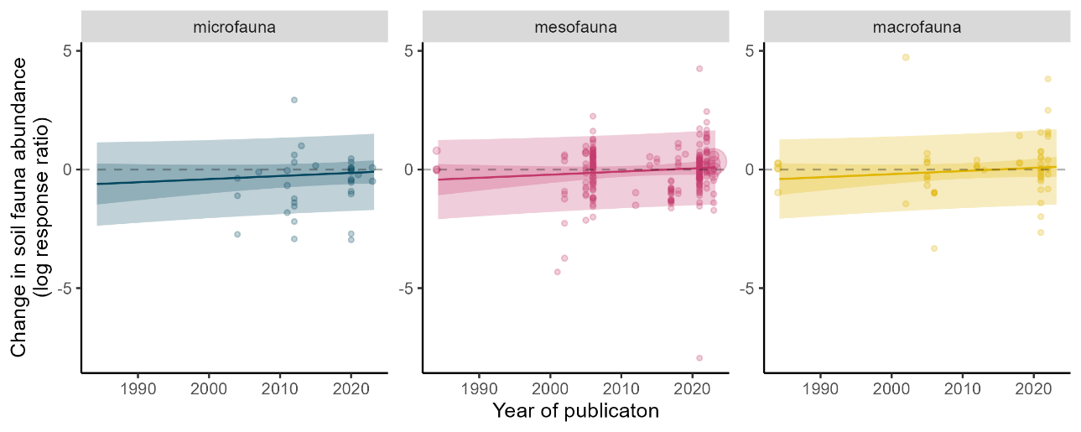

**Figure S2** - Change in effect of precipitation changes over time since publication

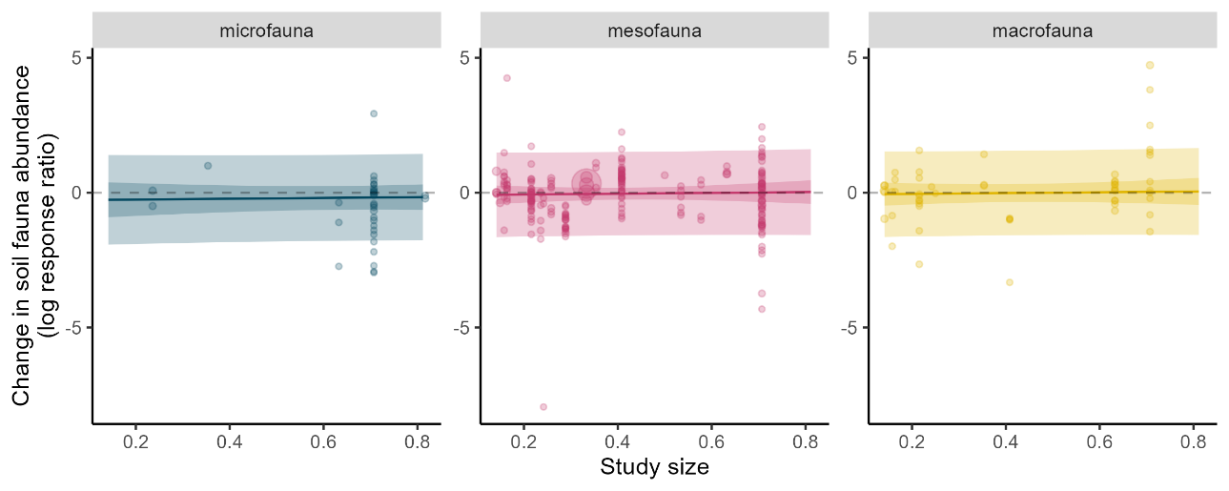

**Figure S3** - Impact of study size on change in effect of precipitation on invertebrate abundance

**Table S9** - Model selection for models of change in the abundance of soil and litter fauna in forests as a result of precipitation changes. In the variables column ‘Taxonomic group’ refers to a variable specifying whether abundance was related to Acari or to Collembola. See Table S1 for description of all other variables.

| **Variables** | **df** | **logLik** | **AICc** | **delta** |
| --- | --- | --- | --- | --- |
| Change in precipitation * Taxonomic group + Decline effect +Small study effect | 9 | -183.90 | 386.85 | 0.00 |
| Change in precipitation * Taxonomic group + Decline effect | 8 | -185.18 | 387.19 | 0.34 |
| Change in precipitation * Taxonomic group Small study effect | 8 | -185.24 | 387.32 | 0.47 |
| Change in precipitation * Taxonomic group | 7 | -186.65 | 387.95 | 1.10 |
| Change in precipitation | 5 | -189.96 | 390.27 | 3.42 |

**Table S10** - Model averaged coefficients for models of changes in faunal abundance for Acari and Collembola with an AICc delta <2

| **Variable** | **Estimate** | **SE** | **z value** | **p value** |
| --- | --- | --- | --- | --- |
| Precipitation change | 0.0054 | 0.0016 | 3.3669 | 0.0008 |
| Acari | -0.1518 | 0.2470 | 0.6146 | 0.5388 |
| Collembola | 0.0516 | 0.2494 | 0.2069 | 0.8361 |
| Decline effect | 0.0066 | 0.0120 | 0.5510 | 0.5817 |
| Small study size | 0.0442 | 0.4905 | 0.0901 | 0.9282 |
| Collembola:Precipitation change | 0.0000 | 0.0009 | 0.0046 | 0.9963 |
| Precipitation change | 0.0054 | 0.0016 | 3.3669 | 0.0008 |

**Figure S4** - Changes in the abundance of Acari and Collembola in forests relative to changes in precipitation. Points represent individual comparisons with different point sizes representing the different weights of comparisons to the analysis. Solid lines represent predictions from the most parsimonious model, with darker coloured bands representing the 95% confidence intervals, and the lighter bands the 95% prediction intervals. Dashed lines represent points at which the x and y axes are equal to zero. K signifies the number of comparisons for each taxonomic group and the number in brackets represents the number of studies.

**Table S11 -** Model selection for models of change in the taxonomic richness of soil and litter fauna in forests as a result of precipitation changes. See Table S1 for description of variables.

| **Variables in model** | **df** | **logLik** | **AICc** | **delta** |
| --- | --- | --- | --- | --- |
| Precipitation change | 5 | -5.12 | 21.71 | 0.00 |
| Precipitation change + Decline effect | 6 | -4.68 | 23.47 | 1.76 |
| Decline effect | 5 | -6.36 | 24.18 | 2.47 |
| Small study effect | 5 | -6.57 | 24.60 | 2.89 |
| Precipitation change + Small study effect | 6 | -5.48 | 25.05 | 3.34 |
| Precipitation change*Exoskeleton | 6 | -5.84 | 25.79 | 4.08 |
| Precipitation change + Decline effect + Small study effect | 7 | -4.52 | 25.92 | 4.21 |
| Decline effect + Small study effect | 6 | -6.33 | 26.77 | 5.06 |
| Precipitation change*Above/belowground | 7 | -5.05 | 26.97 | 5.26 |
| Precipitation change*Exoskeleton + Small study effect | 7 | -6.01 | 28.88 | 7.17 |
| Precipitation change*Above/belowground + Decline effect | 8 | -4.63 | 29.06 | 7.35 |
| Precipitation change*Above/belowground + Small study effect | 8 | -4.86 | 29.51 | 7.80 |
| Precipitation change*Exoskeleton + Decline effect + Small study effect- | 8 | -5.26 | 30.30 | 8.59 |
| Precipitation change*Above/belowground + Decline effect + Small study effect- | 9 | -4.32 | 31.50 | 9.79 |
| Precipitation change*Body size | 8 | -6.58 | 32.96 | 11.25 |
| Precipitation change*Body size + Decline effect | 9 | -5.71 | 34.29 | 12.58 |
| Precipitation change*Body size + Small study effect- | 9 | -6.17 | 35.20 | 13.49 |
| Precipitation change*Body size + Decline effect + Small study effect- | 10 | -4.87 | 35.86 | 14.15 |
| Precipitation change | 5 | -5.12 | 21.71 | 0.00 |

**Table S12** - Model averaged coefficients for models of changes in faunal taxonomic richness with an AICc delta <2

| **Variable** | **Estimate** | **SE** | **z value** | **p value** |
| --- | --- | --- | --- | --- |
| Intercept | -0.0009 | 0.0574 | 0.0156 | 0.9876 |
| Precipitation change | 0.0023 | 0.0012 | 1.9833 | 0.0473 |
| Decline effect | 0.0027 | 0.0047 | 0.5757 | 0.5648 |

**Table S13 -** Model selection for models of change in the Shannon-Wiener diversity of soil and litter fauna in forests as a result of precipitation changes. See Table S1 for description of variables.

| **Variables** | **df** | **logLik** | **AICc** | **delta** |
| --- | --- | --- | --- | --- |
| Decline effect | 5 | -10.08 | 31.78 | 0.00 |
| Precipitation change | 5 | -10.67 | 32.97 | 1.19 |
| Small study effect | 5 | -11.02 | 33.66 | 1.88 |
| Precipitation change + Decline effect | 6 | -10.30 | 34.93 | 3.15 |
| Precipitation change + Small study effect | 6 | -10.66 | 35.65 | 3.88 |
| Decline effect + Small study effect | 6 | -10.86 | 36.06 | 4.28 |
| Precipitation change + Decline effect + Small study effect | 7 | -10.87 | 38.95 | 7.17 |
| Precipitation change*Above/belowground | 7 | -11.13 | 39.46 | 7.68 |
| Precipitation change*Exoskeleton | 7 | -11.95 | 41.09 | 9.32 |
| Precipitation change*Body size | 7 | -11.95 | 41.09 | 9.32 |
| Precipitation change*Above/belowground + Decline effect | 8 | -11.22 | 42.67 | 10.89 |
| Precipitation change*Body size + Small study effect | 8 | -11.31 | 42.85 | 11.08 |
| Precipitation change*Above/belowground + Small study effect | 8 | -11.52 | 43.27 | 11.50 |
| Precipitation change*Exoskeleton + Decline effect | 8 | -11.79 | 43.81 | 12.04 |
| Precipitation change*Body size + Decline effect | 8 | -11.79 | 43.81 | 12.04 |
| Precipitation change*Body size + Decline effect + Small study effect | 9 | -11.03 | 45.51 | 13.73 |
| Precipitation change*Exoskeleton + Decline effect + Small study effect | 9 | -11.03 | 45.51 | 13.73 |
| Precipitation change*Above/belowground + Decline effect + Small study effect | 9 | -11.33 | 46.11 | 14.34 |

**Table S14** - Model averaged coefficients for models of changes in faunal Shannon-Wiener diversity with an AICc delta <2

| **Variable** | **Estimate** | **SE** | **z.value** | **p_value** |
| --- | --- | --- | --- | --- |
| Intercept | -0.1120 | 0.0702 | 1.5943 | 0.1109 |
| Decline effect | 0.0038 | 0.0044 | 0.8440 | 0.3987 |
| Precipitation change | -0.0002 | 0.0009 | 0.2201 | 0.8258 |
| Small study effect | -0.0321 | 0.0873 | 0.3674 | 0.7133 |

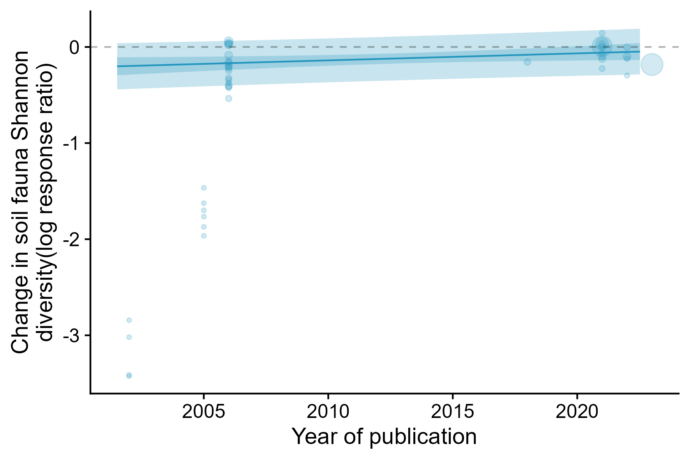

**Figure S5** - Changes in Shannon-Wiener diversity relative year of publication. Points represent individual comparisons with different point sizes representing the different weights of comparisons to the analysis. The solid line represents predictions from the most parsimonious model, with darker coloured bands representing the 95% confidence intervals, and the lighter bands the 95% prediction intervals. Dashed lines represent points at which the y axes are equal to zero.

**References**

Blankinship, J. C., Niklaus, P. A., & Hungate, B. A. (2011). A meta-analysis of responses of soil biota to global change. *Oecologia*, *165*(3), 553–565. https://doi.org/10.1007/s00442-011-1909-0

Bouget, C., & Duelli, P. (2004). The effects of windthrow on forest insect communities: a literature review. *Biological Conservation*, *118*(3), 281–299. https://doi.org/10.1016/j.biocon.2003.09.009

Bozada, T., Borden, J., Workman, J., Del Cid, M., Malinowski, J., & Luechtefeld, T. (2021). Sysrev: A FAIR platform for Data Curation and Systematic Evidence Review. In *bioRxiv* (p. 2021.03.24.436697). https://doi.org/10.1101/2021.03.24.436697

Certini, G., Moya, D., Lucas-Borja, M. E., & Mastrolonardo, G. (2021). The impact of fire on soil-dwelling biota: A review. *Forest Ecology and Management*, *488*, 118989. https://doi.org/10.1016/j.foreco.2021.118989

Cohen, J. (1960). A Coefficient of Agreement for Nominal Scales. *Educational and Psychological Measurement*, *20*(1), 37–46. https://doi.org/10.1177/001316446002000104

Collaboration for Environmental Evidence. (2018). *Guidelines and Standards for Evidence synthesis in Environmental Management. Version 5.0* (Pullin, A.S., Frampton, G.K., Livoreil, B., Petrokofsky, G., Ed.). www.environmentalevidence.org/information-for-authors. [Accessed 6/10/21].

Foo, Y. Z., O’Dea, R. E., Koricheva, J., Nakagawa, S., & Lagisz, M. (2021). A practical guide to question formation, systematic searching and study screening for literature reviews in ecology and evolution. *Methods in Ecology and Evolution / British Ecological Society*, *2041-210X.13654*. https://doi.org/10.1111/2041-210x.13654

Grames, E. M., Stillman, A. N., & Tingley, M. W. (2019). An automated approach to identifying search terms for systematic reviews using keyword co‐occurrence networks. *Methods in Ecology and Evolution / British Ecological Society*. https://besjournals.onlinelibrary.wiley.com/doi/abs/10.1111/2041-210X.13268?casa_token=8N6jJI5Ezz8AAAAA:9Es25xJk4OrSdri7T-2YXnb7Kf6Ruk3vYeCi3DlYGv4MWOGI_670hgf0kqhzcuXELaCRLf2xvQhFGQ

Haddaway, N. R. (2020). *GSscraper: An R package and Shiny app for exporting search results from Google Scholar*.

Haddaway, N. R., Grainger, M. J., Jones, M. L., & Stuart, A. (2021). *bibfix: An R package and Shiny app for repairing and enriching bibliographic data*. https://github.com/nealhaddaway/bibfix.

Haddaway, N. R., & Westgate, M. J. (2019). Predicting the time needed for environmental systematic reviews and systematic maps. In *Conservation Biology* (Vol. 33, Issue 2, pp. 434–443). https://doi.org/10.1111/cobi.13231

Homet, P., Gómez-Aparicio, L., Matías, L., & Godoy, O. (2021). Soil fauna modulates the effect of experimental drought on litter decomposition in forests invaded by an exotic pathogen. *The Journal of Ecology*, *109*(8), 2963–2980. https://doi.org/10.1111/1365-2745.13711

Kristensen, J. Å., Rousk, J., & Metcalfe, D. B. (2020). Below‐ground responses to insect herbivory in ecosystems with woody plant canopies: A meta‐analysis. *The Journal of Ecology*, *108*(3), 917–930. https://doi.org/10.1111/1365-2745.13319

Landesman, W. J., Treonis, A. M., & Dighton, J. (2011). Effects of a one-year rainfall manipulation on soil nematode abundances and community composition. *Pedobiologia*, *54*(2), 87–91. https://doi.org/10.1016/j.pedobi.2010.10.002

Lindberg, N., & Bengtsson, J. (2006). Recovery of forest soil fauna diversity and composition after repeated summer droughts. *Oikos* , *114*(3), 494–506. https://doi.org/10.1111/j.2006.0030-1299.14396.x

Lindberg, N., Engtsson, J. B., & Persson, T. (2002). Effects of experimental irrigation and drought on the composition and diversity of soil fauna in a coniferous stand. *The Journal of Applied Ecology*, *39*(6), 924–936. https://doi.org/10.1046/j.1365-2664.2002.00769.x

Martin, P. A. (2021). *Soil_fauna_systematic_map*. https://sysrev.com/p/98916

Martin, P. A., Perez Izquierdo, L., Luyssaert, S., Guenet, B., Manzoni, S., Spake, R., Santonja, M., & Curiel Yuste, J. (2021). Effects of natural disturbances on soil fauna in forests: a systematic map protocol. In *OSF*. https://doi.org/10.17605/OSF.IO/YQU4W

Martin, P. A., Shackelford, G. E., Bullock, J. M., & Sutherland, W. J. (2020). Management of UK priority invasive alien plants: a systematic review protocol. *Environmental Evidence*. https://link.springer.com/article/10.1186/s13750-020-0186-y

Neary, D. G., Klopatek, C. C., DeBano, L. F., & Ffolliott, P. F. (1999). Fire effects on belowground sustainability: a review and synthesis. *Forest Ecology and Management*, *122*(1), 51–71. https://doi.org/10.1016/S0378-1127(99)00032-8

Nielsen, U. N. (Ed.). (2019). Soil Fauna Assemblages: Global to Local Scales. In *Soil Fauna Assemblages: Global to Local Scales* (pp. v–v). Cambridge University Press. https://www.cambridge.org/core/books/soil-fauna-assemblages/soil-fauna-assemblages/78C28F6983A0011E36D74EB272EC143E

Pressler, Y., Moore, J. C., & Cotrufo, M. F. (2019). Belowground community responses to fire: meta-analysis reveals contrasting responses of soil microorganisms and mesofauna. *Oikos* , *128*(3), 309–327. https://doi.org/10.1111/oik.05738

Santonja, M., Fernandez, C., Proffit, M., Gers, C., Gauquelin, T., Reiter, I. M., Cramer, W., & Baldy, V. (2017). Plant litter mixture partly mitigates the negative effects of extended drought on soil biota and litter decomposition in a Mediterranean oak forest. *The Journal of Ecology*, *105*(3), 801–815. https://doi.org/10.1111/1365-2745.12711

Sohlenius, B., & Wasilewska, L. (1984). Influence of Irrigation and Fertilization on the Nematode Community in a Swedish Pine Forest Soil. *The Journal of Applied Ecology*, *21*(1), 327–342. https://doi.org/10.2307/2403057

Sun, X., Zhang, X., Zhang, S., Dai, G., Han, S., & Liang, W. (2013). Soil nematode responses to increases in nitrogen deposition and precipitation in a temperate forest. *PloS One*, *8*(12), e82468. https://doi.org/10.1371/journal.pone.0082468

Wehner, K., Simons, N. K., Blüthgen, N., & Heethoff, M. (2021). Drought, windthrow and forest operations strongly affect oribatid mite communities in different microhabitats. *Global Ecology and Conservation*, *30*, e01757. https://doi.org/10.1016/j.gecco.2021.e01757

Westgate, M., & Grames, E. (2020). *synthesisr: Import, Assemble, and Deduplicate Bibliographic Datasets*. https://CRAN.R-project.org/package=synthesisr

Westgate, M. J. (2019). revtools: An R package to support article screening for evidence synthesis. *Research Synthesis Methods*, *10*(4), 606–614. https://doi.org/10.1002/jrsm.1374

Xu, G.-L., Kuster, T. M., Günthardt-Goerg, M. S., Dobbertin, M., & Li, M.-H. (2012). Seasonal exposure to drought and air warming affects soil Collembola and mites. *PloS One*, *7*(8), e43102. https://doi.org/10.1371/journal.pone.0043102

Zhou, Z., Wang, C., & Luo, Y. (2020). Meta-analysis of the impacts of global change factors on soil microbial diversity and functionality. *Nature Communications*, *11*(1), 3072. https://doi.org/10.1038/s41467-020-16881-7