**2.0.0 SIMPLE CLASSIFICATION OF SUBSTANCES**

**For Examiners use only.**

|  |  |  |
| --- | --- | --- |
| **Question** | **Maximum Score** | **Candidates Score** |
| **1 – 10** | **57** |  |

*This paper consists of* ***[ Please insert number of pages ]*** *Printed pages.*

*Candidates should check the question paper to ensure that all the*

*Papers are printed as indicated and no questions are missing*

**1.**

(a) The apparatus in the diagram below is used to obtain pure water from impure water.



(i) What temperature would the thermometer show?

…………………… °C

1 mark

(ii) What is the function of the piece of apparatus labelled R?

........................................................................................

........................................................................................

1 mark

(iii) Give the name of the process which purifies water in this way.

………………………

1 mark

(b) The diagram below shows particles in a gas, a solid and a liquid.  
Each arrow, A, B, C and D, represents a change of state.



(i) Choose from the following words to complete the sentences below.

**boiling** **condensing** **distilling** **evaporating**

**filtering** **freezing** **melting**

Change of state A is called ……………………………………………….

Change of state B is called ……………………………………………….

Change of state C is called ……………………………………………….

Change of state D is called ……………………………………………….

4 marks

(ii) Look back to the apparatus in part (a).  
Give the letter, A, B, C or D, from the diagram above, for the change of state which occurs:

in the round-bottomed flask ………………………………………………

in the piece of apparatus labelled R. …………………………………….

2 marks

Maximum 9 marks

**2.**

Chromatography can be used to identify amino acids from a sample of protein.

The diagram shows the chromatogram obtained when four samples of amino acids were analysed.The paper was sprayed with ninhydrin.

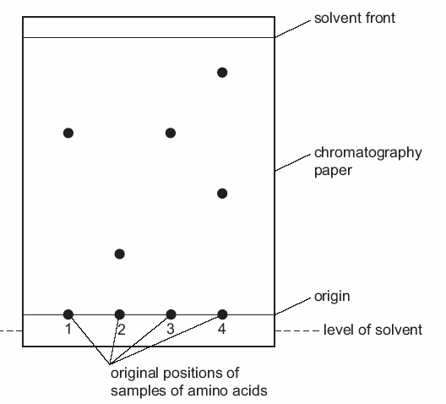

(a) Why is the origin line drawn in pencil?

[1]

(b) Which amino acids could possibly be the same?

[1]

(c) Which amino acid sample contains more than one amino acid? Explain your answer.

Sample

Explanation

[2]

(d) Suggest why it is necessary to spray the chromatogram with ninhydrin.

[1]

[Total: 5]

**3.**

The graph below shows the action of heat on a sample of water, heated from -100C through to 1000C.

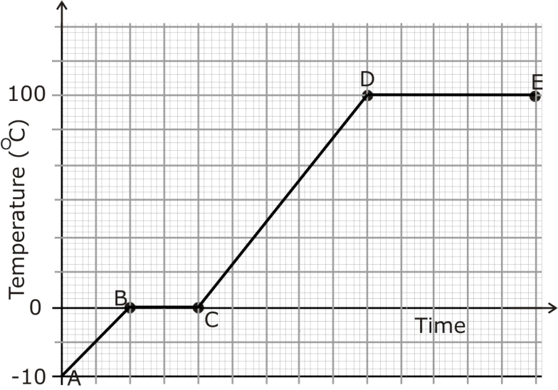

Describe the changes taking place between;

(a) A-B

[1m]

(b) B-C

[2m]

(c) C-D

[1m]

(d) D-E

[2m]

[Total 6m]

**4.**

A student puts some pieces of a solid hydrocarbon wax into a test-tube. She places this test-tube into a beaker of boiling

water until all the solid wax has melted to form a liquid.

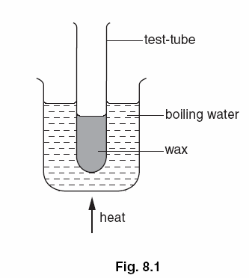

**(a)** Explain why she heats the wax in this way instead of heating the test-tube directly with a burner.

...........................................................................................

...........................................................................................

........................................................................................... [2]

**(b)** Another student puts a thermometer in the wax in the test-tube then removes the test- tube from the boiling water.

He notes the reading of the thermometer every minute as the wax cools. His results are shown in below.

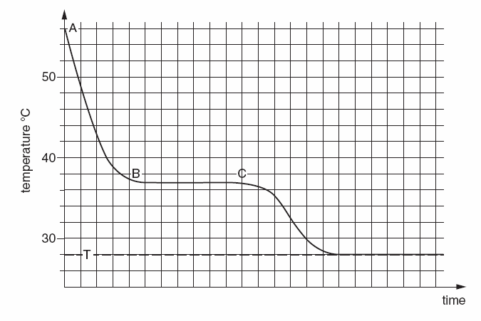

**(i)** Using words from the list below complete the following sentences about this

experiment.

**cooling endothermic exothermic**

**melting solidifying warming**

Between the points **A** and **B** on the graph, the liquid is.............................

Between the points **B** and **C** on the graph, the hydrocarbon is.............................

This an ............................ process. [3]

**(ii)** Use the graph to find the melting point of this hydrocarbon.

Melting point = ...................... °C [1]

**(iii)** How does the shape of the graph show that the hydrocarbon is pure?

...........................................................................................

........................................................................................... [1]

**(iv)** What is the significance of the final temperature **T**?

...........................................................................................

........................................................................................... [1]

[Total 8m]

**5.**

Shuli investigated differences between physical and chemical changes.

She put three chemicals in separate crucibles and weighed each one.  
She heated each crucible as shown below.  
She weighed each crucible again when it had cooled down.

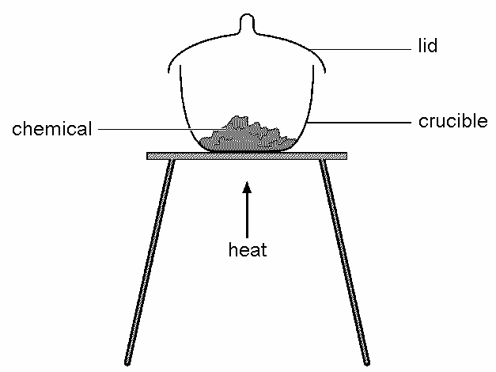

She recorded her observations in a table as shown below.

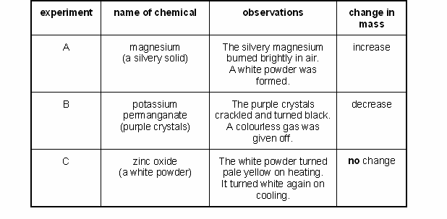

(a) (i) In experiment A, magnesium reacts with a gas in the air.

Complete the word equation for the reaction in experiment A.

magnesium + ............................................ ® ............................................

2 marks

(ii) Explain the increase in mass in experiment A. Use your word equation to help you.

.....................................................................................

.....................................................................................

1 mark

(b) The gas given off in experiment B re-lit a glowing splint.  
Give the name of this gas.

................................................................

1 mark

(c) Name the white powder left at the end of experiment C.

..................................................................

1 mark

(d) In each experiment, did a chemical change or a physical change take place?  
Tick **one** box for each experiment.

|  |  |  |
| --- | --- | --- |
| **experiment** | **chemical change** | **physical change** |
| A |  |  |
| B |  |  |
| C |  |  |

1 mark

Maximum 6 marks

**6.**

(a) Use the kinetic particle theory of matter to explain why energy is needed to melt a solid, at its melting point, to form a liquid.

[2]

(b) A student puts a drop of coloured ink into water. The ink slowly spreads throughout the water.

Use the kinetic particle theory of matter to explain this observation.

[2]

[Total 4m]

**7.**

(a) The table below shows the melting points of four metals.

|  |  |
| --- | --- |
| **metal** | **melting point, in °C** |
| gold | 1064 |
| mercury | -37 |
| sodium | 98 |
| iron | 1540 |

(i) Which metal in the table has the highest melting point?

............................................................

1 mark

(ii) Which metal in the table has the lowest melting point?

............................................................

1 mark

(b) Gold can be a **gas** or a **liquid** or a **solid.**

Choose from these words to fill the gaps below.

When gold is heated from room temperature to 1070°C, the gold

changes from a ................................. to a ................................... .

1 mark

(c) 5 g of gold is melted and **all** of it is poured into a mould to make a pendant as shown below.

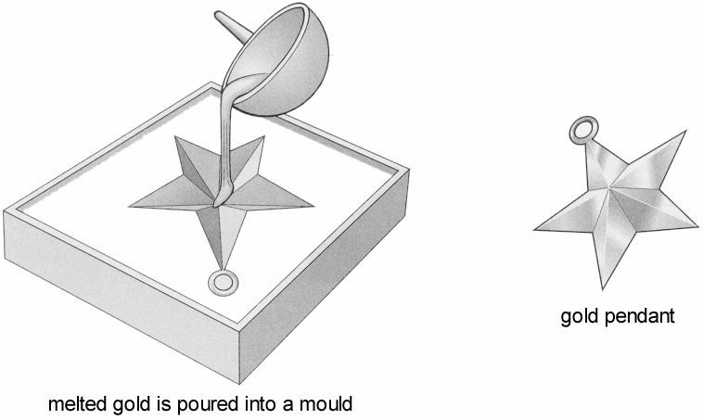

What is the mass of the gold pendant?

........................... g

1 mark

(d) The table below shows how the four metals react with oxygen when heated in air.

|  |  |
| --- | --- |
| **metal** | **reaction when heated in air** |
| gold | no change |
| mercury | slowly forms a red powder |
| sodium | bursts into flames straight away |
| iron | very slowly turns black |

(i) Which is the **most** reactive metal in the table?

............................................................

1 mark

(ii) Which is the **least** reactive metal in the table?

............................................................

1 mark

Maximum 6 marks

**8.**

An isotope of element E has 34 neutrons and its mass number is 64. E forms a cation with 28 electrons.

Write the formula of the cation with 28 electrons. Write the formula of the cation indicating the mass and atomic numbers.

(1mk)

**9.**

The diagrams represent the arrangement of atoms or molecules in four different substances, A, B, C and D.



*not to scale*

Each of the circles, ,  and represents an atom of a different element.

(a) (i) Which substance is a compound?

…………

1 mark

(ii) Which substance is a mixture?

…………

1 mark

(iii) Which **two** substances are elements?

………… and …………

1 mark

(iv) Which **two** substances could be good thermal conductors?

………… and …………

1 mark

(v) Which substance could be carbon dioxide?

…………

1 mark

(b) The following experiment was set up. Test-tubes containing substances B and C were placed together as shown. The

substances did **not** react.  
They were left for five minutes.



(i) How many molecules are there in the mixture compared to the total number in substances B and C?

……………………………………….……………………………………….

1 mark

(ii) Complete the diagram which is a model of this experiment.



1 mark

Maximum 7 marks

**10.**

Use the diagrams below to answer the questions that follow.The choices may be used once, more than once or not at all.

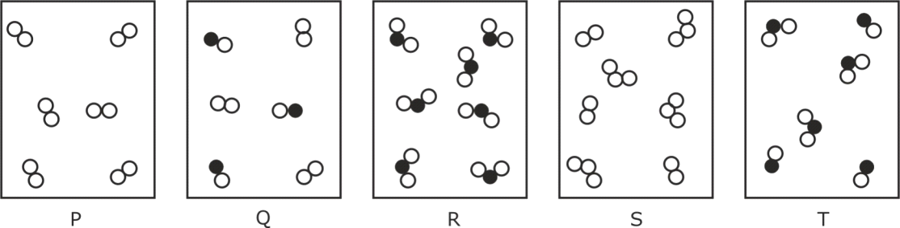

Identify which substance represents

(a) A mixture of two diatomic gases …………………………………………[1m]

(b) A pure element …………………………………………[1m]

(c) A mixture of two compounds …………………………………………[1m]

(d) A pure compound …………………………………………[1m]

(e) A mixture of a compound and an element …………………………………………[1m]

[Total 5m]