**2.0.0 SIMPLE CLASSIFICATION OF SUBSTANCES ANS**

**For Examiners use only.**

|  |  |  |
| --- | --- | --- |
| **Question** | **Maximum Score** | **Candidates Score** |
| **1 – 10** | **57** |  |

**1.**

(a) (i) 100 *accept answers from 98 to 100* 1 (L5)

(ii) to condense the water vapour *accept ‘to change the gas into liquid’* 1 (L5)

***or*** *‘condensation’ or ‘condenser’  
accept ‘to cool the vapour into water’  
do* ***not*** *accept ‘to cool the vapour or water’*

(iii) distillation **or** distilling 1 (L5)

(b) (i) evaporating **or** boiling 1 (L6)

melting 1 (L6)

freezing 1 (L6)

condensing 1 (L6)

(ii) A *accept ‘boiling’* 1 (L6)

D *accept ‘condensing’* 1 (L6)

*accept the letters written in the correct places on the diagram*

**[9]**

**2.**

(a) does not dissolve in solvent / interfere with results owtte (1) [1]

(b) 1 and 3 (1) [1]

(c) sample 4 (1)

two spots present (1) [2]

(d) to show position of the acids / spots (1) [1]

[Total: 5]

**3.**

(a) Ice warms up. Temperature rises from -10 to 00C. No change of state [1m]

(b) Temperature stays constant [1m]. Change of state occurs. Ice changes to liquid [1m] water.

(c) Water warms up. Temperature changes from 00C to 1000C [1m]

(d) Temperature remains constant [1m]. Change of state occurs. Boils to steam at 1000C [1m]

[Total 6m]

**4.**

Ans

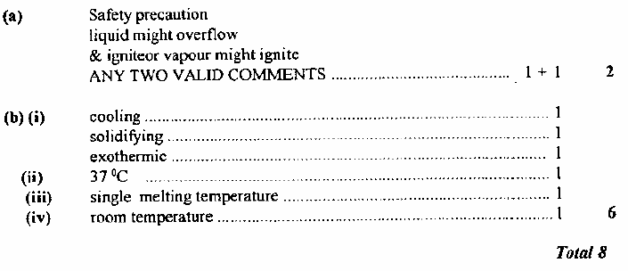

**5.**

(a) (i) *magnesium* + oxygen ® magnesium oxide 2

*do* ***not*** *accept formulae*

(ii) any **one** from *do* ***not*** *accept ‘air’ for oxygen* 1

· the oxygen had mass

· oxygen was added to the magnesium

*accept ‘magnesium has gained an element’*

· the magnesium has reacted with oxygen

*accept ‘magnesium is now part of a compound’*

(b) oxygen *accept ‘O2’* 1

(c) zinc oxide *accept ‘ZnO’* 1

(d)

|  |  |  |
| --- | --- | --- |
|  | chemical change | physical change |
| A |  |  |
| B |  |  |
| C |  |  |

1

***all three*** *ticks are required for the mark*

**[6]**

**6.**

(a) Increase the potential energy of the molecules

OR do work in separating the molecules 1

against intermolecular forces/bonds 1 (2)

(b) Molecules are moving around randomly 1

spread in all directions 1 (2)

[Total 4]

**7.**

(a) (i) iron *do* ***not*** *accept ‘1540°C’* 1

(ii) mercury *do* ***not*** *accept ‘-37°C’* 1

(b) solid *to a* liquid *answers must be in the correct order* 1

***both*** *answers are required for the mark*

(c) 5 1

(d) (i) sodium 1

(ii) gold 1

**[6]**

**8.**

64

30E + 2  wrong/ correct charge ( - ½ )

**9.**

(a) (i) C 1

(ii) D 1

(iii) A and B *answers may be in either order* 1

***both*** *answers are required for the mark*

(iv) A and D *answers may be in either order* 1

***both*** *answers are required for the mark*

(v) C 1

(b) (i) the same *accept ‘seven’* 1

(ii) a random, mixed arrangement of both types of molecule should be 1   
drawn with the molecules not touching each other

**[7]**

**10.**

(a) Q

(b) P or Q

(c) T

(d) R

(e) Q

[Total 5m]