# Site Flow and Sketches

## Step 1: Competitive Analysis

|  |  |
| --- | --- |
| Competitor Site 1: <site name here> <https://www.mydomaine.com/things-to-do-tonight> AnalysisWhat is good about this site?  1. It’s minimalistic 2. It’s easy to navigate 3. Gives a variety of options to do  What is bad about this site?  1. Some ads are present on the website 2. It’s a little too simple, nothing unique 3. It’d be nice if the list was categorized | Competitor Site 2s: <site name here> <https://www.usatoday.com/story/life/health-wellness/2020/03/16/coronavirus-quarantine-100-things-do-while-trapped-inside/5054632002/> AnalysisWhat is good about this site?  1. There is a lot of information provided 2. Overall website is pretty organized 3. Some of the ads are relevant towards user  What is bad about this site?  1. Website takes longer to load 2. Way too much going on, ads and popups 3. Subscription bar on top stays present, gets annoying |

### Competitor 1 Pages

#### Page (or Screen) where you ask “What should I do tonight?”

#### ../Desktop/Screen%20Shot%202020-04-22%20at%204.17.18%20PM.pngPages (or Screens) look for the answer

<paste screen-shot here> 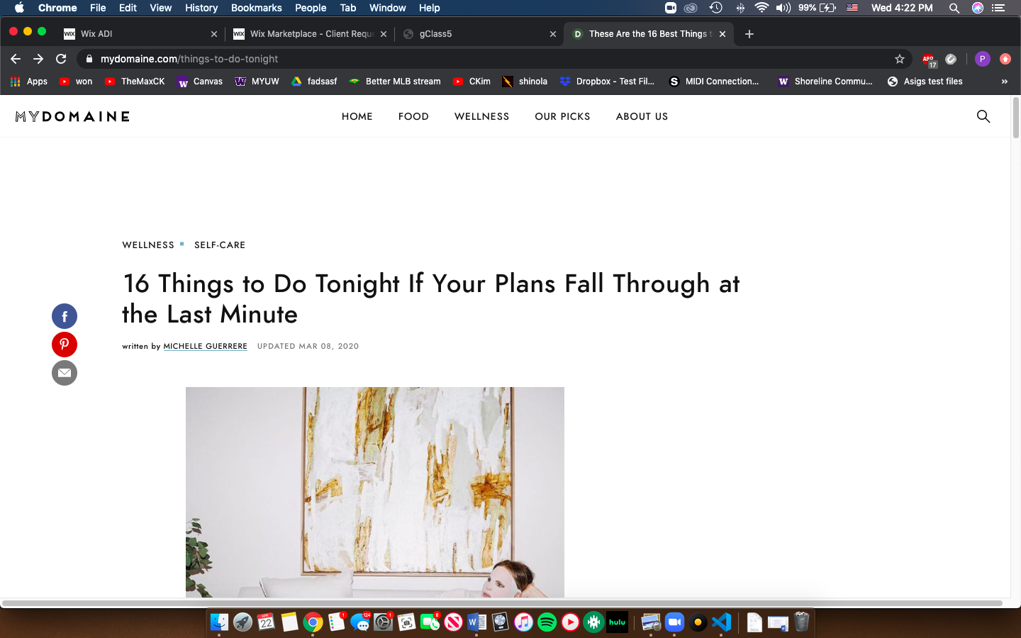

#### Page where you get an answer

<paste screen-shot here> 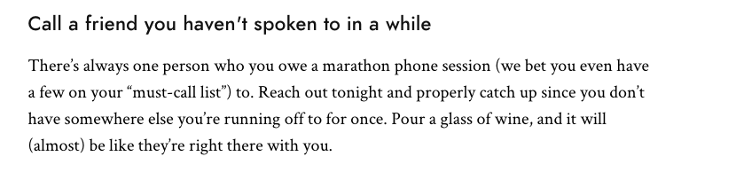

### Competitor 2 Pages

#### Page (or Screen) where you ask “What should I do tonight?”

<paste screen-shot here> 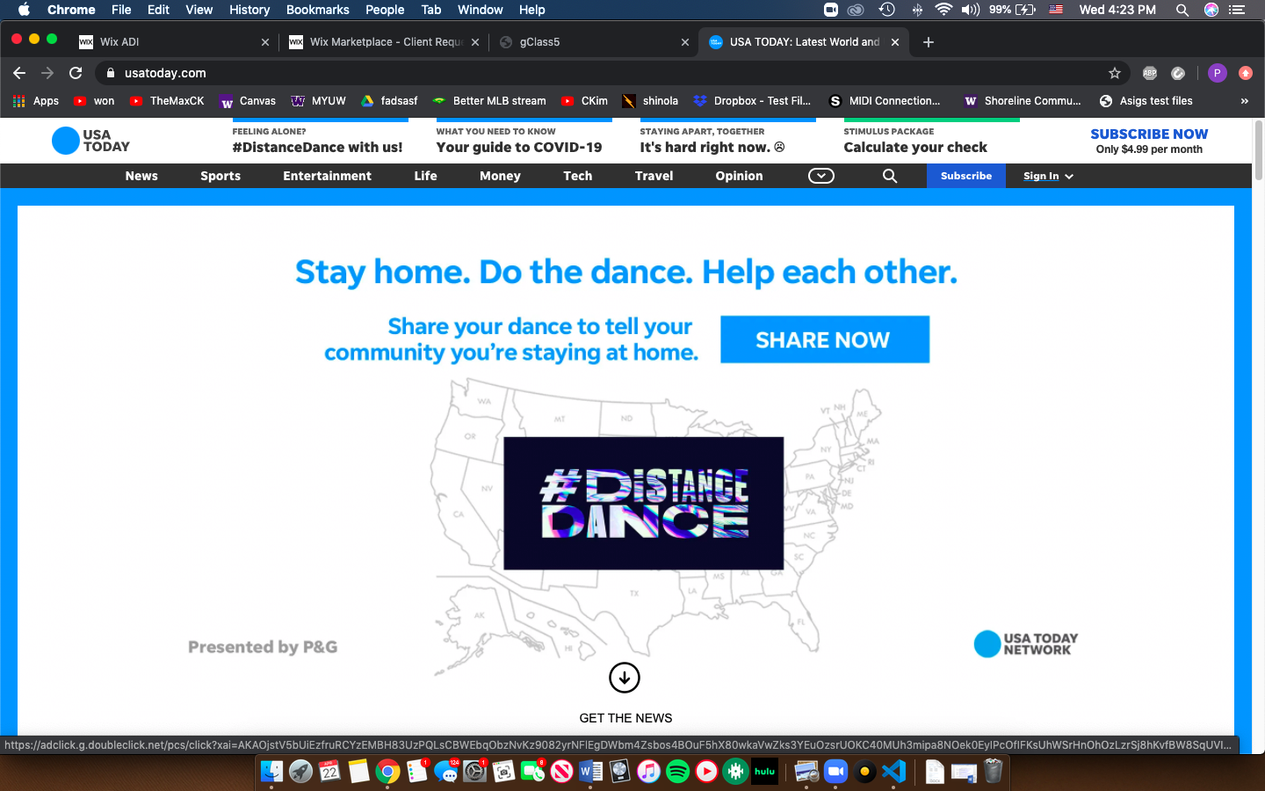

#### Pages (or Screens) look for the answer

<paste screen-shot here> 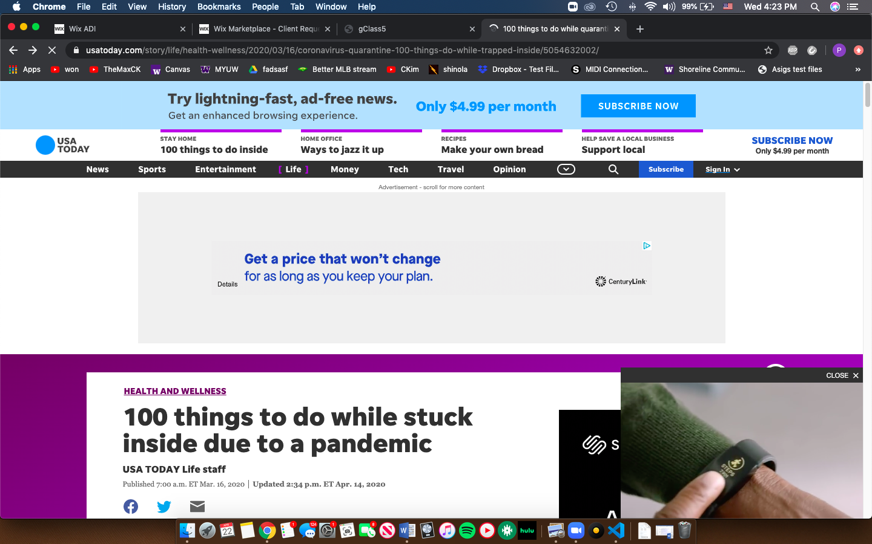

#### Page where you get an answer

<paste screen-shot here> 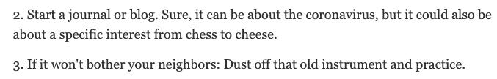

## Step 2: Sketch One Competitor Flow

### Favorite Competitor: Page Flow Sketch

Pages sketched as boxes for the flow between pages (or screens) where you ask “What should I do tonight?”, look for the answer, and get an answer. Arrows drawn between the boxes show how the pages are connected by clicks. Inside the page boxes details include:

* Where you ask the question
* Where the navigation is that allows you to find things to do
* Where the details of the “things to do” are displayed
* Where you click to move from page to page

## ../Desktop/Screen%20Shot%202020-04-22%20at%204.55.38%20PM.png

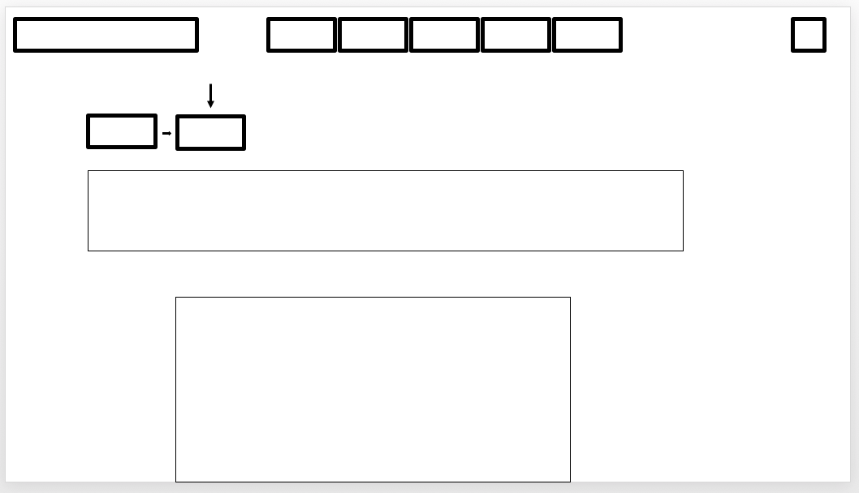

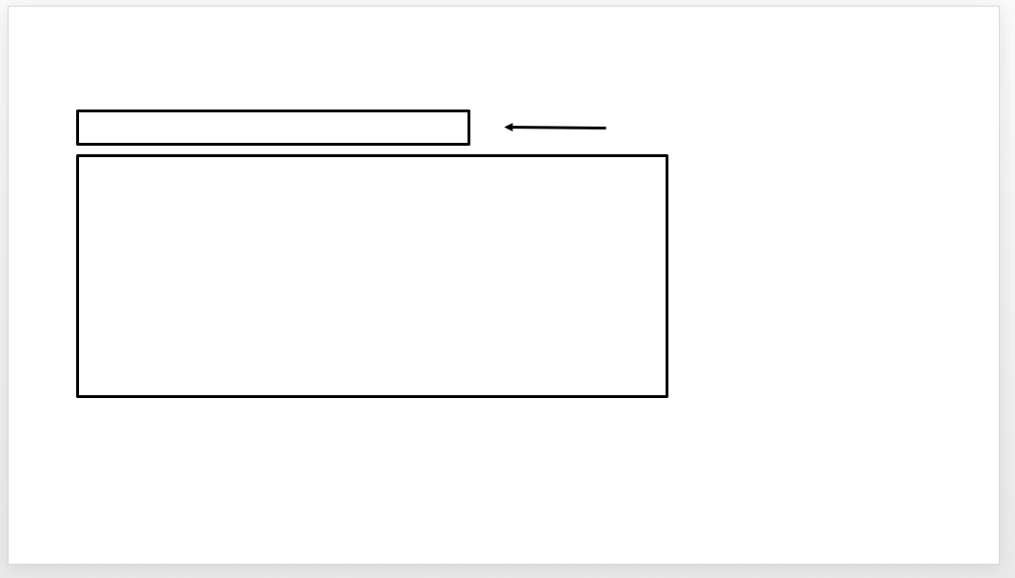

## Step 3: Sketch YOUR Flow

### My Site Name

Quarantineactivites.com

#### Sketch of My Page Flow

Pages sketched as boxes for the flow between pages (or screens) where you ask “What should I do tonight?”, look for the answer, and get an answer. Arrows drawn between the boxes show how the pages are connected by clicks. Inside the page boxes details include:

* Where you ask the question
* Where the navigation is that allows you to find things to do
* Where the details of the “things to do” are displayed
* Where you click to move from page to page

<paste screenshot of sketches here> 