Philip Ho

Project Step 14 Sprint

22 APR 2020

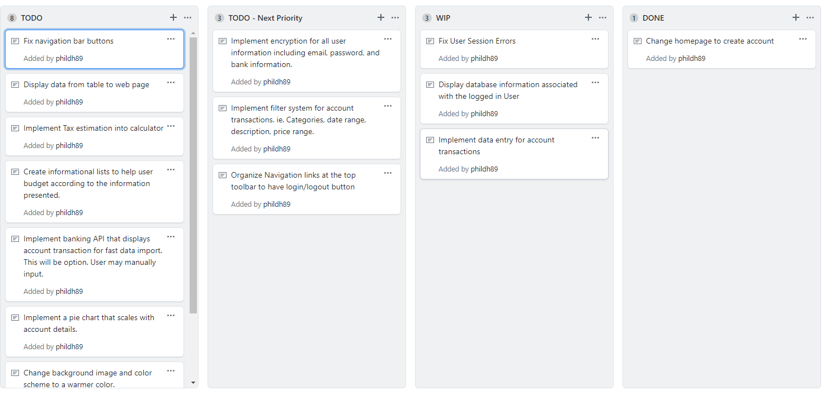

23 APR 2020

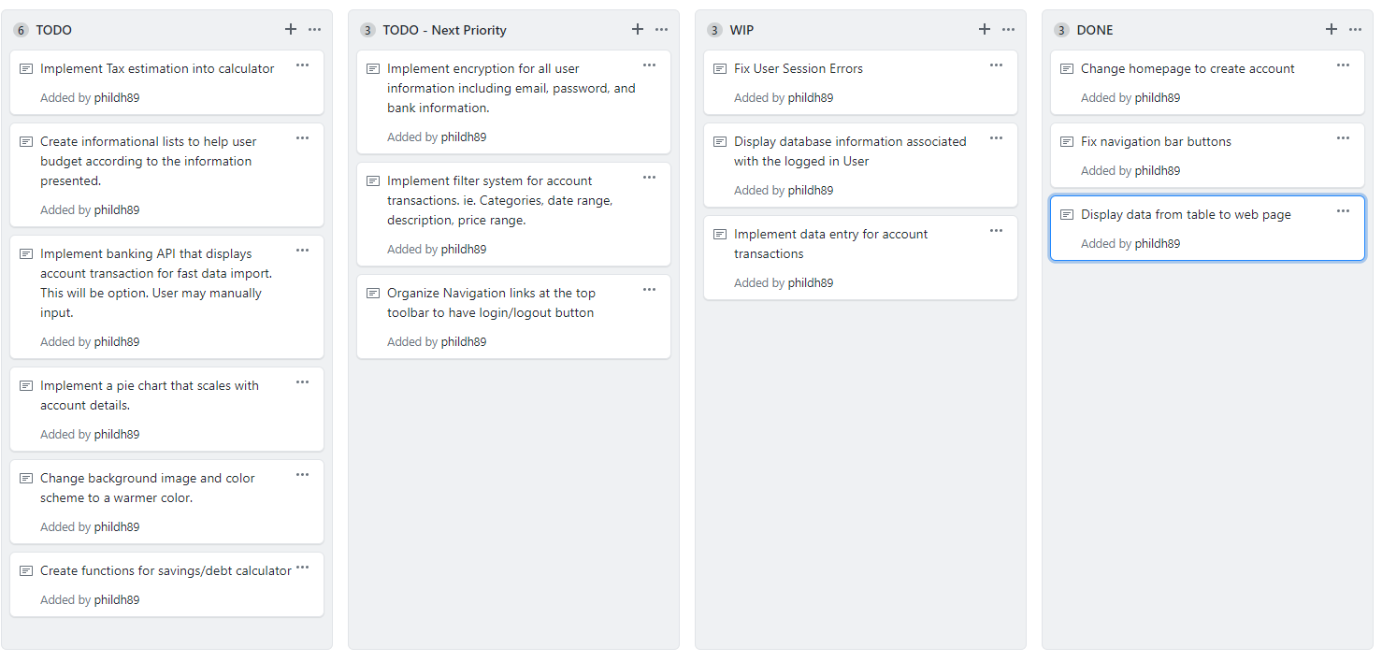

25 APR 2020

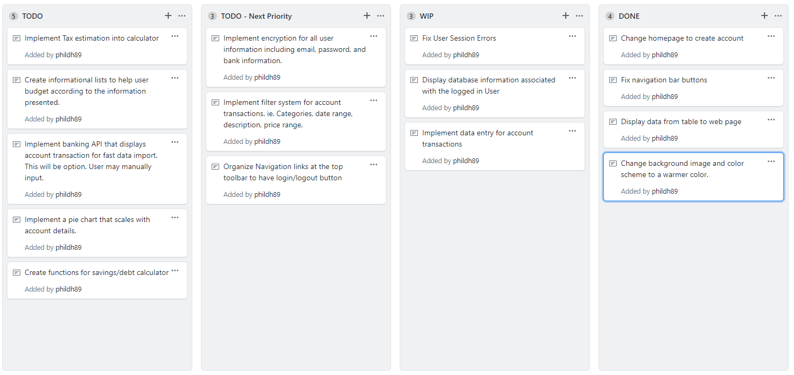

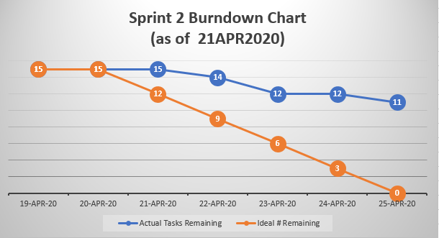

* Did you complete all items in your sprint plan?

No, the tasks I made were too big for me to learn and implement in a few days

* What is your sprint deliverable? (shippable product(s))

None..? Very basic outline and displays all information instead of user log in info.

* Did you have any task volatility, and what was the cause?

Trying to understand user sessions, tempdata and displaying tables took a lot of time and prevented any movement in the project.

* What would you do differently knowing what you know now?

I would make the sprint tasks more achievable. I originally created the sprint to complete the project. I would make smaller tasks.