Specific Aims

Understanding how memories experienced across large time scales are associated together is crucial to understanding episodic memories, since the ability to relate episodes across days is essential to the formation of memory. Recently it has been demonstrated in rodents that two neutral contexts experienced close in time shared a larger proportion of neural ensemble than those experienced more distant in time. Furthermore, subsequent fear conditioning in the later context increased animals’ freezing level in the previous context, suggesting a transfer of fear memory retrospectively. Such results suggest a linking of two temporally distinct memories through overlapping neuronal ensembles, and the phenomenon is termed memory linking. However, it remains unclear what factors may affect the temporal window of memory linking, which is the maximum time interval within which two memories can be linked together. Specifically, it is unknown whether the affective valence of a memory influences the extent or the symmetry of the temporal window of memory linking. For instance, it is unclear whether negative valence of a memory could extend the time window within which it may be linked to a previous memory. Moreover, it is not clear whether a negative memory could link forward with a memory that happens later in time, (i.e linking to a memory prospectively). Furthermore, it’s unclear whether such prospective memory linking has a similar time window as retrospective memory linking (i.e whether the time window is symmetric regarding the temporal order of memories). Thus, the main goal of this proposal is to study how affective value and temporal order affect the temporal window of memory linking, with both behavioral experiments and calcium imaging in behaving animals.

One of the hypothesis that could explain memory linking is the excitability hypothesis, which states that the neurons encoding an earlier memory have a transient increase in excitability, making them more likely to be active during the encoding of a later memory, thus resulting in an increase of ensembles overlap between the two memories. Such increase in the ensembles overlap, in turn, may drive memory linking. Since it has been shown that negative valence increase neuron excitability, it is expected that neurons engaged in a negative memory sustain an elevated level of excitability longer than those in a neutral memory. Thus, for a negative memory, the excitability model would predict a longer temporal window for prospective memory linking comparing to retrospective memory linking. Furthermore, the excitability model would not predict a change of retrospective memory linking window as a function of emotional valence. However, from an ethological point of view, retrospective memory linking is more important than prospective memory linking, since past memories may have a causal contribution to future events, but not the other way around. Moreover, memory linking of more negative events should extend further back in time, since that helps animals to gather more information to avoid future traumatic events. In fact, we have preliminary data suggesting that negative valence increase the retrospective memory linking window, and that retrospective memory linking window is longer than prospective linking window. Thus, we hypothesis that negative emotional valence extend retrospective memory linking time window, and that retrospective memory linking time window is longer than those in prospective memory linking. To test these hypothesis, we will carry out behavior experiments utilizing contextual fear conditioning, as well as in vivo calcium imaging in freely moving animals.

Besides behavior, the other important aspect of memory linking is an increase of overlaps between the ensembles of two linked memories. Thus, our second goal is to study the neural correlates of memory linking during the manipulation of emotional valence and temporal order of contexts. To achieve this goal, we will carry out calcium imaging in behaving animals. One of the difficulties facing this approach is the analysis of imaging data. Various algorithms have been developed to extract calcium traces from raw videos, however a user-friendly pipeline is lacking. Thus our first step towards this goal is to develop analysis pipeline that can visualize the extraction results and register neurons across recording sessions, so that we may compare neural ensembles across sessions. We hypothesize that if the temporal window of memory linking changed, and transfer of fear is observed between two contexts, the overlaps between the ensembles encoding the two contexts should also increase. In addition, by applying dimension reduction analysis such as principal component analysis (PCA), we can uncover the underlying temporal structures of neural ensembles for individual sessions. Thus we also hypothesize that the similarities between principal components of two ensembles are higher if the corresponding contexts are linked together. In other words, the similarities between principal components of two memory
ensembles should be consistent with the overlaps between the two ensembles.

Aim 1: Study the effect of emotional value on the extent and symmetry of the temporal window of memory linking. Test the hypothesis that negative emotional value extend retrospective memory linking time window, and that retrospective memory linking time window is longer than those in prospective memory linking.

Aim 2: Study the neuronal correlate of memory linking. Develop analysis pipeline for calcium imaging data. Test the hypothesis that linked memories have larger neural ensemble overlaps, and that linked memories also has more similarities in ensemble structures.
A. Significance

Understanding how temporally distinct memories can be related together is essential to understanding episodic memory, since the ability to associate different episodes across long periods of times is essential to forming memories [1]. It is generally believed that hippocampus make an important contribution to episodic memories in rodents. Traditionally, studies have focused on hippocampal coding within episodes, which are usually testing sessions of a behavior task repeated across days. Most notably, we have extensive knowledge of how space is coded in familiar settings [2], as well as how time is coded in well-learned time-dependent tasks [3]. On the other hand, it is found that different population of hippocampal neurons are engaged in memories of different contexts across days. Thus the population of neurons encoding a specific memory is termed the ensemble of said memory, and it is found that artificially stimulating an ensemble is sufficient to drive the retrieval of the corresponding memory and elicit behavior response [4]. Interestingly, it is found that ensembles of same familiar environments drift across time, in that different population of neurons are recruited to encode the same environment at different times. Moreover, the number of neurons that are shared between two ensembles, or, the “overlap” between two ensembles, varies in a time-dependent manner, so that the overlap of ensembles encoding memories of the same environment is higher if the memories are separated with shorter time interval [5]. However, it was unclear whether overlaps of ensembles encoding different environments have a similar time-dependent property, and whether such difference in overlaps have any behavior correlates. If different ensembles of memories merely reflect the difference in features, it would be surprising to find any time modulation of the overlaps between memories encoding different environments.

Recently, it has been found in rodent hippocampus that the neuronal ensembles of two distinct contextual memories separated by 5 hours time interval has more overlapping cells than those separated by 2 days or 7 days. Interestingly, subsequent fear conditioning in the later context induce elevated freezing level in the former context when the two contexts are separated by 5 hours, indicating a transfer of fear memory from the second context to the first. Such results suggest a linking of two temporally distinct memories through overlapping neuronal ensembles, and the phenomenon is termed memory linking [6]. Following these findings, two models have been proposed to explain the phenomenon of memory linking: On cellular and circuit level, It has been hypothesized that memory linking happens through excitability mechanism, where the ensemble neurons of first memory sustain an elevated excitability during the memory linking time window, and thus are more likely to be recruited during the encoding of the second memory, facilitating the linking of the two memory [7]; At the same time, from a conceptual and computational aspect, temporal context model suggests that memory linking is a peculiar case of a more general temporal context framework, which argues that features of memories are associated with an ever-drifting temporal context, and all recollection of episodic memories, as well as formation of semantic memories, happen through the retrieval of the associated temporal context [8].

However, various aspects of memory linking remain under-studied. Most notably, it is unclear what factors affect the temporal window of memory linking, defined as the maximum time interval within which two memories could be linked together. Besides, the effect of temporal order on memory linking remains unclear - it has been demonstrated that memory linking can happen retrospectively, in that the fear associated with a later memory can transfer back to a neutral memory that happened earlier. It is unknown, however, whether memory linking could happen prospectively, where the fear associated with a memory can transfer forward to a neutral memory that happens later in time. Moreover, if prospective memory linking exists, it is interesting to see whether it has a same temporal window as retrospective memory linking. Taken together, two important and inter-related questions remain unclear for the memory linking phenomenon: a) whether and how the temporal order of the experiences affect the temporal window of memory linking. b) whether and how negative emotional valence of the experiences affect the retrospective temporal window of memory linking. Regarding the first question, the excitability hypothesis would predict longer memory linking window for prospective memory linking, since negative emotional valence increase the excitability of neurons, making them sustain an elevated excitability for longer period of time comparing to those engaged in neutral memories, thus extend the time window where a negative memory could be linked to a neutral memory in the future, but not in the past. Similarly, the temporal context model would predict a stronger prospective memory linking as well. Regarding the second question,
the excitability hypothesis would not predict an effect of negative emotional valence on retrospective memory linking, since the excitability of neurons engaged in a neutral memory should not be affect by emotional valence of a memory happens in the future. Meanwhile, the temporal context model would fail to provide a prediction regarding the second question since emotional valence has not been integrated into the model.

However, from a ethological perspective, the predictions regarding the two questions would be different from those predicted by the two existing models. Specifically: a) relating a memory to past experiences is more beneficial than relating a memory to future experiences, since only past experiences may have a causal role which is important to learn. b) relating a highly traumatic memory to other experiences (especially past experiences) is more beneficial than relating a neutral memory to others, so that the animal may learn to avoid the same situation in the future. An important example of such perspective is conditioned taste aversion, where the animals learned to associate the negative experience (sickness) with a past experience (consumption of food), and such association depends on the valence of the negative valence (how much sickness was induced).

Thus, the main goal of this proposal is to study the effect of temporal order and emotional valence on memory linking. The study would help us understand the mechanism and behavioral significance of memory linking, and may extend our knowledge on episodic memory in general.

In addition to behavior, it is important to see whether there is neural correlates of memory linking in hippocampus. Traditionally, the analysis of neural recording data in memory linking experiments have been limited to comparing overlapping ensemble cells that are active during recording sessions. Such analysis provided a simple estimation of similarities between ensembles and successfully supported behavior data. However, it reduces the time dimension of each recording session to a binary, “active-or-not” representation, precluding any analysis on the structure of the ensemble within session. This limitation is mainly due to the task-free and one-trial-learning nature of memory linking, where there is no task variables to align the recording data to, nor is there enough time for place cells to be formed and detected. Dimension reduction approaches, or more specifically principal component analysis (PCA) is a very useful tool in such circumstances, since it can transform higher dimension recording data to lower dimension, temporally structured components in an unsupervised manner. Thus another goal of the presented proposal is to apply PCA analysis to neural recording data during memory linking experiments. Such analysis could uncover the underlying structures of memory ensembles, and help us understand the nature of memory linking on the ensemble level.

B. Preliminary

Prospective memory linking window is longer than retrospective linking window for a negative memory

In the preliminary study shown in Figure 1, animals are put into two distinct contexts separated by various time intervals. In the “prospective linking” group, animals received a delayed shock in the first context, and then explore and get tested in the second context. In the “retrospective linking” group, animals explored first context, and then get a delayed shock in the second context, and then put back to the first context for testing. Elevated freezing level in the testing context, where no shock ever occurred for both groups, indicate a transfer of fear and a linking of the two contexts. For both groups, the exploration and testing session last 10 minutes, a shock of 0.75 mA was delivered at fifth minute. The various time intervals are 5 hours, 1 day, 2 days and 7 days for both groups.

In prospective linking group, we observed a significant higher freezing level in testing context with 5 hours interval, but not with either 1 day, 2 days or 7 days interval. This suggest that the fear memories were able to transfer forward to a neutral context 5 hours in the future. On the other hand, in retrospective linking group, we observed higher freezing level with either 5 hours, 1 day or 2 days interval, but not with 7 days interval. This suggest the fear memory was able to transfer backward up to 2 days. Taken together, these results suggest an extended temporal window of retrospective memory linking comparing to prospective memory linking.
Negative emotional valence extend temporal window of memory linking

In the preliminary study shown in Figure 2, animals are first put into a neutral context for exploration. After various time interval, animals are put into a second context. For animals in the aversive group, they received a delayed shock at fifth minute of the exploration, which associate a negative emotional value to the second context. For animals in the neutral group, the exploration of the second context was uninterrupted, and they received a immediate shock in the second context 2 days after the initial exploration, thus the emotional valence of the second context was initially neutral for this group. Both groups were put back to the first context to test for freezing. An elevated freezing level in the first context indicate a transfer of fear.

For the neutral group, we observed significant higher freezing level in the first context with 5 hours interval, but not with either 1 day, 2 days or 7 days interval, suggesting that the two contexts were only linked across 5 hours when the second context was initially neutral during encoding. On the other hand, we observed significant higher freezing level with either 5 hours, 1 day or 2 days interval, but not with 7 days interval, suggesting the two memories were able to link across 2 days when the second memory was initially negative during encoding. Taken together, these results suggest that negative emotional valence was able to extend the time window of memory linking.

In another preliminary study shown in Figure 3, calcium imaging was carried out during all the behavior sessions. The experiment design is similar to the previous behavior study, except the time interval between the initial exploration of the two contexts was fixed at 2 days, since there was a significant behavior effect of negative valence at 2 days interval. Consistent with the behavior results, we found a significant increase in neural overlaps of the two ensembles during the retrieval of the two contexts in the aversive group. Interestingly, between the two groups, there is no significant difference between the neural overlaps of the two ensembles during encoding of the two contexts, suggesting that the changes in the overlaps of the representation of the two contexts, possibly memory linking as well, happened during offline periods between the initial encoding and the testing of the memories.

Minian: a python analysis pipeline for calcium imaging data

One of the challenge facing miniature microscope in behaving animals is the analysis of calcium imaging data. Previously, a constrained non–negative matrix factorization algorithm has been developed to extract calcium traces of different neurons from raw video. However, a lack of user-friendly interface and visualization tools for result inspection limit its popularity among community. Moreover, a method of cross-registering neurons across sessions has not been integrated into the analysis pipeline. To address these issues and facilitate the analysis of imaging data, we have developed a pipeline based on jupyter notebook, which is a document format that combines codes and texts. The adoption of jupyter notebook enables us to take and share text notes, edit and execute codes, as well as dynamically visualize results all in an integrated document, so that we can easily share reproducible analysis to the community (Figure 4). Furthermore, a simple cross-registration method based on euclidean distance of centroids of neurons has been integrated into the pipeline. Application of this method to our preliminary data shows that the method could identify same neurons across sessions with satisfactory accuracy.

C. Approach

Aim 1: Study the effect of emotional value on the extent and symmetry of the temporal window of memory linking.

To test the hypothesis, we will carry out experiments utilizing contextual fear conditioning. We choose contextual fear conditioning because it is a robust and well-established test for long-term memory, and moreover a strong memory can be formed within one learning session.

The experimental design is shown in Figure 5. Specifically, animals will be divided into four groups according to two factors: the shock intensity and the temporal order of the contexts. Two of the four groups receive “low shock”, while the other two groups receive “high shock”; At the same time, two of the four groups are assigned to
“prospective” experiments, while the other two groups are assigned to “retrospective” experiments. Thus, overall the four groups form a 2 by 2 matrix, where groups on the same rows receive same amplitude of shock, and groups on the same column experience contexts in the same order. This design allow us to easily compare between groups, and uncover both the effects and interactions of emotional valence and temporal order.

In all groups, context A, B and C are distinct contexts that differ in lighting conditions, arena shapes, floor textures and scents. For “retrospective” experiments, animals are first put into context A to explore for 5 minutes. Then after a variable time intervals, the animals are put back into context B for 5 minutes, where they receive a delayed shock at fourth minute with an amplitude of either 0.75 mA or 1.5 mA, depending on whether the animals are in “low shock” or “high shock” group. The variable time intervals are achieved by further dividing animals into sub-groups according to different time intervals, and between-group comparison can be carried out. 2 days after these, the testing sequence is carried out, where the animals are put back to context A, B and C in that order, with 2d interval in between. Animals’ freezing levels are assessed from behavior video recordings using standard software. For “prospective” experiments, the contexts, time intervals, shock intensity assignments and testing sequence remain identical to those in “retrospective” experiments. The difference is that in “prospective” experiments, the animals are first put into context B, where they receive a delayed shock, and then put into the neutral context A to explore.

According to preliminary results, we expect to see that in “low shock” and “retrospective” groups, animals are able to link context A and B together when they are separated by either 5 hours or 2 days, but not when they are separated by 4 days or 7 days. Specifically, within “low shock” and “retrospective” group, we expect to see higher freezing in context A for 5 hours and 2 days sub-group, but not for 4 days or 7 days sub-group. Similarly, we expect in “low shock” and “prospective” groups, the animals are only able to link together context A and B when they are separated by 5 hours, but not when they are separated by either 2 days, 4 days or 7 days. Such result would suggest that retrospective memory linking has longer temporal window than prospective memory linking. On the other hand, we expect to see in “high shock” and “retrospective” group, the animals may be able to link context A and B across either 5 hours, 2 days or 4 days, but not 7 days. Such result would suggest that more negative emotional value of a memory can extend the memory linking time window retrospectively.

Aim 2: Study the neuronal correlate of memory linking.

To study the neural correlate of memory linking, we would carry out miniature calcium imaging in behaving animals. We choose miniature calcium imaging due to its capability to record neuronal activities in behaving mice and to track same field-of-view across long period of time, which is essential for the purpose of memory linking studies. We will focus on recording in dorsal CA1 region since it is believed to make a major contribution to contextual memory. The experimental design is identical to Aim 1 as shown in Figure 5. Neuronal activities would be recorded during all experiment sessions to allow collection of rich dataset.

The raw videos from calcium imaging recording could be processed with an open-source analysis toolkit CaImAn implementing a constrained non-negative matrix factorization algorithm. After the process, a spatial matrix representing the spatial footprint of each putative neurons, as well as a temporal matrix representing the calcium traces of each putative neurons will be extracted from the raw data. A custom-written script is used to visually assess the accuracy of the extraction as well as manually refine the results. After this, neurons from different recording sessions are cross-registered based on the euclidean distances between the centroids of their spatial footprint, and a unique master index can be assigned to each neuron in the whole experiment.

The main comparison is the ensemble overlap between context A and B, B and C, as well as A and C during retrieval/testing. We expect to see a higher overlap between context A and B when the two context are linked together and animals exhibit elevated freezing level in both of them, while the overlap between A and B are not expected to be significantly higher than those between B and C or A and C when the two contexts are not linked together.

In addition, a PCA analysis can be carried out to reveal temporal structures of each ensemble. Specifically, for each recording session, given a matrix representing the calcium traces of N neurons along T time-steps (usually frames), a PCA analysis can be applied to extract R principal components, where each components contain a “neuron vector” n of length N, and a “temporal vector'' t of length T. Thus the dimension of the data is reduced from N x T to R x (N + T). The PCA is carried out in a way so that: a) the “neuron vector” of each principle component represent a group of neurons that has a highly correlated firing pattern, and the “temporal vector” represent that averaged pattern treating the whole group as single neuron. b) a dot product can be computed with each “neuron vector” and “temporal vector”, and the sum of R such dot products should closely reproduce the original N T data. c) the R components should explain most of the variance in the original data, thus the value of R can be determined by thresholding the proportion of variance explained.

Once the principal components of each recording sessions are extracted, we can calculate a cross-correlation of the “neuron vector”s between any two session. We can then compare such correlation matrices between linked context and unlinked contexts. We expect to see higher correlations between linked contexts, suggesting that the temporally correlated structures within each ensemble are more likely to be preserved across linked contexts than across unlinked contexts.

The presented approach has two caveats that might require further refining: Firstly, a method to assess the quality of cross-registration is lacking. For this issue, an algorithm developed by Yaniv lab might be more suitable since it can also output the confidence of cross-registration. However, as long as the current approach does not produce systematic bias towards linked contexts, that is, as long as the field-of-view of recordings remain relatively stable, there is no reason to expect a significant artifact from presented methods. Secondly, the application of PCA analysis presume that the neuronal ensembles are structured such that subsets of cells fire together. It may fail to detect other temporal structures, such as sequence of firing. For this, other dimension reduction algorithms might address the issue.
References

- H. Eichenbaum, P. Dudchenko, E. Wood, M. Shapiro, and H. Tanila. The hippocampus, memory, and place cells: Is it spatial memory or a memory space? Neuron, 23:209–226, 1999. PMID: 10399928.

- T. Hartley, C. Lever, N. Burgess, and J. O’Keefe. Space in the brain: how the hippocampal formation supports

spatial cognition. Philosophical Transactions of the Royal Society B: Biological Sciences, 369(1635), February

2014. PMID: 24366125.

- H. Eichenbaum. Time cells in the hippocampus: a new dimension for mapping memories. Nature Reviews

Neuroscience, October 2014. PMID: 25269553.

- S. Ramirez, X. Liu, P. P.-A. Lin, J. Suh, M. Pignatelli, R. L. Redondo, T. J. Ryan, and S. Tonegawa. Creating a false memory in the hippocampus. Science, 341(July):387–392, July 2013.

- A. Rubin, N. Geva, L. Sheintuch, and Y. Ziv. Hippocampal ensemble dynamics timestamp events in long-term memory. eLife, 4:e12247, December 2015.

- D. J. Cai, D. Aharoni, T. Shuman, J. Shobe, J. Biane, W. Song, B. Wei, M. Veshkini, M. La-Vu, J. Lou, S. E. Flores, I. Kim, Y. Sano, M. Zhou, K. Baumgaertel, A. Lavi, M. Kamata, M. Tuszynski, M. Mayford, P. Golshani, and A. J. Silva. A shared neural ensemble links distinct contextual memories encoded close in time. Nature, 534(7605):115–118, June 2016.

- G. Kastellakis, A. J. Silva, and P. Poirazi. Linking Memories across Time via Neuronal and Dendritic Overlaps in Model Neurons with Active Dendrites. Cell Reports, 17(6):1491–1504, November 2016.

- M. W. Howard, M. S. Fotedar, A. V. Datey, and M. E. Hasselmo. The Temporal Context Model in spatial navigation and relational learning: Toward a common explanation of medial temporal lobe function across domains. Psychological review, 112(1):75–116, January 2005. PMID: 15631589.
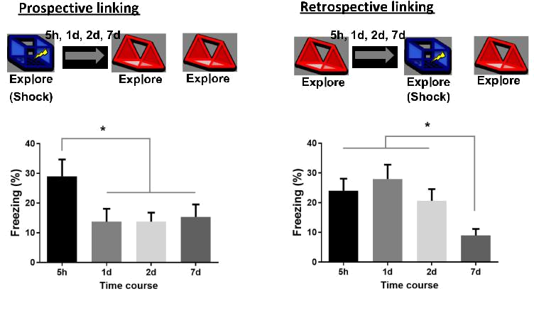

Figure 1: Prospective memory linking window is longer than retrospective linking window for a negative memory.
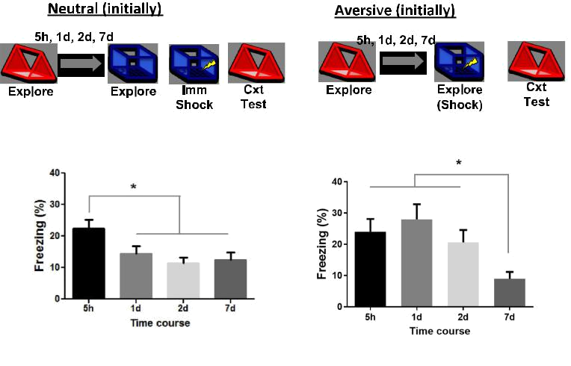

Figure 2: Negative valence increased temporal window of memory linking.
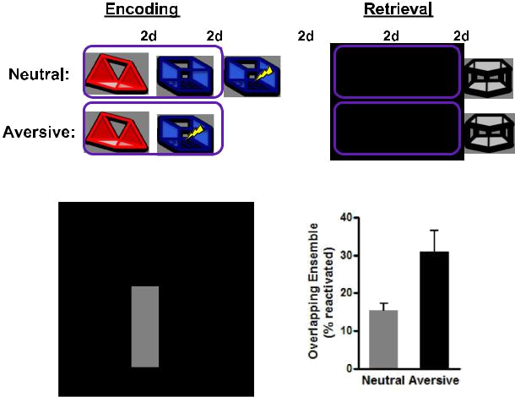

Figure 3: Negative valence increased the ensemble overlap of two memories across 2 days
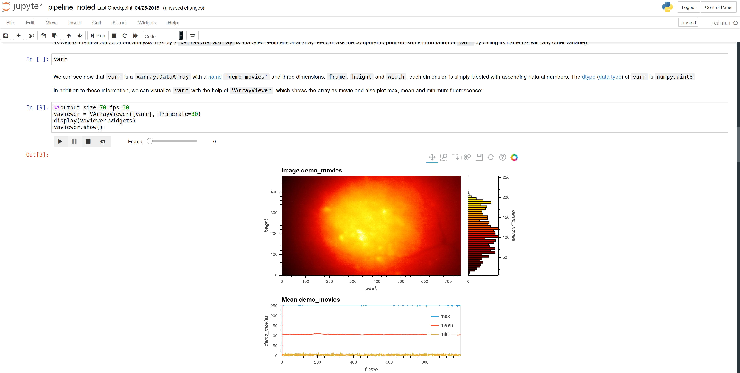

Figure 4: integration of notes, codes and visualization of results in a single document.

Retrospective Prospective

ctx A | ctx B
Low shock | 5h, 2d, 4d, 7d | 2d
5 min | 5 min
 | 0.75 mA shock
ctx A | ctx B
High shock | 5h, 2d, 4d, 7d | 2d
5 min | 5 min
 | 1.5 mA shock



ctx B |  | ctx A
Testing | 5h, 2d, 4d, 7d | 2d | Testing
5 min |  | 5 min
0.75 mA shock
ctx B |  | ctx A
Testing | 5h, 2d, 4d, 7d | 2d | Testing
5 min |  | 5 min
1.5 mA shock
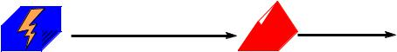
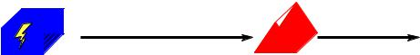

ctx A | ctx B | ctx C
Testing | 2d | 2d
5 min | 5 min | 5 min


Figure 5: behavior experimental design

