|  |  |
| --- | --- |
| **Question** | **Answer** |
| Why are we a group?  What’s the recognition of the problem? |  |
| What do we as a team value? | Trust  Comfortable with uncertainty  Sustainable success |
| What will fill a typical week of this team in 3 years? |  |
|  |  |
| **Vision Statement**/ What we will looking like 5 years from now?  Desired future position of the company |  |
| Mission Statement/ |  |
|  |  |
| **Strategy conversation:** |  |
| * What is the **process** goal?   + Why do we care? >> This is what allows us to repeat and expand * How frequently will we reassess? |  |
| * What is the **outcome** goal? |  |
|  |  |
|  |  |
| What are known landmines?  Which ones are easily avoidable vs ones that need to be worked around? | * People: Shelly, Carrie   + Reporting knowledge locked away * Organization: minimal IT resources   + Legacy systems with opaque codes * Culture: The old Tanger way * Varied consistency of leadership support |
| What are the different tracks we need to follow? | * Transformation/ Application alignment * Triage questions * Develop new datasets * Develop new insights structure * Automate “essential reporting”   + Determine which ones are essential (ie IR quarterly reporting, Exec Reporting, SLT reporting) |

|  |  |
| --- | --- |
| **P1erson** | **Skills + Areas of Expertise** |
| Craig | Connections to high level leaders  Delta app |
| Anna | Retailer experience  Center GM experience  10 years Tanger experiences |
| Rachel | Spun up quality initiatives  Rolled out dashboards  Retailer experience  Tableau |
| Phil | Analytics experience -> Spatial/ Modeling/ Forecasting/ Simulation/ Optimization  Automated reporting  SQL + R |
| Babbage | Spatial analytics  Lots of mobile data |
| Sarah + Jessica M | Historical Tanger experiences |

**Models to consider**

* Behavior change theory
* Adoption spectrum / diffusion theory
  + Innovators -> Early Adopters -> Early Majority -> Late Majority -> Laggards
  + Don’t hit a >50% adoption until getting to the late majority
* Process goals vs outcome goals
  + Implementing blameless post-mortem
    - Recognizing and adjusting strategy when process isn’t working
  + Reflection / stand-up meeting
  + Eg of sports team being successful even without the coach involvement/ or in spite of it
    - Technique
    - Dry land training
    - Keeping them committed
  + What systems will need to be put in place to ensure success is sustainable?
* Data Democracy?
* DMAIC / Lean SixSigma tools?

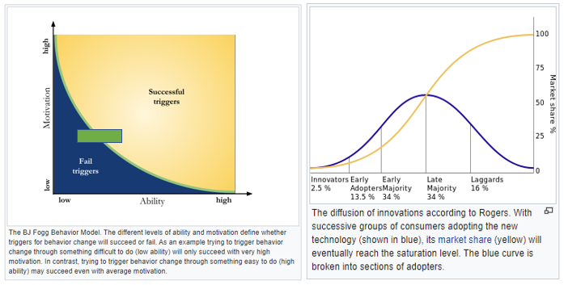

|  |  |
| --- | --- |
| **Year** | **Outcome Measures** |
|  | Established written and socialized vision  Break ground on data governance |
|  | New MRI system  Establish best practices for Data/Analytics  Data Warehouse/ Data Lake |
|  |  |

**What are the data fundamentals?**

* Sources are known/ Data generation process exposed (machine/human)
* Variability/Uncertainty is communicated
  + Distributions are characterized (no assumptions of normality)

**What are analytics essentials?**

* Reports are auditable and document
  + What is the purpose of the report
  + How was it made, what assumptions were made
* DRY (don’t repeat yourself)
  + Codify where possible to ensure repeatability
* Establish a testing and validation process
  + Data is tested before analysis to ensure bugs are induced (ie due to missingness/ dates/ character formats)
* Version control

“Breadcrumbs” in reporting/analysis

Can the user track where the data is coming from/ how drilling happened

|  |  |
| --- | --- |
|  |  |
| Perform | Analysis |
| Influence Directions | Data warehouse.  Data storage |
| Customers | All business elements  .. sales/ leasing  … marketing  … ops |

How to integrate all of our perspectives into a common language?

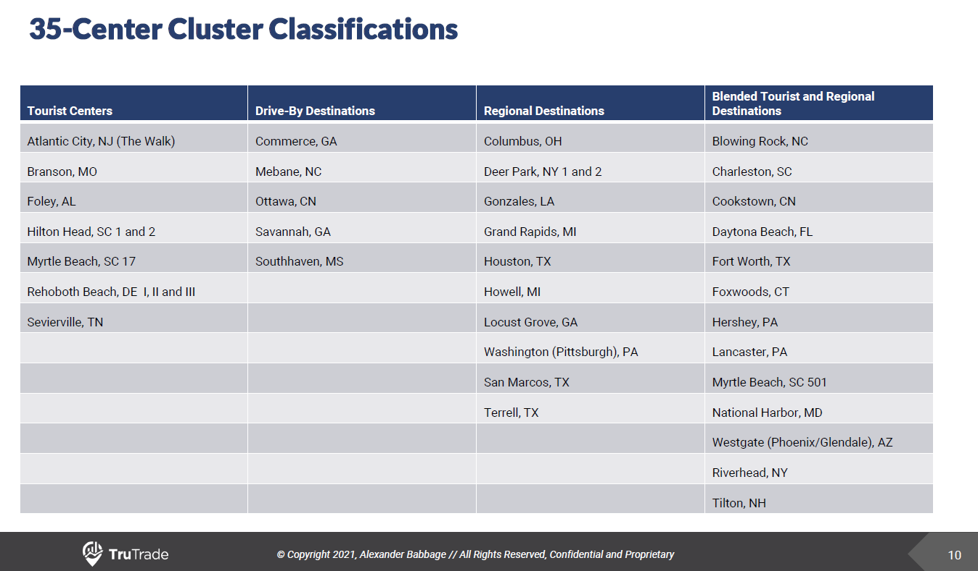

Example of a business knowledge table we would want to creat