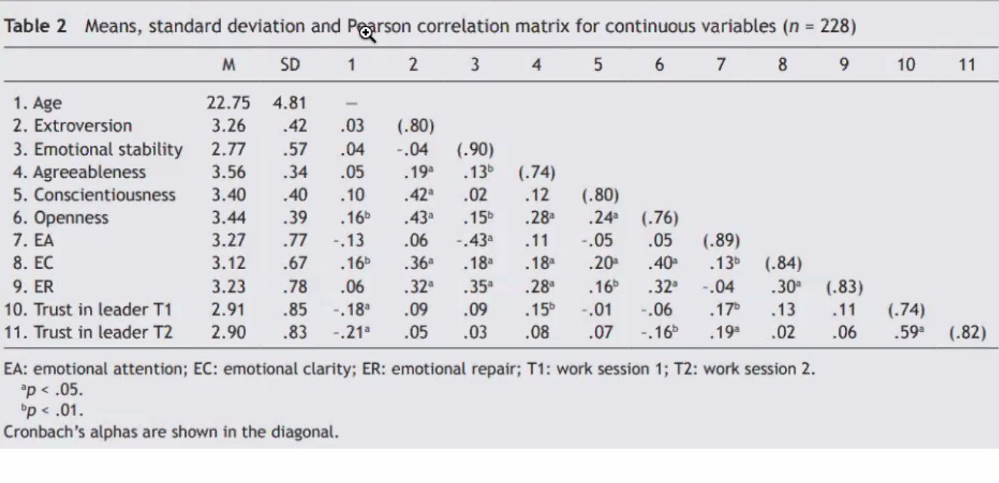
Cronbach alfa

Correlation matrix → Read more

