**API Requirements for Blue Jay**

Author: Philip Wu

Reviewer: Jonathan Chen

Version: 0.13

Date: February 2, 2023

Status: Draft

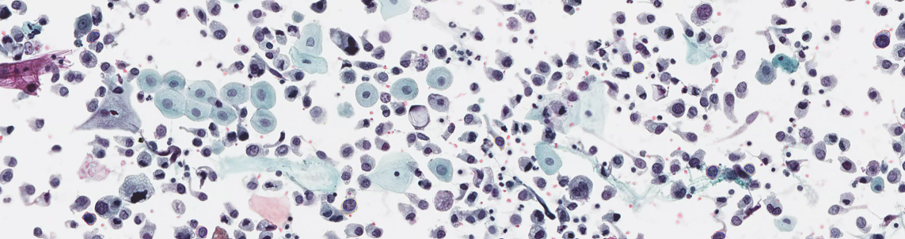

※※※※※ Notice ※※※※※

The content in this document contains confidential information of AIxMed Inc. that is protected under all applicable trade secrets laws and regulations.

If you are not intended recipient or otherwise authorized to receive such information, please do not copy, distribute, or otherwise use the information contained herein and please notify Mr. Jonathan Chen (jonathan.chen@aixmed.com) immediately and destroy this communication accordingly.

**Table of Contents**

1. Introduction 1

1.1 Overview 1

1.2 Blue Jay Scanning Software 1

2. APIs Requirements 2

2.1 State Transition Diagram 3

2.2 Strip-Based Scanning Workflow 3

2.3 Demand of APIs 5

2.3.1 Control APIs 5

2.3.2 Settings and Configuration APIs 5

2.3.3 Stage Preview APIs 6

2.3.4 Scanning APIs 7

2.3.5 Stitch Image APIs 9

2.3.6 Exceptions and Error Handling APIs 10

2.3.7 Miscellaneous APIs 10

Reference 11

Appendix A: Terminology 12

Appendix B: Settings 13

Appendix C: Error Codes 14

Appendix D: Struct and Enumerator 15

Appendix E: An Example of Event Handler Mechanism 17

# Introduction

This document describes the APIs requirements of the Project Blue Jay.

## Overview

The Project Blue Jay will build an imaging system to digitize the urine cytology slides and analyze slide image data. The Blue Jay scanning software needs sets of function interfaces to get/set data from/into the Blue Jay scanner platform, to provide a scanning high quality digitized slide images for cytologists/cytopathologists diagnoses and AI model detection.

When using the Blue Jay imaging system, a user does not need to decide the number of Z-layers initially. The Blue Jay scanning software can automatically select the regions of interests in the X-Y axes under low magnification objective lens and present a clear preview to the user, locate the objects of interests by AIxMed’s proprietary algorithm, and scan the field of view (FOV) at different Z-layers with the optimal focal plane.

## Blue Jay Scanning Software

The software architecture of Blue Jay scanning software is as below:

Following diagram illustrates the high-level Blue Jay scanning software flowchart. The flow diagrams help describes the relationship between functions and system.

# APIs Requirements

The required APIs define those function interfaces for Blue Jay scanning software get/set necessary data from/to scanner platform. The required APIs are classified into following groups:

* Control

Control APIs mainly manipulate operations of scanner platform, such as eject(/load) stage, scan, stop, resume

* Settings and Configuration

Blue Jay scanning software can query settings and configurations of scanner platform, set and save user defined setting.

* Stage preview

To query current stage status, get pre-detected ROI coordinates, set user defined ROI coordinates

* Scanning

Blue Jay scanning software can get the stitched 8x_mag_image regarding the ROI area, get the FOV of 40x_mag_images by specified x-y-z axes

* Stitch image

To retrieve the stitched 40x_mag_image by specified best focal plane (i.e. best Z-layer) of each FOVs and stitched 40x_mag_image of adjacent slices by specified Z-layer.

* Exception and Error Handling APIs

To define two major types of software errors: 1) hardware platform errors, and 2) software functionality errors. For example, HW errors contains HW components errors, camera (preview camera, low/high magnification objective lens) errors, cable connection errors. Software errors might include logical errors and functionality runtime errors.

* Miscellaneous APIs

A variety functions to query of certain information related to scanner software and hardware platform.

## State Transition Diagram

The following state transition diagram shows the behavior model of scanning software, which consists of states, transitions, and high-level description for actions.

When power-on, completing the initiation processes, scanner platform is ready for doing actions by users. This session illustrates function call sequence diagram of two major functions, preview and scan.

## Strip-Based Scanning Workflow

In Blue Jay project, the scanning approach is strip-based scanning mode (i.e., line-scan mode). The following scanning workflow diagram illustrates how scanning software integrated with the strip-based scanning mode. It’s for better understanding the communications between scanning software and hardware platform.

## Demand of APIs

This section describes the possible interface name, required/optional parameters, and return values (data format).

## Control APIs

2.3.1.1 ***hsError hsCtrl_initScanner***

|  |  |
| --- | --- |
| Description | initiate processes of scanner platform, connect scanner instrument |
| Parameter | *none* |
| Return | *hsError* /* struct of message */ |

2.3.1.2 ***hsError hsCtrl_disconnectScanner***

|  |  |
| --- | --- |
| Description | disconnect scanner instrument |
| Parameter | *none* |
| Return | *hsError* /* struct of message */ |

2.3.1.3 ***hsError hsCtrl_stopScanning***

|  |  |
| --- | --- |
| Description | Stop scanning |
| Parameter | *none* |
| Return | *hsError* /* struct of message */ |

## Settings and Configuration APIs

2.3.2.1 ***hsError hsConf_getScannerSettings***

|  |  |
| --- | --- |
| Description | provides system settings and configuration, retrieve existing configuration of scanner instrument |
| Parameter | *TissueScanConfiguration* pTSConfig* /* struct of scanner instrument */ |
| Return | *hsError* /* struct of message */ |

2.3.2.2 ***hsError hsConf_setScannerSettings***

|  |  |
| --- | --- |
| Description | update and save the change of configuration |
| Parameter | *TissueScanConfiguration* pTSConfig* /* struct of scanner instrument */ |
| Return | *hsError* /* struct of message */ |

**(DISCARDED) *templates hsConf_getTemplate***

Description: provides a selected default or predefined template

Parameters: *name*: name of template

Output values: *templates*: template data of scan setup

**(DISCARDED) *RtnCode hsConf_setTemplate***

Description: save a new template or update a predefined template

Input parameters: *name*: name of template

*templates*: template data of scan setup

Output values: *RtnCode*: completed or error_code

Discard hsConf_getTemplate/hsConf_setTemplate due to AIxMed manages and specifies pre-defined setup information with disabling automatic setup.

## Stage Preview APIs

Before requesting scanner platform to provide preview images for each slide, scanning software should request to perform ‘slope adjustment’. This function of ‘slope adjustment’ can also be set an option in Settings.

2.3.3.1 ***SlideSetting hsPrev_getSlideSettings***

|  |  |
| --- | --- |
| Description | retrieves slide status and settings |
| Prerequisites | slide status includes previewing/scanning/analyzing, slide name, status, Z-stacks, resolution, priority |
| Parameter | *nSlideNum* /* index (1~12) of selected slide */ |
| Return | *SlideSettings pSetting* /* slide status data such as name, ROI, focus dots, white balance dot and z-stacks */ |

2.3.3.2 ***hsError hsPrev_setSlideSettings***

|  |  |
| --- | --- |
| Description | allow to update slide settings |
| Prerequisites | slide status includes previewing/scanning/analyzing, slide name, status, Z-stacks, resolution, priority |
| Parameter | *nSlideNum* /* index (1~12) of selected slide */  *SlideSettings pSetting* /* slide status data such as name, ROI, focus dots, white balance dot and z-stacks */ |
| Return | *hsError* /* struct of message */ |

2.3.3.3 ***hsError hsPrev_getLabelImage***

|  |  |
| --- | --- |
| Description | provides label image to requestor function |
| Prerequisites | Label area and preview size must be pre-defined |
| Parameter | *nSlideNum* /* index (1~12) of selected slide */  *slideType* /* the type of slide (default: 1x3) */  *nSlotNumber* /* the number of slots (default: 0) */ |
| Return | *hsError* /* struct of message */ |
| Note | *slideType* and *nSlideNumber* are necessary for future scanner products, use default values for Blue Jay project |

2.3.3.4 ***hsError hsPrev_getPreviewImage***

|  |  |
| --- | --- |
| Description | provides thumbnail by preview lens |
| Prerequisites | Label area and preview size must be pre-defined |
| Parameter | *nSlideNum* /* index (1~12) of selected slide */  *slideType* /* the type of slide (default: 1x3) */  *nSlotNumber* /* the number of slots (default: 0) */ |
| Return | *hsError* /* struct of message */ |
| Note | *slideType* and *nSlideNumber* are necessary for future scanner products, use default values for Blue Jay project |

2.3.3.5 ***hsError hsPrev_getOptimalLoImage***

|  |  |
| --- | --- |
| Description | Retrieve optimal focal low magnification image |
| Parameter | *nSlideNum* /* index of selected slide in slide tray */  *pTemplate* /* struct of Template */ |
| Return | *hsError* /* struct of message */ |
| Additional Information | 1. Apply prefined template regarding the slide preparations (e.g., Thinprep/Cytospin/Surepath) to provide some reference dots for taking the optimal focal plane of 8x_mag image 2. As for ‘Template’, suggest to differing the usage of Templates for 8x_mag/40x_mag scanning |

2.3.3.6 ***hsError hsPrev_reCaptureLoImage***

|  |  |
| --- | --- |
| Description | Request to re-scan optimal focal low magnification image |
| Parameter | *nSlideNum* /* index of selected slide in slide holder */  *pTemplate* /* struct of Template */  *vector<Point2>* /* vector of suggested focus dots */  *ROI* /* re-scanning ROI area */ |
| Return | *hsError* /* struct of message */ |
| Note | For acquiring better quality of low-mag image, provides at least 5 focus dots to have sufficient focus dots for focusing |

2.3.3.7 ***Point2 hsPrev_loPixelToCoordinates***

|  |  |
| --- | --- |
| Description | mapping image pixel position to scanner physical coordinates in low magnification image |
| Parameter | *nSlideNum*  /* index of scanning slide */  *pixelCoordinates* /* pixel position in low magnification image */ |
| Return | *Point2* /* physical coordinates (μm) in low magnification image */ |

2.3.3.8 ***Point2 hsPrev_CoordinatesToLoPixel***

|  |  |
| --- | --- |
| Description | convert scanner physical coordinates to image pixel position in low magnification image |
| Parameter | *nSlideNum*  /* index of scanning slide */  *physicalCoordinates* /* physical coordinates (μm) in low magnification image */ |
| Return | *Point2* /* pixel position in low magnification image */ |

## Scanning APIs

2.3.4.1 ***hsError hsScan_doWhiteBalanceScan***

|  |  |
| --- | --- |
| Description | before starting the scanning operations, needs to request to perform ‘White Balance Scan’ and ‘Create White Balance Curves’ functions |
| Parameter | *nSlideNum* /* index of scanning slide */ |
| Return | *hsError* /* struct of message */ |

2.3.4.2 ***Point2 hsPrev_hiPixelToCoordinates***

|  |  |
| --- | --- |
| Description | mapping image pixel position to scanner physical coordinates (μm) in high magnification image |
| Parameter | *nSlideNum* /* index of scanning slide */  *pixelCoordinates* /* pixel position in high magnification image */ |
| Return | *Point2* /* physical coordinates (μm) in high magnification image */ |

2.3.4.3 ***Point2 hsPrev_CoordinatesToHiPixel***

|  |  |
| --- | --- |
| Description | convert scanner physical coordinates (μm) to image pixel position in high magnification image |
| Parameter | *nSlideNum* /* index of scanning slide */  *physicalCoordinates* /* physical coordinates (μm) in high magnification image */ |
| Return | *Point2* /* pixel position in high magnification image */ |

2.3.4.4 ***vector<Image> hsScan_getCandidateHiFOVs***

|  |  |
| --- | --- |
| Description | provide specified FOV 31-slice (step 1μm) images |
| Parameter | *nSlideNum* /* index of scanning slide */  *pixelCoordinates* /* center point (unit:μm) of FOV in high magnification image */ |
| Return | *Vector<Image>* /* memory address of each slice of this FOV image */ |

2.3.4.5 ***hsError hsScan_setHiFOVBestZ***

|  |  |
| --- | --- |
| Description | set best z-axis of specified FOVs to scanner platform |
| Parameter | *nSlideNum* /* index of scanning slide */  *vector<Point2>* /* vector of center point (unit:μm) of FOVs in high magnification image */  *vector<int>* /* array of best Z */ |
| Return | *hsError* /* struct of message */ |
| Note | These FOVs contains interested cells |

2.3.4.6 ***hsError hsScan_setSurfaceMap***

|  |  |
| --- | --- |
| Description | set surface map (i.e. strip data) to scanner platform |
| Parameter | *nSlideNum* /* index of scanning slide */  *nSlideIdx* /* index of slice, 0 represents best Z plane */  *stripProperty* /* array of strip data */ |
| Return | *hsError* /* struct of message */ |
| Note | Regarding the slice index, the best-Z plane is 0; negative number is for those planes above best-Z; positive number is for those planes below best-Z   |

**(IGNORE) vector<Image> *hsScan_getHiFOVImage***

|  |  |
| --- | --- |
| Description | provides the multiple z-axis images of specified FOVs |
| Parameter | *nSlideNum* /* index of scanning slide */  *Point2* /* index (row, col) of FOV */  *Point2* /* center position (μm) of scanning area */  *z* /* z-axis in physical position */  *(#)* /* number of scanning slices */ |
| Return | *Vector<Image>* /* memory address of FOV image */ |
| Note | 1. Suppose the number of scanning slices is larger than 1, the z-axis offset between 2 slices will be predefined in configuration data, default value is 1μm. The z-axis offset can be configured for each slide 2. The number of requested scanning slices will be odd number. Scanner should provide (odd-1)/2 slices above/below the requested z-axis slice and z-axis slice itself |

2.3.4.7 ***int hsScan_getScanningProgress***

|  |  |
| --- | --- |
| Description | provides status of scanning progress |
| Parameter | *None* |
| Return | *percentage* /* percentage of scanning progress */ |
| Note | (scanned FOVs) ÷ (total of scanning FOVs)  considering this function also supports the scanning process when scanning low magnification image |

## Stitch Image APIs

2.3.5.1 ***hsError hsStit_getStitchedSlice***

|  |  |
| --- | --- |
| Description | provides the specified slide image in high magnification image |
| Parameter | *nSlideIdx* /* slice index */  *nSlideNum* /* index of scanning slide */ |
| Return | *hsError* /* struct of message */ |
| Note | Regarding the slice index, the best-Z plane is 0; negative number is for those planes above best-Z; positive number is for those planes below best-Z |

2.3.5.2 ***String hsStit_getBuiltImage***

|  |  |
| --- | --- |
| Description | provides the file destination of built slide image |
| Parameter | *nSlideNum* /* index of scanning slide */ |
| Return | *url* /* indicate the file destination of built slide image */ |

2.3.5.3 ***TIFF_TAGS hsStit_getTiffProperties***

|  |  |
| --- | --- |
| Description | provides TIFF properties and tags |
| Parameter | *nSlideNum* /* index of scanning slide */ |
| Return | *Tiff_tags* /* TIFF properties and tags in json/xml format */ |

## Exceptions and Error Handling APIs

Events are emitted when expected or unexpected events occurred. Associated handlers need to be implemented to process them well. The event handling in native C++ mechanism will be used for handling expected/unexpected events.

2.3.6.1 ***string hsErrs_getErrorString***

|  |  |
| --- | --- |
| Description | return a user-friendly error string corresponds to the specified error code |
| Parameter | *ErrorCode* /* specified error code */ |
| Return | *error_string* /* a user-friendly error string */ |

2.3.6.2 ***hsErrs_getLastError***

|  |  |
| --- | --- |
| Description | retrieves the calling thread’s last error code value |
| Parameter | *none* |
| Return | *ErrorCode* /* last error code of the calling thread */ |

## Miscellaneous APIs

2.3.7.1 ***hsMisc_getSWVersion***

|  |  |
| --- | --- |
| Description | provides the version number of current running software |
| Parameter | *none* |
| Return | *version* /* version number of software */ |

# Reference

1. LS Scan Flowchart Document, TissueScope LE2.0, Nov. 7, 2022, Huron Digital Pathology
2. Architecture Design Document, ARD-0026, Dec. 23, 2022, Huron Digital Pathology

# Appendix A: Terminology

|  |  |  |
| --- | --- | --- |
| Term / Acronym | Meaning | Description |
| 40x_mag_image |  | 40x magnification image (0.25μm) |
| 8x_mag_image |  | 8x magnification image (1.25µm) |
| Multi-slice image |  | A composite WSI contains multiple slice images |
| Slice image |  | A stitched WSI by specified z-axis for each focal FOV plane |

# Appendix B: Settings

This section provides error codes defined by Huron for reference when creating new error codes for Project Blue Jay.

|  |  |  |
| --- | --- | --- |
| Category | Items | Options |
| GENERAL | Slideholder Name Prefix |  |
|  | Run Mode | <MANUAL>, <AUTO> |
|  | Light Source | <Bright Field> |
|  | Tissue Finding | <OFF>, <ON> |
|  | ROI Setup Mode | <SINGLE>, <MULTIPLE> |
|  | Show Labels | <OFF>, <ON> |
|  | Show ROI# | <OFF>, <ON> |
|  | Slideholder type | <1x3x12> |
| COLOURS | Colour Profile | <profile name>  ROI, Focus Dots, Hightlight, White Balance |
| BARCODE | Barcode Profile | <profile name>  Encode Barcode Image Tag, Only use barcode for image filename,  Skip slide without barcode, Barcode Type, Barcode Sample, Delimiter,  Filename Pattern, Image Tag Pattern |
| IMAGE | Default Resolution | <40x> |
|  | Compression Method | <JPEG> |
|  | JPEG Quality | 10% -- 100% |
|  | Preview File Path | <directory> |
|  | Scan File Path | <directory> |
|  | Group images by slideholder | <OFF>, <ON> |
| QUALITY | Quality Check | <OFF>, <ON> |
|  | Quality Threshold | 10% -- 100% |
|  | Quality Algorithm | <Laplacian>, <Frequency Domain> |
| Z STACK | Make Z-Stack default scan mode | <OFF>, <ON> |
|  | Define Input Parameters By: | <Depth & Step>, <Depth & Slice> |
| TEMPLATES |  |  |

# Appendix C: Error Codes

This section provides error codes defined by Huron for reference when creating new error codes for Project Blue Jay.

|  |  |  |
| --- | --- | --- |
| **Error Type** | **Error Codes** | **Description** |
| *Initialization hardware checks* | | |
| DMC Errors | 0x01** | The connections of components connect to the PC via ethernet are incorrect |
| RIO Errors | 0x02** |  |
| Main Camera Errors | 0x03** | Camera Link cables connection error (incorrect order) |
| Preview Camera Errors | 0x04** |  |
| HW Components Errors | 0x05** | (need to contact support for these issues) |
| Slide holder sensor errors | 0x06** | (need to contact support for these issues) |
| RFID errors | 0x07** | (need to contact support for these issues) |
| Illumination Errors | 0x08** | TOP illumination light error |
|  | 0x09** | Bottom illumination light error |
| *Scanning software errors* | | |
| Errors in low-mag image processing | 0x0A** | 0x0A00: no error  0x0A01: no low-mag image  0x0A02: no ROI  0x0A03: no FOV position  0x0A04: no results by bounding-box algorithm  0x0A05: no results of numbers of layer  0x0A06: insufficient focus points in high-mag image  0x0A07: failed to find best z plane |
| Errors in high-mag image processing | 0x0B** | 0x0B01: failed to calculate optimal surface plane  0x0B02: failed to retrieve FOV image |
| Auto loader errors | 0x0D** |  |
| *During operation error reporting* | | |
| Software related errors | 0x0F** | 0x0F01: no ROI  0x0F02: no focus dots  0x0F03: Exceeded maximum ROIs. The maximum ROIs for a single slide is 100  0x0F04: no tissue detected  0x0F05: configuration files missing or path doesn’t exist |
| Initialization checks | 0x0F09-0x0F10 | FALCON II camera configuration errors |
|  | 0x0F11-0x0F12 | FALCON II camera color correction errors |
|  | 0x0F13-0x0F17 | FALCON II camera flatten PSF errors |
|  | 0x0F30-0x0F34 | Preview camera configuration errors |

# Appendix D: Struct and Enumerator

|  |  |  |  |
| --- | --- | --- | --- |
| Struct | Data Type | Variable Name | Description |
| ScannerSetting | int  bool  string  string | resolution  automaticSetupEnabled  previewLocation  finalImageLocation |  |
| SlideSetting | string  string  int  enum  vector<ROI>  vector<Point2f>  Point2f  bool  int  int  int  int  SlideSetting(){} | slideHolderName  slideName  slideType  status  ROIs  FDs  WhiteBalance  included  resolution  zSliceDepth  zSliceStep  zSliceNum | Name of slideholder  Name of slide  Slide type (1x3, 2x3, 5x7)  Indicator of workflow status  Array of ROIs  Array of focus dots  Location of white balance (x, y)  Added to/excluded from task list  Resolution for final scanning  Depth of z stack  Interval between z stack slices  Number of z stack slices |
| ROI | float  float  float  float  ROI(){} | x  y  width  height |  |
| Point2f | float  float  Point2f(){} | x  y |  |
| Point2i | int  int  Point2i(){} | x  y |  |
| Rectf | float  float  float  float  Rectf(){} | x  y  width  height |  |
| Recti | int  int  int  int  Recti(){} | x  y  width  height |  |
| Image | int  int  int  int  unsigned char *  string  Image(){} | width  height  samples  bitsPerSample  data  name |  |
| Template | vector<Rectf>  vector<Point2f>  Point2f | ROIs  FocusDots  WhiteBalance |  |
| TSConfiguration |  |  |  |
| TIFFProperty | uint32  uint32  uint32  uint16  uint16  uint16  uint16  uint32  uint16  uint16  uint16  string  TIFFProperty(){} | height  width  depth  samplePerPixel  bitsPerSample  photometric  compression  rowsperstrip  orientation  pagenumber  planarconfig  description | Tag code: 0x0101  Tag code: 0x0100  Tag code: 0x0115  Tag code: 0x0102  Tag code: 0x0106  Tag code: 0x0103  Tag code: 0x0116  Tag code: 0x0112  Tag code: 0x0129  Tag code: 0x011C |

|  |  |  |
| --- | --- | --- |
| Enum | Constant Name | Description |
| TSStatus | EMPTY  NO_PREVIEW  COMPLETE_PREVIEW  IN_PROGRESS_FINAL_SCAN  COMPLETE_FINAL_SCAN  ERROR_STATE | No slideholder (removed)  Slideholder inserted (not previewed yet)  Slideholder preview completed  Slideholder in process (preview or scan)  Slideholder scan completed  Error |
| ErrorType | HSERROR_NOERROR  HSERROR_INIT_FAILED  HSERROR_CONNECTION_LOST  HSERROR_AUTOMATICSSETUP_FAILED  HSERROR_SCAN_FAILED  HSERROR_INVALID_SCANSETTING  HSERROR_INSUFFICIENT_DISK  HSERROR_INVALID_RFID  HSERROR_UNKNOWN_RFID  HSERROR_SLIDE_NOTDETECTED  HSERROR_SCANNER_NONRESPONSIVE |  |
| SlideType | SLIDETYPE_1x3  SLIDETYPE_2x3  SLIDETYPE_5x7 |  |
| LEDState | EMPTY = 0  NO_PREVIEW = 1  IN_PROGRESS_PREVIEW = 3  COMPLETE_PREVIEW = 4  IN_PROGRESS_FINAL_SCAN = 6  COMPLETE_FINAL_SCAN = 7  ERROR_STATE_PC = 8  ERROR_STATE_SLOT = 9 | Not present, ‘no color’  Preview not started yet, ‘white’  Currently, not used  ‘blue’  ‘flashing blue’  ‘green’  ‘red’  ‘red’ |

# Appendix E: An Example of Event Handler Mechanism

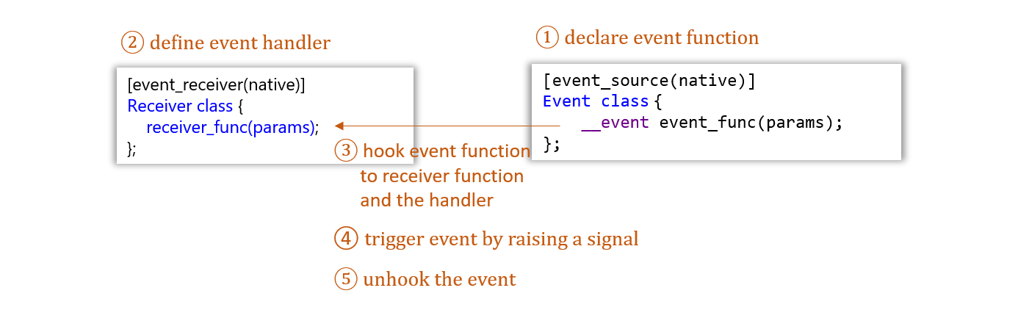

Sample code – declaring events

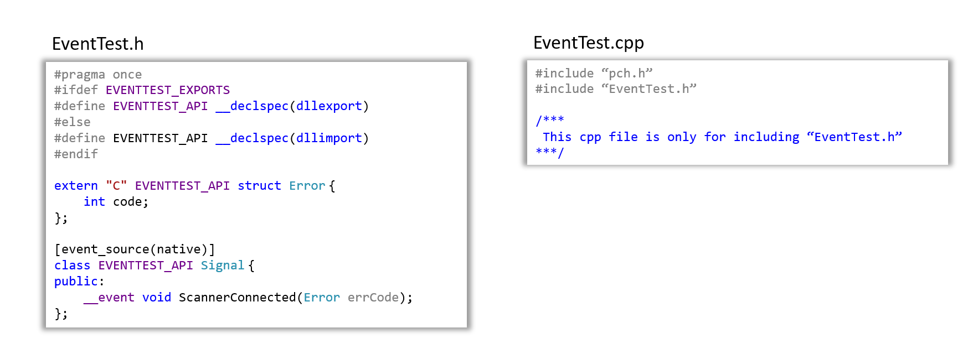

Sample code – Event handler

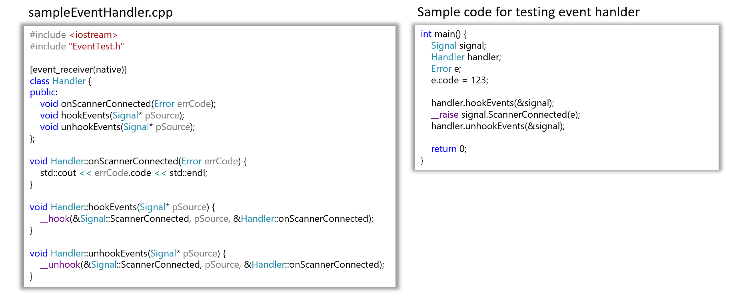

**Revision History**

|  |  |  |  |
| --- | --- | --- | --- |
| Version | Date | Author | Comments |
| 0.1 | 2022-10-28 | Philip Wu | Initial Draft |
| 0.2 | 2022-11-05 | Philip Wu | * Modified according to Jonathan’s review: * Added product characteristics, and corrected terminology * Added appendix of terminology |
| 0.3 | 2022-11-05 | Philip Wu | Modified typos in flowchart |
| 0.4 | 2022-11-07 | Philip Wu | * Modified/Corrected according to Jonathan’s review * Corrected typos in flowchart |
| 0.5 | 2022-11-08 | Philip Wu | * Added confidential & proprietary notice * Used naming convention |
| 0.6 | 2022-11-22 | Philip Wu | * Added software architecture * Added description of function call sequence * Added appendix B to describe settings of TissueScope LE * Added appendix C to describe Huron’s Error Codes for design reference * Updated the naming of APIs |
| 0.7 | 2022-11-23 | Philip Wu | * Added section 2.2.6 |
| 0.8 | 2022-11-30 | Philip Wu | * Corrected typos in API descriptions * Added ***hsScan_doWhiteBalanceScan*** function to request scanner platform performs white balance scan process |
| 0.9 | 2022-12-09 | Philip Wu | * Added section 2.2 for introducing strip-based scanning workflow * Add ***hsConf_applyTemplate***function for taking 8x_mag image * Remove ***hsPrev_prevPixelToCoordinates*** and ***hsPrev_getBestZinLoImage*** * add ***hsScan_setSurfaceMap*** and ***hsStit_getBuiltImage*** |
| 0.10 | 2022-12-13 | Philip Wu | * updated the software architecture diagram |
| 0.11 | 2023-01-04 | Philip Wu | * updated based on Reference[2] * replaced ‘ErrorCode’ to ‘RtnCode’, to avoid confusing with error handler mechanism * removed ***hsCtrl_getSlideAvailability*** since scanner instrument not able to detect slides in slide holder before conduct previewing |
| 0.12 | 2023-02-02 | Philip Wu | * updated Appendix D: Struct and Enumerator by referring to *TissueScanInterfaceDefs.h* * fixed the error in scanning workflow diagram * added a function ***hsError hsPrev_reCaptureLoImage*** for re-capturing low-mag image * added Appendix E: An example of event handler mechanism |
| 0.13 |  | Philip Wu | * added TIFF Tag code in Appendix D |