**API Requirements**

Author: Philip Wu

Reviewer: Jonathan Chen

Version: A.0.4

Date: February 10, 2023

Status: Draft

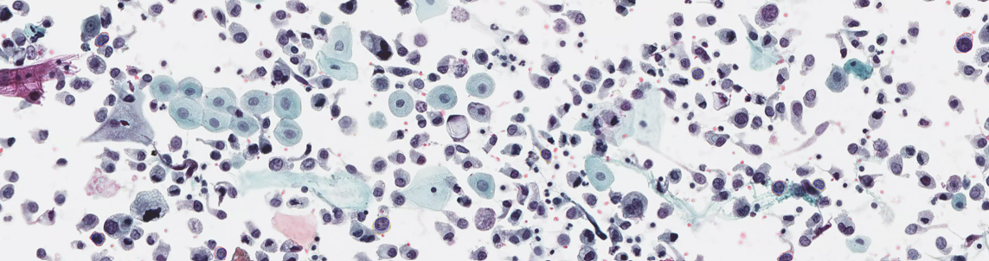

※※※※※ Notice ※※※※※

The content in this document contains confidential information of AIxMed Inc. that is protected under all applicable trade secrets laws and regulations.

If you are not intended recipient or otherwise authorized to receive such information, please do not copy, distribute, or otherwise use the information contained herein and please notify Mr. Jonathan Chen (jonathan.chen@aixmed.com) immediately and destroy this communication accordingly.

**Table of Contents**

1. Introduction 1

1.1 Overview 1

1.2 Scanning Software 1

2. APIs Requirements 2

2.1 State Transition Diagram 3

2.2 Demand of APIs 3

2.2.1 Control APIs 4

2.2.2 Settings and Configuration APIs 4

2.2.3 Stage Preview APIs 4

2.2.4 Scanning APIs 6

2.2.5 Stitch Image APIs 7

2.2.6 Event and Error Handling APIs 7

2.2.7 Miscellaneous APIs 8

Appendix A: Terminology 9

Appendix B: Settings 10

Appendix C: Error Codes 11

Appendix D: Struct and Enumerator 12

Appendix E: An Example of Event Handler Mechanism 14

# Introduction

This document describes the APIs requirements for introducing an overview of AIxMed scanning software and what the scanning software needs that a scanner hardware instrument should provide interfaces to allow scanning software to control the hardware instrument.

## Overview

A project of cytological scanner system aims to build an imaging system to digitize the urine cytology slides for the purpose to analyze slide image data. The scanning software needs sets of function interfaces to get/set data from/into the scanner hardware platform, to provide a scanning high quality digitized slide images for cytologists/cytopathologists diagnoses and AI model detection.

When using the AIxMed imaging system, a user does not need to decide the number of Z-layers initially. The scanning software can automatically select the regions of interests (ROI) in the X-Y axes under low magnification objective lens and present a clear preview to the user, locate the objects of interests by AIxMed’s proprietary algorithm, and scan the field of view (FOV) at different Z-layers with the optimal focal plane.

## Scanning Software

The software architecture of AIxMed scanning software is as below:

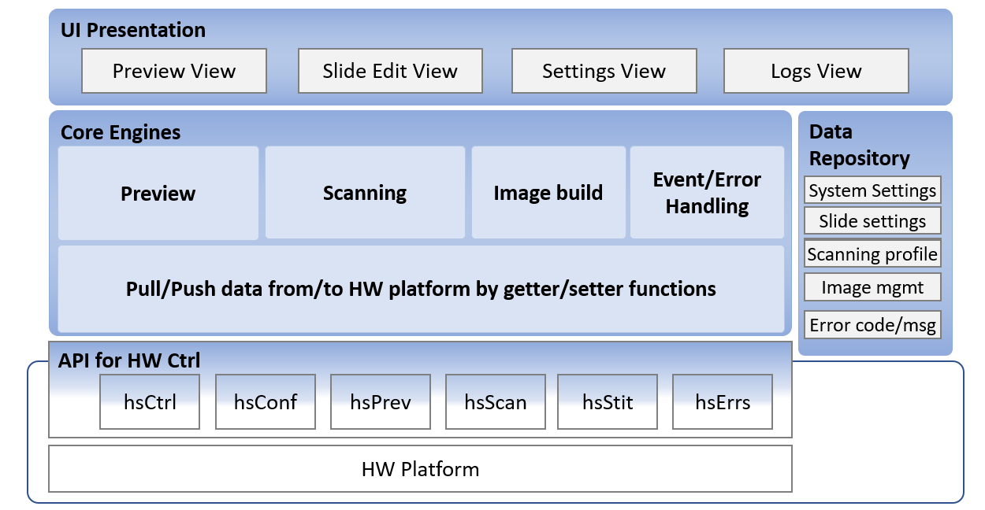

Following diagram illustrates the high-level scanning software flowchart. The flow diagrams help describes the relationship between functions and system.

# APIs Requirements

The required APIs define those function interfaces for scanning software get/set necessary data from/to scanner platform. The required APIs are classified into following groups:

* Control

Control APIs mainly manipulate operations of scanner platform, such as eject(/load) stage, scan, stop, resume

* Settings and Configuration

Scanning software can query settings and configurations of scanner platform, set and save user defined setting.

* Stage preview

To query current stage status, get pre-detected ROI coordinates, set user defined ROI coordinates

* Scanning

Scanning software can get the stitched low_mag_image regarding the ROI area, get the FOV of high_mag_images by specified x-y-z axes

* Stitch image

To retrieve the stitched high_mag_image by specified best focal plane (i.e. best Z-layer) of each FOVs and stitched high_mag_image of adjacent slices by specified Z-layer.

* Event and Error Handling APIs

To define two major types of software errors: 1) hardware platform errors, and 2) software functionality errors. For example, HW errors contains HW components errors, camera (preview camera, low/high magnification objective lens) errors, cable connection errors. Software errors might include logical errors and functionality runtime errors.

* Miscellaneous APIs

A variety functions to query of certain information related to scanner software and hardware platform.

## State Transition Diagram

The following state transition diagram shows the behavior model of scanning software, which consists of states, transitions, and high-level description for actions.

When power-on, completing the initiation processes, scanner platform is ready for doing actions by users. After slides inserted, scanner will capture the preview image and label image and proposed ROI area, focus points and reference background point (or, calibration point). User can manually edit ROI area, add/remove focus points, change the location of reference background point. Within the Preview state, user can also choose the appropriate settings for individual slide.

While completed preview activities and activate scan button, the scanning process will be triggered and save stitched high magnification whole slide image to pre-defined storage location.

## Demand of APIs

This section describes the possible interface name, required/optional parameters, and return values (data format).

## Control APIs

2.2.1.1 ***hsError hsCtrl_initScanner***

|  |  |
| --- | --- |
| Description | Connect and initialize scanner instrument |
| Parameter | none |
| Return | hsError /* an error code indicates the success or failure of function executing */ |

2.2.1.2 ***hsError hsCtrl_disconnectScanner***

|  |  |
| --- | --- |
| Description | Disconnect scanner instrument |
| Parameter | none |
| Return | hsError /* an error code indicates the success or failure of function executing */ |

2.2.1.3 ***hsError hsCtrl_stopScanning***

|  |  |
| --- | --- |
| Description | Stop scanning process |
| Parameter | none |
| Return | hsError /* an error code indicates the success or failure of function executing */ |

## Settings and Configuration APIs

2.2.2.1 ***hsError hsConf_getScannerSettings***

|  |  |
| --- | --- |
| Description | Retrieve existing system settings and configuration of scanner instrument |
| Parameter | hsConfig /* data structure of system setting and configurations */ |
| Return | hsError /* an error code indicates the success or failure of function executing */ |

2.2.2.2 ***hsError hsConf_setScannerSettings***

|  |  |
| --- | --- |
| Description | Update and store the change of settings and configurations |
| Parameter | hsConfig /* data structure of system settings and configurations */ |
| Return | hsError /* an error code indicates the success or failure of function executing */ |

## Stage Preview APIs

2.2.3.1 ***hsSlideSetting hsPrev_getSlideSettings***

|  |  |
| --- | --- |
| Description | Retrieve slide status and settings  ## Prerequisites ##  state (includes previewing/scanning/analyzing), slide name, status, Z-stack, resolution, priority, ROI, focus points, background reference point |
| Parameter | hsSlideNum /* index of selected slide in slide tray */ |
| Return | hsSlideSetting /* structure of slide settings */ |

2.2.3.2 ***hsError hsPrev_setSlideSettings***

|  |  |
| --- | --- |
| Description | Update slide settings  ## Prerequisites ##  state (includes previewing/scanning/analyzing), slide name, status, Z-stack, resolution, priority, ROI, focus points, background reference point |
| Parameter | hsSlideNum /* index of selected slide in slide tray */ hsSlideSetting /* structure of slide settings */ |
| Return | hsError /* an error code indicates the success or failure of function executing */ |

2.2.3.3 ***hsError hsPrev_getLabelImage***

|  |  |
| --- | --- |
| Description | Retrieve label image  ## Prerequisites ##  Lable area and preview size must be pre-defined |
| Parameter | hsSlideNum /* index of selected slide in slide tray */ |
| Return | hsError /* an error code indicates the success or failure of function executing */ |

2.2.3.4 ***hsError hsPrev_getPreviewImage***

|  |  |
| --- | --- |
| Description | Retrieve preview image (for thumbnail)  ## Prerequisites ##  Preview area/size must be pre-defined |
| Parameter | hsSlideNum /* index of selected slide in slide tray */ |
| Return | hsError /* an error code indicates the success or failure of function executing */ |

2.2.3.5 ***hsError hsPrev_getOptimalLoImage***

|  |  |
| --- | --- |
| Description | Retrieve optimal focal low magnification image |
| Parameter | hsSlideNum /* index of selected slide in slide tray */ |
| Return | hsError /* an error code indicates the success or failure of function executing */ |

2.2.3.6 ***hsError hsPrev_reCaptureLoImage***

|  |  |
| --- | --- |
| Description | Request to re-scan optimal focal low magnification image |
| Parameter | hsSlideNum /* index of selected slide in slide tray */  ROI /* re-scanning ROI area */  vector<Point2> /* vector of suggested focus dots */ |
| Return | hsError /* an error code indicates the success or failure of function executing */ |

2.2.3.7 ***Point2 hsPrev_loPixelToCoordinates***

|  |  |
| --- | --- |
| Description | Mapping image pixel position to scanner physical coordinates in low magnification scanning |
| Parameter | hsSlideNum /* index of selected slide in slide tray */ hsPixelPosition /* pixel position in low magnification image */ |
| Return | Point2 /* physical coordinates (μm) in low magnification scanning */ |

2.2.3.8 ***Point2 hsPrev_CoordinatesToLoPixel***

|  |  |
| --- | --- |
| Description | Convert scanner physical coordinates to image pixel position in low magnification image |
| Parameter | hsSlideNum /* index of selected slide in slide tray */ hsCoordinates /* physical coordinates (μm) in low magnification scanning */ |
| Return | Point2 /* pixel position in low magnification image */ |

## Scanning APIs

2.2.4.1 ***Point2 hsScan_hiPixelToCoordinates***

|  |  |
| --- | --- |
| Description | Mapping image pixel position to scanner physical coordinate (μm) in high magnification scanning |
| Parameter | hsSlideNum /* index of selected slide in slide tray */ hsPixelPosition /* pixel position in high magnification image */ |
| Return | Point2 /* physical coordinates (μm) in high magnification scanning */ |

2.2.4.2 ***Point2 hsScan_CoordinatesToHiPixel***

|  |  |
| --- | --- |
| Description | Convert scanner physical coordinates to image pixel position in high magnification image |
| Parameter | hsSlideNum /* index of selected slide in slide tray */ hsCoordinates /* physical coordinates (μm) in low magnification scanning */ |
| Return | Point2 /* pixel position in high magnification image */ |

2.2.4.3 ***vector<Image> hsScan_getCandidateHiFOVs***

|  |  |
| --- | --- |
| Description | Retrieve specified FOV 31-slice (default step: 1μm) images |
| Parameter | hsSlideNum /* index of selected slide in slide tray */ hsCoordinates /* center point (unit:μm) of FOV in high magnification scanning */ |
| Return | Vector<Image> /* memory address of each slice of this FOV */ |

2.2.4.4 ***hsError hsScan_setHiFOVBestZ***

|  |  |
| --- | --- |
| Description | Set the best z-axis of specified FOVs to scanner instrument |
| Parameter | hsSlideNum /* index of selected slide in slide tray */ Vector<Point2> /* vector of center point (unit:μm) of FOVs in high magnification scanning */  Vector<int> /* array of best z-axis of FOVs */ |
| Return | hsError /* an error code indicates the success or failure of this function executing */ |
| Note | These specified FOVs contains interested cells |

2.2.4.5 ***Vector<Image>* *hsScan_getHiFOVImage***

|  |  |
| --- | --- |
| Description | Retrieve the multiple z-axis images of specified FOVs |
| Parameter | hsSlideNum /* index of selected slide in slide tray */ Point2 /* index (row, col) of FOV */  Point2 /* center coordinates (μm) of FOV area */  float /* z-axis in physical coordinates */  int /* number of scanning slices */ |
| Return | Vector<Image> /* memory address of FOV images */ |
| Note | Suppose the number of scanning slices is larger than 1, the z-axis offset between 2 slices will be predefined in slide settings (default is 1μm). The z-axis offset can be configured for each slide.  The number of requested scanning slices must be odd number. Scanner should provide (odd-1)/2 slices above/below the requested z-axis slice and z-axis slice itself. |

2.2.4.6 ***int hsScan_getScanningProgress***

|  |  |
| --- | --- |
| Description | Retrieve progress status of scanning process |
| Parameter | none |
| Return | int /* (scanned FOVs) ÷ (total of scanning FOVs) */ |

## Stitch Image APIs

2.2.5.1 ***hsError hsStit_getStitchedSlice***

|  |  |
| --- | --- |
| Description | Provide the stitched specified slice of specified slide image in high magnification scanning |
| Parameter | hsSliceIdx /* index of which slice */  hsSlideNum /* index of selected slide in slide tray */ |
| Return | hsError /* an error code indicates the success or failure of function executing */ |
| Note | Considering the consumed memory, these stitched slice images will be saved to pre-defined temporary folder  Regarding the slice index, the best-Z plane is 0; negative numbers are for those planes above best-Z; positive numbers are for those planes below best-Z |

2.2.5.2 ***String hsStit_getBuiltImage***

|  |  |
| --- | --- |
| Description | Retrieve the file destination of built whole slide image |
| Parameter | hsSlideNum /* index of selected slide in slide tray */ |
| Return | string /* indicate the file destination of built slide image */ |

2.2.5.3 ***hsTiffTags hsStit_getTiffProperties***

|  |  |
| --- | --- |
| Description | Retrieve TIFF properties and tags |
| Parameter | hsSlideNum /* index of selected slide in slide tray */ |
| Return | hsTiffTags /* TIFF properties and tags in JSON/XML format */ |

## Event and Error Handling APIs

Events are emitted when expected or unexpected events occurred. Associated handlers need to be implemented to process them well. The event handling in native C++ mechanism will be used for handling expected/unexpected events.

2.2.6.1 ***string hsErrs_getErrorString***

|  |  |
| --- | --- |
| Description | Return a user-friendly error string corresponds to the specified error code |
| Parameter | hsError /* specified error code */ |
| Return | string /* a user-friendly description for this ErrorCode */ |

2.2.6.2 ***hsError Errs_getLastError***

|  |  |
| --- | --- |
| Description | Retrieve the last error code |
| Parameter | none |
| Return | hsError /* an error code indicates the success or failure of function executing */ |

## Miscellaneous APIs

2.2.7.1 ***string hsMisc_getSWVersion***

|  |  |
| --- | --- |
| Description | Retrieve the version number of current running software |
| Parameter | none |
| Return | string /* version number of running software */ |

# Appendix A: Terminology

|  |  |  |
| --- | --- | --- |
| Term / Acronym | Meaning | Description |
| high_mag_image |  | The MPP of image is 0.25μm |
| low_mag_image |  | The MPP of image is 1.25µm |
| Multi-slice image |  | A composite WSI contains multiple slice images |
| Slice image |  | A stitched WSI by specified z-axis for each focal FOV plane |

# Appendix B: Settings

This section provides slide settings for scanning software.

|  |  |  |
| --- | --- | --- |
| Category | Items | Options |
| GENERAL | Slide Name Prefix |  |
|  | Run Mode | <MANUAL>, <AUTO> |
|  | Light Source | <Bright Field> |
|  | ROI Setup Mode | <SINGLE>, <MULTIPLE> |
|  | Show Labels | <OFF>, <ON> |
|  | Show ROI# | <OFF>, <ON> |
| COLOURS | Colour Profile | <profile name>  ROI, Focus points, reference background point |
| IMAGE | Default Resolution | <20x>, <40x> |
|  | Compression Method | <JPEG>, <PackBits> |
|  | JPEG Quality | 10% -- 100% |
|  | Preview File Path | <directory> |
|  | Scan File Path | <directory> |
| Z STACK | Make Z-Stack default scan mode | <OFF>, <ON> |
|  | Step of Z-Stack: | <#>μm |

# Appendix C: Error Codes

This section provides error codes defined for scanning software.

|  |  |  |
| --- | --- | --- |
| **Error Type** | **Error Codes** | **Description** |
| *Initialization hardware checks* | | |
| HW Components Errors | 0x01** | The connections of components connect to the PC via ethernet are incorrect |
| Main Camera Errors | 0x03** | Camera Link cables connection error (incorrect order) |
| Preview Camera Errors | 0x04** |  |
| Illumination Errors | 0x08** | TOP illumination light error |
|  | 0x09** | Bottom illumination light error |
| *Scanning software errors* | | |
| Errors in low-mag image processing | 0x0A** | 0x0A00: no error  0x0A01: no low-mag image  0x0A02: no ROI  0x0A03: no FOV position  0x0A04: number of predicted focus points less than 3 in low-mag image  0x0A05: unable to decide numbers of layer  0x0A06: insufficient focus points in high-mag image  0x0A07: failed to find best z plane |
| Errors in high-mag image processing | 0x0B** | 0x0B01: failed to calculate optimal surface plane  0x0B02: failed to retrieve FOV image |
| Configuration errors | 0x0C** | 0x0C01: insufficient space on hard disk  0x0C02: configuration files missing, or path doesn’t exist |
| Auto loader errors | 0x0D** |  |

# Appendix D: Struct and Enumerator

|  |  |  |  |
| --- | --- | --- | --- |
| Struct | Data Type | Variable Name | Description |
| ScannerSetting | int  bool  string  string | resolution  autoSetupEnabled  previewLocation  scanimgLocation |  |
| SlideSetting | string  enum  vector<ROI>  vector<FocusPoint>  Point2  bool  int  int  int  int | slideName  slideStatus  ROIs  FPs  background  included  resolution  zSliceDepth  zSliceStep  zSliceNum | Name of slide  Indicator of workflow status  Array of ROIs  Array of focus points  Location of background point (x, y)  Added to/excluded from task list  Resolution for final scanning  Depth of z stack  Interval between z stack slices  Number of z stack slices |
| ROI | float  float  float  float | x  y  width  height |  |
| Point2 | float  float | x  y |  |
| Point2i | int  int | x  y |  |
| ImageData | unsigned char *  int  int  int | data  width  height  channel | Address of the image  3: RGB; 4: RGBA |
| TiffProperty | uint32  uint32  uint32  uint16  uint16  uint16  uint16  uint32  uint16  uint16  uint16  string | height  width  depth  samplePerPixel  bitsPerSample  photometric  compression  rowsperstrip  orientation  pagenumber  planarconfig  description | Tag code: 0x0101  Tag code: 0x0100  Tag code: 0x0115  Tag code: 0x0102  Tag code: 0x0106  Tag code: 0x0103  Tag code: 0x0116  Tag code: 0x0112  Tag code: 0x0129  Tag code: 0x011C |

|  |  |  |  |
| --- | --- | --- | --- |
| Enum | Constant Name |  | Description |
| SlideStatus | EMPTY  NO_PREVIEW  COMPLETE_PREVIEW  IN_PROGRESS_FINAL_SCAN  COMPLETE_FINAL_SCAN  ERROR_STATE |  | No slide (slide removed)  Slide inserted (not previewed yet)  Slide preview completed  Slide in preview or scan process  Slide scan completed  Error |
| ErrorType | HSERROR_NOERROR  HSERROR_INIT_FAILED  HSERROR_CONNECTION_LOST  HSERROR_AUTOMATICSSETUP_FAILED  HSERROR_SCAN_FAILED  HSERROR_INVALID_SCANSETTING  HSERROR_INSUFFICIENT_DISK  HSERROR_INVALID_RFID  HSERROR_UNKNOWN_RFID  HSERROR_SLIDE_NOTDETECTED |  |  |

# Text Description automatically generated with medium confidenceAppendix E: An Example of Event Handler Mechanism

Sample code – declaring events

Sample code – event handler

**Revision History**

|  |  |  |  |
| --- | --- | --- | --- |
| Version | Date | Author | Comments |
| 0.1 | 2023-01-13 | Philip Wu | Initial Draft |
| 0.2 | 2023-02-01 | Philip Wu | * Additional API ***hsError hsPrev_reCaptureLoImage*** for re-scanning low-mag image |
| 0.3 | 2023-02-02 | Philip Wu | * Updated Appendix D * Added Appendix E to introduce event handling mechanism |
| 0.4 | 2023-02-10 | Philip Wu | * Modified based on Jonathan’s comments * Corrected typos |