Table of Contents
1.0 Project Overview
2.0 Materials and Components
3.0 System Design
3.1 Sensor and Actuator Overview
3.2 Wiring Instructions
3.3 Programming Guide
4.0 Circuit Diagram
5.0 Code Explanation
6.0 Assembly
7.0 Future Improvements
8.0 Conclusion
9.0 References

Project Overview

This project was part of my Year 12 Computer Science course to investigate control systems. I chose to design a solar tracker using an Arduino Uno to maximize light capture by aligning a solar panel with the sun as it moves.
Although the initial design included four photoresistors and two degrees of freedom for, this implementation uses two photoresistors and a single servo motor, achieving one degree of freedom (further explained why in the conclusion). This simplified version still demonstrates the core functionality of a solar tracker by rotating to follow the brightest light source in one axis.

Materials and Components

- Sensors
  - 2 x Photoresistors (analog light sensors)
- Actuator
  - 1 x Micro Servo 9g (for rotation)
- Connections
  - Jumper Wires
  - Breadboard
  - USB A to barrel jack(for programming the Arduino)
- 3D printed parts
  - Solar_cell_holder.stl (37cm^3)
  - Solar_bracket.stl (100cm^3)
- Controller
  - Arduino uno
- Resistors
  - 2 x 10 KΩ resistors for voltage division
- Power Supply Options (Choose based on portability needs)
  - 9V Battery + Barrel Jack Adapter
  - 6 x AA Battery Pack (9V)
  - USB Power Bank (5V)
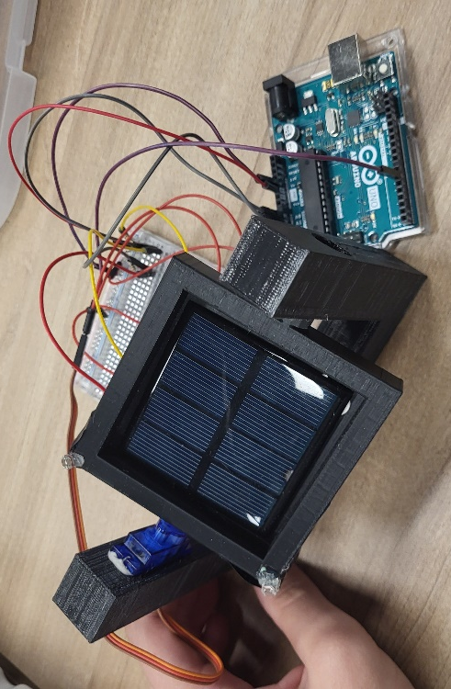
  - 12V DC Power Adapter for stationary setups
Note: For testing, I powered the Arduino with a USB cable from my laptop.

System Design

3.1. What is Being Measured/Controlled?
The photoresistors detect light intensity, with each sensor providing an analogue voltage that correlates to the intensity of light hitting it (0-1024). This information is used to control the servo, which adjusts the angle of the tracker to align with the light source.
3.2. Characteristics of Sensors/Actuator
- Photoresistor (Light Sensor)
  - Type: Analog, passive
  - Signal: Analog voltage proportional to light intensity (range 0-1024 in Arduino’s 10-bits ADC)
  - Voltage Range: 0V to 5V
- Micro Servo
  - Type: Digital, active actuator
  - Signal: PWM (Pulse Width Modulation) to control angle
  - Voltage Range: 4.8V to 6V
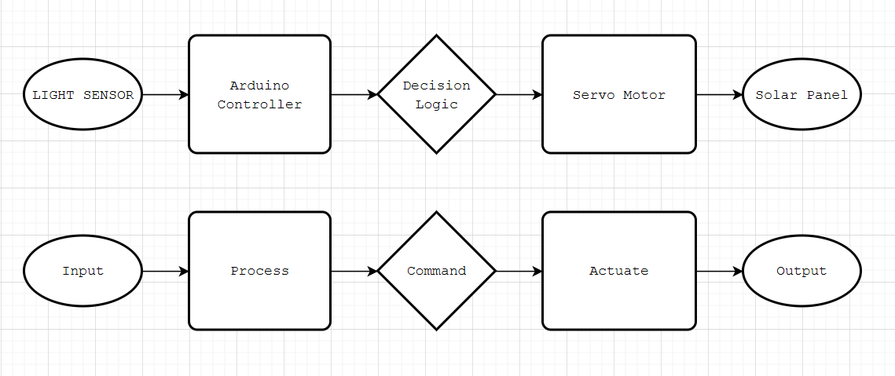
Programming Guide
The code reads the photoresistor values, calculates their difference, and moves the servo to align with the light source. A threshold value is used to filter out noise, preventing constant oscillation due to minor fluctuations in light (see "Possible Improvements" for more on noise handling)

https://github.com/philip344/solar_project/

ASSEMBLY
The assembly diagram below illustrates the positioning and connections of each component in the solar tracker. The labelled parts such as the solar panel, photoresistors, servo, and 3D-printed part a clear reference for setting up the project.
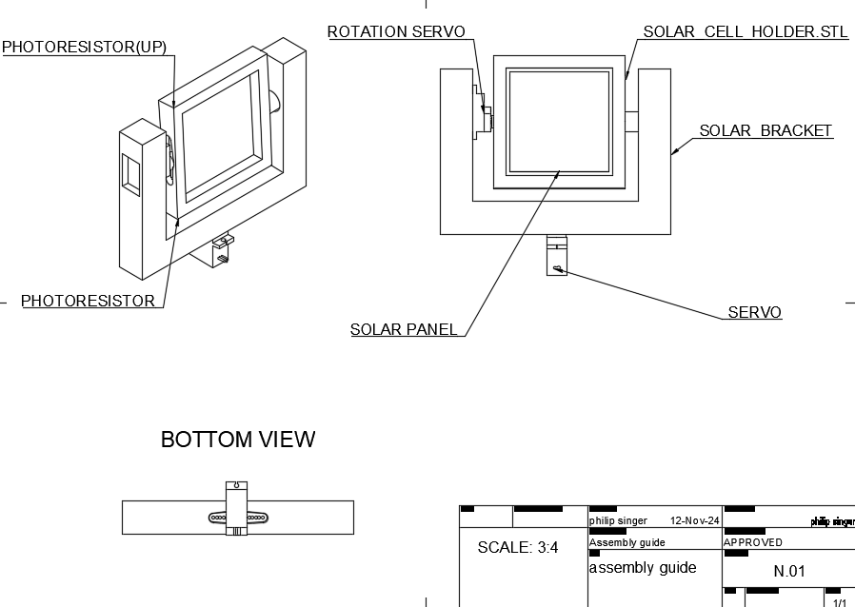

Circuit Diagram
A comprehensive circuit diagram is provided below to show the complete wiring for this project
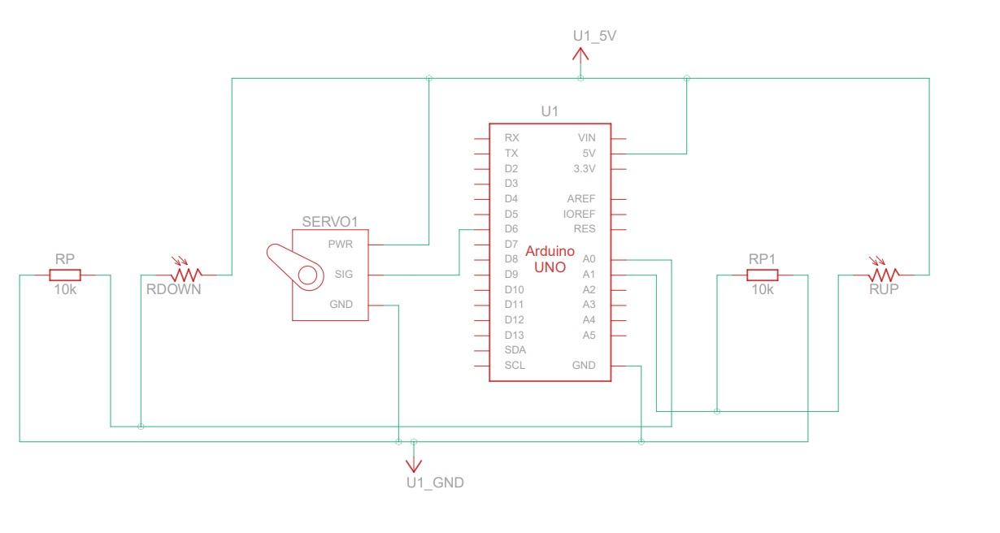
Code Explanation

The program operates as a closed-loop proportional feedback control system. This is ideal for this project because it allows continuous adjustments based on real-time light data. This setup enables the solar tracker to actively align with changing light conditions, maximizing accuracy and responsiveness.
- Threshold Control: Minimizes small, unnecessary servo movements and oscillations.
- Differential Reading: Determines the side with more light and adjusts the servo to reduce the difference.
- Servo Control: Incremental movement ensures smooth tracking without overcorrecting.

Future Improvements

- Mechanical changes:
  - Addition of wire channels: Adding internal wire channels to Solar_cell_holder.stl would prevent the photoresistor leads from tangling, resulting in a neater project
  - Attachment: A stronger, more stable, yet impermanent attachment method to secure Solar_cell_holder.stl to Solar_bracket.stl.
  - Prototyping board: Using a prototyping PCB mounted on the back of Solar_bracket.stl instead of a breadboard would improve cable management. Male header pins could be pre-soldered into the prototyping board for modular connections.
- Code changes:
  - PID Control: Implementing a proportional-integral-derivative (PID) control algorithm for smoother adjustments and to factor in the constant differences in the photoresistors.
  - Constant error correction: With four photoresistors, cross-checking values could enable active error correction, improving accuracy.
  - Granularity: Improved threshold settings and more precise photoresistors (or an advanced noise filtering system) could allow for smoother, movements.
- System changes:
- Control system: While the Arduino Uno is excellent for prototyping, it is computational overkill for this project. An Arduino Nano or even a custom IC on a custom PCB could be more efficient and compact for the final design.
- Adding More Sensors: Four photoresistors for two degrees of freedom, covering both vertical and horizontal planes.
Conclusion
This solar tracker project successfully demonstrates a simple yet effective control system. With additional refinements, it has the potential to be a practical model. Unfortunately, I was unable to complete the project to its fullest extent, as I realized midway through that less was required than initially planned, and the project would be more time-consuming than expected. Furthermore, it would have been drastically more work than was needed. However, I thoroughly enjoyed working on this project and may revisit it in the future to explore further improvements and finish the design.
References
- Arduino Documentation: Arduino.cc
- Servo Library Documentation: Servo Library
- Fusion 360: https://www.autodesk.com/products/fusion-360/
- Draw.io: https://app.diagrams.net/

Philip Singer

