# **// Your name**

**Part 1: Search Algorithms**

***Q1:***

1. 10
2. 4

***Q2:*** *You do not have to use all the rows… stop once you have found the number you are looking for or "learned" it is not there. You can delete the extra rows if you want.*



|  |  |  |  |  |
| --- | --- | --- | --- | --- |
| **Step** | **minLocation** | **maxLocation** | **middleLocation** | **middleValue** |
| 1 | 1 | 10 | 5 | 34 |
| 2 | 1 | 4 | 2 | 8 |
| 3 | 3 | 4 | 3 | 12 |
| 4 | 4 | 4 | 4 | 19 |
| 5 |  |  |  |  |
| 6 |  |  |  |  |
| 7 |  |  |  |  |
| 8 |  |  |  |  |
| 9 |  |  |  |  |
| 10 |  |  |  |  |

|  |  |  |  |  |
| --- | --- | --- | --- | --- |
| **Step** | **minLocation** | **maxLocation** | **middleLocation** | **middleValue** |
| 1 | 1 | 10 | 5 | 34 |
| 2 | 6 | 10 | 8 | 48 |
| 3 | 6 | 7 | 6 | 35 |
| 4 | 7 | 7 | 7 | 42 |
| 5 | 8 | 7 | Not Found |  |
| 6 |  |  |  |  |
| 7 |  |  |  |  |
| 8 |  |  |  |  |
| 9 |  |  |  |  |
| 10 |  |  |  |  |

***Q3:*** **Sorts**

**Insertion sort:**

|  |  |  |  |  |  |  |  |  |
| --- | --- | --- | --- | --- | --- | --- | --- | --- |
| **STEP** | 2 | 5 | 9 | 8 | 4 | 3 | 6 | 7 |
| **1** |  |  |  |  |  |  |  |  |
| **2** |  |  |  |  |  |  |  |  |
| **3** |  |  |  |  |  |  |  |  |
| **4** |  |  |  |  |  |  |  |  |
| **5** |  |  |  |  |  |  |  |  |
| **6** |  |  |  |  |  |  |  |  |
| **7** |  |  |  |  |  |  |  |  |

**Selection sort:**

|  |  |  |  |  |  |  |  |  |
| --- | --- | --- | --- | --- | --- | --- | --- | --- |
| **STEP** | 2 | 5 | 9 | 8 | 4 | 3 | 6 | 7 |
| **1** |  |  |  |  |  |  |  |  |
| **2** |  |  |  |  |  |  |  |  |
| **3** |  |  |  |  |  |  |  |  |
| **4** |  |  |  |  |  |  |  |  |
| **5** |  |  |  |  |  |  |  |  |
| **6** |  |  |  |  |  |  |  |  |
| **7** |  |  |  |  |  |  |  |  |

**Part 2: BYOB**

***Q4:*** Screenshot here - MUST SHOW BLOCKS YOU BUILT

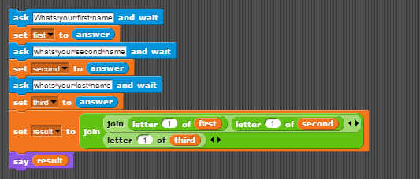

***Q5:*** Screenshot here - MUST SHOW BLOCKS YOU BUILT

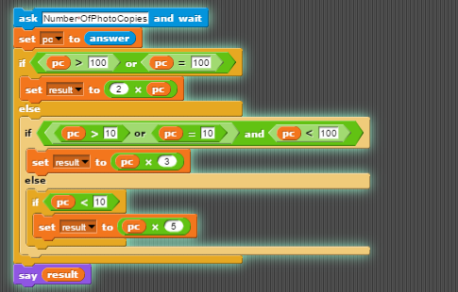

***Q6:*** THESE MUST INCLUDE THE CODE INSIDE THE BLOCK

A)

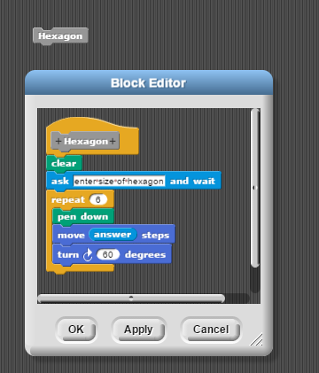

B)

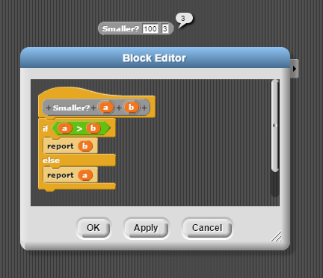

C)

***Q7:*** Screenshot here - MUST SHOW BLOCKS YOU BUILT

***Optional Challenge****:*

**Part 3: 9-Algorithms**

***Q8:***

***Q9:*** Using the same as earlier trick, reconstruct these strings:



***Q10:*** Picture here

***Q11:***