Vibe Coding

Table of Contents
Spec-Driven Development: The End of Vibe Coding 2
What is Vibe Coding? 3
SDD: Specifications as the Source of Truth 3
The Golden Rules 4
The Lifecycle: 6 Phases 4
Phase 1: Analysis (Understand the Problem) 4
Phase 2: Planning (Define the Solution) 4
Phase 3: Solutioning (Design the Architecture) 5
Phase 4: Implementation (Hands on Code) 5
Phase 5: Review (Verify Quality) 6
Phase 6: Sync (Close the Loop) 6
SDD Frameworks: Who Does What 6
BMAD as a Concrete Example 6
Greenfield vs. Brownfield 7
The Project Constitution 8
Final thoughts 8
References 9
6 MCP servers 10
What Is an MCP Server? (Simple Explanation) 10
1. Firecrawl MCP 11
2. GitHub MCP 12
3. Publora MCP 13
Bonus: AnotherWrapper 14
4. Supabase MCP 15
5. E2B MCP 16
6. Taskade MCP 17
Important 18

Spec-Driven Development: The End of Vibe Coding
Diego Rodrigo
https://diegorodrigo.dev/en/2026/04/06/spec-driven-development-the-end-of-vibe-coding/
Why Spec-Driven Development helps teams move beyond vibe coding and work with AI using clearer contracts, context, and validation.
April 6, 2026 · 8 min · Diego Rodrigo | Translations:
- Português
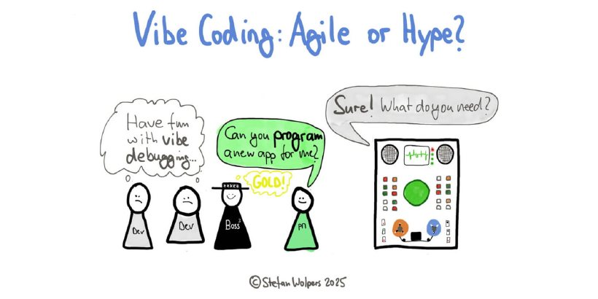
- What is Vibe Coding?
- SDD: Specifications as the Source of Truth
  - The Golden Rules
- The Lifecycle: 6 Phases
  - Phase 1: Analysis (Understand the Problem)
  - Phase 2: Planning (Define the Solution)
  - Phase 3: Solutioning (Design the Architecture)
  - Phase 4: Implementation (Hands on Code)
  - Phase 5: Review (Verify Quality)
  - Phase 6: Sync (Close the Loop)
- SDD Frameworks: Who Does What
  - BMAD as a Concrete Example
  - Greenfield vs. Brownfield
- The Project Constitution
- Final thoughts
  - References
If you’ve ever used AI to write code, you’ve probably been through this: you ask for something, the AI delivers something that looks correct, but when you test it… it’s not quite right. The code compiles, the variable names make sense, but the behavior isn’t what you expected. This has a name: vibe coding.
In this article I’ll introduce Spec-Driven Development (SDD), an approach that changes the way we work with AI agents, moving from “just go and do it” to a process where specifications are the contract the AI follows.

What is Vibe Coding?
Vibe coding is when you give a vague instruction to the AI and hope it understands what you want. It works for simple things, but in real projects it snowballs:
- Code that looks correct but doesn’t meet the requirement
- Architecture decisions made randomly
- No tests, no validation, no traceability
- Each session with the AI starts from scratch, without context
The reality is that devs already use AI in about 60% of their work, but fully delegate only 0-20% of tasks, according to Anthropic’s 2026 Agentic Coding Trends Report. This happens precisely because there’s no clear contract between what we want and what the AI produces.

SDD: Specifications as the Source of Truth
Spec-Driven Development changes the game. Instead of “code is the source of truth”, we shift to: “intent is the source of truth, with AI making specifications executable.”
In practice, this means producing artifacts (PRD, architecture, stories) before writing code. These artifacts form a contract that the AI agent follows.

The Golden Rules
These are principles that, regardless of project or stack, make a difference when working with AI:
# | Rule | Why
1 | Specs before code | AI without specs produces plausible but wrong code
2 | Research before implementing | Agent memory can be outdated. Official docs are current
3 | Quality gates before commit | Code review + tests + build prevent silent regressions
4 | Living specs | Specs updated after implementation, not just before
5 | Decisions become rules | A finding only in a document is wasted. It must become a rule or story
6 | Tests are AC contracts | Each acceptance criterion maps to at least one test

The Lifecycle: 6 Phases
SDD is not a waterfall. It’s a cycle where each phase feeds the next and feedback loops back to update the specs.
UpdatesBecomes ruleFeeds1. Constitution2. Specify3. Plan4. Implement5. Review6. SyncProject rules
Let’s go through each phase:
Expand diagram

Phase 1: Analysis (Understand the Problem)
Here we define vision, personas, success metrics, and domain constraints. The output includes documents like the Product Brief and research reports.
Sounds like bureaucracy? It’s actually the opposite: without this, the AI will make up requirements on its own.

Phase 2: Planning (Define the Solution)
The PM agent produces the PRD (Product Requirements Document) with functional and non-functional requirements. Each functional requirement has acceptance criteria in Given/When/Then format:

Markdown
## FR-001: User Registration

**Priority:** P0 (Critical)

**Acceptance Criteria:**
- GIVEN a new user, WHEN they submit valid email + password,
THEN account is created and verification email sent
- GIVEN an existing email, WHEN registration attempted,
THEN generic error shown (anti-enumeration)
- GIVEN OAuth provider selected, WHEN authorization succeeds,
THEN account created/linked automatically

This format is great because each AC translates directly into an automated test.

Phase 3: Solutioning (Design the Architecture)
The Architect agent makes technical decisions documented as ADRs (Architecture Decision Records), a format proposed by Michael Nygard in 2011. Each ADR records the context, options considered, decision, rationale, and consequences:
Markdown
## ADR-001: Authentication Strategy
**Status:** Accepted
**Context:** Need stateless auth for multi-platform
**Options:** JWT + refresh tokens | Session-based | OAuth-only
**Decision:** Session cookies (web) + Bearer tokens (mobile/API)
**Rationale:** Cookies are more secure for web; Bearer tokens for mobile
**Consequences:** Dual auth flow, CORS configuration, token rotation

Before coding starts, a readiness validation checks that PRD, UX, architecture, and stories are aligned.

Phase 4: Implementation (Hands on Code)
This is where the code comes in, but in a structured way:
- The Scrum Master agent creates the story file with full context
- The Architect agent validates the Definition of Ready (mandatory)
- The Dev agent implements using TDD: RED -> GREEN -> REFACTOR per AC
- Adversarial, multi-perspective code review
- Quality gates: tests + build + type-check
- Commit, update status, sync artifacts

Phase 5: Review (Verify Quality)
Code review from multiple perspectives: architecture, security, logic, performance, style, accessibility. Not a quick glance, a proper adversarial analysis.

Phase 6: Sync (Close the Loop)
This is the phase everyone ignores, but it’s crucial: update sprint status, route maps, architecture docs, and the specs themselves. Specs are living documents they evolve with implementation.

SDD Frameworks: Who Does What
Several frameworks implement SDD in practice. The main ones are:
- BMAD (Breakthrough Method for Agile AI-Driven Development) — simulates a full agile team with multiple specialized AI agents. The most comprehensive, covering the entire lifecycle.
- GitHub Spec-Kit — GitHub’s toolkit with a 4-phase process (Specify → Plan → Tasks → Implement). Great for greenfield projects.
- OpenSpec — lightweight framework focused on brownfield projects. Uses a delta approach (ADDED, MODIFIED, REMOVED) to manage incremental changes.
I mentioned all three because they help frame the space. But to keep the explanation concrete, I’ll use BMAD as the main example in this section. It’s the easiest one to use to show roles, handoffs, and the full delivery flow. The same ideas around specs, readiness, guided implementation, and review still apply when you use Spec-Kit, OpenSpec, or a similar workflow.

BMAD as a Concrete Example
BMAD simulates a full agile team using specialized AI agents. We’re not talking about real people: each “team member” is an AI agent that takes on a specific role. When I say “the Architect validates”, it’s the AI agent in the Architect role doing that.
Each task type routes to the right AI agent:
Task | AI Agent | When to use
Research, discovery | Analyst agent | New domain, market analysis
Requirements, PRD | PM agent | Feature definition, FR/NFR creation
Technical design | Architect agent | ADRs, system design, DB schema
UX/Design | UX Designer agent | Wireframes, components, interactions
Sprint planning | Scrum Master agent | Story creation, sequencing
Implementation | Dev agent | Story execution, coding, tests
Quality | QA agent | Test strategy, automation
Small fix (< 3 files) | Quick Flow | Bug fixes, one-liners
Code review | Reviewer agent | Pre-commit adversarial review
The routing works intuitively:
Add loginPMFix buttonQuick FlowDesign authArchitectImplement story 5-3DeveloperReview codeReviewer

Greenfield vs. Brownfield
Expand diagram
BMAD has two main flows:
- Greenfield (new project): goes through all 6 phases, starting from analysis and discovery
- Brownfield (existing code): enters directly at Phase 2 or 3, since the code already exists and the project context can be extracted from the codebase itself
For small changes (bugs, simple features), there’s the Quick Flow: a simplified path where a single AI agent handles spec + dev + review, without going through all phases. This avoids unnecessary overhead for things that don’t need a PRD or architecture.
Inside BMAD, the rule is: every code change uses a BMAD agent. In other frameworks, that same discipline shows up under different names and commands, but the core idea is the same: don’t jump into implementation without context, criteria, and validation.

The Project Constitution
At the heart of SDD is a project constitution file, something like AGENTS.md, CLAUDE.md, or the equivalent in whatever tool you use. It works as the project’s constitution: a set of rules loaded into every agent session.
AGENTS.md
├── Project overview (what, why, tech stack)
├── Common commands (build, test, lint, dev)
├── Architecture overview (layers, patterns, constraints)
├── Golden rules (non-negotiable principles)
├── Design system rules (if UI project)
├── Language rules (code vs UI)
├── BMAD integration (phases, agents, commands)
└── References to detailed rules (progressive disclosure)

Some important tips for that constitution:
- Size limit: Keep under 200 instructions (~40KB). LLMs consistently follow ~150-200 instructions
- Progressive disclosure: Task-specific knowledge goes into scoped rule files, not into the main constitution
- Positive instructions: Say what TO DO, not what to avoid. In general, flipping negative rules into positive guidance reduces instruction drift a lot
- Primacy/recency effect: Most frequently violated rules go at the very top and very bottom of the file

Final thoughts
SDD might seem like a lot of structure for someone used to just asking the AI to “do the thing”. But the truth is that the more complex the project, the more this structure pays off. According to the TDAD (Test-Driven Agentic Development) paper, TDD with agents reduces regressions by 70%. And according to Scrum.org, teams with well-defined Definition of Ready/Done transition to AI workflows much more smoothly.
In the next article of this series, we’ll dive into the practical side: quality gates, testing strategy, code review, and the complete checklist to set up SDD on a new project.
If you’re getting started with AI-assisted development, my advice is: don’t try to implement everything at once. Start with the project constitution (AGENTS.md, CLAUDE.md, or equivalent), add basic quality gates (tests + build before each commit), and evolve as you feel the need.

References
BMAD Method — Official repository.
GitHub Spec-Kit — Open source SDD toolkit.
OpenSpec — Lightweight SDD framework for brownfield projects.
Anthropic — 2026 Agentic Coding Trends Report.
TDAD: Test-Driven Agentic Development (arXiv 2603.17973).
ADR — Architectural Decision Records (official site).
Michael Nygard — Documenting Architecture Decisions (2011).

6 MCP servers

6 MCP Servers That Are So Good, They Feel Illegal in 2026
Mohit Vaswani , Medium

https://medium.com/@hii_mohit/6-mcp-servers-that-are-so-good-they-feel-illegal-in-2026-4e080b58de14

MCP servers are the future because they can replace all the manual work between your AI and the tools you already use with zero copy pasting and full automation.
They are even improving at complex tasks like browsing the web, writing to databases, posting on social media, and running actual code.
If you don’t use MCP servers now, you might fall behind.
That’s why I bring some MCP servers that will help you become the top 1% of your industry or the work you’re doing now.

What Is an MCP Server? (Simple Explanation)
MCP stands for Model Context Protocol.
Think of it as a USB-C port for your AI. Before MCP, every AI tool had its own plugin system. ChatGPT had plugins. Claude had tool use. Cursor had its own SDK. If you wanted your AI to connect to multiple apps, you needed to build four different integrations.
MCP fixes that. Write one server, and every AI client can use it.
Right now, MCP is supported by Claude Desktop, Claude Code, Cursor, Windsurf, VS Code, and more. The ecosystem crossed 97 million monthly SDK downloads in early 2026.
That’s not a trend. That’s infrastructure.

1. Firecrawl MCP
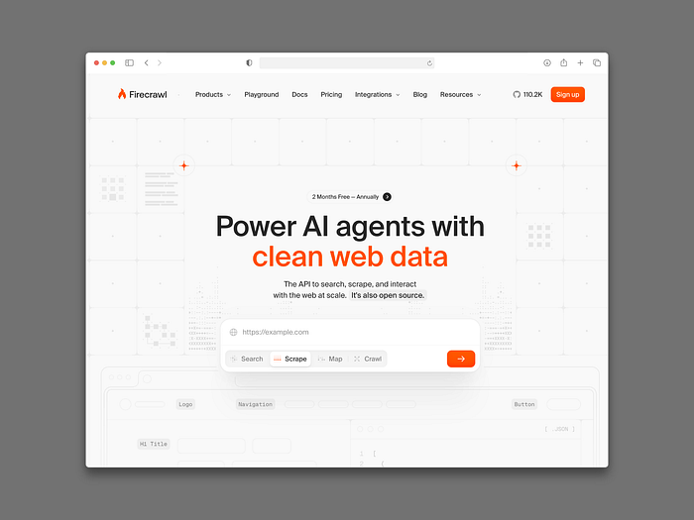
Press enter or click to view image in full size
Firecrawl MCP
Want to give your AI the ability to read any website?
Firecrawl MCP turns any URL into clean, structured data your AI can actually use. Forget manually copying docs or pasting error messages into chat. Your AI scrapes it directly and applies the answer in real time.
It has over 85,000 GitHub stars, making it one of the most trusted web scraping tools in the MCP ecosystem.
Use it when you want your AI to:
- Read competitor websites
- Pull documentation from any URL
- Research topics without leaving your workflow
Try here: firecrawl.dev

2. GitHub MCP
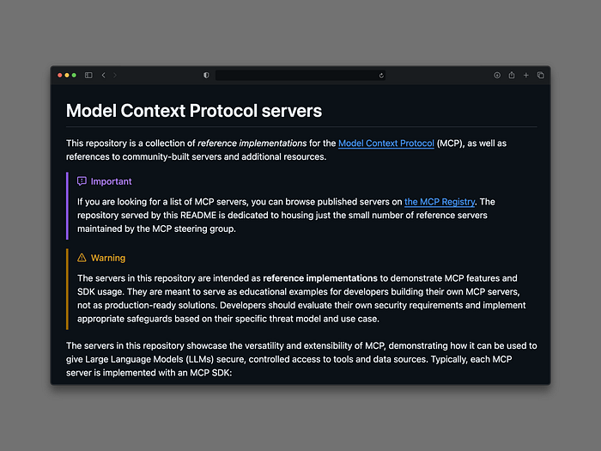
Press enter or click to view image in full size
Github MCP
Want your AI to work directly inside your codebase?
The GitHub MCP server lets your AI interact with repos, issues, pull requests, and commits using natural language. No terminal switching. No manual searching.
You can ask things like:
- “Show me all open issues labeled bug from the last 7 days.”
- “Which files changed the most this month?”
- “Find all functions that reference OrderId.”
It works with Claude Desktop, Cursor, Windsurf, and VS Code. Microsoft backs it, which means it’s not going anywhere.
Try here: github.com/modelcontextprotocol

3. Publora MCP
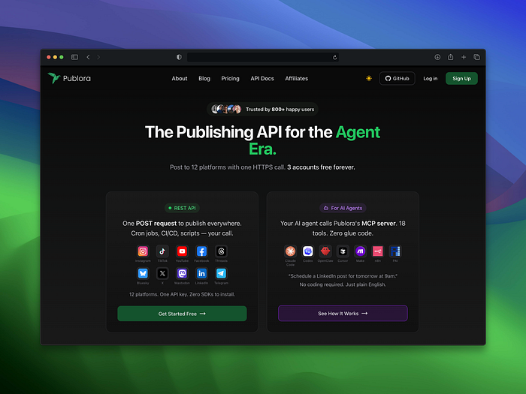
Press enter or click to view image in full size
Publora MCP
Want to do social media on full autopilot?
Publora is an MCP server that connects your AI to 11+ social platforms — Instagram, LinkedIn, X (Twitter), Threads, TikTok, YouTube, Facebook, and more — through a single endpoint.
Instead of opening five different dashboards, you just tell your AI what to post and where.
It’s very easy to use:
- Connect Publora to your MCP client (takes under 2 minutes).
- Tell Claude: “Post this to LinkedIn and X, schedule for Monday 10am.”
- Done. No dashboard. No manual publishing.
For indie builders and content creators, this one is a no-brainer.
Try here: publora.com

Bonus: AnotherWrapper
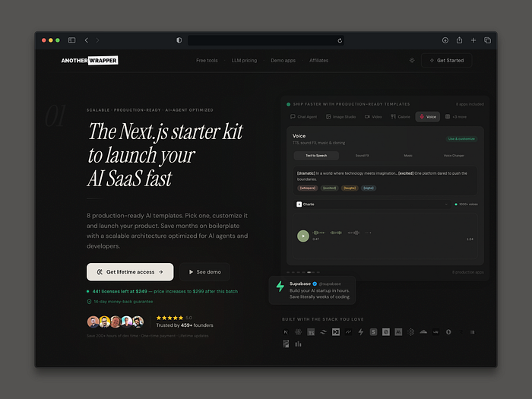
Press enter or click to view image in full size
AnotherWrapper
Want to build your own AI apps and tools without starting from scratch?
Now is a great time to create AI apps and print money fast.
Another Wrapper gives you 10 customizable AI demo apps to choose from. Pick one, add a feature, and you can start your startup and make money fast.
Try here: Anotherwrapper.com

4. Supabase MCP
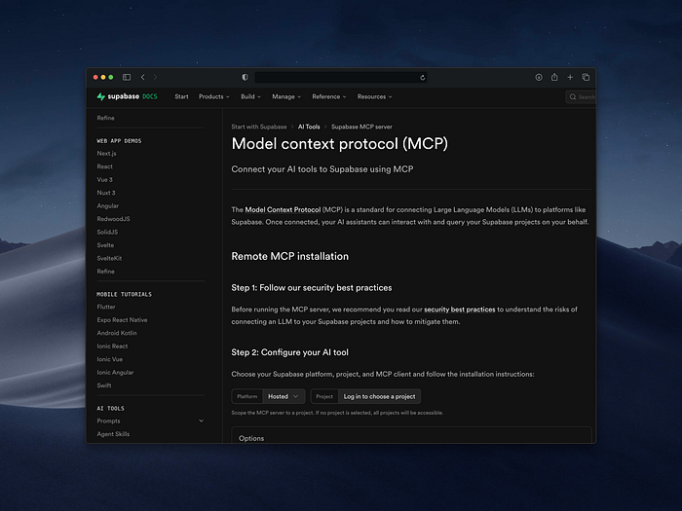
Press enter or click to view image in full size
Supabase MCP
Want your AI to query your database in plain English?
The Supabase MCP server lets your AI write and run SQL directly against your database. No need to write the query yourself. Just ask.
Example: “Show me all users who signed up in the last 7 days” or “Find the most popular products by order count.”
It works with Supabase, Neon, and self-hosted PostgreSQL. The server auto-discovers your schema, so your AI already knows your table structure the moment it connects.
One rule: keep it read-only on production. You don’t want your AI deleting rows at 3am.
Try here: supabase.com

5. E2B MCP
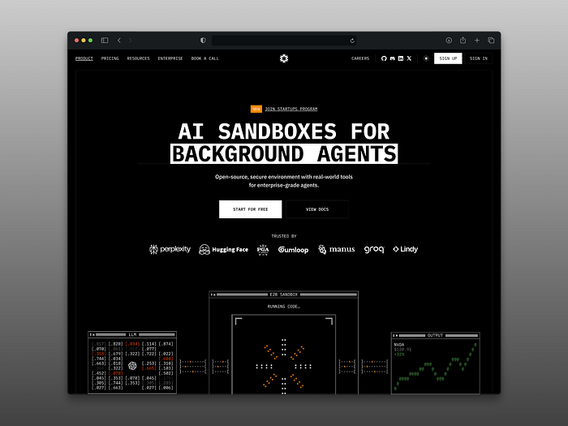
Press enter or click to view image in full size
E2B MCP
Want your AI to actually run code, not just write it?
Most AI assistants can write a Python script. E2B lets them run it too — inside a secure cloud sandbox, isolated from your machine and your production systems.
You can ask your AI to:
- Run a data analysis script and return the chart
- Test a migration before committing
- Execute shell commands safely without touching your laptop
There’s a real difference between an AI that writes code and an AI that runs it, checks the output, and iterates. E2B is that upgrade.
Try here: e2b.dev

6. Taskade MCP
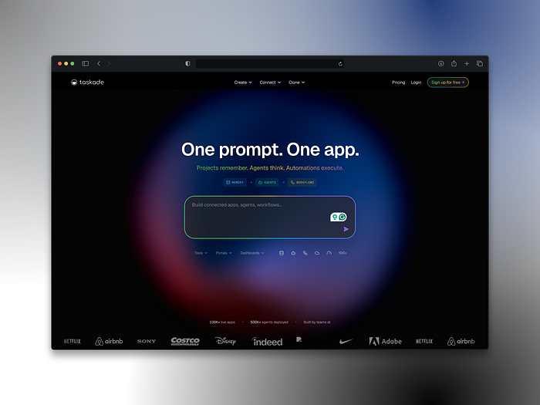
Press enter or click to view image in full size
Taskade MCP
Want one MCP server that does almost everything?
Taskade MCP gives your AI a full workspace with projects, tasks, agents, automations, and integrations behind a single login. It’s the only server that combines workspace memory, agent intelligence, and automation workflows in one place.
It’s the strongest all-in-one production option in 2026 if you want your AI to manage work, not just answer questions.
Plans start at $6/month and there’s a free tier to try.
Try here: taskade.com

Important
MCP servers are not a niche developer thing anymore. Over 500 public MCP servers exist as of 2026. The protocol is now governed by the Linux Foundation. OpenAI and Google DeepMind both support it.
This is the layer that turns your AI from a chatbot into a coworker.
Start with one server that matches your workflow. Add more as you need them. Three focused servers that each do one thing well will beat one giant setup every time.

