1.Check your python version

Search for “cmd” in Windows, and run it (terminal) as administrator.

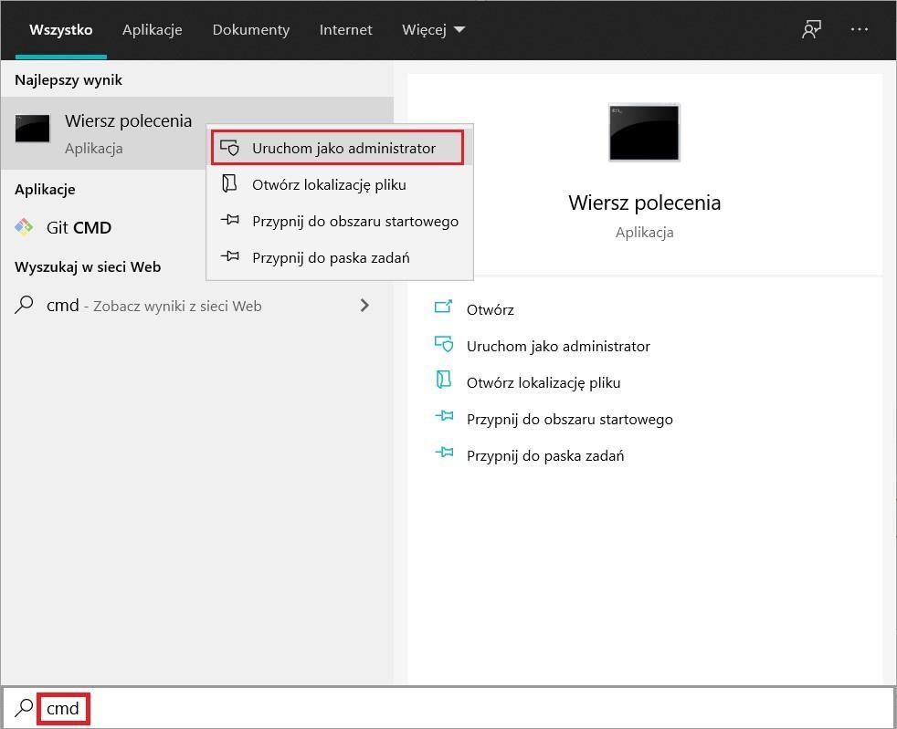

Type python -–version:

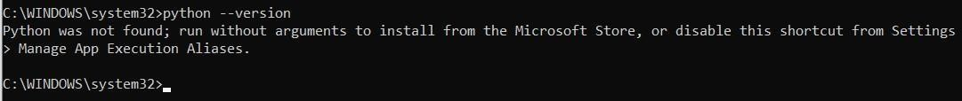

2.Download and install Python.

Visit the site:

[https://www.python.org/downloads/release/python-396/ o](https://steamcommunity.com/linkfilter/?url=https://www.python.org/downloads/release/python-396/)r install the latest stable version available. scroll down the site and choose python version for your os.

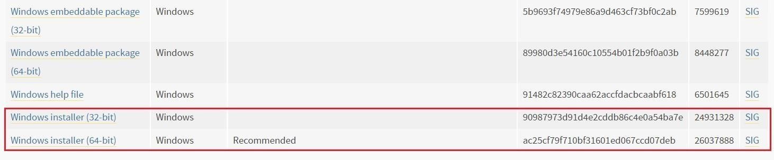

Install python, remember to check both checkboxes:

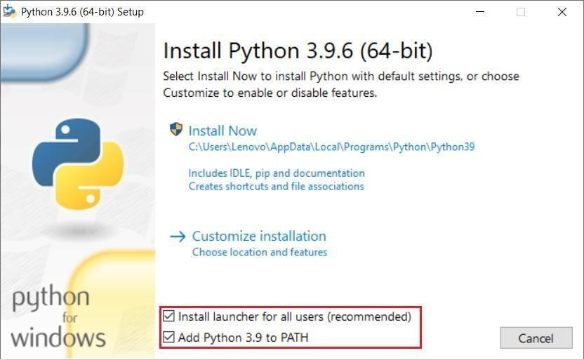

Click install now.

After installation, run new terminal and type python –-version. You should see something like this:

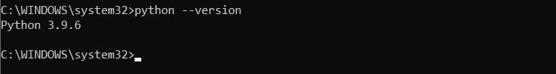

3.Download the <https://github.com/philipesantos136/jime-reader/tree/main>

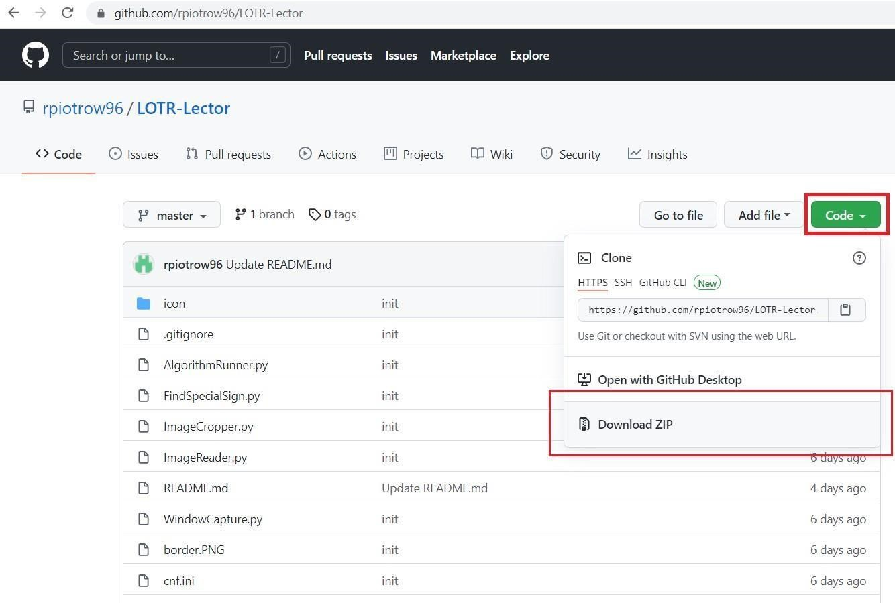

Click Code -> Download ZIP and unzip it.

4.download and install tesseract <https://github.com/UB-Mannheim/tesseract/wiki>

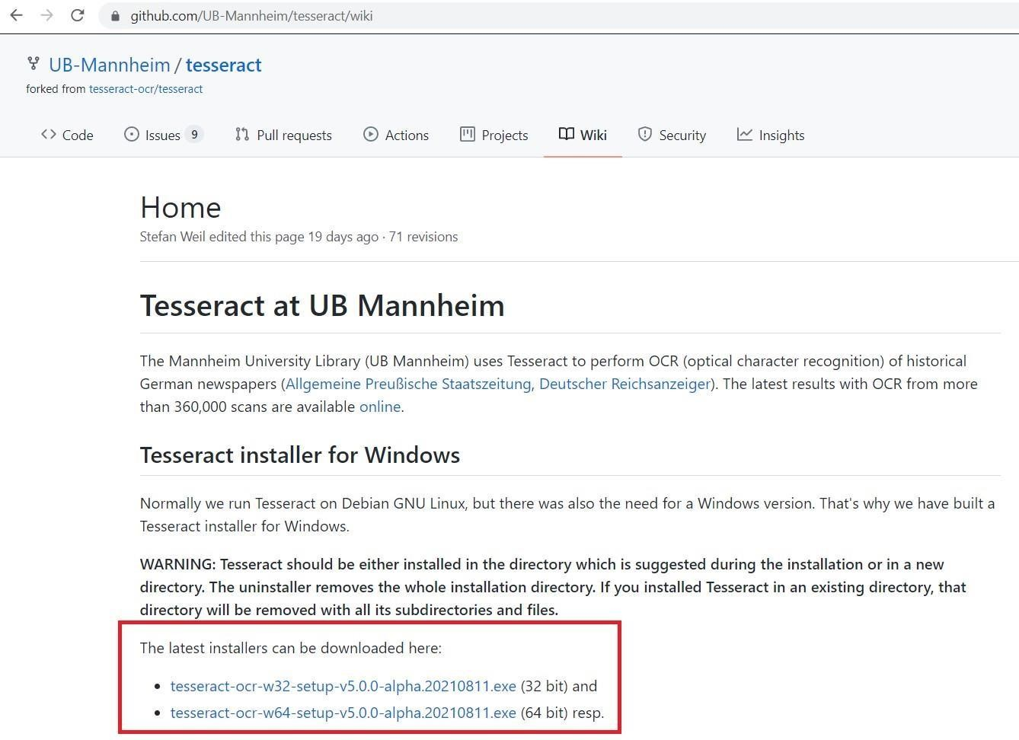

Installation:

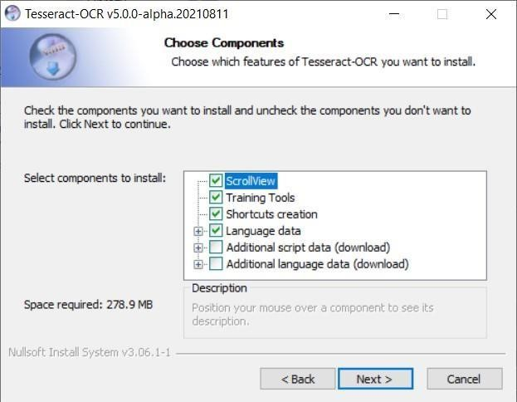

Remember to NOT EDIT the Destination Folder! if you do, you will have to edit the python configuration file as well.

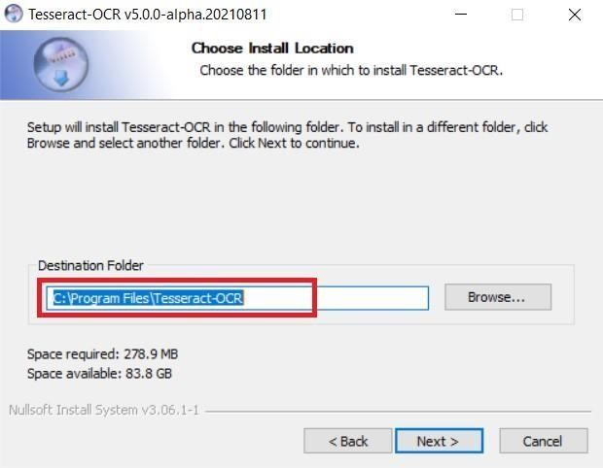

Then click next and install.

5.Download python libraries

Open terminal (as previous) on unzip folder and run command:

pip install -r requirements.txt

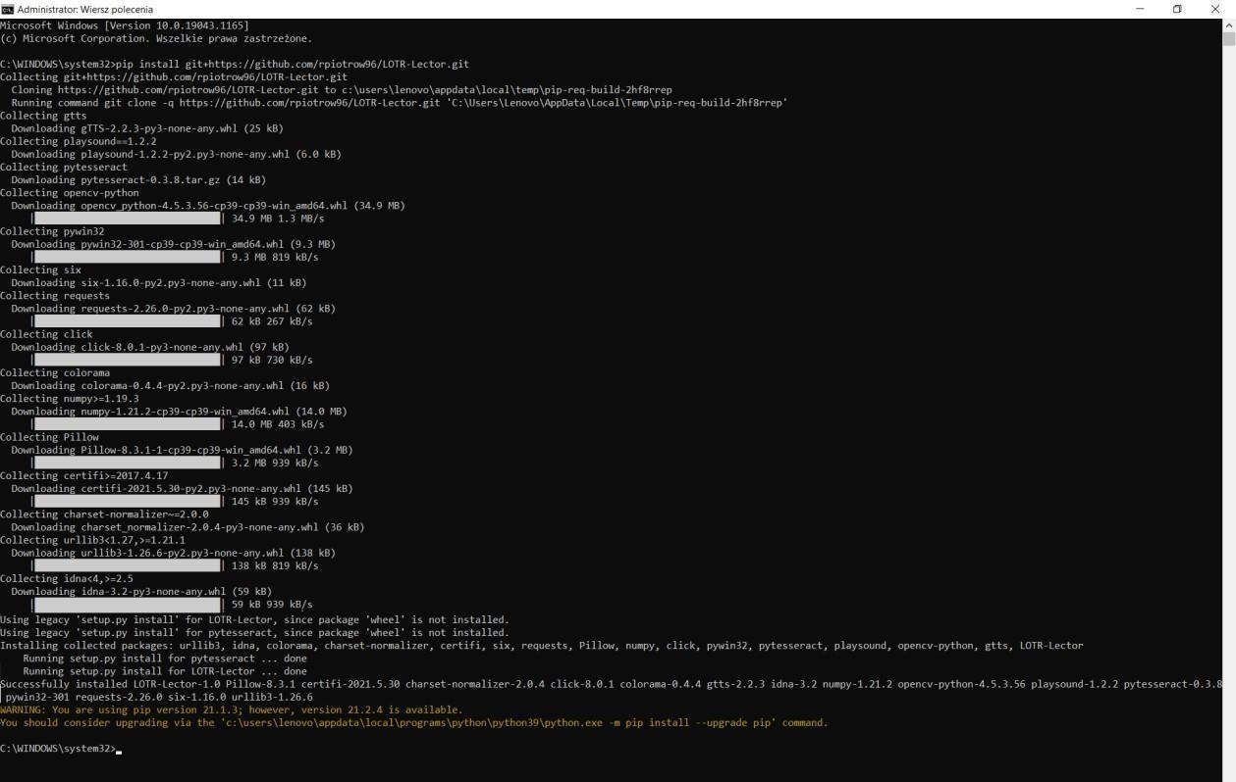

Wait for downloading all libraries and close terminal.

6.Create azure free acount in [https://azure.microsoft.com/pt-br/products/ai-services/text-tospeech/](https://azure.microsoft.com/pt-br/products/ai-services/text-to-speech/)

Não será cobrado até mudar o tier de assinatura, o que não iremos fazer

6.1 – install Microsoft Visual C++ if you don’t have (recommended) [https://learn.microsoft.com/enus/cpp/windows/latest-supported-vc-redist?view=msvc170&preserve-view=true](https://learn.microsoft.com/en-us/cpp/windows/latest-supported-vc-redist?view=msvc-170&preserve-view=true)

6.2 – Create a new multi-service resource in [https://portal.azure.com/#blade/Microsoft_Azure_ProjectOxford/CognitiveServicesHub/SpeechSe rvices](https://portal.azure.com/#blade/Microsoft_Azure_ProjectOxford/CognitiveServicesHub/SpeechServices)

6.2.1 – Click on subscription (assinaturas), then add:

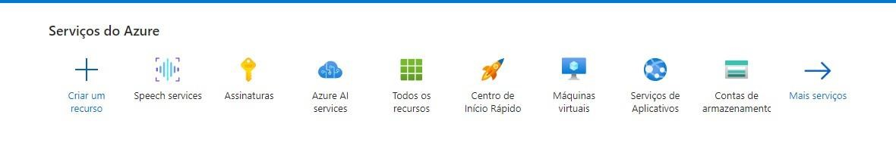

Then add (check if your plan is free to use not pay as you go).

6.2.2 – go to home and then click speech services then create.

6.2.3 – check your subscription (created in the previous step), set up resources group set up reagion (Brazil South), name: Python-lotr and price type, F0. After create, copy one of your Keys, open cmd and paste :

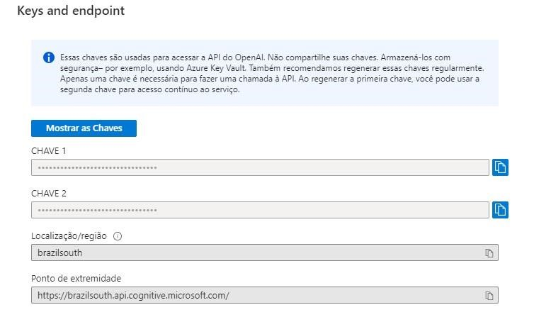

setx COGNITIVE_SERVICE_KEY your-key setx

SPEECH_REGION brazilsouth

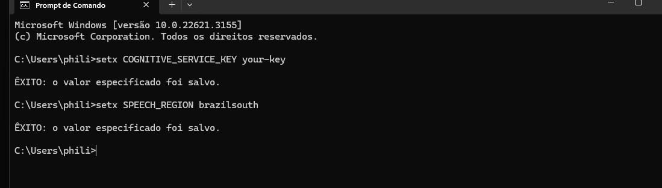

7.Run the app!

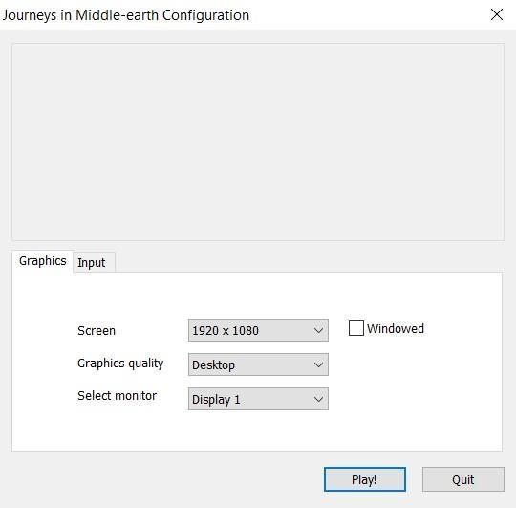

Open terminal and go to directory where you unzipped app.

On my computer I typed: cd ..\..\Users\Lenovo\Desktop\LOTR-Lector-master Then: python main.py



It works!

Example of read txt:

