A Narrative Report in

On-the-Job Training Undertaken at Surigao State College of Technology Located at Narciso St., Surigao City

Presented to the Placement Office

Surigao State College of Technology

Narciso St., Surigao City, 8400

In Fulfillment of the Requirements of the

Degree of Bachelor of Science in Computer Engineering

Submitted by:

**KURTS P. CANOY**

BSCPE-3

Submitted to:

**Dr. Jerry S. Teleron**

2021

**TABLE OF CONTENTS**

* **Introduction ………………………………………………………………….………..1**
* **Certificate of Registration …………………………………………….…………….2**
* **Resume …...…………………………………………………………….……….……..3**
* **The Industry Partner**
  + **Industry Picture ……………………………………………..……….….…...4**
  + **Industry History …………………………………………..………….…..…..5**
  + **Industry Profile …………………………………………..………….….……6**
  + **Industry Organizational Chart …………………………………………….7**
* **Certificate of Completion …………………………………………...……..…….....8**
* **OJT Performance Rating Sheet ……………………………………..…..…….…..9**
* **Research Output ………………………………………………………………..……10**
* **Documentation with Caption ………………………………………………….......11**
* **Assessment of Work Experience …………………………………..…..…………12**

.

**INTRODUCTION**

On the job training or OJT is one method by which students is given a chance to apply the theories and computations that they have learned from the school. It also helps the students to acquire relevant knowledge and skills by performing in actual work setting. Colleges and universities require their students to undergo such training within a specific number of hours as part of the curriculum.

For the students, an OJT or internship program provides opportunities to go through the actual methodologies of a specific job using the real tools, equipment and documents. In effect, the workplace becomes a development venue for a student trainee to learn more about his chosen field and practice what he has learn from academy.

On the other hand, an effective OJT program also benefits the companies who accept trainees. First OJT or intern provides additional manpower for a lesser labor cost than a regular employee. Most of them are all eager to learn the ropes so chances are high that they will cooperate.

Employers can use this internship strategy as a method in recruiting new employees. Since the trainer or the supervisor can follow the trainees’ progress, he can gauge based on performance, behavior and attitude if the trainee will make a good recruit after the completion of his internship

**CERTIFICATE OF REGISTRATION**

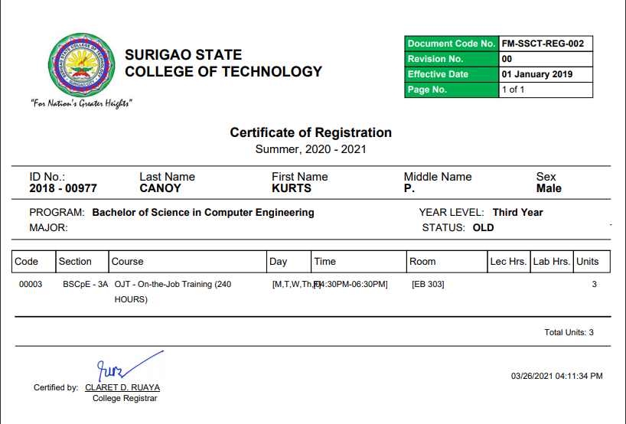

**INDUSTRY PARTNER**

**Industry Picture**

|  |
| --- |
| D:\anton\SSCT REQUIREMENTS\nar.png |
| Surigao State College of Technology – Main  D:\anton\SSCT REQUIREMENTS\office\office1.pngD:\anton\SSCT REQUIREMENTS\office\of2.png |
|  |
| Surigao State College of Technology – ICT Office |

**INDUSTRY HISTORY**

Surigao State College of Technology (SSCT) was formerly Surigao del Norte School of Arts and Trades, established as a trade school with the help of then Governor Jose C. Sering on August 8, 1969 by virtue of Republic Act 6057 under the supervision of Supt. Marcelo S. Bonilla of Cebu School of Arts and Trades, Cebu City.

The school formally started its operation on September 15, 1969 with borrowed technology teachers from three different schools of the province. There were 103 pioneering students in the first secondary trade and the trade technical curricula. Two 2-storey buildings were constructed upon donation of 1.2 hectares of land through the Provincial Government. Along with this, several machineries were acquired from Japan Overseas Cooperation Volunteers; Technical Vocational Education Program; Asian Development Bank; and Philippine Australian Technical Vocational Education Program which became instruments of becoming a full-fledged higher institution offering Bachelor of Science in Industrial Technology and the Bachelor of Science in Industrial Education.

From 1969 to 1988, Dr. Tomas P. Solana, the principal of Numancia National Vocational School (NNVS) served as its 1st Principal and later became the College Vocational School Superintendent II and steered SNSAT for almost two decades. Upon Dr. Tomas P. Solana’s retirement in February 1988, Dr. Ernesto N. Gonzales assumed into office as the Vocational College Superintendent.

Through the efforts of the late Senator Robert Z. Barbers, R.A. 8650 merged SNSAT with the Malimono School of Fisheries, a secondary school that offered the Revised Fisheries Curriculum of 1972 under P.D. 223 in 1975, thereby creating the Surigao State College of Technology (SSCT) which was signed into law on June 5, 1998 by then President Fidel V. Ramos. With the conversion of SNSAT and Malimono School of Fisheries to a State College, there was a major review of its organization, curriculum, and programs and standards under Dr. Teresita T. Tumapon who took the seat as the 1st College President on September 25, 1998.

Surigao State College of Technology, Surigao City .The chartered State College integrated a satellite campus on October 30, 2000 which is the Siargao National College of Science and Technology or SNCST situated in Del Carmen, Surigao del Norte. The integration was made pursuant to Section 8 of RA 7722 and Section 4.1 of RA 8292.Dr. Gloria C. Gemparo, VIS-III of SSCT assumed as its 1st College Administrator until May 14, 1998.

The retirement of Dr. Tumapon on October 2, 2003 paved the way for Dr. Reynaldo T. Peňa as the 2nd College President on October 3, 2003 and after more than four (4) months of presidency, Dr. Peňa opted to end his term on February 29, 2004 to assume as Regional Director of CHED –Region XI, Davao City where the then CHED Regional Director, Dr. Joanna B. Cuenca was designated as the Officer-in-Charge of the College on March 1, 2004 until March 3, 2005.

Engr. Henry L. Laňada, Ph.D. assumed into office on March 4, 2005, as the 3rd College President of the Surigao State College of Technology and unexpectedly resigned on January 4, 2007 which eventually led to the designation of Dr. Jocelyn T. Medina as Acting President effective January 5, 2007 per BOT Resolution No. 490 s. 2007. On May 11, 2007, the Board passed Resolution No. 521 s. 2007 approving the appointment of Dr. Medina as the College President to serve the unexpired term of Dr. Laňada effective May 15, 2007.

On March 4, 2009, Dr. Anastacio P. Martinez succeeded Dr. Medina and was designated as Officer-in-Charge to the Office of the President per BOT Resolution No. 661 s. 2009 who served the College until August 14, 2009.

On August 15, 2009, Dr. Virginia D. Akiate who was the Regional Director of the Commission on Higher Education in CARAGA Region was designated as Officer-in-Charge of the College and was confirmed by the Board per Resolution No. 716 s. 2009 during its Special Meeting on October 30, 2009 at Almont Hotel and Inland Resort in Butuan City. Her designation as OIC ended on November 30, 2010.

The Surigao del Norte College of Agriculture and Technology (SNCAT) which was formerly the Mainit National Agricultural School (MNAS) by virtue of R.A. 5256 1983 Batas Pambansa Blg. 358 on May 26, 1969 was integrated to SSCT through a Memorandum of Surigao State College of Technology, Surigao City .

Under the Memorandum of Agreement, the Higher Education Programs of Surigao del Norte College of Agriculture and Technology (SNCAT) will be placed under the direct supervision of SSCT. The same was confirmed by the Board through Resolution No. 735 s. 2009 on December 28, 2009 during its 44th BOT Meeting. Dr. Georgito G. Posesano, Professor II of SSCT-Main Campus was designated on November 25, 2010 as its Campus Director.

The year 2010 marked another milestone in the history of SSCT as the new lady president, Dr. Gloria C. Gemparo, after undergoing the year-long selection process, assumed into office as the 5th College President of the Surigao State College of Technology on December 1, 2010 pursuant to BOT Resolution No. 25 s. 2010. With Dr. Gemparo at its helm, everybody hopes for a bright future as it faces 21st Century challenges in pursuit of quality and relevant education for all its constituents.

**INDUSTRY PROFILE**

|  |  |
| --- | --- |
| logoD:\anton\SSCT REQUIREMENTS\nar.png | **SURIGAO STATE COLLEGE OF TECHNOLOGY**  *Former Surigao del Norte of Arts and Trades*  Type: State College  Established: June 5, 1998  President: Dr. Gregorio Z. Gamboa Jr.  Location: Surigao City, Surigao del Norte, Philippines  Colors: Green  Website: <http://ssct.edu.ph>  Campus:  Surigao City Main Campus  Del Carmen  Malimono  Mainit |

**PHILOSOPHY**

The Surigao State College of Technology is a community of life-long learners who believe in the worth and total development of every individual. It adheres to the pursuit of excellence and to the democratic tenets, human dignity, wholesome work ethic, equality and equity of opportunity and sustainable progress.

**VISION**

An innovative and technologically-advanced State College in Caraga.

**MISSION**

To provide relevant, high quality and sustainable instruction, research production and extension programs and services within a culture of credible and responsive institutional governance.

**GOALS AND OBJECTIVES**

SSCT aims to produce quality graduates that respond to the dynamics of national and international standards. Its goals and objectives are focused on the 5-point agenda: Instruction, Research Development and Extension (RDE),   Resources Generation, Policy Implementation and Good Governance.

* **Instruction**. To provide enhanced quality instruction that is responsive to the needs of the local, regional, national and global communities.
* **Research, Development and Extension (RDE)**. To develop researches that can provide operative solutions and intensify research-based extension programs to its beneficiaries.
* **Resources Generation**. To increase productivity level in all entrepreneurial center of the College
* **Policy Implementation**. To efficiently and effectively implement policies based on approved institutional manuals and guidelines from CHED, DBM and COA.
* **Good Governance**. To strictly implement reforms in order to sustain good governance and operations.

**QUALITY POLICY**

Surigao State College of Technology provides quality instruction, research, extension, and production services to satisfy its customers by responding to their needs and expectations and continually improving its quality management system.

### INSTITUTIONAL CORE VALUES

SSCT is guided by its institutional core values:

* **S**ervice Oriented,
* **S**ocially Responsive,
* **C**ommited, and
* **T**ransformational.

**AUXILIARY SERVICES**

The College has adequate facilities to cater the needs of the students.

**Office of the College Registrar.** This is the repository of highly important, delicate and confidential documents. The office is the hub of transactions of students’ records, and the data source of enrolment profile. The College Registrar is ably assisted by six working staff.

**College Library**. The four (4) campuses have libraries with a number of books and other library materials such as journals and periodicals of recent publication. The library has been upgraded and enriched with the provision of a computer for students and faculty.

**Guidance and Counseling Services**. This office provides the following services: testing, information, counseling, placement and follow-up.

**Placement Services**. The Placement Coordinator takes charge of job placement services of students through linkages with industrial establishments.

**Student Personnel Services Office**. This Office is directly responsible for quality student–personnel services. It recommends policies to enhance student’s personal and social life or for leadership potentials while in the campus. It implements the official programs, projects and activities and other pastoral services.

**Academic Center**. The Academic Center accommodates social activities and functions of the students and the faculty. It also serves as venue for conferences, seminars and for civic organizations and other agencies on special arrangement.

**College Clinic**. The College is staffed with a Public Health Nurse, Medical and Dental Doctors. The college clinic gives immediate first-aid services, health examination, and other health care medications to faculty and students.

**College Canteen/Bakery**. The College has a canteen/bakery which serves snacks, meals and freshly-baked products at reasonable prices. Both are spacious and well-ventilated.

**Mini-Grocery.** This caters the basic commodities at reasonable prices to all employees and students.

**Multi-Purpose Quadrangle.** The Multi-Purpose Quadrangle serves as a venue for sports activities and other programs for bigger crowd. The stage is equipped with adequate lighting facilities.

**Worship Place**. This serves as a place for which the spirituality of the students as well as the faculty members is exercised and practiced.

**Multimedia Resource Center (MRC).** It brings together educational interactive resources, information, tutorials for those individuals who have interest in the creative and scholarly using emerging multimedia technologies. It promotes, establishes, activates and focuses on multimedia knowledge, software embedded in WizBoard and WizStation, and makes it available for educators and, most especially, for students.

**JEEP Start & Accelerate Laboratories.** Both provide the best venue to augment the English Language Proficiency of the College students to be at edge with others and for them to successfully land jobs in the highly competitive sectors and other employment portals, in both local and international arena.

**INFONET Center.** This is an Internet Laboratory that answers to an increasing demand of the College. It is an educational resource for individuals especially students wishing to learn about the benefits the Internet have to offer.

**Computer Laboratory**. These are made available for instruction, research and students’ use. It allows students’ access to various software programs to acquire and develop the necessary skills. It is also an avenue where students would have the opportunity to develop themselves in matters of programming, networking and the like.

**Students’ Activity Center**. The center is provided with painted steel benches and glass-covered tables surrounded with ornamental plants that make the ambiance so conducive for student activities, enhance learning and engage students to be more productive in doing educational related outputs

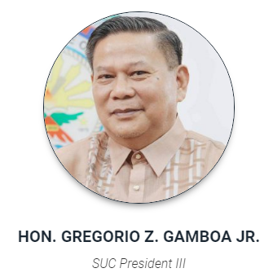**Industry Organizational Chart**

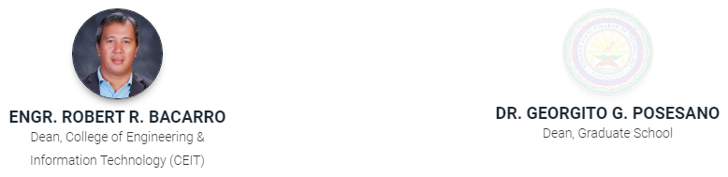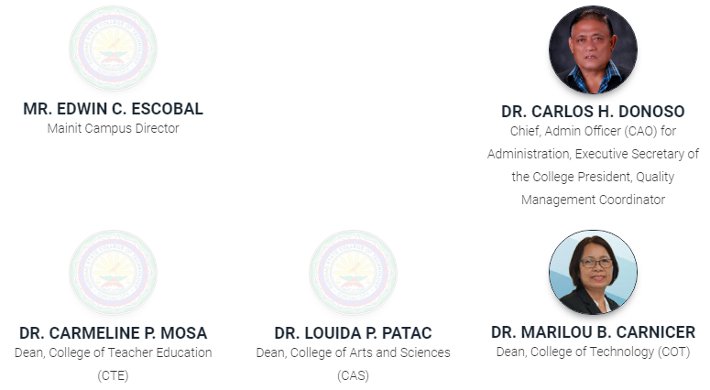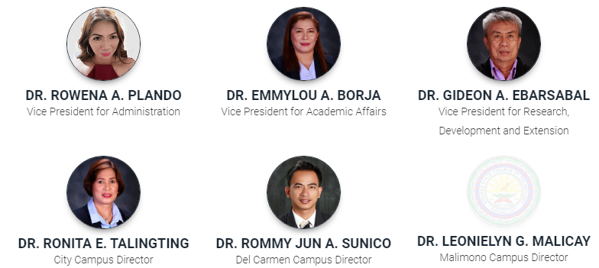.

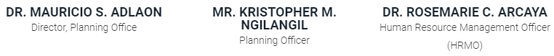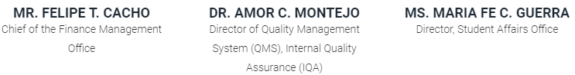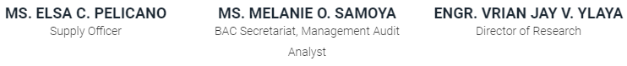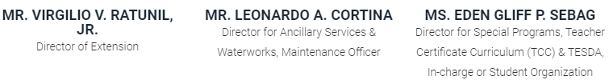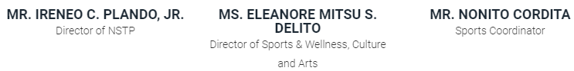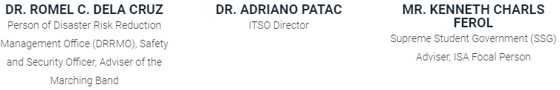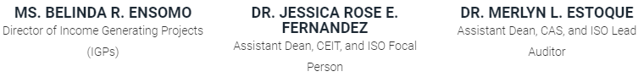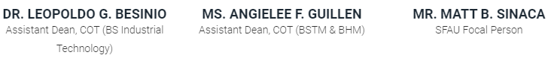

**COLLEGE OF ENGINEERING & INFORMATION TECHNOLOGY**

**COMPUTER ENGINEERING DEPARTMENT**

**C E R T I F I C A T I O N**

This is to certify that **Mr.** **Kurts P Canoy** from Surigao State College of Technology has successfully completed 240 hours of his work from home On-the-Job Training (OJT) with a performance rating of ____________.

This certification is being issued upon the request of **Mr. Kurts P. Canoy** for whatever legal purpose it may serve.

**Engr. Jerry I. Teleron, Ph.D.,PCpE**

BSCpE Program Chair/OJT Coordinator

**REASEARCH OUTPUT**

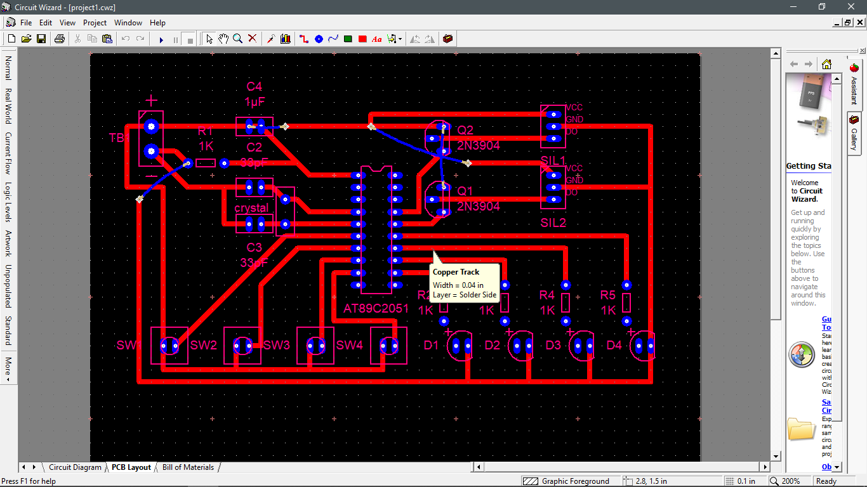

Printed Circuit Board (Single-sided) design for Gate-Controller Circuit

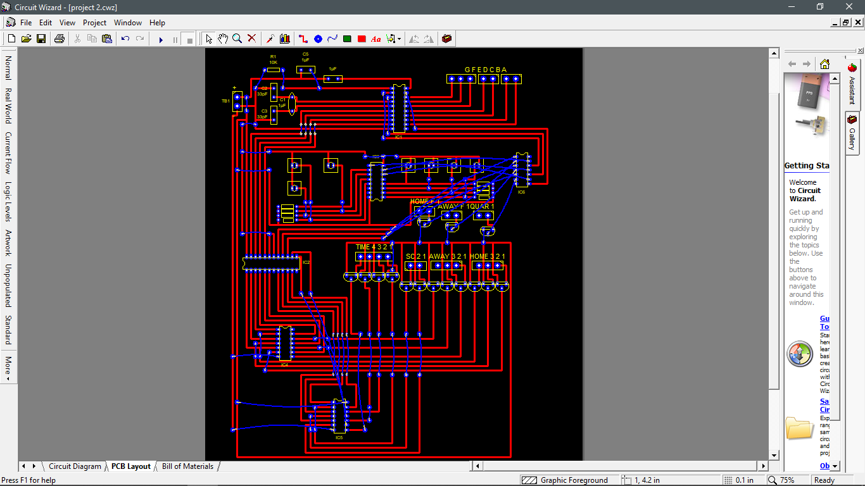

Printed Circuit Board (Single-sided) design for Basketball Scoreboard

**DOCUMENTATION WITH CAPTION**

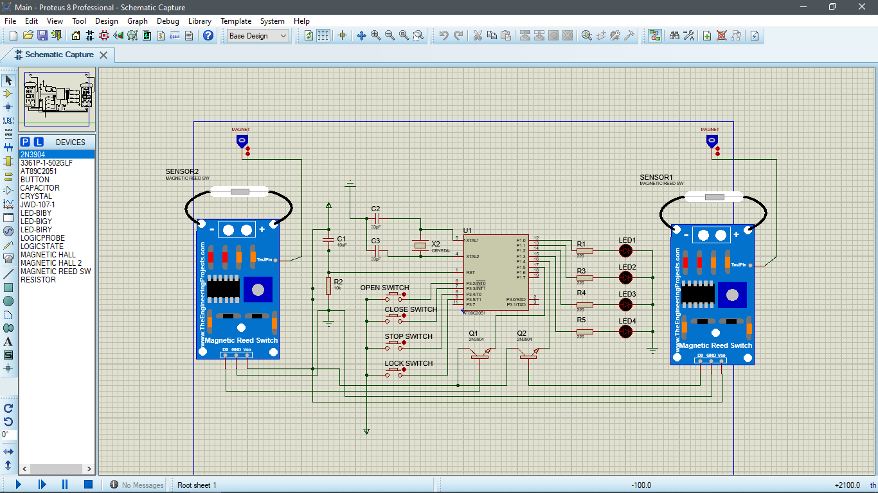Schematic Diagram made from Proteus 8 Professional

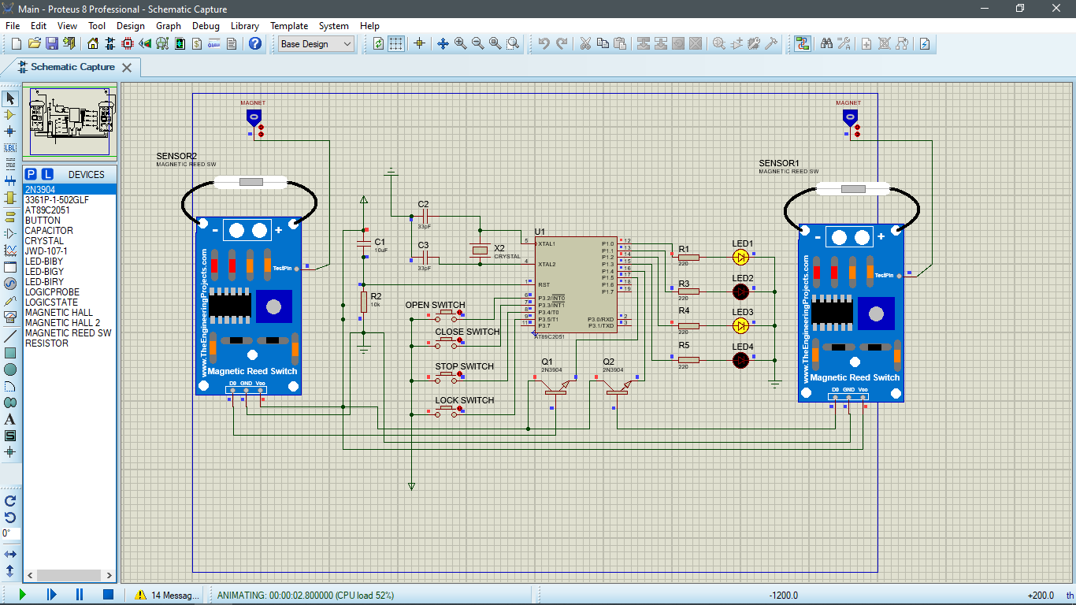

Proteus 8 Gate-controller actual simulation

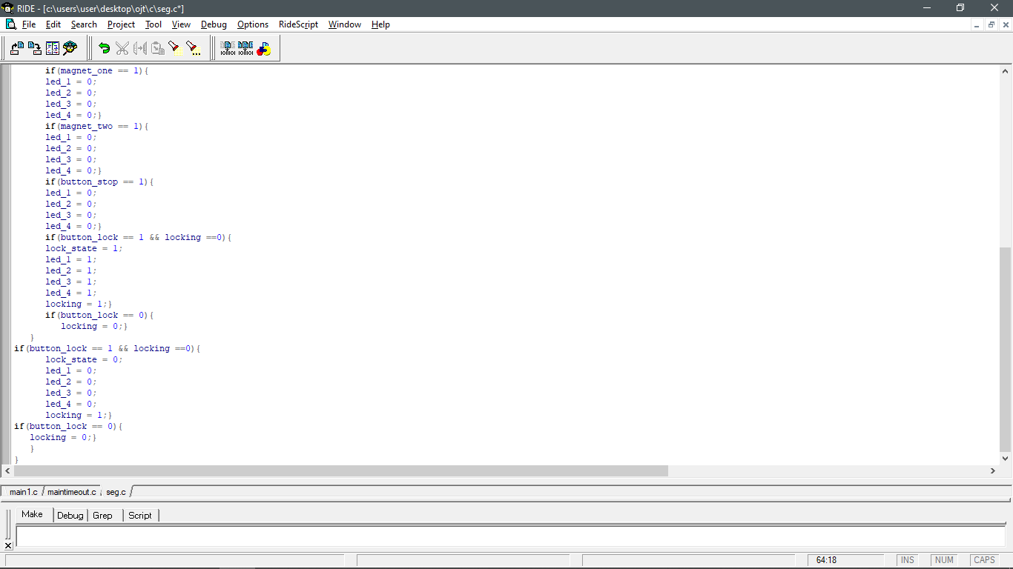

Embedded C Code for the Gate-Controller Circuit

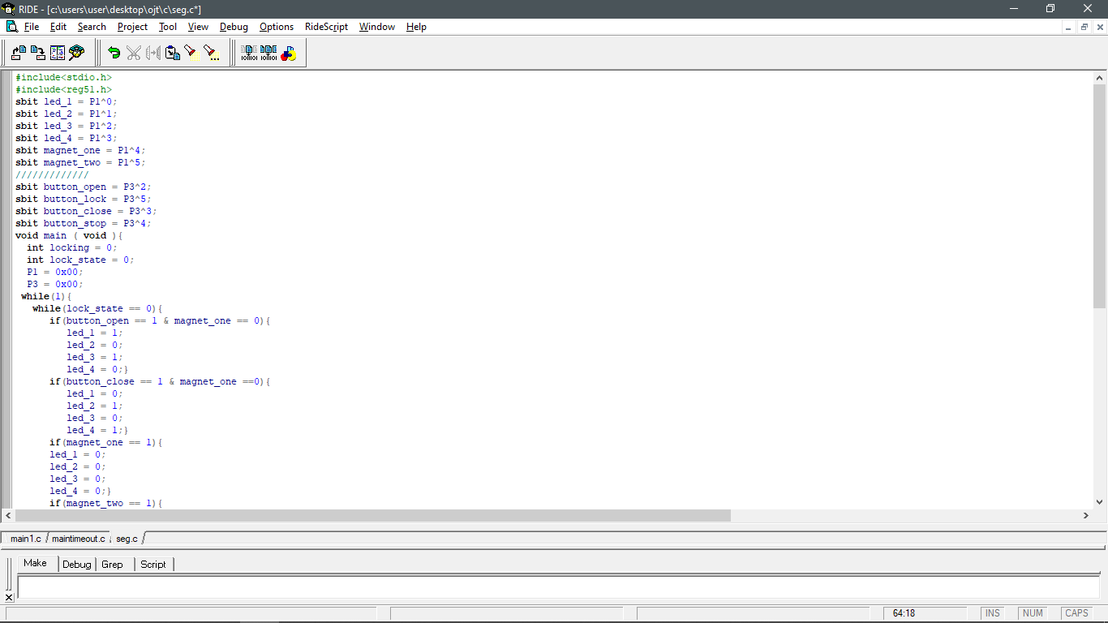

Embedded C Code for the Gate-Controller Circuit

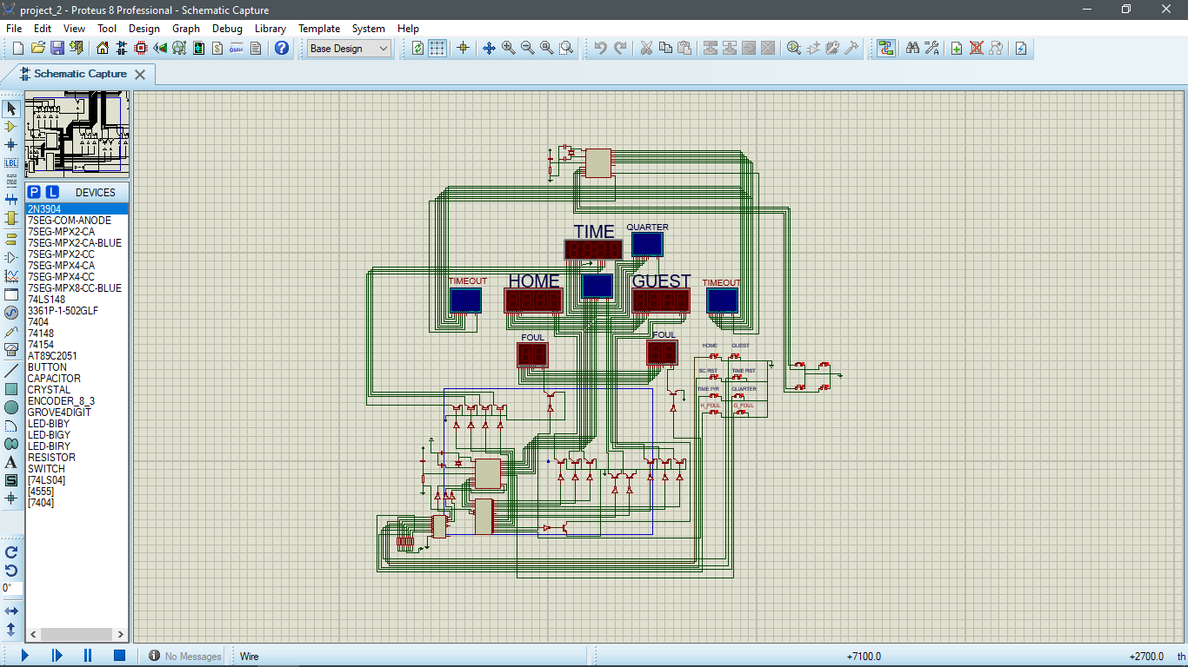Schematic Diagram generated from Proteus 8 Professional

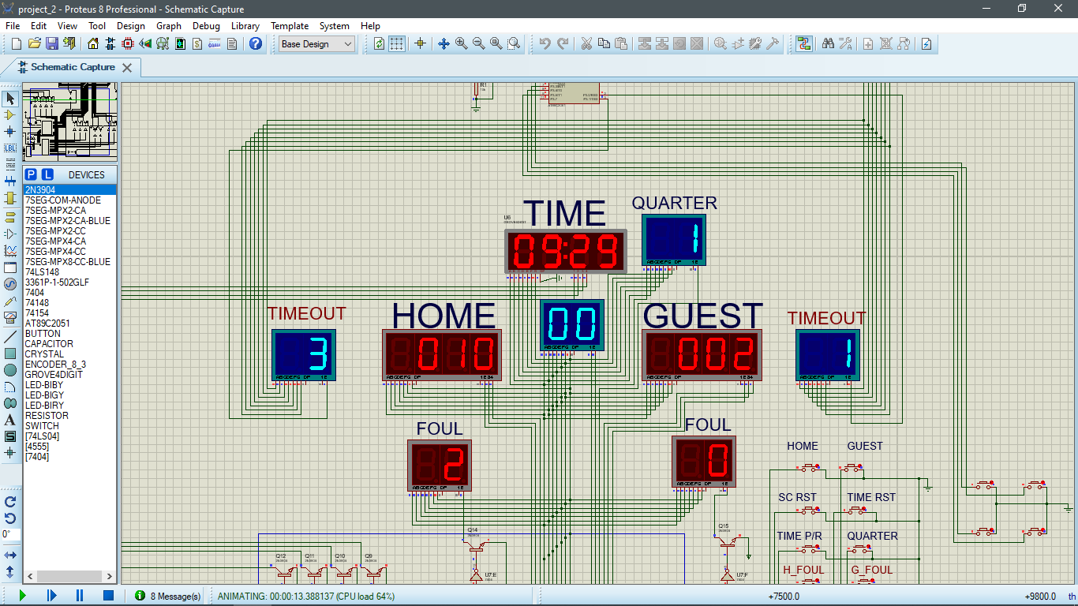

Proteus 8 Basketball scoreboard system simulation

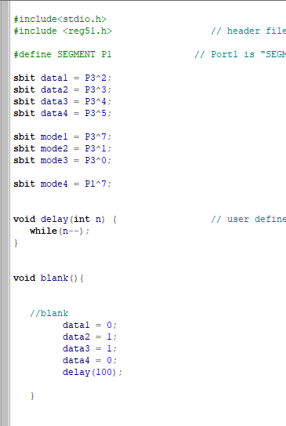 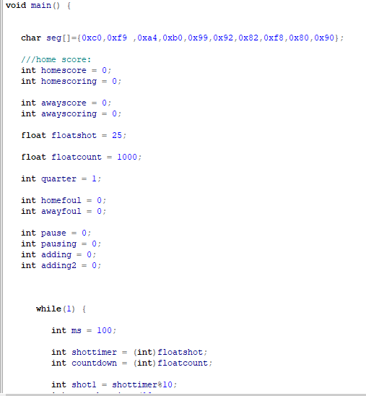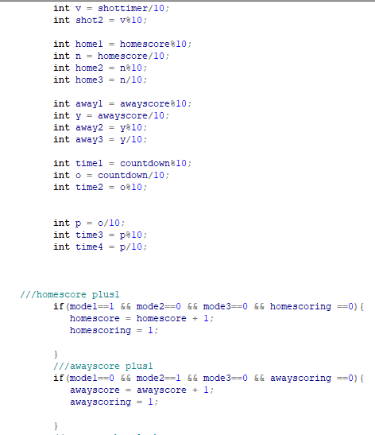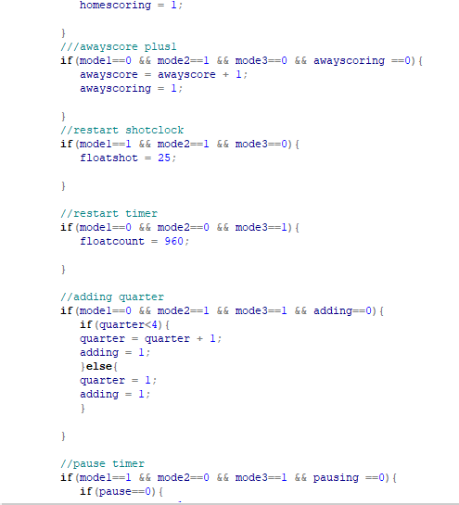

Embedded C Code for the Basketball Scoreboard

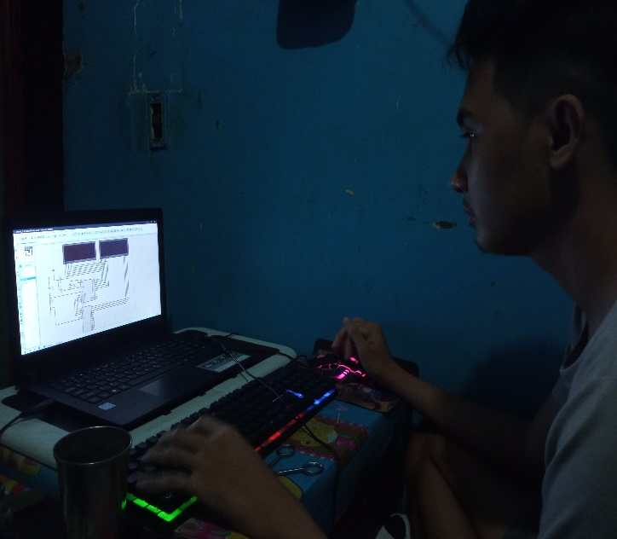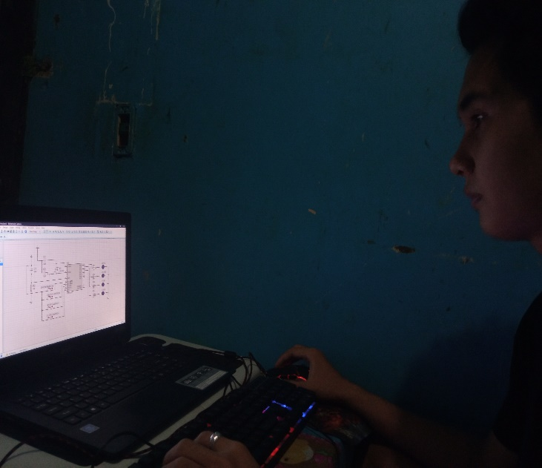

Making the schematic diagram of the circuits on Proteus 8

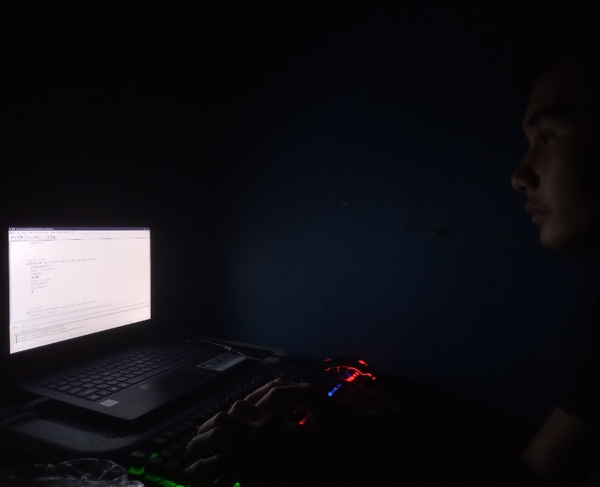

Actual C language programming for the AT89C2051

Using Ride IDE

**ASSESSMENT OF WORK EXPERIENCE**

During my work experience, I was fortunate enough to have experienced and learned, many different sides of what goes into a project, the general process of how a project is initially planned, developed and completed; as well as how much work and detail goes into every stage. Another valuable lesson I have learned during these 240 hours, were the many different types of work an Engineer has to perform, which in turn, have provided me with more insight into the different types of roles and responsibilities that I could perform.

Even though I was not able to fully experience the work because of the current pandemic, I was able to learn a lot of lessons and manage to work on a project given by our instructor.

Through experience and observation, another valuable lesson that I learned while working was that in projects, especially when working in primary stages of certain project, things can change very quickly and dramatically. Another lesson I learned through this was that if there are any uncertainties, from whether a survey was off by a few millimeters, to if materials chosen for a certain aspect of a project were unsuitable, it always has to be checked numerous times and from senior level sources before any conclusions can be made, especially if they are to be presented to a client.