Linux Router on Debian 10.05 installation

Date: 2020/09/12

Companion guide for: <https://blog.notnot.ninja/2020/08/29/lab-vm/>

## Use either the Graphical install (this guide) or text based Install

Machine generated alternative text:
Debian GNU/Linux 
ions 
instal ler menu 
(BIOS mode) 
accessible instal ler menu 
Install with 

Pick your language

Machine generated alternative text:
debian 
Select a language 
Choose the language to be used for the installation process. The selected language will also be the 
default language for the installed system. 
Language. 
Chinese (Traditional) 
Croatian 
Czech 
Danish 
Dutch 
Dzongkha 
English 
Esperanto 
Estonian 
Finnish 
French 
Galician 
Georgian 
German 
Screenshot 
Hrvatski 
Ceötina 
Dansk 
Nederlands 
English 
Esperanto 
Eesti 
Suomi 
Francais 
Galego 
Deutsch 
Go Back 
Continue 

Pick your country

Machine generated alternative text:
debian 
Select your location 
The selected location will be used to set your time zone and also for example to help select the system 
locale. Normally this should be the country where you live. 
This is a shortlist of locations based on the language you selected. Choose "other" if your location is not 
listed. 
Country, terntory or area 
Ireland 
Israel 
New Zealand 
Nigeria 
Philippines 
Seychelles 
Singapore 
South Africa 
United Kingdom 
United States 
Zambia 
Zimbabwe 
other 
Screenshot 
Go Back 
Continue 

Machine generated alternative text:
Configure the keyboard 
Keymap to use 
American English 
Albanian 
Arabic 
Asturian 
Bangladesh 
Belarusian 
Bengali 
Belgian 
Bosnian 
Brazilian 
British English 
Bulgarian (BDS layout) 
Bulgarian (phonetic layout) 
Burmese 
Canadian French 
Canadian Multilingual 
Screenshot 
debian 
Go Back 
Continue 

Machine generated alternative text:
debian 
Load installer components from CD 
Loading ad.. 
itional components 
Retrieving partmanifs 

It is only required to configure eth0 (Home/Office network), the installer will first try to set the IP settings for this network device by using DHCP. We will later change the IP address to a static 192.168.1.10

Machine generated alternative text:
debian 
Configure the network 
Your system has multiple network interfaces. Choose the one to use as the primary network interface 
during the installation. If possible, the first connected network interface found has been selected. 
Pnmary network Interface. 
ethO: Ethernet 
ethl: Ethernet 
Screenshot 
Go Back 
Continue 

Machine generated alternative text:
debian 
Configure the network 
Please enter the hostname for this system. 
The hostname is a single word that identifies your system to the network. If you don't know what your 
hostname should be, consult your network administrator. If you are setting up your own home network, 
you can make something up here. 
Hostname 
routed 
Screenshot 
Go Back 
Continue 

Machine generated alternative text:
debian 
Configure the network 
The domain name is the part of your Internet address to the right of your host name. It is often 
something that ends in .com, .net, .edu, or .org. If you are setting up a home network, you can make 
something up, but make sure you use the same domain name on all your computers. 
Domain name. 
Screenshot 
Go Back 
Continue 

Machine generated alternative text:
debian 
Set up users and passwords 
You need to set a password for 'root', the system administrative account. A malicious or unqualified user 
with root access can have disastrous results, so you should take care to choose a root password that is 
not easy to guess. It should not be a word found in dictionaries, or a word that could be easily 
associated with you. 
A good password will contain a mixture of letters, numbers and punctuation and should be changed at 
regular intervals. 
The root user should not have an empty password. If you leave this empty, the root account will be 
disabled and the system's initial user account will be given the power to become root using the "sudo 
command. 
Note that you will not be able to see the password as you type it. 
Root password. 
Show Password in Clear 
Please enter the same root password again to verify that you have typed it correctly. 
Reenter password to venfy 
Show Password in Clear 
Screenshot 
Go Back 
Continue 

Machine generated alternative text:
debian 
Set up users and passwords 
A user account will be created for you to use instead of the root account for non-administrative activities. 
Please enter the real name of this user. This information will be used for instance as default origin for 
emails sent by this user as well as any program which displays or uses the user's real name. Your full 
name is a reasonable choice. 
Fu// name for the new user. 
philipf 
Screenshot 
Go Back 
Continue 

Machine generated alternative text:
debian 
Set up users and passwords 
Select a username for the new account. Your first name is a reasonable choice. The username should 
start with a lower-case letter, which can be followed by any combination of numbers and more lower- 
case letters. 
username for your account. 
Screenshot 
Go Back 
Continue 

Machine generated alternative text:
debian 
Set up users and passwords 
A good password will contain a mixture of letters, numbers and punctuation and should be changed at 
regular intervals. 
Choose a password for the new user. 
Show Password in Clear 
Please enter the same user password again to verify you have typed it correctly. 
Reenter password to venfy 
Show Password in Clear 
Screenshot 
Go Back 
Continue 

Machine generated alternative text:
debian 
Configure the clock 
If the desired time zone is not listed, then please go back to the step "Choose language" and select a 
country that uses the desired time zone (the country where you live or are located). 
Select a location in your time zone. 
Auckland 
Chatham Islands 
Screenshot 
Go Back 
Continue 

Unfortunately because of the small disk size we cannot use the Guided mode. If manual partition is causing issues for you increase the VMs disk size.

Machine generated alternative text:
debian 
Partition disks 
The installer can guide you through partitioning a disk (using different standard schemes) or, if you 
prefer, you can do it manually. With guided partitioning you will still have a chance later to review and 
customise the results. 
If you choose guided partitioning for an entire disk, you will next be asked which disk should be used. 
Partitioning method 
Guided 
Guided 
Guided 
Manual 
- use entire disk 
- use entire disk and set up LVM 
- use entire disk and set up encrypted LVM 
Screenshot 
Go Back 
Continue 

Machine generated alternative text:
debian 
Partition disks 
This IS an ovemew of your currently configured partitions and mount points. Select a partition to modfy its settings 
(file system, mount point, etc.), a free space to create partitions, or a device to Initialize its partition table. 
Guided partitioning 
Configure iSCSI volumes 
SCS12 (sda) 1.1 GB Msn Virtual Disk 
Undo changes to partitions 
Finish partitioning and write changes to disk 
Screenshot 
Help 
Go Back 
Continue 

Machine generated alternative text:
debian 
Partition disks 
You have selected an entire device to partition. If you proceed with creating a new partition table on the 
device, then all current partitions will be removed. 
Note that you will be able to undo this operation later ifyou wish. 
Create new empty partition table on this device? 
O 
Screenshot 
Go Back 
Continue 

Machine generated alternative text:
debian 
Partition disks 
This IS an ovemew of your currently configured partitions and mount points. Select a partition to modfy its settings 
(file system, mount point, etc.), a free space to create partitions, or a device to Initialize its partition table. 
Guided partitioning 
Configure software RAID 
Configure the Logical Volume Manager 
Configure encrypted volumes 
Configure iSCSI volumes 
SCS12 (sda) 1.1 GB Msn Virtual Disk 
pri/log 
1.1 
Undo changes to partitions 
FREE SPACE 
Finish partitioning and write changes to disk 
Screenshot 
Help 
Go Back 
Continue 

Machine generated alternative text:
debian 
Partition disks 
How to use this free space. 
Create a new partition 
Automatically partition the free space 
Show Cylinder/Head/Sector information 
Screenshot 
Help 
Go Back 
Continue 

Machine generated alternative text:
debian 
Partition disks 
The maximum size for this partition is 1.1 GB. 
Hint: "max" can be used as a shortcut to specify the maximum size, or enter a percentage (e.g. 
use that percentage of the maximum size. 
New partition size 
IGB 
Screenshot 
Go Back 
20%') to 
Continue 

Machine generated alternative text:
Partition disks 
Type for the new partition 
Primary 
Logical 
Screenshot 
debian 
Go Back 
Continue 

Machine generated alternative text:
debian 
Partition disks 
Please choose whether you want the new partition to be created at the beginning or at the end of the 
available space. 
Location for the new partition 
Beginning 
End 
Screenshot 
Go Back 
Continue 

Machine generated alternative text:
debian 
Partition disks 
You are editing partition #1 of SCS12 (0,0,0) (sda). No existing file system was detected in this partition. 
Partition settings 
Use as: 
Mount point: 
Mount options: 
Label: 
Reserved blocks: 
Typical usage: 
Bootable flag: 
Ext4 journaling file system 
defaults 
none 
standard 
Delete the partition 
Done setting up the partition 
Screenshot 
Help 
Go Back 
Continue 

Machine generated alternative text:
debian 
Partition disks 
You are editing partition #1 of SCS12 (0,0,0) (sda). No existing file system was detected in this partition. 
Partition settings 
Use as: 
Mount point: 
Mount options: 
Label: 
Reserved blocks: 
Typical usage: 
Bootable flag: 
Ext4 journaling file system 
defaults 
none 
standard 
Delete the partition 
Done setting up the partition 
Screenshot 
Help 
Go Back 
Continue 

Machine generated alternative text:
debian 
Partition disks 
This IS an ovemew of your currently configured partitions and mount points. Select a partition to modfy its settings 
(file system, mount point, etc.), a free space to create partitions, or a device to Initialize its partition table. 
Guided partitioning 
Configure software RAID 
Configure the Logical Volume Manager 
Configure encrypted volumes 
Configure iSCSI volumes 
SCS12 (sda) 1.1 GB Msn Virtual Disk 
#1 primary 
pri/log 
999.3 MB B f ext4 
73.4 MB 
FREE SPACE 
Undo changes to partitions 
Finish partitioning and write changes to disk 
Screenshot 
Help 
Go Back 
Continue 

Machine generated alternative text:
debian 
Partition disks 
How to use this free space. 
Create a new partition 
Automatically partition the free space 
Show Cylinder/Head/Sector information 
Screenshot 
Help 
Go Back 
Continue 

Machine generated alternative text:
debian 
Partition disks 
The maximum size for this partition is 73.4 MB. 
Hint: "max" can be used as a shortcut to specify the maximum size, or enter a percentage (e.g. 
use that percentage of the maximum size. 
New partition size 
73.4 MB 
Screenshot 
Go Back 
20%') to 
Continue 

Machine generated alternative text:
Partition disks 
Type for the new partition 
Primary 
Logical 
Screenshot 
debian 
Go Back 
Continue 

Machine generated alternative text:
debian 
Partition disks 
You are editing partition #5 of SCS12 (0,0,0) (sda). No existing file system was detected in this partition. 
Partition settings 
Use as: 
Bootable flag: 
swap area 
off 
Delete the partition 
Done setting up the partition 
Screenshot 
Help 
Go Back 
Continue 

Machine generated alternative text:
debian 
Partition disks 
This IS an ovemew of your currently configured partitions and mount points. Select a partition to modfy its settings 
(file system, mount point, etc.), a free space to create partitions, or a device to Initialize its partition table. 
Guided partitioning 
Configure software RAID 
Configure the Logical Volume Manager 
Configure encrypted volumes 
Configure iSCSI volumes 
SCS12 (sda) 1.1 GB Msn Virtual 
Disk 
#1 primary 
#5 logical 
999.3 MB B 
71.3 MB 
ext 4 
swap 
swap 
Undo changes to partitions 
Finish partitioning and write changes to disk 
Screenshot 
Help 
Go Back 
Continue 

Machine generated alternative text:
debian 
Partition disks 
If you continue, the changes listed below will be written to the disks. Otherwise, you will be able to make 
further changes manually. 
The partition tables of the following devices are changed: 
SCS12 (sda) 
The following partitions are going to be formatted: 
partition #1 of SCS12 (0,0,0) (sda) as ext4 
partition #5 of SCS12 (0,0,0) (sda) as swap 
Wnte the changes to disks? 
O 
Screenshot 
Continue 

Machine generated alternative text:
debian 
Install the base system 
Installing the base system 
Extracting uti/-/lnux 

Machine generated alternative text:
debian 
Configure the package manager 
Your installation CD or DVD has been scanned; its label is: 
Debian GNU/Linux 10.5.O Buster - official amd64 NETINST 20200801-11:34 
You now have the option to scan additional CDs or DVDs for use by the package manager (apt). Normally 
these should be from the same set as the installation CD/DVD. If you do not have any additional CDs or 
DVDs available, this step can just be skipped. 
If you wish to scan another CD or DVD, please insert it now. 
Scan another CD or DVD? 
O 
Screenshot 
Go Back 
Continue 

Machine generated alternative text:
debian 
Configure the package manager 
The goal is to find a mirror of the Debian archive that is close to you on the network be aware that 
nearby countries, or even your own, may not be the best choice. 
Deben archwe mrror country 
Lithuania 
Luxembourg 
Macedonia, Republic of 
Mexico 
Moldova 
Netherlands 
New Caledonia 
New Zealand 
Norway 
Philippines 
Poland 
Portugal 
Romania 
Russian Federation 
Réunion 
Screenshot 
Go Back 
Continue 

Machine generated alternative text:
debian 
Configure the package manager 
Please select a Debian archive mirror. You should use a mirror in your country or region if you do not 
know which mirror has the best Internet connection to you. 
Usually, deb.debian.org is a good choice. 
Deben archwe mrror. 
ftp.nz.debian.org 
ftp.citylink.co.nz 
mirror.fsmg.org.nz 
deb.debian.org 
debian-archive.trafficmanager.net 
Screenshot 
Go Back 
Continue 

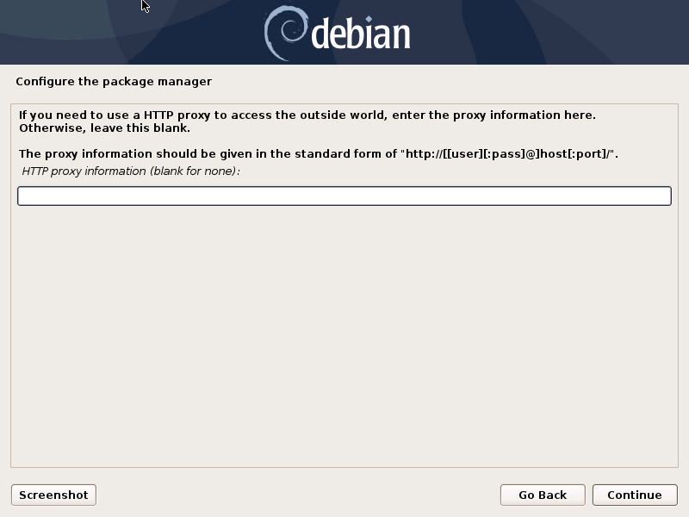

Machine generated alternative text:
Configure the package manager 
Retrieving file 4 of 5 
debian 
Configuring apt 
Cancel 

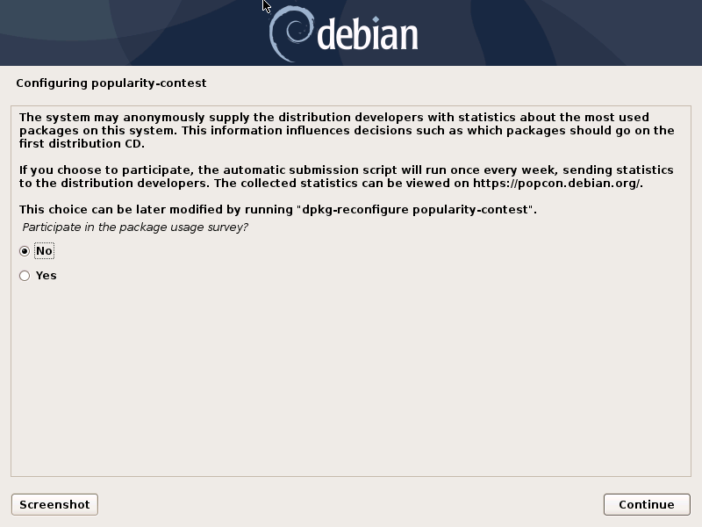

The **standard system utilities are not required**

Machine generated alternative text:
debian 
Software selection 
At the moment, only the core of the system is installed. To tune the system to your needs, you can 
choose to install one or more of the following predefined collections of software. 
Choose software to Install. 
Debian desktop environment 
. GNOME 
Xfce 
KDE Plasma 
Cinnamon 
. MATE 
LXDE 
LXQt 
web server 
print server 
SSH server 
standard system utilities 
Screenshot 
Continue 

Machine generated alternative text:
debian 
Install the GRUB boot loader on a hard disk 
It seems that this new installation is the only operating system on this computer. If so, it should be safe 
to install the GRUB boot loader to the master boot record of your first hard drive. 
Warning: If the installer failed to detect another operating system that is present on your computer, 
modifying the master boot record will make that operating system temporarily unbootable, though GRUB 
can be manually configured later to boot it. 
Install the GRUB boot loader to the master boot record? 
O 
Screenshot 
Go Back 
Continue 

Machine generated alternative text:
debian 
Install the GRUB boot loader on a hard disk 
You need to make the newly installed system bootable, by installing the GRUB boot loader on a bootable 
device. The usual way to do this is to install GRUB on the master boot record of your first hard drive. If 
you prefer, you can install GRUB elsewhere on the drive, or to another drive, or even to a floppy. 
Device for boot loader Installation 
Enter device manually 
/dev/sda (scsi-3600224809830e666c45a4f0cee3f4cfa) 
Screenshot 
Go Back 
Continue 

Machine generated alternative text:
debian 
Finish the installation 
Installation complete 
Installation is complete, so it is time to boot into your new system. Make sure to remove the 
installation media, so that you boot into the new system rather than restarting the installation. 
Screenshot 
Go Back 
Continue 

Machine generated alternative text:
GNU GRUB 
*Debian GNU/l_inux 
version 2.02+dfsg1-20+deb10u2 
Advanced options for Debian GNU/l_inux 
use the T and I kegs to 
Press enter to boot the 
for a command-line. 
The highlighted entru Lui Il 
select which entru is highlighted. 
el to edit the commands before booting or 
selected OS, 
be executed automatically in as. 

Machine generated alternative text:
Debian GNU/l_inux 10 router ttgl 
router login: 

EOF