Minesweeper Heatmap

Philip Heimboeck 500702328  
Florian Mathis 500702331

We decided to use a Minesweeper Port for JavaScript which is available for free and as Open Source (<http://minesweeper.me>). This offers us the possibility to easily send the received Data of the Game via JavaScript to the NoSQL database. We used a JQuery Plugin to handle the requests and posts to the database and also heatmap.js (<http://www.patrick-wied.at/static/heatmapjs/>) for plotting the Heatmaps.

# Installation / Problems

In order to run the minesweeper application you need to add the following snippet to your CouchDB settings file local.ini. There is a problem based on the Same Origin Policy: you cannot access CouchDB from a different host or domain. These configurations allow access from other origins.

The application is configured to run on a local CouchDB server on port 5984 and database minesweeper. Please see file COUCH SETTINGS.txt for more information.

[httpd]

enable_cors = true

[cors]

origins = *

# What data you store and why

We store each Game in the database everytime a game was won or lost by the player. A game consits of a flag of either won or lost, the last position (x/y) the user clicked, the GameFormat which is either Beginner, Intermediate or Experts and differs in the size of the game field and the amount of bombs.

For each game we also save each position (x/y) as the fields array. A field array item is the position X and Y in the game field and a value consisting of several flags that can be set during the game, described below:

**isBomb**: Is this cell a bomb or a normal field?  
**isExposed**: is this cell yet closed or already open?  
**isFlagged**: Does this cell has a bomb flag on it?  
**isQuestion**: Is this cell a question mark?  
**neighborBoms**: Amount of bombs in neighborhood

# What JSON format you use

{

width: numberOfColumns,

height: numberOfRows,

won: bool,

lastClick: [X, Y],

gameFormat: “format”,

fields: [

{

x: columnNumber,

y: rowNumber,

value: {

isBomb: bool,

isExposed: bool,

isFlagged: bool,

isQuestion: bool,

isMarked: bool,

neighborBombs: int

}

}, …

]

}

# Which NoSQL database you use and why

We decided to use CouchDB as our NoSQL database since we wanted to receive data via HTTP requests which is not that easy in, for example, MongoDB which is using a custom protocol. Please see couchdb.zip for the CouchDB database dump and views.

# What MapReduce function you use and to what end

In order to run the application you need to add the views described in the file MapFunctions.txt to your minesweeper database.

## Heatmap Data

The result of this function is the sum of bombs per game field resp. position (x/y) for each game mode (GameFormat). This View is then available in our Heatmap code.

// MAP

function(doc) {

if ( doc.gameFormat == "Beginner") {

//if ( doc.gameFormat == "Intermediate") {

//if ( doc.gameFormat == "Expert") {

for ( var i = 0; i < doc.fields.length; i++ ) {

if ( doc.fields[i].value.isBomb == true ) {

emit([doc.fields[i].x, doc.fields[i].y], 1);

}

}

}

}

// REDUCE

function (key, values, rereduce) {

return **sum**(values);

}

## Number of Games played

This MapReduce function gives us the number of games that are played for each game mode. It is used as a indicator for the Heatmap in order to interpret it.

// MAP

function(doc) {

emit(doc.gameFormat, 1);

}

// REDUCE

function (key, values, rereduce) {

return sum(values);

}

The heatmap(s) you produced including your conclusions about the gameplay based on these heatmaps

As you can see in the following three heatmaps, the bombs are rather evenly distributed but there are some HotSpots. This could also be effected due to the fact the we only played 100 game iterations per mode and the number of data is not enough to prove a bad distribution of bombs.

We asume that you can not cheat the game using a heatmap.

## Beginner Mode

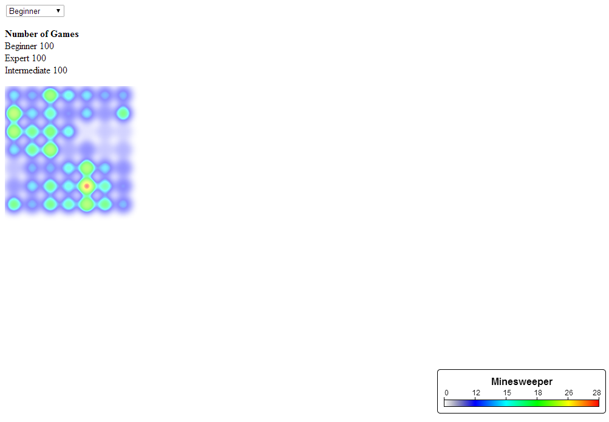

# Intermediate Mode

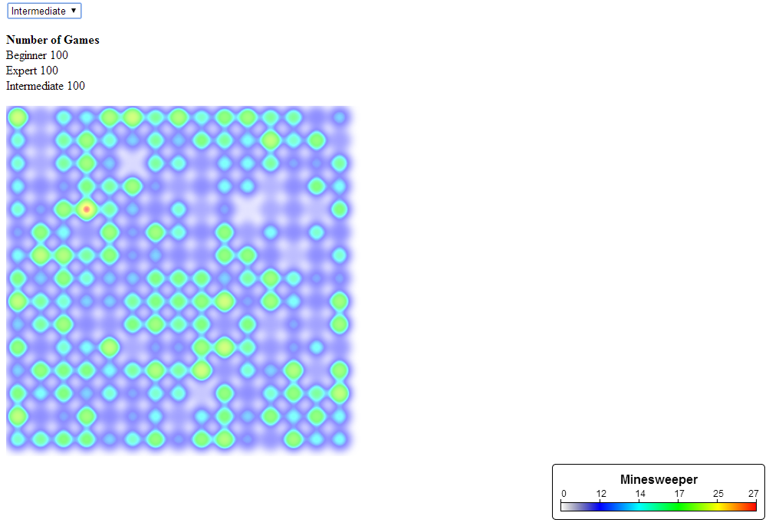

## Expert Mode

