MBIBI PHILIP ONYEBUCHI

B00716472

Question 1

The second text file could be like this:

A B 1

X B 3

A M 1

M X 4

(I don’t have second text file viewing the output like this, and am also making use of three ports)

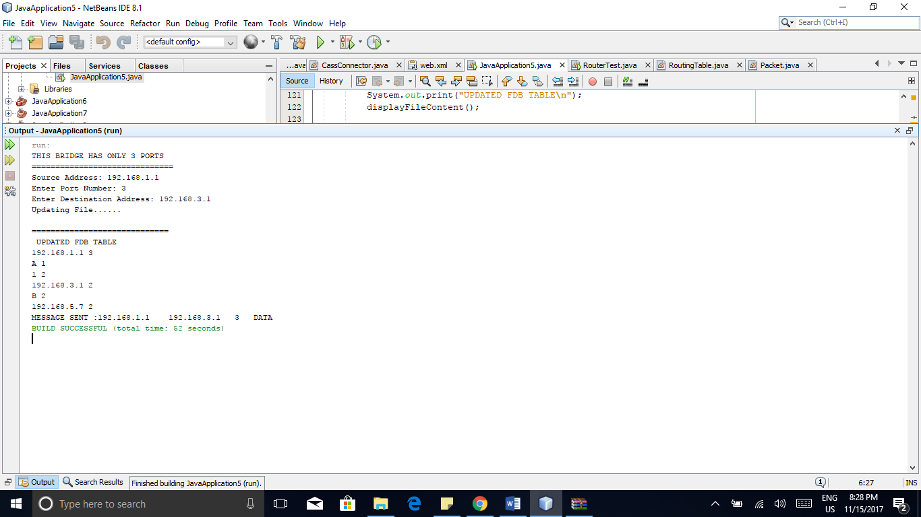

With this I have an update in my text file.

Question 2

