**Philip Mortimer ML**

Task 1

1a + b)

Figure - Validation and training loss of neural network.

I trained a neural network to classify activity type. My model achieves a validation accuracy of 84%. The model’s training loss flatlines after about 5 epochs, demonstrating quick convergence. The validation loss follows a similar trend initially. However, the validation loss is much less smooth and only really settles after about 40 epochs. The final validation loss is about 30% larger than the training loss, which indicates that the model is overfitting to the training set slightly. However, given that both training and validation loss follow similar trends and achieve similar loss, I would say the model has trained effectively.

When training the model, I noticed that the neural network will often get stuck at a local minimum of about 60% classification accuracy. Thus, it typically requires multiple training attempts with different weight initialisations to avoid this local optimum and achieve a higher classification accuracy.

On the test dataset, the neural network achieves a loss of 0.319 and an accuracy of 89.9%. This would indicate that the model generalises well as this is marginally higher than both the training and validation classification accuracies.

1c)

There are wide variety of model hyperparameters to tune when training a neural network. I have decided to analyse the learning rate, neural network architecture, activation function and batch size. For each feature, I have selected a small number of values which are commonly used and cover a broad range of options. To compare them, I define a base neural network architecture and then investigate the relative performance as each variable is changed individually. Each model is trained for the same number of epochs to ensure effective comparison. For the number of training epochs, we can see from *Figure 1* that 5 epochs tends to be sufficient for a model to achieve strong classification. To select the best overall parameters, a randomised grid search would be a suitable search strategy.

Figure - Impact of learning rate on ANN performance

*Figure 2* depicts the impact learning rate has on performance. From this graph, we can see that the model fails to learn for learning rates of 1e-5 and 0.1, whilst it converges for a learning rate of 0.001. This suggests that that 1e-3 is a stronger choice of learning rate. Indeed, this is conclusion is widely adopted as this is typically the default learning rate for the ADAM optimiser [1] and is viewed to be a value that yields effective performance [2]. A larger learning rate means that step sizes are larger, leading to faster initial convergence but also typically struggling to converge at the exact optimum point. Conversely, smaller step sizes converge more slowly but more accurately, even if they are more prone to getting stuck at local optima. However, in the case of ADAM, an adaptive learning rate algorithm, these problems are typically less apparent. A graph of a model
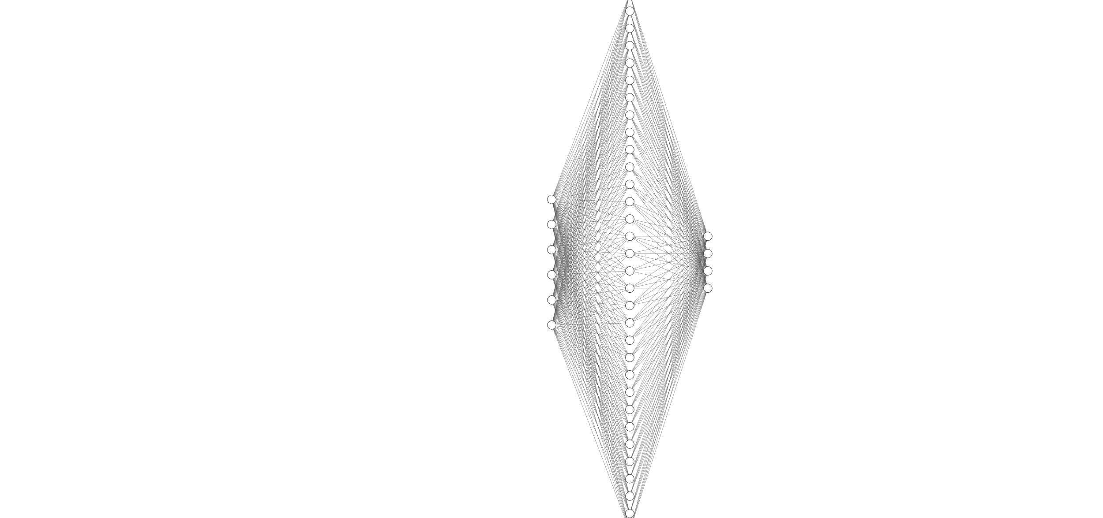

Figure 3 – Impact of model architecture on training performance.

Figure 4 – Neural network architecture with one hidden layer.

In order to assess the impact of the number of hidden layers, I created three networks with differing numbers of hidden layers. Each hidden layer has 32 neurons. It appears that larger networks converge more slowly initially but end up achieving a lower loss. This makes sense as larger networks have more capacity to model complex data relationships. However, they also have more tuneable parameters which means that they will likely learn more slowly. In the case of this instance, the difference in performance between 2 and 3 hidden layers was negligible, suggesting that both have learned the same function. Thus in this case, I would suggest that 2 hidden layers is the optimal configuration. Particularly as larger networks tend to have the capacity to overfit to training data as they can almost memorise specific training examples with their surplus power.

Figure 5 - Impact of activation function on ANN training.

I experimented with three commonly used activation functions for neural networks: ReLu, hyperbolic tangent (tanh) and the sigmoid function. These functions have shown to perform well on a number of tasks. Both the sigmoid and hyperbolic tangent functions perform similarly and better than ReLu. This makes sense as the sigmoid function and tanh are fundamentally similar functions, involving exponential functions, and are commonly used for classification tasks.

Figure 6 - Impact of model optimiser on training.

I experimented with 3 commonly used optimisers for training artificial neural networks: ADAM, stochastic gradient descent (SGD) and RMSprop. Both ADAM and RMSprop are adaptive learning functions where each weights value is altered by a different rate that decays over time. These approaches are considered state-of-the-art and are widely used. Stochastic gradient descent simply updates each weight by its error gradient multiplied by the learning rate. This approach performs noticeably worse than the adaptive optimisers.

Figure 7 - Impact of batch size on training.

It is clear that the model struggles to train when the batch size is too small. Batch sizes of 1 and 2 prove too small for the model to converge, whilst batch sizes greater than 16 do appear to work. This is likely because smaller batch sizes make the overall step direction too inaccurate.

Whilst the hyperparameters are interdependent (e.g., the optimal activation function may differ depending on the network architecture), it is clear that some parameters are more important than others. For instance, for this task, the network architecture seems to yield similar results regardless of size. However, using an adaptive optimiser and using either the sigmoid function or tanh as an activation function do seem to impact network performance significantly.

References

[1] <https://keras.io/api/optimizers/adam/>

[2] <https://arxiv.org/pdf/1412.6980.pdf>