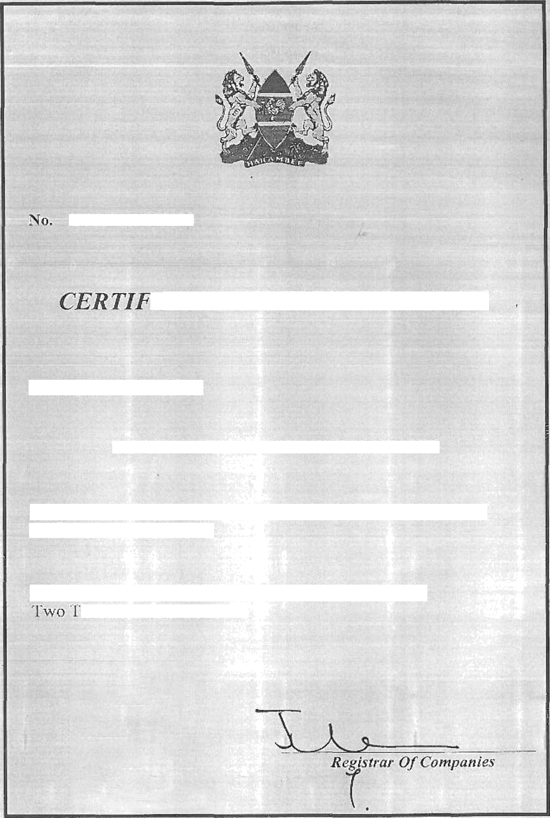

CPR/2014/153330

*"ICT TO OF INCORPORATION*

*I herehy E"ER I“IFY, that -*

VENISON BUILDERS COM PANY LIMITEEi

is this day Incurpotated under thc Companies Act (Cap. 486) and that

the COmFany is LIMITED.

GIVEN undet tny hand at Nairobi this 2s th day of July

housand and Pourieen