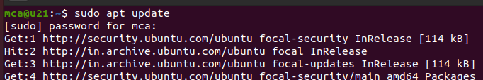

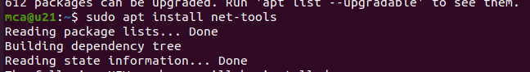

ifconfig

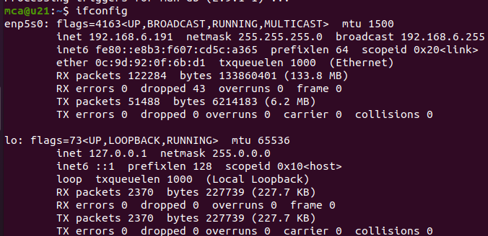



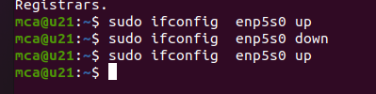

Ping command: command which is used to identify the connectivity between the host and the server

Used to detect the devices on the network and for trouble shooting problems

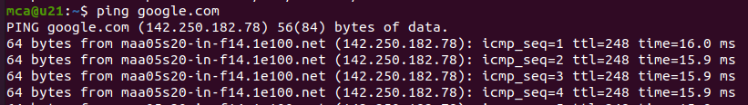

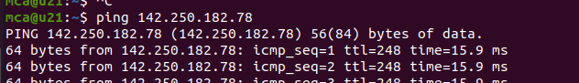

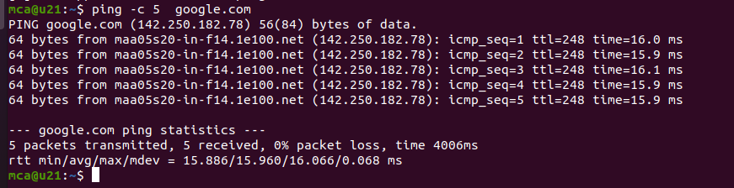

Traceroute : Used to identify the roots taken by the packets to reach the destination

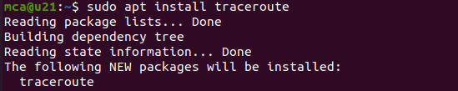

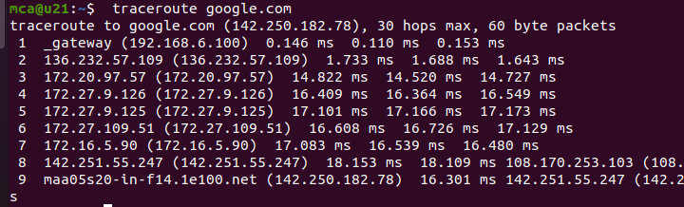

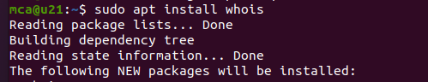

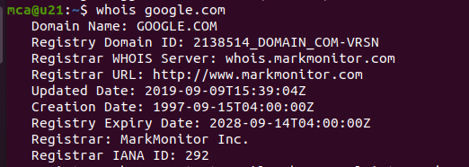

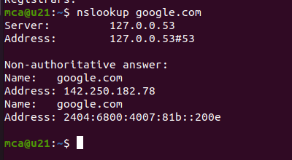

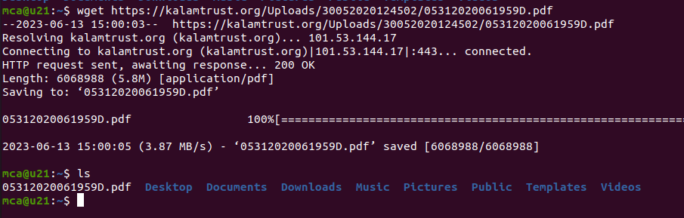

Sudo tcpdump

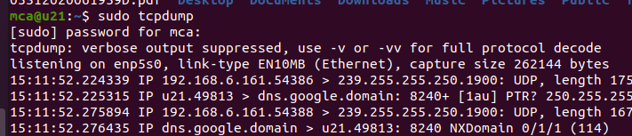

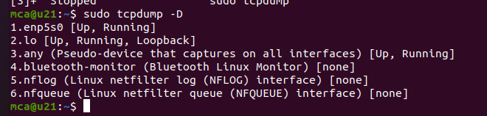

To capture packets from one interface

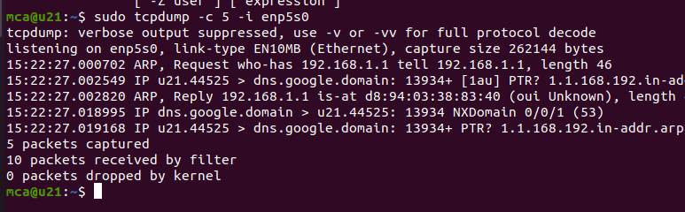

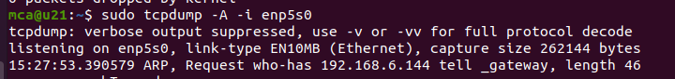

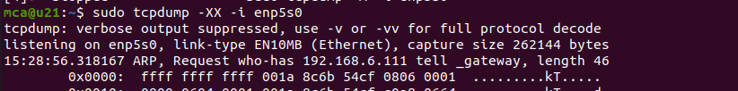

sudo tcpdump -w ab.txt -i enp5s0

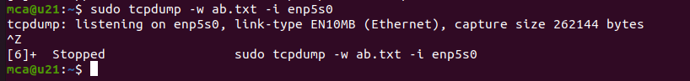

**Wireshark**

Wireshark is an open-source packet analyzer, which is used for education, analysis, software development, communication protocol development, and network troubleshooting.





