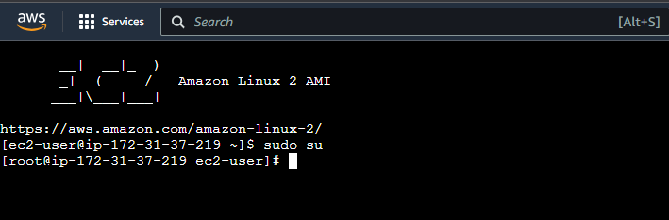

sudo yum install docker -y:

Installs Docker by using the yum package manager with the -y flag to automatically answer "yes" to any prompts or confirmations during the installation process.

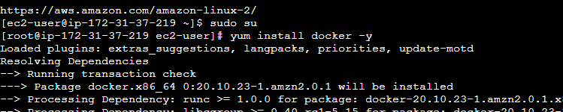

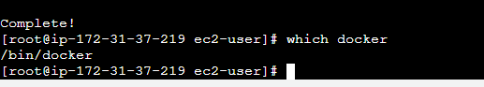

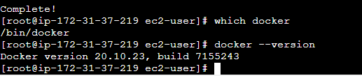

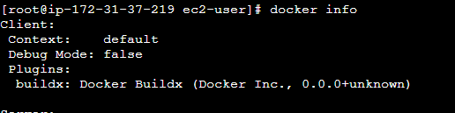

status

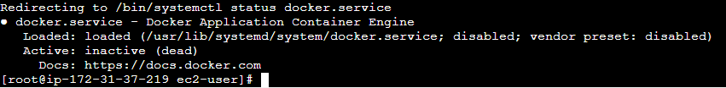

**service docker start:**service docker start," it is used to start the Docker service on a Linux system.

**service docker status**:The command "service docker status" is typically used to check the status of the Docker service on a Linux system

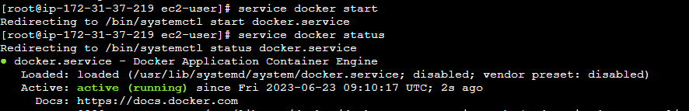

**docker images:**Docker images command used to give detailed descriptions images in the system



**docker ps -a:**docker ps lists the Docker containers that are currently running on our system.



**docker pull ubuntu:**The docker pull command downloads Docker images from the internet

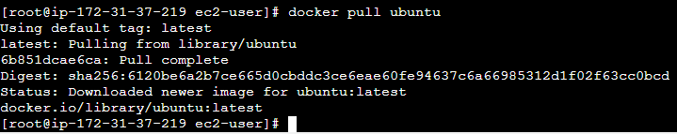

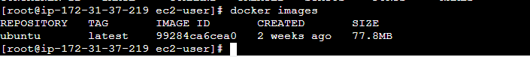

Run container



container

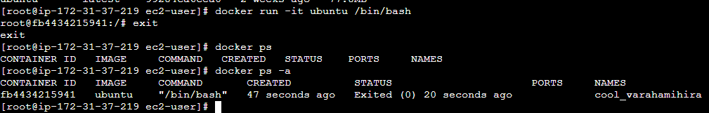

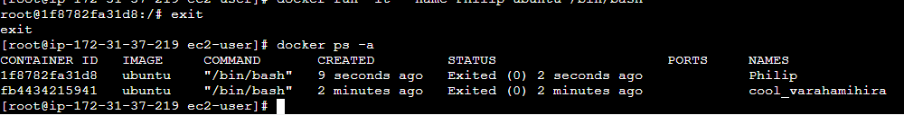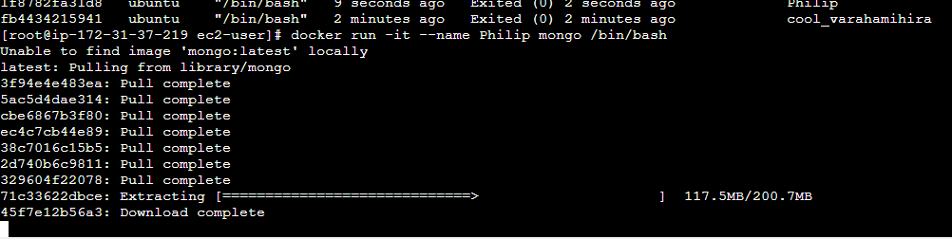

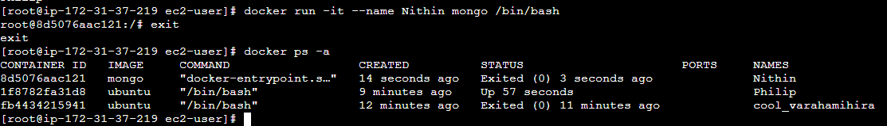

Moving to container

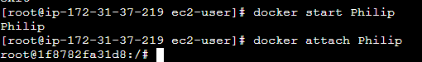

Inside container











