RETROSPECTIVE CORRECTIONS OF PHYSIOLOGICAL SIGNALS: user guide

INTRODUCTION

Physiological signals, cardiac (CARD or ECG) and respiration (RESP), can cause undesired fluctuations in the fMRI signal intensity. Retrospective correction (through the RETROICOR) has been shown to be a gold standard method to reduce both signals on fMRI time series (TS). Retrospective correction is a post processing operation using physiological signal(s) recorded in parallel with an fMRI TS acquisition. This operation is performed in three steps which can be summarized as follows:

- Computation of phases and cycles of a physiological signal at times of acquisition of TS volumes (or time points).

- Computation of a fitting curve, over each TS voxel, function of phases and cycles

- Physiological signal correction.

These 3 operations were implemented in 2 functions:
- PhysioSignal_Plot_PhasesAndCyclesOfSlices2() performing step i
- TimeSerieImagePhysioCorrection1() handling steps ii and iii

Each of both functions can be used alone, but 2 functions were implemented to handle them as main functions:
- PhysioRectroCorrectInTimeSeries2()
- PhysioRectroCorrectInTimeSeries3()

This manual describes the above functions through the computation of steps i to iii.

Although the above functions have been implemented on data acquired on Siemens TRIO and TIM TRIO 3 tesla devices, they can also be adapted to handle data from other devices.

COMPUTATION OF PHASES AND CYCLES OF A PHYSIOLOGICAL SIGNAL

Physiological signals are recorded in files (name.ecg, name.resp and name.puls), along with triggers. They are two types of triggers: synchronization triggers used to signal the start and the end of fMRI acquisitions (or scans), and cyclic triggers delimiting physiological signal periods (heart beats or respiration cycles). Cyclic triggers are used to compute phases and to set cycles of a physiological signal at times of acquisition of TS volumes. Phases and cycles are used in the retrospective correction algorithm.

A good synchronization between the fMRI TS acquisition and a physiological signal recorded in parallel is needed to compute phases and cycles. For this purpose, one should take in account the sequence of events that occur between both measures (Fig.1).

Physio
record
start
Physio
record
end
Scan
start
Scan
end
TS
start
Dummy Time
Scan time
TS acquisition time
Trigger
of time
to start
Time to start
Time at end
Time (sec)
Fig.1: Synchronization between an fMRI TS acquisition and a physiological signal recorded in parallel. The trigger of time to start is a trigger in the physiological signal file announcing how many seconds remain before the fMRI acquisition (scan) starts. The dummy time corresponds to the time of dummy measurements (pre-scan) which are deleted.

As cyclic triggers are important to compute phases, time to start and time at end should be taken long enough to record at least one respiratory cycle (5-6 seconds). This is required to be sure to record at least one respiratory signal trigger before and after the scan. 5-6 seconds are also sufficient to record at least 3 cardiac cycles. This duration is then enough to record at least one trigger at the beginning and one at the end of both physiological signals.
The function that handles the computation of phases and cycles of physiological signals is described below:
=============================================================
FUNCTION HANDLING RECORDED PHYSIOLOGICAL NOISE SIGNAL
=============================================================

PhysioSignal_Plot_PhasesAndCyclesOfSlices2(…)
- Plots unmodified physiological signal(s) and triggers as exported from the scanner.
- Sets recorded triggers at R-waves (ECG or PULS) or computes local maxima & minima (RESP).
- Synchronizes TS acquisition(s) with the physiological signal(s).
- Computes phases and sets cycles of physiological signal(s) at times of acquisition of TS slices.
- Plots synchronized physiological signal(s) along with triggers (ECG or PULS) or with local maxima and minima (RESP). This plot can also be overlapped by a plot of cycles.
- Plots power spectrum (spectra) of synchronized physiological signal(s).

IMPORTANT:
- Can deal with two physiological signals (CARD and RESP, PULS and RESP…) simultaneously.
- Can be used alone to compute and store phases and cycles at times of acquisition of slices in Matlab files for further use.
- Functions SignalAndTimeSerieSynchrone4() are the real engine of this function.

INPUTS: optional inputs are within [brackets]

- PhysioFilename: the physiological signal file name (with path and without extension). Files extensions (.ecg, .resp or .puls are added later in the program)

- Ns: number of slices in each volume of the TS

- Nt: number of volumes (or time points) in the TS

- TR: repetition time or time between 2 volumes in the TS (in second)

- TimePtSpan: when all TS volumes are not used, this parameter sets the span volume interval from START to END, among all TS volumes (ALLTPS). It is a [1x3] array: [START, END, ALLTPS].
The default is: TimePtSpan = [1, Nt, Nt]

Example: if Nt = 1200 and one would like to used volumes between
100 to 1000: TimePtSpan = [100, 1000, 1200]
To use all: TimePtSpan = [ 1, Nt, Nt]

- WhichPhysio: set the physiological signal(s) to be handled:
  - WhichPhysio = 0 => CARD
  - WhichPhysio = 1 => RESP
  - WhichPhysio = 2 => PULS
  - WhichPhysio = 3 => RESP+CARD
  - WhichPhysio = 4 => CARD+RESP
  - WhichPhysio = 5 => RESP+PULS
  - WhichPhysio = 6 => PULS+RESP

- CYCLIC: checks if correction(s) are cyclic or Global, and if RESP phases are computed using a histogram (Histo), like in the RECTROICOR method, or are computed linear:

  - CYCLIC < 0 => 1(or2) signal(s)
1(or2) global correction(s) + RESP Histo

  - CYCLIC == 0 => 1(or2) signal(s)
1(or2) global correction(s) + RESP linear

  - CYCLIC == 1 => 1 signal
1 cyclic correction + RESP linear

  - CYCLIC == 1 => 2 signals
1stcyclic (RESP) & 2ndglobal + RESP linear

  - CYCLIC == 1 => 2 signals
1stglobal & 2ndcyclic (RESP) + RESP linear

  - CYCLIC == 2 => 2 signals
2 cyclic corrections + RESP linear

The default argument of CYCLIC depends on the number of TS
volumes acquired per physiological signal cycle

- [TRIGPRM]: array of 3 elements (or a [2x3] matrix, when 2 signals are required to be corrected) used to set trigger or local extrema parameters:

  - TRIGPRM(1) == 0 =>
- Use triggers recorded during the TS acquisition to compute
new positions of triggers
- NO NEED TO SET TRIGPRM(2)&(3)

  - TRIGPRM(1) >0 =>
- Use a threshold (%) to compute new positions of triggers
- SET TRIGPRM(2) and TRIGPRM(3)
- NO NEED TO SET new positions of triggers

  - TRIGPRM(1) <0 =>
- ONLY FOR THE ECG SIGNAL!!!!
- Uses only triggers recorded during the TS acquisition
- NO NEED TO SET new positions of triggers
- NO NEED TO SET TRIGPRM(2)&(3)

  - TRIGPRM(2)
- It is a THRESHOLD = percentage of amplitude between
the maximum & the mean of the handled physio. signal
- It can be set to: 0% (RESP) & 50-60% (CARD)

  - TRIGPRM(3)
- Time minimum (sec) expected between 2 trigger positions
for the CARD (or ECG) signal
- Need to remove trigger outliers
- NOT USED for RESP!!!!

  - To handle 2 signals, TRIGPRM is a 2x3 matrix

Ex: TRIGPRM = [1, 0, 0.0; → for RESP
1, 50, 0.5] → for CARD
to handle RESP+CARD signals

  - Examples:

- TRIGPRM = [0] => default to handle CARD or RESP
- TRIGPRM = [0; 0] => default to handle CARD & RESP

- TRIGPRM = [0, 0, 0] => 1 signal using recorded triggers

- TRIGPRM = [1, 0, 0] => RESP using threshold

- TRIGPRM = [1, 50, 0.5] => CARD using threshold

- TRIGPRM = [0, 0, 0.0; => RESP using recorded triggers &
1, 50, 0.5] => CARD using threshold

- [Store]: checks if Phases & Cycles must be stored (in a .Mat file). Store have 2 elements when 2 signals are handled, one for each signal:
  - Store > 0 => store Phases & Cycles
  - Store <= 0 => no storage (default)
  - Examples

- Store = [0] => default => do not store anything
- Store = [1] => 1 signal => store its phases & cycles
- Store = [1,1] => 2 signals => store phases & cycles of both
- Store = [0,1] => 2 signals => store phases & cycles of 2nd
- Store = [0,0] => 2 signals => do not store anything
- Store = [1, 0, 0] => RESP using threshold

Phases and Cycles are stored in .mat files in the same directory as physiological signal files. Their file names depend on parameters: WhichPhysio and the CYCLIC. For example, if file names of physiological signals are physioname.ecg, physioname.resp and physioname.puls, then the corresponding phases and cycles file names are as following:

  - If CYCLIC >= 0
    - WhichPhysio=0 => ECG
=> physionamePhasCyclECG.mat
    - WhichPhysio=1 => RESP
=> physionamePhasCyclRESP.mat
    - WhichPhysio=2 => PULS
=> physionamePhasCyclPULS.mat

  - If CYCLIC = -1
    - WhichPhysio=0 => ECG
=> physionamePhasCyclECG.mat
    - WhichPhysio=1 => RESP
=> physionamePhasHistRESP.mat
    - WhichPhysio=2 => PULS
=> physionamePhasCyclPULS.mat

If two signals are handled (WhichPhysio > 2), then two phases and cycles files are then generated according to the above choices.
Also, phases and cycles files contain two matrices PhasesOfSlices and CyclesOfSlices described below in OUTPUTS parameters.

- [Visual]: check if signal(s), power spectra (PS) of signal(s) and cycles must be plotted. It is an array of 2 elements:

  - Visual (1) > 0 => plot signals and PS (default)
Visual (1) <= 0 => do not plot signals and PS

  - Visual (2) > 0 => plot cycles on signal(s)
Visual (2) <= 0 => do not plot cycles (default)

  - Examples

- Visual = [1,0] => plot signals and PS, do not plot cycles
- Visual = [1,1] => plot signals and PS and cycles
- Visual = [0,0] => do not plot anything

- [BandWidth]: sampling frequency of the physiological signal or the inverse of time (in second) between two physiological signal samples. Default values are 1/50 for RESP and 1/400 for CARD.

- [DummyTime]: duration of dummy measurement in seconds
The default value is set to: (3/TR + 1)xTR)

- [CARDchannel]: check which CARD (or ECG) signal to choose when several channels are used during the EGG acquisition.
Several ECG Channels => Several CARD Signals

- [SIGNALyFLIP]: checks if the physiological signal must be Y-flipped. It should be a 2 elements array when dealing with 2 signals:

  - SIGNALyFLIP <= 0 => no Y-Flipped (default)
  - SIGNALyFLIP > 0 => Y-Flipped

OUTPUTS: optional outputs are within [brackets]

- PhasesOfSlices: phases of physiological signal(s) at acquisition times of all TS slices:
  - 1 row -> 1 signal => WHICHPHYSIO < 3
  - 2 rows -> 2 signals => WHICHPHYSIO > 2

- CyclesOfSlices: cycles of physiological signal(s) at acquisition times of all TS slices:
  - 0 row -> no cyclic correction => CYCLIC == 0
  - 1 rows -> 1 cyclic correction => CYCLIC == 1
  - 2 rows -> 2 cyclic corrections => CYCLIC == 2

- [SIGNALS]: optional structure, stores elements of the physiological signal(s):
  - SIGNALS.Sig1 -> array of phys. signal recorded during the TS
  - SIGNALS.Time1 -> array of phys signal time scale during the TS
  - SIGNALS.Trig1 -> array of triggers (or Local Max) during TS
  - SIGNALS.LocMn1-> array of Local Min (RESP only) during TS

If two physiological signals: same as the first signal
  - SIGNALS.Sig2
  - SIGNALS.Time2
  - SIGNALS.Trig2
  - SIGNALS.LocMn2
=============================================================

The function above was designed to be used with 13 input and 3 output arguments as follows:

[PhasesOfSlices, CyclesOfSlices, SIGNALS] = PhysioSignal_Plot_PhasesAndCyclesOfSlices2(PhysioFilename, TR, Ns, TimePtSpan, WhichPhysio, CYCLIC, TRIGPRM, Store, Visual, BandWidth, DummyTime, CARDchannel, SIGNALyFLIP)

This function can also be used without its optional arguments in bold (or in brackets in the description of the function). In this case, optional input arguments are then automatically set to their default values. Further explanations are needed for the trigger TRIGPRM and the CYCLIC parameters. TRIGPRM is important in the delimitation of cardiac cycles, especially when the cardiac signal and its triggers are not properly recorded. TRIGPRM is rarely used for the respiratory signal, where it is often set to its optional value. The CYCLIC parameter determines the type of correction (global or cyclic) and the computation of RESP phase (histogram or linear), as we shall see later.

→ Cyclic triggers recorded from the scanner are often not set on ECG R-waves which clearly delimitate cardiac cycles (fig.2.A). The above function can set recorded triggers on ECG R-waves when R-waves are clearly differentiable and one trigger is found around each R-wave (fig.2.B). In this case TRIGPRM can simply be set to its default values ([0 0 0] for 1 signal, or [0 0 0; 0 0 0] for two signals). Sometimes, the first condition above can be met, but with a lack of triggers around R-waves (fig.2.C). In this case the function will compute triggers on top of R-waves (ECG) or RESP peaks using a threshold calculated as a percentage of the difference SignalMax – SignalMean (fig.2.D). This threshold is set as the second element of TRIGPRM. On ECG, the threshold should be taken higher enough to be over secondary cardiac waves, and low enough to be under the peaks of all R-waves. Most of the time, 50% is enough to resolve all RESP triggers. But cases exist in ECGs where one can not differentiate R-waves from other cardiac waves (fig.3). In this case, phases are computed from recorded triggers with no guarantee of good results. For the respiratory signal, the function is simply stopped with an error message. Clearly, the quality of the physiological signal should be as good as possible and the time to start and the time at end respected so that PhysioSignal_Plot_PhasesAndCyclesOfSlices2() works correctly.

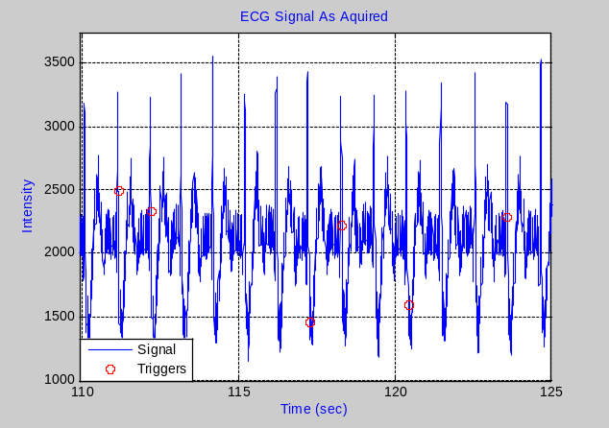
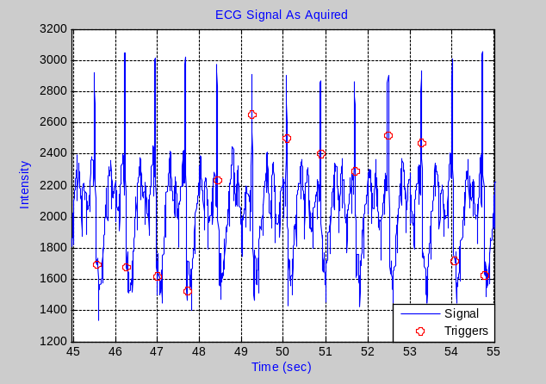
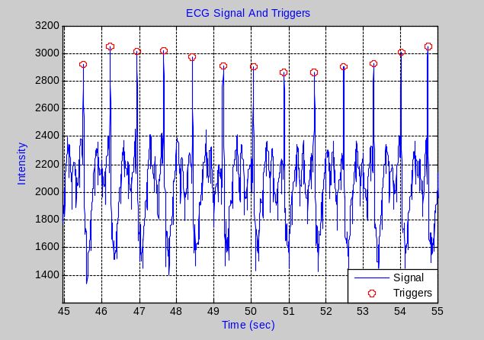
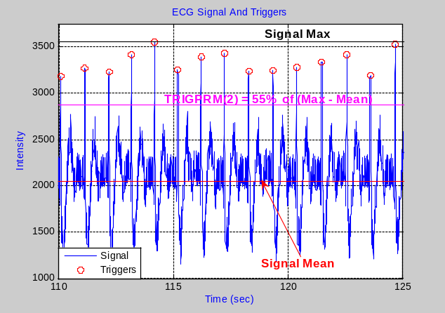
Figure 2. ECG plot with recorded triggers spread around cardiac R-waves (A). In order to accurately delimitate cardiac cycles, setting the trigger parameter TRIGPRM(1) = 0 allows PhysioSignal_Plot_PhasesAndCyclesOfSlices2 to move recorded triggers on top of R-waves (B). ECG recorded with a lack of triggers (C). Plot in D represents the ECG in C with triggers computed using a threshold percentage set in TRIGPRM(2) = %, while TRIGPRM(1) > 0.
C
A
B
D

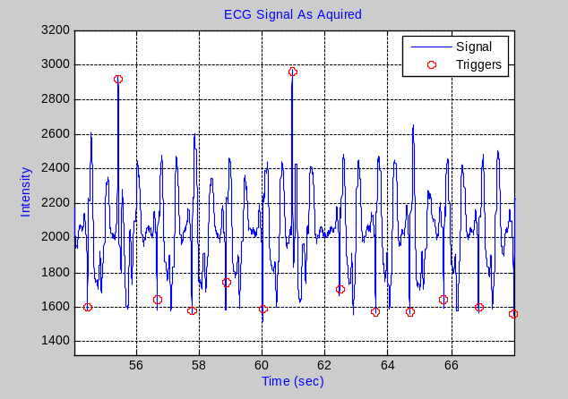
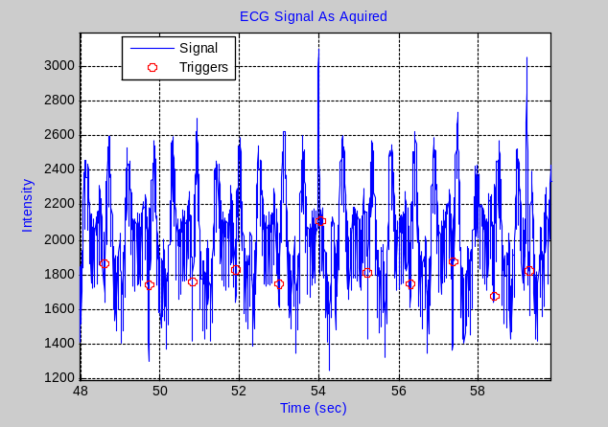
Figure 3. Two ECG plots and their recorded triggers. Cardiac R-waves here are not differentiable from other cardiac waves, which avoids setting triggers at their tops. In this case, cardiac phases can be computed using only using recorded triggers with unpredictable consequences in case of a lack of triggers.
A
B

→ CYCLIC is an optional argument checking if a physiological signal correction is cyclic or not (global) and if RESP signal phases are computed using a histogram or a new linear phase technique. The original retrospective correction (RECTROICOR) of a physiological signal initiated by G. Glover [1] was only global and was computed using a respiratory phases based on a histogram.
In the computation of the histogram based respiratory phase, intensities of the RESP signal are normalized between RESP signal maximum (global max) and minimum (global min). A histogram of 100 bins (fig.4) is built on normalized values (0 to Rmax), and is used to derive a RESP phase equation as follows:

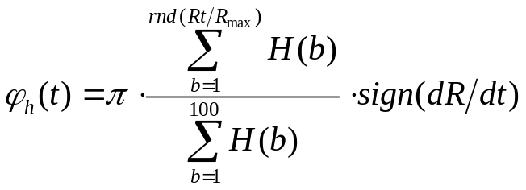

(1)

Where:
      - Rmax= global max - global min
      - Rt = intensity of the RESP signal at time t normalized between 0 and Rmax
      - rnd(x) = rounding function
      - H = histogram, divided into 100 bins
      - H(b) = histogram value of the b^{th} bin
      - sign(dR/dt) is positive while inhaling and negative otherwise

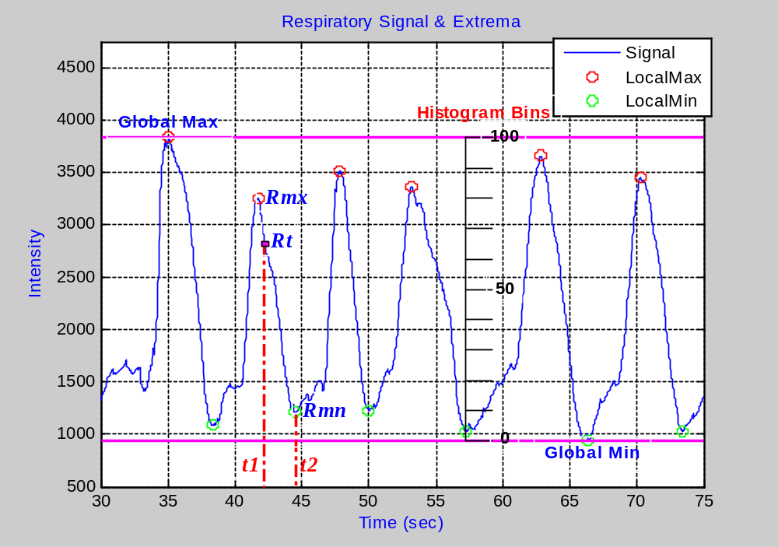
Figure 4. Plot of a piece a RESP signal with elements used in the computation of RESP phases.

In PhysioSignal_Plot_PhasesAndCyclesOfSlices2(), respiratory linear phases are computed based on the linear relationship between time and amplitude of respiration cycles (Eq.2 & fig.4) was newly introduced as:

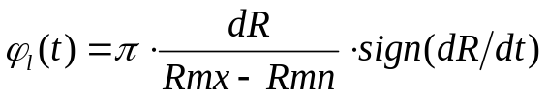
(2)

Where:
      - Rmx & Rmn = local max and min bordering Rt
      - dR = Rt – Rmn
      - dt = t2 – t
      - t2 = time at Rmn

There is only one way to compute cardiac phases. Therefore, the computation of cardiac phases doesn’t change with the type of correction. For cardiac, the CYCLIC parameter is then:

      - CYCLIC ≤ 0 => global correction
      - CYCLIC > 0 => cyclic correction

Explanations of global and cyclic corrections are now given:

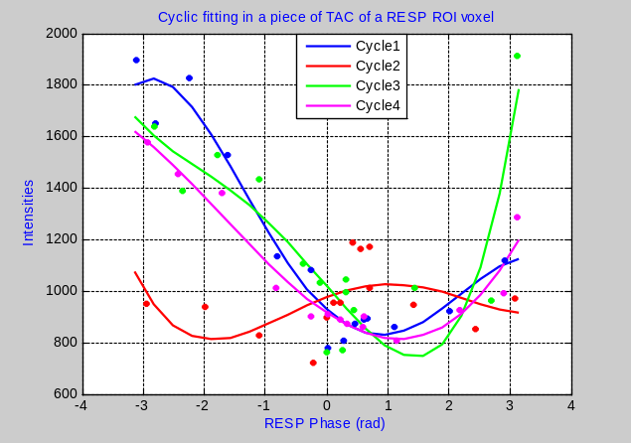
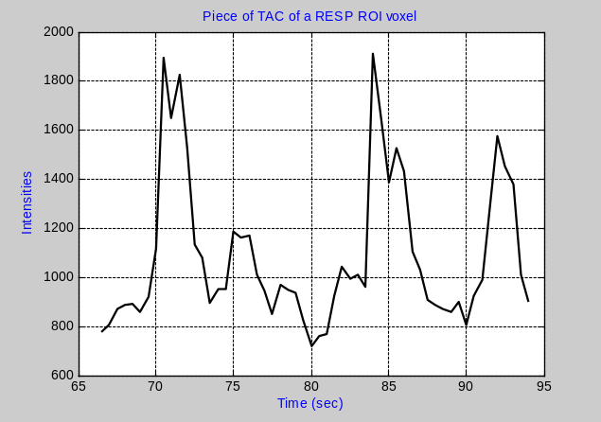
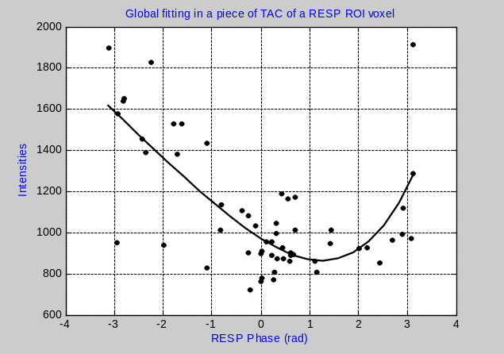
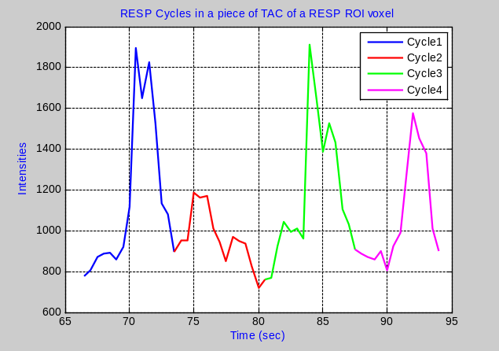
Bc
Ag
Bg
Ac
Figure 5. Left: Time plot of a piece of a voxel time series (VTS) retrieves in RESP ROI (Ag). The same VTS plotted vs. RESP phases and globally fitted by a 4th degree polynomial (Bg). Here, the whole VTS is folded over only one RESP cycle and the fit is performed once. Right: Time plot of the VTS in Ag where RESP cycles were labeled during the computation of RESP phases (Ac). Bc represents the VTS plotted vs. RESP phases and polynomial fitted cycle by cycle. This plot shows that each cycle has its own characteristics which differ from the global fit.

→ Steps of the global correction are described in fig.5 and 6 left below. The time at each fMRI slice acquisition is transformed into a physiological signal phase. The whole acquisition time scale is thus transformed into a phase scale involving only one physiological signal cycle. Then, a curve is fitted over the plots: fMRI Intensity = f(phases of a physiological signal) to computed fitted intensity values at times of acquisition of slices. Finally the correction is achieved by computing the difference between acquired and fitted fMRI intensities.

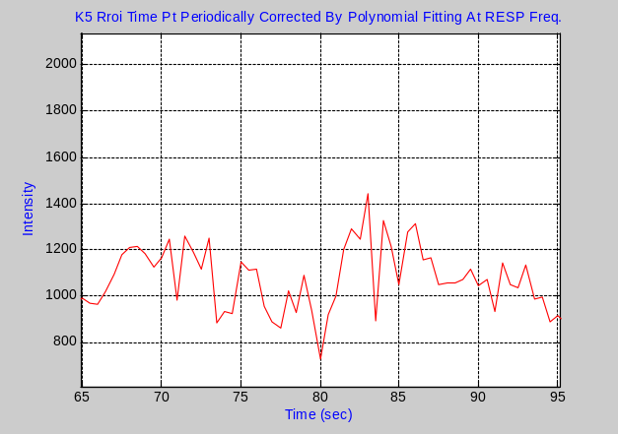
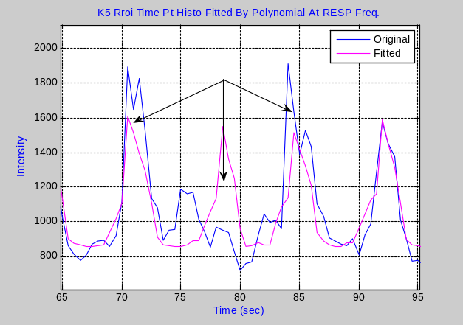
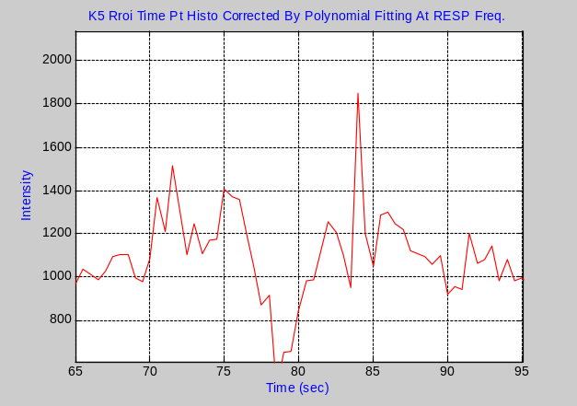
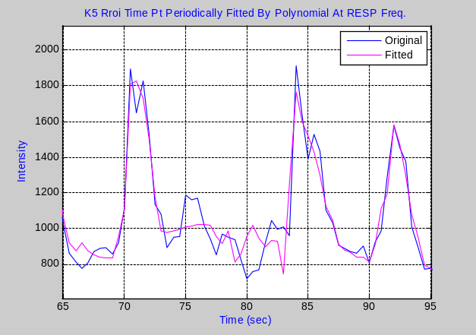
Bc
Ag
Bg
Ac
Figure 6. Overlapping of time plots of the VTS in fig.5 with the global (Ag) and the cyclic (Ac) fitting curves. Ag shows that the global fit produces a kind of mean fitting peaks which better match mean RESP peaks (cycle 4), than taller (cycles 1 & 3) or smaller (cycle 2) peaks. While the cyclic fitting shows to match each RESP peak according to its size. The comparison between the global (Bg) and cyclic (Bc) RESP corrections show that the global correction still presents remaining RESP peaks at cycles 1&4 and a discrepancy at cycle 2.

→ The same step are also needed during the cyclic correction (fig.5 and 6 right) with the difference that the fitting and correction are performed one cycle after another.
Therefore, for the respiratory signal, the global correction is computed either with the histogram (CYCLIC = -1 -> original RETROICOR) or the linear (CYCLIC = 0) phase. The cyclic correction is performed only with the linear phase (CYCLIC = 1 -> only 1 signal is cyclic corrected. If 2 signals are corrected: 1 is cyclic corrected and other is globally corrected; CYCLIC = 2 -> only used with 2 signals and when both are cyclic corrected).

Also, the default argument of CYCLIC depends on the TR. Indeed, if the global correction can be applied for all TR, the cyclic correction is used only for short TR (typically: TR <= 0.2sec for CARD and TR <= 0.5sec for RESP).

References:
[1] Gary H. Glover, et al., MRM 44: 162-167 (2000)

CORRECTION OF THE PHYSIOLOGICAL SIGNAL

The function that handles the computation of phases and cycles of physiological signals is described below:

=============================================================
FUNCTION HANDLING THE CORRECTION OF PHYSIOLOGICAL NOISE SIGNALS
=============================================================

TimeSerieImagePhysioCorrection1(…)
- Function that really performs the physiological signal correction on an fMRI TS.

- Use phases (and cycles) of slices computed by
PhysioSignal_Plot_PhasesAndCyclesOfSlices2(…).

IMPORTANT:
- Can deal with 2 physiological signals (ECG and RESP, PULS and RESP…) at the same time.

INPUTS:
- IM: TS to be corrected. The TS must be a 4D matrix of size [Nx,Ny,Ns,Nt]:
  - Nx, Ny => size of the matrix of slices
  - Ns => number of slices
  - Nt => number of TS volumes (or time points)

- PhasesOfSlices: phases of physiological signal(s) at acquisition times of all TS slices:
  - 1 signal => Array of size [1xNt]
  - 2 signals => matrix of size [2xNt]

- CyclesOfSlices: cycles of physiological signal(s) at acquisition times of all TS slices:
  - CYCLIC < 1 => [ ]
  - CYCLIC = 1 => Array of size [1xNt]
  - CYCLIC = 2 => matrix of size [2xNt]

- WhichPhysio: see above

- Cyclic: see above

- WhichFitMethod: sets the fitting method
  - WhichFitMethod == 0 => Fourier series (default)
  - WhichFitMethod == 1 => polynomial

- FITORDER: set the Fourier series or polynomial order (or degree). Examples:
  - FITORDER == 2 -> (default) for Fourier series
  - FITORDER == 4 -> polynomial

- Interleave: set the TS slice acquisition mode
  - = 0 => Normal
  - >= 1 => Interleave

OUTPUTS:

- IMc: Corrected Time Series

=============================================================

TimeSerieImagePhysioCorrection1() can be use alone if PhasesOfSlices and CyclesOfSlices are already computed and provided. Typically, all its arguments should be provided as follows:

IMc = TimeSerieImagePhysioCorrection1(IM, PhasesOfSlices, CyclesOfSlices, WhichPhysio, Cyclic, WhichFitMethod, FITORDER, Interleave)

In multi slice TS, slices are not always stored as acquired. Most of the time, slice are acquired in interleave mode where odd slices are acquired first and then even (fig.7), or the reverse. The interleave mode is taken into account by the Interleave parameter.

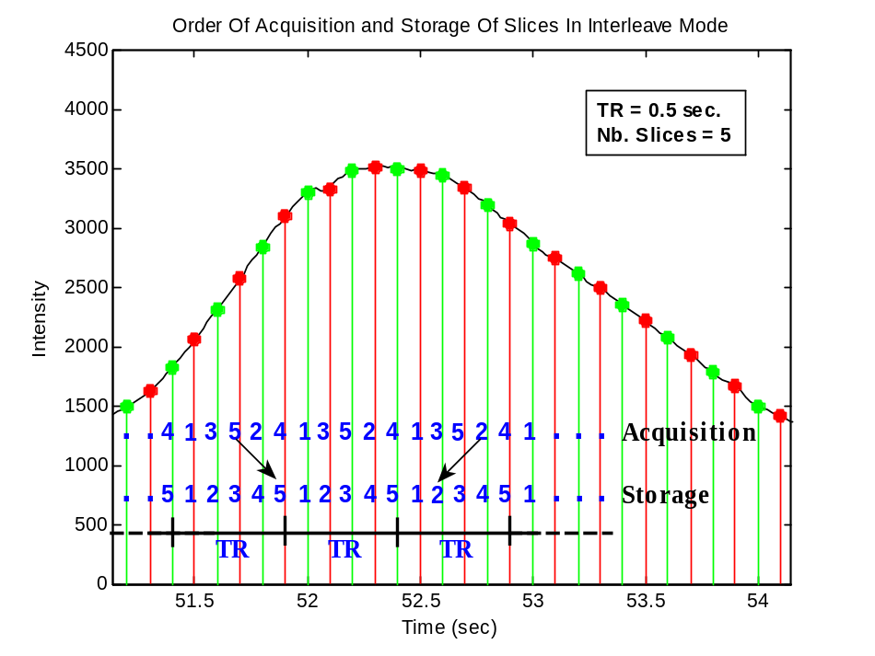
Figure 7. Order of acquisition and storage of slices in a fMRI time series (TR 0.5sec, 5 slices) acquired in interleave mode. During the acquisition process, odd slices are first acquired before even slices at each TR. However, the storage of slices in the time series is performed sequentially (1,2,3,4,5).

MAIN FUNCTIONS

The retrospective correction is handled by two main functions:
- PhysioRectroCorrectInTimeSeries2()
- PhysioRectroCorrectInTimeSeries3()

=============================================================
MAIN FUNCTIONS
=============================================================

PhysioRectroCorrectInTimeSeries2(…)
- Performs physiological noise correction for an fMRI TS using stored phases (and cycles) of the physiological signal computed at acquisition times of all TS slices.

- Phases (and cycles) of slices are already computed and stored in a .mat file.

IMPORTANT:
- Can deal with two physiological signals (ECG and RESP, PULS and RESP…) simultaneously.
- Can handle MREG Time Series.
- Use the function TimeSerieImagePhysioCorrection1().

INPUTS: optional inputs are within [brackets]

- IM: TS to be corrected. The TS must be a 4D matrix of size [Nx,Ny,Ns,Nt]:
  - Nx, Ny => size of the matrix of slices
  - Ns => number of slices
  - Nt => number of TS volumes (or time points)

- TR: repetition time or time between 2 volumes in the TS

- PhysioFilename: physiological signal file name(s) from which phases and cycles were computed (with the path, without extension). Suffixes: PhasCyclECG.mat, PhasCyclRESP.mat, PhasHistRESP.mat or PhasCyclPULS.mat are added later in the program (see the parameter Store above).

- WhichPhysio: see above.

- [TimePtSpan]: see above.

- [CYCLIC]: see above.

- [WhichFitMethod]: see above.

- [FITORDER]: see above.

- [Interleave]: see above.

OUTPUTS:

- IMc: Corrected Time Series

===============================
PhysioRectroCorrectInTimeSeries3(…)
- Computes Phases & Cycles of the physiological signal at times at acquisition times of all TS slices using PhysioSignal_Plot_PhasesAndCyclesOfSlices2().

- Performs physiological signal correction(s) of a fMRI TS using TimeSerieImagePhysioCorrection1().

IMPORTANT:
- Can deal with two physiological signals (ECG and RESP, PULS and RESP…) simultaneously.
- Can handle MREG Time Series.
- Shares all visualization and storing functionalities of
PhysioSignal_Plot_PhasesAndCyclesOfSlices2().

INPUTS: optional inputs are within [brackets]

- IM: see above.

- TR: see above

- PhysioFilename: the physiological signal file name (with the path, without extension). Files extensions .ecg, .resp or .puls are added later in the program.

- WhichPhysio: see above.

- CYCLIC: see above.

- [TRIGPRM]: see above.

- [WhichFitMethod]: see above.

- [FITORDER]: see above.

- [Store]: see above.

- [Visual]: see above.

- [BandWidth]: see above.

- [DummyTime]: see above.

- [TimePtSpan]: see above.

[CARDchannel]: see above.

- [SIGNALyFLIP]: see above.

- [Interleave]: see above.

OUTPUTS: optional outputs are within [brackets]

- IMc: Corrected Time Series (MRSTRUCT Type).

- PhasesOfSlices: see above.

- CyclesOfSlices: see above.

- [SIGNALS]: see above.
=============================================================

PhysioRectroCorrectInTimeSeries2() and PhysioRectroCorrectInTimeSeries3() are used as below, with optional arguments in bold.

IMc = PhysioRectroCorrectInTimeSeries2(IM, PhysioFilename, WhichPhysio, TimePtSpan, CYCLIC, WhichFitMethod, FITORDER, Interleave)

[IMc, PhasesOfSlices, CyclesOfSlices, SIGNALS] = PhysioRectroCorrectInTimeSeries3(IM, PhysioFilename, WhichPhysio, CYCLIC, TRIGPRM, WhichFitMethod, FITORDER, Store, Visual, BandWidth, DummyTime, TimePtSpan, CARDchannel, SIGNALyFLIP, Interleave)

→ PhysioRectroCorrectInTimeSeries2() is used when phases and cycles of slices are already computed and stored in Matlab files (.mat). Typically, this function is convenient when the same data set must be used several times. In this case, phases and cycles of slices are first computed using PhysioSignal_Plot_PhasesAndCyclesOfSlices2() and stored in Matlab files. The computed phases and cycles are then set as arguments in PhysioRectroCorrectInTimeSeries2() for further use. This function is also useful to correct data sets with phases and cycles of slices computed by other means than by using PhysioSignal_Plot_PhasesAndCyclesOfSlices2().

→ As PhysioRectroCorrectInTimeSeries3() performs the computation of phases and cycles of slices, and the signal correction, this function is convenient when a data set needs to be corrected only once. PhysioRectroCorrectInTimeSeries3() is also useful when physiological signal corrections must be repeated on the same data set. In this case, the first correction is performed with PhysioRectroCorrectInTimeSeries3() storing phases and cycles, while the following corrections are made using PhysioRectroCorrectInTimeSeries2().

