**SEG3125 – Lab 10 Report  
Philippe Gagné, 300056229**Conversation 1: Greet and subscribe  
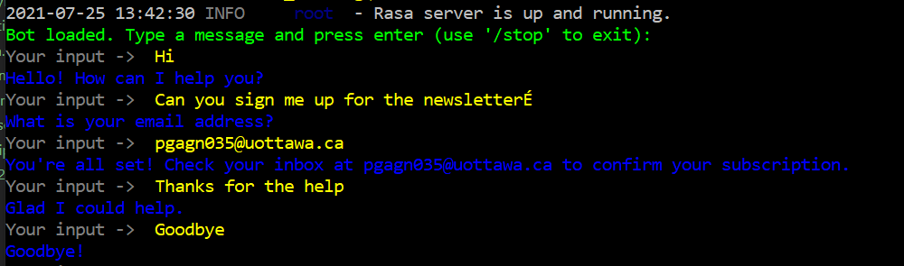

Conversation 2 : Greet and unsubscribe  
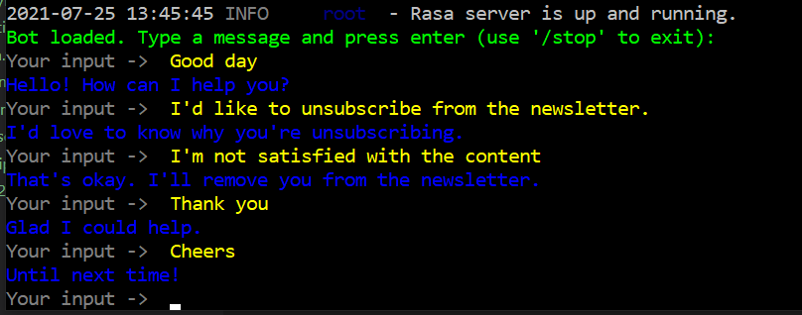

In this folder I’ve attached 5 files: *nlu.yml*, *responses.yml*, *stories.yml*, *rules.yml*, and *forms.yml*, all of which I had to change to make my bot work as intended.