Introduction

Welcome to the powerful Fornux® PowerCalc!

Render beautiful 2D/3D graphics and histogram/scatter plot quickly with smart formatting, trace your graphic coordinates, zoom/translate and send professional reports in seconds. Enter your data as a vector, matrix, fraction, angle, sexagesimal or base-n number to compute any scientific, logical, vectorial, linear and statistical operations including standard deviations and nonlinear regressions. Fornux® PowerCalc comes with a complete documentation, recognizes expressions having polynomials with implicit multiplications, affects entire expression to any variable upon request (thus programmable), spaces your operators intelligently and much more!

Basic operations

Arithmetic operations

- You must type arithmetic operations in the same sequence as in the formula.
- For negative values, press before entering the value.
- To enter floating-point values, press before entering decimals.
- You can navigate thru command history using the ↓ / ↑ keys.

Example | Operation | Display
22 + 8.2 – 57 = -26.8 | 22 8.2 57 | -26.8
60 * -17 ÷ -2.5 = 408 | 60 -17 -2.5 | 408.
(7 + 8) * 10² = 1500 | 7 8 → 10 | 1500.
(1 * 10⁴) + 10 ÷ 5 = 10002 | 1 10 4 → 10 5 | 10002.

Memory calculations

- You can initialize an expression to a variable by using the button.
- Note: The whole expression is kept in memory so that changing any variable inside the expression will modify the resulting value.

The ASCII character “e” can be interpreted as being a variable or the exponent of a number, depending on its context.

Example | Operation | Display
Initialize a = 2.364 | a 2.364
a * 9 = 21.276 | a 5 | 21.276
Initialize b = a * 7.927 | b a 7.927
b - 5 = 5.291 | b 5 | 5.291
Initialize a = 4 | a 4
b - 5 = 6.927 | b 5 | 6.927

Specifying the number of significant digits, scientific display, metric & imperial notation display

- To specify the number of significant digits, go to Settings → Options →Display floating point precision up to [1 - 60] and then .
- Even if the number of significant digits are specified, internal calculations are performed in 62 digits for a mantissa and the displayed value is stored in 60 digits.

Example | Operation | Display
100 ÷ 6 = 16.66666666… | 100 6 | 16.666666…667
 | Settings → Options →  Display floating point precision up to 10 digits | 16.66666667

Fractions

- Mixed and improper fractions are supported.
- Fractions are represented as ratios using and buttons.
- Note: In the following table, the “→” key represents the right arrow on your keyboard.

Example | Operation | Display
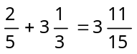 | 2 5 3 1 → 3 | 3:11:15
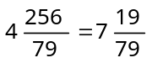 | 4 256 → 79 | 7:19:79
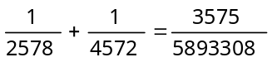 | 1 2578 1 4572 | 3,575:5,893,308
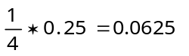 | 1 4 0.25 | 0.0625
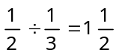 | 1 2 1 3 | 1:1:2
 | Uncheck View → Mixed Fractions | 3:2

Functions

Trigonometric and inverse trigonometric functions

- The unit of angular measurement (degrees, radians, grads) is set by pressing the according radio button .
- Note: In the following table, the “→” key represents the right arrow on your keyboard.

Example | Operation | Display
sin 60° 40’ 53” = 0.8719102627 |  | 0.8719102627
sin 60° 40’ 53” = 0.8719102627 | 60 →→ 40 →→ 53 | 0.8719102627
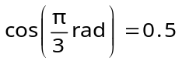 |  | 0.5
 | 3 | 0.5
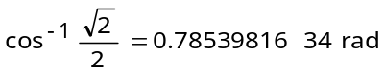 |  | 0.7853981634
 | 2 2
 | Check View → Sexagesimal Notation
 | 2.5
 | 0.8 →
 | 0.9 | 68° 13' 13.5"
 | Uncheck View → Sexagesimal Notation | 68.22042398

Logarithmic and exponential functions

Example | Operation | Display
log 1.53 = 0.1846914308 | 1.53 | 0.1846914308
е^{5.5} = 244.6919323 | 5.5 | 244.6919323
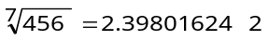 | 456 7 | 2.398016242
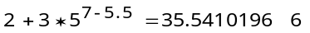 | 2 3 5 7 5.5 | 35.54101966

Hyperbolic and inverse hyperbolic functions

Example | Operation | Display
sinh 4.5 = 45.00301115 |  | 45.00301115
sinh 4.5 = 45.00301115 | 4.5 | 45.00301115
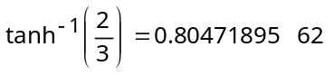 |  | 0.8047189562
 | 2 3 | 0.8047189562

Coordinate transformation

- Fornux® PowerCalc lets you convert rectangular coordinates with polar coordinates and vice-versa.
- Rectangular and polar coordinates are both represented as a vector of 2 elements.

Example | Operation | Display
Given [x, y] = [14, 20.7], find [r, Θ°] |  | [24.99; 55.928]
Given [x, y] = [14, 20.7], find [r, Θ°] | 14 20.7 | [24.99; 55.928]
Given [r, Θ°] = [4.5, 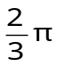rad], find [x, y] |  | [-2.25; 3.8971]
 | 4.5 2 3 | [-2.25; 3.8971]

Other functions (√, x², x⁻¹, x!, ³√, |x|, ran(), floor(x))

- Note: In the following table, the “→” key represents the right arrow on your keyboard.

Example | Operation | Display
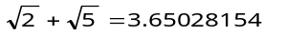 | 2 5 | 3.65028154
2² + 3⁻¹ = 4.333333333 | 2 3 | 4.333333333
9! = 362880 | 49 | 362,880.
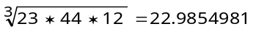 | 23 44 12 → 3 | 22.9854981
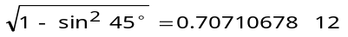 | 1 45 → | 0.7071067812
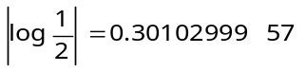 | 1 2 | 0.3010299957
Random number between [0.000, 0.999] |  | e.g. 0.786
Integer part of 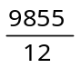 | 9855 12 | 821.

Binary, octal, decimal and hexadecimal calculations

Binary, octal, decimal and hexadecimal conversions

- The 16, 10, 8, 2 numeric base is set by respectively selecting the appropriate radio button.
- Fractional part of floating point numbers is implicitly truncated when converted to hexadecimal, octal and binary numeric base.
- Hexadecimal, octal and binary integers are 64 bits long, so it is possible to cast the integer part of a decimal value to and from its original value.
- Negative numbers in hexadecimal, octal and binary number base are expressed as two’s complement.
- Calculation range for each hexadecimal, octal and binary number base does not exceed [-9,223,372,036,854,775,808.; 9,223,372,036,854,775,807.].
- You can use neither scientific function nor special trigonometric and statistical calculations using a hexadecimal, octal or binary number base.

Example | Operation | Display
Decimal value of 2AFF₁₆
Decimal value of 2AFF₁₆ | 2AFF | 2AFF
Decimal value of 2AFF₁₆ |  | 11007.

Negative expressions

Example | Operation | Display
Negation of 72₈
Negation of 72₈ | -72 | 1777777777777777777706

Basic arithmetic operations

Example | Operation | Display
101110₂ + 110011₂ = 1100001₂
101110₂ + 110011₂ = 1100001₂ | 10110 110011 | 1100001
AF3F₁₆ * 987D₁₆ = 6862F9C3₁₆
 | AF3F 987D | 6862F9C3
4012₁₀ ÷ 12₁₀ = 334.3333333₁₀
4012₁₀ ÷ 12₁₀ = 334.3333333₁₀ | 4012 12 | 334.3333333
4012₁₀ ÷ 12₁₀ = 334.3333333₁₀ |  | 516

Logical operations

Example | Operation | Display
10000₂ OR 11₂ = 10011₂
10000₂ OR 11₂ = 10011₂ | 10000 11 | 10011
A₁₆ XNOR 5D₁₆ = FFFFFFFFFFFFFA8₁₆
A₁₆ XNOR 5D₁₆ = FFFFFFFFFFFFFA8₁₆ | A 5D | FFFFFFFFFFFFFFA8
Two’s complement of 4EE8₁₆
Two’s complement of 4EE8₁₆ | 4EE8 | FFFFFFFFFFFFB117
772644₈ Right Shift 3₈ = 77264₈
772644₈ Right Shift 3₈ = 77264₈ | 772644 3 | 77264
99233₁₀ Modulo 46₁₀ = 11₁₀
99233₁₀ Modulo 46₁₀ = 11₁₀ | 99233 46 | 11

Vector algebra

Basic arithmetic operations

- A vector is enclosed in brackets [] and can contain any type of element (any form of number or fractions).
- The cross product operator recognizes only vectors of size 3.
- You can find out the length of a vector by enclosing the vector inside vertical bars by pressing the button.
- Note: In the following table, the “→” key represents the right arrow on your keyboard.

Example | Operation | Display
[3, 6, 2, 8] + [5, 8, 9, 3] | 3 6 2 8 →  5 8 9 3 | [8.; 14.; 11.; 11.]
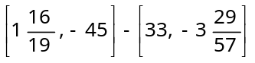 | 1 16 → 19 -45 →  33 -3 29 → 57 | [-31:3:19; -41:28:57]
[10, -9, 25, 3] ∙ [-19, 22, 5, -55] | 10 -9 25 3 →  -19 22 5 -55 | -428.
[21, 5, 9] × [15, 34, -25] | 21 5 9 →  15 34 -25 | [-431.; 660.; 639.]
Norm of [200.5, 145, -55] | 200.5 145 -55 | 253.4763303

Extended operations

- Fornux® PowerCalc supports non-standard vector algebra aimed to facilitate global arithmetic operations.
- Standard operators taking a vector will return a new vector containing the result of the operation applied to each element.
- Standard operators taking 2 vectors will return a new vector containing the result of the operation applied to each matching elements in both vectors.
- Note: In the following table, the “→” key represents the right arrow on your keyboard.

Example | Operation | Display
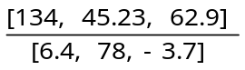 | 134 45.23 62.9 →  6.4 78 -3.7 | [20.9; 0.58; -17.]
ln [245.51, 78.9, 733.25] | 245.51 78.9 733.25 | [5.5; 4.37; 6.6]

Advanced operations

- Note: In the following table, the “→” key represents the right arrow on your keyboard.

Example | Operation | Display
Initialize v = [-76, -45, 2, 18, 49] | v -76  -45  2  18  49
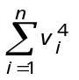 | v 4 | 43,332,594.
Initialize w = [[-11.1, 55.5], [98.23, -14.7], [87.56, 45.76], [2.09, -142.6], [19.2, 87]] | w -11 55.5 →  98.23 -14.7 →  87.56 45.76 →  2.09 -142.6 →  19.2 87
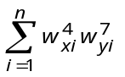 |  | 2.980969539e19
 | Tools → Insert → colx(w) | 2.980969539e19
 | w → 4 | 2.980969539e19
 | Tools → Insert → coly(w) | 2.980969539e19
 | w → 7 | 2.980969539e19

Linear algebra

Basic matrix operations

- A matrix is enclosed with nested brackets [[], [], …] and can contain any type of element (any form of number or fractions).
- To find the determinant of a matrix, use the vertical bars by pressing the button.
- The inverse of a matrix is the matrix itself powered up by -1.
- Matrices can be added, subtracted, multiplied and divided by a scalar variable.
- Note: In the following table, the “→” key represents the right arrow on your keyboard.

Example | Operation | Display
[[1, 3, 2], [1, 0, 0], [1, 2, 2]] +  [[0, 0, 5], [7, 5, 0], [2, 1, 1]] | 1 3 2 →  1 0 0 →  1 2 2 →→  0 0 5 →  7 5 0 →  2 1 1 | [[1.; 3.; 7.]; [8.; 5.; 0.]; [3.; 3.; 3.]]

Statistical calculations

Standard deviation

- Data is represented as a simple vector.
- Either multiple data of the same value can be input after the data itself by repeatedly pressing or by typing the number of times the data is repeated in braces.

Unbiased estimate of standard deviation [√variance(v)]
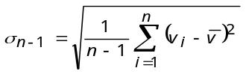

Maximum likelihood of standard deviation [√variancemle(v)]
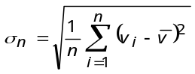

Mean [mean(v)]
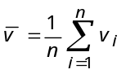

Median [median(v)]
If n is odd
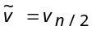
If n is even
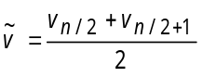

Example | Operation | Display
Data 45, 67, 55, 55, 59 | v 45 67 55 59
Standard deviation σ_{n-1}
Standard deviation σ_{n-1} | v | 7.949842766
Standard deviation σ_{n} | v | 7.110555534
Number of elements | v | 5.
Mean | v | 56.2
Sum total | v | 281.
Sum of squares | v | 16,045.
Initialize v to | v 10  30 {10}  50 {75}  70 {30}  90 {55}
  Value | Frequency
  10 | 2
  30 | 10
  50 | 75
  70 | 30
  90 | 55
Calculate σ_{n-1} | V | 20.27285654

Regression

- The data is represented as a vector having vectors of 2 elements representing [x, y].
- Multiple data of the same value can be input after the data itself by repeatedly pressing .

Constant term [α(w)]
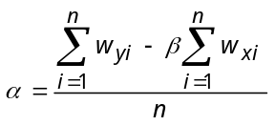

Regression coefficient [β(w)]
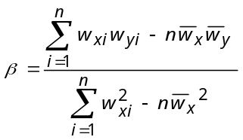

Correlation coefficient [γ(w)]
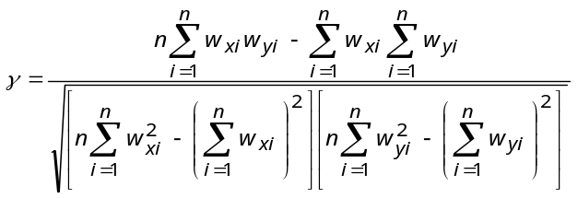

Linear regression

Formula
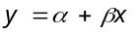
Estimated values
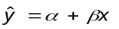 | 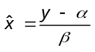

- Note: In the following table, the “→” key represents the right arrow on your keyboard.

Example | Operation | Display
Initialize w to the following data | w 10 1003 →  15 1005 →  20 1010 →  25 1011 →  30 1014
  x | y
  10 | 1003
  15 | 1005
  20 | 1010
  25 | 1011
  30 | 1014
Constant term α
Constant term α | w | 997.4
Regression coefficient β | w | 0.56
Correlation coefficient γ | w | 0.9826073689
Estimated value when y = 1000 | 1000 w →→  w | 4.642857143
Covariance given by  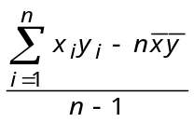 | w →  w →  w →→  w →→→  w → 1 | 35.

Logarithmic regression

- Enter the x data as the logarithm ln(x) and the y data inputs the same as that for linear regression.
- Example: In “Example\statistics.fcv”, see variable L (CTRL + E, L) for a graphical example (remark: you need to affect the variable K with its previous expression if you modify the contents of J).

Formula
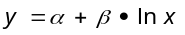
Estimated values
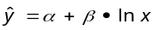 | 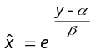

Exponential regression

- Enter the y data as the logarithm ln(y) and the x data inputs the same as that for linear regression.
- The constant term α is obtained with: е^α(w), where w is a vector of paired variables.
- Example: In “Example\statistics.fcv”, see variable P (CTRL + E, P) for a graphical example (remark: you need to affect the variable O with its previous expression if you modify the contents of N).

Formula
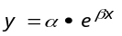

Estimated values
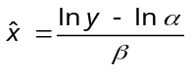

Power regression

- Enter the both x and y data as the logarithm ln(x) and ln(y).
- The constant term α is obtained with: е^α(w), where w is a vector of paired variables.
- Example: In “Example\statistics.fcv”, see variable T (CTRL + E, T) for a graphical example (remark: you need to affect the variable S with its previous expression if you modify the contents of R).

Formula
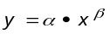

Estimated values
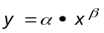 | 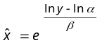

Graphics

Range parameters

- You can lookup and specify new range parameters for the x, y and z coordinates by selecting Settings → Range.
- Each range parameter consist of a minimum, maximum and a scale factor (distance between hash marks).
- The range settings are automatically adjusted before displaying histograms and scatter plots when Settings → Graphic → Adjust range settings when displaying histograms and scatter plots is checked.
- You can reset the range settings by pressing Settings → Range → Defaults button and then Ok.

2D function graphs

- 2D graphics can be generated by initializing an expression to y and by selecting Tools → Plot F(x).

Example | Operation
y = 2x² + 3x – 4 | Settings → Range
   | X Axis | Y Axis
  Minimum | -5 | -10
  Maximum | 5 | 10
  Scale Factor | 2 | 4
y = 2x² + 3x – 4 | y 2x 3x 4
y = 2x² + 3x – 4 | Tools → Plot F(x)
Display
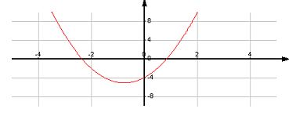

Zoom function

- This function lets you enlarge or reduce the x, y and / or z coordinates.

Example | Operation
Zoom in the graphic | Tools → Zoom In
Display
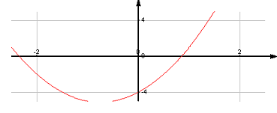

Trace function

- This function lets you move a pointer across the actual graphic and will display the x, y and / or z coordinates of the current pointer location.
- You can move the pointer using keyboard arrow ← / → for the x axis and ↓ / ↑ for the y axis (3D graphics).
- Holding CTRL down while pressing the left and right arrow will move the pointer faster.

Example | Operation
Trace x and y values | Tools → Zoom → 100%  Tools → Trace Mode
Display
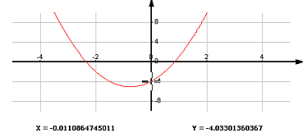

2D graphic example

Example | Operation
y = x⁴ + 4x³ – 36x² – 160x + 300 | Settings → Range
   | X Axis | Y Axis
  Minimum | -10 | -600
  Maximum | 10 | 600
  Scale Factor | 2 | 200
y = x⁴ + 4x³ – 36x² – 160x + 300 | y x 4  4x 3  36  160x  300
y = x⁴ + 4x³ – 36x² – 160x + 300 | Tools → Plot F(x)
Display
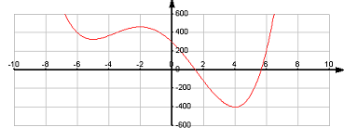

3D graphic example

- 3D graphics can be generated by initializing an expression to z and by selecting Tools → Plot F(x, y).

Example | Operation
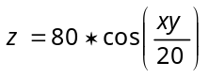 | Settings → Range → Defaults
   | X Axis | Y Axis | Z Axis
  Minimum | -100 | -100 | -100
  Maximum | 100 | 100 | 100
  Scale Factor | 25 | 25 | 25
 | z 80 xy 20
 | Tools → Plot F(x, y)
Display
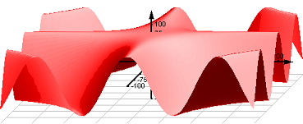

Single variable statistical graph (bar chart)

- Histograms can be generated by initializing an expression to v and by selecting Tools → Bar Chart.
- It is possible to draw over a histogram with an F(x) function with by selecting Tools → F(x) after the first graph is completed.

Example | Operation
 | Check Settings → Graphic →  Adjust range settings when displaying histograms and scatter plots
  Rank | Frequency
  0 | 1
  10 | 3
  20 | 3
  30 | 2
  40 | 5
  50 | 1
  60 | 9
  70 | 15
  80 | 10
  90 | 4
v 0
10
20
30
40 {5}
50
60 {9}
70 {15}
80 {10}
90

 | Tools → Bar Chart
Display
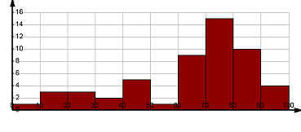

- Note: In the following table, the “→” key represents the right arrow on your keyboard.

Example | Operation
Draw a normal distribution curve given  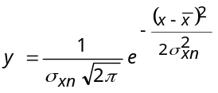 | Tools → Clear
Settings → Range
 | X Axis | Y Axis
Minimum | 0 | 0
Maximum | 110 | 0.02
Scale Factor | 10 | 0.005

y
x v →→
2 v → →→→
v → 2
 | Tools → Plot F(x)
Display
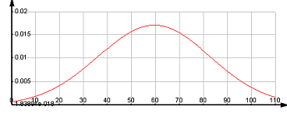

Paired variables statistical graph (scatter plot)

- Scatter plots can be generated by initializing an expression to w and by selecting Tools → Scatter Plot.
- It is possible to draw over a scatter plot with an F(x) function with by selecting Tools → F(x) after the first graph is completed.
- Note: In the following table, the “→” key represents the right arrow on your keyboard.

Example | Operation
 | Tools → Clear
  x | y
  0.21 | 150
  0.24 | 189
  0.35 | 253
  0.18 | 142
  0.09 | 97
  0.16 | 124
  0.23 | 172
  0.05 | 90
  0.28 | 209
  0.14 | 107
Check Settings → Graphic →
Adjust range settings when displaying histograms and scatter plots

w 21 150 →
24 189 →
35 253 →
18 142 →
9 97 →
16 124 →
23 172 →
5 90 →
28 209 →
14 107

 | Tools → Scatter Plot
Display
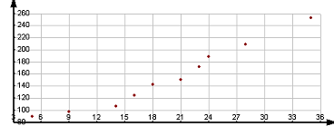

- Note: In the following table, the “→” key represents the right arrow on your keyboard.

Example | Operation
Draw a linear regression over the previous scatter plot

Draw a linear regression over the previous scatter plot | y w →  w →  x
Draw a linear regression over the previous scatter plot | Tools → Plot F(x)
Display
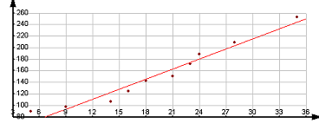

Annex I

Commands

 | Calculate
 |  | Evaluate an expression and returns its value.
 | Return | Evaluate an expression and returns its value.
 | Recall last result
 |  | Display the result of the last expression in proper format.
 | F9 | Display the result of the last expression in proper format.
 | Clear memory
 |  | Erase the value kept in memory.
 | F5 | Erase the value kept in memory.
 | Recall memory
 |  | Display the memorized value in proper format.
 | F6 | Display the memorized value in proper format.
 | Memorize difference
 |  | Subtract the current result from the memorized value.
 | F7 | Subtract the current result from the memorized value.
 | Memorize sum
 |  | Add the current result to the memorized value.
 | F8 | Add the current result to the memorized value.

Constant

π | Pi
π |  | Ratio of a circle's circumference to its diameter.
π | ALT + Z, ALT + P | Ratio of a circle's circumference to its diameter.

Operator precedence

- The power operator “^” is evaluated from right to left.

Precedence | Operators
1 | (…) | […]
2 | !
3 | [unary +] | [unary -] | |…| | not
4 | ^
5 | √
6 | [implicit *]
7 | * | / | × | ∙ | mod
8 | + | -
9 | << | >>
10 | and
11 | xor
12 | or

Annex II

Basic operators

x + y  x – y  x * y  x / y | Arithmetic operators
x + y  x – y  x * y  x / y |  | The combining of x and y using an addition, subtraction, multiplication or division operator.
x ^ y | Power
x ^ y |  | Exponent to which a given quantity is raised.
√ x | Square Root
√ x |  | The square root of x is a number which multiplied by itself, gives you the original number x.
√ x | ALT + S
x ! | Factorial
x ! |  | The product of all the integers up to and including the given integer x.
| x | | Absolute Value
| x | |  | The numerical value x regardless of its sign.

Basic functions

ln(x) | Natural Logarithm
ln(x) |  | The logarithm of x having base е.
log(x) | Logarithm
log(x) |  | The exponent required to produce x in base 10.
еxp(x) | Exponential
еxp(x) |  | Base of the natural logarithm.
floor(x) | Integer part
floor(x) |  | Gives the largest integer less than or equal to x.
ran() | Random number
ran() |  | Returns a random number between [0.001, 0.999]. Repeated calls to ran() generate random numbers with a uniform distribution.

Combinatorics

permutation(x, y) | Permutation
permutation(x, y) |  | Returns the arrangement of any determinate number of things in all possible orders, one after the other.
combination(x, y) | Combination
combination(x, y) |  | Returns the different arrangements of a number of objects into groups.

Geometry

polar(v) | Polar conversion of rectangular coordinates
polar(v) |  | Converts rectangular coordinates into polar coordinates (distance from a fixed pole and angle from a fixed line passing through the pole).  The operand must be a vector of size 2 containing the x and y coordinates.
rectangular(v) | Rectangular conversion of polar coordinates
rectangular(v) |  | Converts polar coordinates into rectangular coordinates (rectilinear two-dimensional x, y coordinates).  The operand must be a vector of size 2 containing r and Θ.

Vector operators

u ∙ v | Dot product
u ∙ v |  | Scalar that is the product of two vectors.
u ∙ v | ALT + Z, ALT + D | Scalar that is the product of two vectors.
u × v | Cross product
u × v |  | Vector that is the product of two other vectors.  The operands must be vectors of size 3.
u × v | ALT + Z, ALT + C
| v | | Norm
| v | |  | Norm of a vector.

Vector functions

sort(u) | Sort
sort(u) |  | Sorts a vector in ascending order.
sort(u) | Tools → Insert → sort(u) | Sorts a vector in ascending order.
part(i, u) | i’th member
part(i, u) |  | Returns the i’th element of a vector.
part(i, u) | Tools → Insert → part(i, u) | Returns the i’th element of a vector.
merge(u, v) | Merge
merge(u, v) |  | Creates a vector having elements in both u and v.
merge(u, v) | Tools → Insert → merge(u, v) | Creates a vector having elements in both u and v.
length(v) | Number of element
length(v) |  | Gives the number of elements in v.
sum(v) | Sum
sum(v) |  | Gives the total of the elements in v:  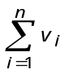
product(v) | Product
product(v) |  | Gives the product of the elements in v:  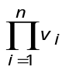
mean(v) | Mean
mean(v) |  | Unweighted average of the elements in v:  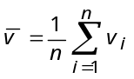
median(v) | Median
median(v) |  | Middle value of the elements in v:  If n is odd  If n is even  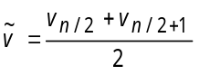
√variance(v) | Unbiased estimate of standard deviation
√variance(v) |  | Standard deviation using sample data of population v:  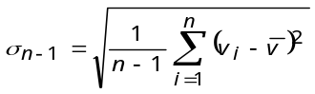
√variancemle(v) | Maximum likelihood of standard deviation
√variancemle(v) |  | Standard deviation using all data of finite population v:  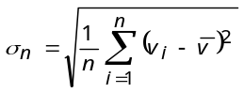

Matrix operators

w ^ -1 | Inverse
w ^ -1 |  | Returns the inverse of the matrix.
| w | | Determinant
| w | |  | Returns the determinant of the matrix

Matrix functions

sumxy(w) | Sum of individual products
sumxy(w) |  | Gives the total of the product of each x and y components in v:  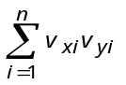
colx(w) | X column
colx(w) |  | Transposes a vector of paired variables and returns its first vector representing x values of w.
coly(w) | Y column
coly(w) |  | Transposes a vector of paired variables and returns its second vector representing y values of w.
transpose(w) | Transposition
transpose(w) |  | Transposes a rectangular matrix.  The vector elements of the parameter must be vectors of exact same size.
transpose(w) | Tools → Insert → transpose(w)
α(w) | Constant term of regression
α(w) |  | Constant term of regression given by:  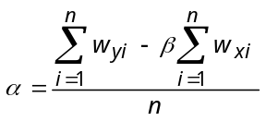
α(w) | ALT + Z, ALT + L, ALT + A
β(w) | Regression coefficient of regression
β(w) |  | Regression coefficient given by:  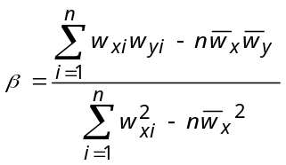
β(w) | ALT + Z, ALT + L, ALT + B
γ(w) | Correlation coefficient of regression
γ(w) |  | Quantity which gives the quality of a least squares fitting to the original data:  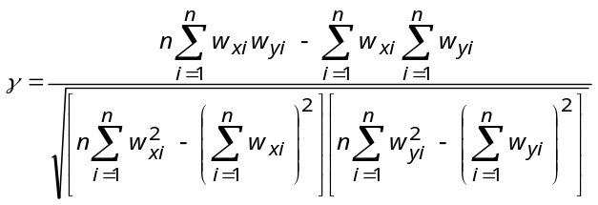
γ(w) | ALT + Z, ALT + L, ALT + G

Logical operators

x and y  x or y  x xor y  x xnor y | Product / Sum / Exclusive sum / Negation of exclusive sum
x and y  x or y  x xor y  x xnor y |  | Bitwise operators.
not x | Negation
not x |  | Each bit of the number is inverted (zeros are replaced with ones and vice versa).
x mod y | Modulo
x mod y |  | Returns the remainder after integer division of its first argument by its second.
x << y | Left shift
x << y |  | Left shift an integer value.  The second operand cannot exceed 64.
x >> y | Right shift
x >> y |  | Right shift an integer value.  The second operand cannot exceed 64.

Trigonometric functions

sin(x)  cos(x)  tan(x) | Trigonometric
sin(x)  cos(x)  tan(x) |  | Standard trigonometric functions.
asin(x)  acos(x)  atan(x) | Inverse trigonometric
asin(x)  acos(x)  atan(x) |  | Standard inverse trigonometric functions.
atan2(y, x) | Inverse tangent of 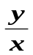
atan2(y, x) |  | Inverse tangent of 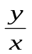 , using the signs of both arguments to determine the quadrant of the return value.
sinh(x)  cosh(x)  tanh(x) | Hyperbolic trigonometric
sinh(x)  cosh(x)  tanh(x) |  | Standard hyperbolic trigonometric functions.
asinh(x)  acosh(x)  atanh(x) | Inverse hyperbolic trigonometric
asinh(x)  acosh(x)  atanh(x) |  | Standard inverse hyperbolic trigonometric functions.

Other

result(x) | Copy of the result of an expression
result(x) |  | Evaluates the expression in x and returns a copy of the result. This is useful to increment a value relative to its old value while avoiding recursivity.
result(x) | Tools → Insert → result(x)

Annex III

Standard conversions

- The proportions here are exact.
- The second column is directly proportionate to its first except for temperature conversions.
- Temperature conversions require you to replace 1 in the second column by its matching quantity.

Angle
1 gradient | 0.9 degree
1 radian | 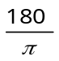 degrees

Pressure
1 bar | 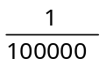 Pascal
1 atmosphere | 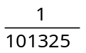 Pascal

Temperature
1 Fahrenheit | 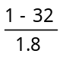 Celsius
1 Kelvin | 1 - 273.15 Celsius

Energy
1 kilocalorie | 4183.98 joules

Power
1 horsepower | 746 watts

Speed
1 knot | 1.852 kilometer per hour

Weight
1 carat | 0.2 gram
1 grain | 0.06479891 gram
1 hundredweight, long | 50802.34544 grams
1 hundredweight, short | 45359.237 grams
1 ounce, avoirdupois | 28.349523125 grams
1 ounce, troy | 31.1034768 grams
1 pound | 453.59237 grams
1 stone | 6350.29318 grams
1 ton (UK) | 1016046.9088 grams
1 ton (US) | 907184.74 grams
tonnes | 1000000 grams

Length
1 inch | 0.0254 meter
1 foot | 0.3048 meter
1 yard | 0.9144 meter
1 mile | 1609.344 meters
1 mile (nautical) | 1852 meters
1 cubit | 0.432 meter
1 hand | 0.1016 meter
1 fathom | 1.8288 meter
1 furlong | 201.168 meters
1 link | 0.201168 meter
1 rod | 5.0292 meters
1 span | 0.229 meter

Area
1 square foot | 0.09290304 square meters
1 square yard | 0.83612736 square meters
1 square mile | 2589988.11 square meters
1 acre | 4046.8564224 square meters
1 hectare | 10000 square meters
1 rood | 1011.7141056 square meters

Volume
1 cubic inch | 16.387064 cubic centimeters
1 cubic foot | 28316.84659 cubic centimeters
1 cubic yard | 764554.858 cubic centimeters
1 liter | 1000 cubic centimeters
1 barrel (oil) | 158987.294928 cubic centimeters
1 bushel | 35239.07016688 cubic centimeters
1 fluid ounce (UK) | 28.4130625 cubic centimeters
1 fluid ounce (US) | 29.5735295625 cubic centimeters
1 gallon (UK) | 4546.092 cubic centimeters
1 gallon (US dry) | 4404.88377086 cubic centimeters
1 gallon (US liquid) | 3785.411784 cubic centimeters
1 pint (UK) | 568.26125 cubic centimeters
1 pint (US dry) | 550.6104713575 cubic centimeters
1 pint (US liquid) | 473.176473 cubic centimeters
1 quart (UK) | 1136.5225 cubic centimeters
1 quart (US dry) | 1101.220942715 cubic centimeters
1 quart (US liquid) | 946.352946 cubic centimeters

Universal physical constants

Quantity | Symbol | Value (approx.) | Unit | Relative std. uncertainty
Speed of light in vacuum | c, c₀ | 2.99792458e8 | 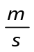 | Exact
Magnetic constant | µ₀ | 4π*1e-7 | 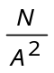 | Exact
Electric constant | ε₀ | 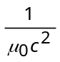 | 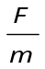 | Exact
Characteristic impedance of vacuum | Z₀ | µ₀c | 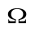 | Exact
Planck constant | h | 6.62606876e-34 | J * s | 7.8e-8
Planck constant | h | 4.13566727e-15 | eV * s | 3.9e-8
Planck constant | ћ | 1.054571596e-34 | J * s | 7.8e-8
Planck constant | ћ | 6.58211889e-16 | eV * s | 3.9e-8
Planck mass | m_{p} | 2.1767e-8 | kg | 7.5e-4
Planck length | l_{p} | 1.6160e-35 | m | 7.5e-4
Planck time | t_{p} | 5.3906e-44 | s | 7.5e-4
Newtonian constant of  gravitation | G | 6.673e-11 | 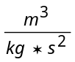 | 1.5e-5
Newtonian constant of  gravitation | 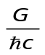 | 6.707e-39 | 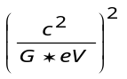 | 1.5e-5

Annex IV

Examples

- The file “Example\scientific.fcv” contains different graphical expression you may affect to y and z.
- Statistical expression can be found in “Example\statistics.fcv”.

Technical Specs

Calculation range | [-1e4923; 1e4923]
Infinity representation | NAN
Not-A-Number representation | NAN
Base-N range | [-9,223,372,036,854,775,808₁₀; 9,223,372,036,854,775,807₁₀]
Base-N integer size | 64 bits
Rounding | Internal calculations use up to 64 decimal places of precision. The displayed value is rounded according to the specified number of decimal places (maximum of 60).
Number of steps | Expressions having more than 1000 depth levels of variable lookups will be considered infinitely recursive.
Number of variables | 26 variables.
Number of functions | 36 functions, 10 operators and 8 binary operators.

Bugs and limitations

- Infinite numbers are regarded as being unreal numbers (NAN).
- Results higher than [-1e4923; 1e4923] is undefined (may be represented as NAN).
- Graphical range limits cannot be lower or higher than [-1e308; 1e308].

