You can use this script to check Aboot version for Field Notice 0044

<https://www.arista.com/en/support/advisories-notices/fieldnotices/8756-field-notice-44>

The script by default will log an entry in CVP Change Control that state if the device needs to be patched or not

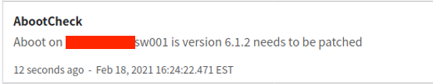

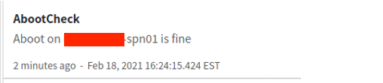

AND will also create a file (/tmp/AbootCheck.txt) with the same entries for all switches

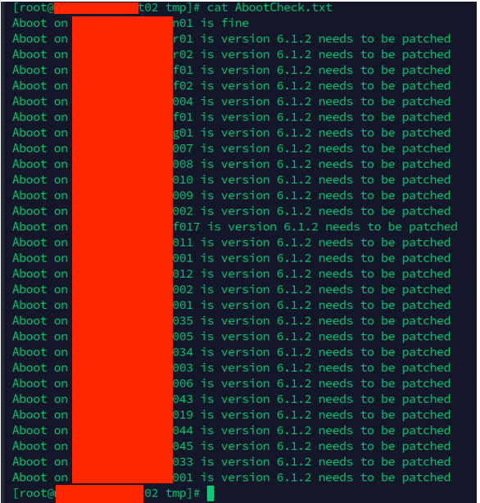

NOTE : if CVP is in cluster, the file will be created where scriptaction is running

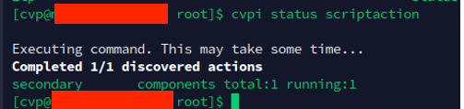

NOTE2: destination file can be changed in the YAML file

