Sprint 1 Plan
Product Name: Code Performance Analyzer
Sprint 1 Goal
Sprint 1 will establish the foundation of the Code Performance Analyzer by creating the first model capable of producing simple Big-O estimates for standalone Python functions. At the same time, we will build the initial extension UI framework and implement a mocked complexity annotation to preview how results will appear in the editor.
User Stories - Backend
User Story 1.1: As a user, I want to run a simple model that can analyze Python code through a local script so that I can get an initial Big-O complexity estimate.
- 1.1.1: Research Model Feasibility – 4 hours
- 1.1.2: Setup model hosting infrastructure – 8 hours
- 1.1.3: Setup model inference – 6 hours

User Stories - Frontend
User Story 1.2: As a user, I want to see a mocked complexity annotation inside the editor UI so I can preview how the extension will eventually present feedback.
- 1.2.1: Research API and Extension Capabilities – 6 hours
- 1.2.2: UI Design for annotations and layout – 6 hours
- 1.2.3: Mock Implementation – 6 hours

Team Roles
Team Member | Role
Philip Pesic | Backend Developer
Adwaith Madadi | Backend Developer
Rohit Mandal | Backend Developer
Michael Pimentel | Frontend Developer
Juan Alvarez Sanchez | Frontend Developer

Task Assignment
Philip Pesic: Backend Tasks 1.1.1, 1.1.2, 1.1.3
Adwaith Madadi: Backend Tasks 1.1.1
Rohit Mandal: Backend Tasks 1.1.2, 1.1.3
Michael Pimentel: Frontend Tasks 1.2.1, 1.2.2, 1.2.3
Juan Alvarez Sanchez: Frontend Tasks 1.2.1, 1.2.2, 1.2.3

Scrum Board
https://docs.google.com/document/d/15PlzT7TNhLe6Ni6R2BIPt3uAZVzQrlsptkJnA_Or7GM/edit?usp=sharing
Sprint 1 Burnup Chart
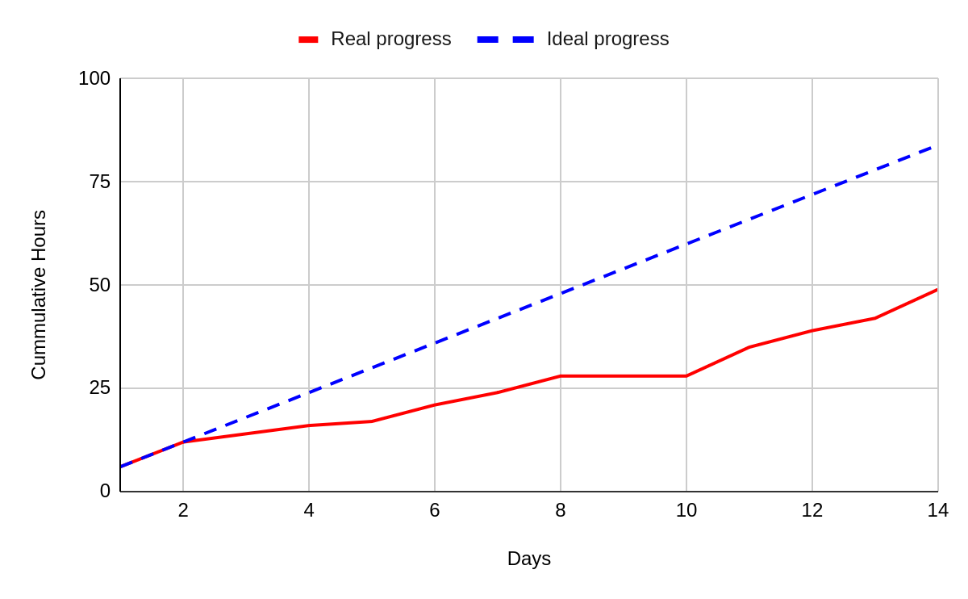
Scrum Meetings
Day | Location
Saturday | Zoom
Monday | Zoom/In Person
Thursday | Zoom and TA Meeting

Sprint 1 Recap
In Sprint 1, we completed the first version of the complexity model and confirmed it could run locally to estimate Big-O behavior. We also built the initial UI and delivered a working mock annotation, giving us a functional prototype across both backend and frontend components.

