Sprint 2 Plan
Product Name: Code Performance Analyzer
Sprint 2 Goal
Sprint 2 will focus on improving model accuracy by generating training data, training and tuning the model, and creating a script to compare its outputs. On the frontend, we will research how to connect the backend to the extension and build a sidebar that displays the complexity results from the model.
User Stories - Backend
User Story 2.1: As a user, I want the extension to return a relatively accurate time-complexity estimate so that the extension is useful.
- 2.1.1: Set up framework for training data generation – 10 hours
- 2.1.2: Train and tune the complexity of the model – 4 hours
- 2.1.3: Create script to compare the model outputs – 4 hours

User Stories - Frontend
User Story 2.2: As a user, I want the extension to clearly display complexity in an editor annotation, terminal, and sidebar.
- 2.2.1: Research how to integrate backend with current frontend structure – 4 hours
- 2.2.2: Create UI sidebar for feature display - 6 hours
- 2.2.3: Integrate runtime performance results into the sidebar – 6 hours

Team Roles
Team Member | Role
Philip Pesic | Backend Developer
Adwaith Madadi | Backend Developer
Rohit Mandal | Backend Developer
Michael Pimentel | Frontend Developer
Juan Alvarez Sanchez | Frontend Developer

Task Assignment
Philip Pesic: Backend Tasks 2.1.1
Adwaith Madadi: Backend Tasks 2.1.3
Rohit Mandal: Backend Tasks 2.1.2
Michael Pimentel: Frontend Tasks 2.2.1, 2.2.2
Juan Alvarez Sanchez: Frontend Tasks 2.2.2, 2.2.3

Scrum Board
https://docs.google.com/document/d/15PlzT7TNhLe6Ni6R2BIPt3uAZVzQrlsptkJnA_Or7GM/edit?usp=sharing

Sprint 2 Burnup Chart
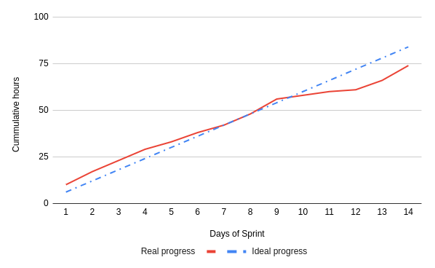
Scrum Meetings
Day | Location
Saturday | Zoom
Tuesday | Zoom/In Person
Thursday | Zoom and TA Meeting

Sprint 2 Recap
During Sprint 2, the backend team generated training data, trained and tuned the model, and built a comparison script to check its outputs. The frontend team researched backend integration, created the new sidebar interface, and began showing runtime complexity results inside the extension.

