Sprint 3 Plan
Product Name: Code Performance Analyzer
Sprint 3 Goal
Sprint 3 will focus on building a backend test-generation framework, integrating selected code into test results, and adding file-saving functionality. On the frontend, we will set up a local server, connect the model results to the UI, and add a fallback mechanism for when the server is inaccessible.

User Stories - Backend
User Story 3.1: As a user, I want to be able to generate a test script to profile for real performance metrics like execution time and memory usage.
- 3.1.1: Create test generation framework and endpoint – 8 hours
- 3.1.2: Integrate selected code and complexity for test results – 4 hours
- 3.1.3: Add file saving functionality - 6 hours

User Stories - Frontend
User Story 3.2: As a user, I want to submit code through the extension and have the locally hosted model instantly return real complexity results, so the extension becomes functional.
- 3.2.1: Create local server to host model endpoints– 8 hours
- 3.2.2: Integrate new model results into frontend– 4 hours
- 3.2.3: Create fallback for inaccessible server - 4 hours

Team Roles
Team Member | Role
Philip Pesic | Frontend Developer
Adwaith Madadi | Backend Developer
Rohit Mandal | Backend Developer
Michael Pimentel | Frontend Developer
Juan Alvarez Sanchez | Frontend Developer

Task Assignment
Philip Pesic: Frontend Tasks 3.2.1, 3.2.2
Adwaith Madadi: Backend Tasks 3.1.2
Rohit Mandal: Backend Tasks 3.1.1, 3.1.2, 3.1.3
Michael Pimentel: Frontend Tasks 3.2.1, 3.2.2
Juan Alvarez Sanchez: Frontend Tasks 3.2.1, 3.2.3
Scrum Board
https://docs.google.com/document/d/15PlzT7TNhLe6Ni6R2BIPt3uAZVzQrlsptkJnA_Or7GM/edit?tab=t.0
Sprint 3 Burnup Chart
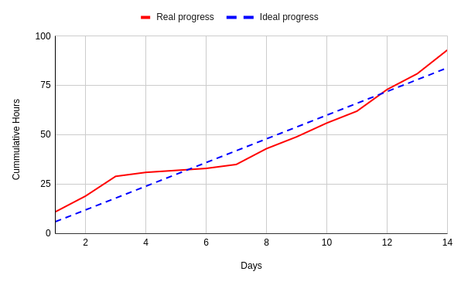
Scrum Meetings:
Day | Location
Saturday | Zoom
Tuesday | Zoom/In Person
Thursday | Zoom and TA Meeting

Sprint 3 Recap
In Sprint 3, the backend team created the test-generation framework, integrated code and complexity into test outputs, and added file-saving support. The frontend team built the local server, connected the model results to the extension interface, and implemented a fallback system to handle cases where the server could not be reached.

