Sprint 4 Plan
Product Name: Code Performance Analyzer
Sprint 4 Goal
Sprint 4 will focus on migrating the model to a production server, setting up a Kind cluster with Docker support, and creating CI/CD scripts to simplify deployment. On the frontend, we will add performance charts to the sidebar, build a test-generation interface, and implement result exporting.

User Stories - Backend
User Story 4.1: As a user, I want to be able to use the model without having to download it and use my computer’s resources.
- 4.1.1: Upgrade to production server for stability – 8 hours
- 4.1.2: Setup Kind cluster and Docker image handling – 6 hours
- 4.1.3: Create CI/CD scripts for easy deployment handling – 4 hours

User Stories - Frontend
User Story 4.2: As a user, I want the interface to highlight inefficient patterns and show a visual performance chart so I can understand and improve my code’s behavior over time.
- 4.2.1: Integrate complexity performance charts into sidebar – 8 hours
- 4.2.2: Create test generation interface – 4 hours
- 4.2.3: Add result export - 6 hours

Team Roles
Team Member | Role
Philip Pesic | Backend Developer
Adwaith Madadi | Backend Developer
Rohit Mandal | Backend Developer
Michael Pimentel | Frontend Developer
Juan Alvarez Sanchez | Frontend Developer

Task Assignment:
Philip Pesic: Backend Tasks 4.1.1, 4.1.2, 4.1.3
Adwaith Madadi: Backend Tasks 4.1.2
Rohit Mandal: Frontend Tasks 4.2.3
Michael Pimentel: Frontend Tasks 4.2.1
Juan Alvarez Sanchez: Frontend Tasks 4.2.2, 4.2.3

Scrum Board:
https://docs.google.com/document/d/15PlzT7TNhLe6Ni6R2BIPt3uAZVzQrlsptkJnA_Or7GM/edit?tab=t.0

Sprint 4 Burnup Chart:
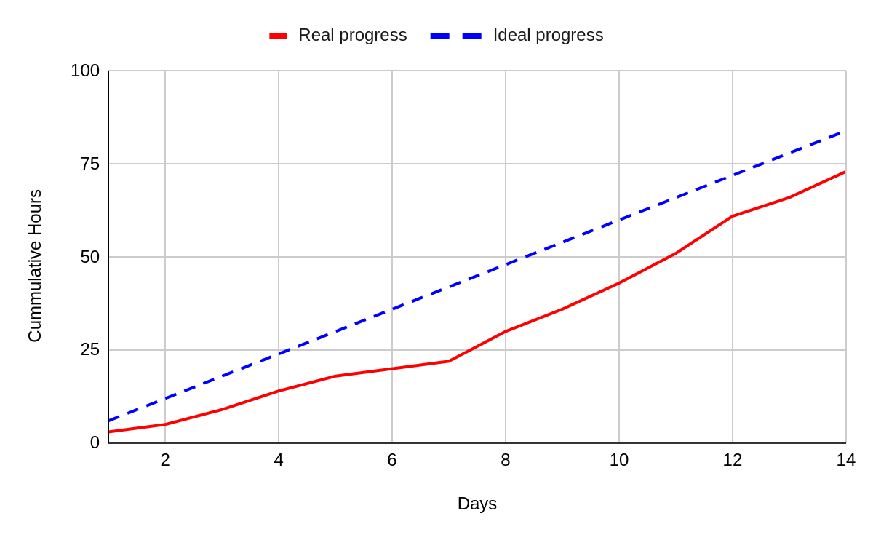

Scrum Meetings:
Day | Location
Saturday | Zoom
Tuesday | Zoom/In Person
Thursday | Zoom and TA Meeting

Sprint 4 Recap:
In Sprint 4, the backend team upgraded the system to a production server, configured the Kind cluster with Docker image handling, and added CI/CD scripts for smoother deployments. The frontend team integrated performance charts, created the test-generation interface, and implemented export functionality to give users clearer insights and more control over results.

