Temporal changes in species diversity of fishes in the center of marine biodiversity

Introduction
The Coral Triangle has long been considered the area of highest marine biodiversity ​(Bellwood and Wainwright 2002; Mora et al. 2003)​. The Philippines has been identified as the global epicenter of marine biodiversity and fish diversity ​(Carpenter and Springer 2005; Allen 2008; Sanciangco et al. 2013)​ with peaks in the central Philippines, which is known as the Visayas Region. Hypotheses attribute this peak of species richness within the Coral Triangle to processes that occur at geological time scales. However, changes in biodiversity may occur on ecological time scales, allowing for the assessment of the potential impact of anthropogenic activities. The Philippines also ranks highest globally for threats to marine biodiversity and coral reefs ​(Bryant et al. 1998; Roberts et al. 2002)​. Therefore, identifying the impacts of human activity, such as overexploitation and habitat degradation, on the diversity of fishes in the Philippines is of growing concern.
Within the Philippines, the Visayas Region is the center of marine conservation adversity ​(Nañola et al. 2011)​. Coastal development, pollution, and overexploitation of marine resources have caused widespread and severe habitat degradation and ecological impacts over recent centuries (Halpern et al. 2008, 2015; McCauley et al. 2015). Overexploitation is the leading threat to marine fishes ​(Collette et al. 2011; Dulvy et al. 2014)​ with exploitation related species richness losses and local extirpations recorded in the Visayas Region ​(Lavides et al. 2009, 2016; Nañola et al. 2011)​. Furthermore, the Philippines is the top supplier of marine ornamental fishes to the global aquarium trade resulting in intense overharvest ​(Rhyne et al. 2017)​, and destructive collection methods (e.g. muro-ami, cyanide, overturning coral heads, dynamite) indirectly affect fish populations through habitat degradation ​(Mamauag 2004; Ochavillo et al. 2004; Pratchett et al. 2008)​. Additional studies are needed to better understand the extent of diversity loss in the most marine biodiverse and anthropogenically threatened region on Earth.
The Smithsonian Institution fish biodiversity collection was a survey of Philippine nearshore fishes from the Visayas Region in 1978 and 1979 (Fig. 2.A) These two collections provide a historical baseline of species diversity and genetic diversity that will be compared to contemporary collections to evaluate the effect of fishing pressure and habitat degradation on changes in nearshore fish diversity in the Visayas Region of the Philippines.
Thus, to explore the potential impacts of overfishing and habitat degradation on fish populations in the Visayas Region, I will identify spatiotemporal decadal changes in species diversity of fishes from an ichthyocide study.
Q1: To what extent has reef fish biodiversity changed over decades of human impacts in the Visayas Region?
H1: Biodiversity indices will decrease over time (Lavides et al. 2009, 2016; Nañola et al. 2011).

Methods
Historical and modern fish biodiversity datasets were compared to determine changes in fish biodiversity over four decades in the Visayas Region. To do this, we took advantage of a collection from the Smithsonian Institution (SI survey) that surveyed fish biodiversity in 1978 and 1979. This study was used to establish a baseline of historical fish biodiversity in the Visayas. The SI survey collected fishes using the ichthyocide rotenone from 71 stations (Fig. 2). The SI survey recorded important metadata such as station coordinates, depth, distance from shore, and habitat, providing an opportunity for accurately modern duplicates. Twenty-four of the historical stations were duplicated in 2019 (3) and 2022 (21).
The contemporary dataset consists of two surveys: 1. The California Academy of Sciences conducted a rotenone survey in 2016 (NSF Award #1257632), which sampled 13 stations in the Central Visayas (CAS survey). 2. The present study has duplicated 24 of the rotenone stations from the historical SI survey in collaboration with Silliman University (SU survey, Fig. 2). Three of the SI rotenone stations were sampled in 2019 and 21 in 2022. Twenty-two of these stations are coral reef habitats and will be the focus of the present study.

Rotenone targets smaller, cryptic species compared to other types of biodiversity surveys such as fish visual census (FVC), which are more biased towards highly visible reef fishes that swim over and above the reef ​(Labrosse et al. 2002)​.
The CAS and SU surveys will be analyzed as both a combined dataset and independent datasets to compare to the historical SI survey. Sample- and individual-based abundance data will be analyzed from the rotenone surveys to create species accumulation curves to test for biodiversity changes between surveys. Tests for differences between historical and contemporary biodiversity samples will use rarefaction and extrapolation analytical methods that have proven robust in comparisons of biodiversity using large samples sizes, while assuming data is not standardized in terms of collection methods and area sampled ​(Beck and Kitching 2007; Colwell et al. 2012; Carvalheiro et al. 2013)​. The data will be treated as non-random, and nonparametric methods will be applied using a biodiversity assessment approach comparing historical versus contemporary collections ​(e.g., Zuur et al. 2007; Williams et al. 2010)​.
The statistical package PRIMER ​(Clarke and Gorley 2018)​ and the vegan package ​(Oksanen et al. 2020)​ in R will be used to generate (1) multivariate analyses on changes in fish community structure, (2) similarity matrices to test for statistically significant clustering using similarity profiles (SIMPROF), and (3) the similarity percentage routine (SIMPER) will be used to identify species that contribute the most to the differentiation between clusters. Associations of fish assemblage and habitat, as well as other geographical patterns, will be identified by analyzing rotenone stations with non-metric multidimensional-scaling (MDS) ordination based on the Bray-Curtis similarity matrix of incidence data. Principal components analysis (PCA) and discriminant analysis of principal components (DAPC) will be used to further understand which species assemblages are responsible for differences among stations. These analyses will be conducted on both the historical and contemporary datasets to compare differences in both spatial and temporal patterns in species communities.

Preliminary Results
To estimate the extent to which species richness has changed over approximately four decades the historical dataset (n=71) was compared to the contemporary dataset (n=16), which included the CAS survey (n=13) and the SU survey stations that were sampled in 2019 (n=3; Fig. 2.A). Interpolation, rarefaction, and extrapolation of the datasets created sample- and individual-based species accumulation curves for the historical and contemporary surveys. Across the 16 rotenone stations (samples) from the contemporary survey 4,995 individuals were encountered, which consisted of 360 unique species. This dataset was extrapolated three times to 48 samples (Fig. 3.A) and 14,985 individuals (Fig. 3.B). When comparing the two sample-based species accumulation curves (Fig. 3.A), a total of 31.8% reduction in species richness was observed, which equates to a reduction of 8.3% per decade. The individual-based species accumulation curve (Fig. 3.B) still observed the same reduction in species richness, however the two datasets would not be considered significantly different on a per individual basis after extrapolation of the contemporary survey. Nevertheless, the extrapolation suggests that if more stations were sampled and more individuals were encountered, then the curves would diverge further, supporting a significant decrease in species richness in the Visayas Region between the two surveys.
The observed 8.3% decrease in species richness per decade in the Visayas Region is over four times higher than the 2% per decade reported in a previous study ​(Nañola et al. 2011)​. Yet, given that the authors did not have a historical baseline of species richness to compare to contemporary surveys, they used space as a proxy for time when comparing the species richness of the Visayas Region to the adjacent Sulu Sea, the region with the highest species richness. It is important to note that Nañola et al. (2011) used data from FVC surveys, which are biased towards the highly visible reef fishes that swim over and above the reef, instead of the smaller, cryptic species, which are better represented in rotenone surveys. Therefore, due to differences in sampling methodology, the current study can’t be directly compared to the results from Nañola et al. (2011), but our preliminary results provide further evidence of biodiversity loss in a global biodiversity hotspot and unless threats such as overfishing and habitat degradation are reduced, further declines can be expected.
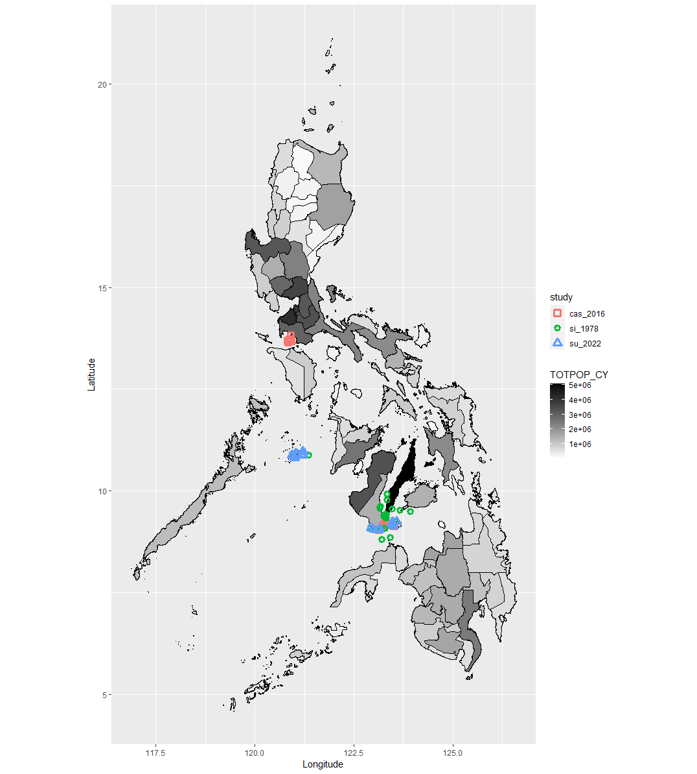

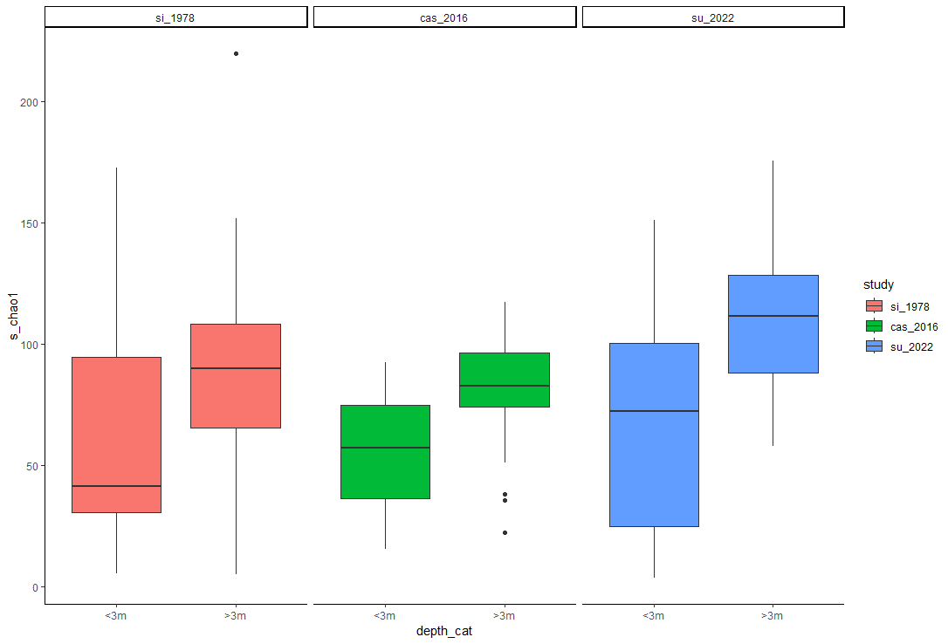
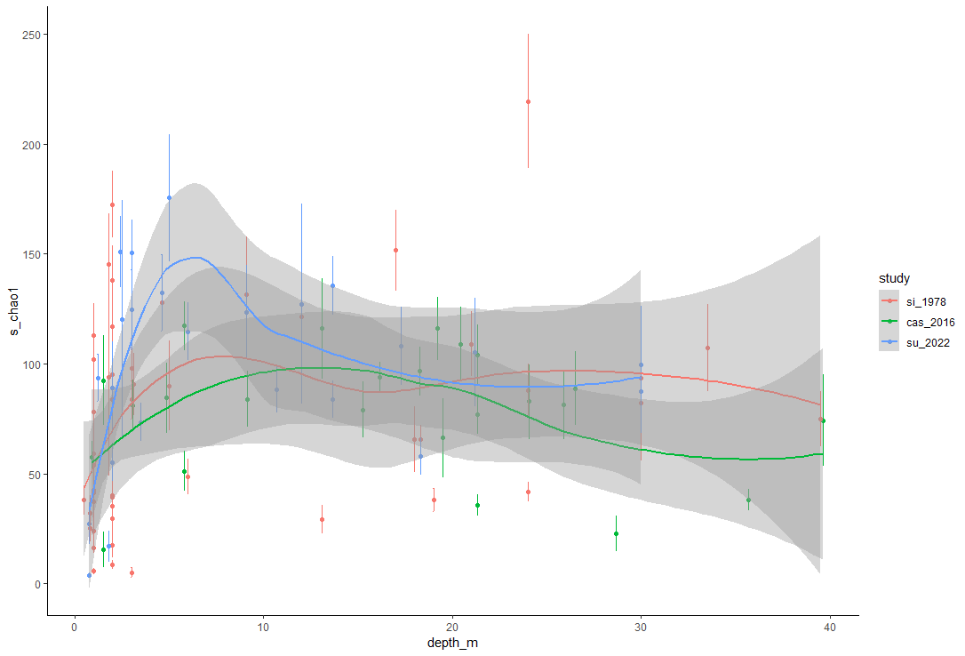
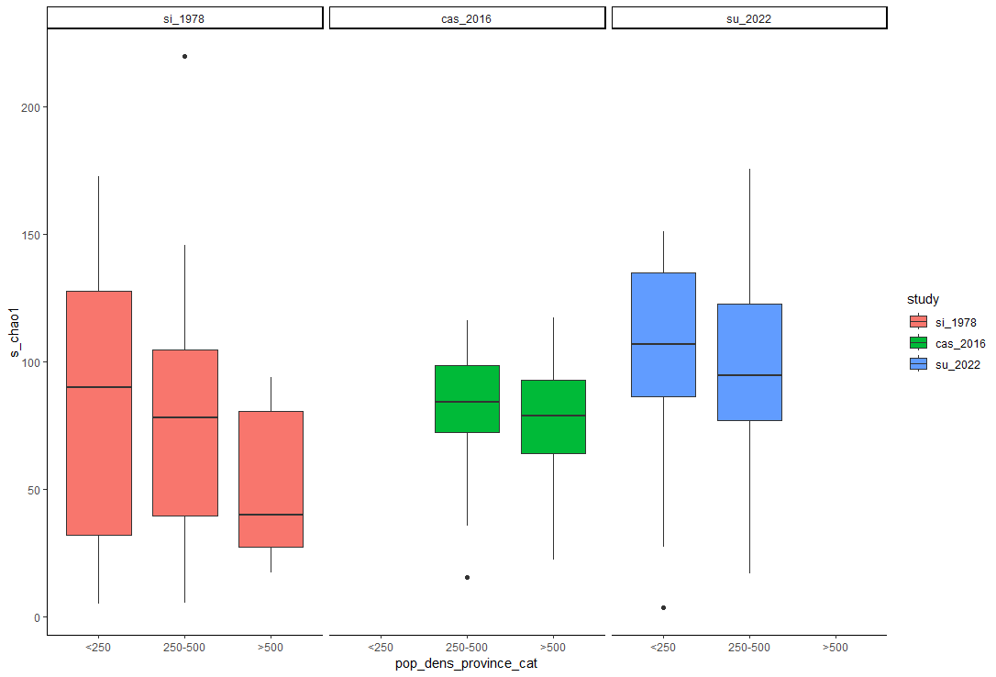

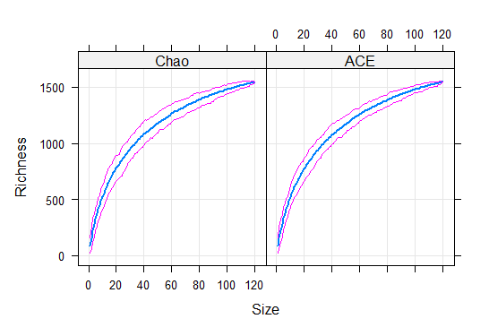
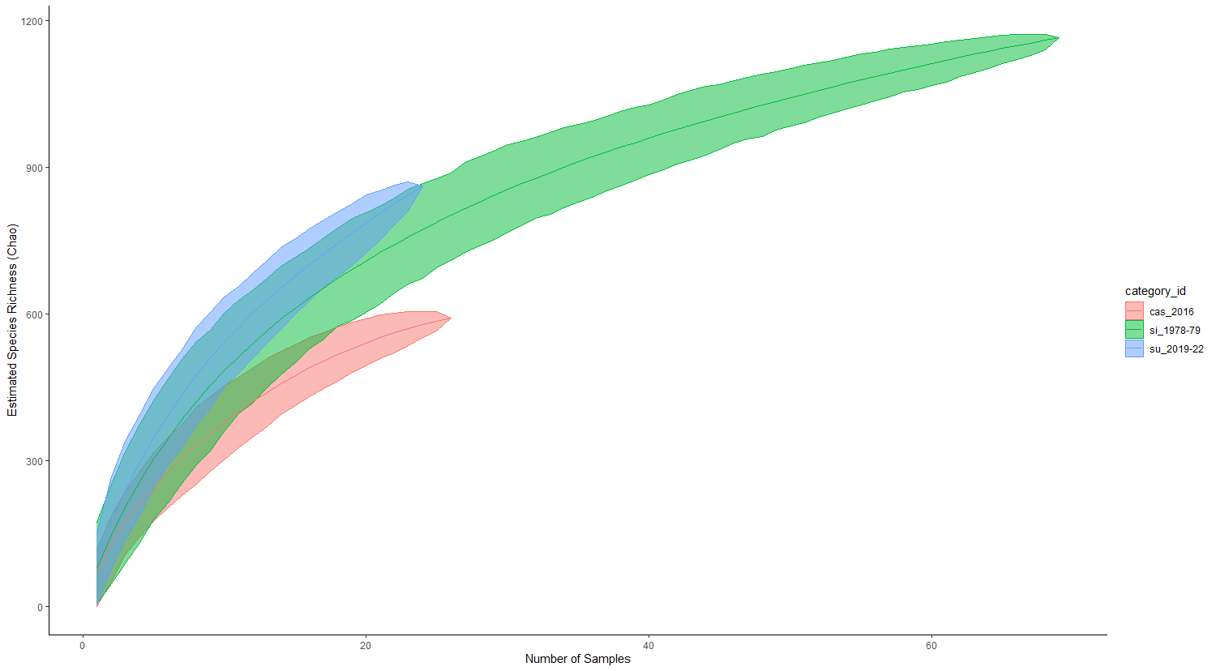

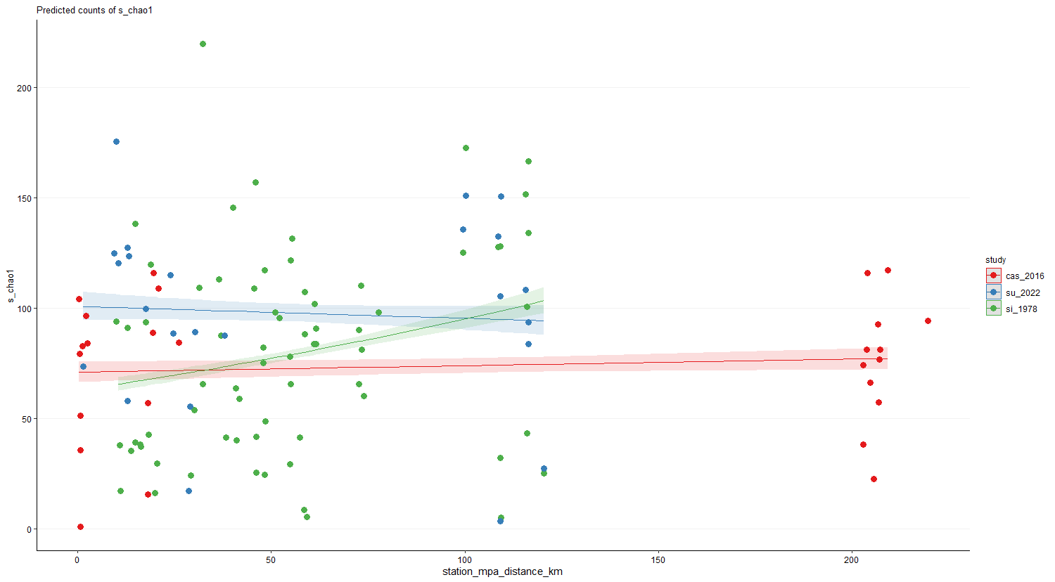

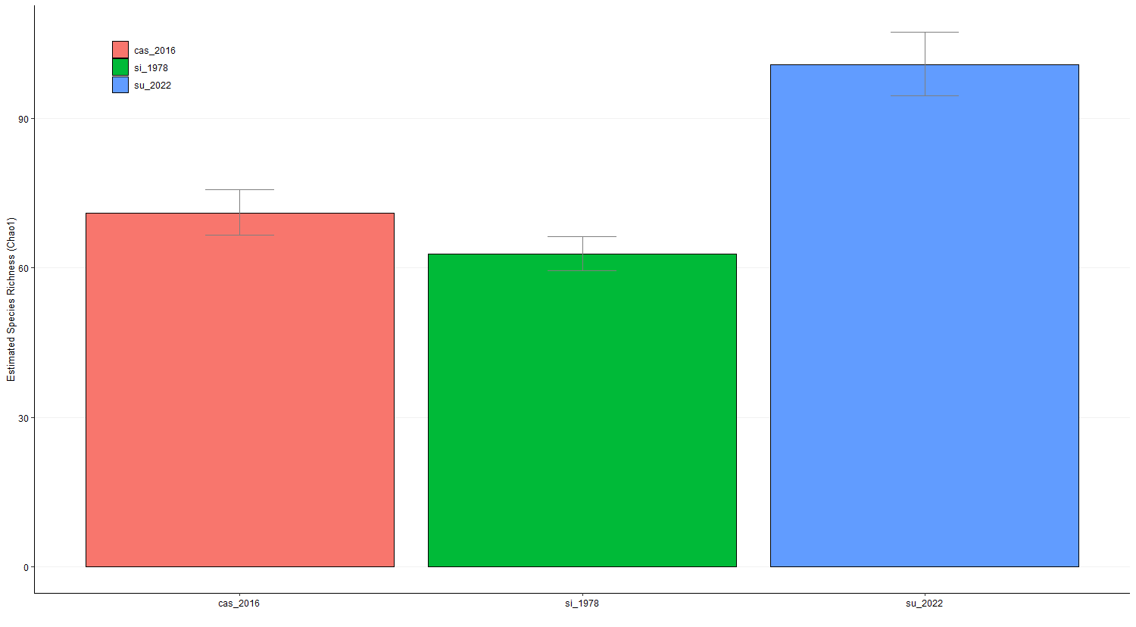

References
Allen GR (2008) Conservation hotspots of biodiversity and endemism for Indo-Pacific coral reef fishes. 556:541–556. doi: 10.1002/aqc
Antonovics J (1976) The Input from Population Genetics: “The New Ecological Genetics.” Systemic Botany 1:233–245.
Antonovics J (2003) Toward community genomics? Ecology 84:
Bankevich A, Nurk S, Antipov D, Gurevich AA, Dvorkin M, Kulikov AS, Lesin VM, Nikolenko SI, Pham S, Prjibelski AD, Pyshkin A v., Sirotkin A v., Vyahhi N, Tesler G, Alekseyev MA, Pevzner PA (2012) SPAdes: A new genome assembly algorithm and its applications to single-cell sequencing. Journal of Computational Biology. doi: 10.1089/cmb.2012.0021
Beck JAN, Kitching IANJ (2007) Estimating regional species richness of tropical insects from museum data: a comparison of a geography-based and sample-based methods. 672–681. doi: 10.1111/j.1365-2664.2007.01291.x
Belkhir K (2004) Genetix 4.05, logiciel sous Windows TM pour la genetique des populations.
Bellwood DR, Wainwright PC (2002) The History and Biogeography of Fishes on Coral Reefs.
Carpenter KE, Springer VG (2005) The center of the center of marine shore fish biodiversity: The Philippine Islands. Environ Biol Fishes 72:467–480. doi: 10.1007/s10641-004-3154-4
Carvalheiro LG, Kunin WE, Keil P, Aguirre-Gutiérrez J, Ellis WN, Fox R, Groom Q, Hennekens S, van Landuyt W, Maes D, van de Meutter F, Michez D, Rasmont P, Ode B, Potts SG, Reemer M, Roberts SPM, Schaminée J, Wallisdevries MF, Biesmeijer JC (2013) Species richness declines and biotic homogenisation have slowed down for NW-European pollinators and plants. Ecol Lett. doi: 10.1111/ele.12121
Clarke KR, Gorley RN (2018) Getting started with PRIMER v7.
Collette BB, Carpenter KE, Polidoro BA, Juan-Jordá MJ, Boustany A, Die DJ, Elfes C, Fox W, Graves J, Harrison LR, Mcmanus R, Nelson R, Restrepo V, Schratwieser J, Sun C, Amorim A, Brick M, Canales C, Cardenas G, Chang S, Chiang W, Jr NDOL, Lessa R, Fredou FL, Oxenford HA, Serra R, Shao K, Sumaila R (2011) High Value and Long Life - Double Jeopardy for Tunas and Billfishes. 98–100.
Colwell RK, Chao A, Gotelli NJ, Lin SY, Mao CX, Chazdon RL, Longino JT (2012) Models and estimators linking individual-based and sample-based rarefaction, extrapolation and comparison of assemblages. Journal of Plant Ecology 5:3–21. doi: 10.1093/jpe/rtr044
Dulvy NK, Fowler SL, Musick JA, Cavanagh RD, Kyne M, Harrison LR, Carlson JK, Davidson LNK, Sonja V (2014) Extinction risk and conservation of the world’s sharks and rays. 1–35. doi: 10.7554/eLife.00590
Dunham J, Peacock M, Tracy CR, Nielsen J, Vinyard G (1999) Assessing extinction risk: Integrating genetic information. Ecology and Society. doi: 10.5751/es-00087-030102
Excoffier L, Lischer HEL (2010) Arlequin suite ver 3.5: A new series of programs to perform population genetics analyses under Linux and Windows. Mol Ecol Resour. doi: 10.1111/j.1755-0998.2010.02847.x
Goudet J (1995) FSTAT (Version 1.2): A Computer Program to Calculate F-statistics. Journal of Heredity. doi: 10.1093/oxfordjournals.jhered.a111627
Hauser L, Adcock GJ, Smith PJ, Ramı JHB, Carvalho GR (2002) Loss of microsatellite diversity and low effective population size in an overexploited population of New Zealand snapper ( Pagrus auratus ). doi: 10.1073/pnas.172242899
He T, Lamont BB, Krauss SL, Enright NJ, Miller BP (2008) Covariation between intraspecific genetic diversity and species diversity within a plant functional group. 96:956–961.
Hutchinson WF, Oosterhout C van, Rogers SI, Carvalho GR (2003) Temporal analysis of archived samples indicates marked genetic changes in declining North Sea cod (Gadus morhua). 2125–2132. doi: 10.1098/rspb.2003.2493
Jakobsdóttir KB, Pardoe H, Magnússon Á, Björnsson H, Pampoulie C, Ruzzante DE, Marteinsdóttir G (2011) Historical changes in genotypic frequencies at the Pantophysin locus in Atlantic cod (Gadus morhua) in Icelandic waters: Evidence of fisheries-induced selection? Evol Appl. doi: 10.1111/j.1752-4571.2010.00176.x
Labrosse P, Kulbicki M, Ferraris J (2002) Underwater fish visual census surveys.
Lamy T, Laroche F, David P, Massol F, Jarne P (2017) The contribution of species – genetic diversity correlations to the understanding of community assembly rules. 759–771. doi: 10.1111/oik.03997
Lavides MN, Polunin NVC, Stead SM, Tabaranza DG, Comeros MT, Dongallo JR (2009) Finfish disappearances around Bohol, Philippines inferred from traditional ecological knowledge. Environ Conserv. doi: 10.1017/S0376892909990385
Lavides MN, Molina EP v, Rosa GE de (2016) Patterns of Coral-Reef Finfish Species Disappearances Inferred from Fishers’ Knowledge in Global Epicentre of Marine Shorefish Diversity. PLoS One 11:1–24. doi: 10.1371/journal.pone.0155752
Mamauag SS (2004) The live reef food fish trade in the Philippines.
Marçais G, Kingsford C (2011) A fast, lock-free approach for efficient parallel counting of occurrences of k-mers. Bioinformatics. doi: 10.1093/bioinformatics/btr011
Maruyama T, Fuerst PA (1985) Population bottlenecks and nonequilibrium models in population genetics. III. Genic homozygosity in populations which experience periodic bottlenecks. Genetics. doi: 10.1093/genetics/111.3.691
Mora C, Chittaro PM, Sale PF, Kritzer JP, Ludsin SA (2003) Patterns and processes in reef fish diversity. Nature 2003 421:6926 421:933–936. doi: 10.1038/nature01393
Nañola CL, Aliño PM, Carpenter KE (2011) Exploitation-related reef fish species richness depletion in the epicenter of marine biodiversity. Environ Biol Fishes 90:405–420. doi: 10.1007/s10641-010-9750-6
Ochavillo D, Hodgson G, Shuman C, Ruz R (2004) Status of the Philippine Marine Aquarium Fish Trade. In: Turbulent Seas: The Status of Philippine Marine Fisheries. Department of Agriculture-Bureau of Fisheries and Aquatic Resources, Cebu City, pp 60–64
Oksanen J, Blanchet FG, Friendly M, Kindt R, Legendre P, Mcglinn D, Minchin PR, O’hara RB, Simpson GL, Solymos P, Henry M, Stevens H, Szoecs E, Maintainer HW (2020) Package “vegan” Title Community Ecology Package Version 2.5-7.
Pinsky ML, Palumbi SR (2014) Meta-analysis reveals lower genetic diversity in overfished populations. Mol Ecol 23:29–39. doi: 10.1111/mec.12509
Pratchett MS, Munday PL, Wilson SK, Graham NAJ, Cinner JE, Bellwood DR, Jones GP, Polunin NVC, McClanahan TR (2008) Effects of climate-induced coral bleaching on coral-reef fishes ecological and economic consequences. In: Oceanography and Marine Biology: An Annual Review.
Prjibelski A, Antipov D, Meleshko D, Lapidus A, Korobeynikov A (2020) Using SPAdes De Novo Assembler. Curr Protoc Bioinformatics. doi: 10.1002/cpbi.102
Rhyne AL, Tlusty MF, Szczebak JT, Holmberg RJ (2017) Expanding our understanding of the trade in marine aquarium animals. PeerJ 5:e2949. doi: 10.7717/peerj.2949
Roberts CM, McClean CJ, Veron JEN, Hawkins JP, Allen GR, Mcallister DE, Mittermeier CG, Schueler FW, Spalding M, Wells F, Vynne C, Werner TB, Vertut J, Doyle A, Mittermeier CG, Schueler FW (2002) Marine Biodiversity Hotspots and Conservation Priorities for Tropical Reefs. 295:1280–1284.
Rohland N, Reich D (2012) Cost-effective, high-throughput DNA sequencing libraries for multiplexed target capture. Genome Res. doi: 10.1101/gr.128124.111
Rousset F (2008) GENEPOP’007: A complete re-implementation of the GENEPOP software for Windows and Linux. Mol Ecol Resour. doi: 10.1111/j.1471-8286.2007.01931.x
Ryman N, Utter F, Laikre L (1995) Protection of intraspecific biodiversity of exploited fishes. Rev Fish Biol Fish. doi: 10.1007/BF01103814
Sanciangco JC, Carpenter KE, Etnoyer PJ, Moretzsohn F (2013) Habitat Availability and Heterogeneity and the Indo- Pacific Warm Pool as Predictors of Marine Species Richness in the Tropical Indo-Pacific. doi: 10.1371/journal.pone.0056245
Smith DG, Williams JT (1999) The Great Albatross Philippine Expedition and its fishes.
Therkildsen NO, Nielsen EE, Swain DP (2010) Large effective population size and temporal genetic stability in Atlantic cod (Gadus morhua) in the southern Gulf of St. Lawrence. 1595:1585–1595. doi: 10.1139/F10-084
Vellend M (2003) Island Biogeography of Genes and Species. Am Nat 162:358–365.
Vellend M (2005) Species Diversity and Genetic Diversity : Parallel Processes and Correlated Patterns.
Vurture GW, Sedlazeck FJ, Nattestad M, Underwood CJ, Fang H, Gurtowski J, Schatz MC (2017) GenomeScope: Fast reference-free genome profiling from short reads. In: Bioinformatics.
Willi Y, van Buskirk J, Hoffmann AA (2006) Limits to the adaptive potential of small populations. Annu Rev Ecol Evol Syst 37:
Williams JT, Carpenter KE, Tassell JL van, Hoetjes P, Toller W, Smith M (2010) Biodiversity Assessment of the Fishes of Saba Bank Atoll, Netherlands Antilles. 5:1–37. doi: 10.1371/journal.pone.0010676
Zuur AF, Leno EN, Smith GM (2007) Analyzing Ecological Data.

