Temporal changes in reef fish communities in the center of marine biodiversity

Introduction
The Coral Triangle has long been considered the area of highest marine biodiversity ​(Bellwood and Wainwright 2002; Mora et al. 2003)​. The Philippines has been identified as the global epicenter of marine biodiversity and fish diversity ​(Carpenter and Springer 2005; Allen 2008; Sanciangco et al. 2013)​ with peaks in the central Philippines, which is known as the Visayas Region. Hypotheses attribute this peak of species richness within the Coral Triangle to processes that occur at geological time scales. However, changes in biodiversity may occur on ecological time scales, allowing for the assessment of the potential impact of anthropogenic activities. The Philippines also ranks highest globally for threats to marine biodiversity and coral reefs ​(Bryant et al. 1998; Roberts et al. 2002)​. Therefore, identifying the impacts of human activity, such as overexploitation and habitat degradation, on the diversity of fishes in the Philippines is of growing concern.
Within the Philippines, the Visayas Region is the center of marine conservation adversity ​(Nañola et al. 2011)​. Coastal development, pollution, and overexploitation of marine resources have caused widespread and severe habitat degradation and ecological impacts over recent centuries (Halpern et al. 2008, 2015; McCauley et al. 2015). Overexploitation is the leading threat to marine fishes ​(Collette et al. 2011; Dulvy et al. 2014)​ with exploitation related species richness losses and local extirpations recorded in the Visayas Region ​(Lavides et al. 2009, 2016; Nañola et al. 2011)​. Furthermore, the Philippines is the top supplier of marine ornamental fishes to the global aquarium trade resulting in intense overharvest ​(Rhyne et al. 2017)​, and destructive collection methods (e.g. muro-ami, cyanide, overturning coral heads, dynamite) indirectly affect fish populations through habitat degradation ​(Mamauag 2004; Ochavillo et al. 2004; Pratchett et al. 2008)​. Additional studies are needed to better understand the extent of diversity loss in the most marine biodiverse and anthropogenically threatened region on Earth.
The Smithsonian Institution fish biodiversity collection was a survey of Philippine nearshore fishes from the Visayas Region in 1978 and 1979 (Fig. 1, Table 1), which was duplicated in 2019 and 2022. These two collections provide a historical baseline of reef fish communities that will be compared to contemporary collections to evaluate the what changes in nearshore fish diversity have occurred over four decades in the Visayas Region of the Philippines.
Thus, to explore the potential impacts of overfishing and habitat degradation on reef fish communities in the Visayas Region, we will identify spatiotemporal changes in reef fish communities using the ichthyocide study in order to answer the question: To what extent has reef fish biodiversity and communities changed over decades of human impacts in the Visayas Region? We hypothesize that fish biodiversity indices will decrease over time and changes in fish communities will be observed (Lavides et al. 2009, 2016; Nañola et al. 2011).
Methods
Study Area and Sampling Design
Historical and modern fish biodiversity datasets were compared to determine changes in coral reef fish biodiversity over four decades in the Bohol Sea and the Sulu Sea of the Visayas Region. To do this, we took advantage of a collection from the Smithsonian Institution (SI) that surveyed coral reef fish communities in 1978 and 1979. This study was used to establish a baseline of historical biodiversity. The SI 1978/1979 survey collected fishes using the ichthyocide rotenone from 71 stations. The SI survey recorded important metadata such as station coordinates, depth, distance from shore, and habitat, allowing resampling during the Silliman University (SU) survey in 2019 and 2022 (Fig. 1). Sampling sites were distributed across the Bohol and Sulu Seas, two distinct areas within the Visayas Region. A total of 21 historical stations were duplicated, resulting in 42 paired coral reef fish biodiversity samples (Table 1).

Data Collection
Fishes were collected using the ichthyocide rotenone, following established standardized methods consistent between both survey periods. Specimens were identified to the lowest possible taxonomic level using available field guides, morphological keys, and expert taxonomic verification. Taxonomic ambiguities were categorized into species complexes at the genus or family level when necessary. Eschmeyer's Catalog of Fishes (Fricke et al., 2025) was used for taxonomic verification across fish identification resources. Species abundance was recorded for each station, forming the basis for subsequent biodiversity and community analyses. Data was analyzed in R Studio (Posit team, 2025) using the vegan (Oksanen et al., 2025) and clustsig (Clarke et al., 2008) packages.

Alpha Diversity
Alpha diversity was quantified for each station (n = 42) to assess within-site diversity and preserve variability among replicates. Metrics included species richness (S), Shannon’s diversity index (H), Pielou’s evenness (J), Simpson's index (D), inverse Simpson's index (1/D), unbiased Simpson’s index, and Fisher’s alpha (Fisher’s α), calculated using the diversity, specnumber, fisher.alpha, and simpson.unb functions in the vegan package (Oksanen et al. 2025). For Pielou’s evenness, Shannon’s index was divided by the natural logarithm of richness: H/ln(S).
To test for spatiotemporal differences, each metric was modeled using linear mixed-effects models of the form: metric ~ Survey * Sea + (1 | station_pair), where Survey (Historical: SI 1978/1979; Modern: SU 2019/2022) and Sea (Bohol Sea, Sulu Sea) were fixed effects, and station pair was a random effect to account for repeated sampling of the same location. Type III Wald χ² tests were used for significance testing with the anova function from the car package (Fox & Weisberg, 2019). Post-hoc pairwise comparisons of estimated marginal means were conducted using the emmeans package with Tukey adjustment for multiple comparisons.

Species Accumulation and Richness Estimators
Species accumulation curves compared sample-based (poolaccum and estaccumR; Gotelli & Colwell, 2001) and individual-based (specaccum rarefaction; Gotelli & Graves, 1996) richness across eras and seas. Richness estimators included the Abundance-based coverage estimator (ACE: Chao et al., 1993) Chao1 (Chao, 1984), Jackknife 1, Jackknife 2 (Burnham & Overton, 1979), and Bootstrap (Smith & van Belle, 1984). Non-overlapping 95% confidence intervals indicated significant richness differences between groups.

Beta Diversity and Community Structure
To evaluate differences in reef fish community composition across survey era (Historical vs. Modern) and sea (Bohol Sea vs. Sulu Sea), Bray-Curtis dissimilarities (bc_dist) among sites were calculated using the vegdist function in the vegan package (Oksanen et al. 2025). A permutational multivariate analysis of variance (PERMANOVA) was applied using the adonis2 function on the Bray–Curtis dissimilarity matrix with the formula: bc_dist ~ survey * sea. This was tested with 999 permutations.
Although adonis2 does not support random effects, repeated sampling of the same locations was considered during interpretation. Post-hoc pairwise PERMANOVA comparisons were calculated using the pairwiseadonis package (Martinez Arbizu 2020) with Bonferroni-adjusted p-values to examine differences across the four survey × sea combinations.
To assess homogeneity of multivariate dispersion (beta dispersion), we used the betadisper function in vegan to calculate the average distance of each station to its group centroid. A two-way repeated-measures ANOVA was performed on these distances with survey, sea, and their interaction as fixed effects with the formula: bc_dist ~ survey * sea.

Community Similarity and Cluster Analysis
To evaluate spatiotemporal differences in reef fish community structure, a hierarchical cluster analysis was performed using Bray–Curtis dissimilarity and the unweighted pair group method with arithmetic mean (UPGMA) linkage. The similarity profile (SIMPROF) test was used to identify statistically significant clusters (α = 0.05) with the simprof function from the clustsig package (Whitaker & Christman, 2014). The analysis incorporated all 42 sampled reef fish communities from 21 paired stations across the two survey eras and two seas. Each station’s community composition was independently assessed based on species abundance data without prior aggregation. The resulting clusters were visualized in a dendrogram. Similarity percentage (SIMPER) analyses were used to identify species contributing significantly to observed differences among communities (Clarke, 1993) using the simper function from the vegan package.

Trophic Level
To assess spatiotemporal differences in trophic composition, we calculated the community-weighted mean (CWM) trophic level for each survey station. FishBase trophic level data were retrieved using the ecology function from the rfishbase package. Trophic levels were extracted from both DietTroph and FoodTroph fields, prioritizing DietTroph when available. Of 957 total species (including complexes), 638 matched to FishBase records.
The CWM trophic level was calculated using the formula: CWM = ∑(pᵢ × TLᵢ), where pᵢ is the proportional abundance of species i and TLᵢ is its trophic level. CWM values were computed using a proportional abundance matrix derived by dividing the abundance of each species by the total count per site.
To test for significant spatiotemporal differences, we fit a linear mixed-effects model using the lmer function from the lme4 package with survey era, sea, and their interaction as fixed effects and station pair as a random effect. Type III Wald χ² tests were conducted using the anova function from the car package (Fox & Weisberg, 2019).
Results
The reef fish biodiversity study sampled 42 total stations across the Bohol (n = 26) and Sulu Seas (n = 16) between the Historical (n = 21) and Modern (n = 21) survey eras. The study sampled 26,254 individuals, 957 species, 292 genera, and 77 families (Table 1). Fewer individuals, species, and genera were encountered in the Modern survey, however more families were represented. The Sulu Sea encountered fewer species but more individuals, genera, and families, despite fewer stations sampled. Both the Bohol and Sulu Seas had fewer species and genera in the Modern survey, but more families. The number of individuals encountered decreased in the Bohol Sea, but increased in the Sulu Sea.
Station-level resolution, coupled with mixed-effects modeling, strengthens the reliability of our findings by controlling for spatial autocorrelation and repeated sampling. These analytical choices enhance the interpretability of subtle but ecologically meaningful patterns that may be obscured in more aggregated analyses.

Alpha Diversity
The linear mixed-effect model testing spatiotemporal differences in alpha diversity metrics for paired reef fish communities identified that there were no statistically significant differences across survey era, sea, or their interaction for most metrics (Table 2). However, Shannon’s H showed a significant effect of the Survey x Sea interaction (χ² = 4.05, p = 0.044) suggesting a potential interactive effect between time and location on evenness. Fisher’s α showed a significant effect of Sea (χ² = 5.37, p = 0.020), with higher values in the Sulu Sea compared to the Bohol Sea. This suggests a spatial variation in diversity, regardless of era, with greater species richness and/or rarity in Sulu reef communities. The Survey x Sea interaction effect was marginally significant (0.053 < p < 0.089) for Pielou’s J, the Simpson Index, unbiased Simpson Index, and Alpha, further suggesting a potential interactive effect between time and location. However, post-hoc comparisons (Table S1) revealed no significant pairwise differences for each metric after Tukey correction. However, comparisons involving the Sulu Sea tended to show slightly greater diversity estimates, particularly in the historical era. Considering the limited sample sizes, the statistical power for post-hoc tests may be modest.

Species Accumulation and Richness Estimators
Individual-based species accumulation curves examined species richness accounting for the number of individuals sampled per survey with rarefaction and identified a decrease in species richness over time (Fig. S2) and higher species richness in the Sulu Sea than the Bohol Sea (Fig. S3). There was an increase in species richness in the Bohol Sea and a decrease in the Sulu Sea (Fig. 2), however the Modern Bohol Sea survey sampled the fewest number of individuals. The Historical Bohol Sea survey and the Historical and Modern Sulu Sea survey sampled between 7,537 and 7,807 individuals, while the Modern Bohol Sea survey sampled 3,366, which is 43.1-44.7% of the other surveys. Therefore, the apparent increase in species richness in the Bohol Sea species accumulation curves is more of a function of a reduction in the number of individuals encountered (catch) than a reduction in the number of species (396), which was similar to that of the Modern Sulu Sea survey (410), resulting in the discrepancy between the slopes of the curves.
Sample-based species accumulation curves suggested a reduction in species richness over time only with the incidence data and the bootstrap method (Fig. S8). The other incidence-based methods (Fig. S8) and abundance-based methods (Fig. S5) did not reveal temporal changes in species richness. Several incidence- (Fig. S6) and abundance-based methods (Fig. S9) suggest spatial differences in species richness with higher estimates in the Sulu Sea than the Bohol Sea. Abundance-based species richness estimators identified Sea as a significant effect for both Chao and ACE (Table 3), with pairwise comparisons identifying Historical Sulu Sea species richness as higher than that for Bohol Sea for both eras suggesting spatiotemporal changes in species richness (Fig. 3, Table S2). Furthermore, several incidence-based species richness estimators suggest a decrease in the Bohol Sea (first- and second-order jackknife and bootstrap) and the Sulu Sea (first-order jackknife and bootstrap). It is important to consider the reduced sample sizes upon pooling stations by survey era and sea may limit the statistical power to detect sample-based differences in species richness, however confidence intervals (ribbons) for the two eras overlapped at low sampling effort and diverged with increasing pooled samples, indicating a statistically robust decline in richness through time.

Beta Diversity and Community Structure
The PERMANOVA revealed significant effects of survey era (p = 0.001), sea (p = 0.001), and their interaction (p = 0.024) on reef fish community composition (Table 4). Pairwise PERMANOVA comparisons (Table 5) revealed significant compositional differences between all pairs of groups (adjusted p < 0.05) except between Historical Sulu and Bohol Sea (adjusted p = 0.054) which displayed marginal significance. These pairwise differences corroborate the global PERMANOVA findings and support distinct faunal assemblages between survey eras and seas.
Despite these compositional shifts, the test for homogeneity of group dispersions (beta dispersion) showed no significant differences among groups (Table S3), suggesting that observed differences in community structure were not confounded by differences in within-group variability. The NMDS plot shows segregation by sea along NMDS1 and survey era along NMDS2 (Fig. 5). Ellipses for each group show consistent overlap and separation consistent with homogeneous dispersion, further supporting the validity of the PERMANOVA results.

Community Similarity and Cluster Analysis
The SIMPROF analysis identified 17 significant clusters (Figure 6, Table S5). Clusters varied widely in their composition, revealing both spatial (Bohol vs. Sulu Sea) and temporal (Historical vs. Modern) patterns. Stations from similar geographic regions generally grouped together, with notable separation between the Bohol Sea and Sulu Sea communities. However, temporal distinctions were also evident within these spatial groupings. For example, clusters 1, 7, 8, and 9 comprised exclusively Historical Sulu Sea stations, while clusters 5, 6, and 12 were exclusively Modern Sulu Sea stations, illustrating clear temporal shifts in community structure within the Sulu Sea. Similarly, in the Bohol Sea, clusters predominantly contained stations from a single era, with cluster 16 containing mostly Historical Bohol Sea sites and clusters 13 and 14 primarily grouping Modern Bohol Sea stations. Notably, cluster 17 showed mixed-era grouping in shallow-water communities (approximately 2.0–3.5 m) from the Bohol Sea, indicating similarities in reef fish community composition across eras in shallow habitats at these locations.

Trophic Level
Variation in community-weighted mean trophic level was observed with a decrease in mean trophic level in both the Bohol and Sulu Sea, however these changes were not significant between survey eras and seas (Fig. 7, Table S4).
Conclusion
Alpha diversity analyses revealed subtle but ecologically relevant spatial differences in reef fish community structure, particularly higher Fisher’s α in the Sulu Sea. The lack of strong temporal effects may indicate community stability at the alpha scale across decades, although the interaction term for Shannon’s H metric suggests that compositional evenness may vary with survey era and sea. Additionally, the interaction terms for Pielou’s J, Simpson Index, unbiased Simpson Index, and Fisher’s α were marginally significant reinforcing a subtle variation with survey era and sea. These findings underscore the value of analyzing each station independently, maintaining site-level resolution while leveraging mixed models to account for spatial pairing. Given their mathematical robustness and interpretability, Shannon’s H and Fisher’s α are recommended as primary diversity metrics in marine fish community studies (Magurran 2013; Chao et al. 2014; Jost 2007). Fisher’s α is particularly appropriate for taxonomically rich communities like reef fishes where rare species are prevalent, whereas Simpson’s Index, and its derivatives, are less sensitive to rare species but useful to assess dominance/evenness.
The sample-based species accumulation analysis demonstrates a significant loss of reef fish species richness between survey eras particularly in the Sulu Sea. These results, consistent across multiple richness estimators, suggest a substantial and spatially structured decline in reef fish diversity over the past four decades in the central Philippines. The Sulu Sea supported greater species richness than the Bohol Sea in both eras but also experienced a more marked reduction in richness over time. These results reinforce the conclusion of significant, location-specific losses in coral reef fish diversity across the region. This supports several studies that observed declines in fish species richness and local extirpations within the Visayas Region of the Philippines ​(Lavides et al. 2009, 2016; Nañola et al. 2011)​.
The beta diversity and community structure analyses confirm statistically significant changes in reef fish communities between eras and seas. The beta dispersion analysis provides assurance that these results are not driven by differences in within-group variability, thus validating the interpretation of the PERMANOVA results. This combined approach provides strong evidence for spatiotemporal shifts in community composition. Differences in community composition were statistically supported by the global and pairwise PERMANOVA tests but not driven by unequal group dispersions. Therefore, the observed spatiotemporal differences in reef fish assemblages are more likely attributable to shifts in species composition rather than variation in community heterogeneity.
The SIMPROF-based cluster analysis provided robust statistical support for both spatial and temporal distinctions in reef fish community structure. The clear separation of stations by sea (Bohol vs. Sulu) and survey era (Historical vs. Modern) highlights significant changes in reef fish assemblages over the four-decade interval between surveys. These results suggest strong spatial heterogeneity and notable temporal shifts, which could be linked to regional environmental differences and long-term ecological or anthropogenic changes influencing reef habitats and their fish communities. The detection of significant clusters supports the hypothesis of differential community responses to local and regional factors over time.
Community-weighted mean trophic level declined over time, but not significantly, indicating a resilience to a potential shift toward lower trophic-level fish in modern reef communities, which does not support the fishing down the food web hypothesis (Pauly et al., 1998). However, similarity profiles indicate temporal shifts in fish communities in both seas, potentially indicating that there have been winner and loser species.

Significance
This multi-faceted analysis of reef fish biodiversity provides new insights into how tropical reef communities have responded to ecological and anthropogenic pressures across space and time. This study reveals that while local diversity (alpha scale) has remained relatively stable over four decades, community composition and species richness have shifted markedly—particularly in the Sulu Sea.
The decline in species richness and significant changes in beta diversity across survey eras provide strong evidence for long-term biotic homogenization and community turnover in Philippine reef fish assemblages. The observed shifts reflect real ecological change likely driven by a combination of habitat degradation, fishing pressure, and other anthropogenic stressors (Cinner et al. 2016; Maire et al. 2023; Richardson et al. 2020). These findings contribute to a growing body of literature documenting biodiversity loss in the Coral Triangle (Barneche et al. 2021; McLean et al. 2021) and reinforce the urgency of spatially explicit conservation strategies that account for regional and temporal heterogeneity in ecological responses.

Figures
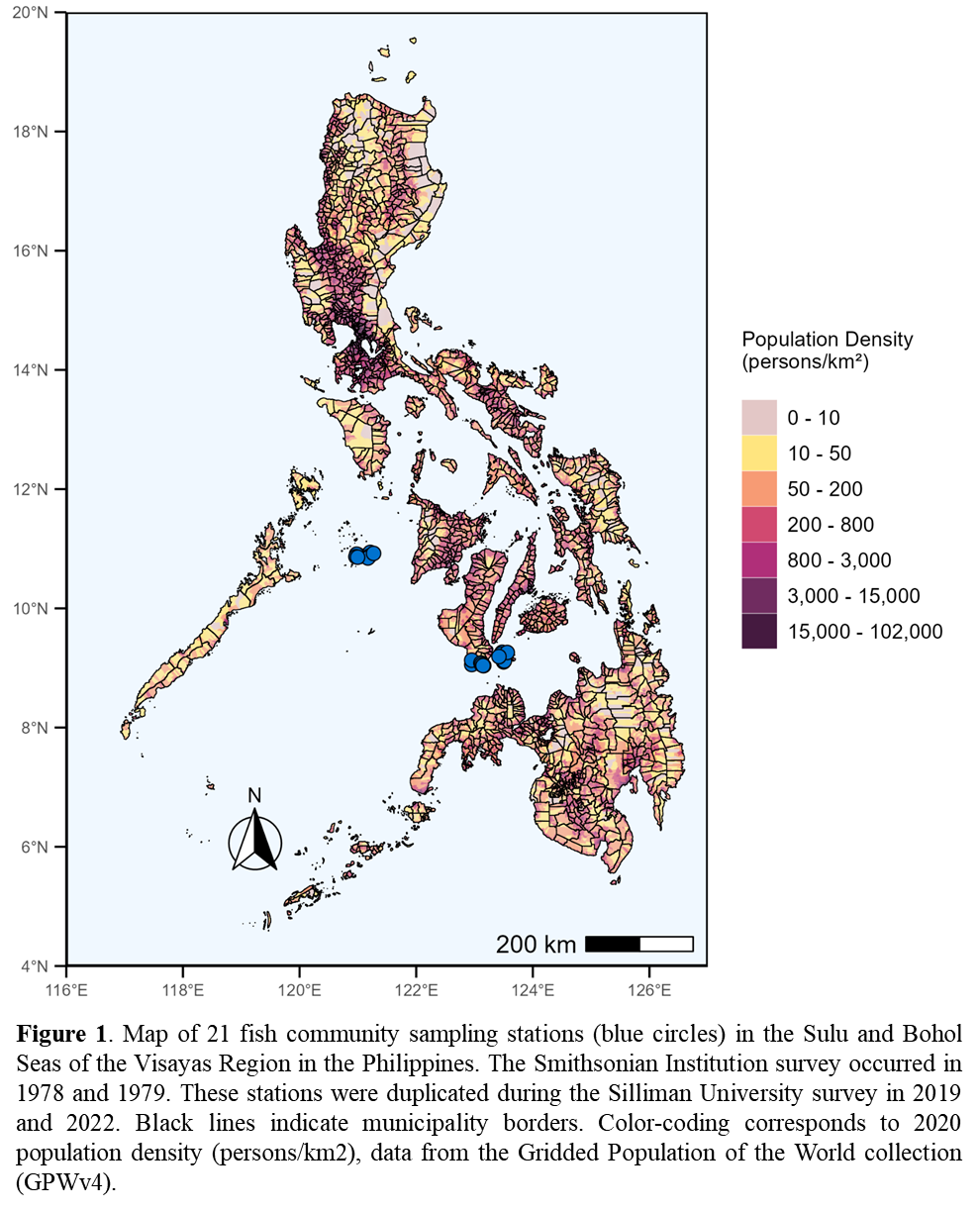
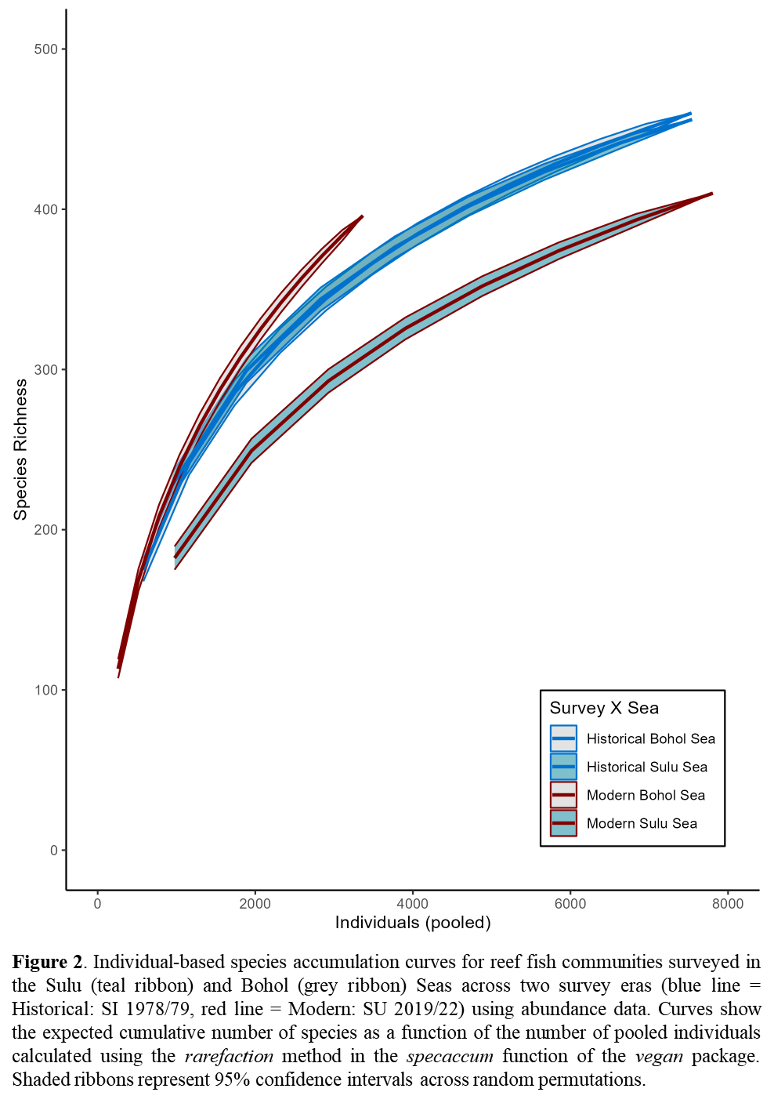
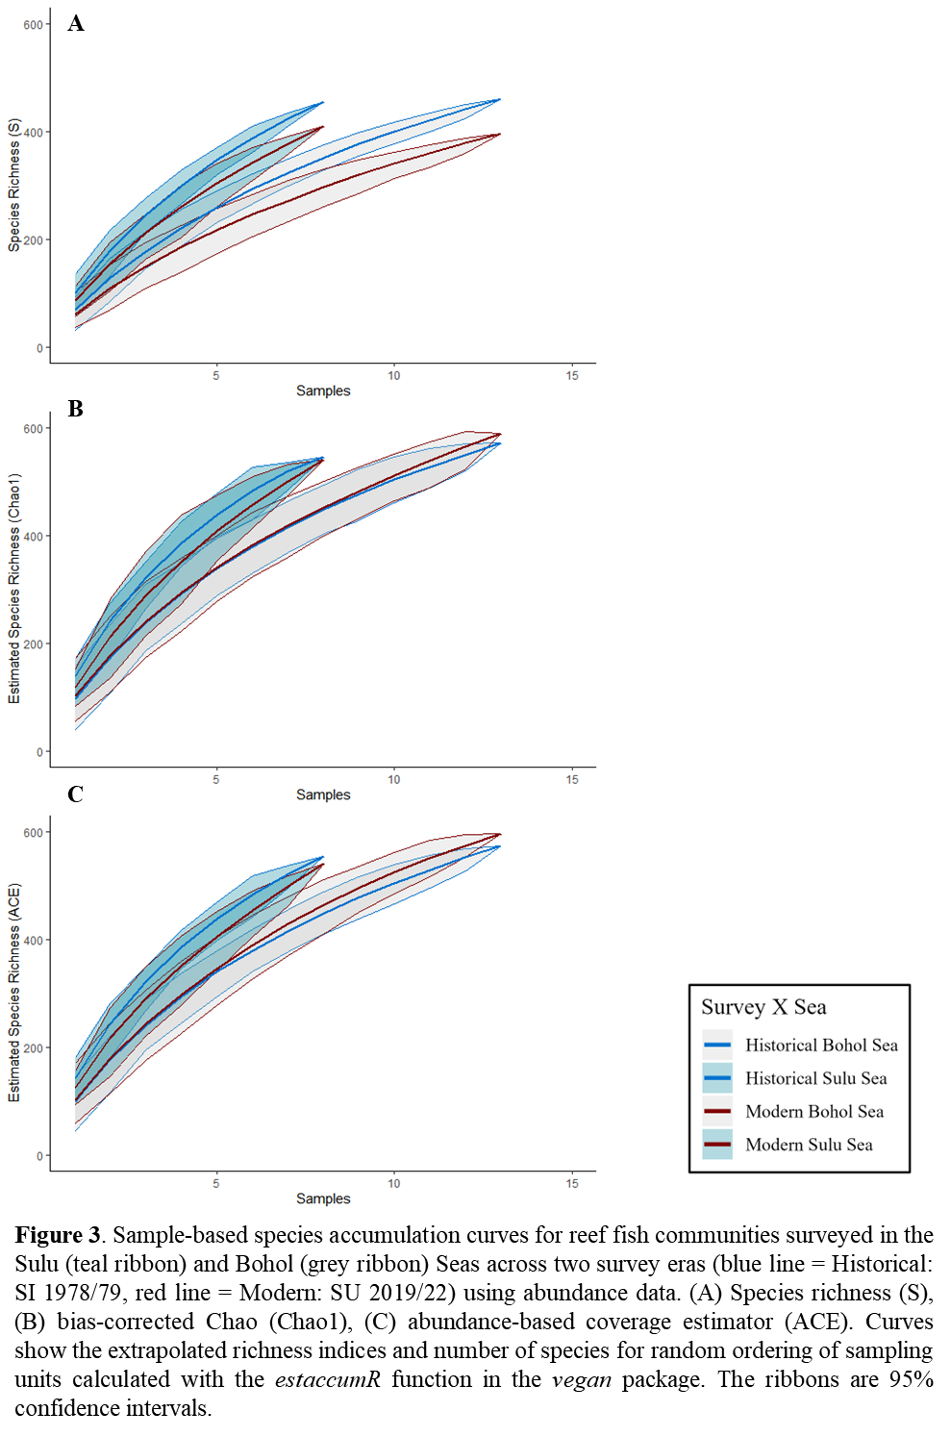
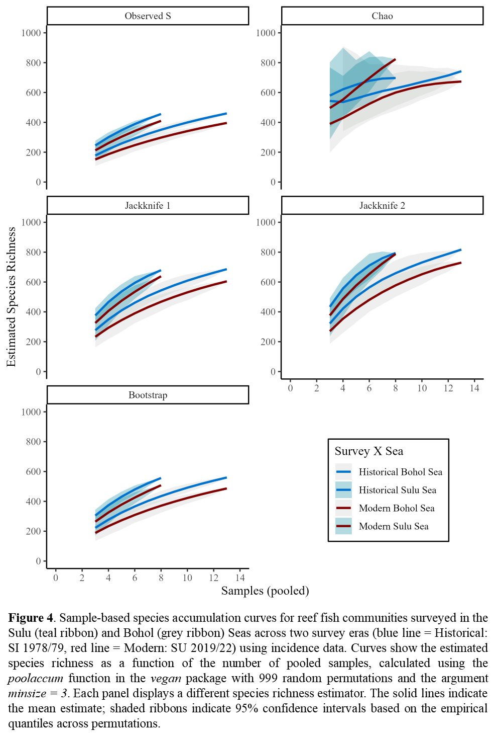
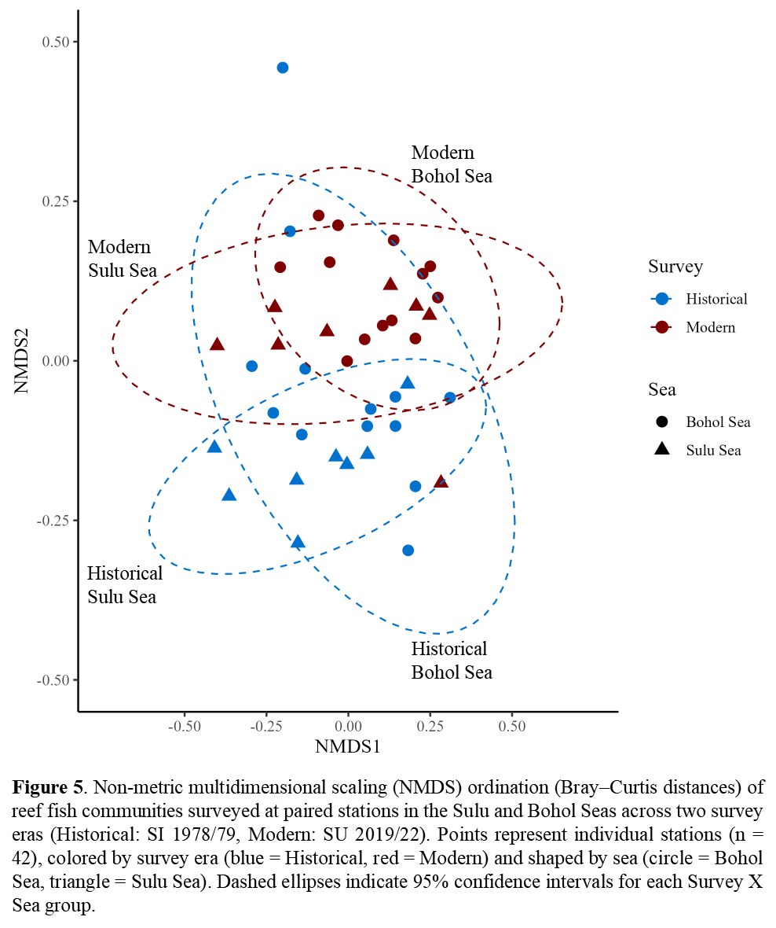

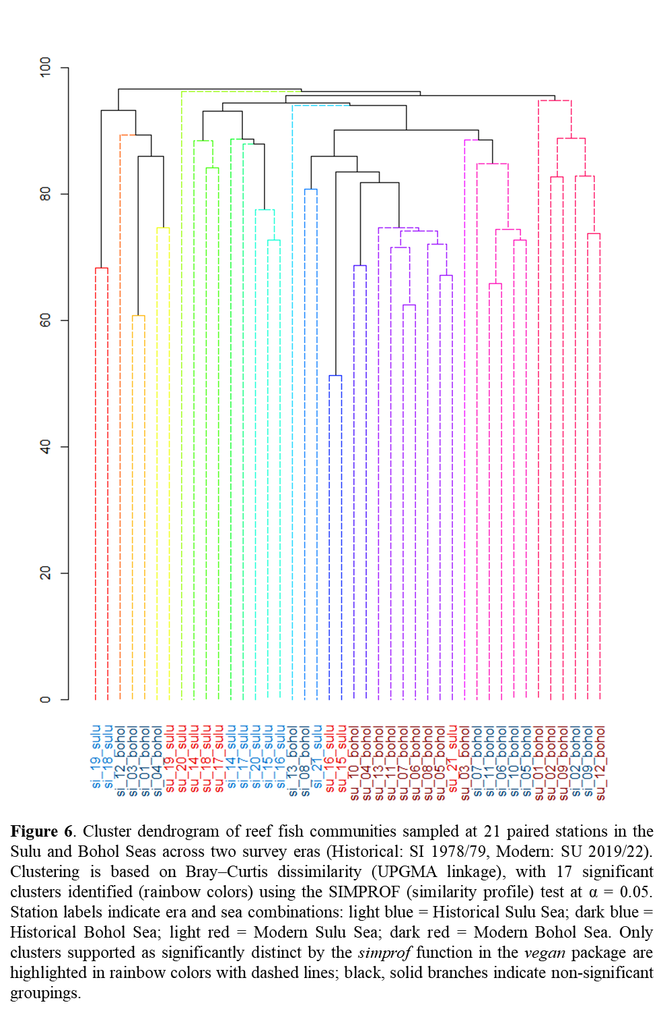
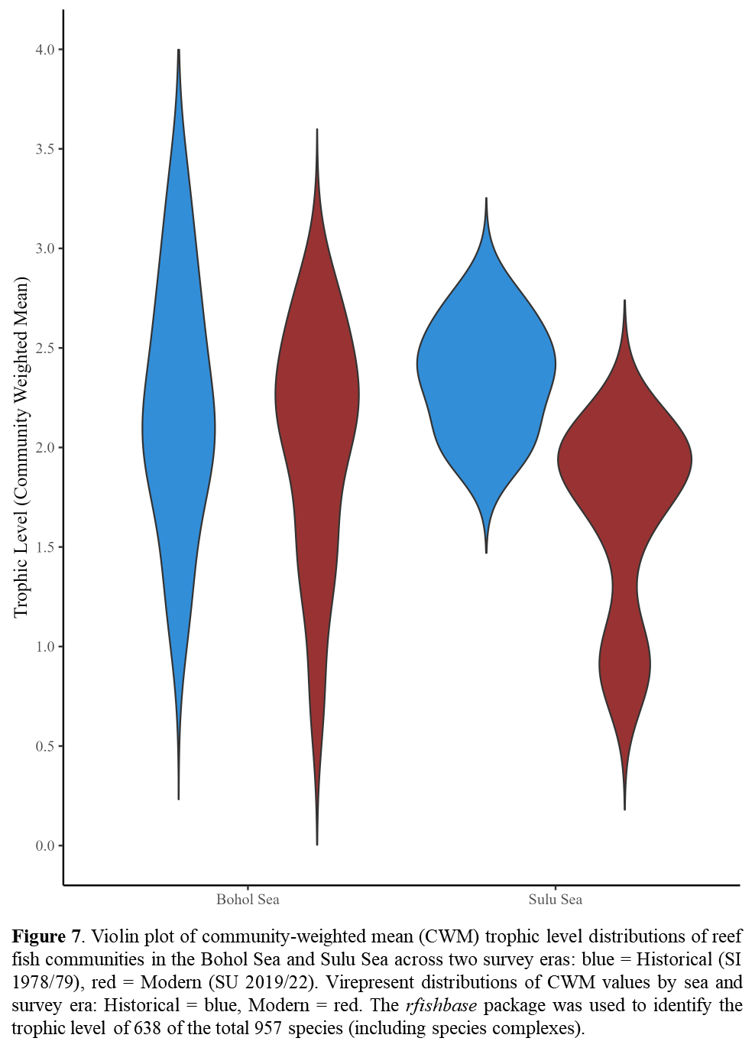
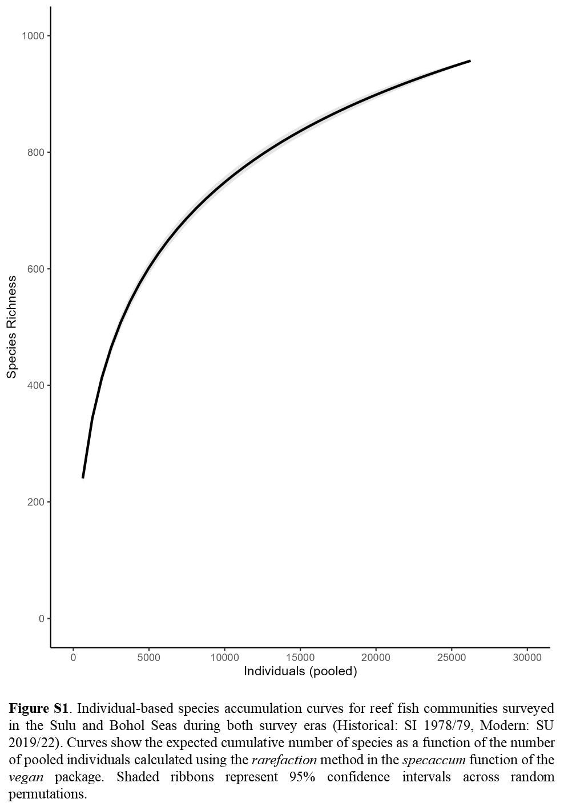
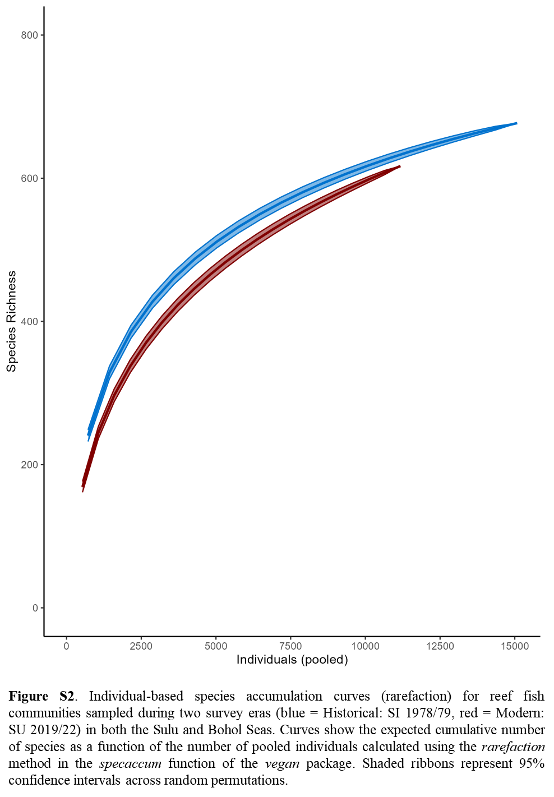
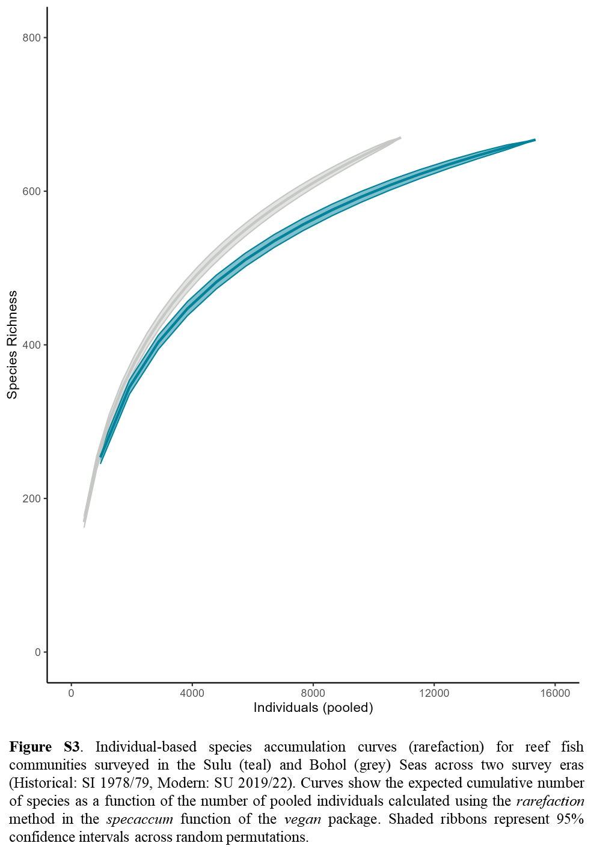
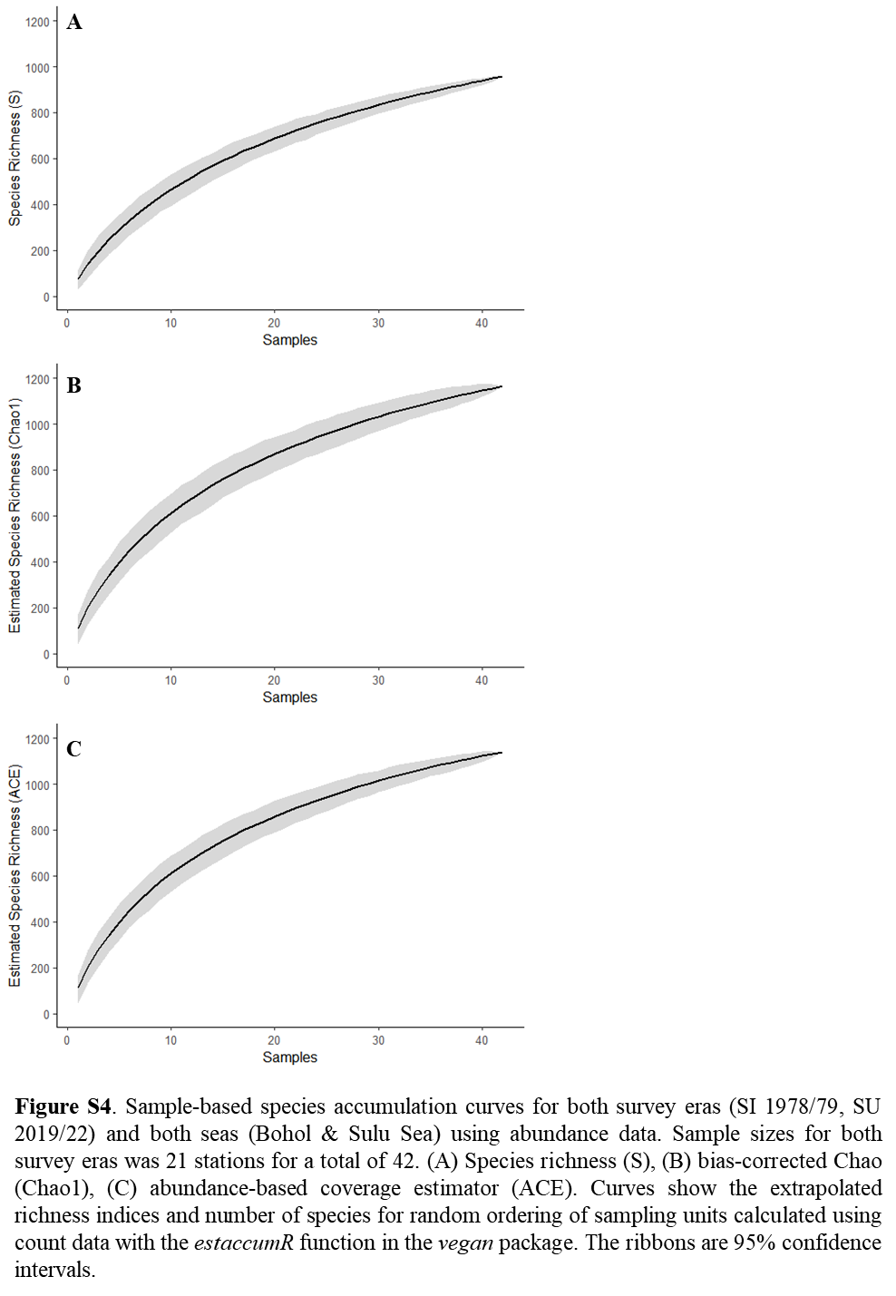
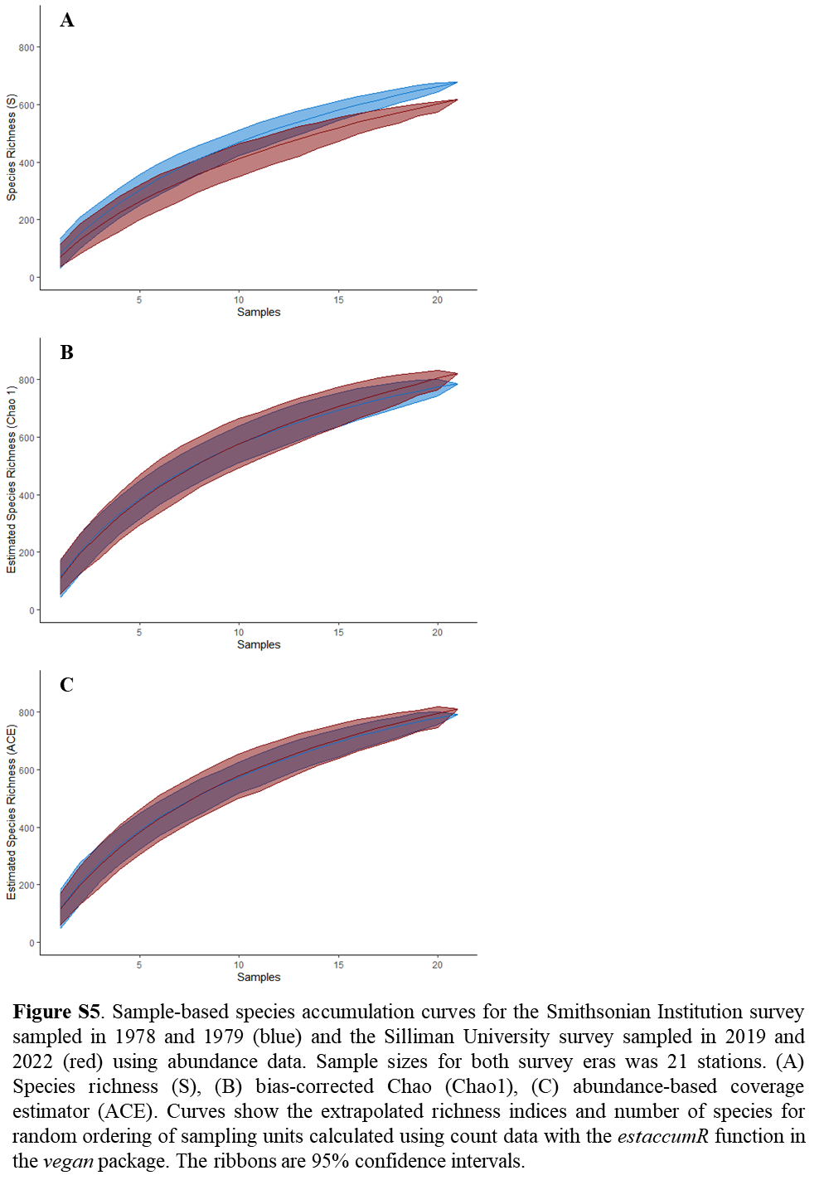
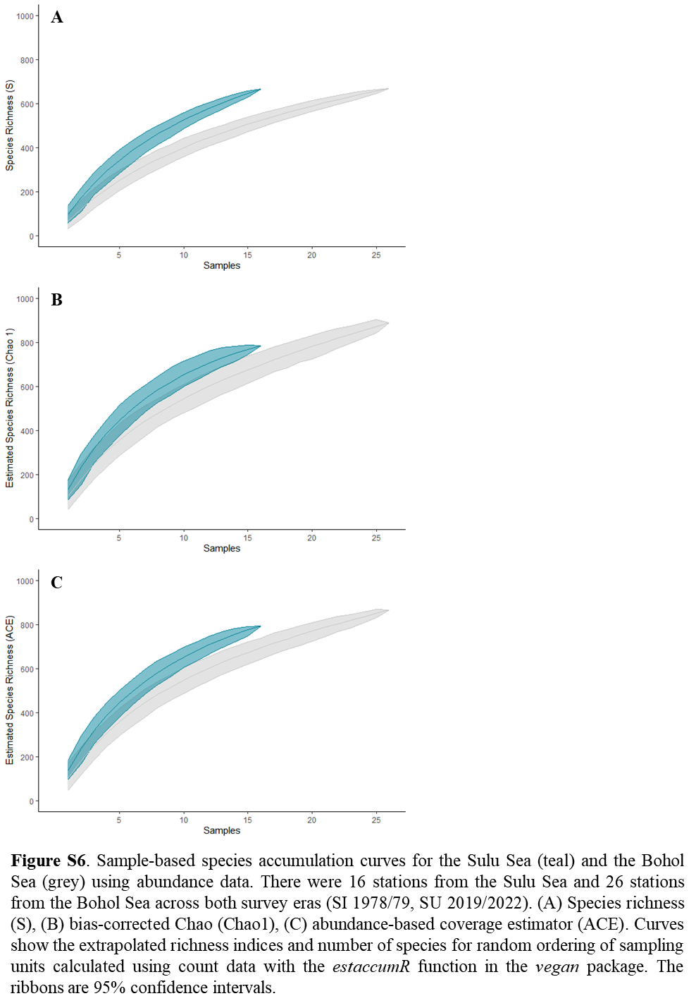
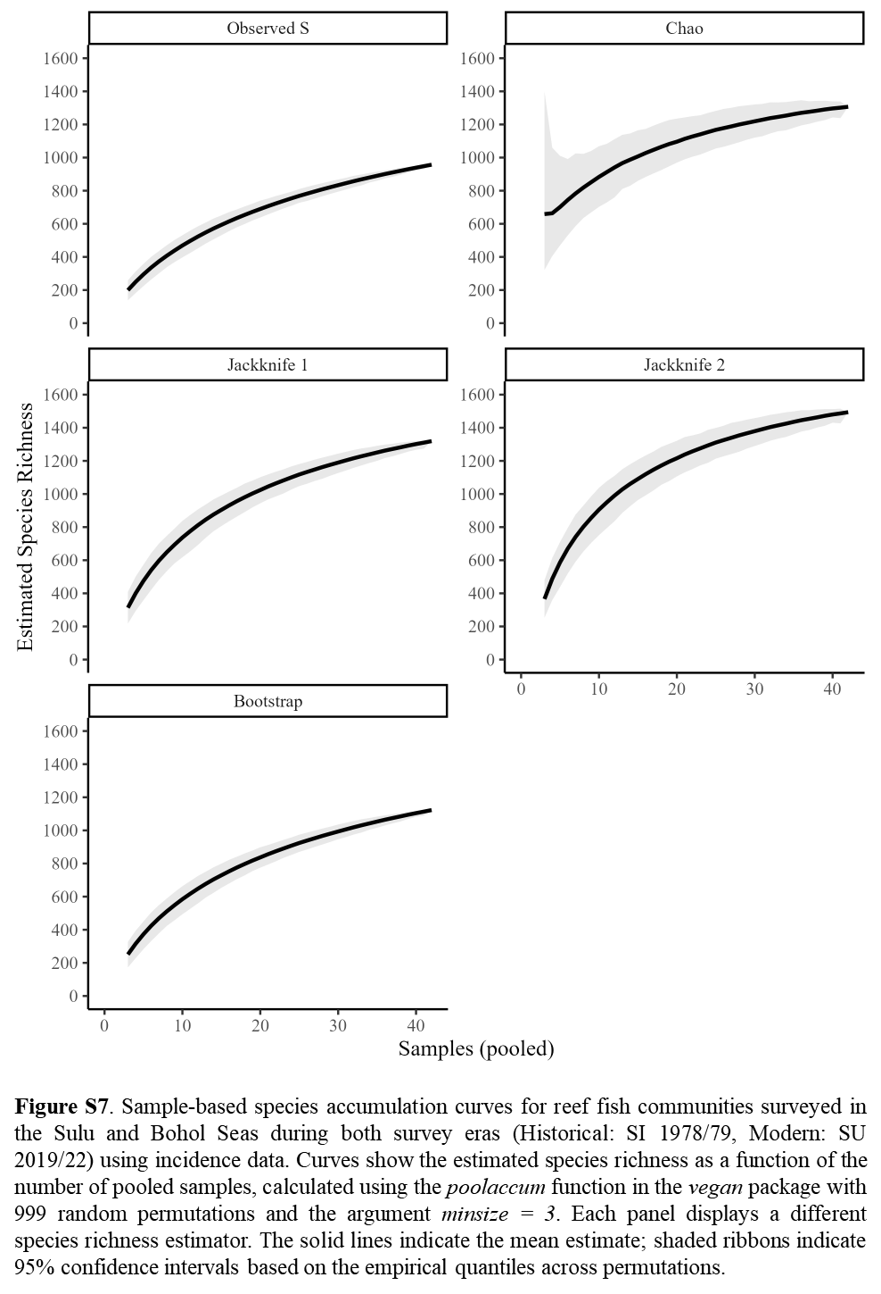
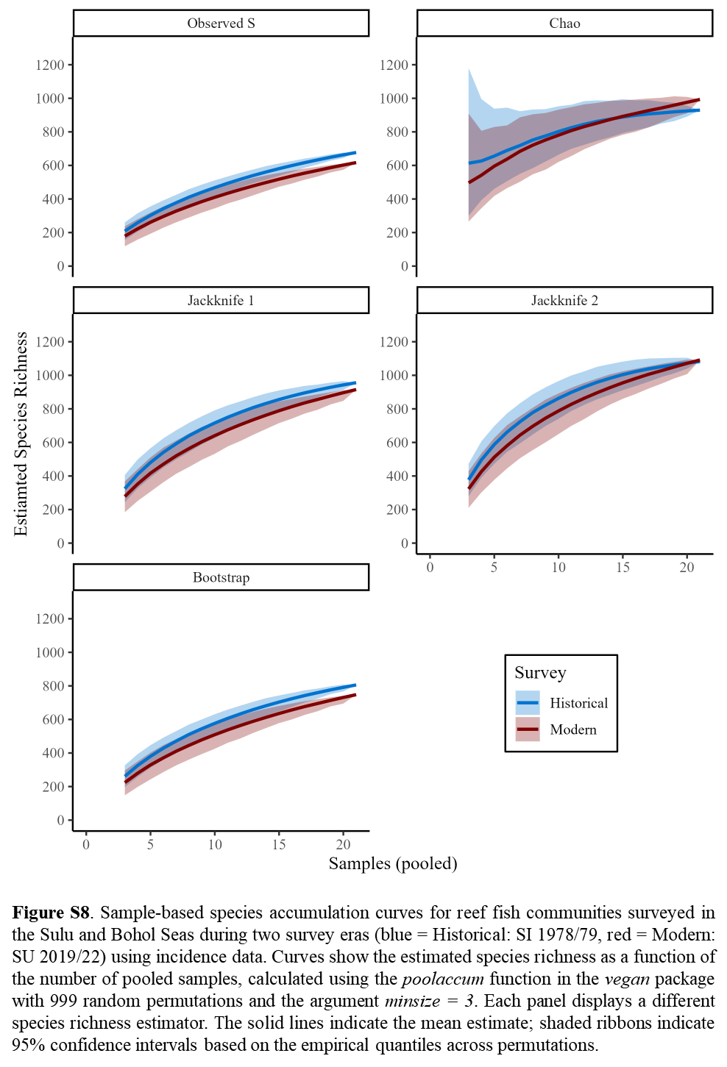
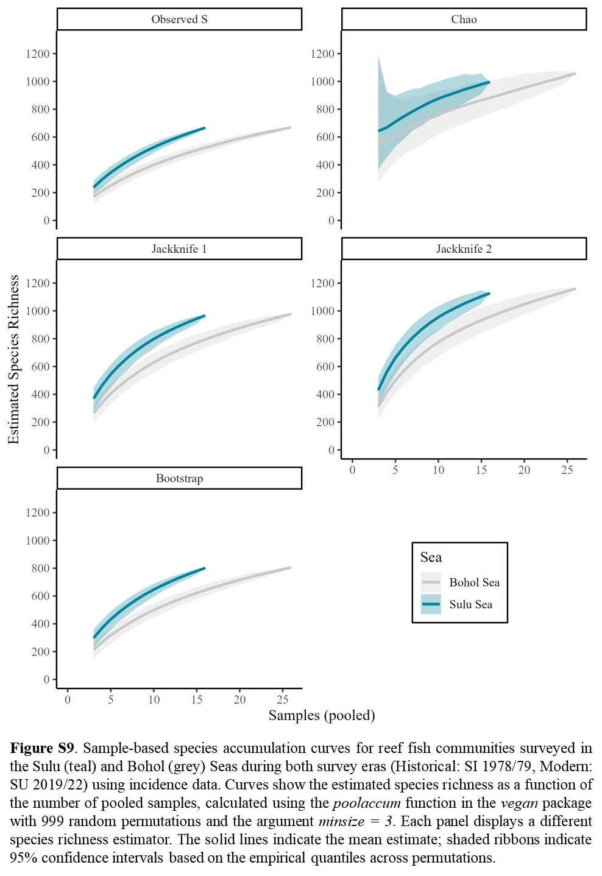

Tables

Table 1. Sample sizes and counts of unique families, genera, species, and individuals collected for each survey era and sea combination. The historical survey is the Smithsonian survey that sampled in 1978 and 1979 (SI 1978/79) and the modern survey is the Silliman University survey that duplicated the same stations in 2019 and 2022 (SU 2019/2022). The number of genera include taxa that were identified to the family level and were combined into a species complex. The number of species include taxa that were identified to the genus or family level and were combined into a species complex.
Survey | Sea | Stations | Families | Genera | Species | Individuals
All | All | 42 | 77 | 292 | 957 | 26,254
Historical | All | 21 | 59 | 237 | 677 | 15,081
Modern | All | 21 | 62 | 226 | 617 | 11,173
All | Bohol Sea | 26 | 69 | 231 | 670 | 10,903
All | Sulu Sea | 16 | 70 | 240 | 667 | 15,351
Historical | Bohol Sea | 13 | 52 | 186 | 460 | 7,537
Modern | Bohol Sea | 13 | 56 | 174 | 396 | 3,366
Historical | Sulu Sea | 8 | 52 | 186 | 456 | 7,544
Modern | Sulu Sea | 8 | 55 | 178 | 410 | 7,807

Table 2. Results of linear mixed-effect models (LME) testing spatiotemporal differences on alpha diversity metrics for paired reef fish communities. Each metric was analyzed using a linear mixed-effect model of the form: metric ~ Survey * Sea + (1 | station_pair) where Survey (Historical: SI 1978/1979 vs. Modern: SU 2019/2022) and Sea (Bohol Sea vs. Sulu Sea) were treated as fixed effects and station_pair (duplicated site code) as a random effect (accounting for repeated sampling). For each metric, fixed-effect estimates are shown with standard errors (SE) and 95% confidence intervals (CI). Analysis of Deviance (Type III ANOVA) tests are shown with Wald chi-square statistics (χ²) and corresponding p-values. The Intercept represents Historical Bohol Sea; the Survey represents the difference between Modern and Historical surveys in the Bohol Sea; the Sea represents the difference between the Sulu and the Bohol Seas within the Historical Survey, and the Survey × Sea interaction represents the additional difference for the Modern Sulu Sea.

 |  | Fixed Effects |  |  | ANOVA
Metric | Term | Estimate | SE | CI | χ² | p
Shannon's H | Intercept | 3.20 | 0.13 | 2.95 - 3.46 | 606 | 0.000
 | Survey | 0.07 | 0.16 | -0.24 - 0.38 | 0.19 | 0.661
 | Sea | 0.39 | 0.21 | -0.02 - 0.8 | 3.44 | 0.064
 | Survey × Sea | -0.51 | 0.26 | -1.01 - -0.01 | 4.05 | 0.044
Pielou's J | Intercept | 0.76 | 0.03 | 0.70 - 0.82 | 677.76 | 0.000
 | Survey | 0.05 | 0.04 | -0.03 - 0.12 | 1.48 | 0.223
 | Sea | 0.02 | 0.05 | -0.07 - 0.12 | 0.24 | 0.626
 | Survey × Sea | -0.11 | 0.06 | -0.24 - 0.01 | 3.25 | 0.071
Simpson Index | Intercept | 0.91 | 0.02 | 0.86 - 0.95 | 1739 | 0.000
 | Survey | 0.01 | 0.03 | -0.05 - 0.07 | 0.07 | 0.795
 | Sea | 0.04 | 0.04 | -0.03 - 0.11 | 1.29 | 0.255
 | Survey × Sea | -0.09 | 0.05 | -0.19 - 0 | 3.67 | 0.055
Inverse Simpson | Intercept | 14.59 | 2.02 | 10.63 - 18.55 | 52 | 0.000
 | Survey | 0.66 | 2.46 | -4.17 - 5.49 | 0.07 | 0.788
 | Sea | 5.23 | 3.27 | -1.19 - 11.65 | 2.55 | 0.110
 | Survey × Sea | -6.00 | 3.99 | -13.83 - 1.82 | 2.26 | 0.133
Unbiased Simpson | Intercept | 0.91 | 0.02 | 0.87 - 0.95 | 1720 | 0.000
 | Survey | 0.01 | 0.03 | -0.05 - 0.07 | 0.11 | 0.735
 | Sea | 0.04 | 0.04 | -0.03 - 0.11 | 1.22 | 0.269
 | Survey × Sea | -0.09 | 0.05 | -0.19 - 0 | 3.74 | 0.053
Alpha | Intercept | 22.81 | 2.01 | 18.88 - 26.74 | 129 | 0.000
 | Survey | 3.47 | 2.24 | -0.92 - 7.87 | 2.40 | 0.121
 | Sea | 7.54 | 3.25 | 1.16 - 13.91 | 5.37 | 0.020
 | Survey × Sea | -6.17 | 3.63 | -13.28 - 0.95 | 2.88 | 0.089

Table 3. Results of linear mixed-effect models (LME) testing spatiotemporal differences on Chao and ACE for paired reef fish communities. Each metric was analyzed using a linear mixed-effect model of the form: metric ~ Survey * Sea + (1 | station_pair) where Survey (Historical: SI 1978/1979 vs. Modern: SU 2019/2022) and Sea (Bohol Sea vs. Sulu Sea) were treated as fixed effects and station pair as a random effect (accounting for repeated sampling). For each metric, fixed-effect estimates are shown with standard errors (SE) and 95% confidence intervals (CI). Analysis of Deviance (Type III ANOVA) tests are shown with Wald chi-square statistics (χ²) and corresponding p-values. The Intercept represents Historical Bohol Sea; the Survey represents the difference between Modern and Historical surveys in the Bohol Sea; the Sea represents the difference between the Sulu and the Bohol Seas within the Historical Survey, and the Survey × Sea interaction represents the additional difference for the Modern Sulu Sea.

 |  | Fixed Effects |  |  | ANOVA
Metric | Term | Estimate | SE | CI | χ² | p
Chao | Intercept | 97.2 | 8.1 | 81.39 - 112.96 | 145.5 | < 0.001
 | Survey | 6.2 | 11.1 | -15.5 - 27.88 | 0.31 | 0.576
 | Sea | 42.2 | 13.1 | 16.66 - 67.82 | 10.5 | 0.001
 | Survey × Sea | -25.2 | 17.9 | -60.34 - 9.95 | 1.970 | 0.160
ACE | Intercept | 100.4 | 7.8 | 85.08 - 115.79 | 164.3 | < 0.001
 | Survey | 4.3 | 10.0 | -15.27 - 23.77 | 0.18 | 0.669
 | Sea | 42.1 | 12.7 | 17.22 - 66.98 | 11.0 | 0.001
 | Survey × Sea | -20.2 | 16.1 | -51.84 - 11.41 | 1.570 | 0.210

Table 4. PERMANOVA of community centroids by survey, sea, and the survey x sea interaction on Bray–Curtis distances (bc_dist) using the adonis2 function from the vegan package with the formula bc_dist ~ survey * sea and 999 permutations. df: degrees of freedom; Sum Sq: sum of squares; Mean Sq: mean square; F-statistic: pseudo-F statistic; R²: proportion of variance explained; p: p-value. Significant terms are indicated in bold. The Intercept represents Historical Bohol Sea; the Survey represents the difference between Modern and Historical surveys in the Bohol Sea; the Sea represents the difference between the Sulu and the Bohol Seas within the Historical Survey, and the Survey × Sea interaction represents the additional difference for the Modern Sulu Sea.

Term | df | Sum Sq | Mean Sq | F-statistic | R² | p
Survey | 1 | 1.023 | 1.023 | 2.531 | 0.057 | 0.001
Sea | 1 | 0.881 | 0.881 | 2.178 | 0.049 | 0.001
Survey × Sea | 1 | 0.578 | 0.578 | 1.429 | 0.032 | 0.024
Residual | 38 | 15.366 | 0.404 |  | 0.861
Total | 41 | 17.848 |  |  | 1.000

Table 5. Pairwise PERMANOVA results comparing reef fish community composition across four study–sea combinations using Bray–Curtis dissimilarity. F-statistic represents pseudo-F statistics. P-values are bonferroni-adjusted.

Pairs | df | Sum Sq | F-statistic | R² | p
Historical Bohol vs Historical Sulu | 1 | 0.699 | 1.670 | 0.081 | 0.054
Historical Bohol vs Modern Bohol | 1 | 0.915 | 2.292 | 0.087 | 0.006
Historical Bohol vs Modern Sulu | 1 | 0.808 | 1.915 | 0.092 | 0.012
Historical Sulu vs Modern Bohol | 1 | 1.041 | 2.692 | 0.124 | 0.006
Historical Sulu vs Modern Sulu | 1 | 0.686 | 1.661 | 0.106 | 0.042
Modern Bohol vs Modern Sulu | 1 | 0.760 | 1.947 | 0.093 | 0.048

Table S1. Pairwise post-hoc comparisons (Tukey-adjusted) for estimated marginal means from linear mixed-effects models of diversity metrics. Contrasts include all six pairwise comparisons between the four Survey x Sea combinations.

Metric | Contrast | Mean Difference | SE | df | t-ratio | p
Shannon's H | Historical Bohol - Modern Bohol | -0.069 | 0.157 | 19 | -0.439 | 0.971
 | Historical Bohol - Historical Sulu | -0.391 | 0.211 | 35 | -1.855 | 0.266
 | Historical Bohol - Modern Sulu | 0.054 | 0.211 | 35 | 0.254 | 0.994
 | Modern Bohol - Historical Sulu | -0.322 | 0.211 | 35 | -1.527 | 0.432
 | Modern Bohol - Modern Sulu | 0.123 | 0.211 | 35 | 0.581 | 0.937
 | Historical Sulu - Modern Sulu | 0.445 | 0.201 | 19 | 2.215 | 0.155
Pielou's J | Historical Bohol - Modern Bohol | -0.047 | 0.039 | 19 | -1.218 | 0.623
 | Historical Bohol - Historical Sulu | -0.023 | 0.047 | 37 | -0.487 | 0.962
 | Historical Bohol - Modern Sulu | 0.043 | 0.047 | 37 | 0.910 | 0.799
 | Modern Bohol - Historical Sulu | 0.024 | 0.047 | 37 | 0.512 | 0.956
 | Modern Bohol - Modern Sulu | 0.090 | 0.047 | 37 | 1.910 | 0.241
 | Historical Sulu - Modern Sulu | 0.066 | 0.049 | 19 | 1.336 | 0.553
Simpson Index | Historical Bohol - Modern Bohol | -0.008 | 0.030 | 19 | -0.260 | 0.994
 | Historical Bohol - Historical Sulu | -0.040 | 0.035 | 38 | -1.138 | 0.669
 | Historical Bohol - Modern Sulu | 0.045 | 0.035 | 38 | 1.274 | 0.585
 | Modern Bohol - Historical Sulu | -0.032 | 0.035 | 38 | -0.917 | 0.796
 | Modern Bohol - Modern Sulu | 0.053 | 0.035 | 38 | 1.495 | 0.450
 | Historical Sulu - Modern Sulu | 0.085 | 0.038 | 19 | 2.232 | 0.150
Inverse Simpson | Historical Bohol - Modern Bohol | -0.662 | 2.464 | 19 | -0.269 | 0.993
 | Historical Bohol - Historical Sulu | -5.232 | 3.275 | 36 | -1.598 | 0.393
 | Historical Bohol - Modern Sulu | 0.108 | 3.275 | 36 | 0.033 | 1.000
 | Modern Bohol - Historical Sulu | -4.570 | 3.275 | 36 | -1.396 | 0.510
 | Modern Bohol - Modern Sulu | 0.770 | 3.275 | 36 | 0.235 | 0.995
 | Historical Sulu - Modern Sulu | 5.340 | 3.141 | 19 | 1.700 | 0.351
Unbiased Simpson | Historical Bohol - Modern Bohol | -0.010 | 0.030 | 19 | -0.338 | 0.986
 | Historical Bohol - Historical Sulu | -0.039 | 0.035 | 38 | -1.106 | 0.688
 | Historical Bohol - Modern Sulu | 0.045 | 0.035 | 38 | 1.267 | 0.589
 | Modern Bohol - Historical Sulu | -0.029 | 0.035 | 38 | -0.819 | 0.845
 | Modern Bohol - Modern Sulu | 0.055 | 0.035 | 38 | 1.554 | 0.417
 | Historical Sulu - Modern Sulu | 0.084 | 0.038 | 19 | 2.193 | 0.161
Alpha | Historical Bohol - Modern Bohol | -3.473 | 2.241 | 19 | -1.550 | 0.429
 | Historical Bohol - Historical Sulu | -7.536 | 3.251 | 33 | -2.318 | 0.114
 | Historical Bohol - Modern Sulu | -4.843 | 3.251 | 33 | -1.490 | 0.455
 | Modern Bohol - Historical Sulu | -4.063 | 3.251 | 33 | -1.250 | 0.600
 | Modern Bohol - Modern Sulu | -1.370 | 3.251 | 33 | -0.421 | 0.974
 | Historical Sulu - Modern Sulu | 2.693 | 2.857 | 19 | 0.943 | 0.783

Table S2. Pairwise post-hoc comparisons (Tukey-adjusted) for estimated marginal means from linear mixed-effects models of Chao and ACE estimates of species richness at each station sampled. Contrasts include all six pairwise comparisons between the four survey x sea combinations. Significant contrasts are indicated in bold.

Metric | Contrast | Mean Difference | SE | df | t-ratio | p
Chao | Historical Bohol - Modern Bohol | -6.19 | 11.1 | 19.0 | -0.559 | 0.943
 | Historical Bohol - Historical Sulu | -42.24 | 13.1 | 37.9 | -3.236 | 0.013
 | Historical Bohol - Modern Sulu | -23.23 | 13.1 | 37.9 | -1.780 | 0.299
 | Modern Bohol - Historical Sulu | -36.05 | 13.1 | 37.9 | -2.762 | 0.042
 | Modern Bohol - Modern Sulu | -17.04 | 13.1 | 37.9 | -1.305 | 0.565
 | Historical Sulu - Modern Sulu | 19.01 | 14.1 | 19.0 | 1.348 | 0.546
ACE | Historical Bohol - Modern Bohol | -4.25 | 10.0 | 19.0 | -0.427 | 0.973
 | Historical Bohol - Historical Sulu | -42.1 | 12.7 | 36.6 | -3.317 | 0.011
 | Historical Bohol - Modern Sulu | -26.13 | 12.7 | 36.6 | -2.059 | 0.186
 | Modern Bohol - Historical Sulu | -37.85 | 12.7 | 36.6 | -2.982 | 0.025
 | Modern Bohol - Modern Sulu | -21.88 | 12.7 | 36.6 | -1.724 | 0.326
 | Historical Sulu - Modern Sulu | 15.97 | 12.7 | 19.0 | 1.258 | 0.600

Table S3. Results from a two-way repeated measures ANOVA test for homogeneity of dispersions (betadisper function in the vegan package) on Bray–Curtis distances using the formula distance ~ survey * sea to test for effects of Survey, Sea, and their interaction (Survey x Sea). The Intercept represents Historical Bohol Sea; the Survey represents the difference between Modern and Historical surveys in the Bohol Sea; the Sea represents the difference between the Sulu and the Bohol Seas within the Historical Survey, and the Survey × Sea interaction represents the additional difference for the Modern Sulu Sea.

Factor | Df | Sum Sq | Mean Sq | F-statistic | p
Survey | 1 | 0.006 | 0.006 | 1.475 | 0.232
Sea | 1 | 0.000 | 0.000 | 0.084 | 0.774
Survey x Sea | 1 | 0.005 | 0.005 | 1.363 | 0.250
Residuals | 38 | 0.144 | 0.004

Table S4. Results of linear mixed-effect models (LME) testing spatiotemporal differences on community-weighted mean trophic level (cwm_troph) for paired reef fish communities analyzed using a linear mixed-effect model of the form cwm_troph ~ Survey * Sea + (1 | station_pair) where survey (Historical: SI 1978/1979 vs. Modern: SU 2019/2022) and Sea (Bohol Sea vs. Sulu Sea) were treated as fixed effects and station_pair (duplicated site code) as a random effect (accounting for repeated sampling). Fixed-effect estimates are shown with standard errors (SE) and 95% confidence intervals (CI). Analysis of Deviance (Type III ANOVA) tests are shown with Wald chi-square statistics (χ2) and corresponding p-values. The Intercept represents Historical Bohol Sea; the Survey represents the difference between Modern and Historical surveys in the Bohol Sea; the Sea represents the difference between the Sulu and the Bohol Seas within the Historical Survey, and the Survey × Sea interaction represents the additional difference for the Modern Sulu Sea.

 | Fixed Effects |  |  | ANOVA
Term | Estimate | SE | CI | χ² | p
Intercept | 2.212 | 0.148 | 1.93 - 2.49 | 222 | <2e-16
Survey | -0.190 | 0.207 | -0.59 - 0.21 | 0.838 | 0.360
Sea | 0.138 | 0.240 | -0.32 - 0.60 | 0.332 | 0.565
Survey × Sea | -0.502 | 0.336 | -1.15 - 0.15 | 2.232 | 0.135

Table S5. Similarity profile test (SIMPROF) of significant structure (α = 0.05) between clusters in the Bray–Curtis dendrogram using the simprof function from the clustsig package. Seventeen SIMPROF significant clusters were identified from the 42 stations across the Bohol and Sulu Seas and the historical (SI 1978/79) and modern (SU 2019/22) survey eras.

Station Code | SIMPROF Significant Cluster | Survey | Sea | Province | Municipality | Depth (m)
si_19_sulu | 1 | Historical | Sulu Sea | Palawan | Magsaysay | 4.6
si_18_sulu | 1 | Historical | Sulu Sea | Palawan | Magsaysay | 3.0
si_12_bohol | 2 | Historical | Bohol Sea | Siquijor | Siquijor | 1.0
si_03_bohol | 3 | Historical | Bohol Sea | Negros Oriental | Siaton | 3.0
si_01_bohol | 3 | Historical | Bohol Sea | Negros Oriental | Siaton | 2.0
si_04_bohol | 4 | Historical | Bohol Sea | Negros Oriental | Siaton | 3.0
su_19_sulu | 4 | Modern | Sulu Sea | Palawan | Magsaysay | 4.6
su_20_sulu | 5 | Modern | Sulu Sea | Palawan | Magsaysay | 13.6
su_14_sulu | 6 | Modern | Sulu Sea | Palawan | Cuyo | 1.2
su_18_sulu | 6 | Modern | Sulu Sea | Palawan | Magsaysay | 3.0
su_17_sulu | 6 | Modern | Sulu Sea | Palawan | Magsaysay | 2.4
si_14_sulu | 7 | Historical | Sulu Sea | Palawan | Cuyo | 1.0
si_17_sulu | 8 | Historical | Sulu Sea | Palawan | Magsaysay | 2.0
si_20_sulu | 9 | Historical | Sulu Sea | Palawan | Magsaysay | 13.7
si_15_sulu | 9 | Historical | Sulu Sea | Palawan | Cuyo | 13.7
si_16_sulu | 9 | Historical | Sulu Sea | Palawan | Cuyo | 17.4
si_13_bohol | 10 | Historical | Bohol Sea | Siquijor | Siquijor | 30.5
si_08_bohol | 11 | Historical | Bohol Sea | Siquijor | Larena | 30.5
si_21_sulu | 11 | Historical | Sulu Sea | Palawan | Magsaysay | 21.3
su_16_sulu | 12 | Modern | Sulu Sea | Palawan | Cuyo | 17.3
su_15_sulu | 12 | Modern | Sulu Sea | Palawan | Cuyo | 13.6
su_10_bohol | 13 | Modern | Bohol Sea | Siquijor | San Juan | 6.0
su_04_bohol | 13 | Modern | Bohol Sea | Negros Oriental | Siaton | 3.0
su_13_bohol | 14 | Modern | Bohol Sea | Siquijor | Siquijor | 30.0
su_11_bohol | 14 | Modern | Bohol Sea | Siquijor | San Juan | 10.7
su_07_bohol | 14 | Modern | Bohol Sea | Negros Oriental | Siaton | 18.3
su_06_bohol | 14 | Modern | Bohol Sea | Negros Oriental | Siaton | 12.0
su_08_bohol | 14 | Modern | Bohol Sea | Siquijor | Larena | 30.0
su_05_bohol | 14 | Modern | Bohol Sea | Negros Oriental | Siaton | 9.1
su_21_sulu | 14 | Modern | Sulu Sea | Palawan | Magsaysay | 21.2
su_03_bohol | 15 | Modern | Bohol Sea | Negros Oriental | Siaton | 5.0
si_07_bohol | 16 | Historical | Bohol Sea | Negros Oriental | Siaton | 18.3
si_11_bohol | 16 | Historical | Bohol Sea | Siquijor | San Juan | 10.7
si_06_bohol | 16 | Historical | Bohol Sea | Negros Oriental | Siaton | 12.2
si_10_bohol | 16 | Historical | Bohol Sea | Siquijor | San Juan | 6.1
si_05_bohol | 16 | Historical | Bohol Sea | Negros Oriental | Siaton | 9.1
su_01_bohol | 17 | Modern | Bohol Sea | Negros Oriental | Siaton | 3.5
su_02_bohol | 17 | Modern | Bohol Sea | Negros Oriental | Siaton | 2.5
su_09_bohol | 17 | Modern | Bohol Sea | Siquijor | San Juan | 2.0
si_02_bohol | 17 | Historical | Bohol Sea | Negros Oriental | Siaton | 2.0
si_09_bohol | 17 | Historical | Bohol Sea | Siquijor | San Juan | 2.0
su_12_bohol | 17 | Modern | Bohol Sea | Siquijor | Siquijor | 2.0

Table S6. Similarity percentages (simper function in the vegan package) of the top species that contribute to 20% of the cumulative differences between survey eras.

Species | Average | SD | Cumulative Sum | Historical | Modern | Ratio | p
Verulux cypselurus | 0.025 | 0.112 | 0.026 | 0.0 | 101.9 | 0.222 | 0.997
Plotosus lineatus | 0.022 | 0.052 | 0.050 | 11.3 | 7.6 | 0.432 | 0.885
Chromis ternatensis | 0.022 | 0.065 | 0.073 | 31.2 | 1.7 | 0.336 | 0.028
Ostorhinchus cyanosoma | 0.018 | 0.044 | 0.093 | 8.4 | 13.6 | 0.412 | 0.662
Spratelloides gracilis | 0.018 | 0.078 | 0.111 | 0.0 | 29.9 | 0.229 | 0.991
Spratelloides delicatulus | 0.018 | 0.057 | 0.130 | 11.0 | 12.0 | 0.311 | 0.221
Pycnochromis retrofasciatus | 0.017 | 0.027 | 0.148 | 14.0 | 7.1 | 0.647 | 0.820
Cirrhilabrus ryukyuensis | 0.014 | 0.024 | 0.163 | 0.0 | 14.7 | 0.572 | 0.947
Ostorhinchus nigrofasciatus | 0.012 | 0.016 | 0.176 | 9.4 | 5.5 | 0.734 | 0.376
Ostorhinchus multilineatus | 0.011 | 0.015 | 0.187 | 5.5 | 9.9 | 0.693 | 0.998
Ostorhinchus fleurieu | 0.011 | 0.041 | 0.198 | 8.4 | 0.6 | 0.261 | 0.012
Dascyllus reticulatus | 0.010 | 0.026 | 0.209 | 3.7 | 7.8 | 0.392 | 0.963

Table S7. Similarity percentages (simper function in the vegan package) of the top species that contribute to 20% of the cumulative differences between seas.

Species | Average | SD | Cumulative Sum | Bohol Sea | Sulu Sea | Ratio | p
Verulux cypselurus | 0.035 | 0.137 | 0.037 | 0.0 | 133.7 | 0.257 | 0.001
Spratelloides gracilis | 0.028 | 0.104 | 0.067 | 0.0 | 39.1 | 0.266 | 0.001
Chromis ternatensis | 0.019 | 0.054 | 0.086 | 20.9 | 9.3 | 0.348 | 0.652
Spratelloides delicatulus | 0.016 | 0.046 | 0.104 | 8.9 | 15.8 | 0.349 | 0.659
Cirrhilabrus ryukyuensis | 0.016 | 0.030 | 0.121 | 3.5 | 13.6 | 0.528 | 0.116
Plotosus lineatus | 0.015 | 0.038 | 0.137 | 14.9 | 0.6 | 0.399 | 1.000
Ostorhinchus cyanosoma | 0.015 | 0.038 | 0.153 | 12.6 | 8.4 | 0.395 | 0.980
Pycnochromis retrofasciatus | 0.014 | 0.023 | 0.167 | 14.9 | 3.6 | 0.607 | 0.999
Chrysiptera rollandi | 0.013 | 0.016 | 0.181 | 1.7 | 12.6 | 0.816 | 0.001
Enneapterygius | 0.013 | 0.034 | 0.194 | 0.5 | 20.5 | 0.365 | 0.002
Cirrhilabrus | 0.012 | 0.030 | 0.207 | 1.0 | 11.5 | 0.385 | 0.009

Table S8. Similarity percentages (simper function in the vegan package) of the top species that contribute to 20% of the cumulative differences between survey eras in the Bohol Sea.

Species | Average | SD | Cumulative Sum | Historical Bohol Sea | Modern Bohol Sea | Ratio | p
Plotosus lineatus | 0.039 | 0.068 | 0.042 | 18.2 | 11.6 | 0.579 | 0.006
Chromis ternatensis | 0.027 | 0.080 | 0.071 | 39.8 | 2.0 | 0.334 | 0.374
Pycnochromis retrofasciatus | 0.026 | 0.031 | 0.098 | 18.6 | 11.2 | 0.843 | 0.011
Ostorhinchus cyanosoma | 0.025 | 0.059 | 0.125 | 6.0 | 19.2 | 0.421 | 0.290
Spratelloides delicatulus | 0.022 | 0.074 | 0.149 | 17.8 | 0.0 | 0.302 | 0.400
Ostorhinchus fleurieu | 0.020 | 0.056 | 0.170 | 13.5 | 0.6 | 0.349 | 0.001
Ostorhinchus nigrofasciatus | 0.019 | 0.020 | 0.190 | 14.1 | 7.6 | 0.964 | 0.001
Pycnochromis atripes | 0.018 | 0.050 | 0.209 | 26.6 | 0.0 | 0.356 | 0.001

Table S9. Similarity percentages (simper function in the vegan package) of the top species that contribute to 20% of the cumulative differences between survey eras in the Sulu Sea.

Species | Average | SD | Cumulative Sum | Historical Sulu Sea | Modern Sulu Sea | Ratio | p
Verulux cypselurus | 0.062 | 0.167 | 0.066 | 0.0 | 267.4 | 0.373 | 0.358
Spratelloides gracilis | 0.042 | 0.108 | 0.110 | 0.0 | 78.3 | 0.384 | 0.380
Enneapterygius | 0.018 | 0.035 | 0.129 | 13.1 | 27.9 | 0.520 | 0.167
Cirrhilabrus ryukyuensis | 0.018 | 0.023 | 0.148 | 0.0 | 27.3 | 0.782 | 0.334
Cirrhilabrus | 0.017 | 0.034 | 0.167 | 23.0 | 0.0 | 0.513 | 0.138
Helcogramma desa | 0.017 | 0.036 | 0.184 | 40.5 | 3.8 | 0.463 | 0.147
Spratelloides delicatulus | 0.015 | 0.035 | 0.200 | 0.0 | 31.5 | 0.432 | 0.631

References
Allen GR (2008) Conservation hotspots of biodiversity and endemism for Indo-Pacific coral reef fishes. 556:541–556. doi: 10.1002/aqc
Antonovics J (1976) The Input from Population Genetics: “The New Ecological Genetics.” Systemic Botany 1:233–245.
Antonovics J (2003) Toward community genomics? Ecology 84:
Bankevich A, Nurk S, Antipov D, Gurevich AA, Dvorkin M, Kulikov AS, Lesin VM, Nikolenko SI, Pham S, Prjibelski AD, Pyshkin A v., Sirotkin A v., Vyahhi N, Tesler G, Alekseyev MA, Pevzner PA (2012) SPAdes: A new genome assembly algorithm and its applications to single-cell sequencing. Journal of Computational Biology. doi: 10.1089/cmb.2012.0021
Beck JAN, Kitching IANJ (2007) Estimating regional species richness of tropical insects from museum data: a comparison of a geography-based and sample-based methods. 672–681. doi: 10.1111/j.1365-2664.2007.01291.x
Belkhir K (2004) Genetix 4.05, logiciel sous Windows TM pour la genetique des populations.
Bellwood DR, Wainwright PC (2002) The History and Biogeography of Fishes on Coral Reefs.
Carpenter KE, Springer VG (2005) The center of the center of marine shore fish biodiversity: The Philippine Islands. Environ Biol Fishes 72:467–480. doi: 10.1007/s10641-004-3154-4
Carvalheiro LG, Kunin WE, Keil P, Aguirre-Gutiérrez J, Ellis WN, Fox R, Groom Q, Hennekens S, van Landuyt W, Maes D, van de Meutter F, Michez D, Rasmont P, Ode B, Potts SG, Reemer M, Roberts SPM, Schaminée J, Wallisdevries MF, Biesmeijer JC (2013) Species richness declines and biotic homogenisation have slowed down for NW-European pollinators and plants. Ecol Lett. doi: 10.1111/ele.12121
Clarke KR, Gorley RN (2018) Getting started with PRIMER v7.
Collette BB, Carpenter KE, Polidoro BA, Juan-Jordá MJ, Boustany A, Die DJ, Elfes C, Fox W, Graves J, Harrison LR, Mcmanus R, Nelson R, Restrepo V, Schratwieser J, Sun C, Amorim A, Brick M, Canales C, Cardenas G, Chang S, Chiang W, Jr NDOL, Lessa R, Fredou FL, Oxenford HA, Serra R, Shao K, Sumaila R (2011) High Value and Long Life - Double Jeopardy for Tunas and Billfishes. 98–100.
Colwell RK, Chao A, Gotelli NJ, Lin SY, Mao CX, Chazdon RL, Longino JT (2012) Models and estimators linking individual-based and sample-based rarefaction, extrapolation and comparison of assemblages. Journal of Plant Ecology 5:3–21. doi: 10.1093/jpe/rtr044
Dulvy NK, Fowler SL, Musick JA, Cavanagh RD, Kyne M, Harrison LR, Carlson JK, Davidson LNK, Sonja V (2014) Extinction risk and conservation of the world’s sharks and rays. 1–35. doi: 10.7554/eLife.00590
Dunham J, Peacock M, Tracy CR, Nielsen J, Vinyard G (1999) Assessing extinction risk: Integrating genetic information. Ecology and Society. doi: 10.5751/es-00087-030102
Excoffier L, Lischer HEL (2010) Arlequin suite ver 3.5: A new series of programs to perform population genetics analyses under Linux and Windows. Mol Ecol Resour. doi: 10.1111/j.1755-0998.2010.02847.x
Goudet J (1995) FSTAT (Version 1.2): A Computer Program to Calculate F-statistics. Journal of Heredity. doi: 10.1093/oxfordjournals.jhered.a111627
Hauser L, Adcock GJ, Smith PJ, Ramı JHB, Carvalho GR (2002) Loss of microsatellite diversity and low effective population size in an overexploited population of New Zealand snapper ( Pagrus auratus ). doi: 10.1073/pnas.172242899
He T, Lamont BB, Krauss SL, Enright NJ, Miller BP (2008) Covariation between intraspecific genetic diversity and species diversity within a plant functional group. 96:956–961.
Hutchinson WF, Oosterhout C van, Rogers SI, Carvalho GR (2003) Temporal analysis of archived samples indicates marked genetic changes in declining North Sea cod (Gadus morhua). 2125–2132. doi: 10.1098/rspb.2003.2493
Jakobsdóttir KB, Pardoe H, Magnússon Á, Björnsson H, Pampoulie C, Ruzzante DE, Marteinsdóttir G (2011) Historical changes in genotypic frequencies at the Pantophysin locus in Atlantic cod (Gadus morhua) in Icelandic waters: Evidence of fisheries-induced selection? Evol Appl. doi: 10.1111/j.1752-4571.2010.00176.x
Labrosse P, Kulbicki M, Ferraris J (2002) Underwater fish visual census surveys.
Lamy T, Laroche F, David P, Massol F, Jarne P (2017) The contribution of species – genetic diversity correlations to the understanding of community assembly rules. 759–771. doi: 10.1111/oik.03997
Lavides MN, Polunin NVC, Stead SM, Tabaranza DG, Comeros MT, Dongallo JR (2009) Finfish disappearances around Bohol, Philippines inferred from traditional ecological knowledge. Environ Conserv. doi: 10.1017/S0376892909990385
Lavides MN, Molina EP v, Rosa GE de (2016) Patterns of Coral-Reef Finfish Species Disappearances Inferred from Fishers’ Knowledge in Global Epicentre of Marine Shorefish Diversity. PLoS One 11:1–24. doi: 10.1371/journal.pone.0155752
Mamauag SS (2004) The live reef food fish trade in the Philippines.
Marçais G, Kingsford C (2011) A fast, lock-free approach for efficient parallel counting of occurrences of k-mers. Bioinformatics. doi: 10.1093/bioinformatics/btr011
Maruyama T, Fuerst PA (1985) Population bottlenecks and nonequilibrium models in population genetics. III. Genic homozygosity in populations which experience periodic bottlenecks. Genetics. doi: 10.1093/genetics/111.3.691
Mora C, Chittaro PM, Sale PF, Kritzer JP, Ludsin SA (2003) Patterns and processes in reef fish diversity. Nature 2003 421:6926 421:933–936. doi: 10.1038/nature01393
Nañola CL, Aliño PM, Carpenter KE (2011) Exploitation-related reef fish species richness depletion in the epicenter of marine biodiversity. Environ Biol Fishes 90:405–420. doi: 10.1007/s10641-010-9750-6
Ochavillo D, Hodgson G, Shuman C, Ruz R (2004) Status of the Philippine Marine Aquarium Fish Trade. In: Turbulent Seas: The Status of Philippine Marine Fisheries. Department of Agriculture-Bureau of Fisheries and Aquatic Resources, Cebu City, pp 60–64
Oksanen J, Blanchet FG, Friendly M, Kindt R, Legendre P, Mcglinn D, Minchin PR, O’hara RB, Simpson GL, Solymos P, Henry M, Stevens H, Szoecs E, Maintainer HW (2020) Package “vegan” Title Community Ecology Package Version 2.5-7.
Pinsky ML, Palumbi SR (2014) Meta-analysis reveals lower genetic diversity in overfished populations. Mol Ecol 23:29–39. doi: 10.1111/mec.12509
Pratchett MS, Munday PL, Wilson SK, Graham NAJ, Cinner JE, Bellwood DR, Jones GP, Polunin NVC, McClanahan TR (2008) Effects of climate-induced coral bleaching on coral-reef fishes ecological and economic consequences. In: Oceanography and Marine Biology: An Annual Review.
Prjibelski A, Antipov D, Meleshko D, Lapidus A, Korobeynikov A (2020) Using SPAdes De Novo Assembler. Curr Protoc Bioinformatics. doi: 10.1002/cpbi.102
Rhyne AL, Tlusty MF, Szczebak JT, Holmberg RJ (2017) Expanding our understanding of the trade in marine aquarium animals. PeerJ 5:e2949. doi: 10.7717/peerj.2949
Roberts CM, McClean CJ, Veron JEN, Hawkins JP, Allen GR, Mcallister DE, Mittermeier CG, Schueler FW, Spalding M, Wells F, Vynne C, Werner TB, Vertut J, Doyle A, Mittermeier CG, Schueler FW (2002) Marine Biodiversity Hotspots and Conservation Priorities for Tropical Reefs. 295:1280–1284.
Rohland N, Reich D (2012) Cost-effective, high-throughput DNA sequencing libraries for multiplexed target capture. Genome Res. doi: 10.1101/gr.128124.111
Rousset F (2008) GENEPOP’007: A complete re-implementation of the GENEPOP software for Windows and Linux. Mol Ecol Resour. doi: 10.1111/j.1471-8286.2007.01931.x
Ryman N, Utter F, Laikre L (1995) Protection of intraspecific biodiversity of exploited fishes. Rev Fish Biol Fish. doi: 10.1007/BF01103814
Sanciangco JC, Carpenter KE, Etnoyer PJ, Moretzsohn F (2013) Habitat Availability and Heterogeneity and the Indo- Pacific Warm Pool as Predictors of Marine Species Richness in the Tropical Indo-Pacific. doi: 10.1371/journal.pone.0056245
Smith DG, Williams JT (1999) The Great Albatross Philippine Expedition and its fishes.
Therkildsen NO, Nielsen EE, Swain DP (2010) Large effective population size and temporal genetic stability in Atlantic cod (Gadus morhua) in the southern Gulf of St. Lawrence. 1595:1585–1595. doi: 10.1139/F10-084
Vellend M (2003) Island Biogeography of Genes and Species. Am Nat 162:358–365.
Vellend M (2005) Species Diversity and Genetic Diversity : Parallel Processes and Correlated Patterns.
Vurture GW, Sedlazeck FJ, Nattestad M, Underwood CJ, Fang H, Gurtowski J, Schatz MC (2017) GenomeScope: Fast reference-free genome profiling from short reads. In: Bioinformatics.
Willi Y, van Buskirk J, Hoffmann AA (2006) Limits to the adaptive potential of small populations. Annu Rev Ecol Evol Syst 37:
Williams JT, Carpenter KE, Tassell JL van, Hoetjes P, Toller W, Smith M (2010) Biodiversity Assessment of the Fishes of Saba Bank Atoll, Netherlands Antilles. 5:1–37. doi: 10.1371/journal.pone.0010676
Zuur AF, Leno EN, Smith GM (2007) Analyzing Ecological Data.

