Spatiotemporal changes in Ecsenius species in the Philippines
Results
Across the 21 historical and 21 modern duplicate-station samples, Ecsenius richness, abundance, and occurrence all declined significantly through time. Overall, the historical collections contained 125 individuals representing eight species, whereas the modern collections contained 35 individuals representing four species. Irrespective of era, the Bohol Sea is less specious (5 species) than the Sulu Sea (7 species), with 3 species observed in both areas (E. bimaculatus, E. monoculus, E. yaeyamaensis).
Unpaired Wilcoxon tests indicated significant temporal declines in station-level richness (W = 310, p = 0.011) and abundance (W = 315.5, p = 0.008), and Fisher’s exact test further showed that Ecsenius was significantly less likely to be detected at modern stations than at historical stations (odds ratio = 0.20, p = 0.028). Thus, under an unpaired station-level framework, modern samples had fewer Ecsenius species, fewer individuals, and a lower probability of any Ecsenius occurrence than historical samples.
This temporal pattern was not spatially uniform, however, and was driven primarily by the Bohol Sea portion of the dataset. In the Bohol Sea, all three unpaired comparisons were significant, with strong declines in richness, abundance, and presence/absence between historical and modern samples (p = 0.0010, 0.0012, and 0.0016, respectively), whereas no significant temporal differences were detected within the Sulu Sea (p = 0.50, 0.45, and 1.00, respectively). Descriptive counts reflected the same pattern: the Bohol Sea declined from 64 individuals and five species historically to zero individuals and zero species in the modern collection, while the Sulu Sea declined more modestly from 61 individuals and six species to 35 individuals and four species. Multivariate analyses of nonzero stations likewise indicated that assemblage composition differed significantly by sea (PERMANOVA, R² = 0.170, p = 0.009), but not by era (R² = 0.075, p = 0.25), and dispersion did not differ between eras (p = 0.793). Taken together, these results indicate a strong overall temporal decline in Ecsenius, but one that is concentrated in the Bohol Sea rather than expressed as a uniform shift across both regions.
In the Sulu Sea, 3 species were not resampled in the modern collection (E. bimaculatus, E. namiyei, E. yaeyamaensis). E. lineatus was the only species that was observed in the historical collection and increased in the number of individuals observed, albeit just from 2 to 3. E. bicolor was not observed in the historical collection, however 2 were observed in the modern collection. Notably, E. monoculus observations remained stable in the Sulu Sea (33 to 29).
In the Bohol Sea, Within the Bohol Sea, southern Negros oriental had 2 species and 51 individuals observed, while Siquijor had 4 and 13. E. pictus was the only species observed in both locations. E. pictus was evenly distributed between Negros Oriental (n = 4) and Siquijor (n = 6) and similarly disappeared from both locations. Besides E. pictus, a major change was observed in E. monoculus, which decreased from 47 observations in southern Negros Oriental to 0.

Discussion
The clearest biological signal in these data is that temporal change in Ecsenius was spatially uneven. The strongest decline occurred in the Bohol Sea, where Ecsenius was absent from all modern duplicate stations, while the Sulu Sea retained four species and 35 individuals in the modern collection. This contrast suggests that local or regional environmental context may be more important than time alone in explaining change in this assemblage. Because the era effect was significant in the univariate analyses but not in the nonzero-station PERMANOVA, the dominant temporal signal appears to be a reduction in station occupancy, richness, and abundance, rather than a consistent historical-to-modern turnover in species composition wherever Ecsenius remained present. In other words, the principal change is not that modern stations contain a wholly restructured Ecsenius assemblage, but that many modern stations, especially in the Bohol Sea, no longer contain Ecsenius at all. This interpretation is also consistent with the NMDS, which should be treated cautiously because the very low stress likely reflects the sparse, low-dimensional structure of the dataset rather than a highly robust ordination pattern. These results corroborate anecdotal observations of Ecsenius throughout this region (Carpenter, 2026).
Ecologically, these results fit the expectation that declines in small cryptobenthic reef fishes are likely filtered through species-specific habitat associations and local disturbance regimes rather than occurring uniformly across taxa. The strongest losses were concentrated in taxa and regions plausibly associated with shallow, structurally complex reef habitats, while several species persisted only in the Cuyo Archipelago of Palawan, a comparatively remote part of the Sulu Sea. Historically, the Bohol Sea contained five Ecsenius species and included substantial numbers of E. monoculus and E. pictus, yet no Ecsenius were recorded there in the modern duplicates; by contrast, E. monoculus remained relatively stable in the Sulu Sea, and E. bicolor and E. lineatus persisted or appeared there in the modern collection. These patterns are consistent with the hypothesis that local habitat degradation, chronic human pressure, or both have disproportionately affected the Bohol Sea assemblage, whereas parts of Palawan may still function as a partial refuge for more resilient or flexible Ecsenius species. At the same time, the small number of species, rarity of several taxa, and the use of unpaired station-level analyses mean these results should be framed cautiously as evidence consistent with strong regional decline, rather than as definitive proof of local extinction at particular stations because absence of evidence is not evidence of absence, especially with such low sample sizes for some of these species.
Differences among Ecsenius species suggest that the declines observed were likely not taxonomically uniform but instead filtered through species-specific ecological strategies. Although all nine taxa are small reef-associated combtooth blennies with broadly similar reproductive mode (oviparity, adhesive demersal eggs, and planktonic larvae) they likely differ in vulnerability because they vary in habitat breadth, depth distribution, and geographic range size (Springer 1988; Brandl et al. 2018). In coral-reef fishes more generally, habitat specialists tend to be more sensitive to disturbance than habitat generalists, especially when degradation reduces live coral, structural complexity, or the specific microhabitats on which fishes depend (Feary 2007; Wilson et al. 2008). Applied to this assemblage, the most disturbance-sensitive species are plausibly those with the narrowest habitat associations. E. lividanalis, for example, occurs in small groups in live corals of lagoons and sheltered reefs, while E. bimaculatus inhabits reef crests and slopes with rich coral growth and is often associated with sponges and tunicates. E. monoculus is among the shallowest members of the genus and occurs on shallow, algae-covered gutters, which may make it especially susceptible to sedimentation, coastal runoff, thermal extremes, and physical degradation of very shallow reef habitat. E. kurti may be particularly vulnerable because it is a Palawan microendemic known only from the Cuyo Islands and is listed as Vulnerable, so even moderate local habitat deterioration could produce strong abundance declines in a species with such a restricted range (Springer 1988; Froese and Pauly 2025). Under this framework, the collapse of Ecsenius in Negros Oriental and Siquijor, and the strong decline of some Palawan taxa such as E. kurti and E. yaeyamaensis, are consistent with the expectation that shallow, coral-dependent, or range-restricted species should be the first to disappear as reef condition deteriorates.
By contrast, the persistence of some taxa in Palawan suggests that not all Ecsenius respond equally to environmental change. E. bicolor, E. namiyei, and E. lineatus appear to occupy broader habitat or depth ranges than the most specialized species, and E. pictus is one of the deeper-dwelling members of the genus, typically associated with outer reef walls, corals, and large sponges at moderate depth (Springer 1988; Froese and Pauly 2025). These traits may buffer some species from the most intense impacts affecting shallow, nearshore reefs, although deeper specialists may still decline if outer-wall coral and invertebrate structure are lost. Palawan is remote and less heavily impacted than the Bohol Sea sites. E. monoculus remained relatively stable in the Sulu Sea while disappearing from Negros Oriental, and E. lineatus and E. bicolor persisted or appeared only in modern Palawan samples. That pattern is broadly consistent with the wider Philippine context, in which the Sulu Sea region had the highest hard coral cover among the country’s major reef biogeographic regions, even as Philippine reefs overall have continued to decline since the 1970s (Licuanan et al. 2019). The Palawan region, specifically the Cuyo archipelago, is potentially a partial refuge in which ecologically flexible Ecsenius species can still persist, whereas the complete absence of the genus in modern Negros Oriental and Siquijor is more consistent with local habitat simplification, chronic human pressure, or both. At the same time, this interpretation should remain cautious: rotenone duplicates are still limited in number, several species were rare even historically, and for uncommon or deeper taxa, non-detection in the modern collection cannot be treated as definitive local extinction.
A further complication is the timing of Typhoon Odette (Rai) relative to the modern collections. Three Siquijor stations were sampled in 2019, but the remaining modern stations were sampled in 2022, after Odette crossed the central Philippines in December 2021 and made landfall in Negros Oriental on 17 December before continuing west toward Palawan. During the storm, PAGASA placed both Siquijor and Negros Oriental under Tropical Cyclone Wind Signal No. 4, indicating very destructive typhoon-force winds. Severe tropical cyclones can cause abrupt losses of shallow-reef structure through wave damage, sediment resuspension, and coral breakage, and those habitat changes can reduce reef-fish abundance, alter assemblage composition, and especially affect small, shallow, structure-dependent fishes (Lassig 1983; Wilson et al. 2006; Triki and Bshary 2019). Odette therefore provides a plausible additional explanation for depressed 2022 abundances at the Negros Oriental and Palawan sites, particularly for species tied to very shallow reef crests and live coral microhabitats. At the same time, because the Siquijor modern samples predate the storm by about two years, Odette cannot explain the entire modern absence of Ecsenius in the Bohol Sea; rather, the typhoon likely acted as an added acute disturbance in addition to longer-term local stressors such as chronic habitat degradation and human pressure.

Figure 1. NMDS plot of non-zero stations. 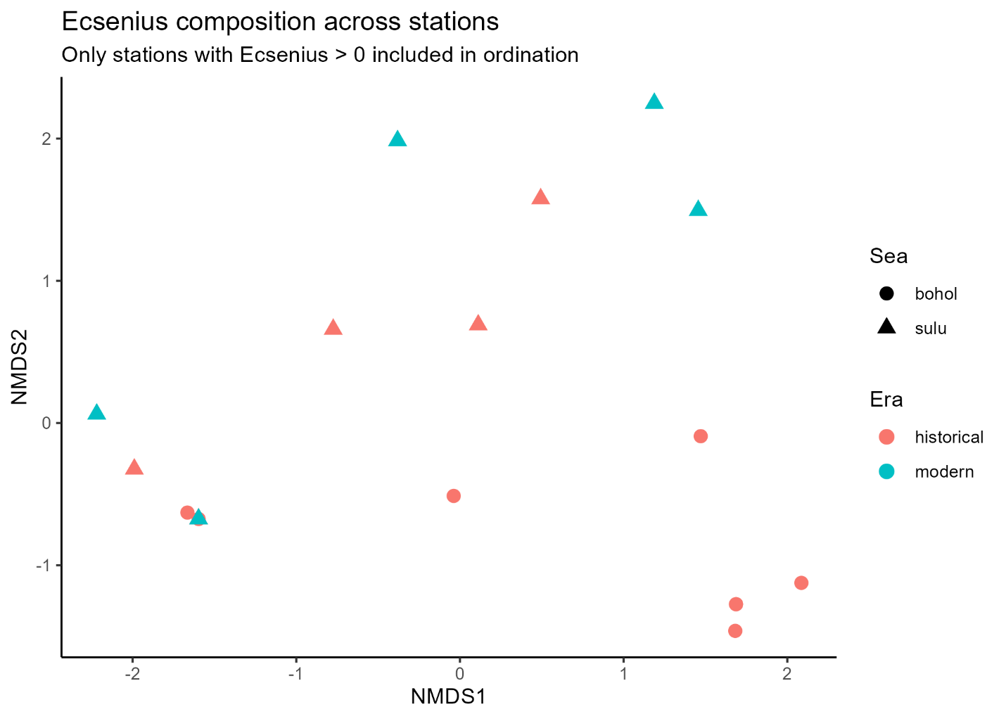

Table 1. Biodiversity metrics of Ecsenius by Era, Sea, and Province from historical (1978, 1979) and modern (2019, 2022) duplicate rotenone collections in the Philippines.
Era | Sea | Province | Total Stations | Stations w/ Ecsenius | Total Individuals | Mean Abundance | SD Abundance | Mean Richness | SD Richness | Total Species
Historical | All | All | 21 | 13 | 125 | 6.0 | 8.7 | 1.0 | 1.1 | 8
Modern | All | All | 21 | 5 | 35 | 1.7 | 5.9 | 0.3 | 0.6 | 4
Historical | Bohol | Siquijor, Negros Oriental | 13 | 8 | 64 | 4.9 | 9.0 | 0.8 | 0.8 | 5
Historical | Sulu | Palawan | 8 | 5 | 61 | 7.6 | 8.6 | 1.4 | 1.4 | 6
Modern | Bohol | Siquijor, Negros Oriental | 13 | 0 | 0 | 0.0 | 0.0 | 0.0 | 0.0 | 0
Modern | Sulu | Palawan | 8 | 5 | 35 | 4.4 | 9.2 | 0.8 | 0.7 | 4
Historical | Bohol | Negros Oriental | 7 | 4 | 51 | 7.3 | 11.9 | 0.6 | 0.5 | 2
Historical | Bohol | Siquijor | 6 | 4 | 13 | 2.2 | 2.8 | 1.0 | 1.1 | 4
Historical | Sulu | Palawan | 8 | 5 | 61 | 7.6 | 8.6 | 1.4 | 1.4 | 6
Modern | Bohol | Negros Oriental | 7 | 0 | 0 | 0.0 | 0.0 | 0.0 | 0.0 | 0
Modern | Bohol | Siquijor | 6 | 0 | 0 | 0.0 | 0.0 | 0.0 | 0.0 | 0
Modern | Sulu | Palawan | 8 | 5 | 35 | 4.4 | 9.2 | 0.8 | 0.7 | 4

Table 2. Ecsenius individual counts and number of stations present per species by Era & Sea.
Era | Sea | Species | Total Individuals | Number of Stations Present
Historical | Bohol | E. bicolor | 0 | 0
Historical | Bohol | E. bimaculatus | 1 | 1
Historical | Bohol | E. kurti | 0 | 0
Historical | Bohol | E. lineatus | 0 | 0
Historical | Bohol | E. lividanalis | 5 | 1
Historical | Bohol | E. monoculus | 47 | 2
Historical | Bohol | E. namiyei | 0 | 0
Historical | Bohol | E. pictus | 10 | 5
Historical | Bohol | E. yaeyamaensis | 1 | 1
Historical | Sulu | E. bicolor | 0 | 0
Historical | Sulu | E. bimaculatus | 1 | 1
Historical | Sulu | E. kurti | 13 | 3
Historical | Sulu | E. lineatus | 2 | 1
Historical | Sulu | E. lividanalis | 0 | 0
Historical | Sulu | E. monoculus | 33 | 3
Historical | Sulu | E. namiyei | 1 | 1
Historical | Sulu | E. pictus | 0 | 0
Historical | Sulu | E. yaeyamaensis | 11 | 2
Modern | Bohol | E. bicolor | 0 | 0
Modern | Bohol | E. bimaculatus | 0 | 0
Modern | Bohol | E. kurti | 0 | 0
Modern | Bohol | E. lineatus | 0 | 0
Modern | Bohol | E. lividanalis | 0 | 0
Modern | Bohol | E. monoculus | 0 | 0
Modern | Bohol | E. namiyei | 0 | 0
Modern | Bohol | E. pictus | 0 | 0
Modern | Bohol | E. yaeyamaensis | 0 | 0
Modern | Sulu | E. bicolor | 2 | 1
Modern | Sulu | E. bimaculatus | 0 | 0
Modern | Sulu | E. kurti | 1 | 1
Modern | Sulu | E. lineatus | 3 | 2
Modern | Sulu | E. lividanalis | 0 | 0
Modern | Sulu | E. monoculus | 29 | 2
Modern | Sulu | E. namiyei | 0 | 0
Modern | Sulu | E. pictus | 0 | 0
Modern | Sulu | E. yaeyamaensis | 0 | 0

Table 3. Sample size and p-values from nonparametric statistical tests on biodiversity metrics to evaluate temporal change within each sea.
Sea | Historical Stations | Modern Stations | Richness p-value | Abundance p-value | Presence p-value
Bohol | 13 | 13 | 0.001 | 0.001 | 0.002
Sulu | 8 | 8 | 0.504 | 0.450 | 1.000

References
Brandl SJ, Goatley CHR, Bellwood DR, Tornabene L (2018) The hidden half: ecology and evolution of cryptobenthic fishes on coral reefs. Biol Rev 93:1846–1873.
Brandl SJ, Johansen JL, Casey JM, Tornabene L, Morais RA, Burt JA (2020) Extreme environmental conditions reduce coral reef fish biodiversity and productivity. Nat Commun 11:3832.
Feary DA (2007) The influence of resource specialization on the response of reef fish to coral disturbance. Mar Biol 153:153–161.
Froese R, Pauly D (eds) (2025) FishBase. World Wide Web electronic publication.
Lassig BR (1983) The effects of a cyclonic storm on coral reef fish assemblages. Environmental Biology of Fishes 9:55–63.
Licuanan WY, Robles R, Reyes M (2019) Status and recent trends in coral reefs of the Philippines. Mar Pollut Bull 142:544–550.
Springer VG (1988) The Indo-Pacific blenniid fish genus Ecsenius. Smithsonian Contrib Zool 465:1–134.
Triki Z, Bshary R (2019) Fluctuations in coral reef fish densities after environmental disturbances on the northern Great Barrier Reef. PeerJ 7:e6720.
Wilson SK, Graham NAJ, Pratchett MS, Jones GP, Polunin NVC (2006) Multiple disturbances and the global degradation of coral reefs: are reef fishes at risk or resilient? Global Change Biology 12:2220–2234.
Wilson SK, Burgess SC, Cheal AJ, Emslie MJ, Fisher R, Miller I, Polunin NVC, Sweatman HPA (2008) Habitat utilization by coral reef fish: implications for specialists versus generalists in a changing environment. J Anim Ecol 77:220–228.

