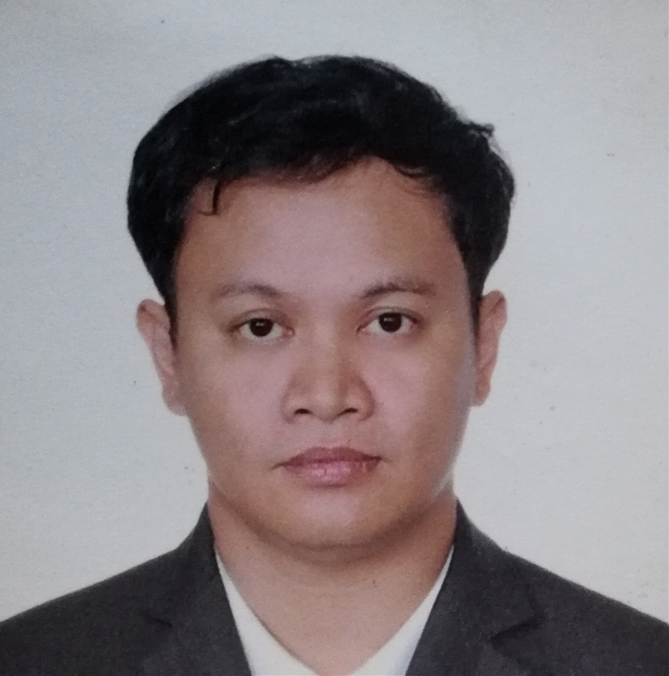
#2-D 20th Avenue Cubao Quezon City Philippines

Home No. 02-573-3645

Cell No. +639175445646

E-mail Address: jkatilla@yahoo.com,, jkatilla22@gmail.com

ATILLA, John Kristoffer JAMILANO

System Background

- Knowledgeable in Unix Shell scripting / Powershell / Chef / Json / AJAX
- Knowledgeable in DBMS Such as SQL /Mysql / MongoDB/ Oracle / Sybase
- Knowledgeable in HTML 5 /CSS / PHP /VB.NET /ASP.NET / C#/ JavaScript /VB Scripting / Python Programming / C++.
- Knowledgeable in Framework MVC.Net
- Knowledgeable in Cloud base Technology AWS / AZURE

EDUCATIONAL BACKGROUND

OJT EXPERIENCE

EDUCATIONAL GROUNDGROUND

Graduate : System Technological Institute College March 2005
Cubao Quezon City
Course : Master in Information Technology (MIT)
College : Technological Institute of the Philippines March 2002
Aurora Boulevard.

PROFESSIONAL EXPERIENCE

OJT EXPERIENCE

EDUCATIONAL GROUNDGROUND

WebOps Engineer / DevOps Feb 2017 - Present
Solarwinds Worldwide LLC. (https://www.solarwinds.com)
- Maintain and Support Solarwinds Core Web Application and servers.
- Deploy website using TeamCity and Buildmaster web application.
- Knowledgeable using monitoring tools such as SAM Orion,Papertrail,PingDom.
- Part of DevOps/Webops Team.
- Investigate and solve problem in web issues facing Stake holders.
- Knowledgeable using Powershell Script and CHEF.
- Understand using SQL Scripts and WebConfig files in aspx.
- Knowledgeable and understand Unix / .NET Framework.
- Experience with the following: C#, ASP.NET, AJAX, CSS, HTML, JavaScript, web services, XML and SQL.

Senior Web Developer Oct 2011 - Dec 2017
DBP (Development Bank of the Philippines Data Center)(https://www.devbnlphl.com.ph)
Makati Avenue Makati City
- Maintain and Develop Corporate website https://www.devbnkphl.com application such a Develop Internal Website Network monitoring tools created in ASP.NET C# /PHP mysql/VB.NET SQL Server.
- Monitor Security for Possible Intrusion in web.
- Solving Production Issue in web Application production.
- Main and Support company Datawarehaus
- Optimize MSSQL scripts and design process in DTS/SSIS (SQL Server Integration Services)
- Develop tools for reporting Crystal Report design.
- Support Inhouse System and modify using C#/ ASP.NET / VB.NET systems.
- Maintain and support daily/monthly ETL (Extract Transform load) for Operations.

Sr. Application Developer / Solution Analyst July 2007 - Jun 2011
Globe Telecommunication Company (https://www.globe.com.ph)
Boni Avenue Pioneer Highlands Philippines

NATURE AND SCOPE OF WORK:
- Creating Reports using Crystal Report v.10
- Creating Script in UNIX KORN Shell and other Unix environment
- Sybase database programming
- Solving Production Issue
- Design and develop solution for the issue encounter.
- Knowledge in Oracle/Unix Environment.
- Designing Cron Job and Monitor Jobs Unix
- MS SQL
- Optimizing Script in Unix
- Unix Programming
- VB.NET / Salesforce
- Develop tools for reporting Crystal Report
- Support Web Application System using PHP as language

