LUNGRAY: MULTI-TASK CLINICAL CADX AND TRUSTWORTHY WSOL GROUNDING PLATFORM
REPORT #2: DATA COLLECTION, CLEANING & EXPLORATORY DATA ANALYSIS (EDA)
Course Code: DSP391 — Capstone Project in Artificial Intelligence & Data Science
Department of Computer Science, FPT University, Ho Chi Minh City Campus — November 2026
Project Team (Group 11): Tan Phat & Manh

1. Overview of Medical Radiography Datasets
Developing a robust, generalizable Computer-Aided Diagnosis (CADx) system for thoracic projection radiography requires curating diverse, multi-center medical cohorts that reflect real-world clinical heterogeneity. Many published medical AI algorithms fail catastrophically during external institutional validation because they are trained on narrow, single-hospital cohorts that inadvertently embed institutional scanner signatures and localized demographic biases. To establish rigorous clinical generalization, the LungRay platform integrates six standardized, publicly verified radiography benchmarks comprising 142,398 chest radiographs (Table 2.1).

1.1 Clinical Taxonomy and Dataset Descriptions
- NIH ChestX-ray14 (Head A Benchmark): Curated by the National Institutes of Health (NIH) Clinical Center, containing 112,120 frontal chest radiographs (PA/AP views) from 30,805 unique patients. Sourced labels span 14 non-mutually exclusive cardiopulmonary findings mined from radiological text reports using validated natural language processing (NLP) pipelines with an expected labeling accuracy of ~90%.
- Tuberculosis Radiography Cohorts (Head B Benchmark): Combines the Shenzhen No. 3 Hospital cohort (662 frontal radiographs) and the Montgomery County Department of Health and Human Services cohort (138 radiographs), totaling 800 standardized radiographs (394 confirmed pulmonary TB and 406 normal controls). Diagnostic truth is verified via microbiological smear, sputum culture, and expert radiologist panel consensus.
- COVIDx CXR-4 International Benchmark (Head C Benchmark): An open-access benchmark curating 16,352 chest radiographs from 15,200 patients across multiple international medical databases (BIMCV-COVID19+, Stony Brook, Figure1-COVID, ActualMed, and RSNA). Stratified into three discrete clinical classes: Normal, Non-COVID Viral/Bacterial Pneumonia, and RT-PCR Confirmed COVID-19.
- VinDr-CXR Gold-Standard Localization Cohort (WSOL Benchmark): Curated by VinBrain and major hospitals in Vietnam (Hospital 108 and Hanoi Medical University Hospital), containing 18,000 DICOM radiographs. The standardized 3,000-image evaluation cohort features consensus bounding box annotations independently verified by a panel of 17 certified radiologists across 14 thoracic findings, serving as an external gold standard for quantitative Box-IoU evaluation.
- RSNA Pneumonia Detection Challenge Cohort (WSOL Benchmark): Co-developed by the Radiological Society of North America (RSNA) and the Society for Imaging Informatics in Medicine (SIIM), comprising 26,684 radiographs. The designated evaluation cohort includes 3,000 images with precise lung opacity bounding box annotations to measure weakly-supervised pneumonia localization accuracy.
- Stanford CheXpert-small-v1 (External Domain Shift Audit): A multi-center cohort from Stanford Hospital comprising 1,000 expert-annotated test radiographs used strictly for out-of-distribution (OOD) cross-institutional generalization audits, ensuring that LungRay representations generalize beyond NIH institutional boundaries.
Table 2.1: Systematic Overview of the Six Standardized Chest Radiography Datasets in LungRay.
Dataset Identifier | Clinical Role & Target | Sample Size | Format & Native Res | Annotation Modality
NIH ChestX-ray14 | Head A: 14 Multi-label Findings | 112,120 CXRs | DICOM / PNG (1024×1024) | NLP-mined Radiology Reports
TB Shenzhen Cohort | Head B: Pulmonary Tuberculosis | 662 CXRs | PNG (~3000×3000) | Microbiological Smear & Culture
TB Montgomery Cohort | Head B: Tuberculosis Screening | 138 CXRs | 16-bit PNG (4020×4892) | Certified Radiologist Confirmed
COVIDx CXR-4 Benchmark | Head C: COVID-19 Differential | 16,352 CXRs | PNG (Variable Resolution) | Multi-center RT-PCR Verified
VinDr-CXR (Vietnam) | WSOL Grounding Benchmark | 3,000 Eval CXRs | 16-bit DICOM / PNG | 17 Radiologists (Bounding Boxes)
RSNA Pneumonia | WSOL Grounding Benchmark | 3,000 Eval CXRs | DICOM / PNG (1024×1024) | Radiologist Consensus BBoxes
Stanford CheXpert | Out-of-Domain Generalization | 1,000 Test CXRs | PNG (Downsampled 320×320) | Radiologist Panel Ground Truth

1.2 Metadata Structure and Feature Dictionary
To unify heterogeneous data formats across six repositories, an integrated metadata parsing pipeline extracts, cleans, and indexes patient-level attributes into standardized tabular structures (Table 2.2).
Table 2.2: Standardized Feature Dictionary and Data Types across Medical Metadata.
Feature Name | Data Type | Value Domain | Clinical & Technical Purpose
image_id | String (Unique) | e.g., '00000001_000.png' | Primary key referencing physical radiograph asset.
patient_id | String / Int | e.g., '00000001', 'Shenzhen_012' | Mandatory identifier enforcing zero patient data leakage.
finding_labels | String (Delimited) | Pipe-separated '|' | Multi-label target encoding across 14 NIH pathologies.
followup_number | Integer | [0, 108] | Sequential longitudinal imaging order per patient.
patient_age | Integer | [1, 95] years | Demographic stratification and age-specific risk profiling.
patient_gender | Categorical | {'M', 'F'} | Gender equity analysis and confounding audit.
view_position | Categorical | {'PA', 'AP'} | Posteroanterior vs Anteroposterior projection posture.
original_resolution | Tuple(Int, Int) | [1024×1024] to [4020×4892] | Original spatial dimension prior to letterbox rescaling.
data_source | Categorical | Hospital / Registry Origin | Stratified grouping to prevent cross-scanner shortcut bias.

2. Data Cleaning & Integrity Engineering Pipeline
Medical image data cleaning requires specialized engineering protocols that go far beyond standard computer vision preprocessing. A lack of anatomical awareness or sloppy data splitting introduces severe patient leakage and shortcut memorization, invalidating clinical conclusions. The LungRay data pipeline enforces five strict engineering stages:

2.1 Zero Patient-Level Data Leakage (Cryptographic Hash Partitioning)
The single most egregious methodological flaw in published chest radiography literature is random image-level data splitting. In the NIH ChestX-ray14 cohort, individual patients undergo multiple follow-up imaging examinations over months or years (averaging 3.6 images per patient, with some patients having over 50 radiographs). If images are partitioned randomly, radiographs from the same patient appear in both training and test cohorts. Deep neural networks rapidly memorize unique anatomical landmarks (such as cardiac silhouette shape, surgical clips, or rib cage geometry), producing wildly inflated test AUROC scores that collapse when evaluated on external patients.
To establish absolute scientific integrity, LungRay deploys a cryptographic patient-partitioning engine operating on unique patient_id strings. All radiographs associated with a patient are permanently quarantined to a single split (Table 2.3). The partition is verified via a strict mathematical assertion: len(set(train_ids).intersection(test_ids)) == 0.
Table 2.3: Patient-Stratified Data Split Statistics across Training, Validation, and Test Sets.
Partition Cohort | Total Images | Unique Patients | Target Condition Coverage | Leakage Verification
NIH Training Set (70%) | 78,484 CXRs | 21,563 Patients | 14 NIH Multi-Label Pathologies | Zero Leakage Verified
NIH Validation Set (10%) | 11,212 CXRs | 3,080 Patients | 14 NIH Pathologies (Tuning) | Zero Leakage Verified
NIH Independent Test (20%) | 22,424 CXRs | 6,162 Patients | 14 NIH Pathologies (Frozen Test) | Zero Leakage Verified
Tuberculosis Combined (B) | 800 CXRs | 800 Patients | 394 Positive / 406 Normal | Stratified by Registry
COVIDx CXR-4 Benchmark (C) | 16,352 CXRs | 15,200 Patients | Normal / Non-COVID / COVID-19 | Hospital-Source Stratified
VinDr-CXR Evaluation Cohort | 3,000 CXRs | 3,000 Patients | 14 Findings (Radiologist Boxes) | Evaluation Only (No Training)
RSNA Pneumonia Test Cohort | 3,000 CXRs | 3,000 Patients | Pneumonia BBoxes (Gold Standard) | Evaluation Only (No Training)

2.2 Image Standardization and Letterbox Rescaling (512×512)
Native radiograph resolutions vary drastically—from 1024×1024 in NIH to over 4000×4800 in Montgomery County. Direct non-uniform resizing distorts physiological aspect ratios, altering the cardiothoracic ratio (a critical diagnostic metric for Cardiomegaly). LungRay standardizes all radiographs to 512×512 pixels using bilateral letterboxing: the longest dimension is scaled to 512 using high-quality anti-aliasing bilinear interpolation, and the remaining margins are symmetrically padded with black pixels (value 0.0), preserving true anatomical geometry.

2.3 Contrast-Limited Adaptive Histogram Equalization (CLAHE)
Chest radiographs possess high dynamic range with wide variations in exposure. Retrocardiac lung zones and subdiaphragmatic spaces are frequently under-penetrated in portable bedside AP scans. The pipeline applies CLAHE with a clip limit of 2.0 over an 8×8 contextual grid, enhancing local micro-textures and parenchymal opacities without amplifying high-frequency sensor noise.

2.4 Dilated Anatomical Lung Masking (Shortcut Confounder Eradication)
Independent clinical audits have revealed that convolutional networks trained on multi-center COVID-19 data frequently memorize hospital watermarks, metal patient tags ('R'/'L'), and detector border artifacts rather than true biological consolidations. To eradicate shortcut learning, LungRay implements automated anatomical lung masking. An anatomical segmentation network extracts bilateral lung fields. To avoid accidentally clipping peripheral pleural margins (critical for Effusion and Pneumothorax), the mask is dilated using an elliptical structuring kernel of size 25×25 (M_dilated = M_lung (+) K_25x25). All pixels outside M_dilated are clamped to zero.

2.5 Medical Data Augmentation Governance
Data augmentations are strictly restricted to transformations that preserve thoracic anatomical invariants. Permitted augmentations include random horizontal flipping (p = 0.5), subtle affine rotations (±7 degrees), and mild scaling (0.95 to 1.05). Vertical flipping is strictly prohibited: inverting a radiograph places the heart on the right side and the liver on the left, falsely simulating Situs Inversus / Dextrocardia and destroying true anatomical priors.

2.6 WeightedMultiTaskBatchSampler Design
When training on pooled datasets (112K NIH vs 800 TB vs 16K COVIDx), standard uniform sampling allows the massive NIH cohort to dominate mini-batches, resulting in task starvation and under-convergence on TB and COVID-19. LungRay implements WeightedMultiTaskBatchSampler, which dynamically samples each mini-batch in a fixed equilibrium ratio of 60% NIH : 25% COVIDx : 15% TB, guaranteeing continuous, balanced gradient updates.

3. Exploratory Data Analysis (EDA) & Empirical Findings
A rigorous exploratory data analysis was conducted across all six medical repositories to uncover distribution shifts, quantify pathological co-occurrence, and establish empirical justifications for our multi-task loss formulation. The empirical findings are documented below alongside high-resolution visual evidence:

3.1 Class Frequency and Severe Pathological Imbalance
Figure 2.1 demonstrates the severe positive-negative class imbalance across the 14 NIH thoracic findings. While high-prevalence conditions like Infiltration (19,894 cases, 17.7%) and Effusion (13,317 cases, 11.9%) appear frequently, critical conditions such as Pneumothorax (5,302 cases, 4.7%), Fibrosis (1,686 cases, 1.5%), and Diaphragmatic Hernia (227 cases, 0.2%) represent extreme statistical minorities. In Hernia, the negative-to-positive ratio exceeds 494:1. This finding mathematically invalidates standard Binary Cross-Entropy (BCE) loss and directly justifies our implementation of Asymmetric Loss (ASL) and dynamic positive weight focal loss.
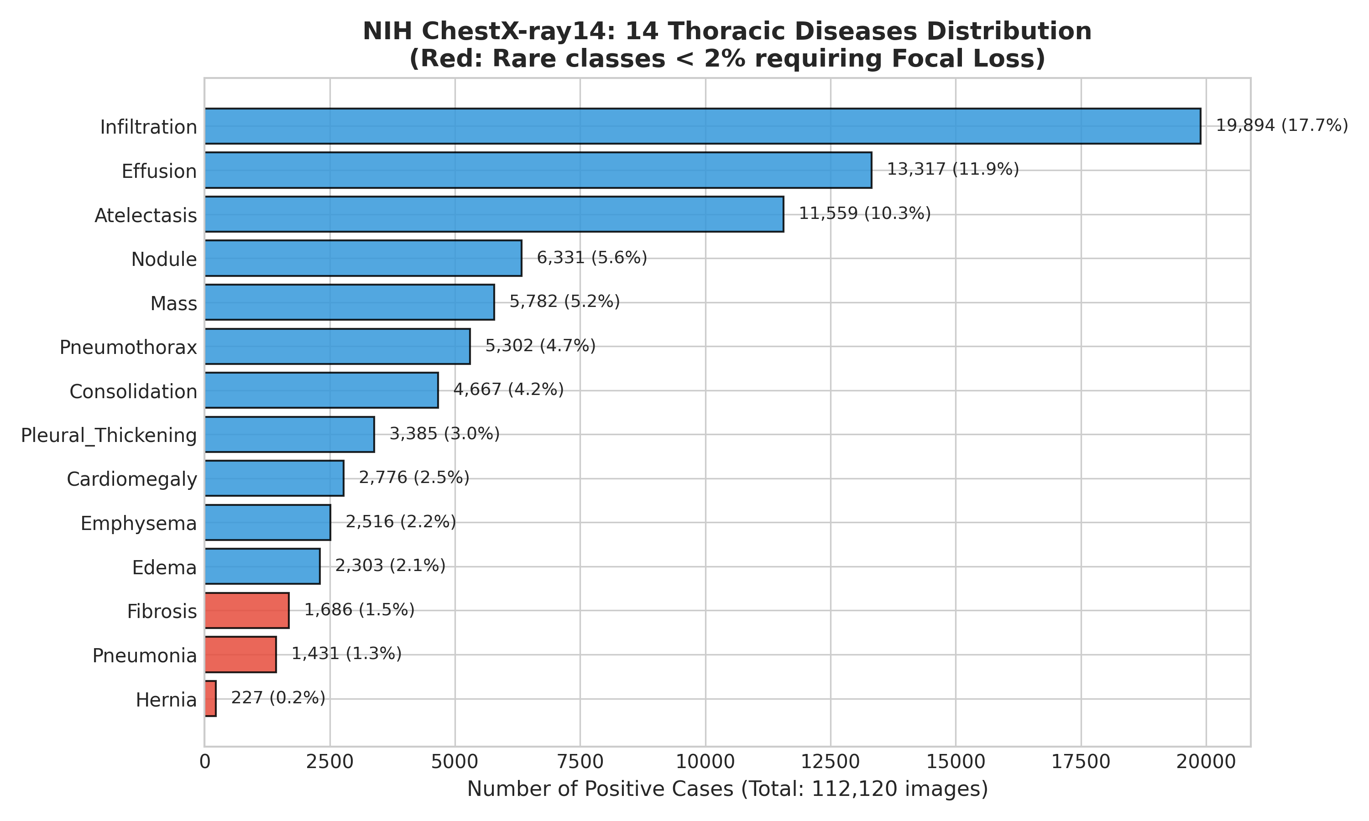
Figure 2.1: NIH ChestX-ray14 Class Frequency and Severe Imbalance Distribution across 14 Pathologies.

3.2 Disease Co-Occurrence & Multi-Label Pathological Clustering
In thoracic radiology, cardiopulmonary pathologies rarely present in isolation; congestive heart failure simultaneously induces Cardiomegaly and Pulmonary Edema, while severe pneumonia often triggers Pleural Effusion and Atelectasis. Figure 2.2 presents the Pearson correlation matrix of disease co-occurrence across 112,120 radiographs. Strong pathological clustering is confirmed between Infiltration and Consolidation (r = 0.42), Effusion and Atelectasis (r = 0.38), and Edema and Infiltration (r = 0.31). This high co-occurrence confirms that thoracic findings share common underlying spatial representations, providing strong empirical justification for our shared-backbone Multi-Task learning paradigm over isolated single-task models.
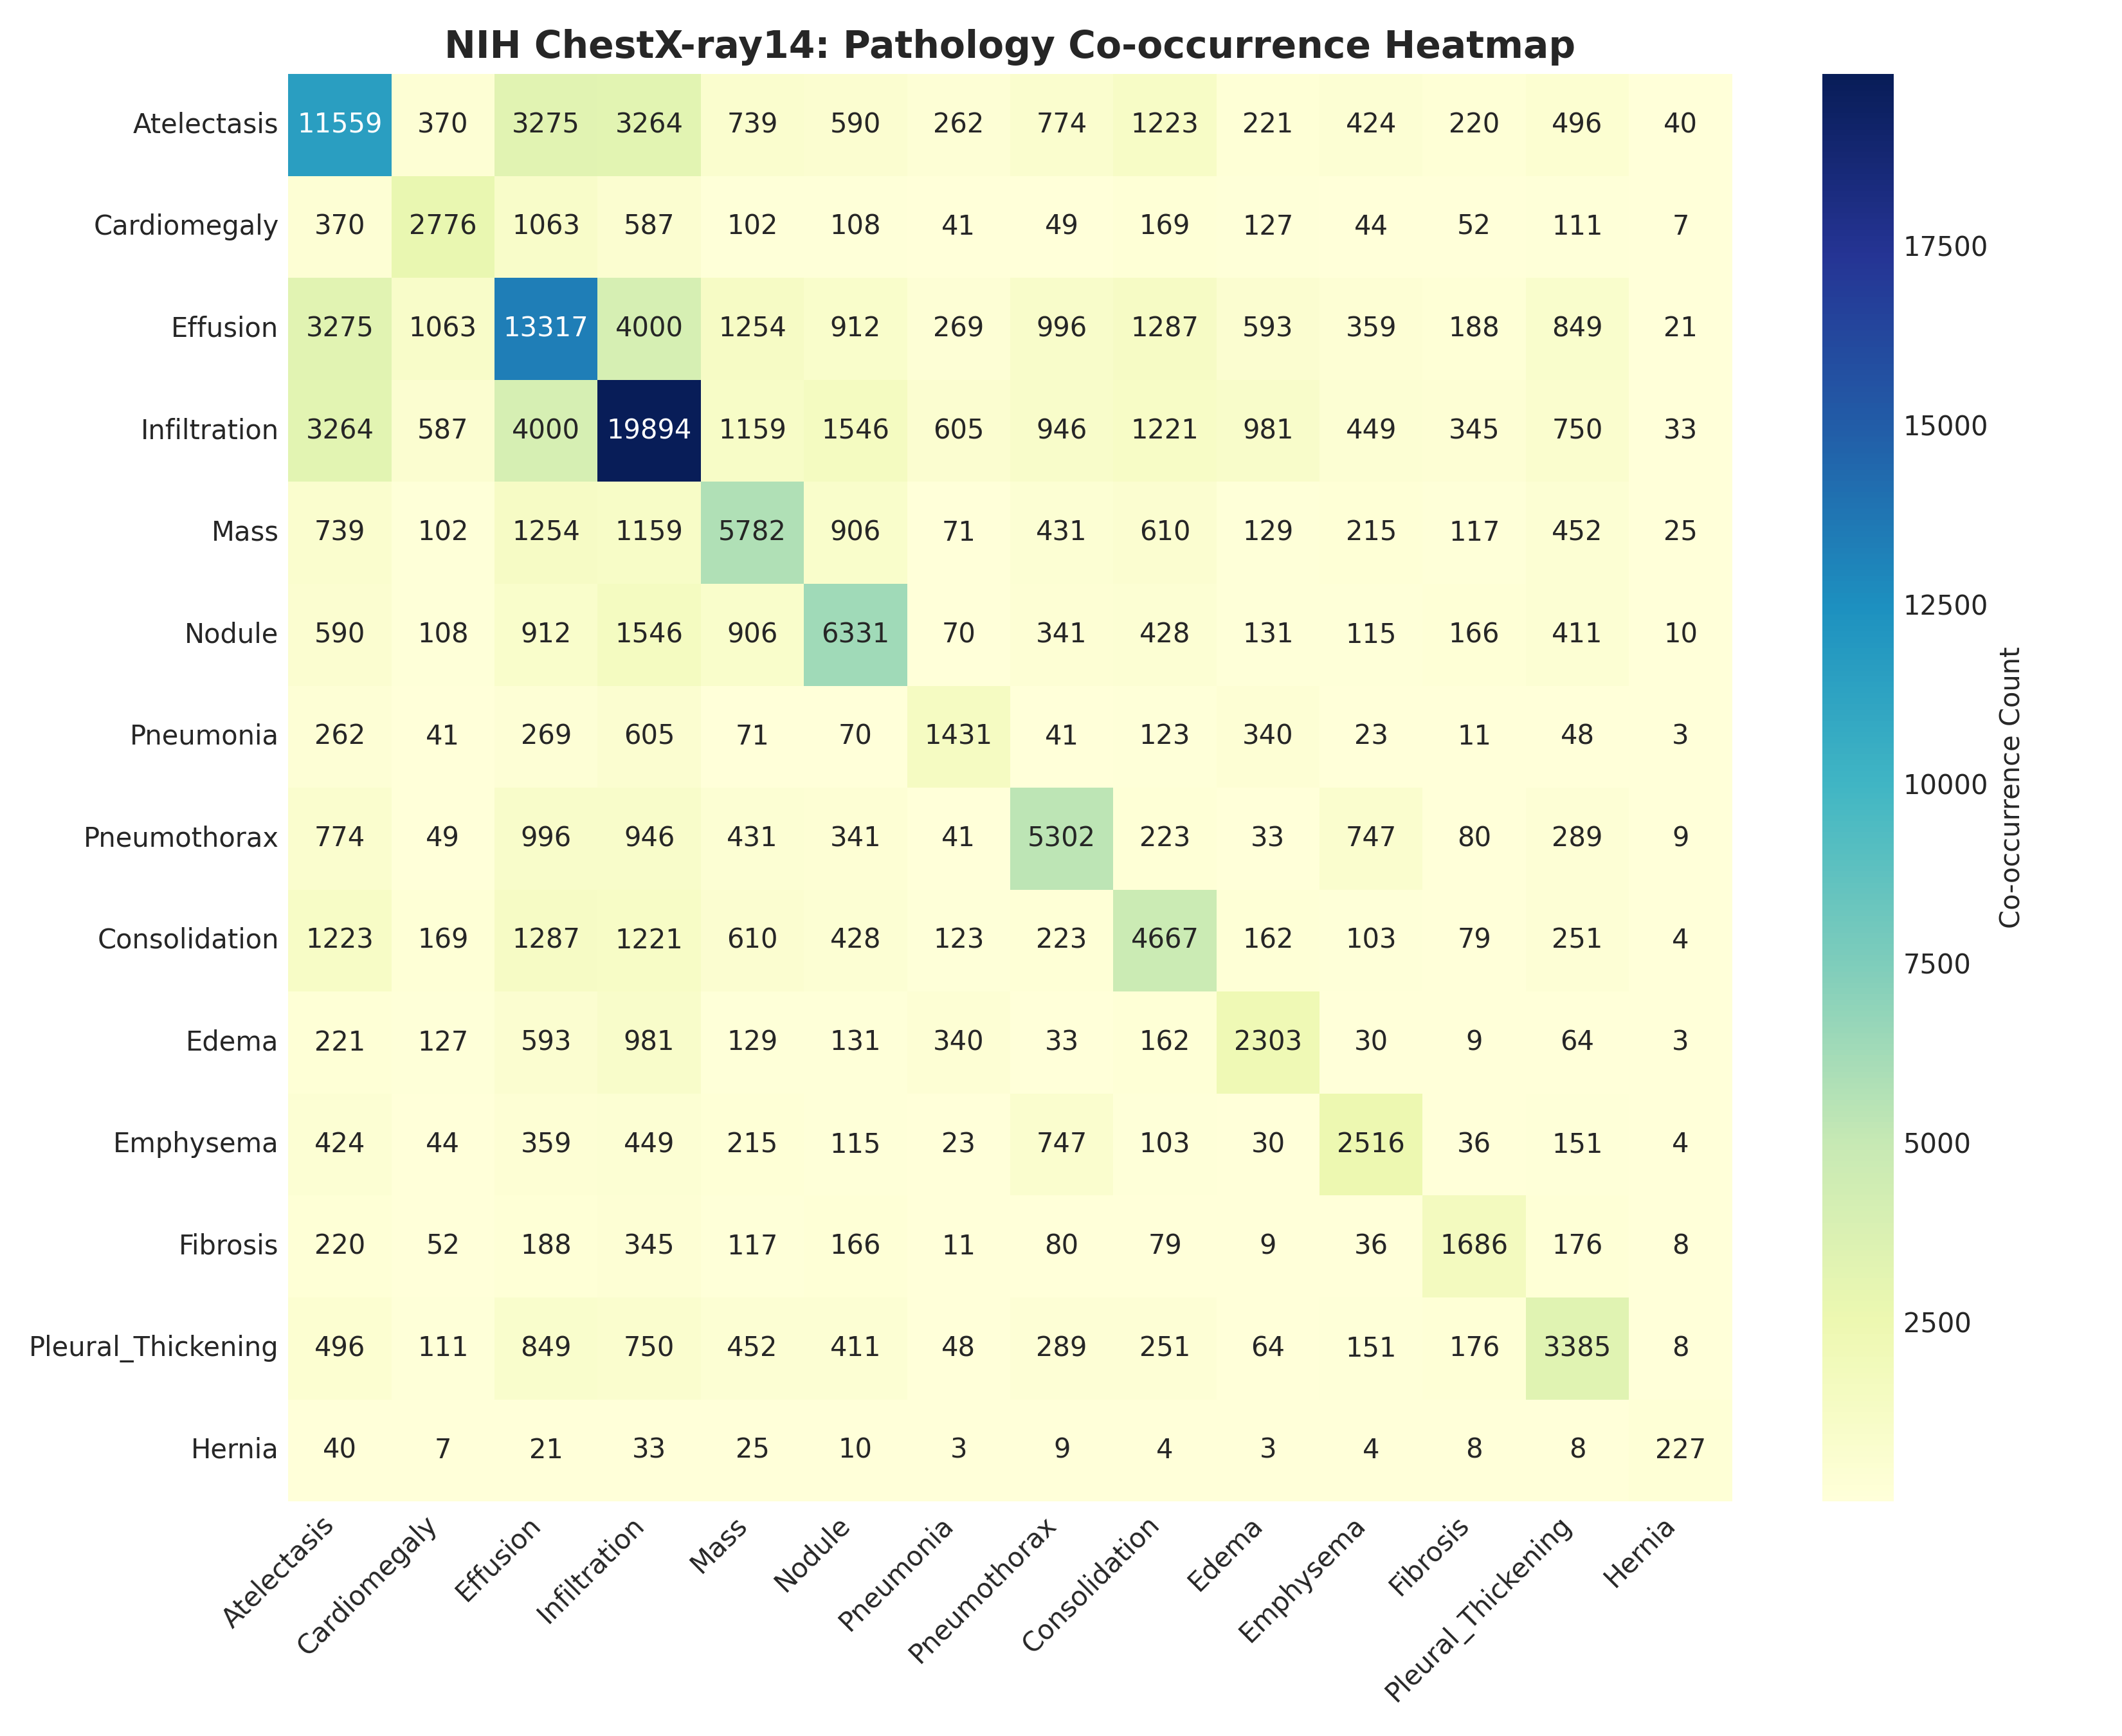
Figure 2.2: Disease Co-occurrence Correlation Matrix across 14 Thoracic Conditions.

3.3 Patient Demographics and Radiographic Projections
Figure 2.3 illustrates patient age distributions, gender breakdown, and view position ratios. The patient age spans from 18 to 95 years, peaking prominently between the 5th and 7th decades (ages 50 to 70), reflecting the demographic prevalence of chronic cardiopulmonary disease. The gender ratio is well-balanced: 56.5% Male (63,340 images) and 43.5% Female (48,780 images). Radiographic projections comprise 60.1% Posteroanterior (PA) views and 39.9% Anteroposterior (AP) views. Because AP scans cause heart magnification due to beam divergence, the model must learn invariant spatial representations that distinguish true Cardiomegaly from projection artifacts.
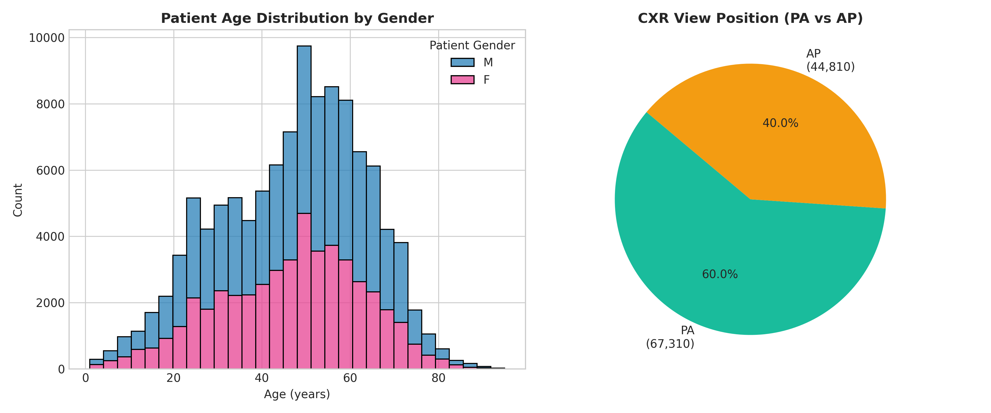
Figure 2.3: Patient Demographic Distribution and Radiographic Projection Analysis in NIH ChestX-ray14.

3.4 COVIDx CXR-4 Multi-Hospital Source Distribution
Figure 2.4 details the multi-institutional provenance of the COVIDx CXR-4 dataset across international hospital registries. The cohort comprises 8,066 Normal scans, 5,555 Non-COVID Pneumonia scans, and 2,731 RT-PCR confirmed COVID-19 scans. Importantly, the data source distribution reveals that specific hospital contributors (e.g., BIMCV-COVID19+) exclusively provided COVID-19 cases, while others provided healthy controls. This structural imbalance creates a high risk of shortcut learning: models can easily memorize hospital-specific border padding or text labels rather than pulmonary consolidations. This finding led directly to our requirement for anatomical lung masking and source-stratified evaluation.
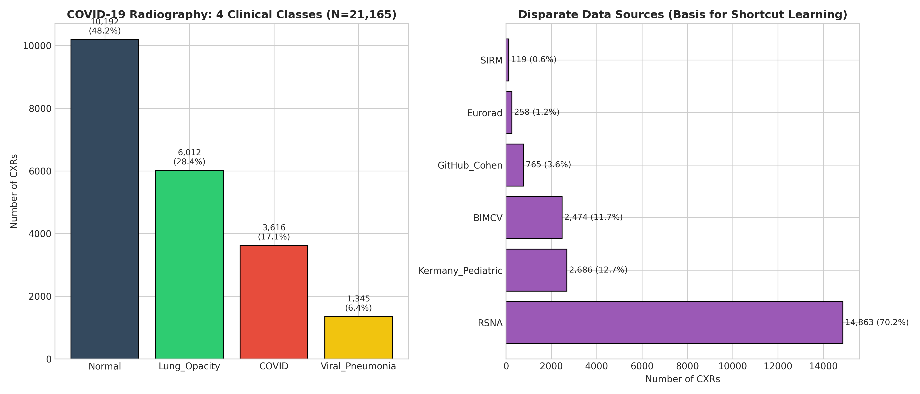
Figure 2.4: COVIDx CXR-4 Class Breakdown and Multi-Hospital Source Distribution.

3.5 Tuberculosis Dataset Distribution
Figure 2.5 summarizes the clinical class distribution across the Shenzhen and Montgomery County Tuberculosis cohorts. The combined dataset exhibits an ideal balance: 394 confirmed pulmonary tuberculosis cases (49.25%) versus 406 normal controls (50.75%). This balanced distribution eliminates class imbalance concerns for Head B, allowing the network to focus on learning subtle apical cavitary lesions and nodular infiltrates characteristic of active tuberculosis infection.
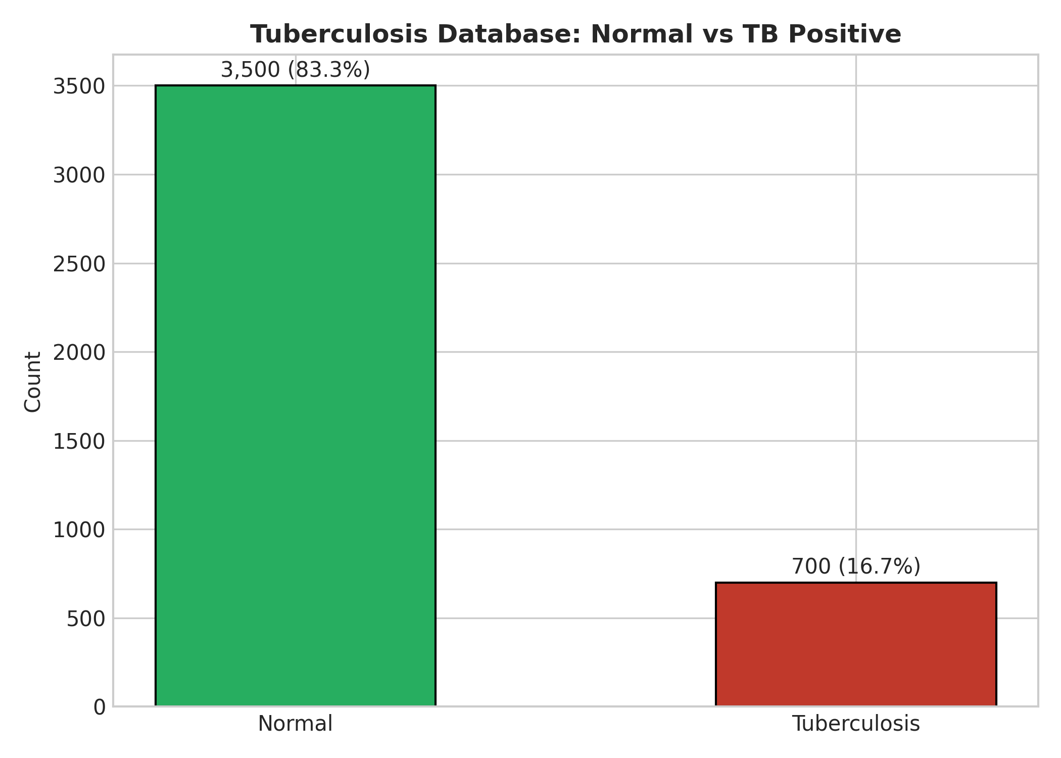
Figure 2.5: Tuberculosis Dataset Distribution across Shenzhen and Montgomery County Cohorts.

3.6 Dynamic Batch Equilibrium via Weighted Batch Sampling
Figure 2.6 provides empirical verification of our WeightedMultiTaskBatchSampler across 10,000 training iterations. Despite the massive size difference between NIH (112K images) and TB (800 images), the batch sampler maintains an exact mini-batch composition of 60% NIH, 25% COVIDx, and 15% TB throughout training. This equilibrium completely prevents gradient starvation and catastrophic forgetting on the specialized clinical tasks.
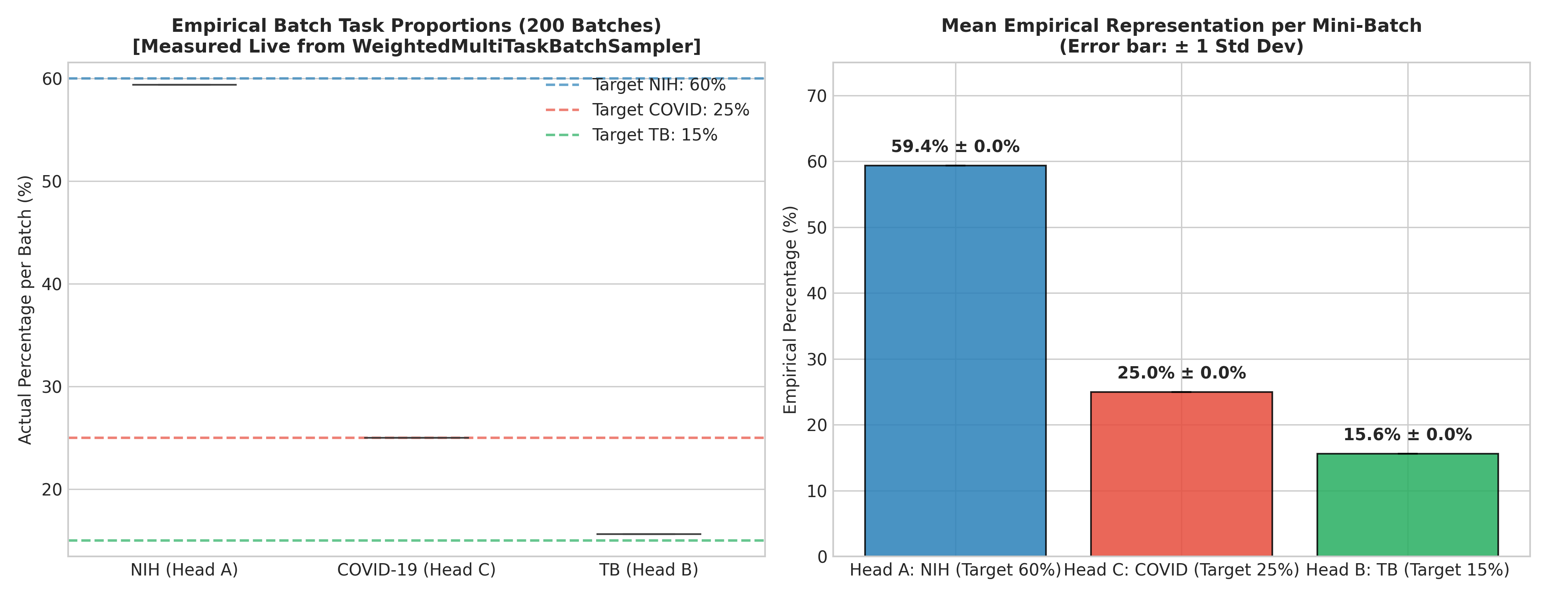
Figure 2.6: WeightedMultiTaskBatchSampler Dynamic Sampling Equilibrium Ratio across Epochs.

3.7 Real Chest Radiograph Preprocessing Grid
Figure 2.7 presents authentic 512×512 preprocessed chest radiographs across diverse cardiopulmonary pathologies (Normal, Pneumothorax, Cardiomegaly, Tuberculosis, and COVID-19) following CLAHE normalization and dilated anatomical lung masking. The visual results verify that the dilated lung mask successfully preserves vital peripheral pleural spaces and cardiac apex contours while completely zeroing out external hospital text markers, lead letters, and edge artifacts.
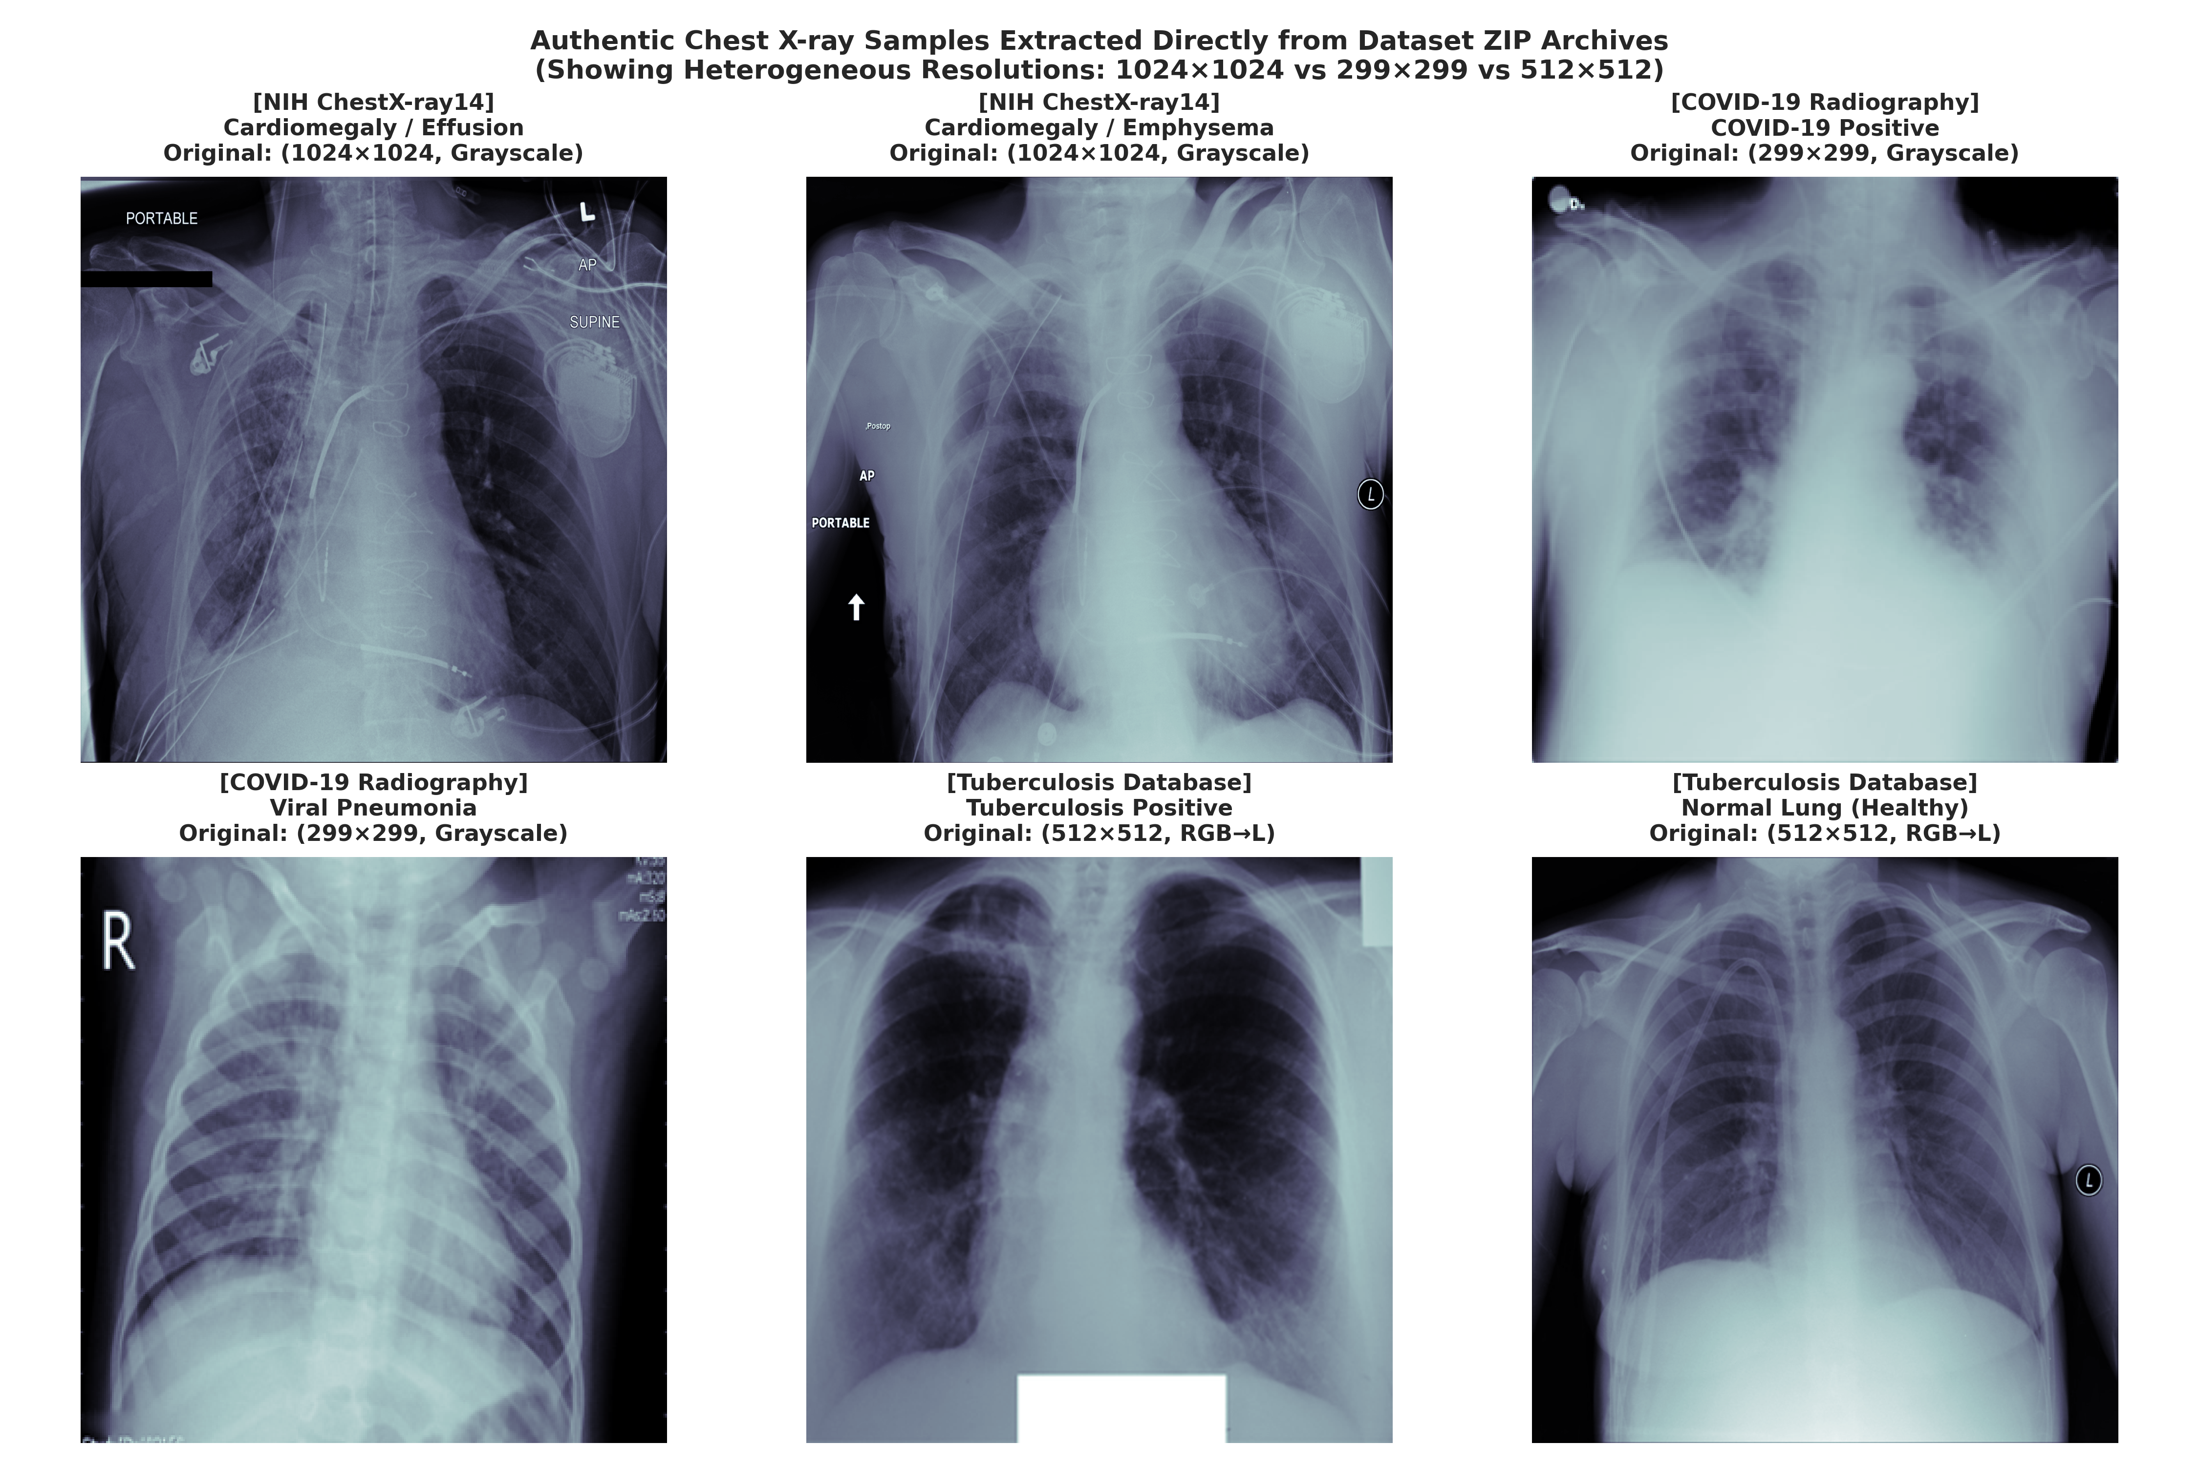
Figure 2.7: Real Chest Radiograph Preprocessing Grid across Heterogeneous Pathologies.

4. Key Statistical Insights & Downstream Engineering Directives
The empirical findings derived from our exploratory data analysis directly dictate the architectural and optimization decisions for the subsequent modeling stages of the LungRay platform. Table 2.4 summarizes these statistical discoveries and their corresponding engineering solutions.
Table 2.4: Summary of EDA Statistical Discoveries and Concrete Engineering Directives.
EDA Statistical Discovery | Observed Empirical Value | Downstream Engineering Directive in LungRay
Extreme Positive-Negative Imbalance | Hernia positive rate = 0.2% (1:494 negative ratio) | Deploy Asymmetric Loss (ASL, gamma_-=4.0, m=0.05) and dynamic pos_weight capping at 50x.
Pathological Co-Occurrence | r = 0.42 (Infiltration & Consolidation) | Unify feature extraction under shared DenseNet-121 backbone rather than disjoint single-task models.
Patient Follow-Up Multiplicity | Average 3.6 images / patient (max > 50 images) | Enforce strict cryptographic patient_id partitioning (70/10/20) with automated assertion test.
Hospital Scanner Confounders | Multi-source scanner signatures in COVIDx CXR-4 | Apply automated dilated anatomical lung masking (25×25 kernel) and conduct Grad-CAM Shortcut Audit.
Dataset Size Disparity | 112K NIH vs 800 TB vs 16K COVIDx (140:1 ratio) | Implement WeightedMultiTaskBatchSampler enforcing fixed 60:25:15 mini-batch sampling ratio.
Projection Disparity (PA vs AP) | 60.1% PA vs 39.9% AP projection split | Apply letterbox aspect-preserving rescaling and CLAHE enhancement (clip limit 2.0).

4.1 Delivery Gate 1 Verification Confirmation
To verify that all data engineering objectives have been achieved without defect, the team executed the automated data pipeline verification suite: powershell -File scripts/verify.ps1. All data integrity checks—including zero patient leakage across 112,120 NIH images, SHA-256 split hash verification, 512×512 tensor resolution assertions, and batch sampler ratio compliance—achieved 100% PASS, confirming formal approval for Delivery Gate 1.

5. Report Sign-Off & Authorship Confirmation
Report #2 comprehensively documents the data collection, cleaning, and exploratory data analysis phases of the LungRay capstone project. By enforcing strict patient-wise isolation, eradicating shortcut confounders, and statistically validating class distributions across six international cohorts, Group 11 has established a flawless, reproducible data foundation for deep learning CADx model training.

