WriCLE:
A learner corpus for Second Language Acquisition Research

Amaya Mendikoetxea
Department of English Philology
Universidad Autónoma de Madrid
amaya.mendikoetxea@uam.es

Michael O’Donnell
Department of English Philology
Universidad Autónoma de Madrid
michael.odonnell@uam.es

Paul Rollinson
Department of English Philology
Universidad Autónoma de Madrid
paul.rollinson@uam.es

Abstract

The validity and reliability of Second Language Acquisition (SLA) hypotheses rest heavily on adequate methods of data gathering. In this paper, we analyse the reasons why many SLA researchers are still reticent about using corpora and how good corpus design and adequate tools to annotate and search corpora could help overcome some of the problems observed. We do so by describing the key design principles of a learner corpus we are compiling (WriCLE: Written Corpus of Learner English), the way data has been collected and how it is being annotated using UAM CorpusTool. We then present some studies based on the WriCLE corpus and show how our corpus (and software) can be used to test current hypotheses in SLA. Our paper concludes with a brief analysis of future challenges for corpus-based SLA research.

1. Introduction

Much current SLA research relies on elicited experimental data and disfavours natural language use data. This situation, however, is beginning to change thanks to the availability of computerized linguistic databases and learner corpora. The area of linguistic inquiry known as ‘learner corpus research’ has recently come into being as a result of the confluence of two previously disparate fields: corpus linguistics and Second Language Acquisition (see Granger 2002, 2004; Barlow 2005). Despite the interest in what learner corpora can tell us about learner language, studies in corpus-based SLA research are mostly descriptive, focusing on differences between the language of native speakers and the learners’ interlanguage(s), as observed in the written performance of advanced learners from a variety of L2 backgrounds (see e.g. Granger 2002, 2004 and Myles 2005, 2007 for a similar evaluation). The aims of this paper are: (i) to evaluate the impact of learner corpus research in recent SLA theory; and (ii) to describe the WriCLE corpus and its contribution to this area of inquiry, as a corpus designed for SLA purposes.
We first present the case for the use of corpora in SLA research and evaluate the impact of learner corpora within this field of SLA studies (section 2). We then focus of the WriCLE corpus: key design principles, data collection and annotation (section 3). In section 4, we describe briefly two research projects that use WriCLE for SLA hypothesis-testing purposes and another project which uses WriCLE for pedagogical purposes, in particular, to profile the grammatical competence of each learner proficiency level to facilitate curriculum design within Foreign Language Teaching (FLT). Finally, in the concluding section (section 5) we point out what we believe is the way forward for learner corpus research.

2. Corpora in SLA: why we need them

2.1 Gathering learner data
As pointed out by Granger (2002: 5) “much current SLA research favours experimental, metalinguistic and introspective data, and tends to be dismissive of natural language use data.” In order to understand why this is the case, we have to look at the purpose of SLA research. The main aim of SLA research is to build models of the underlying representations of learners at a particular stage in the process of L2 learning and of the developmental constraints that shape and constrain L2 production. The central source of evidence for these mental processes is the language produced by learners, whether spontaneously or through a variety of data elicitation procedures, as Myles (2005: 374) states. Findings in SLA depend highly on these procedures and the success of SLA research relies crucially on access to good quality data.
Several reasons can be given for why elicitation techniques are favoured in SLA research. For instance, Mackey & Gass (2005) provide the following reasons why metalinguistic data may be used in SLA research, as opposed to natural language use data: (i) the particular structure you want to investigate may not occur in natural production: it may be absent or there may not be enough instances, and, conversely, (ii) to answer your research question you may need to know what learners rule out as a possible L2 sentence: (a) presence of a particular structure/feature in the learners’ natural output does not necessarily indicate that the learners ‘know’ the structure, and (b) absence of a particular structure/feature in natural language use data does not necessarily indicate that learners do not ‘know’ the structure. An additional reason is provided by Granger (2002: 6): it is difficult to control the variables that affect learner production in a non-experimental context. The consequence of all this is that the empirical base of SLA research tends to be relatively narrow, based on the language produced by a very limited number of subjects, which, as pointed out by Granger (2002: 6), raises questions about whether results can be generalised.
Case studies and small-scale studies have greatly served the hypothesis-building endeavour in SLA research, but there are now many researcher who feel that the time has come to test hypotheses on larger and better constructed databases to see whether findings can be generalised (see Myles 2005) and to discover sets of data nor normally found in small studies which can become crucial in order to inform currents debates (e.g. what aspects of grammar are more vulnerable to transfer or cross-linguistic influence). These are the main reasons for the use corpora in SLA research, to which we can add another two which are common to corpus linguistics in general as a field of inquiry: to discover patterns of use and for quantitative studies (e.g. frequency).

2.2. Learner corpora in SLA research
Studies using learner corpora in SLA fall within two categories (i) hypothesis-driven/corpus-based studies and (ii) hypothesis-finding/corpus-driven studies (see Granger 1998, and Tognini-Bonelli 2001). According to Barlow (2005: 344), the former involve using learner corpus data to test specific hypotheses or research questions about the nature of learner language generated through introspection, SLA theories, or as a result of the analysis of experimental or other sources of data. The latter involve investigating learner corpus data in a more exploratory way to discover patterns of data, which may then be used to generate hypotheses about learner language. The majority of studies within the area of learner corpus research fall within category (ii), as revealed by an analysis of the papers collected in recent edited volumes within the field (e.g. Granger et al. 2002 and Aston et al. 2004). For instance, Altenberg (2002) and Aijmer (2002) are good examples of the kinds of studies that corpus linguistics has made easier to carry out, according to Myles (2005): they rely on large written corpora and they focus on the use of discrete items and in different cross-sectional populations: typically one or more L1s compared with native use. Hypothesis-driven, corpus-based studies are hard to find (two examples from the volumes mentioned above are Housen 2002 and Tono 2004).
As Barlow (2005) points out, there are biases in practice: with the experimental/generative tradition favouring category (i) studies, and corpus linguists favouring category (ii) studies, but on the whole, it can be said that the contribution of learner corpus research so far has been much more substantial in description than interpretation of SLA data (Granger 2004, Myles 2005). According to Granger (2004: 134-135), this is because learner corpus research has been mainly conducted by corpus linguists, rather than SLA specialists (Hasselgard 1999), and the type of learner language corpus that researchers have been most interested in (intermediate to advanced) was so poorly described in the literature that they felt the need to establish the facts before launching into theoretical generalisations. That is, most work is rather descriptive, documenting differences between native and non-native English, rather than explaining. Additionally, there is very little or no reference to current debates and hypotheses in the SLA literature (Myles 2005). However, as pointed out by Myles (2005: 381): “such research is useful nonetheless, as we need to have good descriptions of learner language in order to inform our understanding of what shapes its development, but it is now time that corpus linguists and SLA specialists work more closely together in order to advance both their agendas”.

3. WriCLE: A Written Corpus of Learner English

The WriCLE corpus was created as part of the WOSLAC project (Word Order in Second Language Acquisition Corpora), whose purpose was to investigate the lexical, syntactic and discoursive properties affecting word order in L2 English and L2 Spanish (see section 4 below for details). In this section, we first describe the key design principles of WriCLE, as a corpus primarily intended for SLA research purposes. We then comment briefly on data collection and annotation.

3.1. Key design principles

3.1.1. Principle 1: Focus on written language
Though the majority of available learner corpora are written, there is some debate among learner corpus researchers as to whether written data, as opposed to spoken data, is a good representation of the learners’ underlying mental grammar, i.e. there are questions concerning the suitability of written production data for the testing of SLA hypotheses. Mitchell et al. (2008), for instance, advocate the use of spoken learner corpora, as spontaneous speech in naturalistic or semi-naturalistic settings is likely to provide more direct evidence of the L2 learner’s underlying interlanguage system. However, written corpora are often used to study native grammars and are considered to be a good reflection of language competence for language speakers, so, why should that not be the case for L2 learners?
Without understating the validity of spoken data, there are several reasons why we believe that written data is adequate for SLA research. First, there are likely to be fewer performance errors in the written language and the errors found are those that escape monitoring, indicating grammatical or lexical gaps in the learners’ mental grammar. Second, learners tend to use more complex structures when they are writing, which could be more revealing in terms of their linguistic competence than the simplified language often found in oral language. Finally, written corpora are particularly suitable to study the features of the interlanguage of advanced learners, especially in comparison with similar corpora of native speakers: (i) learner corpus research in the ICLE tradition (Granger et al. 2002) shows that advanced learner texts are a valuable source of data to study aspects such as modality, degree adverbs, tenses, collocations, phraseology, the expression of causativity, information structure, clefts, anaphora, etc. (see also section 2.2 above), and (ii) written corpora can also be used in hypothesis-testing studies: e.g. passivised structures and expletives (Oshita 2000, 2004) and the study of subject inversion in L2 English (Lozano & Mendikoetxea 2008, 2009, in press) (see section 4.1 below).

3.1.2. Principle 2: Authenticity
Following Sinclair’s (1996) definition of what is a corpus, Granger (2002: 7) defines learner corpora as: “electronic collections of authentic FL/SL textual data according to explicit design criteria for a particular SLA/FLT purpose” (FL: Foreign Language; SL: Second Language). But as Granger (2002) herself points out, learner data is rarely fully natural, especially in the case of EFL learners, who learn English in a classroom. Some researchers talk about a scale of naturalness: fully natural – product of teaching process – controlled task – scripted (Nesselhauf 2004:128). In general, the more intervention by the researcher, the further away we are from ‘authentic’ data
The kind of texts compiled in WriCLE are argumentative or discussion essays written by learners of L2 English (L1 Spanish) outside the classroom environment for the Academic Writing component of English Language I and English Language III courses of a degree in English Studies in a Spanish university (see § 3.2 below for details). As such, they constitute ‘authentic’ (written) learner data: “data resulting from authentic classroom activity” (Granger 2002: 8).

3.1.3. Principle 3: Variety of learner levels
The corpus includes makes provision for learners at six different proficiency levels so as to maximize its usefulness to study development in L2 English. A standardised proficiency measure is used: the levels correspond to those of the Common European Framework of Reference for Languages and are determined by the score obtained in the Quick Placement Test (UCLES 2001) taken by each of the learners and available to researchers in a database that accompanies the corpus. This is essential for SLA research: experimental and metalinguistic studies in SLA always provide a proficiency measure, as hypotheses and generalisations depend greatly on the learners’ proficiency level. Any corpus designed for SLA purposes must include a formal measure of proficiency, crucially, for cross-sectional or longitudinal studies but also when the analysis involves learners at a particular developmental stage.

3.1.4. Principle 4: Documentation
Information about learners and task is crucial for SLA research. As part of the WriCLE project, each learner fills in a Learner Profile questionnaire and for each essay there is an Essay Profile questionnaire (one profile per essay as a learner may contribute more than one essay) (see section 3.2 below). All this information, together with information about proficiency level (see section 3.1.3 above), year of collection, year of study, etc. is stored in a spreadsheet (Microsoft Excel 2007) and will be available to researchers together with the corpus.

3.1.5. Principle 5: Homogeneity
One of the criteria for corpus design in Sinclair (2005) is homogeneity: “a corpus should aim for homogeneity in its components, while maintaining adequate coverage, and rogue texts should be avoided” (Sinclair 2005, Criterion 9). In WriCLE, internal criteria guarantee homogeneity (essay topics, learner types, context of instruction, etc.). Rogue texts are manually eliminated by researchers (e.g. instances of plagiarism).
Homogeneity facilitates comparisons with similar corpora. This is an important design principle, as SLA research often involves comparisons between different groups of learners (different proficiency levels, different L1, etc.), as well as between learners and natives. As part of our research project, we have created a comparable ‘mirror image’ corpus: CEDEL2: Corpus Escrito del Español como Segunda Lengua (Written Corpus of L2 Spanish), which contains a variety of texts written by learners of L2 Spanish (L1 English), and which has been designed along the same principles as WriCLE (see Lozano 2009, forthcoming). This allows researchers to explore issues to do with transfer: we can see, for instance, whether Spanish null subjects are transferred into L2 English, and conversely we can check whether English overt subjects are transferred into L2 Spanish. CEDEL2 also contains a subcorpus of native Spanish texts, which is our ‘control’ corpus for L2 Spanish, but can also be used to see if features of L1 Spanish are present in the L2 English of L1 Spanish speakers.
The two corpora designed by Granger and her team: ICLE (International Corpus of Learner English) and LOCNESS (Louvain Corpus of Native English Essays) are also comparable to WriCLE. Since ICLE contains several subcorpora depending on the learners’ L1, we can establish comparisons between different groups of learners according to their L1, and we can also compare the learners’ L2 English production with the natives’ L1 production in LOCNESS, following the methodological approach known within the field of learner corpus research as Contrastive Interlanguage Analysis (Granger 1996; Gilquin 2001).

3.1.6. Principle 6: Annotation
Most learner corpora are ‘raw’, because of the difficulty of annotating learner language, which shows a high degree of variability. It is this high degree of variability that makes it difficult to use automatic annotation software, which has often been designed on the basis of the native language, so manual annotation is the norm for learner corpora. Ideally, standardised corpus annotation should be employed in order to ensure comparability between different annotated corpora (see Granger 2002: 10). Researchers in L1 acquisition have been employing standardised annotation for a few decades under the CHILDES project (MacWhinney 2000a, 2000b). This, together with the availability of the annotated texts for the use of other researchers, is in part responsible for the remarkable developments in L1 acquisition research in the last decades. Though some argue that CHILDES can clearly be adapted to the needs of SLA researchers (see Rutherford & Thomas 2001, Myles 2005 and Mitchell et al. 2008), where such research demands dealing with large quantities of L2 data and sophisticated coding schemes, questions arise concerning, for instance, its suitability for complex written data and its user-friendliness.
In the absence of a standard coding scheme for learner data, SLA researchers tend to develop their particular annotation schemes, adapted to their specific projects. Annotation of WriCLE has been done using UAM CorpusTool (O’Donnell 2008): it is flexible – it can be adapted for each research project -, it allows for semi-automatic annotation, it produces annotations in an exchangeable XML format, and it incorporates a statistical package, among other features (more details in section 3.3 below).

3.1.7. Principle 7: Accessibility
As discussed above, progress in L1 acquisition research is partly due to data sharing, though the CHILDES project. Myles (2005) points out that if SLA research is going to experience a similar development, it is essential that data is shared in a similar fashion. This is why our intention is to make the complete corpus and database available to the academic community for research purposes. Figure 1 shows the WriCLE homepage (in progress) and Figure 2 shows the online search interface, which is currently being developed (see note 4 below). It will incorporate the database described in section 3.1.4 above and will allow for the searching of subcorpora within WriCLE (e.g. according to proficiency level):

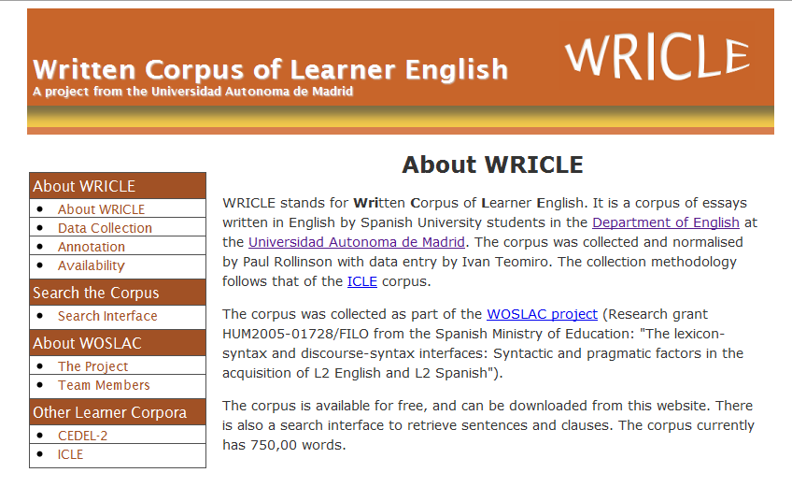
Figure 1: Homepage for WriCLE

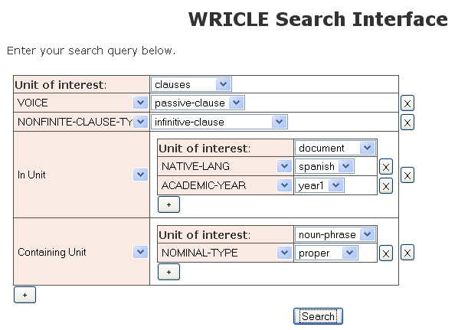
Figure 2: Online search interface for WriCLE

3.2. WriCLE data collection
For three academic years (starting in 2005), 1st and 3rd year students of a four year B.A. degree in English Philology at the Universidad Autónoma de Madrid were asked to submit their course assignment for the Academic Writing component of English Language I and III. At the moment of writing this paper, the corpus contains 705 essays, after cleaning. Table 1 shows the number of texts contributed by 1st year and 3rd year students

Number of texts | Texts per year
705 | 1st yr | 451  (64.0%)
705 | 3rd yr | 254  (36.0%)
Table 1: Texts in WriCLE (July 2009)

Texts were normalised following the procedures employed in the compilation of ICLE: personal data, titles, footnotes, endnotes, graphics, maps and bibliographies were stripped out. Quotations and references were replaced with <Q> and <R>, respectively.
At the moment, the corpus contains 658,000 words (Table 2), but collection is still continuing and our aim is to reach 1,000.000 words. Essay length ranges from approximately 500 to 2000 words, the average being 933 words. As Table 3 shows, 3rd year essays are considerably longer than 1st year essays, which means that, though 1st year learners contribute more essays than 3rd year learners, more than half of the words in the corpus belong to 3rd year essays, as Table 2 shows:

Number of words | Words per year
658,000 | 1st yr | 312,000
658,000 | 3rd yr | 346,000
Table 2: Number of words in WriCLE (July 2009)

Average length of essay | Average length per year
933 words | 1st yr | 691 words
933 words | 3rd yr | 1360 words
Table 3: Average number of words per essay

Essays were submitted electronically along with a Release form /Essay Profile, specifying the resources used to write the essay, language reference tools, time it took to write the essay and so on, as well as a request permission to use the data for research purposes. Contributors also submitted a Learner Profile form soliciting information regarding age, gender, language background, self-estimated English language proficiency, etc. Though the forms contain more information that was needed for the WOSLAC project (see section 4.1 below), within which WriCLE was conceived, this information will allow researchers to conduct other studies; for instance, contrasting the learner’s self estimated proficiency with the actual score obtained in the Quick Placement Test (UCLES 2001) (taken at a time close to the writing of each essay). This score, as well as the rest of the metadata was entered into Microsoft Excel 2007. This information will be available to researchers, together with the corpus. Table 4 shows proficiency levels in the 1st and 3rd year according to the Common European Framework of Reference for Languages (see note 2 below).

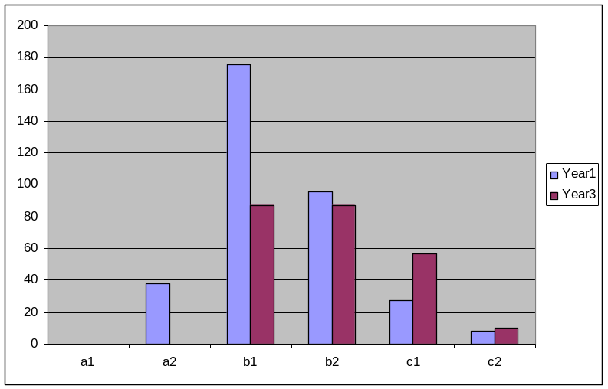
Table 4: Proficiency levels in WriCLE

3.3. Segmentation and annotation

As mentioned in section 3.1.6 above, the corpus is being segmented and annotated using UAM CorpusTool 2.0. This tool performs automatic segmentation using the Stanford Parser. Figures 3 and 4 show examples of actual learner texts in the corpus, as segmented for NPs and clauses, respectively.

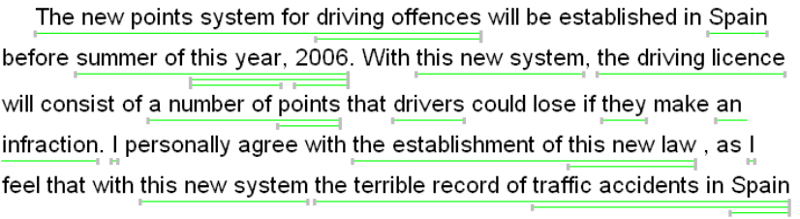
Figure 3: NP automatic segmentation

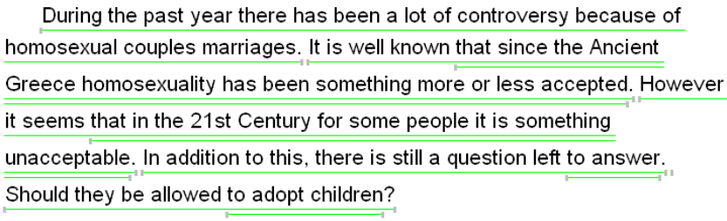
Figure 4: Clause automatic segmentation

Each of the segments can be assigned features (e.g. clause type) following a user-defined feature hierarchy, which the user steps through using the controls shown at the bottom of the window in Figure 5, where the highlighted clause has been classified as ‘dependent clause’, ‘nominally-dependent’ clause, etc. and finally as a ‘relative’ clause.
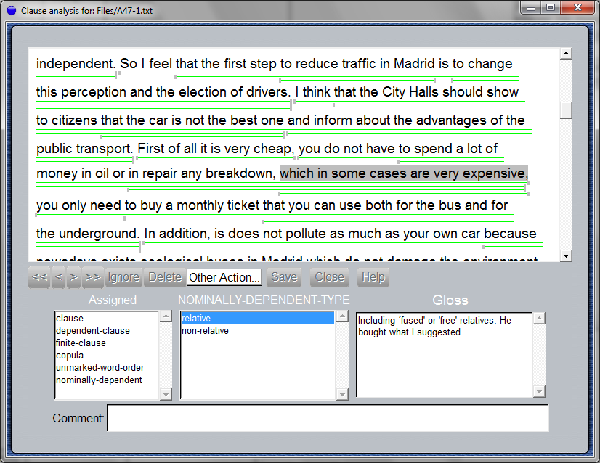
Figure 5: Corpus annotation with UAM Corpus Tool

The menus are automatically generated following the annotation scheme, which can be easily created by the researchers and can be adapted to particular research projects. Figure 6, for instance, shows part of the scheme created to annotate the corpus for the WOSLAC project, where clauses were coded, among other things, for word order markedness (preposing, dislocation, inversion, etc.) (see section 4.1 below).

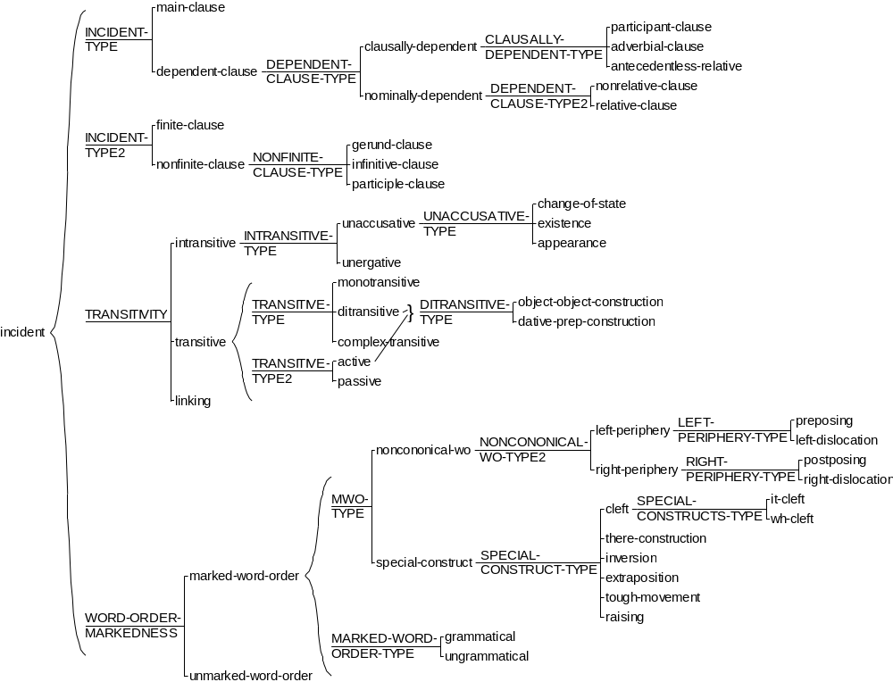

Figure 6: WOSLAC annotation scheme

4. Studies with WriCLE

Learner corpus research uses the main tools and methods of corpus linguistics in order to provide better descriptions of learner language, which can be used for the purposes of SLA (hypothesis-testing, hypothesis-finding, frequency, patterns, etc.), as well as for pedagogical purposes in FLT (see Granger 2002). Initially, WriCLE was created for SLA purposes, according to the design principles outlined in the section above. In this section, we describe briefly two SLA research projects that use data from WriCLE, as well as a pedagogical project that has just been initiated.

4.1. WOSLAC: Word Order in Second Language Acquisition Corpora

The aim of the original project for which WriCLE was created was to determine the lexicon-syntax and syntax-discourse properties which constrain word order in the interlanguage of L2 learner corpora: L2 English (with L1 Spanish) and L2 Spanish (with L1 English). Within this context, we conducted a number of studies on Verb-Subject inversion in L2 English, whose purpose was to examine the validity of the Unaccusative Hypothesis (Perlmutter, 1978) at the lexicon-syntax interface (e.g. the role of verb type) and the role of discourse functions such as topic and focus (along a scale of retrievability or discourse familiarity) at the syntax-discourse interface in learner English (Lozano & Mendikoetxea 2008, 2009, forthcoming).
Two research questions guided our corpus analysis on Verb-Subject order: (i) What are the conditions governing the production of VS structures in L2 English by L1 Spanish and L1 Italian learners? (Lozano & Mendikoetxea 2008), and (ii) Do learners of English (L1 Spanish) produce inverted subjects (VS) under the same conditions as English natives do, regardless of problems to do with syntactic encoding (grammaticality)? (Lozano & Mendikoetxea 2009, forthcoming). Previous SLA research has shown that learners of L2 English whose L1 allows null subjects (e.g. Italian and Spanish) produce Verb-Subject order with a (sub)class of intransitive verbs, which, since Perlmutter (1978) have been known under the term ‘unaccusative’, as opposed to ‘unergative’ (e.g. Zobl 1989 and Rutherford 1989, among many others). Unaccusative verbs in Verb-Subject constructions are verbs expressing existence or appearance on the scene: come, exist, remain, arrive, and so on. We extracted from the corpus Subject-Verb /Verb-Subject constructions with these verbs, as well as a set of unergative verbs (cry, shout, swim, dance, run, etc.). Our corpus analysis, using WriCLE, as well as ICLE (Itallian, Spanish and French subcorpora), revealed that a proper analysis of Verb-Subject structures must take into account not only the properties of the verb under the Unaccusative Hypothesis, but crucially it must also take into account the properties of the postverbal subject, which shows a strong tendency to represent new (or relatively new) information (focus) and to be ‘heavy’ or ‘complex’. That is, unaccusativity appears to be a necessary but not a sufficient condition for Verb-Subject production in L2 English, as in L1 English, a fact gone unnoticed in previous small-scale SLA studies.

4.2. OPOGRAM: Optionality and pseudo-optionality in native and non-native grammars

The aim of OPOGRAM is to study the factors causing optionality and pseudo-optionality in the non native grammars of L2 learners of English (L1 Spanish) and L2 learners of Spanish (L1 English) at different proficiency levels, where optionality is defined as the co-existence of more than one learner form to express the same propositional, and crucially, discoursive content. Pseudo-optionality, however, involves the use of more than one learner form to express the same propositional content, but different discoursive content (e.g. active vs. passive form).
In order to do that, our corpus analysis must test hypotheses currently put forward in the SLA literature on the basis of experimental work. In particular, our purpose is to test the following hypotheses:.(i) optionality is in part determined by competition between L1 and L2 forms (intermediate stages) and by competition between two L2 forms in apparently free variation in the input which yield different discursive interpretations (advanced and near native states); (ii) at different proficiency levels, variation is located in different areas of the grammar (syntax at beginner and intermediate stages and the interfaces between syntax and other modules at advanced and near native stages), and (iii) advanced learners exhibit residual optionality in the syntax-discourse interface, as argued by Sorace (2004, 2005). To verify (or falsify) these hypotheses, we need to consult large datasets, such as WriCLE and CEDEL2, and to improve existing tools for analysis, e.g. a methodology for the combination of experimental and corpus analysis (see Gilquin and Gries 2009).

4.3. TREACLE: Teaching Resource Extraction from and Annotated Corpus of Learner English

The TREACLE Project (Teaching Resource Extraction from an Annotated Corpus of Learner English) is applying the WriCLE corpus towards pedagogical goals. A first step is to produce profiles of each proficiency level, showing the grammatical competence of the average learner at each level. To produce the profiles, a two prong approach is followed: firstly, performing an automatic grammatical analysis of each learner text (to see what learners are attempting), and secondly, manually coding errors within the texts (to see what learners do wrong). Both the manual and automatic analyses are performed using UAM CorpusTool (see section 3.3. above). For automatic grammatical analysis, the tool makes use of the Stanford parser (Klein and Manning: 2003), although the sentence analyses produced by this parser are converted into a format more typical of pedagogical grammars of English.
The intention of this recently started project is to use the grammatical profiles of proficiency levels to inform the reform of grammar teaching curricula within Spanish universities, showing which grammatical structures would most fruitfully be taught at a particular point in the course, and what amount of time should be spent on each problem area. The WriCLE corpus is well suited to this project because it contains real texts drawn from the population being modelled, provides the proficiency data needed for the study, and contains more than sufficient data. (see O’Donnell et al. 2009 for more details).

5. Learner corpora: the way forward

If learner corpus research is going to make a significant contribution to SLA research existing corpora need to be made available to the research community and new corpora must be created. There is a need for corpora of L2s other than L2 English, spoken corpora, longitudinal corpora - to address the developmental dimension of L2 learning -, as well as for cross-sectional corpora, with learners at different levels of proficiency. Such corpora must be compiled according to explicit design criteria which make them useful to conduct SLA research: they must be compiled by SLA researchers (or in collaboration with them): most available corpora are ‘opportunistic’ and no formal measurement of proficiency is provided, and they must be fully documented: e.g. to select texts for subcorpora.
As for corpus analysis, tools must be developed which are suitable for learner data and are not reliant on manual tagging and methodologies have to be developed to combine corpus data with experimental data in search for converging evidence and to test aspects which cannot be adequately tested with corpus data. There is a need for a clearer relationship between (learner) corpus linguists and SLA, with more hypothesis-testing, more explanatory studies (see Granger 2004), but this will only be possible if corpus design and methodologies are useful for SLA purposes.

This project was funded by the Spanish Ministry of Education (research grant: HUM2005-01728/FILO). See http://www.uam.es/proyectosinv/woslac/ for details.
The Common European Framework of Reference for Languages was developed by the Council of Europe provides a basis for the mutual recognition of language qualifications. For more information see: http://www.coe.int/t/dg4/linguistic/CADRE_EN.asp.
The Quick Placement Test is published by Oxford University Press. More information in: http://www.oup.com/elt/catalogue/isbn/40031?cc=br
The corpus will shortly be available in: http://www.uam.es/proyectosinv/woslac/Wricle/.
For more details see: http://cecl.fltr.ucl.ac.be/Cecl-Projects/Icle/icle.htm
Both forms can be downloaded from: http://www.uam.es/proyectosinv/woslac/docs.htm.
UAM CorpusTool can be freely downloaded at: http://www.wagsoft.com/CorpusTool/
The TREACLE project will receive funding from the Spanish Ministry of Education (research grant: FFI2009-14436/FILO) from January 2010. However, the project has been informally in process since January 2009, involving staff at both the Universidad Autónoma de Madrid and the Universitat Politècnica de València. References Aijmer, K. (2002). “Modality in advanced Swedish learners’ written interlanguage”. In S. Granger, J. Hung and S. Petch-Tyson (eds.), 55-76. Altenberg, B. (2002). “Using bilingual corpus evidence in learner corpus research”. In S. Granger, J. Hung and S. Petch-Tyson (eds.), 37-54. Aston, G., S. Bernardini, and D. Stewart (2004). Corpora and Language Learners. Amsterdam: John Benjamins. Barlow, M. (2005). “Computer-based analysis of learner language”. In R. Ellis and G. Barkhuizen (eds.) Analysing Learner Language. Oxford: OUP, 335-357. Gilquin, G. (2001). “The Integrated Contrastive Model. Spicing up your data”. Languages in Contrast, 3, 1, 95-123. Gilquin, G. and S. Th. Gries (2009). “Corpora and experimental methods: A state-of-the-art review”. Corpus Linguistics and Linguistic Theory, 5, 1, 1-26. Granger, S. (1996). “From CA to CIA and back: An integrated approach to computerized bilingual and learner corpora”. In: K. Aijmer, B. Altenberg and M. Johansson (eds.) Languages in Contrast. Text-based Cross-linguistic Studies. Lund Studies in English 88. Lund: Lund University Press, 37-51. Granger, S. (1998). “The computerized learner corpus: a versatile new source of data for SLA research”. In S. Granger (ed.) Learner English on Computer. London & New York: Addison Wesley Longman. Granger S., E. Dagneaux and F. Meunier (2002). The International Corpus of Learner English. Handbook and CD-ROM. Louvain-la-Neuve: Presses Universitaires de Louvain. Granger, S, (2002). “A bird's-eye view of computer learner corpus research”. In S. Granger, J. Hung and S. Petch-Tyson (eds.), 3-33. Granger, S. (2004). “Computer learner corpus research: current status and future prospects”. In U. Connor and T. A. Uptom (eds) Applied Corpus Linguistics. A Multidimensional Perspective . Amsterdam: Rodopi, 123-146. Granger, S., J. Hung and S. Petch-Tyson (2002).Computer Learner Corpora, Second Language Acquisition and Foreign Language Teaching. Language Learning and Language Teaching 6. Amsterdam & Philadelphia: John Benjamins. Hasselgard, H., (1999). “Review of S. Granger (ed.) Learner English on Computer”. Icame Journal, 23, 148-152. Housen, A. (2002). “A corpus-based study of the L2 acquisition of the English verb system”. In S. Granger, J. Hung and S. Petch-Tyson (eds.), 77-118. Klein, D. And C. Manning (2003). “Fast exact inference with a factored model for natural language parsing”. Advances in Neural Information Processing Systems 15 (NIPS 2002), Cambridge, MA: MIT Press, 3-10. Lozano, C. (forthcoming). “CEDEL2: Corpus Escrito del Español L2)”. In C. M. Bretones Callejas, et al. (eds) Applied Linguistics Now: Understanding Language and Mind / La Lingüística Aplicada Hoy: Comprendiendo el Lenguaje y la Mente. Almería: Universidad de Almería. Lozano, C. and A. Mendikoetxea, (2008). “Postverbal subjects at the interfaces in English and Italian learners of English: a corpus study”. In B. Díaz, G. Guilquin and S. Papp (eds.) Linking up Contrastive and Learner Corpus Research. Amsterdam: Rodopi, 85-126. Lozano, C. and A. Mendikoetxea (2009) “L2 syntax meets information structure: Word order at the interfaces”. In J. Chandlee, M. Franchini, S. Lord and M. Rheiner (eds.) BUCLD 33: Proceedings of the 33rd Annual Boston University Conference on Language Development. Cascadilla Press: Somerville, Massachusetts, 313-324 Lozano, C. and A. Mendikoetxea (forthcoming). “Interface conditions on postverbal subjects: a corpus study of ‘inversion’ in L2 English”. Bilingualism: Language and Cognition. Mackey, A. and S. M. Gass. (2005). Second Language Research. Methodology and Design. London: Lawrence Erlbaum. MacWhinney, B. (2000a). The CHILDES Project: Tools for Analyzing Talk. Volume I: Transcription Format and Programs. 3rd Edition. Mahwah, N.J: Lawrence Erlbaum. MacWhinney, B. (2000b). The CHILDES Project: Tools for Analyzing Talk. Volume II: The Database. 3rd Edition. Mahwah, N.J: Lawrence Erlbaum. Mitchell, R., L. Domínguez, M. Arche, F. Myles and E. Marsden, (2008). “SPLLOC: A new corpus for Spanish second language acquisition research”. Paper submitted to EUROSLA Yearbook 8. Myles, F. (2005). “Review article. Language corpora and second language acquisition research”. Second Language Research, 21, 4, 373-391. Myles, F. (2007). “Using electronic corpora in SLA research”. In D. Ayoun (ed.) French Applied Linguistics. Amsterdam: John Benjamins, 377-400. Nesselhauf, N., (2004). Collocations in a Learner Corpus. Amsterdam: John Benjamins. O'Donnell, M. (2008). “Demonstration of the UAM CorpusTool for text and image annotation”. Proceedings of the ACL-08:HLT Demo Session (CompanionVolume), Columbus, Ohio, 13–16. O’Donnell, M., S. Murcia and R. García (2009). “Annotating a learner corpus of English”. Paper presented at Corpus Linguistics 2009, University of Liverpool, Oshita, H. (2000). “What is happened may not be what appears to be happening: a corpus study of “passive” unaccusatives in L2 English”. Second Language Research, 16, 293-324. Oshita, H. (2004). “Is there anything there when there is not there? Null expletives in second language data”. Second Language Research, 20, 95-130. Perlmutter, D. (1978). “Impersonal passives and the Unaccusative Hypothesis.” Proceedings of the Fourth Annual Meeting of the Berkeley Linguistics Society. Berkeley: University of California, 157-189. Rutherford, W. (1989). “Interlanguage and pragmatic word order”. In S. Gass and J. Schachter (eds.) Linguistic Perspectives on Second Language Acquisition. Cambridge: Cambridge University Press, 163-182. Rutherford, S and M. Thomas (2001). “The Child Language Exchange System in research on second language acquisition.” Review Article. Second Language Research, 17, 2 195-212. Sinclair, J. (1996). EAGLES. Preliminary Recommendations on Corpus Typology. Online manuscript. Sinclair, J. (2005). "Corpus and Text - Basic Principles". In M. Wynne (ed.) Developing Linguistic Corpora: a Guide to Good Practice. Oxford: Oxbow Books, 1-16. Available online from http://ahds.ac.uk/linguistic-corpora/ . Sorace, A. (2004). “Native language attrition and developmental instability at the syntax-discourse interface: Data, interpretations and methods”. Bilingualism: Language and Cognition, 7, 2, 143-145. Sorace, A. (2005). “Selective optionality in language development”. In L. Cornips & K. P. Corrigan (eds.) Syntax and Variation: Reconciling the Biological and the Social. Amsterdam: John Benjamins, 55-80. Tognini-Bonelli, E. (2001). Corpus Linguistics at Work. Amsterdam: John Benjamins. Tono, Y. (2004). “Multiple comparisons of IL, L1 and TL corpora: The case of L2 acquisition of verb subcategorization patterns by Japanese learners of English”. In G. Aston et al. (eds.), 45-66. UCLES (2001). Quick Placement Test. Oxford: Oxford University Press. Zobl, H. (1989). “Canonical typological structures and ergativity in English L2 acquisition”. In S. Gass & J. Schachter (eds.) Linguistic Perspectives on Second Language Acquisition Cambridge: Cambridge University Press, 203-221. Our corpora and tools: WriCLE (Written Corpus of Learner English) Rollinson, P, & A. Mendikoetxea (2008) Written Corpus of Learner English (WriCLE). http://www.uam.es/proyectosinv/woslac/Wricle/ CEDEL2 (Corpus Escrito del Español como L2) [compiled by Cristóbal Lozano] http://www.uam.es/proyectosinv/woslac/cedel2.htm UAM CorpusTool [by Michael O’Donnell] http://www.wagsoft.com/CorpusTool/

