Kid’s Programming Language

*BETA* Teacher’s User Manual

from Morrison Schwartz

THIS IS USER DOCUMENTATION CURRENTLY BEING
TESTED AND REVIEWED. PLEASE VISIT THE KPL
TEACHER’S FORUM TO PROVIDE US WITH FEEDBACK

Web site: www.kidsprogramminglanguage.com

Kid’s Programming Language
Teachers’ User Manual

Table of Contents

Introduction: Kid’s Programming Language 3
Why did we build Kid’s Programming Language? 3
What is Kid’s Programming Language (KPL)? 3
KPL’s Programming Environment Screenshot 3
Section One: The Integrated Development Environment 4
KPL’s Menu System 4
KPL’s Toolbar 10
KPL’s Code Editor 12
Explorer Pane 17
Messages Pane 18
Section Two: KPL’s Programming Language 19
Identifiers 19
Data Types 19
Variables 20
Key Words 21
Comments 21
Loops 22
Decisions and Branching 23
Functions and Methods 23
Section Three: System Methods available in KPL 25
MATH FUNCTIONS 25
DATA FUNCTIONS 26
KEYBOARD FUNCTIONS 27
KEYBOARD METHODS 27
CONSOLE FUNCTIONS 27
CONSOLE METHODS 28
SCREEN FUNCTIONS 29
SCREEN METHODS 29
PEN METHODS 30
SPRITE FUNCTIONS 32
SPRITE METHODS 32
SOUND METHODS 34
TRACE AND RUNTIME METHODS 34

Introduction: Kid’s Programming Language
Why did we build Kid’s Programming Language?
- U.S. Computer Science enrollments have dropped by 2/3 the last few years, and shouldn’t
- We wanted to teach our own kids how to program
- We have fond memories of starting as programmers by coding games in BASIC
- Beginning programmers have been forgotten by the software industry for 20 years
- Specifically, VS.NET and Eclipse, the industry standard development environments, are NOT beginner environments
- Educational software could do much more for kids if it were easier to create, and with KPL it now is easier to create – even by teachers or parents who are not professional programmers
What is Kid’s Programming Language (KPL)?
- was created for teaching beginners how to program
- is a simplified but modern programming language and development environment
- offers lots of sample educational KPL programs and games
- emphasizes graphics, sprites, sounds and game development
- is designed to help a beginner ‘graduate’ to Visual Studio or Eclipse
- can even generate C# or VB.NET code
KPL’s Programming Environment Screenshot
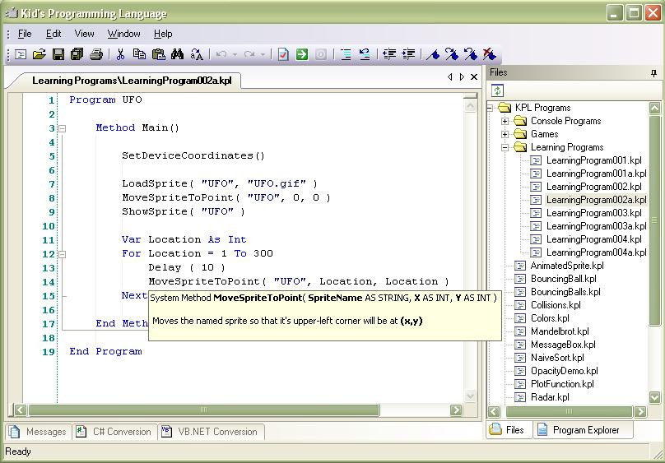
Section One: The Integrated Development Environment
KPL offers a simple but usable Integrated Development Environment which is designed to help a beginner ‘graduate’ to Visual Studio.NET, Eclipse, or another commercial development environment.
Our documentation of the IDE will be organized according to these regions:
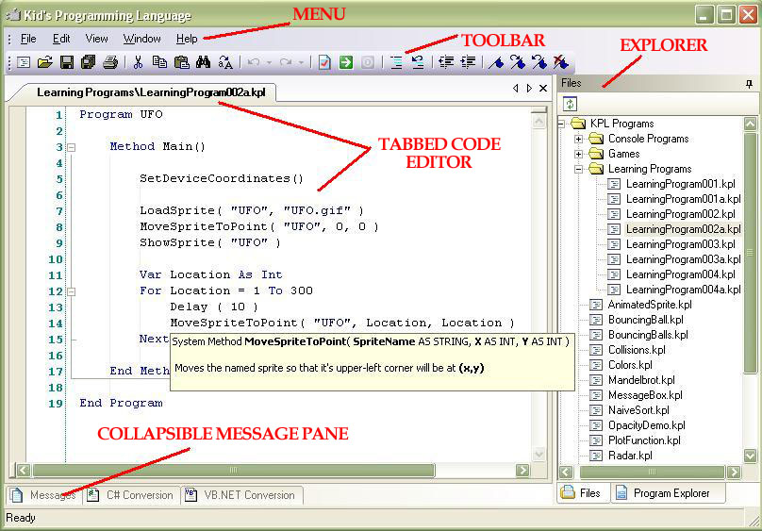

KPL’s Menu System

File Menu | Edit Menu | View Menu | Window Menu | Help Menu
New Program | Cut | Messages | 1 First open program | About KPL
Open Program | Copy | Files Explorer | 2 Second open program | Technical Support
Save Program | Paste | Program Explorer | 3 Third open program
Save As… | Undo | C# Conversion | etc…
Save All | Redo | VB.NET Conversion
Close Program | Select All
Print Program | Find
Exit KPL | Replace
File Menu
The File menu can be accessed by holding the Alt key down and pressing the F key (Alt+F). Once the File menu is displayed, items on it can be selected by pressing the Key which is underlined in the menu selection. For example, pressing Alt+F then N will open a new KPL program as described below. This is Windows-standard behavior.
New Program (Ctrl+N) – Creates a new template KPL program, which is properly structured, compiles and runs – though it does not do anything functional until further code is provided. Ctrl-N indicates this function can also be invokes by holding the Ctrl key and typing N.
Open Program (Ctrl+O) – Launches a dialog allowing the user to browse to and open a KPL program from disk – either local disk or networked, of course. Ctrl-O indicates this function can also be invokes by holding the Ctrl key and typing O.
Save Program (Ctrl+S) – Saves any code changes which have been made to the currently selected KPL program.
Save As… – Opens a dialog which allows the currently selected KPL program to be saved with a different name or in a different location on disk.
Save All (Ctrl+Shift+S) – Saves any code changes which have been made to all open KPL programs.
Close Program (Ctrl+F4) – Closes the currently selected KPL program file. If changes have been made to that file, a dialog will allow you to save those changes before the file is closed, if you wish to save them.
Print Program (Ctrl+P) – Launches a Windows-standard Print dialog allowing you to print the currently selected KPL program.
Exit KPL (Alt+F4) – Exits and closes the KPL development environment. If changes have been made to any open KPL program files, warning dialogs will allow you to save those changes before exiting KPL, if you wish to save them.

Edit Menu
The Edit menu can be accessed by holding the Alt key down and pressing the E key (Alt+E). Once the Edit menu is displayed, items on it can be selected by pressing the Key which is underlined in the menu selection. Each of the functions on this menu applies to the currently selected KPL program file in the tabbed code editor. The more usual way to access these functions, of course, is to use the keyboard shortcuts associated with each, as shown below. This is Windows-standard behavior.
Cut (Ctrl+X) – Cuts the currently selected text from the currently selected KPL program file. Cut text is placed on the Windows Clipboard.
Copy (Ctrl+C) – Copies the currently selected text from the currently selected KPL program file, without deleting it. Copied text is placed on the Windows Clipboard.
Paste (Ctrl+V) – Pastes the Windows Clipboard contents into the currently selected KPL program file at the cursor location. Pasted text is still available on the Windows Clipboard.
Undo (Ctrl+Z) – Reverts the last change made to the currently selected KPL program file. This command can be repeated multiple times, each time reverting the previous change, all the way back to when the file was opened in KPL.
Redo – Reverts the last Undo made in the currently selected KPL program file. This command can be repeated multiple times, each time reverting the previous Undo.
Select All (Ctrl+A) – Selects and highlights all text in the currently selected KPL program file. Regions which are “collapsed” in the code editor (see the Code Editor section below) will still be selected in full with this function.
Find (Ctrl+F) – See image below. Displays a Find/Replace dialog as shown which allows for text searches within the current KPL program file. The Find command does not allow for changing found text – see the Replace command below for that functionality.
To use Find, type the text you want to find in the “Find what:” textbox and hit Enter or click the “Find Next” button. The next instance of the word you are finding will be selected in the Code Editor, and the editor will scroll if necessary to display the selected text. If the next instance of that word happens to be in a collapsed region, that region will also be expanded as the text is found and selected.
Searches begin at the top of the KPL program file by default, and proceed downward as you click Find Next. To search from the bottom of the file up, you can check the Search Up checkbox and click Find Next.
Text searches, by default, will match the text no matter whether it appears in upper or lower case. To perform a case-specific search, click the Match Case checkbox.
Text searches, by default, will match text which is embedded within longer words. To match only whole words, you can check the Match whole word checkbox.
The Mark All button will place Bookmarks on each line in the KPL program file which contains the word you are searching for. For more information on Bookmarks, see the Code Editor section below.
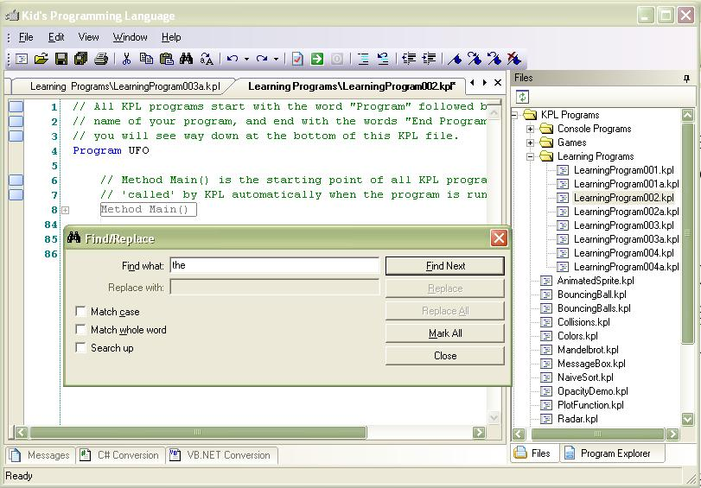
Replace (Ctrl+H) – Displays the Find/Replace dialog described above, with the Replace and Replace All buttons enabled to allow text replacement as well as searching. To perform a replace, type the new text you would like inserted into the Replace with: textbox. Clicking the Replace button will cause only the currently selected instance of the found word to be replaced with your new text. Clicking the Replace All button will cause all instances of the found word in the file to be replaced, and will tell you how many instances were found and replaced. A single Undo action will revert a Replace All action.

View Menu
The View menu can be accessed by holding the Alt key down and pressing the V key (Alt+V). Once the View menu is displayed, items on it can be selected by pressing the key which is underlined in the menu selection. For example, pressing Alt+V then M will cause the Message pane to be displayed.
Messages (Ctrl+M) – This command displays the Messages panel in the Collapsible Message Pane (see that section below). If the Collapsible Message Pane is not already open, this command will extend it.
Files Explorer (Ctrl+Shift+F) – This command displays the Files panel in the Explorer Pane (see that section below). If the Explorer Pane is not already open, this command will extend it.
Program Explorer (Ctrl+E) – This command displays the Program Explorer panel in the Explorer Pane (see that section below). If the Explorer Pane is not already open, this command will extend it.
C# Conversion – This command displays the C# Conversion panel in the Collapsible Message Pane (see that section below). If the Collapsible Message Pane is not already open, this command will extend it.
VB.NET Conversion – This command displays the VB.NET Conversion panel in the Collapsible Message Pane (see that section below). If the Collapsible Message Pane is not already open, this command will extend it.

Window Menu
Each open KPL program file will be added to this menu as it is open and removed as it is closed. It simply provides a menu and keyboard-based shortcut to those open files. For instance typing Alt+W then 1 will select the first open KPL program file, Alt+W then 3 will select the third open KPL program file, etc…

Help Menu
About KPL – This menu function displays the KPL about box as shown below. The about box is important because it provides version information about the version of KPL which is installed on the computer, and because it offers a convenient link to the Kids Programming Language website.
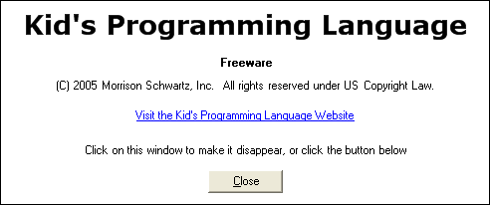
Technical Support – This menu function displays the dialog as shown below, offering information about and a link to KPL technical support online.
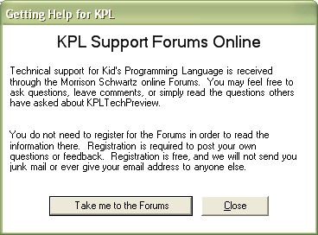

KPL’s Toolbar

KPL’s toolbar is Windows-standard, including support for mouse-over tooltips, which match the functions in the table below. Note that toolbar buttons will enable or disable as appropriate. For instance, if no KPL program files are open in the Code Editor, nearly all the toolbar buttons are greyed out and disabled – since they are only relevant to a selected KPL program file.

Function | Icon | Explanation
New Program |  | Creates a new template KPL program, which is properly structured, compiles and runs – though it does not do anything functional until further code is provided. This function is also available from the Ctrl+N hotkey.
Open Program |  | Launches a dialog allowing the user to browse to and open a KPL program from disk. This function is also available from the Ctrl+O hotkey.
Save Program |  | Saves any code changes which have been made to the currently selected KPL program. This function is also available from the Ctrl+S hotkey.
Save All |  | Saves any code changes which have been made to all open KPL program files. This function is also available from the Ctrl+Shift+S hotkey.
Print Program |  | Launches a Windows-standard Print dialog allowing you to print the currently selected KPL program. This function is also available from the Ctrl+P hotkey.
Cut |  | Cuts the currently selected text from the currently selected KPL program file. Cut text is placed on the Windows Clipboard. This function is also available from the Ctrl+X hotkey.
Copy |  | Copies the currently selected text from the currently selected KPL program file, without deleting it. Copied text is placed on the Windows Clipboard. This function is also available from the Ctrl+C hotkey.
Paste |  | Pastes the Windows Clipboard contents into the currently selected KPL program file at the cursor location. Pasted text is still available on the Windows Clipboard. This function is also available from the Ctrl+V hotkey.
Find |  | See the Find dialog described under the View menu above. This function displays the Find dialog. This function is also available from the Ctrl+F hotkey.
Replace |  | See the Replace dialog described under the View menu above. This function displays the Replace dialog. This function is also available from the Ctrl+H hotkey.
Undo |  | Reverts the last change made to the currently selected KPL program file. This button is greyed if no changes are available to Undo, blue if there are changes to Undo. This command can be repeated multiple times, each time reverting the previous change, all the way back to when the file was opened in KPL. This function is also available from the Ctrl+Z hotkey.
Redo |  | Reverts the last Undo made in the currently selected KPL program file. This command can be repeated multiple times, each time reverting the previous Undo. This button is greyed if no changes are available to Redo, blue if there are changes to Redo.
Check program for errors |  | This function causes KPL to check the currently select program file for errors. The Messages pane will display the results of this check. If the Messages pane is not displayed when this function is invoked, it will be displayed.
Run the program |  | This function causes KPL to check the currently select program file for errors, and if no errors are found, to launch the run dialog to run the program. The Messages pane will display the results of the check. If the Messages pane is not displayed when this function is invoked, it will be displayed.
Stop the running program |  | This functions stops the currently running KPL program. If no program is running, the button is disabled and greyed as shown. When a program is running, the button is enabled and red in color.
Comment selected code |  | This function causes one or more selected lines of KPL code to be “commented out” so that they will no longer be part of the compiled and running KPL program. This is done by placing the // comment indicator at the beginning of the line.
Uncomment selected code |  | This function causes one or more selected lines of KPL code to be “uncommented,” so that it will again be part of the compiled and running KPL code for the program. If the // comment indicator is located at the beginning of the line of code. This function has no effect if the line of code is not already commented out, or if the comment indicator is not at the beginning of the line of code.
Decrease indent |  | This function causes one or more selected lines of KPL code to be shifted to the left by one indented tab stop. If the code on the selected line already begins at the left margin, it will not be shifted.
Increase indent |  | This function causes one or more selected lines of KPL code to be shifted to the right by one indented tab stop.
Toggle bookmark |  | Toggles a bookmark on or off on the currently selected line of KPL code. Bookmarks can be used to quickly return to a particular place in your KPL program. For more information on bookmarks, see the Code Editor section below.
Go to next bookmark |  | This function moves the cursor within the KPL program to the next line of code which is bookmarked. This function will wrap to the first bookmark from the top of the KPL program, if there is a bookmark above the current cursor but not one below.
Go to previous bookmark |  | This function moves the cursor within the KPL program to the first previous line of code which is bookmarked. This function will wrap to the first bookmark from the bottom of the KPL program, if there is a bookmark below the current cursor but not one above.
Clear all bookmarks |  | This function clears all bookmarks in the currently selected KPL program file.

KPL’s Code Editor
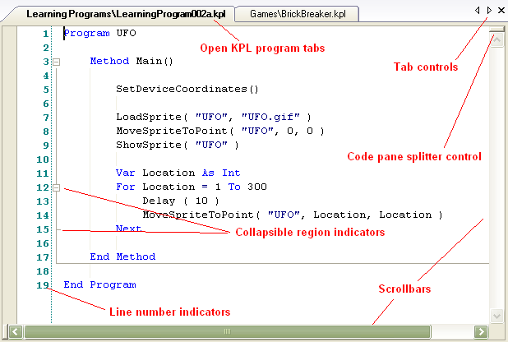

Open KPL program tabs
Each KPL program file which is open appears on its own tab in the code editor. Clicking on the tab for any open file will cause the code for that file to be shown in the code editor pane. The selected tab clearly visually indicates which file is being displayed. A right-click on a tab shows the pop-up menu below:

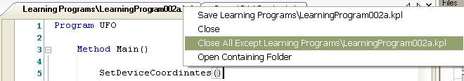

Save and Close are self-evident, and refer to the file whose tab was right-clicked.

Close All Except… is a very handy feature. Often, multiple files can be open in the editor, and using this function closes all of the open files except for the file which is right-clicked. It’s a convenient way to “clean up” by closing program files which are no longer being used.

Both Close functions will, of course, prompt the user to save a file before closing, if unsaved changes have been made to the file.

Open Containing Folder is also a convenient shortcut. It will launch a standard File Explorer dialog for the Windows folder which contains the right-clicked KPL program. This allows for all the usual Windows file functions – for instance, zipping the file, mailing it to someone, copying it to a different location, etc…

Tab Controls
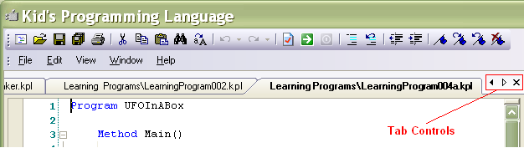
Three small controls at the far right of the strip of tabs are the Tab Controls, which allow additional control of those tabs.

The left and right arrow indicators allow scrolling of the displayed tabs to the right or the left, in case there are so many tabs displayed that they cannot all fit in the width of the Code Editor Pane. Each indicator will be filled in with black if there are tabs in the indicated direction which are not fully displayed.

The X indicator, as usual, is a shortcut to close the selected KPL program file. Again as usual, if changes have been made to the selected file and not yet saved, you will be asked if you wish to save them before this function closes the file.

Code Pane Splitter Control
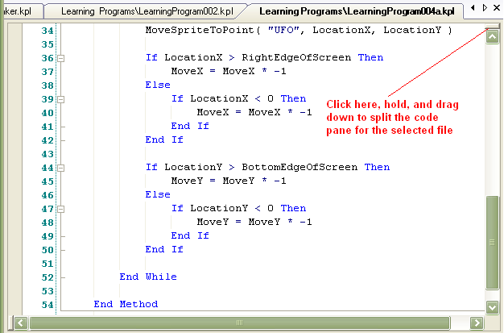
As the image shows, click the little rectangle at the top of the code pane, hold, and drag down to create a splitter allowing independent parts of the code file to be displayed and viewed. This can be convenient when comparing or working with code in different parts of a single KPL file.

You can then click on the splitter bar, hold, and drag back up to the top to remove the split view in the KPL program file, as shown here:
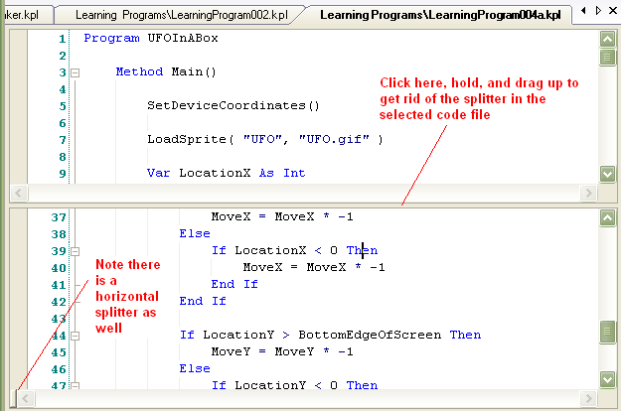

Note that there is a similar horizontal splitter control at the left end of the horizontal scroll bar.

Collapsible Region Indicators
It can often be convenient when programming to “collapse” code which you are not currently working on, in order to concentrate better on code which you are currently working on.

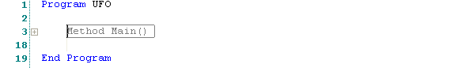

As you can see by noting the line numbers above, this does not remove the collapsed code from the KPL program, it simply hides it until you “expand” the collapsed region, as shown here:

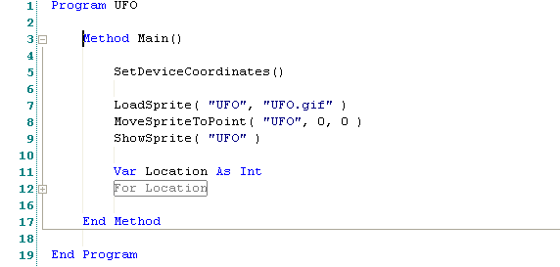

There are several points to note about regions. First, a convenient vertical line extends down the left edge of the code region, and then a horizontal line extends across to show the bottom of the region, making it very easy to see how much code is included within the region.

Second, it is possible to have collapsible regions within other regions in the code, as shown with the FOR loop above. KPL automatically creates a collapsible region for every function, method, loop, structure and if…then block.

Third, try collapsing a region and then placing the mouse cursor over that collapsed region. KPL will automatically display a tooltip (potentially a very large one!) which shows the code in that region, without the need to open the region in the code pane. Here’s how that looks, with the mouse over the collapsed Method Main():
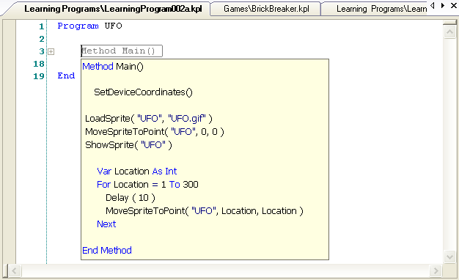

Line Number Indicators
KPL is not a line-number driven sequential language, like BASIC used to be, and you cannot reference line numbers in code, like the old GOTO 200 programming commands. In KPL, line numbers are simply informational.

The most common use for line numbers is in the Messages Pane (more details about that below), when KPL needs to report and error or a warning in the KPL program. Here’s an example:
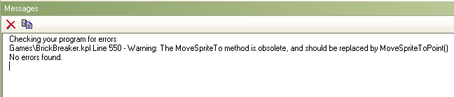
When KPL refers to a line of code by number this way in the Messages pane, you can doubleclick on the line in the Messages pane and the code editor will automatically move to and display that line of code.

Working with KPL Code in the Code Editor
It is traditional in coding to “indent” code to help indicate its hierarchical organization. This makes it easier for you and for others to understand the flow of your program. Indenting is normally done as you move deeper “into” the KPL code – such as into Method Main() below, and then again into a FOR loop within the method:
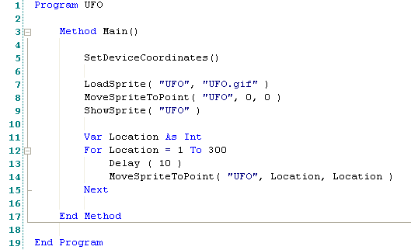
The usual way to indent is simply using the <Tab> key. Each tab stop is 4 characters wide. Note that faint vertical lines actually show the location of each tab stop, to make it easy to keep code aligned.

Code which is neatly aligned, indented, and organized using white space is far easier to read, understand and work with – whether you wrote it yourself, or someone else did. So it is important to develop good discipline and practices such as these.

The KPL Code Editor supports the usual Cut, Copy and Paste functions (see above). It does not at the moment support dragging and dropping of selected blocks of code.

Intellisense/Autocomplete in the Code Editor
With the cursor blinking on a blank line in the Code Editor, type a P, then hold the CTRL key and type J (CTRL+J). This is the Microsoft-standard keystroke for invoking “Intellisense.” Intellisense presents you with a list of possible methods to complete the word you began typing. For instance, if you typed P, you will see a popup which presents you with all know system methods or functions which begin with the letter P, plus any methods or functions in your KPL file which begin with the letter P, in alphabetical order, as shown below:
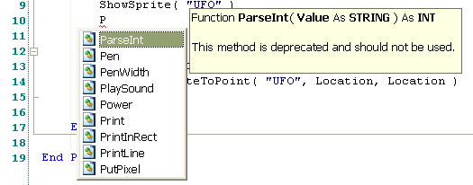
When the Intellisense popup is displayed, you can use the up/down arrows or the mouse to select a function in the list. When a function is selected, a tooltip will be displayed showing its definition and description. If you hit <Enter> or double-click on a function in the list, it will be placed into the code file at the cursor location. If you hit <Esc> while the list is displayed, the list will go away and your code will not be changed.

Another example of Intellisense is what happens when you type a known method or function name in the KPL code editor. KPL recognizes it, and as soon as you type the ( after the method, displays a tooltip below your line of code defining the function or method you are calling. This is an extremely helpful and convenient reminder.
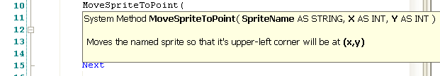

An interesting and useful side effect of Intellisense is that if you hit CTRL+J on a blank line in the code editor, the popup list which appears will present ALL available methods and functions – those available from KPL as well as those available from your own code. It’s sometimes more convenient to look things up in the IDE than in this document. :)

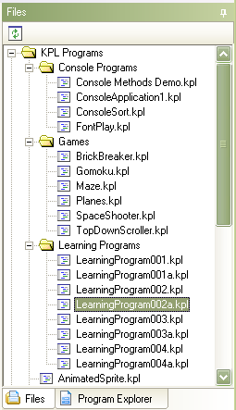
Explorer Pane
The Explorer Pane is one of the optional panes in the KPL user interface. By default, it is located to the right of the Code Pane, and is “pinned” open. There are two tabs within the explorer pane, Files and Program Explorer. In this case the tabs are displayed and selectable at the bottom of the pane. Horizontal and vertical scrollbars are automatically displayed if needed.

The Files tab shows files under the KPL install folder, and also shows folders under the KPL install folder, if those folders contain KPL program files. Folders in this display can be opened or closed. Double click or right-click on a file to “open” it in KPL.

The Program Explorer tab is commonly enough used when working with KPL that it’s best to leave it as displayed by default. If you “unpin” it by clicking the small pin icon in the upper right of the pane, the pane will collapse to the edge of the KPL window. When the pane is collapsed, the Files and Program Explorer tabs will still be displayed, and clicking on them will expand the pane, showing the view matching the tab you clicked. Unpinning to a collapsed Explorer Pane can be useful at times, to allow for more space for viewing or working with code in the code pane. You can re-pin the pane open by clicked the pin icon again.

This pane can also be resized – place the mouse over the left edge of the pane until the cursor changes, then click and drag to move the left edge to where you would like it to be.
Messages Pane
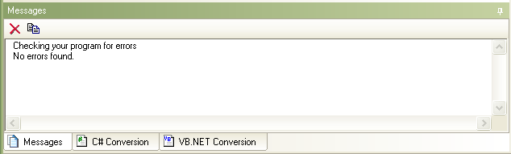
The Messages Pane is the second optional pane in the KPL user interface. By default, it is located below the Code Pane, and is “pinned” open. There are three tabs at the base of the Messages pane: Messages, C# Conversion and VB.NET Conversion. In this case the tabs are displayed and selectable at the bottom of the pane. Horizontal and vertical scrollbars are automatically displayed if needed.

The Messages tab is where KPL displays status messages as KPL checks your program for errors. Note that if an error or warning referring to a particular line of code is displayed here in the messages tab, you can double-click that line in the messages tab, and the code editor will automatically display and place the cursor on that line of code.

The Messages tab is also where trace messages are displayed as your program runs, when you use the Trace() system method in your code.

KPL will also automatically inform you of certain important status information on the Message tab, such as when there is an update available to KPL available.

The Messages Pane is commonly enough used when working with KPL that it’s best to leave it as displayed by default. If you “unpin” it by clicking the small pin icon in the upper right of the pane, the pane will collapse to the edge of the KPL window. When it is collapsed, its tabs will still be available, and clicking on them will expand the pane, showing the view matching the tab you clicked. Unpinning to a collapsed Messages Pane can be useful at times, to allow for more space for viewing or working with code in the code pane. You can re-pin the pane open by clicked the pin icon again.

This pane can also be resized – place the mouse over the top edge of the pane until the cursor changes, then click and drag to move the top edge to where you would like it to be.
The C# Conversion tab and the VB.NET Conversion tab are where code in each language will be generated and displayed when you click the matching View menu option. This code is a syntactically complete and accurate conversion of the KPL code into that language. KPL’s system methods and functions will available soon to Visual Studio.NET programmers using C#, VB.NET or other .NET languages – but until they are, the conversions generated by KPL cannot be run in Visual Studio.NET, and this generated code is for educational purposes only.
Section Two: KPL’s Programming Language
Identifiers
An identifier is the name of a variable, method, or function, and must start with either a letter or the underscore character, and can consist of numbers, letters, and the underscore. An Identifier may not be a Keyword, as described below.
Valid identifiers:
Monkey
I
_BallLocationX
Ball2_Position_X
Invalid Identiers:
2WaysToGo - Starts with a number
Ball-Position.X – contains invalid characters
Keywords and identifiers are not case-sensitive. In other words, the following statements are equivalent:
Var Monkey AS STRING = “Monkey”
VAR MONKEY as string = “Monkey”
Data Types

Simple Data Types
KPL supports the following atomic data types:
- INT – Any whole number in the range from negative 2,147,483,648 to positive 2,147,483,647, inclusive. Examples: 1, 5, -323, 12345678
- STRING – A unit of text represented by a sequence of characters surrounded by double quotes. Examples: “Monkey”, “Bob”, “Jonah”
- BOOL – A Boolean value which can contain the value TRUE or FALSE. Boolean expressions that evaluate to 0 are treated as FALSE, all other values result in being evaluated as TRUE.

Complex Data Types
KPL supports the following complex data types:
Arrays
An Array is a collection of variables of the same type, and has the following structure
VAR <Identifier> AS <Type> [ <Expression> ]
Example:
VAR Values AS INT[ 3 ]
Values[0] = 10
Values[1] = 20
Values[2] = 30
Print( “Value of index 0 is: “ + Values[0] )
Structures
A STRUCTURE allows you to keep track of several pieces of information (variables) while treating them all as a single logical entity. It it important to note that the fields in a STRUCTURE do not require the VAR keyword, and cannot use an initializer, unlike regular variables.
STRUCTURE <Identifier>
<Identifier> AS <Type>
…
END STRUCTURE
Fields in a STRUCTURE variable are accessed by using the name of the variable, followed by a ‘.’ (dot) character, followed by the name of the field.
Example:
STRUCTURE Ball
Color AS STRING
Size AS INT
END STRUCTURE
VAR MyBall AS BALL
MyBall.Color = “Blue”
MyBall.Size = 2
PRINT(“My “ + MyBall.Color + “ is “ + MyBall.Size + “ inches in diameter” )
Variables
KPL variables are defined as follows:
VAR <Identifier> AS <Data Type> [ = <Expression> ]
In English, this means that a variable declaration starts with the keyword VAR, followed by a valid identifier, the keyword AS, the DataType that will be contained in the variable, and optionally an initial value. The initial value can be a literal value such as “Monkey” or 10, or a variable or other expression that evaluates to the correct data type.
Variables can be defined at the top of the program (after Structures) to be available to all methods, or can be defined within the body of a method to be available to that method only. A variable cannot be declared inside of a loop or If…Then…Else construct. A variable must be declared before the code that uses it. There are several VAR declarations show in context above, but we will repeat them here to reinforce them:
Var Monkey AS STRING = “Monkey”
or
VAR MONKEY as string = “Monkey”
…
VAR Values AS INT[ 3 ]
…
STRUCTURE Ball
Color AS STRING
Size AS INT
END STRUCTURE
VAR MyBall AS BALL

Key Words
The following words are part of the KPL language itself and cannot be used as an identifier. Note that not all of these keywords are in use at this time, and may be reserved for future use.

AND
AS
DO
EACH
END
EXIT
FALSE
FOR
FUNCTION
GOTO
WHILE
METHOD
MOD
NOT
OR
PROGRAM
RETURN
STEP
STRUCTURE
TRUE

Comments
A comment can be a line comment or a block comment. A comment is a part of your program that is ignored when the program is run, and allows you to leave yourself “notes” directly in the program code.

Line comments
Line comments are preceded by two forward slashes and everything to the end of the line is treated as a comment.
Example:
// These are line comments. Everything to the right of the ‘//’
// is a comment and is ignored. Line comments end at the end of
// the line.

Block Comments
Block comments are started by the /* characters and end with the */ characters. Everything between is a comment.\
Example:
/*
This comment can span multiple
lines. You can leave really big comments
using this style of comment.
*/

Loops
KPL currently supports two types of loops:

For Loop
A FOR loop executes a specific number of times based on the number of times it takes from reach <End Value> from <Start Value>, and has the following structure:
FOR <Variable> = <Start Value> TO <End Value> [ <Step> <Value> ]
<Statements>
NEXT

While Loop
A WHILE loop executes while the <Boolean Expression> evaluates to TRUE, and has the following structure:
WHILE <Boolean Expression>
<Statements>
END WHILE

Decisions and Branching
KPL supports decision structures that allow you to run code based on a defined condition using the If / Then / Else / End If construct, which has the following structure:
IF <Boolean Expression> THEN
…
END IF
OR
IF <Boolean Expression> THEN
…
ELSE
…
END IF

Functions and Methods
KPL allows the user to create methods and functions, which are chunks of executable code that can be called from elsewhere in the program to perform a specific set of functions. See section four below for a full list of the system functions and methods available to a KPL programmer.

Methods
A method is defined by the METHOD keyword followed by a valid identifier, list of parameters, any number of code statements, and the END METHOD keywords.
Examples:
METHOD HelloWorld()
PRINT( “Hello World” )
END METHOD
METHOD PrintText( Text AS STRING )
PRINT( Text )
END METHOD

Functions
A function is nearly identical to a METHOD, with the exception that it can return a value to the caller while a METHOD cannot. A function is defined by the FUNCTION keyword followed by a valid identifier, list of parameters, return type, any number of code statements, and the END FUNCTION keywords. A function must contain a RETURN statement that returns a value to the caller.
Examples:
FUNCTION TripleIt( Value AS INT ) AS INT
RETURN Value * 3
END FUNCTION
FUNCTION ContainsMonkey( Text AS STRING ) AS BOOL
IF SubString( Text, “Monkey” ) <> 0 THEN
RETURN TRUE
ELSE
RETURN FALSE
END IF
END FUNCTION
All method and function calls require the use of parenthesis around the arguments, unlike other languages like BASIC.
Example:
- Print( “Hello World” ) - will call the Print() function with the argument “Hello World”
- Clear() – will clear the screen. The Clear() method does not have any arguments, so an open parenthesis followed by a closed parenthesis is used to indicate that no arguments are being passed.
- Print “Hello World” – is not a valid method call because it lacks parenthesis, and will not run.
Section Three: System Methods available in KPL

The current list of supported System Methods and Functions available from KPL code, divided by category of function:

MATH FUNCTIONS

Function Abs ( Value AS INT ) AS INT
Returns the absolute (positive) value of the integral number stored in Value

Function Acos ( d AS Decimal ) AS Decimal
Returns the arccosine or inverse cosine in degrees for the cosine value specified in d

Function ArcTan ( d AS Decimal ) AS Decimal
Returns the angle whose tangent is specified in d

Function ArcTan2 ( X AS Decimal, Y as Decimal ) AS Decimal
Returns the angle in degrees that is the arctangent of Y / X

Function Asin ( d AS Decimal ) AS Decimal
Returns the angle in degrees that is the arcsine of the value in d

Function Ceiling ( d AS Decimal ) AS Decimal
Returns the smallest integer that is not smaller than the value d

Function Cos ( d AS DECIMAL ) AS DECIMAL
Returns the cosine of the angle specified in d

Function CosH ( d AS DECIMAL ) AS DECIMAL
Returns the hyperbolic cosine of the value specified in d

Function Exp ( d AS DECIMAL ) AS DECIMAL
Returns e raised to the power d

Function Floor ( d AS Decimal ) AS Decimal
Returns the largest integer that is not larger than the value d

Function Log ( d AS DECIMAL ) AS DECIMAL
Returns the natural (base e) logarithm of the number specified in d

Function Log10 ( d AS DECIMAL ) AS DECIMAL
Returns the base 10 logarithm of the number specified in d

Function LogBase ( value AS DECIMAL, base AS DECIMAL ) AS DECIMAL
Returns the logarithm of the value in the base of base

Function Max ( ValueA AS Any, ValueB as Any ) AS Any
Returns whichever of ValueA or ValueB is the larger value

Function Min ( ValueA AS Any, ValueB as Any ) AS Any
Returns whichever of ValueA or ValueB is the smaller value

Function Power ( value AS DECIMAL, power AS DECIMAL ) AS DECIMAL
Returns the result of value raised to the power of power

Function Random ( MIN AS INT, MAX AS INT ) AS INT
Returns a random Integer (whole) number in the range from MIN to MAX, inclusive. For example: Random ( 1, 10 ) returns a random number between 1 and 10.

Function Round ( d AS Decimal ) AS Decimal
Returns the integer that is closest to the value d

Function RoundToPlace ( d AS Decimal, decimalPlaces As Decimal ) AS Decimal
Rounds a decimal d to decimalPlaces decimal places.

Function Sin ( d AS DECIMAL ) AS DECIMAL
Returns the sine of the angle specified in d

Function Sqrt ( d AS DECIMAL ) AS DECIMAL
Returns the square root of d

Function Tan ( d AS DECIMAL ) AS DECIMAL
Returns the tangent of the angle specified in d

Function TanH ( d AS DECIMAL ) AS DECIMAL
Returns the hyperbolic tangent of the value specified in d

Function TickCount ( ) AS DECIMAL
Returns the number of seconds since KPL started running – useful as a timer

DATA FUNCTIONS

Function ArrayLength ( List as ARRAY ) as INT
Returns the length of the array stored in List

Function ConvertToBool ( value as ANY ) as BOOL
Converts value to a BOOL

Function ConvertToDecimal ( value as ANY ) as DECIMAL
Converts value to a DECIMAL

Function ConvertToInt ( value as ANY ) as INT
Converts value to an INT

Function ConvertToString ( value as ANY ) as STRING
Converts value to a STRING

Function FormatString ( FormatString AS STRING, Value AS ANY ) AS STRING

Function IndexOf ( Value AS STRING, Pattern AS STRING ) AS INT
Returns the position in Value of the first occurrence of the string stored in Pattern

Function ParseInt ( Value AS STRING ) AS INT
Converts the string stored in Value into an Integer value

Function Split ( Text AS STRING, Delimiter AS STRING ) AS ARRAY
Splits the string stored in Text into an array of strings. Splits Text at each occurrence of Delimiter

Function StringLength ( Text AS STRING ) AS INT
Returns the length of the string stored in Text

Function StringReplace ( Text AS STRING, Pattern AS STRING, NewPattern AS STRING ) AS STRING
Replaces any occurrence within Text of the string in Pattern with the string in NewPattern

Function Substring ( Text AS STRING, StartPos AS INT, Length AS INT ) AS STRING
Returns the part of Text starting at StartPos, to a maximum of Length letters

Function ToLower ( Value AS STRING ) AS STRING
Converts the string stored in to all lowercase letters

Function ToUpper ( Value AS STRING ) AS STRING
Converts the string stored in Value to all uppercase letters

KEYBOARD FUNCTIONS

Function Confirm( Message As STRING, Title As STRING ) As BOOL

Function GetKey ( ) AS STRING
Returns the last key that the user pressed, or an empty string ("") if no key has been pressed.

Function IsKeyDown ( Key AS STRING ) AS BOOL
Returns True if the named Key is currently being pressed by the user. For example, IsKeyDown( "Right" ) will return True if the user is pressing the right arrow key

KEYBOARD METHODS

Method Alert( Message As STRING, Title As STRING)

CONSOLE FUNCTIONS

Function ConsoleReadDecimal( Prompt As String, EchoToConsole As Bool ) As DECIMAL

Function ConsoleReadInt( Prompt As String, EchoToConsole As Bool ) As INT

Function ConsoleReadKey( EchoToConsole As Bool ) As STRING

Function ConsoleReadLine( Prompt As String, EchoToConsole As Bool ) As STRING

CONSOLE METHODS

Method ConsoleWrite( Message As STRING )

Method ConsoleWriteLine( Message As STRING )

Method ClearConsole( )

Method HideConsole( )

Method MaximizeConsole( )

Method SetConsoleBackgroundColor( Color As INT)

Method SetConsoleBulletMode( IsBulletModeOn As BOOL )

Method SetConsoleFont( Name As STRING, Size As INT )

Method SetConsoleFontColor( Color As INT )

Method SetConsoleFontSize( Size As DECIMAL )

Method SetConsoleFontStyle( Bold As BOOL, Italic As BOOL, Underline As BOOL )

Method SetConsoleHangingIndent( Indent As INT )

Method SetConsoleHeight( Height As INT )

Method SetConsoleIndent( Indent As INT)

Method SetConsoleTextAlignment( Alignment As STRING )

Method ShowConsole( )

SCREEN FUNCTIONS

Function ScreenHeight ( ) AS INT
Returns the height of the KPL screen, in pixels

Function ScreenWidth ( ) AS INT
Returns the width of the KPL screen, in pixels

SCREEN METHODS

Method BeginFrame ( )
Causes KPL to not refresh the screen until RefreshScreen() is called

Method Clear ( )
This method clears the screen

Method Delay ( Milliseconds AS INT )
Causes the running KPL program to wait for Milliseconds milliseconds.

Method Circle ( Size AS INT, Filled AS BOOL )
Draws a circle on screen using the current pen location and pen color

Method Maximize ( )
Makes the running KPL program take up the whole screen

Method Print ( text AS STRING )
Prints the contents of text at the location of the drawing pen, using the current pen color. Numeric variables, if passed to this method, will be automatically formatted and printed as strings.

Method PrintInRect ( text AS STRING, X AS INT, Y AS INT, Width AS INT, Height AS INT )
Prints the contents of text withing the specified rectangle. Words will be wrapped to fit horizontally, and cropped vertically if they go beyond the bottom of the rectangle. Numeric variables, if passed to this method, will be automatically formatted and printed as strings.

Method PrintLine ( text AS STRING )
Prints the contents of text at the location of the drawing pen, using the current pen color, then adds a Carraige Return to move the pen to the next line. Numeric variables, if passed to this method, will be automatically formatted and printed as strings.

Method RefreshScreen ( )
Causes KPL to refresh all sprites and graphics on the screen

Method ScrollBackground (X AS INT, Y AS INT, Width AS INT, Height AS INT, ScrollX AS INT, ScrollY AS INT )
Scrolls a rectangular background region defined by X, Y as the upper left corner, and the specified Width and Height. ScrollX and ScrollY specify the amount to scroll along each axis.

Method SetDeviceCoordinates ( )
Causes KPL to use computer device coordinates (X, Y) origin of (0, 0) is the upper left of the KPL window

Method SetFont ( FontName AS STRING, Size AS INT, Bold AS BOOL, Italic AS BOOL, Underline AS BOOL )
Sets the current font used for printing text

Method SetScreenSize ( Width as INT, Height as INT )
Causes KPL to set the runtime screen size to Width and Height

Method Status ( Text AS STRING )
Displays the string value stored in Text in the status bar at the bottom of the running program's window

Method TileBitmap ( SpriteName AS STRING, X AS INT, Y AS INT, Width AS INT, Height AS INT, SourceX AS INT, SourceY AS INT )

Method TileSprite ( SpriteName AS STRING, X AS INT, Y AS INT, Width AS INT, Height AS INT, OffsetX AS INT, OffsetY AS INT )

PEN METHODS

Method Circle ( Diameter AS INT, Filled AS BOOL )
Draws an circle on screen using the current pen location and pen color

Method Color ( Color AS INT )
Sets the color of the drawing pen using color constants, which can be specified either by name or by number as shown. Examples: Color ( Blue ) or Color ( 10 ).

Transparent = 0
AliceBlue = 1
AntiqueWhite = 2
Aqua = 3
Aquamarine = 4
Azure = 5
Beige = 6
Bisque = 7
Black = 8
BlanchedAlmond = 9
Blue = 10
BlueViolet = 11
Brown = 12
BurlyWood = 13
CadetBlue = 14
Chartreuse = 15
Chocolate = 16
Coral = 17
CornflowerBlue = 18
Cornsilk = 19
Crimson = 20
Cyan = 21
DarkBlue = 22
DarkCyan = 23
DarkGoldenrod = 24
DarkGray = 25
DarkGreen = 26
DarkKhaki = 27
DarkMagenta = 28
DarkOliveGreen = 29
DarkOrange = 30
DarkOrchid = 31
DarkRed = 32
DarkSalmon = 33
DarkSeaGreen = 34
DarkSlateBlue = 35
DarkSlateGray = 36
DarkTurquoise = 37
DarkViolet = 38
DeepPink = 39
DeepSkyBlue = 40
DimGray = 41
DodgerBlue = 42
Firebrick = 43
FloralWhite = 44
ForestGreen = 45
Fuchsia = 46
Gainsboro = 47
GhostWhite = 48
Gold = 49
Goldenrod = 50
Gray = 51
Green = 52
GreenYellow = 53
Honeydew = 54
HotPink = 55
IndianRed = 56
Indigo = 57
Ivory = 58
Khaki = 59
Lavender = 60
LavenderBlush = 61
LawnGreen = 62
LemonChiffon = 63
LightBlue = 64
LightCoral = 65
LightCyan = 66
LightGoldenrodYellow = 67
LightGreen = 68
LightGray = 69
LightPink = 70
LightSalmon = 71
LightSeaGreen = 72
LightSkyBlue = 73
LightSlateGray = 74
LightSteelBlue = 75
LightYellow = 76
Lime = 77
LimeGreen = 78
Linen = 79
Magenta = 80
Maroon = 81
MediumAquamarine = 82
MediumBlue = 83
MediumOrchid = 84
MediumPurple = 85
MediumSeaGreen = 86
MediumSlateBlue = 87
MediumSpringGreen = 88
MediumTurquoise = 89
MediumVioletRed = 90
MidnightBlue = 91
MintCream = 92
MistyRose = 93
Moccasin = 94
NavajoWhite = 95
Navy = 96
OldLace = 97
Olive = 98
OliveDrab = 99
Orange = 100
OrangeRed = 101
Orchid = 102
PaleGoldenrod = 103
PaleGreen = 104
PaleTurquoise = 105
PaleVioletRed = 106
PapayaWhip = 107
PeachPuff = 108
Peru = 109
Pink = 110
Plum = 111
PowderBlue = 112
Purple = 113
Red = 114
RosyBrown = 115
RoyalBlue = 116
SaddleBrown = 117
Salmon = 118
SandyBrown = 119
SeaGreen = 120
SeaShell = 121
Sienna = 122
Silver = 123
SkyBlue = 124
SlateBlue = 125
SlateGray = 126
Snow = 127
SpringGreen = 128
SteelBlue = 129
Tan = 130
Teal = 131
Thistle = 132
Tomato = 133
Turquoise = 134
Violet = 135
Wheat = 136
White = 137
WhiteSmoke = 138
Yellow = 139
YellowGreen = 140

Method ColorRGB ( Red AS INT, Blue AS INT, Green AS INT )
Sets the color of the drawing pen using combined intensities of Red, Green and Blue. Examples: ColorRGB ( 0, 0, 0 ) is black, and ColorRGB ( 255, 255, 255 ) is white.

Function DrawLine ( StartX AS INT, StartY AS INT) to (EndX AS INT, EndY AS INT)
Draws a line on the screen from (StartX,StartY) to (EndX,EndY), in the current pen color

Method Ellipse ( Width AS INT, Height AS INT, Filled AS BOOL )
Draws an ellipse on screen using the current pen location and pen color

Method MoveBy ( DeltaX AS INT, DeltaY AS INT )
Moves the drawing pen/cursor by the specified amounts along the x and y axes

Method MoveTo ( X AS INT, Y AS INT )
Moves the drawing pen/cursor to the (X, Y) location

Method Pen ( IsPenDown AS BOOL )
Controls whether the drawing pen is ‘down’ and thus whether it will draw as it is moved

Method PenWidth ( PenWidth AS INT )
Specified the drawing pen’s drawing width in pixels

Method PutPixel ( X AS DECIMAL, Y AS DECIMAL )
Puts a pixel on the screen at the coordinates (X, Y), in the current pen color

Method Rectangle ( Width AS INT, Height AS INT, Filled AS BOOL )
Draws a rectangle in the current pen color, starting at the current pen position, Width pixels wide and Height pixels high. If Filled is True, the rectangle will be filled.

SPRITE FUNCTIONS

Function GetSpriteFrameCount ( SpriteName AS STRING ) AS INT
Returns the number of frames that can be shown for the sprite

Function GetSpriteHeight ( SpriteName AS STRING ) AS INT
Returns the current height of the named sprite's bounding box

Function GetSpriteLeft ( SpriteName AS STRING ) AS INT
Returns the X position of the named sprite's upper-left corner

Function GetSpritesThatIntersectWith ( SpriteName AS STRING ) AS UNKNOWN[]
Returns a string array with the names of all sprites that are touching (intersecting) with the named sprite

Function GetSpriteTop ( SpriteName AS STRING ) AS INT
Returns the Y position of the named sprite's upper-left corner

Function GetSpriteWidth ( SpriteName AS STRING ) AS INT
Returns the current width of the named sprite's bounding box

Function SpriteContainsPoint ( SpriteName AS STRING, X AS INT, Y AS INT ) AS BOOL
Returns True if the point specified by (X,Y) is occupied by the sprite named by SpriteName

Function SpritesIntersect ( SpriteName1 AS STRING, SpriteName2 AS STRING ) AS BOOL

SPRITE METHODS

Method ClearSprites ( )
Clears all sprites from the screen

Method HideSprite ( SpriteName AS STRING )
Causes the named sprite to no longer be visible

Method LoadSprite ( SpriteName AS STRING, FileName AS STRING )
Creates a new sprite whose name is specified by SpriteName. The sprite's picture will be loaded from Filename.

Method MoveSpriteBy ( SpriteName AS STRING, DeltaX AS INT, DeltaY AS INT )
Moves the named sprite by adding DeltaX to the sprite's current X value, and adding DeltaY to the sprite's current Y value.

Method MoveSpriteTo ( SpriteName AS STRING, X AS INT, Y AS INT )
Moves the named sprite so that it's upper-left corner will be at (X, Y)

Method MoveSpriteToPoint ( SpriteName AS STRING, X AS INT, Y AS INT )
Moves the named sprite so that it's upper-left corner will be at (X, Y)

Method RotateSprite ( SpriteName AS STRING, RotationAmount AS STRING )
Rotates the named sprite. RotationAmount is the angle (in degrees) to rotate the sprite

Method RotateSpriteBy ( SpriteName AS STRING, AmountOfChange AS STRING )
Rotates the named sprite by changing it's current rotation by the amount specified in AmountOfChange, which is in degrees

Method ScaleSprite ( SpriteName AS STRING, ScaleFactor AS DECIMAL )
Sets named sprite's size by scaling it to the indicated ScaleFactor (as a percentage)

Method SetSpriteActiveFrame ( SpriteName AS STRING, FrameNumber AS INT)
Sets the active frame for the sprite. FrameNumber must be less than or equal to the number of available frames

Method SetSpriteAnimationTimeline ( SpriteName AS STRING, AutoRewind AS BOOL, Timeline AS ARRAY )
Begins automatic animation of the named sprite by setting an INT[] array, where each element of the array specifies how long to show the frame with the same index as the element

Method SetSpriteCanCollide ( SpriteName AS STRING, CanCollide AS BOOL)
Sets whether the named sprite can collide (intersect) with other sprites. This is useful for background sprites where collision information is not needed

Method SetSpriteClip (X AS INT, Y AS INT, Width AS INT, Height AS INT)
Sets a clipping region for the sprite which prevents any of it from being drawn outside of the specified rectangle

Method SetSpriteOpacity ( SpriteName AS STRING, OpacityPercent AS INT)
Sets how transparent the named sprite is. An OpacityPercent of 100 means that the sprite is fully visible, and a value of 0 means that it is completely invisible

Method SetSpriteZIndex Method)
Sets the names sprite's Z-Index, which is the order in which a sprite is drawn. A sprite with a higher Z-Index will always be drawn on top of sprites with a lower Z-Index

Method ShowSprite ( SpriteName AS STRING )
Makes the sprite whose name is specified by SpriteName visible

Method StampSprite ( SpriteName AS STRING )
Causes the named sprite to be drawn permanently on the background canvas

Method StopSpriteAnimation ( SpriteName AS STRING )
Stops the named sprite from being automatically animated. Used to stop animation after a call to SetSpriteAnimationTimeline()

Method UnloadSprite ( SpriteName AS STRING )
Unloads the sprite whose name is specified by SpriteName

SOUND METHODS

Method PlaySound ( FileName AS STRING )
Plays the sound file specified by Filename

TRACE AND RUNTIME METHODS

Method ClearTrace ()
Clears the Program Trace Messages window

Method ShowTrace ()
Displays the Program Trace Messages window

Method Stop ()
Stops execution of the running program

Method Trace ( Text AS STRING )
Sends the string stored in Text to the 'Program Trace' window. Use ShowTrace() or press the 'Trace Messages' button to view the trace window

