Hands-On Lab

Lab Manual
“Indigo” – Service Framework Introduction

Please do not remove this manual from the lab
The lab manual will be available from CommNet

Information in this document is subject to change without notice. The example companies, organizations, products, people, and events depicted herein are fictitious. No association with any real company, organization, product, person or event is intended or should be inferred. Complying with all applicable copyright laws is the responsibility of the user. Without limiting the rights under copyright, no part of this document may be reproduced, stored in or introduced into a retrieval system, or transmitted in any form or by any means (electronic, mechanical, photocopying, recording, or otherwise), or for any purpose, without the express written permission of Microsoft Corporation.

Microsoft may have patents, patent applications, trademarked, copyrights, or other intellectual property rights covering subject matter in this document. Except as expressly provided in any written license agreement from Microsoft, the furnishing of this document does not give you any license to these patents, trademarks, copyrights, or other intellectual property.

©2026 Microsoft Corporation. All rights reserved.

Microsoft, MS-DOS, MS, Windows, Windows NT, MSDN, Active Directory, BizTalk, SQL Server, SharePoint, Outlook, PowerPoint, FrontPage, Visual Basic, Visual C++, Visual J++, Visual InterDev, Visual SourceSafe, Visual C#, Visual J#, and Visual Studio are either registered trademarks or trademarks of Microsoft Corporation in the U.S.A. and/or other countries.

Other product and company names herein may be the trademarks of their respective owners.

Contents

Lab 1: Using “Indigo” Service Framework 1
Lab Objective 1
Exercise 1 – Building the LabServer 1
Task 1 – Creating the Server 1
Task 2 – Creating the QuestionService 1
Task 3 – Editing App.config 2
Task 4 – Editing ActivatableServices & Enumerate ServiceEnvironment Objects 2
Exercise 2 – Building the LabClient 3
Task 1 – Creating the Client 3
Task 2 – Editing App.config 3
Task 3 – Building the LabServer Proxy 3
Task 4 – Using the LabServer Proxy 4
Task 5 – Testing the Scenario 5

Please run C:\Indigo\Setup\ResetLabs.bat to reset this lab to its initial state.

Lab 1: Using “Indigo” Service Framework
This lab shows how to build a basic service and client using the “Indigo” service framework. This lab does not implement security, reliability or transactions. You will use these facilities in later labs.

Lab Objective

This lab should take you 35-40 minutes to complete.
The objective of this lab is to build a console project called LabServer which implements a service called QuestionService. Next you will create a console application called LabClient that will consume this service. Finally you will test the scenario.

- Building the LabServer
- Building the LabClient

Exercise 1 – Building the LabServer

Note: If at any time you need help refer to the completed projects located in the Done folder. For this lab the path is C:\Indigo\Lab-310\lab\done

Task 1 – Creating the Server

- Start a new instance of Visual Studio.
- Create a new Visual C# project; choose the “Indigo” Service Framework Service template. Name this project LabServer. Create this project in the C:\Indigo\Lab-310\lab\ directory. You can change the path of the project (where it will be created) by using the browse button on the create project window.
- Delete the file named IndigoService.cs. You will be creating your own service from scratch.
Note: this template creates a console application with an “Indigo” specific App.Config and Host.cs file that loads the ServiceEnvironment. A reference has been set to the System.MessageBus assembly for this project. The ServiceEnvironment will load services and other “Indigo” aspects at run-time.

Task 2 – Creating the QuestionService

- Add a new class item called QuestionService to the LabServer project. Make sure you add this to the project. Choose class as the new item type from list.
- Add the following using statements to this class:
using System.MessageBus;

using System.MessageBus.Services;
- Add a DatagramPortType attribute to the QuestionService class. Using the constructor of the DatagramPortType attribute set the Name property to QuestionService and the Namespace property to “uri:labserver”.
For example:
[DatagramPortType(Name="QuestionService", Namespace="uri:labserver")]
public class QuestionService{..}

Note: A DatagramPortType attribute will enable simple communication with no guarantees of delivery or idempotency. A DatagramPortType has no instancing model. The Name value is the public promoted name of the service. The namespace is the namespace qualification when referencing this service.
- Within the QuestionService class add new public method named AskQuestion. AskQuestion takes a string and returns a string. Write the question to the Console. The return value should be an echo of the question.
For example:
public string AskQuestion(string question)
{
Console.WriteLine("New question: {0}", question);
return ("Question received: " + question);
}

- Add a ServiceMethod attribute to the AskQuestion method.
For example:
[ServiceMethod]
public string AskQuestion(string question)
{…}

Note: A ServiceMethod attribute enables the function to be called in a correlated request/response manner. In WSDL terms this produces an <input> and <output> operation.

Task 3 – Editing App.config

- Open the App.config file.
- Locate the <identityRole> element. Change the value to read as soap.tcp://localhost:46001/LabServer/.
For example:
<identityRole>soap.tcp://localhost:46001/LabServer/</identityRole>

Note: The <identityRole> element instructs the ServiceEnvironment to direct messages to a given application or service when messages arrive at a port. Once the port is opened you cannot change the name.

Task 4 – Editing ActivatableServices & Enumerate ServiceEnvironment Objects

- Open the Host.cs file. Locate the code that reads
sm.ActivatableServices.Add (typeof(LabServer.”Indigo”Service))
Change the type that is added to the collection to LabServer.QuestionService.
For example:
sm.ActivatableServices.Add (typeof(LabServer.QuestionService));
Note: ActivatableServices is a collection objects that implement DatagramPortType or DialogPortType. Basically it is a collection of services that can be mapped via their qualified name. In this example it would be urn:labserver:QuestionService. Adding a type to ActivatableServices allows the infrastructure to publish it and create instances of it when a message is sent to it

- Within the Host.cs file add code, immediately after the ServiceEnvironment has been opened (the line that reads environs.Open(); ) , add code that enumerates the objects contained within the ServiceEnvironment. Write the name of the type to the console window.
For example:
foreach (object o in environs)
{
Console.WriteLine(o.GetType().FullName);
}

Note: The ServiceEnvironment can contain any number of objects that it will use and manage to process “Indigo” aspects. You can add or remove items at run-time or via config.

- Compile the project and fix any errors before continuing.
- At this point you should be able to start the LabServer project and test the loading of the ServiceEnvironment. Press F5 to start the project. You should see the following screen after start-up.

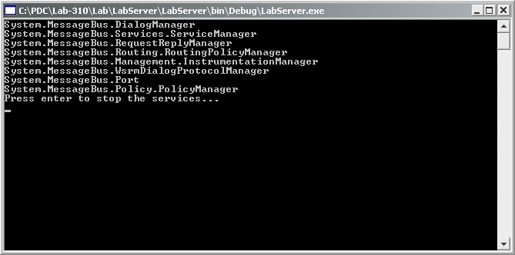

Exercise 2 – Building the LabClient

Task 1 – Creating the Client

- Open a new instance of Visual Studio.
- Create a new Visual C# project; choose the “Indigo” Service Framework Service template. Name this project LabClient. Create this project in the C:\Indigo\Lab-310\lab\ directory.
Note: this template creates a console application with an “Indigo” specific App.Config and a Host.cs file that loads the ServiceEnvironment. A reference has been set to the System.MessageBus assembly for this project.

- Delete the IndigoService.cs file.

Task 2 – Editing App.config

- Find the element that reads <identityRole> change the value to read:

<identityRole>soap.tcp://localhost:46000/LabClient/</identityRole>

Note: This is the URI that the client listens on for responses. The client will include this response URI in their original message and the server will send its response there.

Task 3 – Building the LabServer Proxy

- Open an instance of the Longhorn build environment via Start->Programs->Microsoft Longhorn SDK->Open Build Environment Window->Longhorn Build Environment.
- Change directory to C:\Indigo\Lab-310\labs\LabServer\bin\debug. This is the build directory for the LabServer project. Note: this path may contain an additional LabServer directory if you have created solution folder to contain the LabServer project.

- Run the following command:

WSDLGEN.exe labserver.exe

Note: you should see 3 files created. These files are the dynamically generated WSDL and schema files based on the service attribute information located in the LabServer.exe file. These files could be used to generate client proxies or to rebuild server implementations.

- Run the following command:

WSDLGEN.exe labserver.wsdl labserver.xsd

Note: you should see 1 file [labserver.cs] created. When processing WSDL files WSDLGEN will create a proxy that consumers can use to create channels capable of talking to the service. Think of this in terms of how the wsdl.exe works today in the .NET Framework V1.1.

Task 4 – Using the LabServer Proxy
- Go back to the LabClient Visual Studio project. From the Project menu, choose Add Existing Item and add the labserver.cs file created in Task 3.4 to the LabClient project.

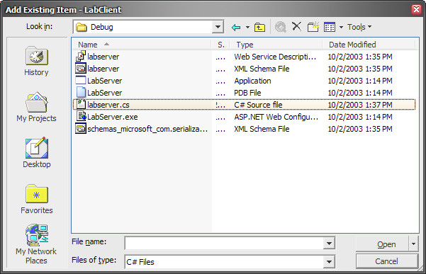

- In the LabClient project open the Host.cs file. Remove the line of code that reads: sm.ActivatableServices.Add (typeof(LabClient.”Indigo”Service));.
- Immediately after the line of code that reads environs.Open () - add code to query the user for a question.
For example:
Console.Write("What is your question? ");
string question = Console.ReadLine();
Console.WriteLine();
- Continuing after the above code create a new System.Uri instance based on the identityRole value of the LabServer.

For example:
System.Uri uriLabServer = new System.Uri("soap.tcp://localhost:46001/LabServer/");

Note: We need to create this uri in order to configure the channel to talk to the appropriate physical location of the service. The generated proxy does not contain uri or addressing information.

- Create a new instance of labserver.IQuestionServiceChannel. You will need to use the CreateChannel method of the sm variable to create the channel. Pass the uriLabServer instance to the constructor.

For example:
labserver.IQuestionServiceChannel channel = (labserver.IQuestionServiceChannel)(
sm.CreateChannel(typeof(labserver.IQuestionServiceChannel), uriLabServer));
Note: This code creates a typed channel that is capable of communicating with the service. The channel will perform the heavy lifting of dispatching the message to appropriate port and will provide addressing information.

- Using the channel instance call the AskQuestion method and write out the response to Console.
For example:
string response = channel.AskQuestion(question);
Console.WriteLine("LabServer responded with: {0}", response);

- Compile the project and fix any errors.

Task 5 – Testing the Scenario

- Start the LabServer project. You should see the ServiceEnvironment collection items written to the console.
- Start the LabClient project.
- Type in your question. You should see the question output on the LabServer console window.
- If you are experiencing errors add try/catch statements around your code and also refer to the event log (application log) or refer to the completed projects located in the done directory.
- If you want to ask multiple questions place a while loop around the statement for AskQuestion.

Congratulations you have just successfully built your first “Indigo” application!

Please run C:\Indigo\Setup\ResetLabs.bat to reset this lab to its initial state.

