Operating instructions:

Upon starting of the solution you will see two forms:
1) Host form:
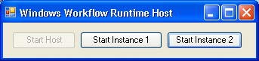

2) windows workflow manager form:
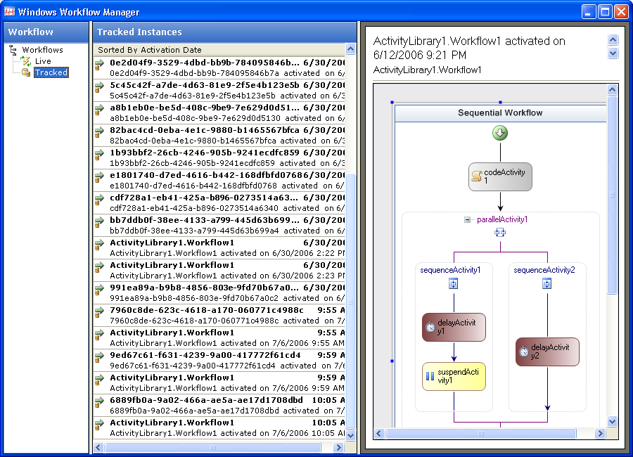
By default it has tracking data source selected and currently shows 4 workflow instances that were tracked some time ago.
The left pane has a list supported data sources – tracking and live.
The middle pane has a list of workflows supplied by the selected data source
The right pane shows a preview of the instance selected in the middle pane.

When user double clicks on some instance in the list, she would be presented with another form that shows details of that particular instance and allows some actions to be performed on it:
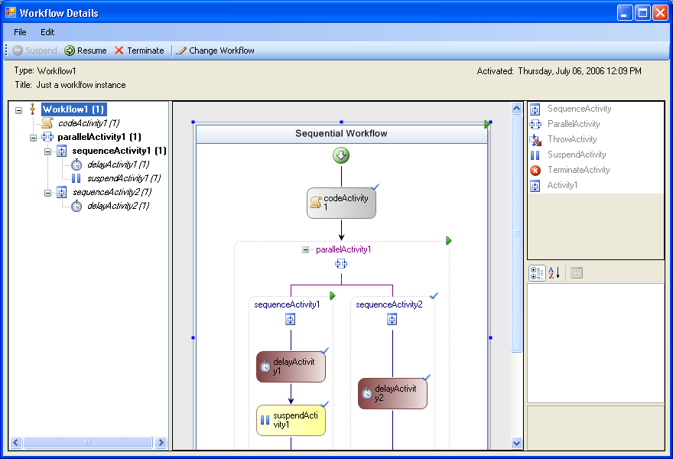 The left pane hosts an extended doc outline control that shows current stated of activities in the instance along with the number of instances of every activity that are/were executing in this workflow instance. Middle pane shows a read-only view of the workflow and the right pane hosts two controls – toolbox and property grid control that are also in the read only mode.
The toolbar allows resuming/suspending/terminating the instance and also has an option to change the instance. If the instance has not been completed yet, that option should be enabled and upon clicking it user will be presented with a slightly different view:
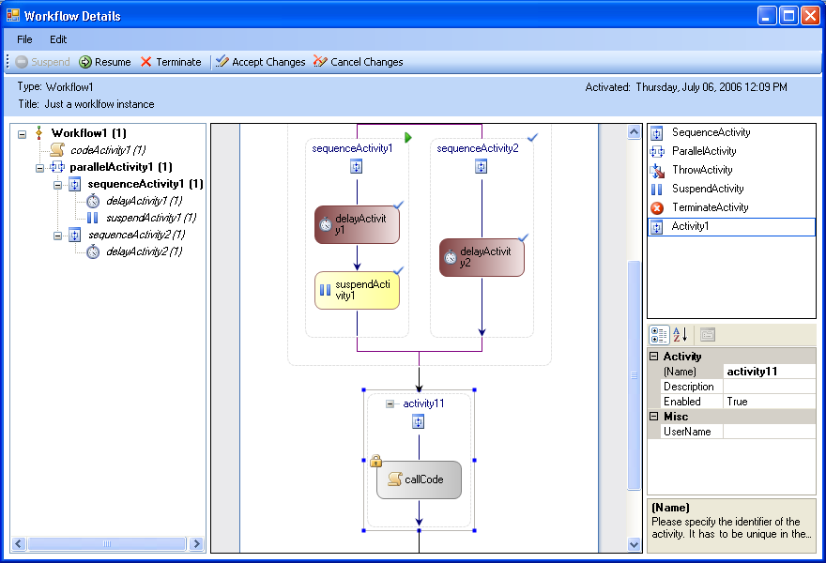
As you see controls in the right pane are enabled now and user may drag and drop items from the toolbox to the workflow view or delete activities from the instance. When user clicks Accept changes, list of all changes up to that point is sent to the host and applied to the live instance.
If there were errors, user will be show a message box, otherwise workflow details view changes back to the read-only mode.
When user clicks resume, the extended document outline view shows activity states changes happening during instance execution.
Appendix 1

Instructions on how to create and populated tracking database:
a) create database mytrackingdb
b) run Tracking_Schema.sql and Tracking_Logic.sql from %WINDIR%\Microsoft.NET\Framework\v3.0\Windows Workflow Foundation\SQL\EN.
c) run trackingDbMyLogic.sql sql script

There’s a config file TrackingShell.exe.config that gives controls over a bunch of configuration points:
- <liveTrackingDatabase> controls path to the database runtime would be tracking instances into (could be empty – in this case no more instance data would be tracked)
- <instanceDataProviderTrackingDatabase> specifies database where to read instances from
- <toolboxItems> - specifies which controls to have in the toolbox (currently there are 5 standard and 1 custom activity type specified)
- <activateWorkflowTypeTwo> specifies type to be activiated when user clicks “start instance 2”
- <activateWorkflowTypeOne> isn’t supported – “start instance 1” currently instantiates xoml wf in startInstance1_Click() of \trackingshell2\HostForm\Form1.cs

