BizTalk

Initiative for Business Process Orchestration
White Paper

Abstract
The BizTalk™ Initiative represents the collective set of investments that Microsoft is making to enable business process orchestration within and between organizations using Internet-standard protocols and formats. The Initiative is made up of the Microsoft® BizTalk Framework, various cross-industry investments including the BizTalk.org business document library, as well as Microsoft BizTalk Server 2000, a business process orchestration server. These investments are being made with industry standards groups, technology, and service providers, as well as key global organizations.
This paper briefly explains the motivation for this initiative and the reasons why current integration technologies do not provide the infrastructure necessary to quickly and cost-effectively deploy distributed business processes. It also addresses what is needed in an environment to address these shortcomings and what investments are being made to address this challenge.

Prepared May 15, 2000

NOTE: This is a preliminary document and may be changed substantially prior to final commercial release of the software described herein. It is current as of the BizTalk Server 2000 Technology Preview release, but we expect capabilities to be added, and some changed, before final release of the product later this year.

The information contained in this document represents the current view of Microsoft Corporation on the issues discussed as of the date of publication. Because Microsoft must respond to changing market conditions, it should not be interpreted to be a commitment on the part of Microsoft, and Microsoft cannot guarantee the accuracy of any information presented after the date of publication.
This document is for informational purposes only. MICROSOFT MAKES NO WARRANTIES, EXPRESS OR IMPLIED, IN THIS DOCUMENT.
The example companies, organizations, products, people, and events depicted herein are fictitious. No association with any real company, organization, product, person, or event is intended or should be inferred.
Microsoft may have patents, patent applications, trademarks, copyrights, or other intellectual property rights covering subject matter in this document. Except as expressly provided in any written license agreement from Microsoft, the furnishing of this document does not give you any license to these patents, trademarks, copyrights, or other intellectual property.

© 2000 Microsoft Corporation. All rights reserved.

Microsoft, BizTalk, MSN, and Windows are either registered trademarks or trademarks of Microsoft Corporation in the United States and/or other countries.
The names of actual companies and products mentioned herein may be the trademarks of their respective owners.

Additional Disclaimer
NOTICE REGARDING INFORMATION AND SERVICES AVAILABLE IN THIS DOCUMENT. In no event shall Microsoft, and/or its respective suppliers, be liable for any special, indirect, or consequential damages or any damages whatsoever resulting from loss of use, data or profits, whether in action of contract, negligence, or other tortious action, arising out of or in connection with the use or performance of any guidelines, documents, provision of or failure to provide services or information available from this document.

BizTalk Initiative for automating business process integration i
The Importance of your Integration Infrastructure 2
Historic Integration Challenges 2
Business Drivers for Integration 3
What Is BizTalk? 4
Framework 4
Cross-Industry Investments 5
Products 6
Customer and Partner Support 9
BizTalk Roadmap 10
Summary 10
Where do I start? 10

The Importance of Your Integration Infrastructure
Integrating enterprise applications has always been extremely costly and time-consuming. But integrating applications is just a means to an end—the real end is integrating business processes. Organizations that want to thrive in the 21st century must do a better job of integrating their processes, not only within their organization, but between them, their partners, and their key customers as well.
Business processes should always be automated and integrated within the context of other more tangible business objectives. Organizations must embrace the global marketplace to expand the market for their goods and services. While that indeed expands their possible reach, it also introduces fundamentally new computing demands for many —the need to maintain systems (or more systems than before) that are designed to run non-stop—24 hours by 365 days a year. Furthermore, organizations need to reduce cycle times, for physical as well as virtual processes, to reduce time to market and deliver against higher customer and partner expectations.
Organizations also need to make better decisions and make them faster than before to outsmart competitors. They need to create, maintain, and share knowledge more effectively to identify and capitalize on new business opportunities as well as simply not making mistakes that could be avoided. They need to establish and maintain dynamic business relationships to streamline producing and providing goods and services to their customers.
None of these requirements should be novel or surprising, but it is interesting to consider that all of these challenges are about integration and interoperability.
Since your competitors are trying to achieve these same objectives, the distributed computing platform and associated integration services you choose become critical to realize these objectives as cost-effectively as possible in the short- and long-term, but more important, with the fastest time to market. If you do not adapt your organization to meet these challenges “on Internet time,” you will eventually lose your customers and key partners to those that do.

Historic Integration Challenges
Traditional methods of application integration have revolved around Remote Procedure Call (RPC) mechanisms for years. An RPC is when an application makes a function call to code that is running on a remote computer. This activity requires specialized protocol support to package, send, and receive the appropriate messages back and forth between those cooperating computers to service that request. There are many RPC technologies; each of the major object technologies has their own. The Microsoft Component Object Model (COM) has DCOM, CORBA has IIOP, and Java uses RMI.
But this “first-generation” technique of integrating distributed systems, characterized as “Distributed Objects,” has some inherent and well-known challenges when used to integrate more distributed systems. Since the application interfaces are “tightly coupled,” relying on intimate knowledge of the destination systems, they are very brittle: a calling application often breaks if the component being accessed is upgraded because of incompatible interfaces. Development and maintenance costs are very high because of the very “granular” nature of these interoperating components. There are also inherent scalability challenges since making synchronous calls to those components often “block” while waiting for a response from the remotely accessed resource.
To address some of the scalability and manageability challenges of the tightly coupled approach, more loosely coupled methods were introduced that allowed more geographically distributed systems to be integrated using message-passing techniques. This allows applications to “fire and forget” messages, which was more resilient, and more scalable, since this (normally) did not block the calling application. There are various technologies available to accomplish this from vendors such as Microsoft and IBM. There also are companies that provide products that extend or resemble these queuing technologies, often adding data transformation and routing functionality as well as “application adaptors” to facilitate bringing data in and out of the central messaging “hub.”
But this second generation of integration technologies, loosely referred to as “Message Brokers,” have some fairly predictable limitations as well. First, they are normally based on highly proprietary technologies, using proprietary interfaces and proprietary internal data representations, even if open data formats can be initially accepted by the system. Second, they are very expensive to buy and even more expensive to integrate and subsequently maintain. Quite frequently they require client licenses or software running at both ends of an application connection, adding further expense, time, and integration complexity. But most limiting is that they do not easily work outside of the organization’s walls. This infrastructure might help integrate enterprise applications internally, but it normally is not effective with a more critical challenge in the new market: integrating applications and business processes between you and your customers and trading partners.
What is required is to apply the concepts of loosely coupled, message-passing integration to the new marketplace. Also required is to use industry-standard transport protocols, data formats, and data transformation technologies to provide integration services that can cost-effectively be used within as well as between organizations.
Beyond the infrastructure, an organization needs to be able to define, implement, and maintain the flows of dynamic business relationships and processes easily across a virtual value chain as well. Furthermore, this must be in the hands of the people who run the business and not require application integration or coding whenever something changes. In the new market, the people who make the business decisions must be able to drive the business systems, and they must be able to do it quickly.

Business Drivers for Integration
To make it fundamentally easier to orchestrate business processes within and between organizations, and do it so that you accomplish the business objectives above at the lowest cost and with the fastest time to market, a number of challenging issues need to be addressed:
- Open standards must be leveraged wherever possible for business document formats as well as the envelope formats for routing documents between disparate systems… to ease interoperability between networks of systems, data stores, and business applications.
- Automated and standard transformation and routing services must be available to convert and route data in varying formats between systems… to make it easier to move data between the systems that execute a distributed business process, including the operational systems that are already in place.
- A graphical, business-oriented design tool is needed for modeling and managing distributed business processes across an arbitrary number of trading partners… to allow the business process experts to design and manage those processes in complete, sophisticated real-world scenarios.
- The graphical design tool must allow distributed processes to be created and implemented across heterogeneous systems… to preserve flexibility, lower cost, and decrease risk by using the computing assets you already have.
- Modeled business processes must be reused and easily combined into larger, composite business processes that are distributed across an arbitrary number of roles and tasks… to allow dynamic business relationships to be established and maintained by business personnel with the lowest maintenance cost.
- Security must be built into the model, allowing data to be encrypted and digitally signed using Internet standards… to guarantee the privacy and authenticity of internal and external communications in a platform independent manner.
- Simple mechanisms must exist for existing as well as new applications to use these integration services… to increase ROI and decrease time to market by allowing easy access to these services without substantial development.
- The services must leverage standard Internet transport protocols as well as open data formats… to easily work between organizations as well as within them and provide a consistent, lower cost integration infrastructure.
- The services must be cost-effective and accessible to small and medium as well as large organizations… to effectively enable mass-market business-to-business (B2B) interaction and trading, increasing alternatives and lowering costs for all involved.
- The services must work with the operating systems, transports, and business document formats that you already have in place… to minimize the time to market, maximize ROI, and minimize risk.
BizTalk provides a compelling solution that addresses these issues directly.

What Is BizTalk?
The BizTalk Initiative represents the collective set of investments that Microsoft is making to enable business process orchestration within and between organizations using Internet-standard protocols and formats. The Initiative is made up of the Microsoft® BizTalk Framework, various cross-industry investments including the BizTalk.org business document library, as well as Microsoft BizTalk Server 2000, a business process orchestration server. These investments are being made with industry standards groups, technology and service providers, as well as key global organizations.
By providing a comprehensive and integrated environment consisting of all of these elements, automating business processes becomes faster, easier, and far less expensive. Furthermore, by making the technology cost-effective for small and medium-sized organizations, an organization’s base of potential customers and trading partners can dramatically expand, providing more opportunities and lower operating costs.

Framework
The first set of investments surround the BizTalk Framework. The BizTalk Framework is a set of implementation guidelines that any organization can use to define and route business data using Extensible Markup Language (XML). XML allows creating markup tag sets that can represent electronic data easily, while possessing the power and flexibility of expressing nearly any object or idea imaginable. Some basic conventions are needed to promote using XML in a consistent way, but also to promote the open and interoperable routing of XML data.
The BizTalk Framework is not a new standard; it builds on existing standards. The BizTalk Framework implementation guidelines are documented and accessible on http://www.biztalk.org. Since the BizTalk Framework is 100 percent compliant with the World Wide Web Consortium (W3C) XML 1.0 standard, it is operating system, programming model, and programming language independent. BizTalk documents are being used by applications on many different platforms today.
The BizTalk Steering Committee drives the BizTalk Framework. The steering committee is made up of more than 20 industry standards organizations, large software companies, and multinational corporations that share the interest of promoting the use of XML to provide better interoperability between applications and processes. Members of the steering committee include American Petroleum Institute, Ariba, Baan, Boeing, Clarus, CommerceOne, Compaq, Concur, Data Interchange Standards Association (DISA), Dell, EXE, Extensibility, Extricity, Ford, GE Information Systems (GEIS), Harbinger, I2, Intelisys, JD Edwards, Merrill Lynch, Microsoft, Neon, Open Applications Group, PeopleSoft, Pivotal, Reuters, SAP, Siebel, Sterling Commerce, UPS, U.S. Department of Defense, and webMethods.
Microsoft also has industry experts that work closely with relevant standards groups in various industries to promote adopting XML for intra and inter-organization application and process integration.

Cross-Industry Investments
The second set of investments represent cross-industry efforts in the form of a community, a globally accessible document library, and many third-party products, tools, portals, and services that support BizTalk.
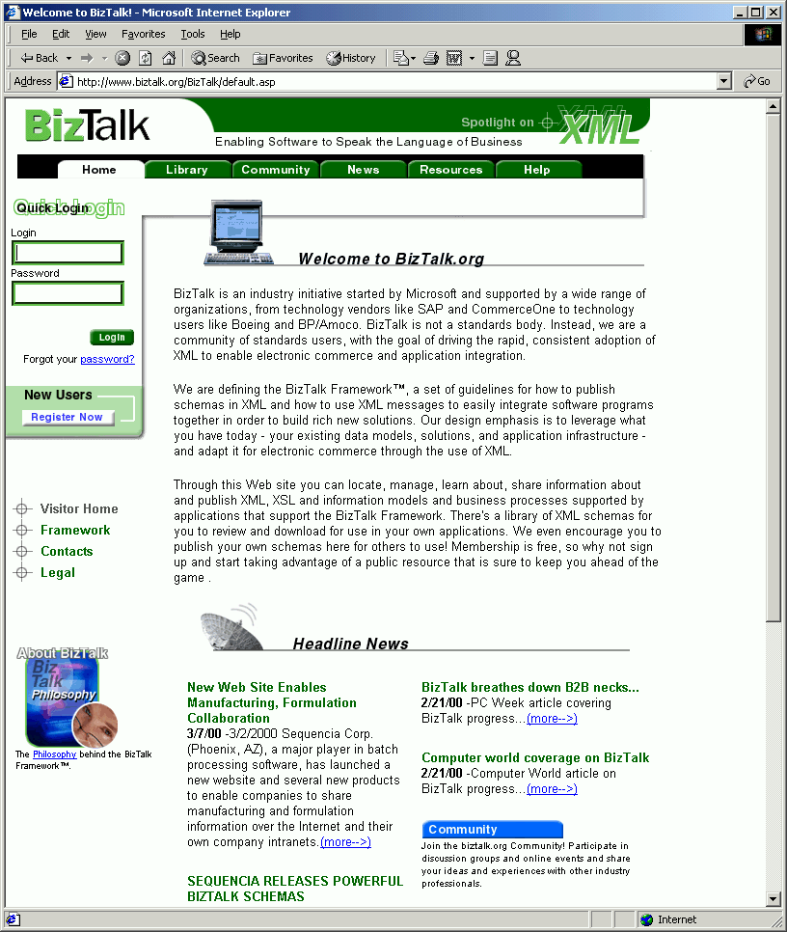
First, BizTalk.org, accessible over the Internet at http://www.biztalk.org, provides a community that allows organizations to learn about XML, access pointers to training, as well as collaborate through newsgroups and other public forums. The site hosts a “collaborative workspace” that allows partners to collaborate on creating standard business documents that are used in a project, supply chain, or industry.
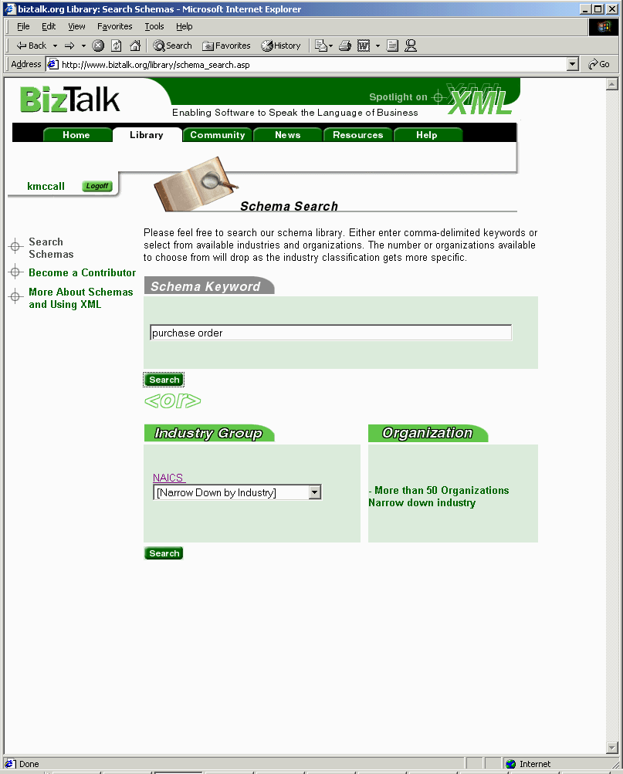
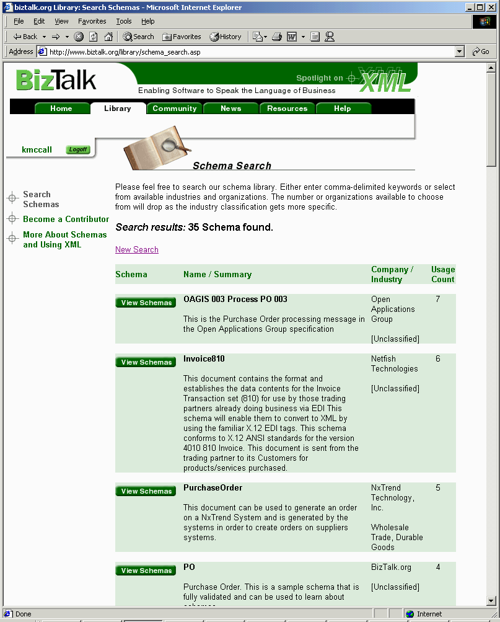
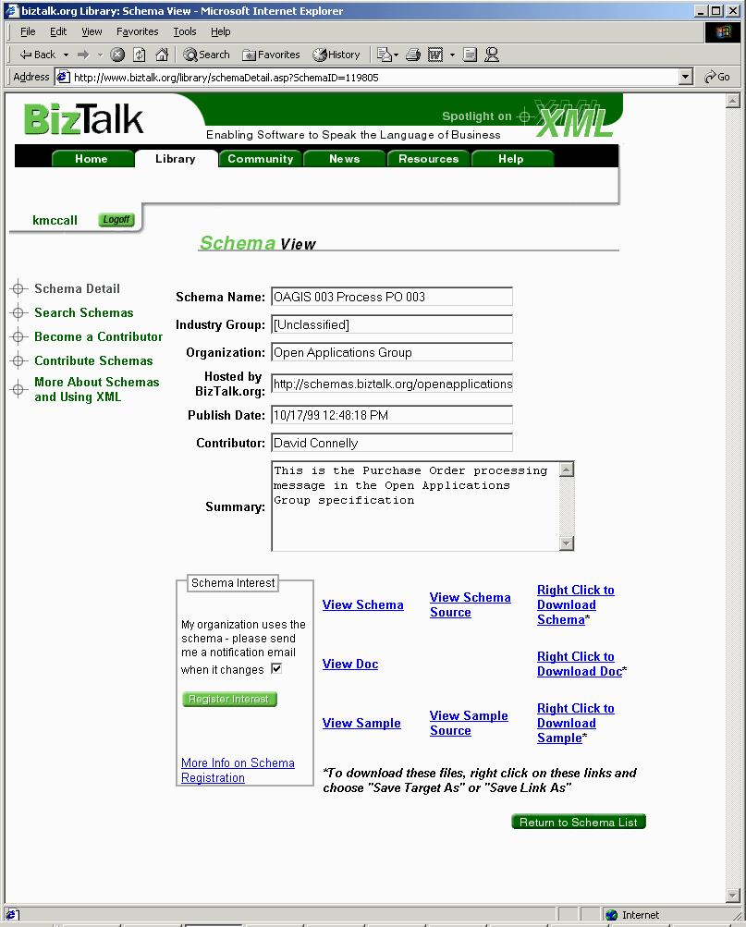
The second tangible cross-industry investment is a public library to store BizTalk document schemas, also hosted at http://www.biztalk.org. This library allows organizations to find and reuse business document schemas that are valuable to them, but also to register themselves as interested parties or users of those schemas so that they are automatically notified when updates occur. Furthermore, organizations can upload their own schemas to use across a set of partners or trading community or to promote an XML business document as a tool for solving a specific business challenge. At this time, there are more than 400 business document schemas in the BizTalk.org library that have been submitted by more than 150 different organizations.
Figure 1: BizTalk.org Community and Library
Figure 2: Performing a string search for all schemas containing the text "purchase order" in the title or description (left), which returns the list (middle), then viewing more detailed information on one of them (right).
The third cross-industry effort is working with partners so that organizations have many choices for products, tools, and services that use BizTalk technology. The complete list of partners that provide complementary offerings can be viewed at http://www.microsoft.com/biztalk/partners.htm.

One BizTalk-driven online service within the MSN™ network of Internet services is eShop, a shopping portal accessible at http://eShop.msn.com. eShop allows consumers to find and compare products in more than 100 product categories, then find out where to purchase those products either online or in retail stores. Various manufacturers around the world can upload information on their products so that consumers can learn about them, and merchants who sell those products online can send simple messages to eShop that allows them to extend offers to consumers online. In both cases, standard BizTalk schemas are available so that both manufacturers and merchants worldwide have platform-independent formats for sending information to the site. Any merchant who wants to offer their goods and services on eShop online could then go to BizTalk.org, download the “eShop Offers” schema, and build a new application or easily adapt an existing one using free BizTalk tools. This would allow them to easily automate sending electronic offers to eShop to present to consumers online as represented below.
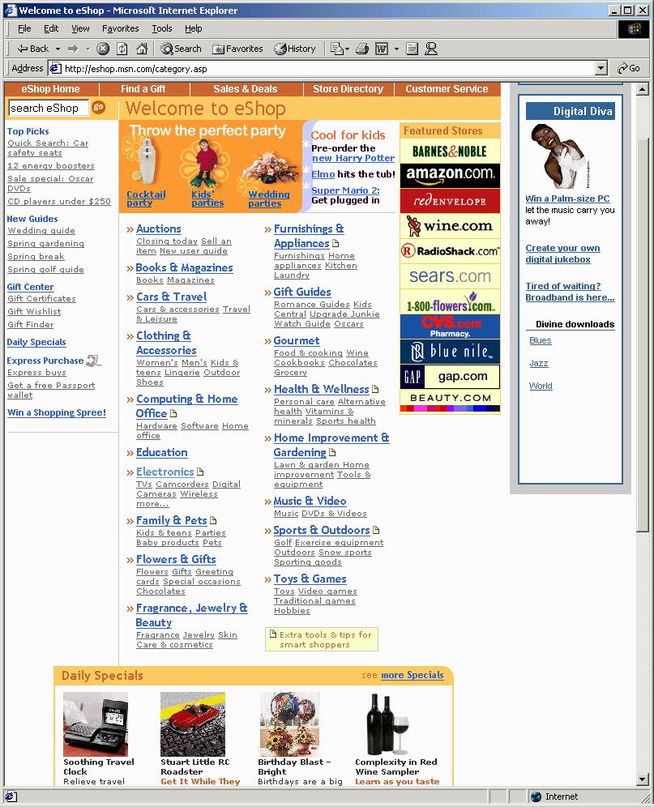
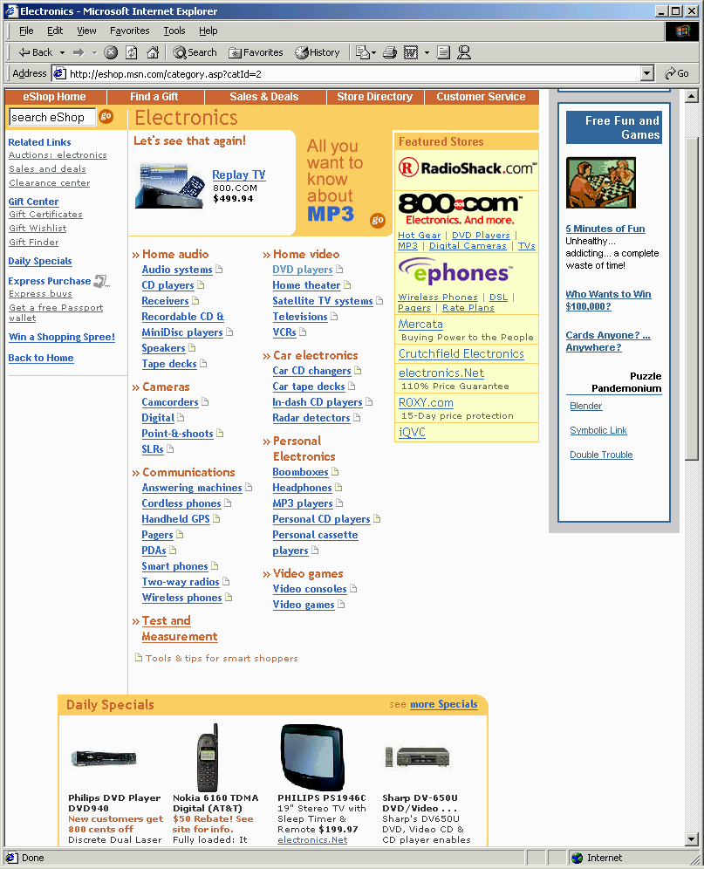
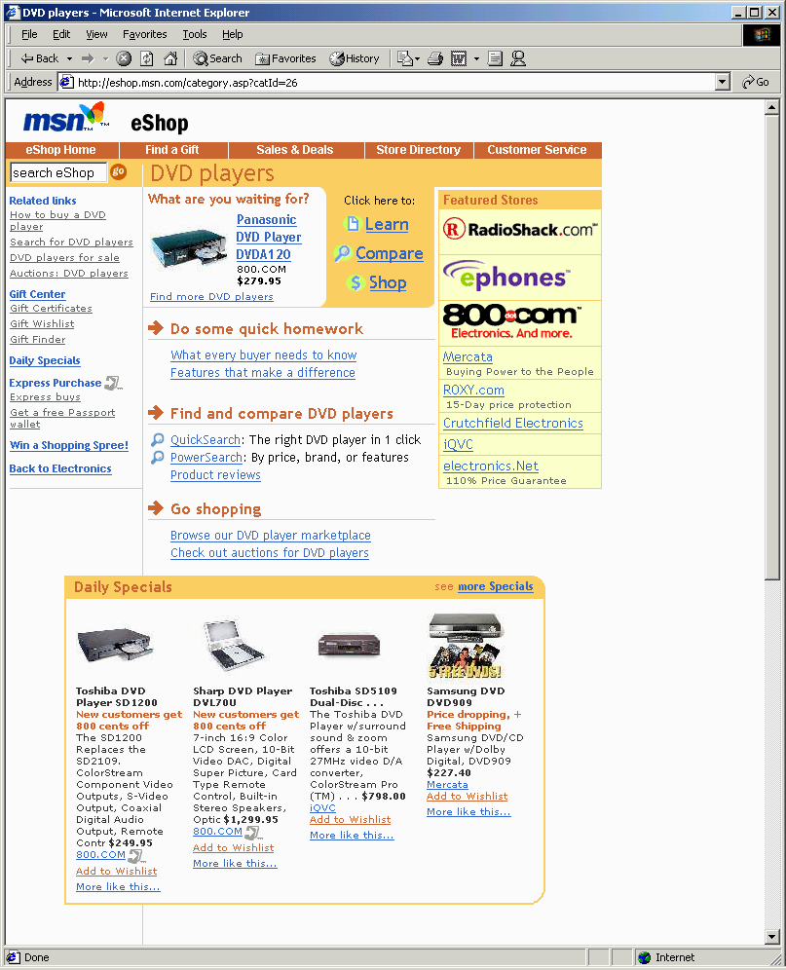
There are many other portals and marketplaces than eShop that are using similar mechanisms to provide Internet-based business-to-business marketplace services. A few include processPoint.com, a portal for bringing together product owners and contract manufacturers; capitalstream.com, a portal for bringing together providers and consumers of commercial credit; and businessengine.net, a portal for bringing together providers and consumers of professional services.
Figure 3: A consumer is first presented with generic product offers (left), but after entering the "Electronics" section they are presented with electronics offers (middle), and finally specific offers on DVD players after selecting that product category (right).

Products
The third set of investments is in tangible products and includes the Microsoft Windows® 2000 operating system, great tools, and BizTalk Server 2000.
It starts with the platform itself. All of the versions of Windows 2000 have XML support built-in. Not only does Windows 2000 support the core W3C XML standard, but also other key XML technologies, such as XML Namespaces, the XML Document Object Model (DOM), XSL, and XML Schema. Independent of Windows 2000, this XML support is also provided with Microsoft Internet Explorer 5.0 and is also available in a discreet component so that it can be used on any Windows client or server.
Beyond the ability to process and transform XML, as you move XML information between applications internally as well as between your systems and those of partners and customers, there are other important required capabilities. For example, it is critically important to be able to encrypt information as it flows between systems to protect it in transit. You also need the ability to digitally sign information so that the recipients know that you sent it, as well as know that it has not been tampered with. Lastly, to minimize bandwidth use, it is also useful to compress that information as it flows between systems.
All of the support to encrypt, digitally sign, as well as compress your business data as it moves between systems is built into all versions of Windows 2000 Server. For example, Windows 2000 Server supports the ability to encrypt data using the SSL and S/MIME standards, as well as the ability to digitally sign data using an integrated PKI infrastructure supporting X.509v3 certificates.
Appropriate tools are also required to create valid schemas to use internally or between you and your trading partners, as well as to map between various data formats. The document transformation necessary at run time to send data between different systems may occur between XML or non-XML document formats, such as EDI or flat files or between one of each. The BizTalk Editor and BizTalk Mapper, the tools that will address these needs respectively, will be available with BizTalk Server 2000.
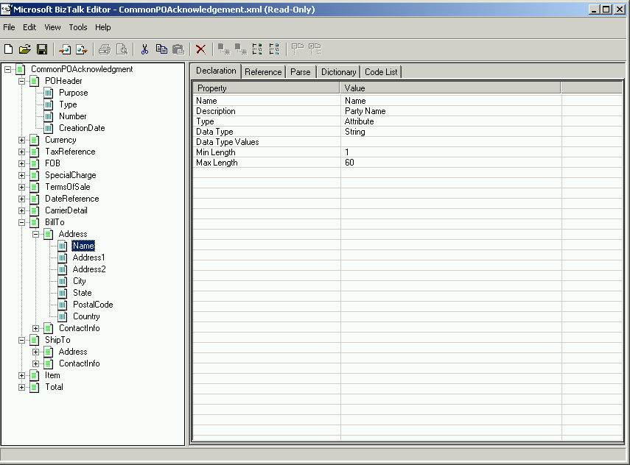
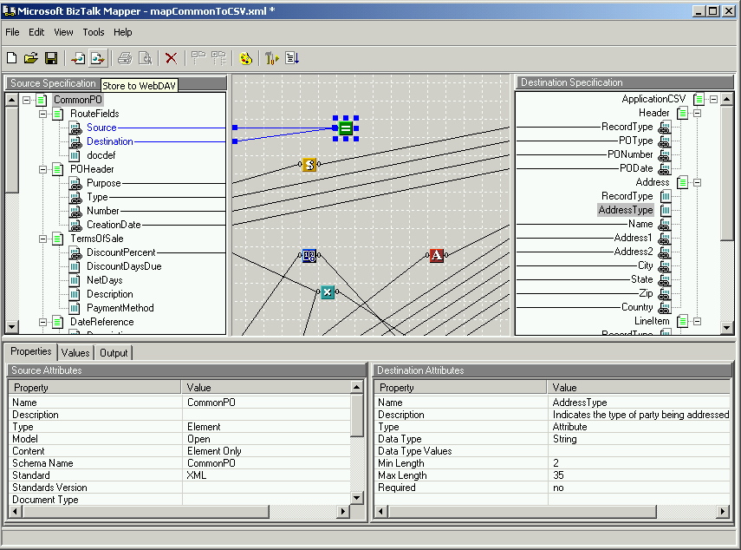
The BizTalk Editor allows any XML, EDI (either UN/EDIFACT or ANSI X12), or flat file (delimited or positional) to be easily defined from scratch or by opening an actual instance of that document. The BizTalk Editor will then generate an XML description of that file so that it can be easily processed by BizTalk Server 2000. It also supports Document Type Definitions (DTDs) to facilitate migration to the XML Schema standard in the future.
Figure 4: the BizTalk Editor and BizTalk Mapper tools, included with BizTalk Server 2000.
The BizTalk Mapper allows XML, EDI, and flat file business documents to be easily transformed between alternative formats. Since BizTalk Server 2000 represents all structured documents internally as XML, the BizTalk Mapper can not only be used to easily transform XML documents between different formats, but also between XML and non-XML document formats, as well as two non-XML document formats. This allows the BizTalk Mapper to facilitate transforming EDI documents to SAP IDOC documents, for example, while still leveraging the Internet-standard XSL technology to do so.
BizTalk Server 2000 is a business process orchestration server that allows you to coordinate activities that span various applications, organizations, people and time. At its core, BizTalk Server 2000 provides the secure, reliable environment and tools (mentioned above) for document transformation and routing to facilitate trading partner integration, electronic procurement, B2B portals and extranets, as well as automating value-chain processes. In addition, the product will provide a visual process modeling environment, called BizTalk Orchestration, that will allow you to model, deploy, and maintain distributed business processes within and between organizations. This environment will support the creation of sophisticated, distributed processes that include multiple parties and can be reused and combined as building blocks as those processes and relationships change over time.
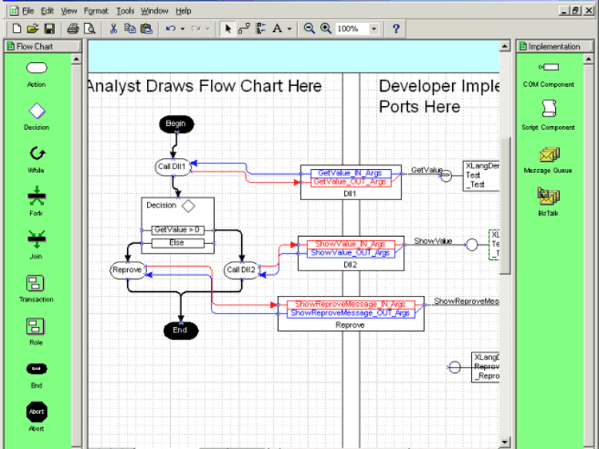
Figure 5: The BizTalk Orchestration environment allows distributed business processes
to be defined and maintained.
BizTalk Orchestration leverages the loosely coupled application integration model mentioned prior, but it also allows a business analyst to include synchronous access to applications, as well as include workflow and collaboration processes that are normally people-driven. In short, BizTalk Orchestration coordinates activities across an environment that includes Enterprise Application Integration (EAI) functionality, also referred to as A2A (application to application), B2B functionality, and workflow and collaboration systems, while providing the sophistication of process automation tools in order to sequence and manage the orchestrated activities as they proceed.
BizTalk Server 2000 also provides the core facilities to integrate disparate applications, supporting transport protocols such as COM/DCOM and Microsoft Message Queue Server (MSMQ), but also Internet standard protocols such as HTTP, HTTPS, and SMTP. In addition, through the facilities of the Microsoft Host Integration Server, other methods such as SNA and MQSeries can be used, and Application Integration Components can be used to integrate with many systems in use today. The graphical BizTalk Management Desk, shown below, supports the definition and maintenance of trading partners that are referred to within the BizTalk Orchestration environment.
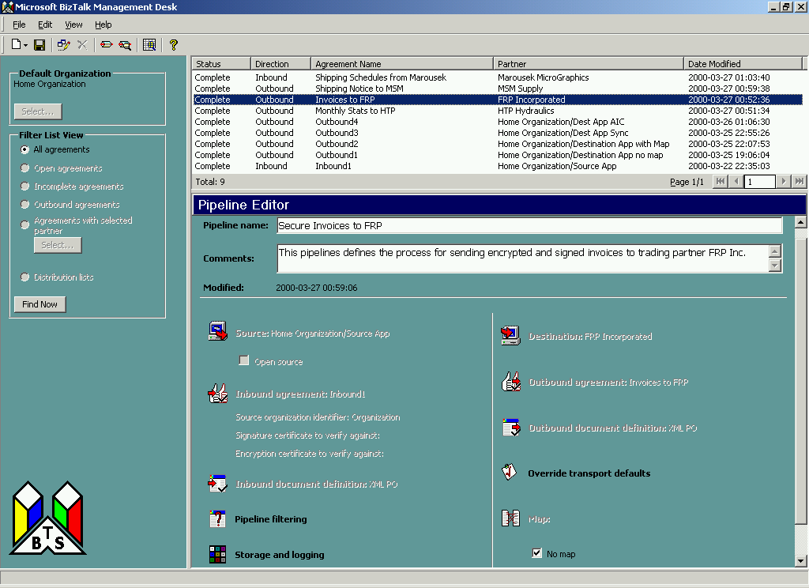
Figure 6: The BizTalk Server 2000 Management Desk within which application and business
agreements are defined.

Customer and Partner Support
Many Microsoft partners and customers are using BizTalk today to facilitate business process integration within and between organizations. As mentioned previously, Internet-based portals and marketplaces such as processPoint.com, capitalstream.com, and businessengine.net currently exist that use BizTalk technology to facilitate B2B trading and collaboration across organizational boundaries. Other portals driven by BizTalk technology include iProcure.com, a portal for automating the procurement of MRO goods by industrial organizations, and even sites such as planetagol.com, a worldwide soccer community that drives automated content upload and management using standard BizTalk messages. Large multi-national organizations such as Dell, Marks and Spencer, Ford Motor Company, and Sainsbury’s are using BizTalk technology as well to facilitate business process integration.
The most current information available regarding partners that are building or have built services and solutions that use BizTalk technology can be accessed at http://www.microsoft.com/biztalk/partners.htm, and the current set of documented case studies is available at http://www.microsoft.com/biztalk/casestudies.htm.

BizTalk Roadmap
Most of the investments that make up the BizTalk Initiative are available for customer use today and have been used to build BizTalk-based applications that are currently in use within large and small organizations as well as various B2B marketplaces. The BizTalk Framework, the BizTalk.org community and library, and the BizTalk JumpStart Toolkit (the predecessor to BizTalk Server 2000) have been used extensively to build applications that integrate trading partner relationships, independent of computing platform, using XML as an open format. In addition, these applications will migrate to BizTalk Server 2000 when it becomes available.
The BizTalk Server 2000 Technology Preview became available on April 11, 2000. It provides the comprehensive and integrated facilities for integrating enterprise applications within and between organizations. By providing support for integrating applications and business processes based on many transports, various document formats, and with powerful routing, security, and analysis features built-in, BizTalk Server 2000 Technology Preview provides an environment that can be used today to build secure and reliable integration solutions.
The BizTalk Server 2000 Beta release, which will include the BizTalk Orchestration environment, will be available during the summer of 2000.
The general release of BizTalk Server 2000 is currently scheduled for late calendar year 2000.

Summary
Integrating distributed business processes is hard work within an organization and is frequently prohibitively expensive between organizations. There are many things that need to be done to make it fundamentally easier to orchestrate business processes within and between companies. The BizTalk Initiative is that collective set of investments that Microsoft is making to fundamentally ease business process orchestration independent of operating system, programming model, or programming language.
By providing this comprehensive and integrated environment through BizTalk, Microsoft provides the fastest, easiest, and most cost-effective way to orchestrate business processes not only within organizations, but also between organizations using the Internet.

Where Do I Start?
You can build BizTalk-based applications today. But before you do so, we recommend getting more familiar with XML and XML Schema as core technologies, as well as considering involvement with various XML efforts within your industry.

- Learn more about XML and XML Schema (http://msdn.microsoft.com/xml)
- Join the BizTalk Community (http://www.biztalk.org)
- Download the Microsoft BizTalk Server 2000 Technology Preview (http://www.microsoft.com/biztalkserver)

