BizTalk Orchestration
A Technology for Orchestrating Business Interactions
White Paper

Abstract
The advent of the Internet has spawned a whole new dimension of technologies that enable individuals and organizations to do business more efficiently and effectively. With these opportunities have come a host of new challenges – including integrating and automating business processes within and between organizations.
BizTalk Orchestration is a new technology for creating and orchestrating business processes that span time, organizations, applications and people.
This paper briefly explains the business needs that motivated Microsoft’s creation of BizTalk Orchestration, and provides a high-level overview of the features and characteristics of the technology itself.

Prepared June 5, 2000

The information contained in this document represents the current view of Microsoft Corporation on the issues discussed as of the date of publication. Because Microsoft must respond to changing market conditions, it should not be interpreted to be a commitment on the part of Microsoft, and Microsoft cannot guarantee the accuracy of any information presented after the date of publication.
This document is for informational purposes only. MICROSOFT MAKES NO WARRANTIES, EXPRESS OR IMPLIED, IN THIS DOCUMENT.
The example companies, organizations, products, people, and events depicted herein are fictitious. No association with any real company, organization, product, person, or event is intended or should be inferred.
Microsoft may have patents, patent applications, trademarks, copyrights, or other intellectual property rights covering subject matter in this document. Except as expressly provided in any written license agreement from Microsoft, the furnishing of this document does not give you any license to these patents, trademarks, copyrights, or other intellectual property.

© 2000 Microsoft Corporation. All rights reserved.

Microsoft, BizTalk, SQL Server are either registered trademarks or trademarks of Microsoft Corporation in the United States and/or other countries.
The names of actual companies and products mentioned herein may be the trademarks of their respective owners.
Additional Disclaimer
NOTICE REGARDING INFORMATION AND SERVICES AVAILABLE IN THIS DOCUMENT. In no event shall Microsoft, and/or its respective suppliers, be liable for any special, indirect, or consequential damages or any damages whatsoever resulting from loss of use, data or profits, whether in action of contract, negligence, or other tortious action, arising out of or in connection with the use or performance of any guidelines, documents, provision of or failure to provide services or information available from this document.

Introduction 2
Communication 2
Integration 2
Orchestration 3
BizTalk Orchestration: A Technology For Orchestrating Business Interactions. 5
Feature Overview 5
Separation of Definition from Implementation. 5
Dynamic Processes 6
“Any to Any” Integration 7
Composability 7
Complete Process Flow Semantics Including Concurrency and Synchronization 8
Long-Running Transactions 9
Management and Monitoring 10
Summary 10
Availability 10
For More Information 10

Introduction
Since the dawn of organized commerce, man has strived to conduct business more efficiently and more effectively. Whether it was the invention of the wheel, of writing and accounting systems for record keeping, the steam engine, the continuous-process factories of the industrial revolution, or the internal combustion engine, man has always enlisted technology to increase efficiency, decrease costs and more-effectively take advantage of partnerships in order to raise profits.
With the advent of the Internet, a whole new dimension of technological possibilities has been made available to people and businesses. The incorporation and strategic use of these technologies is fast becoming the differentiating factor between success and failure. The new economy has been thrust upon businesses, and with these new possibilities comes a level of complexity unrivaled in the history of commerce. We have seen the evolution of several generations of technology being applied to business problems and each of these generations has brought with it a host of new challenges.

Communication
The first era of Internet history was the Communication Era. This saw the construction and coalescence of the hardware infrastructure and software protocols necessary to build and maintain a single, reliable and robust network built on open standards. It was the first step in getting people and eventually businesses “online.” EDI VANS were and are still used today to electronically exchange information between entities, but they are brittle, proprietary, exclusive networks that are purpose-specific. Banks or insurance companies, for example, potentially could participate in multiple VANS for different purposes each with their own requirements for physical infrastructure, protocols, platforms and applications.

Integration
We find ourselves today in the second era of the Internet, the Integration Era.
This coalescence of physical and software infrastructure was a necessary first step on the path towards true e-commerce. However, it is still a long way from providing the necessary foundation for companies to do business digitally with one another. By far the broadest use of the physical and TCP/IP infrastructure has been SMTP and HTTP, email and Web pages. In the early years, these provided people with a new and exciting way to communicate and exchange information. But the limitations of these technologies for exchanging structured documents and data presented a roadblock. HTML was designed primarily as a means to lay out and present textual information and pictures to viewers through Web browsers – essentially desktop publishing for the Web. SMTP was intended to allow people to send blobs of text and attachments to one another. Neither of these technologies was designed for the exchange of structured data – such as purchase orders or insurance claims –over the Internet between businesses and applications.
Consider the process of corporate procurement: the buying of supplies such as pens, chairs and computers necessary for a company to do business. Before the Internet existed, these processes were largely paper-based, with orders for equipment being sent via mail or perhaps fax. The communications infrastructure of the Internet brought us a step closer to Internet-based commerce: we could now view a product catalog on a Web page and send an order to a supplier via email. The supplier would then take the information in the email and most likely re-enter it by hand into various financial and inventory-management applications, or perhaps use an entirely paper-based system. But there was still no way to place an order electronically and have that order pass straight through to the supplier’s IT infrastructure without several layers of human intervention.
Enter XML. XML was designed to enable the exchange of data in a simple, standards-based way over the Internet. Having already created the communications infrastructure, XML was the first step in building the integration infrastructure. With all the hype around XML in the late 1990s, people thought it was the final step in enabling commerce over the Web. The opposite was true. XML is essentially an agreement on how to structure data in a standard way that any adherent application can understand. With XML technology, the Internet community had effectively agreed upon an alphabet for e-commerce. It quickly became apparent that to meaningfully exchange data other layers of agreement would be required. These layers came in the form of schema. A schema is an agreed way of formatting XML for a specific use, such as a purchase order. If XML is the alphabet of the new language of e-business, then schema are the words and sentences. The proliferation of schema has happened at a lightning pace, and there are thousands available for every application in every vertical industry. Today there are libraries such as http://www.biztalk.org that serve as clearing houses for schema.
As has been the case with every evolutionary step in the history of the Internet, the addition of another layer of technology, in this case XML and the integration infrastructure, has not only brought with it new opportunities and solutions, but a new level of complexity as well. Returning to our corporate procurement process, XML provides us with a way to directly pass an order from our purchasing application or a Web page over the Internet and straight through to the supplier’s customer and inventory management applications – all without any human intervention. There is however, one not-so-trivial caveat: the customer and supplier must agree on the format of the data; they must agree on the schema.
At first glance this is a seemingly trivial requirement. But add a thousand customers dealing with ten thousand suppliers – all formatting their purchase orders in a different way – and a whole new problem arises. This new level of complexity – thousands of schema, and thousands of ways for businesses to describe purchase orders, insurance claims and the like – has spawned an entirely new market for offering integration solutions. The market for products offering normalization of data, and mapping and transformation between schemas, is growing at an overwhelming pace. The hype of XML in the late 1990s has been subsumed by the hype of the B2B marketplace and B2B data exchange. And, as with XML, business analysts, software developers and IT professionals are starting to realize that the building of the integration layer is another interim step towards the realization of true e-commerce. There is, however, one step left in the construction of the infrastructure for e-commerce: the orchestration layer.

Orchestration
Just over the horizon we can see the first light of dawn of the next step in the Internet’s evolution: orchestration.
Having built the communications infrastructure, we are making rapid progress on constructing the integration infrastructure. But the language of e-commerce is not yet complete. We have the alphabet (XML) and words and sentences (schema), but together they are not sufficient. There must be process in order to communicate. Today we have a way of very explicitly representing the data we wish to exchange, and the format we wish to exchange it in, but we have no way of consistently representing how or why we want to exchange the data. With the integration and communication infrastructures complete our applications can now “speak” to other applications over the Internet, but we don’t have a good mechanism for telling them when and how to say it. We have no way of representing the process. Today the “process” is spread throughout the implementation code of every participant involved in the process. This mechanism for representing the process of business interactions is fragile, prone to ambiguities, does not cross organizational boundaries well, and does not scale. The larger the process gets and the more participants that are involved, the more static the process is and the harder it is to propagate changes and new players into the process.
Consider once again our corporate procurement process. We now have a way to send a purchase order over the Internet to any arbitrary supplier in a relatively simple way. But, there is still a significant process we must build, manage and maintain. We have applications that place the orders; applications that transform the order into a schema that the supplier can understand; applications that receive purchase-order acknowledgements and transform them into schema we can understand; and applications that keep track of financial and payment elements of the process. There is also most likely a review process that happens before an order is sent and when it is received to ensure that the order is correct and that we are getting what we paid for, as well as many other steps that must take place before the process is complete (see Figure 1).
How do we describe this process? How do we build in such a way as to maximize scalability and flexibility as we add new steps and new partners to the process? What happens when we want to add security and fault tolerance to the process? What happens when it is time to upgrade our hardware and our software? Even with the communication and integration layers we are still faced with challenges like these in trying to truly realize Internet-based commerce. These are the very challenges that the orchestration infrastructure will address.
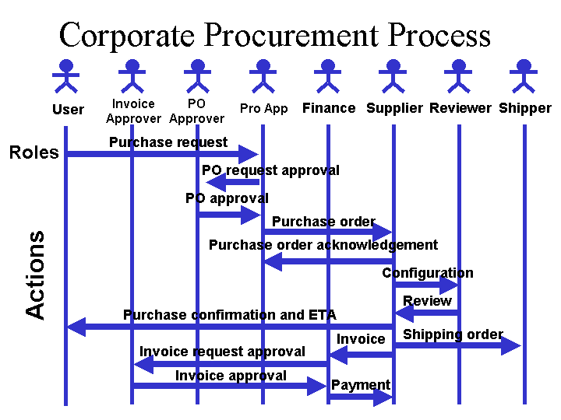
Figure 1 - An Abstraction of the Corporate Procurement Process
Orchestration is about building and executing B2B interactions that span time, organizations, applications, and people both behind that firewall and across the Internet. It is about combining the best of integration and automation in a way that makes business interactions scalable, dynamic and robust. Orchestration has three broad requirements:
- Separation of Definition from Implementation
The process definition must not be tied to or driven by implementation details and vice versa. If the process is not separated from the implementation it is difficult to build, maintain, modify or scale business interactions.
- Dynamic Processes
The process must be able to change itself dynamically based on data and interactions that can only be known at runtime. We shouldn’t have to know at runtime who all the participants in a process are going to be or exactly what they are going to do.
- “Any to Any” Integration
The process must be able to communicate and interact with any of the constituent parts of the implementation of the process. We can’t dictate to everyone we want to interact with what platform, application, schema, and protocols they have to do business with. Doing so would severely limit the pool of potential business partners.

BizTalk Orchestration: A Technology For Orchestrating Business Interactions.
BizTalk Orchestration is a technology for designing, building and executing dynamic business interactions that span organizations, platforms, applications and people. BizTalk Orchestration, shipping with BizTalk Server 2000 Beta, includes:
- A visual design environment that enables business analysts and IT professionals to work with developers to define business processes and connect them to software implementations.
- A set of bindings to connect business-process definitions to a number of different technologies – including any COM component, any MSMQ queue, script components, the messaging features of BizTalk Server 2000, and a host of third-party applications.
- An Orchestration Engine for executing the business processes, maintaining their state, and monitoring and debugging them. Details of this technology are discussed below.

Feature Overview

Separation of Definition from Implementation.
Building business interactions within and across organizational boundaries requires both the definition of the process and the development of the software components and applications that implement the pieces of that process. Today, most often the two are inextricably tied to one another. The code that implements the software applications and components is the same code that tries to create and control the process. This means of building and maintaining business interactions is badly flawed. Building the process into the implementation means that:
- The process is tied to a specific platform, application, protocol, etc. Changing the implementation technology means throwing out existing process code and rewriting it using the new implementation technology. Changes to the process require changes to the implementation code and vice versa.
- In large business interactions, the process is spread throughout the implementation code of all of the various participants, which may include many different platforms, applications, protocols, etc. This makes it difficult to maintain and evolve.
- The process doesn’t easily scale to include large numbers of participants.
- The larger the process, the more difficult it is to propagate changes to the process across all of the participants.
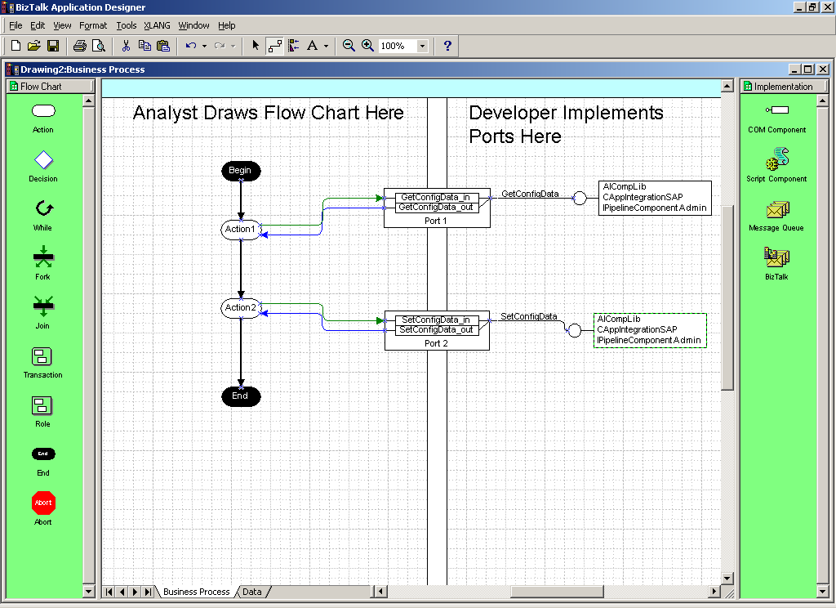
Figure 2 - Separation of the business process from the software implementation in the visual design environment. The process is defined on the left and then connected to the visual representation of the software implementation, in this case two COM components, on the right.
BizTalk Orchestration makes a distinct separation between the process definition and the underlying implementation. The two are literally separated in the visual design environment, allowing business analysts and IT professionals to design and build the process and work with developers to connect it to the underlying software implementations. BizTalk Orchestration provides a complete semantics for describing any process, as will be discussed below, and a mechanism for connecting applications, protocols, transports, etc., to that process. This separation has many benefits:
- It allows a combination of the best of process and the best of implementation. Business analysts and IT professionals can focus on defining the process and work with developers to build software implementations to be connected to that process.
- It allows the process to be modified and maintained without breaking the underlying software implementations, and vice versa.
- It allows flexibility of hardware and software choice. The underlying implementations can be upgraded or changed entirely without throwing away the work done to define the process.
- It makes it easy to add new elements and new participants to the process.

In fact, to really take advantage of the dynamic process functionality of BizTalk Orchestration we want to know as little about the implementation details of a process as possible when designing the process.

Dynamic Processes
Business processes are not static entities – they are living things that are constantly changing and interacting with new participants. BizTalk Orchestration provides exceptionally powerful functionality that allows a process to dynamically change at runtime based on its communications with the applications, data and elements involved in the process.
For example, consider a simple merchant Web site. We know at the end of the buying process we want to ship the merchandise, but we won't know which shipper we will be using until the customer has almost completed the checkout process. With BizTalk Orchestration, we can design an executable business process where the shipping order is sent to an abstract shipper. At runtime, the shipper used will be determined by choices made by the customer during the checkout process. That shipper's application infrastructure will then be bound to the shipping actions in our business process. For the remainder of the process, the shipper the customer selected at runtime will be substituted wherever we referred to the abstract shipper at design time . We can add an infinite number of shippers without changing the process, and changes in our process do not affect any of the shippers we interact with.
Consider a more complex example at a merchant site – cross-selling. We know that from each catalog page we want to recommend another product based upon what we know of the user – but this cross-sell product is dynamically recalculated with each page-click. With BizTalk Orchestration, we can completely design this business interaction between buyer and seller even though the destination Web page that we want the user to visit next is not determined until runtime as the user clicks through pages, on an instance-by-instance basis.
Consider our corporate-procurement scenario. As a seller, we would like to have a standard business process that all of our customers can buy through. As part of this process, we would like to receive a standard purchase order form at a fixed address. After receiving this standard form, we would like to send an acknowledgement to the buyer. The destination that we will send this acknowledgement to will be determined by the address information included in the buyer’s purchase order. Using BizTalk Orchestration we can design exactly this process. At design time we define the process to send the acknowledgement to the destination specified in the purchase order we received at runtime. This allows us to have one process for all of our customers, requiring no customization on a per-customer basis.
BizTalk Orchestration’s dynamic process functionality provides business analysts, IT professionals and developers with the power and functionality they need for building business processes that are dynamic, robust and scalable.

“Any to Any” Integration
“Any to Any” Integration is a requirement for successfully orchestrating business interactions. While it is necessary that we separate the definition of the process from the implementation of that process, it is also crucial that we are able to communicate with (or “bind”) the process to any of the constituent pieces of the implementation at runtime. Our process has to be able to talk to the software that it is calling upon to do work. That software may include applications and components running in heterogeneous environments. BizTalk Orchestration has an open binding architecture, and BizTalk Server 2000 will ship with adapters for COM, MSMQ, SQL and SOAP, as well as a host of adapters for popular financial, CRM, accounting and other third-party applications. Through its open binding architecture BizTalk Orchestration enables integration with any application on any platform using any protocol over any transport. This level of integration is necessary to orchestrate business processes that span heterogeneous environments.

Composability
Just as the component parts of the software implementation of a process are spread across its functional units, the same should be true of the semantic definition of the process. It may not be possible for a single participant to be responsible for or maintain the definition of a large process that spans many organizations. BizTalk Orchestration enables the semantic definition of a process to be distributed across the functional units of that process. Consider our corporate procurement process that involves the participation of several discreet organizations – both internal to a company, such as the finance department, and external, such as a supplier. The definition of each of the participants’ roles in the process can be defined by the participants themselves. The finance department can define the part of the process that they are directly responsible for, such as the process of paying invoices. The resulting sub-processes can then be “composed” and executed by the Orchestration Engine as if they were a single process. This enables the constituent parts of the process to be maintained and modified by those who know them best.

Complete Process Flow Semantics Including Concurrency and Synchronization
At the core of BizTalk Orchestration is a set of primitives used to semantically describe any process. These primitives include branching, sequencing, concurrency and synchronization, and others.

Concurrency and Synchronization
Often, many sub-processes that are not dependent on one another can be executed at the same time. For example, if a single customer order has multiple items coming from different suppliers, we do not need to wait for one order to be placed before we place the next. In fact that would be a grossly inefficient way of executing the process. Concurrency is common to most business processes but rarely is it supported in programming languages or development tools. BizTalk Orchestration, however, provides full support for describing and executing concurrent sub-processes. Synchronization goes hand in hand with concurrency. Consider the previous example. While we can place all of the orders concurrently, we can’t send the customer an order confirmation until all of the orders are placed. We used BizTalk Orchestration’s support for concurrency to spawn the concurrent orders, and we would use BizTalk Orchestration’s synchronization support to ensure that all the orders were completed before continuing with the ordering process and sending the customer a confirmation. Building this kind of concurrency and synchronization into business processes today is exceptionally difficult, and is often simulated at great expense. With BizTalk Orchestration it is as easy as drawing the concurrent processes in the visual design environment (see Figure 2) and connecting them to their respective software implementations. BizTalk Orchestration takes care of coordinating the concurrent processes and their subsequent synchronization.

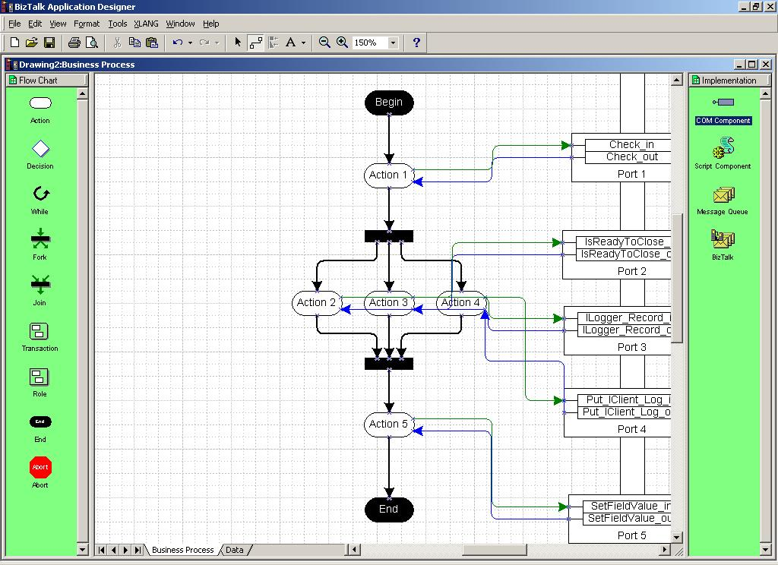
Figure 3 – With BizTalk Orchestration, creating independent concurrent processes and synchronizing them is as simple as adding the fork and join elements to the process as demonstrated in this diagram.

Long-Running Transactions
Today, transactions are confined to tightly coupled, synchronous interactions between systems or components. However, in the new, loosely coupled, message-based, asynchronous B2B environment, we will require more functionality than this if our processes are going to have any degree of reliability or robustness. BizTalk Orchestration provides functionality that allows us to treat long-running, loosely coupled business processes that may span days or weeks or months as if they were a single, synchronous, tightly-coupled transaction. Using the long-running transaction features of BizTalk Orchestration, we can encompass a loosely coupled B2B interaction that may span multiple participants running on multiple platforms, in a transactional context. BizTalk Orchestration also includes a complete semantics for writing the compensating code for execution should the long-running transaction fail. The details of this functionality are beyond the scope of this paper, but the implications of being able to execute long-running business processes in a transactional context are profound.
Consider once again our corporate procurement scenario. There are a series of steps that need to be successfully executed in order for the process to complete – steps that involve many different organizations both internal to the company and external. What happens if one or more of those steps fails? What happens if a piece of a process that involves many different applications, people and businesses fails? Today developers and IT professionals have very few choices in dealing with these issues. Often they are simply left to pick up the pieces by hand and over the phone if part of the process does not succeed. BizTalk Orchestration provides a relatively simple solution to this problem. Adding a transactional context to a process or part of a process simply requires drawing a transactional rectangle around the parts of the business process you wish to put in a transactional context, and writing the compensating process that would run if one or more of the steps in the process should fail. BizTalk Orchestration provides a consistent and reliable way for dealing with problems and failures in business interactions both behind and across the firewall.
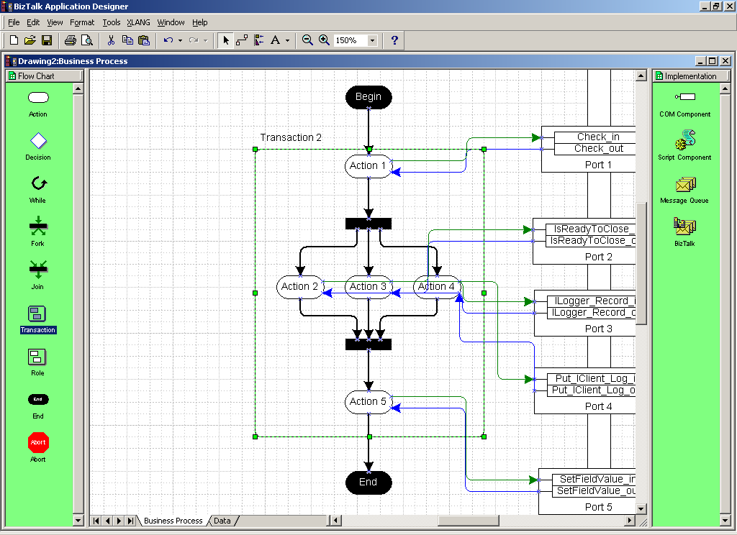
Figure 4 – By wrapping part of this process in the transactional rectangle we can attach a compensating process and treat the business interaction as if it were a tightly coupled transaction.

Management and Monitoring
The state of all running processes is persisted in an open XML schema and can be stored in any XML-compatible database such as SQL Server 7.0. This allows both the simple querying of the state of processes and advanced management, monitoring and debugging of those processes by compatible tools. For example, a business analyst or IT professional could run a query to discover how many processes are still not completed, what stage of completion they are at, or if they are blocked at a particular point in the process.

Summary
The integration of business processes is not sufficient to fully realize the potential of e-commerce. These processes must also be orchestrated in order to be at all effective. BizTalk Orchestration is a technology that gives business analysts, IT professionals and developers the tools they need to build and maintain powerful, dynamic and scalable business processes that span organizations, applications, schema, protocols and people.

Availability
The BizTalk Orchestration technology will first ship with the beta version of BizTalk Server 2000, available summer 2000.

For More Information
For more information on the BizTalk initiative including BizTalk Server 2000, The BizTalk Framework and Biztalk.org please visit http://www.microsoft.com/biztalk

