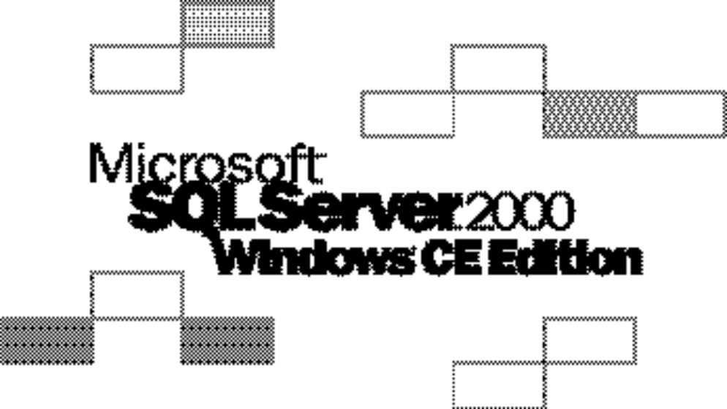
Product Highlights
Microsoft® SQL Server™ 2000 Windows® CE Edition extends the SQL Server product family to new devices such as the Windows Powered Pocket PC, while providing developers with a consistent programming model for rapid application development. It delivers essential relational database functionality in a small footprint: a robust data store; an optimizing query processor; and reliable, scalable bi-directional merge replication capabilities.

Rapid Application Development
SQL Server 2000 Windows CE Edition makes application development easy while providing a consistent development model and API set. Visual Basic developers can rapidly develop Windows CE applications using embedded Visual Basic and ADOCE. C++ developers can leverage their existing skills to build sophisticated Windows CE-based database applications that target mobile and embedded solutions for sales force automation, service dispatch, point-of-sale, and shop floor management using embedded Visual C++ and ADOCE or OLEDBCE.

High-Performance Database Engine
SQL Server 2000 Windows CE Edition offers full relational database functionality in the small footprint necessary for the memory limitations of today’s devices. Developers familiar with Microsoft SQL Server will appreciate the robust feature set, which includes:
- Full referential integrity with cascading deletes and updates
- A wide range of data-types, including:
- TINYINT, SMALLINT, INTEGER, BIGINT
- REAL, NUMERIC, FLOAT DOUBLE
- BIT, BINARY, VARBINARY
- UNICODE character data types NATIONAL CHARACTER, NATIONAL CHARACTER VARYING, NTEXT
- IMAGE, MONEY, DATETIME
- UNIQUEIDENTIFIER, IDENTITY
- 32 indexes per table, multi-column indexes
- NULL support
- Nested transactions
- 128 bit file level encryption
- DDL – Create/alter databases, referential integrity, default values
- DML – INSERT, UPDATE, DELETE
- SELECT – SET Functions (aggregates), INNER/OUTER JOIN, sub-select, GROUP BY/HAVING
- Scrollable and Forward-only cursors

Merge Replication
Merge replication in SQL Server 2000 Windows CE Edition is based upon SQL Server 2000 merge replication and is ideally suited to portable devices because it enables data to be updated independently on the portable device and the server. The data on the device and the server can later be synchronized when the device is connected to the server.
Usage scenarios for merge replication include: read only replication; data capture and upload; and replicate, update and synchronize. Most applications will use these replication alternatives in combination. For example, a sales support application might use read only replication to download a price list to a device while relying on data capture and upload to capture new orders on the device and easily uploaded them to a server. This same application might use replicate, update and synchronize to download customer information, enabling information to be updated on the device. The resulting data could then uploaded to the server.
The database administrator can use both horizontal and vertical filters to define and maintain unique subsets of data for different clients or groups or clients. Horizontal filters can be used to replicate a subset of the rows in a published table. Vertical filters can be used to replicate a subset of the columns in a published table.

General Stages to Merge Replication
- The database administrator creates a publication containing SQL Server data that is eligible for replication. A publication is simply a collection of articles. An article is simply a table that is eligible for replication.
- Once the database administrator defines the publication, a Windows CE application can subscribe to the publication by invoking the Replication Object. The published data is then downloaded to the SQL Server database on the Windows CE device.
- The data in the database can then be
updated by applications running on the Windows CE device.
- The Windows CE application invokes the Replication Object to trigger synchronization. For example, the application may choose to perform synchronization at the user’s request or when the device first connects to the server. When synchronization is performed, the updates made to the replica are sent to the publisher where they are merged into the publisher’s database. Similarly, changes made at the publisher since the initial download or most recent merge are sent to the Windows CE device where they are merged into the database.

Message-Based Internet Replication
SQL Server 2000 Windows CE Edition performs synchronization by establishing an HTTP connection to SQL Server through Microsoft Internet Information Server (IIS). It uses the authentication, authorization, and encryption services of IIS and can communicate with a SQL Server system located behind a firewall or proxy server. Replication can be performed over wired and wireless LANs and WANs. The communication protocol is well suited for wireless transports: compression reduces the amount of transmitted data and encryption safeguards sensitive user data. Following a communication failure, transmissions resume from the last successful transmission.

Remote Data Access (RDA)
RDA provides a simple way for a Windows CE application to access SQL Server data located in a remote SQL Server 6.5, SQL Server 7.0, or SQL Server 2000 database. RDA can be used whether the Windows CE device is continuously connected or intermittently connected to the SQL Server system. Applications use RDA when they do not need the full functionality of merge replication. You can use RDA without configuring SQL Server replication or creating publications.
Applications can use RDA in two ways. The application can submit a SQL DML statement that is simply forwarded to the SQL Server system for execution. Alternatively, the application can submit a SQL query that returns a row set. The resulting row set is transmitted to the Windows CE device where it is stored in a table. All changes made by the application will be tracked, and at the request of the application the updated rows will be sent back to the server where they are applied to the SQL Server database.
RDA uses the authentication, authorization and encryption services of IIS. It supports anonymous and basic authentication as well as SSL encryption.

Support for all Windows CE platforms
SQL Server 2000 Windows CE Edition runs on Windows CE P/PC’s (Palm-size PC and Pocket PC), H/PC’s (Handheld),
and embedded systems running Windows CE version 2.11 and later operating systems. It runs on all Windows CE 2.11-supported CPUs including SH3/4, SA1100, and MIPS 39xx and 4xxx.

For more information on Microsoft SQL Server 2000, visit http://www.microsoft.com/sql/.

For the latest developer news and more information on Microsoft’s broad range of resources for developers, including support programs, events, training, and the MSDN Library Online, visit MSDN Online at http://msdn.microsoft.com/.

© 2000 Microsoft Corporation. All rights reserved. This data sheet is for informational purposes only. MICROSOFT MAKES NO WARRANTIES, EXPRESS OR IMPLIED, IN THIS SUMMARY. The example companies, organizations, products, people, and events depicted herein are fictitious. No association with any real company, organizations, product, person, or event is intended or should be inferred.
Microsoft, Active Directory, ActiveX, SQL Server, IntelliSense, MSDN, Visual Basic, Visual C++, Visual Studio, Win32, and Windows are either registered trademarks or trademarks of Microsoft Corporation in the United States and/or other countries.
Other product and company names mentioned herein may be the trademarks of their respective owners.
Microsoft Corporation • One Microsoft Way • Redmond, WA 98052-6399 • USA
Microsoft Canada Inc. • 320 Matheson Blvd. West • Mississauga, ON L5R 3R1 • Canada
Product Availability:
Beta testing for SQL Server 2000 Windows CE Edition begins in Q2 2000. To learn more, contact SSCEbeta@microsoft.com.

