Allocation Profiler
Abstract
Allocation Profiler (AP) is a tool that allows one to look inside the CLR’s GC heap and understand the objects that are allocated from your application. It is an intrusive tool – expect a slowdown of a factor of 10 when running your app under AP. Therefore you will not get accurate timing information from this tool and shouldn’t be used for such. Instead, AP could be used in conjunction with a traditional profiler such as Numega’s TrueTime or Rational’s Quantify. There are currently two caveats/issues with the allocation profiler:
- Currently can’t profile child processes (hangs, but will be fixed).
- Need at least power user privileges on the machine.
Contents
1. FAQ 1
2. Introduction 2
3. Description of Allocation Profiler views on a simple app 2
4. Description of Allocation Profiler views on Terrarium 7
5. How to use Allocation Profiler on ASP.NET 15

FAQ
What is it? Allocation Profiler is a tool for visualizing and analyzing allocations on the GC heap. It hooks into the profiling APIs in the CLR in order to log information about each allocation, collect call stacks. It presents the data from this log file in a variety of interesting and useful views. In that sense it's not a code path profiler like VTune or IceCAP, but it can be used to verify program execution (e.g. ensure you've allocated only the objects you thought) and to detect possible memory leaks. Over the past few versions, profiling has become easier and easier. No longer do you need batch files and environment variables. Simply launch AP, point it at your EXE and click a button.

Any downsides? Your application will run about 10 times slower with profiling is enabled. Obviously and application which makes a lot of allocations will degrade more than a more disk or CPU-intensive one. While this doesn't affect the execution of the GC heap (the number and order of allocations will be the same), it could affect the order of allocations in a multi-threaded application.

Where can I get Allocation Profiler? – http://www.gotdotnet.com

Where can I get a doc for it? - http://www.gotdotnet.com (the GC chapter in Jeff Richter's book is a pretty good background)

Is this made public to external customers? - Not yet. It will be in the next 2 weeks on www.gotdotnet.com and will be part of the .NET SDK in the long-term (still investigating whether this can be in Everett).

In order to profile ASP.NET apps with the recent RTM security change to run under machine as opposed to system account, you need to make sure that you have the following in the config file under the process Model flag:
userName="SYSTEM"
instead of
username=”machine”

On IIS6 (Windows.NET server), you need to be sure to set this flag in IIS config file (as ASP.NET uses IIS process model on IIS6) instead of machine.config.

How do I get support for this tool? None (yes, really! ☺). Allocation Profiler is provided as-is as an unsupported tool for use at your own risk. With that said, please feel free to use the newsgroup microsoft.public.dotnet.framework.performance to discuss issues. Our perf team monitors this newsgroup.

Introduction
Managed code is great in that it solves many of the traditional problems with memory usage such as memory leaks, dangling pointers, dereferencing null pointers etc. However, to many the GC heap is a mysterious blackbox and currently there are no tools available that “demystify” the GC heap and allow the developer to debug his or her app. Allocation Profiler is designed to do exactly that.
In addition to the above, another issue with managed memory is that its terribly easy to allocate objects and hold on to them for far too long – one of the biggest perf problems in managed code is memory retention – yes, holding on to memory for far too long and bloating the GC heap. Allocation Profiler helps fix these types of issues.

Scenarios
The following are the major feature scenarios:
Joe is a developer who sees that his managed app has a working set of 20+ MB. He first uses vadump to figure out the breakdown of his app into managed modules, unmanaged modules, managed memory (GC heap), unmanaged memory and system. Example of how to use vadump is at http://msdn.microsoft.com/library/default.asp?url=/library/en-us/dndotnet/html/dotnetperftechs.asp. Vadump is on the Windows 2000 resource kit. http://www.microsoft.com/windows2000/techinfo/reskit/tools/existing/vadump-o.asp

He can then use Allocation Profiler to drill into the GC heap (managed memory) to see from where objects are being allocated and how he can eliminate/minimize those allocations.

Description of Allocation Profiler views on a simple app
In order for you to better understand how all the views work, and what the connection is between the graphical presentation in the views and what you’re program is doing, I’m going to do this presentation in three steps:
- First, I’ll show you most of the views with a simple, carefully contrived program example.
- Second, I’ll use AllocationProfiler to dig out some information about a real application. Obviously, things get a lot more complex than in the simple example.
- Third, I’ll show you how you can analyze ASP.NET applications using this tool, and I’ll go into some depth there also.

Use of Allocation Profiler on a Simple Scenario
Well, ok, so let’s get started with the simple example:
I have its source code here in notepad. As you can see, the main program allocates 500 instances of an array of DemoClass instances. Then function FillTable is called which allocates the DemoClass instances to fill the array with.
So let me bring up AllocationProfiler to analyze this simple app. I just select File/Profile Application to bring up a file open dialog and klick on the app – easy enough. The app starts up and runs. While it’s running, everything that relates to garbage collection is logged in a file. When the app exits, AllocationProfiler reads that file and displays a graph, that shows what types got allocated by the app, and what methods allocated it.
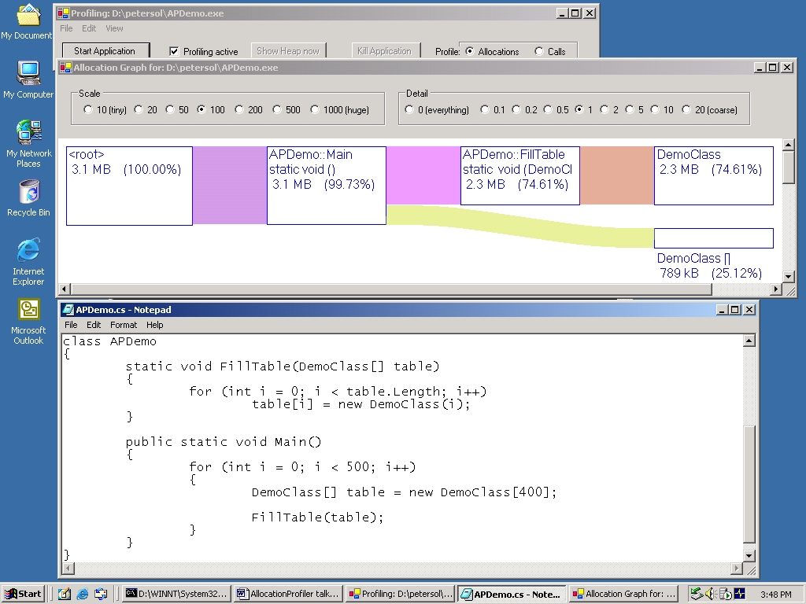

Let me explain a couple things about this graph:
- The height of the boxes and the width of the colored lines are proportional to the amount allocated. By default, we simply set 100% of allocations to 100 pixels, but you can change that.
- To the very left, the node called <root> is the total of all allocations in the app – 3.1 MB in this case.
- To the very right, you see how much memory was allocated for each type. In our case, there were 2.3 MB worth of Democlass instances, and 789 kB of DemoClass[] arrays.
- In between, you have the methods that allocated – basically a graph that symbolizes the call stack at allocation time. So for the DemoClass instances, we see they were all allocated by FillTable, which was called by Main.
- You can make the graph larger or smaller by using the Scale menu. This changes the number of pixels 100% is mapped to. Let me show you…
- You can show more detail by using the Detail menu. This changes the threshold in pixels below which details are suppressed. In this example, when I set the detail to 0.1, you see there’s one or more System.Object[] arrays allocated by the system, outside of Main – presumably on startup. If I click on 0 (Everything), the picture gets a whole lot more complex. For example, you see there was an OutOfMemoryException pre-allocated.

Histogram view on simple example
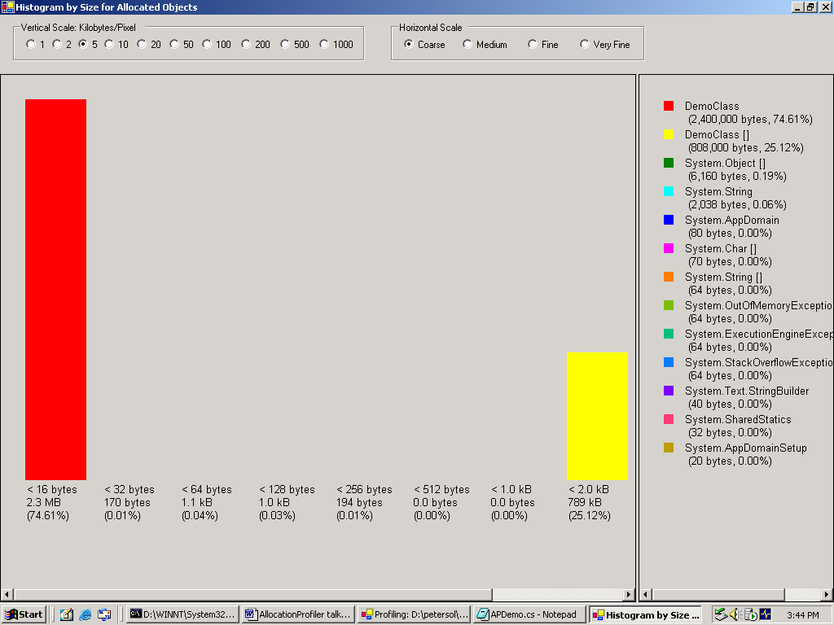
Sometimes you’re also interested in the size and count of objects of the various types, so for this purpose we have a histogram for the types allocated. Let me bring it up…

- So in the left hand pane you see there’s a large red bar which the right pane says is type DemoClass. If I scroll to the right, I also see a smaller yellow bar that is type DemoClass[] array.
- When I hover over a bar, there’s a tooltip giving more precise information – in this case, it tells me 200,000 instances were allocated, with a size of 12 bytes.
- I can change the vertical and horizontal scales with the groups of radio buttons at the top, but it’s not very interesting in this case.
- I can select a bar, and right click to obtain further information – for example, who allocated this.
- I can do the same in the right hand panel. Note also how the selected bar (or bars) become black, while the others are faded to highlight the selection.

There is also of histogram of relocated types, meaning the objects that the garbage collector relocated at one time or another. This looks just like the one we just looked at.
The purpose of this is to be able to find types that survive longer than they should, for example because they have finalizers.

Objects by address view on simple example
This gives you a pictorial representation of the heap at a certain point in time – in this case at the end of the program run.

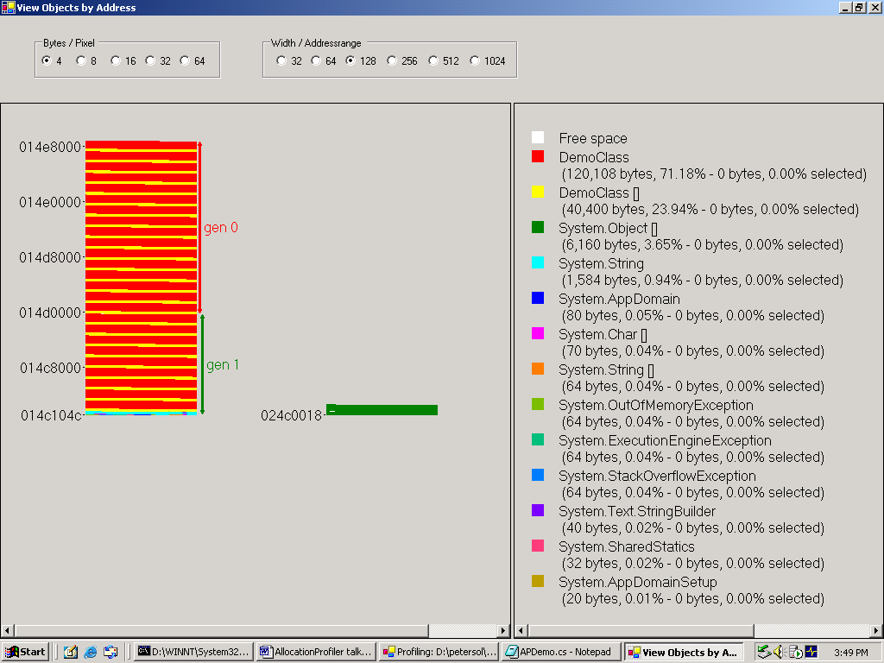
A couple of points about this view:
- There’s a vertical bar for each address range that corresponds to a gc heap. This is for the workstation build, so there a two – the normal heap and the large object heap.
- Within each bar, there’s one pixel for every n bytes of memory (in our case, every dword). The pixel gets a color that corresponds to the type. Again, in our case DemoClass is colored red, and DemoClass[] yellow.
- Thus each horizontal line in the display also corresponds to a certain amount of memory (4*128 = 512 bytes in our case), and for higher addresses we move up.
- There are labels for the addresses at the left side of each bar, and arrows for the gc generations at the right hand side.
- Hovering over a bar will give you information about the object sitting there, its address, its size and its age.
- You can select an address range and get statistics about what’s in it in the right hand pane.
- You can also drill down from a selected range and get who allocated the objects in it, or what the histogram of the sizes and types looks like.
- You can also click in the right hand pane, which selects a type, changing its color.
- By right clicking when you have both an address range and a type selected, you can again drill down and for example find out who allocated the objects of that type in the selected address region.

Histogram by age on simple example
There’s another kind of histogram, the histogram by age. You’ve seen that the address view also gives you ages of objects, but it’s hard to get the overall picture that way.
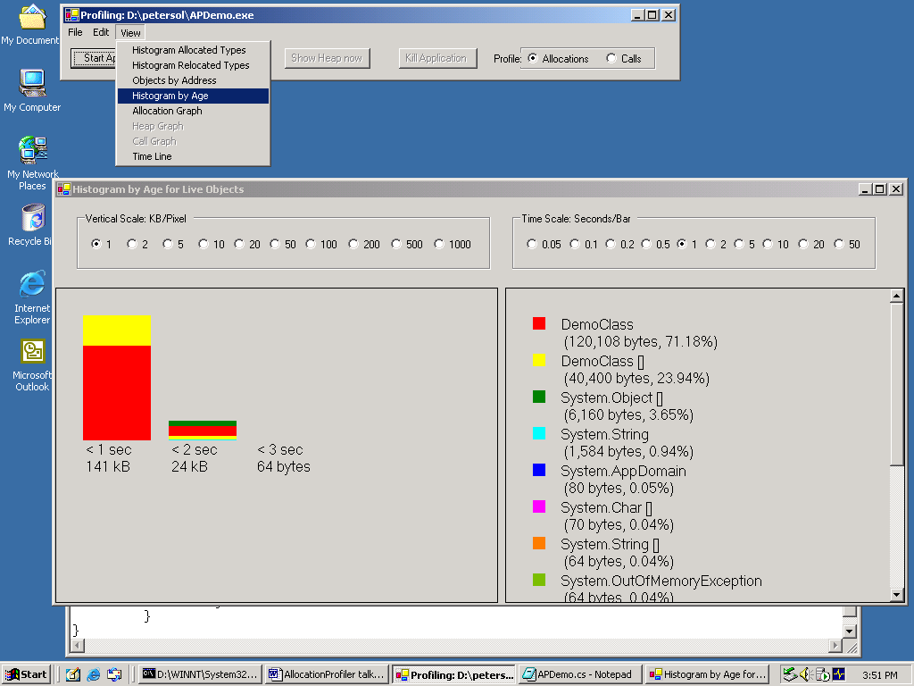
So by bringing up the age histogram we can see that most objects in this example are very young. Makes sense, because after each iteration in this example, we allocate a new array and forget about the old stuff.
Otherwise, this histogram view works pretty much like the others, so I won’t go into the details again.

Timeline view on simple example
Last but not least, there is a time line view that gives you easy access to temporal information.
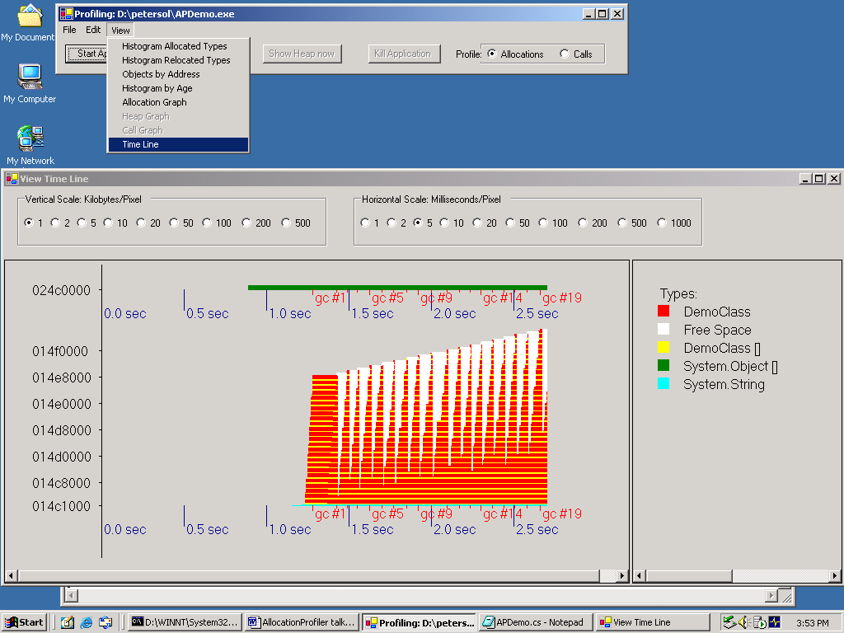
Let me explain a couple things about this view:
- For each address range that contains gc objects, there’s a separate chart. This corresponds to the separate vertical bars in the address view.
- The vertical axis is addresses, which are shown in hexadecimal on the left.
- The horizontal axis is time, which is shown at the bottom of each heap.
- If you move horizontally, you have the history of what objects lived at that address during the run.
- Moving vertically, you get what objects were alive at a given time.
- You also see markers for garbage collections. They all get a tick mark, but not all of them get a label for lack of screen space. The markers have different colors for different generation gc’s – generation 1 gc markers are green, generation 2 blue.
- As in the previous view, there’s a legend for the types in the right panel.
- Hovering over the graph gives you the type of the object at the spot you’re pointing at, its address, and the point in time at this spot, and the current heap size.
- You can select a certain point in time by just clicking on the graph. This gives you statistics about the heap at this instance in the right hand pane.
- Having selected a point in time, you can request additional information with a right click.
- You can also select a time interval. Then you get statistics about which types got allocated during that time interval, and you can again drill down.

Description of Allocation Profiler views on Terrarium
So now I’m going to show how to use all these views to gain insight about a real app – Terrarium available at http://www.gotdotnet.com/terrarium/

Use of Allocation Profiler on Terrarium
So let me select File/Profile Application… again, and the app I’m going to profile is terrarium.
So terrarium is starting up, and while I let it run for a little while, let me ask whether there are any questions about the first part?
So now I shut down terrarium, and AllocationProfiler loads the log file, which looks like it’s pretty large, so maybe there were a lot allocations.
Now we get the allocation graph – let’s scroll to the right – wow, that looks pretty complicated.
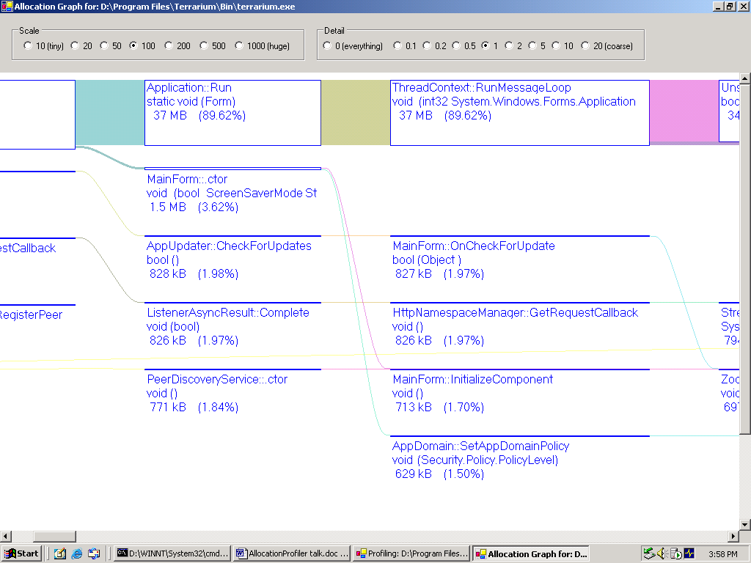
Well, on the right hand side we see that the objects allocated are mainly strings and OrganismState[] arrays.

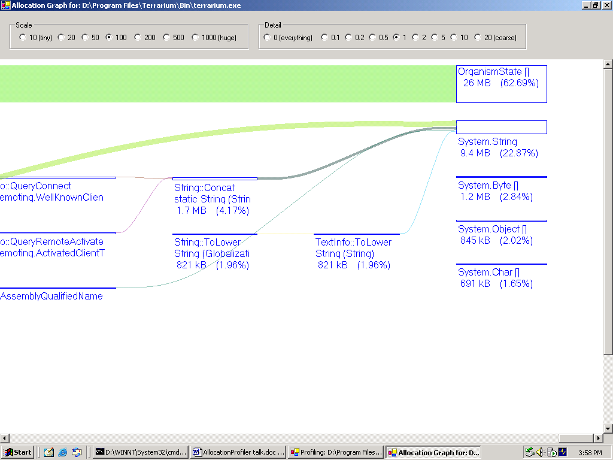
So let’s see whether we can see more interesting stuff in the other views.

Histogram view
Histogram Relocated Types shows the OrganismState[] thingies are also getting relocated frequently.
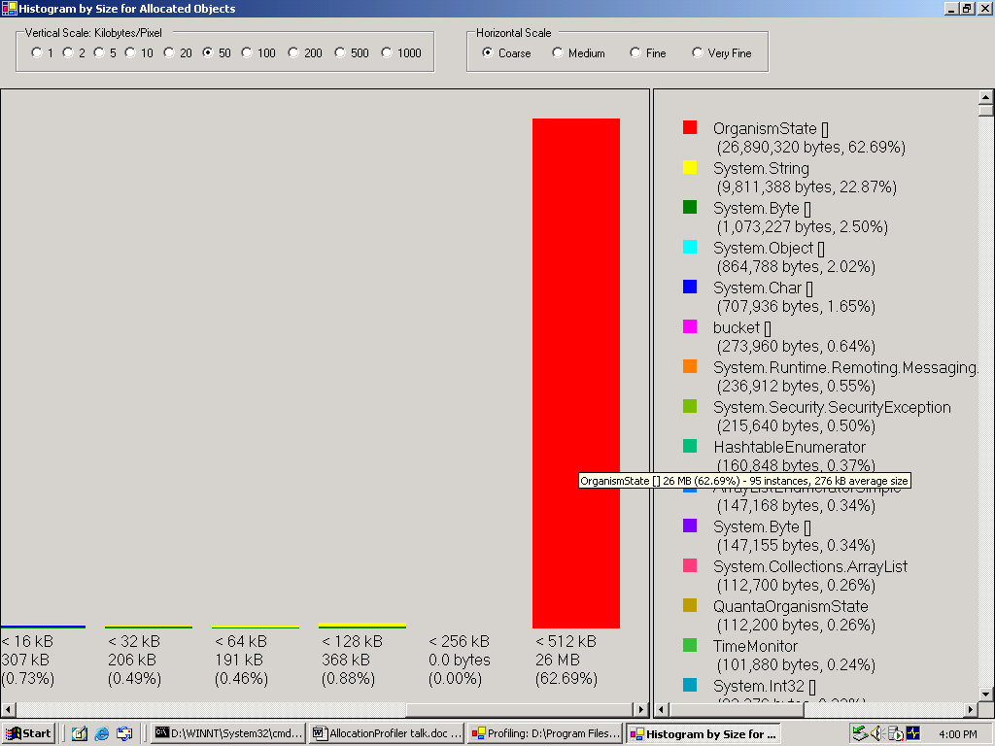
When we do View/Object by Address, we see the Large Object Heap (the bar on the right), is largely occupied by OrganismState[] arrays.
The normal heap on the left is mostly strings (shown in yellow).

Histogram by Age
In the Histogram by Age view, we see that there are mostly young and old objects. This good – otherwise we would suspect a memory leak.

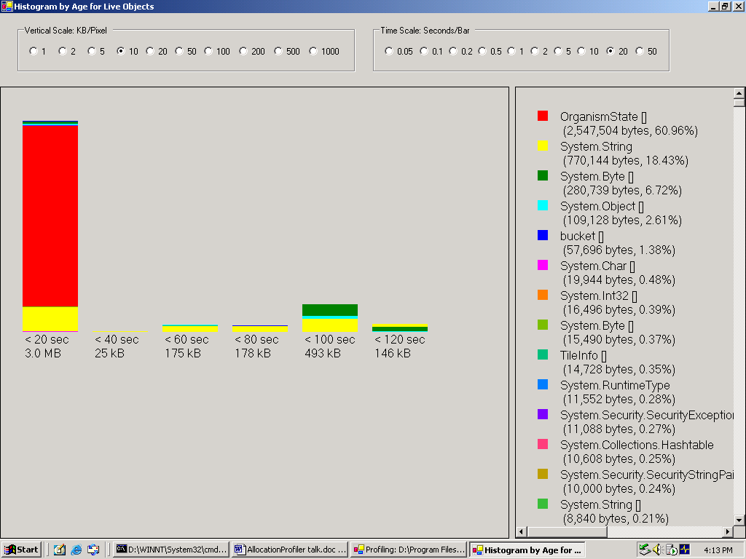

We also see OrganismState[] instances alive are all young. So we seem to have quite a bit of churn, because we saw lots are allocated, but few are live.

Timeline view
There are quite a few gc’s happening, so that means a lot is being allocated as the program runs.
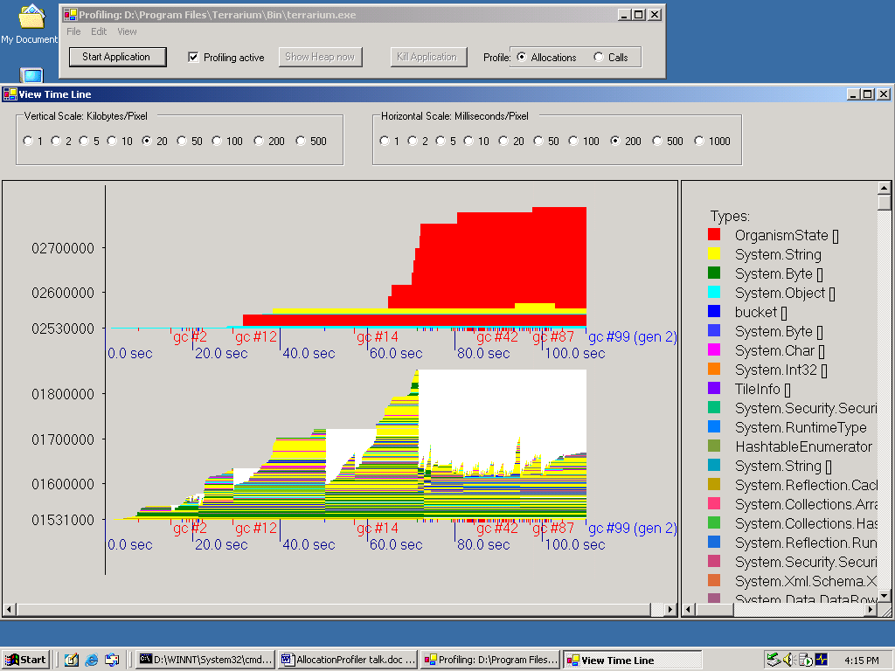
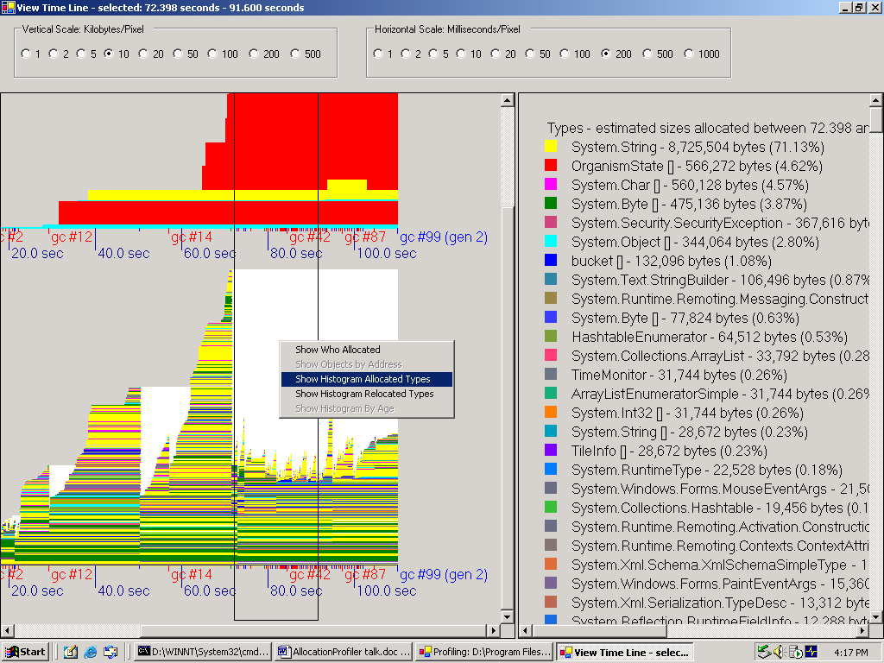
So let’s select an interval where it seems to have stabilized, and drill down to find out who allocates all this stuff.
Let’s go to the histogram again to see what got allocated.

Histogram View
Strings are near the top, let’s find out who allocated them.

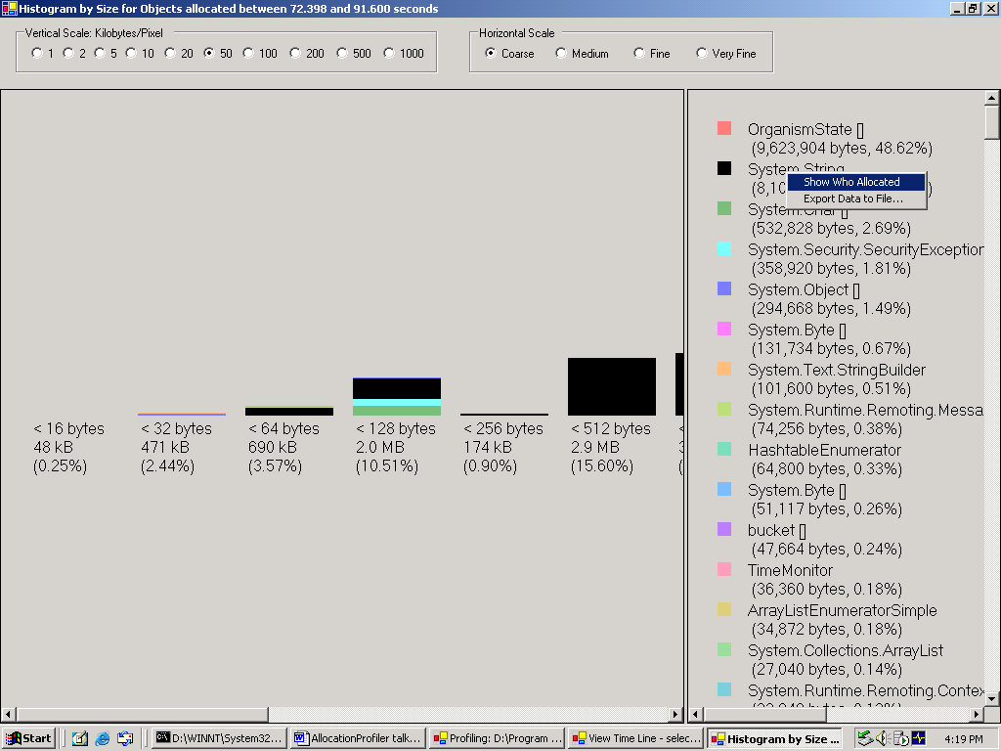
So we right click and select Show Who Allocated. Ok, so if we scroll to the right we see it’s this security function here that allocates most of it. Not directly, but by calling other security functions, and finally string.Format().
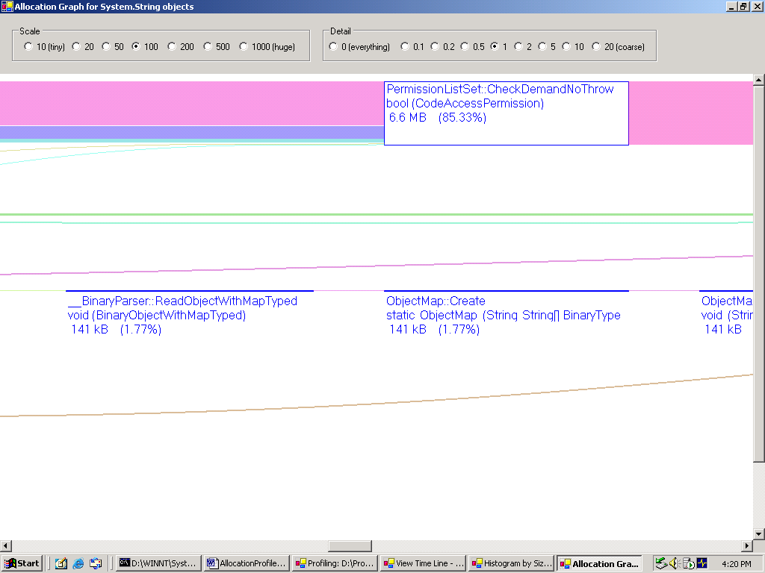
Ok, let’s go back to histogram and ask the same question for the OrganismState[] arrays.
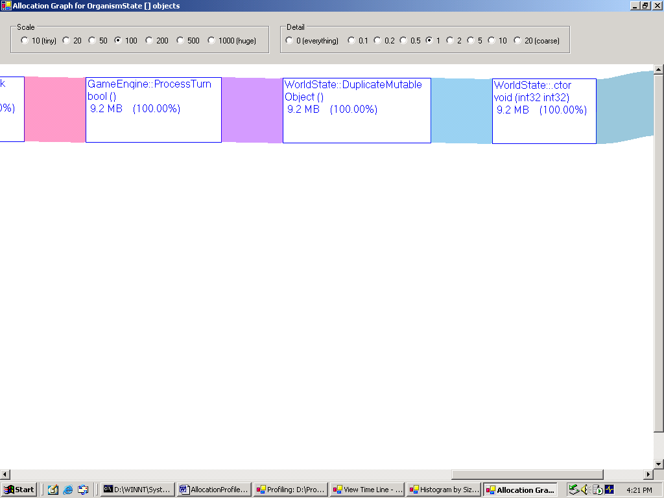

So here we see things GameEngine::ProcessTurn and WorldState::DuplicateMutable.
So the bottom line is if we wanted to trim down allocation for terrarium, we’d focus on the string allocations caused by the frequent security checks and the OrganismState[] allocations. And we know where these things are happening, so we can find them in the source code, I hope.

How to use Allocation Profiler on ASP.NET
Finally, I’m going to show you how to profile an ASP.NET application. I’ll show you how, but I won’t demo it in this presentation.

Initialization
First of all, select File/Profile ASP.NET. This will shut down IIS, inject some environment variables that we need for profiling, and then restart IIS.
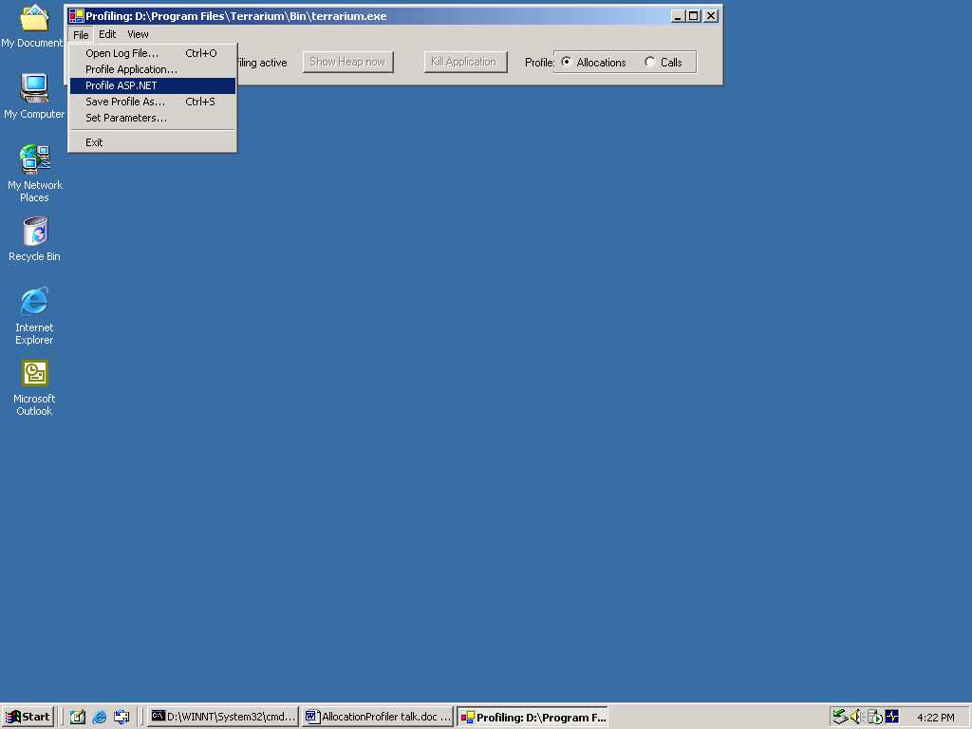
Then the AllocationProfiler waits for the ASP.NET worker process to start up. So you need to bring up your web page or exercise your app via homer or wcat or act or whatever.
When you’re done, you shut down IIS again by clicking on this button (it’s label will change to Kill ASP.NET). Which will shut down IIS, take out the environment variables, and restart IIS.
So here’s a log file that I obtained last week. It’s a 90 second run on an 8-way server, exercising a flavor of msnapp via homer.
This log file is about 100 MB in size, it corresponds to about 300 MB of allocations, so it takes a little while to load on this laptop.

Graph view
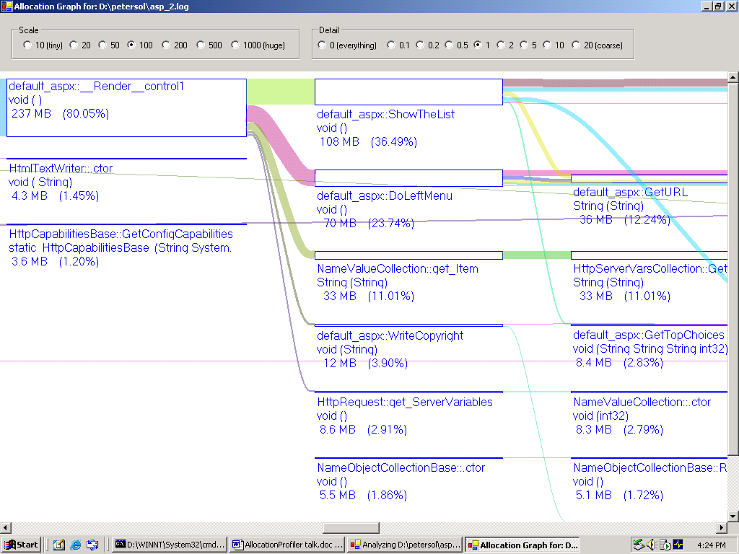

So let’s see – the allocation graph looks pretty simple in the beginning, but get’s rapidly more complex as we go to the right. As for the types allocated, the vast majority is strings.

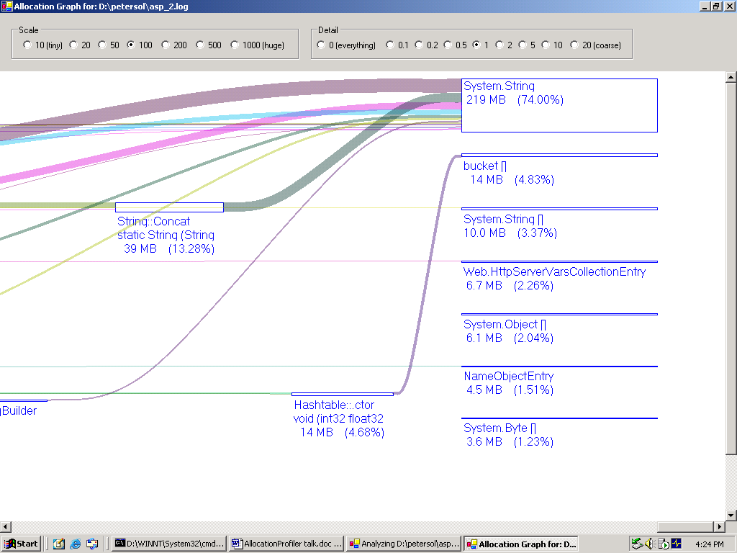
This is borne out by the histogram – there are lots of strings of lots of sizes.

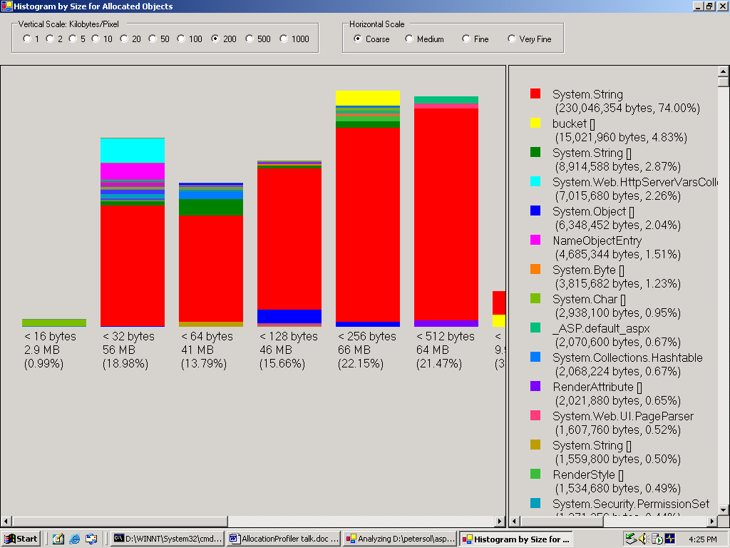
Histogram View
This is the histogram view of MSNApp allocations:

Objects by Address View
Now the Objects by Address view looks a lot different than before. This is because we’re now on the server build of the execution engine, where you have one heap per cpu, plus one large object heap. I said this was an 8-way server, and in fact, we see 9 vertical bars here.
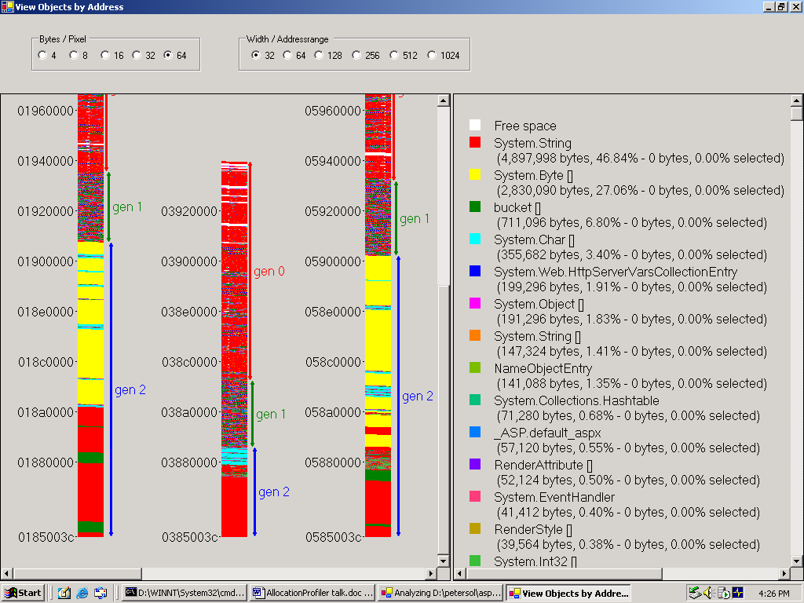
So let’s look at one of the heaps in more detail. Let me change the scales.
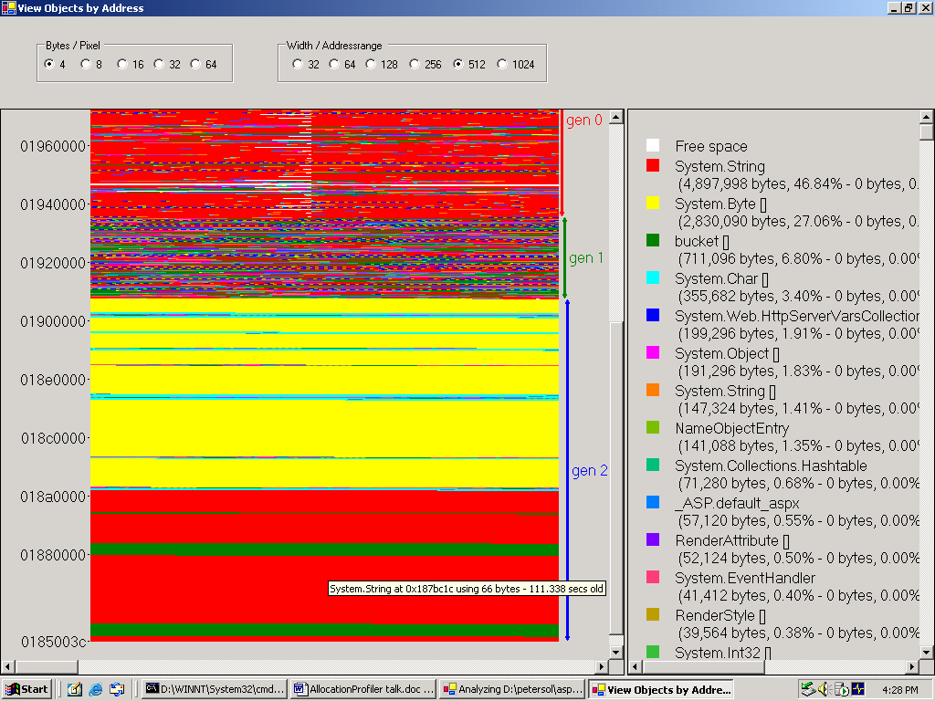
So it’s kind of an interesting archaeology that you can do here – at the bottom are strings and bucket[] arrays, then later we allocated lots of byte[] and char[] arrays – I believe they are used as buffers in ASP.NET, then the new objects are strings, bucket[] arrays and some string[] arrays.

Histogram by Age

If you switch to the Histogram by Age, you again see no middle aged objects – good.
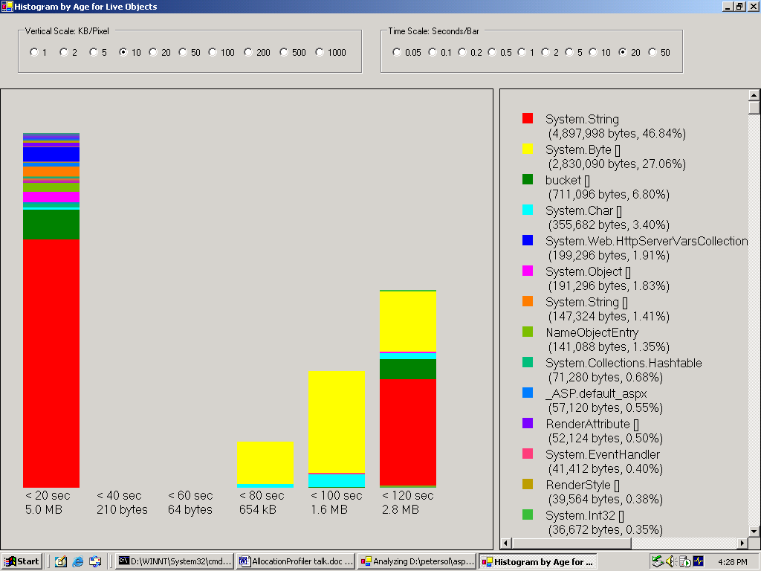

Timeline view
Why even the youngest objects are between 10 and 15 seconds old will become clear when we look at the time line.
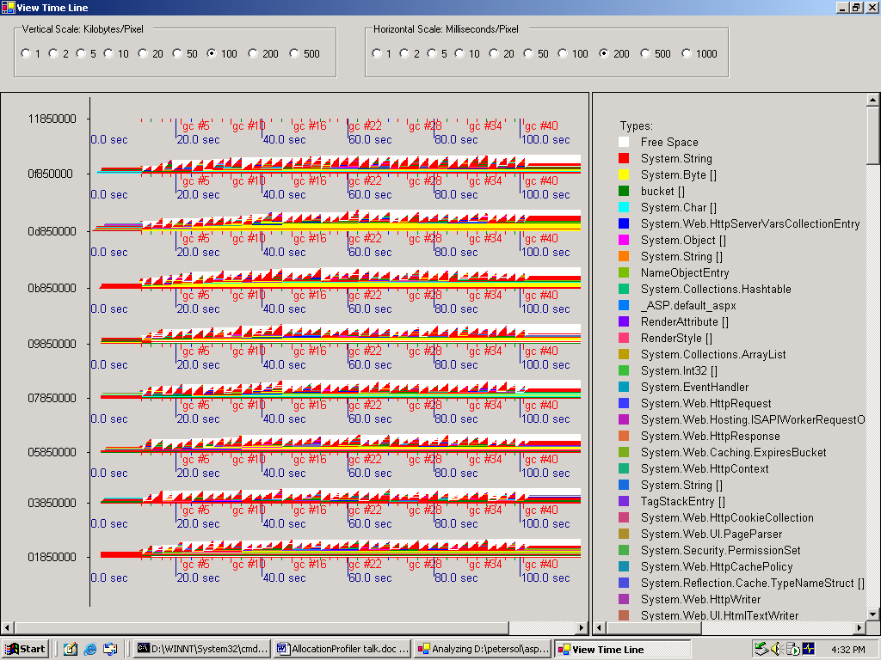

Let’s look at one in more detail. And now you see why there were no very young objects – we stopped exercising the web site about 10 seconds before the actual end of the run.

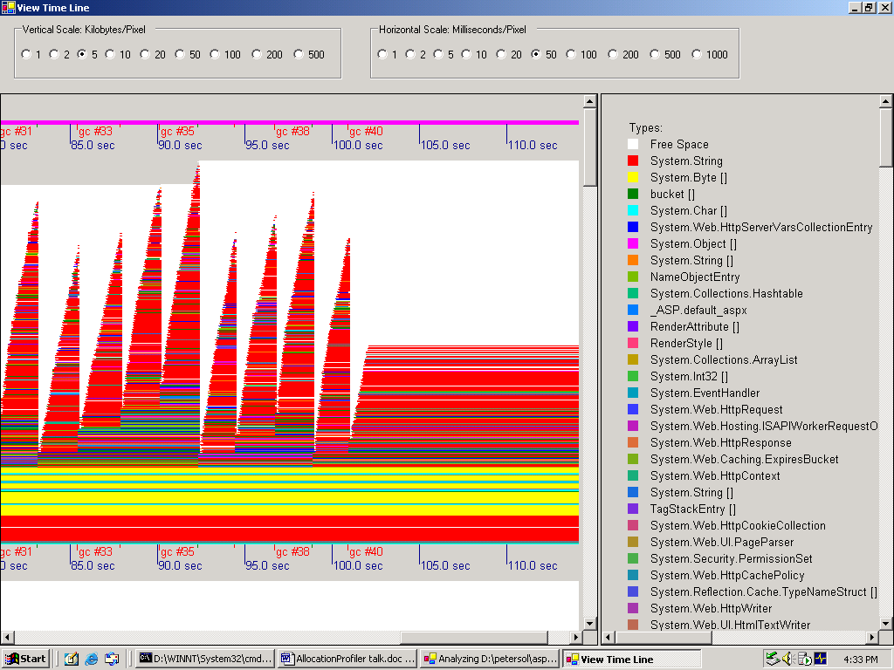

Note the characteristic double sawtooth pattern – we do a gen 0 gc pretty frequently, but some objects survive, so every three or four gc’s we do gen 1 to clean that up.

On the other hand, full gc’s (gen 2 gc’s) are very rare. Server scenarios are actually pretty well suited for garbage collection, because so little survives when a request is finished.

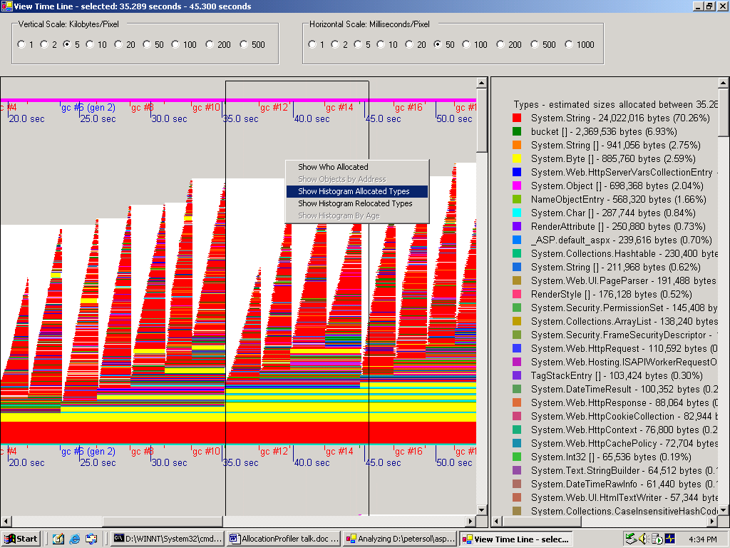

So now let’s again select a time interval and ask for the histogram of allocated types. Ok, 75% strings.

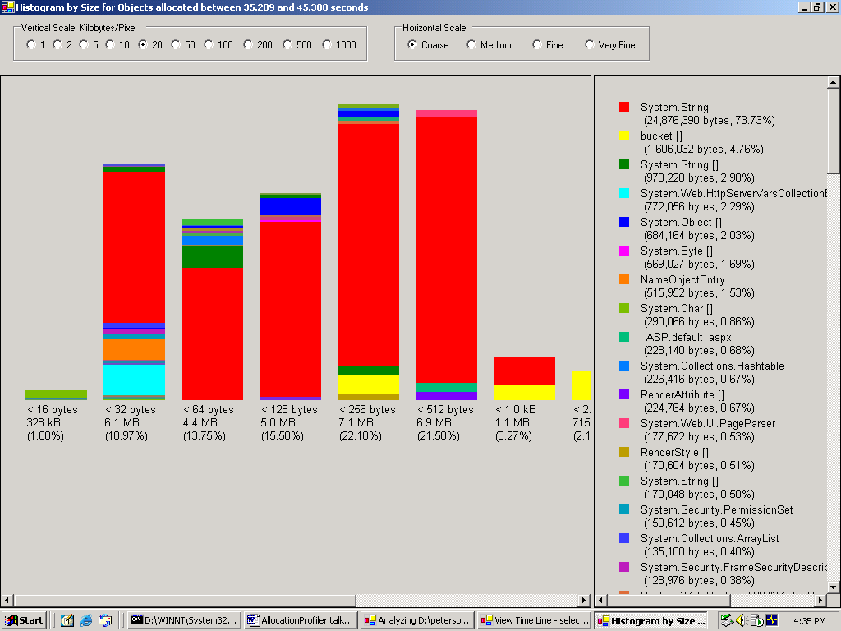

So now let’s find out who allocates them. Well the graph still looks pretty complicated, but in order to reduce the amount of allocations, that’s the bowl of spaghetti you’d have to dive into…

