Global XML Web Services Architecture

White Paper
October 2001

Introduction

Over the past five years, Microsoft has worked with other computing industry leaders to create and standardize a set of specifications for a new model of distributed computing called XML Web services. Already there are hundreds of customers deploying and running XML Web services and thousands more in the process of development. XML Web services standards, which include SOAP, XML, and WSDL, provide a high level of interoperability across platforms, programming languages and applications, enabling customers to solve integration problems easily.

But as XML Web services solutions become more global in reach and capacity – and therefore more sophisticated – it becomes increasingly important to provide additional capabilities to ensure global availability, reliability and security. Recognizing the need for standardizing these additional capabilities, Microsoft has released a new set of specifications that are the beginning of the Global XML Web Services Architecture. The aim of this architecture is to provide additional capabilities to baseline XML Web services specifications. The Global XML Web Services Architecture specifications are built on current XML Web services standards. Microsoft intends to work with key industry partners and standards bodies on these and other specifications important to XML Web services.

This paper outlines the state of XML Web services today. It demonstrates the need for a set of additional capabilities as companies deploy XML Web services to support increasingly sophisticated business processes. Finally, it addresses how Microsoft is beginning to address the need for additional capabilities with the Global XML Web Services Architecture and its supporting specifications.

XML Web Services Today

Companies are implementing XML Web services to integrate applications within the enterprise and to extend the reach of their businesses to partners and customers. This creates business efficiencies and exposes companies to new sources of revenue. Consider what the following companies are doing with XML Web services today:

Department Store Chain – Enterprise Application Integration
Background: The chain discovered that different credit approval applications had been developed in various parts of the company.
Solution: The chain exposed one credit approval application as an XML Web service. They linked this, in turn, to their point-of-sale, warehouse, and financial applications.
Business Benefits: The chain was able to expose the new credit approval application and use it with the three distinct applications operating around the company. As a result:
- Credit approvals became more consistent
- Maintenance costs decreased
- Billing back to departments became more efficient

Car Rental Company – Interoperability with Key Partner
Background: A major airline approached the car rental company about putting a link to the car reservation system on the airline’s Web site. Linking the two proprietary reservation systems presented an extreme challenge.
Solution: The car rental company created a translation engine for sending data between the two systems.
Business Benefits:
- Car rental company developed another large sales channel
- Solution got to market quickly

Some early-adopter companies are implementing next-generation XML Web services solutions that support more sophisticated business processes. The next snapshot is representative of such a service.

Insurance Company – Interoperability across Several Companies
Background: A large insurer needed to generate quotes for dental coverage and make them available on the intranet of one of their large corporate customers. The insurer had already used XML Web services to integrate its rating and quotes engine. But it had outsourced the maintenance of the dental providers’ directory and the credit rating service. These outsourced services were two vital elements for the generation of dental quotes and made the problem of their availability to clients non-trivial.
Solution: The insurance company, credit rating service, and dental provider orchestrated these applications to generate a quote that was requested by the customer on a corporate intranet.
Business Benefits: The insurance company considered this a transformational competitive advantage for the following reasons:
- It generated quotes in half the time of its competitors and provided them via a corporate intranet to one of its major customers.
- It automated existing business relationships at the level of multiple, interoperating applications. As a result, outsourcing became much more valuable, cutting the cost of quote generation by one third.
- It increased profitability in a thin-margin business.
- It provided a more seamless relationship with one of its biggest customers.

Because of application re-use and shortened time-to-market, companies can realize significant cost savings from taking an XML Web services approach to a solution. Through the integration of backend applications and key partner applications, companies are able to realize new efficiencies in the way they do business. Finally, by extending core functionality to partners, businesses are able to create new sales channels.

Trend toward Greater Sophistication
As with the adoption of any technology, XML Web services solutions are being developed to support increasingly sophisticated business processes. Apparent in the three examples above are three tiers of XML Web services development.

Tier 1 -- Enterprise Application Integration
More often than not, this is the beginning point for most companies. As in the first case study, companies initially use XML Web services to integrate internal applications. XML Web services allow them to expose legacy applications to business applications in heterogeneous environments without having to rewrite significant amounts of code.

Tier 2 – Interoperability with Key Partners
The next step for most companies is to integrate one or two key partners outside the company. Companies use XML Web services because they allow for interoperability between applications across the public Internet. Because of the lack of broadly-adopted specifications, companies must agree upon the technologies they will use to develop these interoperating XML Web services.

Tier 3 – Interoperability across Multiple Companies
Companies want to extend their computing out to more partners and customers to build business ecosystems like the one illustrated below.

Business Ecosystems

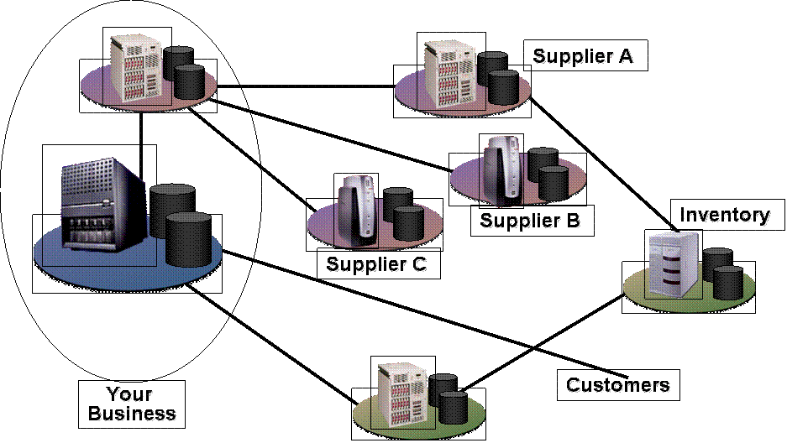

Business ecosystems take the benefits of the integration of systems within organizations and extend these capabilities outward to partners and customers. However, the lack of broadly-adopted specifications for security, routing and other necessary capabilities limits integration to those cases where bilateral, out-of-band agreements can be negotiated and maintained. So, to ensure secure, reliable cross-company interoperability, developers are forced to implement a series of ad hoc solutions.

A recent survey of CTOs in InfoWorld magazine called out interoperability across multiple companies as a significant benefit of XML Web services. These CTOs believe that a strong source of future business value is through business-to-business e-commerce and supply chain rationalization.

In what areas will XML Web services be most effective for your company?
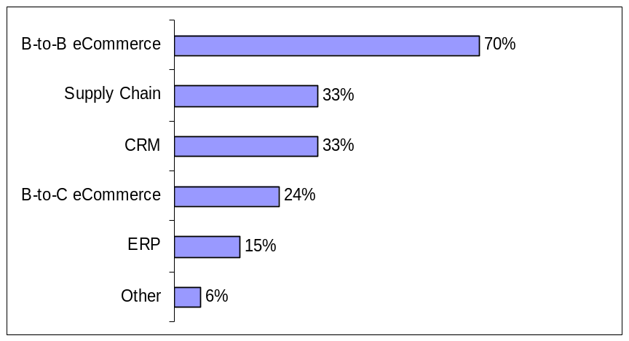
Source: InfoWorld
2001

Future Requirements for XML Web Services

As the business requirements that drive XML Web services become more complex, developers require additional capabilities not addressed by current XML Web services standards. These capabilities include the following:
- Security: This is the most common concern for companies implementing XML Web services solutions today. In business ecosystems, developers need an end-to-end security architecture that is straightforward to implement across companies and trust boundaries.
- Routing: Companies building XML Web services solutions are concerned about the scalability and fault-tolerance of the business ecosystems they are building. Developers need a way of specifying messaging paths and the ability to configure those message paths dynamically.
- Reliable Messaging: This is a key requirement for mission-critical applications. Developers need an end-to-end guarantee of message delivery across a range of semantics such as: at-least-once, at-most-once, and exactly once.
- Transactions: Business ecosystems require the ability to transact across companies. As a result, developers need flexible process and compensation-based transaction schemes.

Because there are no broadly-adopted specifications for security, routing, reliable messaging, and transactions, developers today either have to go without these capabilities or they develop ad-hoc solutions that they must resolve separately with each partner or customer.

Going without these capabilities can expose a company to risks and degrade the value of its XML Web services. Creating ad-hoc solutions is time consuming and expensive. In addition, ad-hoc solutions encroach upon a central value area of XML Web services – cross organizational interoperability. Thus there is a need to provide the additional capabilities required by more sophisticated XML Web services on a broader basis to unleash the full power and promise of XML Web services development.

The Global XML Web Services Architecture

The Global XML Web Services Architecture builds on today’s XML Web services baseline specifications of SOAP, WSDL, and UDDI. The overview of this architecture is shown in the graphic below.

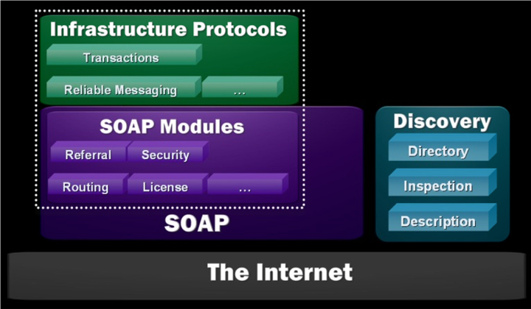

The Global XML Web Services Architecture is built on the Internet and the XML family of technologies. The architecture is divided into three conceptual layers: SOAP, SOAP modules, and infrastructure protocols.

SOAP is a lightweight, extensible, XML-based protocol for information exchange in a decentralized, distributed environment. Primarily, SOAP defines a framework for message structure and a message processing model. SOAP also defines a set of encoding rules for serializing data and a convention for making remote procedure calls. The SOAP extensibility model provides the foundation for a wide range of composable modules and protocols running over a variety of underlying protocols such as HTTP.

Microsoft designed SOAP to be extensible. SOAP modules leverage this extensibility to provide composable building blocks suitable for building the higher-level capabilities. Removed from the burden of specifying unnecessary capabilities, modules tend to be simple and focused.

Modules express elements of functionality that can be used individually or combined to achieve composite and higher-level results. The functions provided by the module are consistently available and consistently expressed. This generality, breadth and uniformity allow a wide range of services to take advantage of XML Web services-enabled network infrastructure such as routers, switches, proxies, caches, and firewalls.

Infrastructure protocols build on SOAP modules to provide end-to-end functionality. Protocols at this layer tend to have semantically-rich finite state machines as part of their definition. They maintain state across a sequence of messages and may aggregate the effect of many messages to achieve a higher-level result. Example infrastructure protocols include reliable messaging and transactions.

Global XML Web Services Architecture - Design Principles

The Global XML Web Services Architecture rests on four key design principles:

- Modular: Rather than define large, monolithic specifications that offer end-to-end functionality, this architecture is built on modular components. These can be composed into solutions to offer the exact set of features required by the problem at hand, neither omitting features nor burdening implementations with unnecessary ones. This building-block approach is a distinct advantage in creating an agile architecture. As new or extended features or capabilities are required, modular protocols can be created.

- General-Purpose: The Global XML Web Services Architecture is designed for a wide range of XML Web service scenarios, from B2B and EAI solutions to peer-to-peer applications and B2C services. Each module is uniformly expressed whether used individually or in combination with others, and is independent of any limited application domain.

- Federated: The Global XML Web Services Architecture does not require central servers or centralized administrative functions. The architecture enables communication across trust boundaries and autonomous entities. Neither the modules nor the protocols make any assumption about the implementation technology at the message endpoints. Any technology can be used; technologies can be transparently upgraded over time; services can be delegated or brought inside over time.

- Standards-Based: The Global XML Web Services Architecture builds entirely on the baseline XML Web services specifications SOAP, WSDL, and UDDI. Further, Microsoft is committed to working with industry partners to standardize future specifications critical for XML Web services interoperability.

Global XML Web Services Architecture – New Specifications

The following describes a set of new Global XML Web Services specifications made available in October 2001. These specifications represent a significant step toward a comprehensive Global XML Web Services Architecture.

The four specifications — WS-Security, WS-License, WS-Routing and WS-Referral — build on the SOAP family of Extensible Markup Language (XML) interoperability technologies. For the specifications themselves and more extensive technical background, please see http://msdn.microsoft.com/webservices.

Security
Organizations building and managing secure XML Web services need to ensure that only authorized parties are allowed to use the XML Web services and that the SOAP messages sent and received by the XML Web services can only be modified or viewed by appropriate parties. As discussed above, these secure XML Web services typically operate in heterogeneous environments that span multiple authentication technologies and trust domains; consequently the underlying XML Web service security protocols must be very flexible.

WS-Security describes how to use the existing W3C security specifications, XML Signature and XML Encryption, to ensure the integrity and confidentiality of SOAP messages. And together with WS-License, it describes how existing digital credentials and their associated trust semantics can be securely associated with SOAP messages. Together, these specifications form the bottom layer of a comprehensive modular security architecture for XML Web services. Future security specifications will build on these basic capabilities to provide mechanisms for credential exchange, trust management, revocation, and other higher-level capabilities.

The two initial security specifications provide the following capabilities:

- WS-Security is a simple, stateless, SOAP extension that describes how digital credentials should be placed within SOAP messages, and how these credentials should be associated with a message to ensure message integrity and confidentiality. WS-Security describes how message integrity is maintained even for SOAP messages that use the WS-Routing specifications described below. Using WS-Security, XML Web services can examine incoming SOAP messages and, based on an evaluation of the credentials, determine whether or not to process the request. WS-Security supports a wide range of digital credentials and technologies including both public key and symmetric key cryptography.

- WS-License describes how several common license formats, including X.509 certificates and Kerberos tickets, can be used as WS-Security credentials. WS-License includes extensibility mechanisms that enable new license formats to be easily incorporated into the specification.

Routing
As SOAP messaging evolves into a general-purpose Global XML Web Services Architecture there must be a means of addressing and transmitting SOAP messages over various types of communications systems. This enables a wide range of communication patterns such as peer-to-peer or store-and-forward networking. It also allows messages to be efficiently vectored to distributed processing nodes.

These features are supported by the following specifications:

- WS-Routing is a simple, stateless SOAP extension for sending SOAP messages in an asynchronous manner over a variety of communication transports such as TCP, UDP, HTTP. WS-Routing provides addressing mechanisms that enable specification of a complete message path for the message (including its return path). This enables one-way messaging, two-way messaging such as request/response, peer-to-peer conversations, and long running dialogs.

- WS-Referral is a simple SOAP extension that enables the routing between SOAP nodes on a message path to be dynamically configured. This configuration protocol enables SOAP nodes to efficiently delegate part or all of their processing responsibility to other SOAP nodes.

Because WS-Security, WS-License, WS-Routing, and WS-Referral are modular, they can be used together. For example, WS-Security describes how to digitally sign SOAP messages that use a WS-Routing header. Each of these specifications provides extension and composition mechanisms that enable future Global XML Web Services Architecture specifications to be incorporated into a complete solution.

Global XML Web Services Architecture - Roadmap

Interactions across organizations have many opportunities for failure ranging from transmission errors to incompatible or unavailable business processes. Reliable Messaging and Transactions allow the builders of XML Web services to manage the scope and effect of failures.

Reliable Messaging
XML Web services need to operate reliably over intranets and the public Internet, over transport protocols that are not completely reliable. Reliable messaging addresses issues arising from transmission errors. This SOAP-level reliable messaging protocol provides delivery guarantees isolating application processes from the detailed handling of transmission failure and its recovery, allowing a developer to concentrate on automating a process with a much-simplified error handling model. In the exchange of messages, individually or as part of a long-running process, communicating parties will be able to obtain end-to-end delivery guarantees so that messages will not be lost, duplicated or delivered in the wrong order.

Transactions
Transactions address the possibility of business-level inability to complete a process. Transactions allow multiple parties involved in a process to arrive at a consistent final outcome (or discover that this is not possible). Existing “two-phase” commit protocols are appropriate in some circumstances. Also needed are more loosely-coupled techniques, such as exceptions and compensation, which enable a broader range of transactions to be automated across trust boundaries. Developers will have powerful process-modeling languages to express the patterns of messages exchanged between XML Web services, the interactions of those messages, and the business processes they reflect, including both normal and exceptional conditions.

Reliable messaging and transactions represent important challenges that companies face today when developing advanced XML Web services across trust boundaries. The Global XML Web Services Architecture provides the flexibility to develop such additional capabilities and the structure to implement and deploy them.

Microsoft’s Commitment to Standards and the Standards Process

As it has done in the past, Microsoft will continue to drive specifications from the research lab to the developer. As specifications are developed, they are released to the public for review. Customers and partners may provide input, building consensus and validating the applicability of the specifications. When the specifications have matured, the next step in their evolution is introduction to the standardization process. Microsoft works with partners to drive interoperability in XML Web services specifications across products.

Microsoft’s commitment to the standards is supported by a history of participation in the standards process. In 1996, Microsoft co-authored the first draft of XML. In 1999, Microsoft and its partners presented SOAP to the IETF. In March 2001, WSDL was submitted to the W3C by IBM and Microsoft. Microsoft is a member of the industry initiative developing UDDI. This strong commitment carries through the specifications underlying the Global XML Web Services Architecture and is similar to other efforts we have taken with specifications behind XML Web services.

Summary

As the business requirements that drive XML Web services become more complex, the architecture for XML Web services requires additional capabilities to handle the increasingly complex nature of XML Web services solutions. Recognizing this emerging need for additional capabilities, Microsoft has released a new set of specifications that are the beginning of the Global XML Web Services Architecture. The aim of this architecture is to provide additional capabilities to current XML Web services standards. Microsoft intends to work with key industry partners and standards bodies on these and other specifications important to XML Web services.

The information contained in this document represents the current view of Microsoft Corporation on the issues discussed as of the date of publication. Because Microsoft must respond to changing market conditions, it should not be interpreted to be a commitment on the part of Microsoft, and Microsoft cannot guarantee the accuracy of any information presented after the date of publication.
This White Paper is for informational purposes only. MICROSOFT MAKES NO WARRANTIES, EXPRESS OR IMPLIED, AS TO THE INFORMATION IN THIS DOCUMENT.
Complying with all applicable copyright laws is the responsibility of the user. Without limiting the rights under copyright, no part of this document may be reproduced, stored in or introduced into a retrieval system, or transmitted in any form or by any means (electronic, mechanical, photocopying, recording, or otherwise), or for any purpose, without the express written permission of Microsoft Corporation.
Microsoft may have patents, patent applications, trademarks, copyrights, or other intellectual property rights covering subject matter in this document. Except as expressly provided in any written license agreement from Microsoft, the furnishing of this document does not give you any license to these patents, trademarks, copyrights, or other intellectual property.
© 2001 Microsoft Corporation. All rights reserved.
Microsoft and InfoWorld are either registered trademarks or trademarks of Microsoft Corporation in the United States and/or other countries.
The names of actual companies and products mentioned herein may be the trademarks of their respective owners.

