How to Debug Script Code Using Visual Studio .NET

By
Monica Rosculet
mkoller@microsoft.com
Visual C# Debugger QA Team

Introduction 1
Setting up your machine for script debugging 1
Who can do script debugging? 2
Client side script debugging 2
What is client side script? 2
How to debug it? 3
Client-side script inside .aspx pages in a web application 4
Server side script debugging 4
What is server side script? 4
If the page is not inside a web application 5
If the page is part of a web application project 6
If the page is part of a web application project created on a remote machine 6
Using JIT Debugging for Script 7
Debugging Both Script and Managed Code 8
Troubleshooting 8
“Application debugging is disabled” in the Running Documents window 9
There is no “Script” option for attaching to the script host 9
The JIT Dialog doesn’t come up 10
Can’t Hit Breakpoints in Client-side code in a Web Form 10
Your Web Application is created at a Non-Default Port 10
Random weird debugging failures 10

Introduction

While trying to help the internal and external customers that are posting questions on the newsgroups I have noticed that a lot of them have problems with debugging client side script code or classic ASP server side script code. Hence I summarized in this document the possible scenarios in which a user could debug script code and some troubleshooting tips that might help in case the user encounters a problem.

This document covers:
- Client side script debugging
- Server side script debugging
- Troubleshooting

Setting up your machine for script debugging

The first thing you need to do before being able to debug script code on your machine is enable this feature in Internet Explorer. To do this, go to Tools | Internet Options and on the Advanced tab make sure that the Disable script debugging box is unchecked.

!!! Note: Unchecking the Disable script debugging box might open some security vulnerabilities.

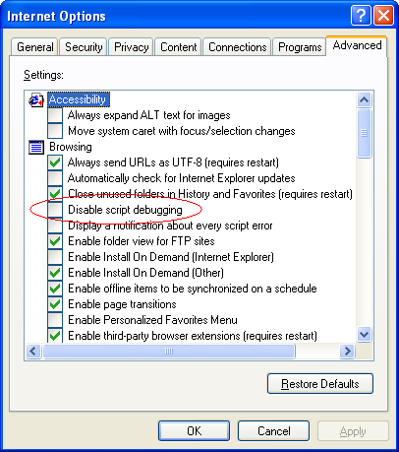

Who can do script debugging?

In order to be able to debug script code running on your machine you need to be a member of the Debugger Users group. If the owner of the process the script is running in is a different user than you, you will have to be an administrator on the machine to be able to debug it. Also, the user account that the script host is running as needs to be a member of the Debugger Users group or of the Administrators group.

Client side script debugging

What is client side script?

By client side script code we mean any VB script or JScript code that is loaded by client application running on your local machine. For example, such code could be embedded inside a .html, .asp or .aspx page loaded in Internet Explorer or could reside inside a .js or .vbs file loaded into wscript.exe, cscript.exe or some other script host.

How to debug it?

To debug such code:

- Run your script code by loading it inside Internet Explorer or the script host of your choice.
- Attach to the script host specifying Script as the program to be debugged:

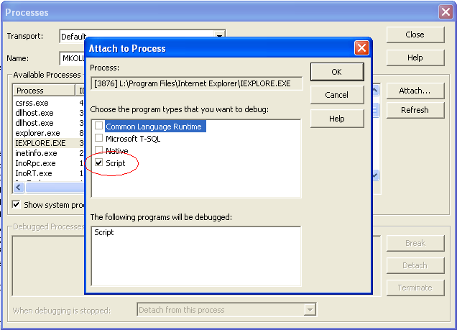

- Open the Debug | Windows | Running Documents window. There you will see all the files containing client side script code that are loaded into the script host that you are attached to.
- In the Running Documents window double-click on the file containing the code you want to debug. That file will be opened and you will be able to set breakpoints in it that will be hit when the code will be executed.
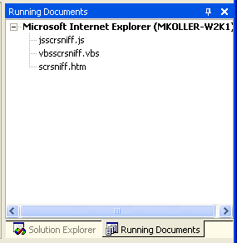

!!! Note: Don’t open the file using the File | Open | File command because breakpoints set this way will not be hit. This is a very common mistake that users do.

If your script code resides in a .js or .vbs file that will be run inside wscript.exe or cscript.exe, make sure that you specify the /D or /X switch in order to enable debugging:

wscript.exe myscript.vbs /D

Client-side script inside .aspx pages in a web application

If your client side script is embedded in an .aspx page that’s part of a web application, all you will have to do in order to debug it is to F5 the web application project so the debugger will be attached automatically to Internet Explorer and then to open the .aspx page from the Running Documents window and set breakpoints in it that will be hit the next time you refresh the page.

Server side script debugging

What is server side script?

By server-side script we mean any VBScript or JScript code embedded in a classic .ASP or .ASA page between the <script runat=server></script> or <%%> tags. Such code will be run on the server where the page is located inside a script worker process like mtx.exe, inetinfo.exe, dllhost.exe or w3wp.exe depending on the OS and on the settings inside IIS. Depending on whether the page containing the server-side script is part of a web application project or not, there are some settings that need to be changed in order to be able to debug it.

If the page is not inside a web application

Then it is under a virtual directory inside IIS. In order to debug it, you have to configure that virtual directory so that ASP debugging will be enabled for it.
This is what you need to do for this:

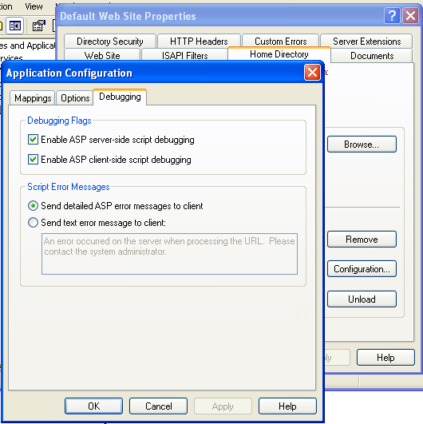

- Open IIS Manager
- Open the properties window for the directory under which your page is located.
- Go to the Directory tab and push the Configuration button.
- Go to the Debugging tab and check the Enable ASP server-side and client-side script debugging boxes.
- Reset IIS so that the setting will be applied.

After this change, load your page and attach to the ASP worker process having the Script option checked inside the Attach to Process dialog box. Again, you will have to use the Debug | Windows | Running Documents window for opening the page containing the code you need to debug. You will have to be an administrator in order to be able to attach to the ASP worker process in this case.

If the page is part of a web application project

Then all you need to do is make sure that ASP debugging is enabled in the Properties pages for that project:

- Open the Project Properties window for the project.
- Go to the Configuration Properties node and open the Debugging page.
- Set Enable ASP debugging to true.

This is true for both C# and VB web applications.
After this, make sure that your page is set as a start-up page for your application. Next time you will hit F5 to debug your application, you will be prompted to enter a user-name and password of a user with rights to configure IIS on that machine. Such a user needs to be an administrator. After you provide this information, the VS.NET debugger will attach automatically to the ASP worker process and you will be able to debug your script code.

Note: Unless you really need it enabled, it’s good to disable ASP.NET debugging in the Project Properties window in this case. This way the debugger will not have to attach to the ASP.NET worker process in the same time.

If the page is part of a web application project created on a remote machine
Then simply doing F5 to debug your server-side script will not do the trick. You will have to apply the following work-around on the machine where the web application is located:
With the Visual Studio .NET debugger, you can debug an ASP Web application on the local machine or a remote server. For remote debugging to work properly, there are some prerequisite steps to perform:
- First, the Visual Studio .NET Remote Debugging Components must be installed on the server you want to debug (if not the whole Visual Studio .NET product).
- You must be a Debugger User on the remote server.
- Using regedit.exe, you must set these two registry keys on the remote machine:
- [HKEY_LOCAL_MACHINE\SOFTWARE\Classes\AppID\{6EB22881-8A19-11D0-81B6-00A0C9231C29}]
- @="Catalog Class"
- "DllSurrogate"=""

- [HKEY_LOCAL_MACHINE\SOFTWARE\Classes\CLSID\{6EB22881-8A19-11D0-81B6-00A0C9231C29}]
- @="Catalog Class"
"AppID"="{6EB22881-8A19-11D0-81B6-00A0C9231C29}"
- Finally, you must configure DCOM permissions on the Web server.
To configure DCOM permissions on the Web server
- From the Start menu, choose Run.
- In the Run dialog box, type dcomcnfg.exe and click OK.
- In the Distributed COM Configuration Properties dialog box, on the Applications tab, select Catalog Class and click Properties.
- In the Catalog Class Properties dialog box, choose the Security tab.
- Select Use custom access permissions, and then click Edit.
- Add the users that you want to give debugging permission to by granting them Allow Access rights (or add the Administrators group to this list).
- Click OK.
- Select Use custom launch permissions, and then click Edit.
- Add the users that you want to give debugging permission to by granting them Allow Launch rights (or add the Administrators group to this list).
- Click OK.
- On the Identity tab, select The interactive user.
- Click Apply, and then click OK to close the Catalog Class Properties dialog box.
- Click OK to close the Distributed COM Configuration Properties dialog box.
After this, the next time you use F5 to start debugging the remote application you will see the dialog for entering your credentials and everything should work as in the local case.

Using JIT Debugging for Script

Whenever there is a run-time error generated by your code (like an unhandled exception, syntax error etc) you will have the chance to use the JIT (Just-in-Time) mechanism to attach to the running process and to see where did the error occur. You will see a dialog telling you that an error occurred and asking you if you want to debug. If you choose Yes, the JIT dialog will come up.
There is not much difference between JITting client and server side script except that in the case of server side script the JIT dialog will come up on the machine where the server-side code is running. In order to JIT debug script code you need the same privileges as for regular script debugging (Debugger users can debug script code running in processes that they own and administrators can debug any script code running on that machine).

Debugging Both Script and Managed Code

If your script code calls into a managed DLL you will be able to debug both of them at the same time if you attach to the script host in both Script and Common Language Runtime modes. For this, all you need to do is select both of these in the Attach to Process dialog:

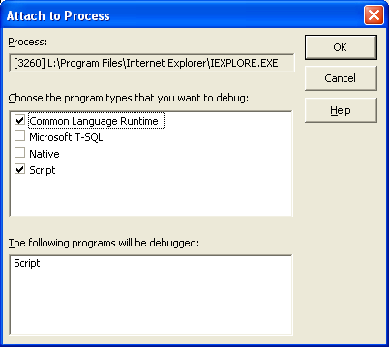
After this, you will be able to step into and hit breakpoints inside the managed dll and to see a merged call stack showing both script and managed frames.
Note: You will not be able to debug both script and native code at the same time. This feature is not supported.

Troubleshooting

I am going to list here the most common problems the users run into when debugging script and give some possible ways to fix these problems. Again, most of these problems were brought up on the newsgroups by our customers. Thanks to Gregg Miskelly and to M. K. Park for finding solutions to most of these problems.

“Application debugging is disabled” in the Running Documents window

If you are trying to debug server-side script and you see such a message in the Running Documents window, it means that you forgot to enable ASP debugging in IIS for the virtual directory there your page is located (see the “If the page is not inside a web application” section).

There is no “Script” option for attaching to the script host

If in the Processes window there is no “Script” option in the Type column for the script host you are trying to attach, there might be several possible causes for this:
- If you are trying to debug client-side script, did you remember to enable script debugging on your machine (see the “Setting up your machine for script debugging” section in the beginning of this document)?
- If you are trying to debug server-side script, is the user account the script host is running under (dllhost.exe, inetinfo.exe, mtx.exe, w3wp.exe) a member of the Debugger Users group? This is a common scenario when the user installed IIS after installing VS.NET. Adding the IWAM_MachineName account to the Debugger Users group usually solves this problem.
- pdm.dll or scriptle2.dll might not be correctly registered on your machine. First make sure there’s just one copy of each of these dll’s on your machine and then use regsvr32.exe to register them.
- Make sure that you have the default DCOM permissions on your machine. For this, you can check if the HKLM/Software/Microsoft/Ole/DefaultAccessPermission registry key exists on your machine and if it does, just delete or rename it. This will restore the default settings. If you made any intentional change to the DCOM Access permissions and you don’t want the default to be restored, just add the Local System and the user who is running the script host process to the DCOM Access permissions. To do this:
  - Run dcomcnfg.exe
  - Go to Component Services | Computers | My Computer and open the Properties dialog for My Computer.
  - Go to the Default COM Security tab and edit the Default Access permissions. Add the System account and the account of the user the script host is running as.
Note: Editing the default DCOM permission on your machine affect any DCOM applications running on it. Make sure that you trust the users you are adding to the Default Access permissions, otherwise this could open a security hole.
Also, it is recommended that you don’t modify the default settings on the Default Properties tab either.

The JIT Dialog doesn’t come up
Make sure that JIT debugging is enabled in VS.Net. Go to Tools | Options | Debugging | Just-In-Time and make sure that Script is checked there.

Can’t Hit Breakpoints in Client-side code in a Web Form

Are you attached to Internet Explorer and did you open the .aspx page from the Running Documents window? If so, you might want to check the “There is no “Script” option for attaching to the script host” section above.

Your Web Application is created at a Non-Default Port

If your ASP page is in a web application that was created at a different port than the default port 80 and you enable ASP debugging for your project, you will not be able to F5 the application. This is a known issue and the only work-around is to use the default port 80.

Random weird debugging failures

If while you are debugging client side script in Internet Explorer you are encountering different random debugging failures like discrepancies between the source code and the location where the execution is stopped while stepping, some breakpoints not being hit all the time or if you’re getting an unexpected error message saying that we that the debugger cannot show source code for the location where execution is stopped, this is another known issue. It is due to a timing bug in Internet Explorer 6. One possible work around could be to have all your script code in one block, although this could not be applicable or convenient all the time.

