Nile Benchmark Kit:
Benchmarking IBM® Websphere® 4.0 vs. Microsoft® .NET

October 21, 2001

Contents
Contents 1
Abstract 2
Introduction 3
Websphere 4.0 Versions of Nile 3
The NileJSP Application 3
The NileEJB Application 4
Enterprise Java Beans (EJB) 4
Tuning the Code 6
Tuning WebSphere 8
Output Caching 8
Summary of Nile Websphere 4.0 Design 9
The Nile .NET Implementation 9
Tuning Nile .NET 9
Running a Benchmark to Test IBM Websphere 4.0 vs. Microsoft .NET 10
Things to Keep in Mind When Configuring the Benchmark Hardware 10

Abstract
The Nile @Bench benchmark is a complete end-to-end ecommerce application server benchmark that has been widely used by independent testing laboratories including Doculabs®, eWeek®, and PC Magazine® to benchmark application server products. Now that the .NET wave has begun, we wanted to use this same application to enable customers to benchmark the performance and scalability of ASP.NET vs. IBM® Websphere® 4.0 using this complete data-driven Web application. The Nile application is a useful benchmark because it is simple and straightforward, yet exercises the common elements found in most real Web applications including:

- 90% Data-driven pages
- Use of scripting and components on the server for business and data logic
- Ad-hoc database searching and browsing
- Database transactions (product orders, new customer accounts)
- User authentication/login
- Realistic dataset (1 million customer records, 2 million product records)
- Session state (shopping cart)
- Dynamic page output caching

We do not actually present any benchmark results in this paper, since we are prevented from doing so based on the IBM Websphere 4.0 license agreement. We hope that IBM Websphere 4.0 customers will undertake their own technical evaluation and perform this benchmark on their own. However, see the paper Microsoft .NET vs. Sun Microsystem’s J2EE: The Nile Ecommerce Application Server Benchmark
at http://www.gotdotnet.com/compare to examine complete .NET test results for this benchmark on a variety of hardware configurations. Customers can download the complete and fully optimized IBM Websphere 4.0 Nile source code and the .NET source code at http://www.gotdotnet.com/compare. The IBM Websphere 4.0 version of Nile was created by an independent firm and developed and tuned for performance and scalability according to IBM Websphere published best practices.

This article describes the design decisions and the techniques used in implementing a J2EE version of Nile, the online bookstore multi-tiered Web application, using IBM’s WebSphere® Application Server 4.0.

Introduction
This article discusses the implementation decisions that were made when creating the Nile application with JSP and Java EJB technology using IBM WebSphere Application Server (WAS). It also discusses the .NET implementation of Nile, and how to conduct your own comparative benchmarks.

Websphere 4.0 Versions of Nile
WebSphere 4.0 leverages the Java 2 Platform Enterprise Edition (J2EE), which defines a set of standards for designing and developing enterprise applications. J2EE provides a set of core services that include:
- JavaServer Pages (JSPs)
- Java Servlets
- Java Database Connectivity (JDBC)
- Java Message Service (JMS)
- Java Transaction Service (JTS)
- Java Naming and Directory Interface (JNDI)

Two versions of the Nile application, NileJSP and NileEJB were implemented following the J2EE paradigm and design model. Both versions were designed to work with Oracle 8i.

The NileJSP Application
NileJSP is a pure JSP application, which uses JDBC to connect to an Oracle database. IBM’s HTTP Server was used to process the incoming requests by forwarding the requests for JSP pages to the WebSphere Application Server. Before the JSP pages are executed, however, they are converted to Servlets. A Servlet is server-based Java program that accepts input data from an HTTP GET or PUT, and then creates HTML as output. The Servlet is then compiled into bytecode (a .class file) which is then executed by WebSphere’s Servlet Engine. The JSP pages use JDBC directly to execute stored procedures and to retrieve the returned data back to the user.

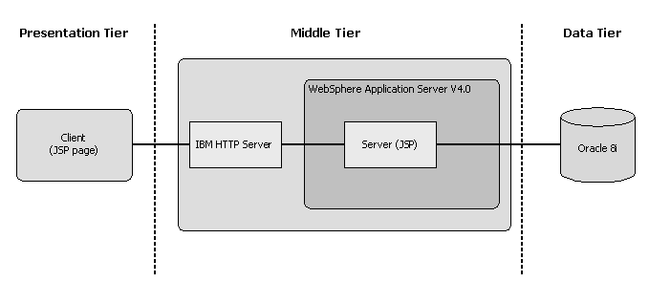

The NileEJB Application
NileEJB extends NileJSP to make use of middle-tier components called Enterprise Java Beans (EJBs). All of the business logic for the application is encapsulated in these middle-tier components and the JSP pages make pass through calls to the middle-tier, which subsequently make the appropriate database stored procedure calls via JDBC.
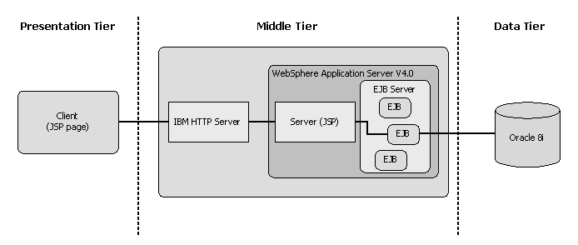

Enterprise Java Beans (EJB)
A brief overview of how EJB works is necessary to understand the design and performance decisions that were made within the Nile application. There are two types of EJBS, Session Beans and Entity Beans:
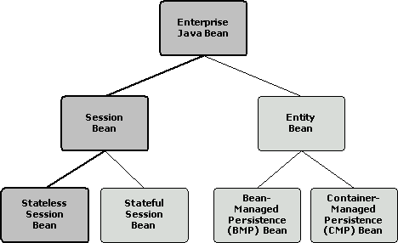
The NileEJB application makes use of Stateless Session Beans for the fastest performance, leveraging stored procedures within a relational database (see S. M. Saracco’s IBM article entitled “Leveraging DBMS Stored Procedures Through Enterprise JavaBeans”). Stateless session beans only have two states as shown in the figure below:
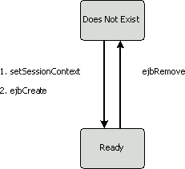
When a client application needs to interact with an instance of an enterprise bean, it never actually invokes the method directly. Instead, the client’s invocation is intercepted by the EJB Container or Server and is then delegated to the bean instance. The delegation is executed through the EJB object that is implemented by the container. The following summarizes how an Enterprise Java Bean is invoked:
- A client uses JNDI to access the naming service to retrieve a home object reference for the requested Enterprise Java Bean.
- The Home object, which exposes a home interface, is an object factory that is responsible for instantiating and destroying EJB objects.
- Using the home interface, the client requests the home object to create the EJB object.
- The home object then returns the EJB object reference back to the client.
The following diagram illustrates how a typical EJB client (in this case a JSP page) would interact with an EJB.
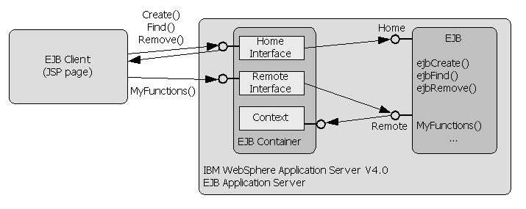
By using the remote interface that an EJB object implements, the client can invoke business methods that are exposed by the enterprise bean through the EJB object delegation process.

Tuning the Code
The Nile application relies heavily on data access, roughly 90% of the Nile application is dynamic and requires database access. The biggest performance boasts were achieved by using WebSphere’s Data Sources, which provided access to database connection pooling. When accessing database it is important to minimize the number of connections made where possible, this is particularly true for Oracle. Using a data source you can open a database connection once and then reuse it for different requests.
Another recommendation it to use prepared statements where possible as this reduces the amount of string concatenation that is required during statement preparation.
In addition, caching the context as shown below reduced the Data Source JNDI access:
// database credentials
private final String JDBC_JNDI = "jdbc/Nile";
private final String USERNAME = "nile";
private final String PASSWORD = "nile";
private final String DS_VAR = "nileDS";

// store data source in an application variable
private DataSource dsNile = null;

/**
* getDataSouce is used to minimize JNDI lookup. We store
* the DataSource in an application variable.
*/
public DataSource getDataSource(ServletContext app)
{
DataSource ds = null;
try
{
// get data source if exist
ds = (DataSource) app.getAttribute(DS_VAR);
if (ds == null)
{
// create once when the servlet engine is started
InitialContext ctx = new InitialContext();
ds = (DataSource) ctx.lookup(JDBC_JNDI);
app.setAttribute(DS_VAR, ds);
}
}
catch (Exception e)
{
System.out.println("Error getDataSource: " + e.toString());
}
return ds;
}
Significant performance gains are possible by minimizing the number of JNDI lookups.
We also found it necessary to tune the following JavaServer Page Directives:
- Page Buffers: <%@page buffer="16kb" %>
- Sessions: <%@page session="false" %>
- Threading: <%@page isThreadSafe="true" %>
The use of Strings in Java also requires very careful consideration. Whenever we are appending strings together we rely on the StringBuffer class to avoid unnecessary object creation and deletion. For example:
String Buffer strBuffer = new StringBuffer("");
strBuffer.append("One");
. . .
strBuffer.append("Two");
String str = strBuffer.toString();
There are also considerations when converting a string to an integer as shown below:
int I = Integer.parseInt("12345");

Tuning WebSphere
There are many parameters that control the performance of WebSphere. These include the number of threads in the web container and how these are apportioned in the internal HTTP transport, JVM Heap sizes, ORB configuration, the number of database connections allocated in a Data Source and the use of WebSphere’s proprietary servlet caching technology. Typically you will also need to tune the HTTP server that feeds the requests into WebSphere. You can connect directly to the WebSphere internal HTTP transport, however IBM does not recommend this. There are many variables involved in tuning the WebSphere application server and quite often small numbers are better than large ones. An example of this is in the configuration of connections in a data source. Quite often it is better to open a small number of connections than to try to make the system manage large numbers of connections as data sources can consume large amounts of memory.

Output Caching
IBM Websphere 4.0 supports dynamic page output caching. We encourage customers to benchmark Websphere using output caching and not using output caching to get an idea of the performance in each case. The Nile search results page and the specials page are ideal for caching, as their content does not need to be updated on every request. A section of the file, servletcache.xml, is shown below to demonstrate how the caching works within WebSphere for the search page.
…
<servlet>
<timeout seconds="6000" />
<path uri="/NileEJB/browseresult.jsp" />
<request>
<parameter id="Page" data_id="Page" />
<parameter id="subjectID" data_id="subjectID" />
<parameter id="txtTitle" data_id="txtTitle" />
<parameter id="txtAuthor" data_id="txtAuthor" />
<parameter id="txtSubject" data_id="txtSubject" />
</request>
</servlet>
…
With this file and caching turned on in the Administrator’s console, every request for the page /NileEJB/browseresult.jsp will be initially be passed to the caching engine. The caching engine will search the cache with a key passed on all the parameters listed for the request. If the engine finds a matching key in the request then the response will be served from the cache, otherwise the request will be forwarded to the servlet engine.
The use of the servlet cache can drastically improve the performance of applications, especially if there are several pages where the content doesn’t change rapidly. In the case of Nile we decided to cache all product based pages.

Summary of Nile Websphere 4.0 Design
The design of both NileJSP and NileEJB followed the best practices for accessing stored procedures using J2EE model. In addition to writing tuned code and fully tuning the database for the queries executed, it is also very important to properly setup and tune the IBM WebSphere Application Server and IBM HTTP Server. There are many parameters in tuning WebSphere and many of the parameters are inter related, so it is important to understand the implications of changing each parameter.

The Nile .NET Implementation
The .NET implementation of Nile was created for use with SQL Server 2000. This implementation uses ASP.NET Web Forms with inline C# code calling into a middle tier .NET assembly component also implemented using C#. We use the new managed SQL Server provider (System.Data.SqlClient) to communicate with the database using ADO.NET Datareaders. The programming logic mirrors that for Websphere 4.0. The Nile .NET code can be downloaded from http://www.gotdotnet.com/compare.

Tuning Nile .NET
Nile .NET requires very little tuning. In running benchmarks in our lab, we changed machine.config as follows:

Set Authentication to none
Set EnableViewState to false
Turned off session state (since we track in the database using custom code, as in the Websphere implementation)

You can also test the application both in-process and out-of-process by toggling “EnableProcessModel= true/false.”

Running a Benchmark to Test IBM Websphere 4.0 vs. Microsoft .NET
To run the benchmark, you will need at least an evaluation version of Websphere 4.0, available from the IBM Website, and a copy of the latest release of Microsoft .NET Framework, available from msdn.microsoft.com. We suggest running with the PDC build of the .NET framework based on optimizations made over the Beta 2 release.

You can create your own test scripts and use the free Microsoft Web stress tool (also available on msdn.microsoft.com), or you can use a commercial load testing product. We recommend either Impirix e-Load or Quest Software’s Benchmark Factory. Benchmark Factory comes with a precompiled set of scripts for Nile, so you do not even have to create test scripts. Both the Websphere 4.0 implementations and the .NET implementations will work with Benchmark Factory. You will need to make sure to get a copy of the latest cwadnile_internet.dll from Benchmark Factory and set the benchmark properties to “Enable Form Values By Name” for it to properly work with .ASPX files. If not using Benchmark Factory, make sure to create realistic workloads that randomize simulated user inputs.

For data showing our complete benchmark results for the .NET version of Nile (as well as ASP/COM+ and ISAPI versions of Nile), see the paper titled Microsoft .NET vs.
Sun Microsystem’s J2EE: The Nile Ecommerce Application Server Benchmark, available at http://www.gotdotnet.com/compare. This paper also illustrates a useful test lab configuration for performing the load test. A simple load test will not require such an elaborate setup, however.

Things to Keep in Mind When Configuring the Benchmark Hardware
Make sure that you have sufficient database hardware to ensure that the benchmark is not bottlenecked by the database. Both the provided Oracle schema and the SQL Server 2000 schema are highly tuned with proper indexes. However, if the database horsepower is too low relative to the middle tier hardware horsepower, you will not be performing a valid middle tier comparison. Monitor database CPU utilization during testing to ensure it does not exceed 60-70% and start to become the bottleneck. Also make sure you test the .NET and Websphere versions on the same hardware, or very similarly configured hardware. For example, if testing Websphere 4.0 on AIX using a 4-CPU machine, compare results to .NET running on a 4-CPU Intel-based machine with similar CPU clock speeds and with the same amount of RAM and same NICs. If you are running on very high-end equipment, ensure that the network does not become the bottleneck by running on a gigabit backbone with multiple NICs and clients separated onto separate subnets. This should not be a concern unless your pages/sec reaches into the >4K range. A final caveat is to make sure that you have enough clients to ensure that the clients do not become the bottleneck in the testing. Some benchmark software has higher client resource requirements than other software, so make sure to monitor the client CPU and memory utilization. Otherwise, the test will actually not be putting full load on the servers. Also make sure to understand the implications of running with and without think times. Think times of 5-15 seconds per page may make your tests more realistic. However, running with no think time is a great way to really put stress on a server while running less virtual users. Also, make sure you have some way to monitor the validity of the pages being served by the server. It may look like a product is doing great returning 2,000 pgs/sec on a 1-CPU server…until you discover that every page is coming back with an http 404 (file not found) or other error! Many benchmark programs check the response for valid HTML…however be careful that enabling client-side validation does not impair the ability of the client to put true load on the system (monitor client resources carefully).

The information contained in this document represents the current view of Microsoft Corporation on the issues discussed as of the date of publication. Because Microsoft must respond to changing market conditions, it should not be interpreted to be a commitment on the part of Microsoft, and Microsoft cannot guarantee the accuracy of any information presented after the date of publication.

This White Paper is for informational purposes only. MICROSOFT MAKES NO WARRANTIES, EXPRESS OR IMPLIED, AS TO THE INFORMATION IN THIS DOCUMENT.

Complying with all applicable copyright laws is the responsibility of the user. Without limiting the rights under copyright, no part of this document may be reproduced, stored in or introduced into a retrieval system, or transmitted in any form or by any means (electronic, mechanical, photocopying, recording, or otherwise), or for any purpose, without the express written permission of Microsoft Corporation.

Microsoft may have patents, patent applications, trademarks, copyrights, or other intellectual property rights covering subject matter in this document. Except as expressly provided in any written license agreement from Microsoft, the furnishing of this document does not give you any license to these patents, trademarks, copyrights, or other intellectual property.

© 2001 Microsoft Corporation. All rights reserved.

Microsoft, Visual Basic, Visual Studio.Net, Visual C++ and Windows are either registered trademarks or trademarks of Microsoft Corporation in the United States and/or other countries.

The names of actual companies and products mentioned herein may be the trademarks of their respective owners.

The most recent use of Nile was in a PC Magazine benchmark that appears in the May, 2001 issue of the publication. While IBM states in documents published on their Web site that Websphere 4.0 demonstrated the best performance of all the J2EE products in this published review, PC Magazine did not test or evaluate Microsoft .NET in the review—instead testing just the Microsoft ASP/COM+ technology (since Microsoft .NET was still in beta testing at the time). With this kit, we provide a .NET version of Nile, as well as the full source code and tuning guidelines to a Websphere 4.0 version of Nile that we believe is more optimized and higher performance than that tested by PC Magazine. The Websphere J2EE implementation tested here was implemented using JSPs (implementation 1) and JSPs calling stateless session beans (implementation 2) with optimized logic over the PC Magazine version to remove unnecessary database calls, clean up database and business logic, and use Oracle procompiled stored procedures as opposed to static SQL statements. Most importantly, the versions contained in this kit follow IBM best practice guidelines, while the PC Magazine version used EJB container managed persistence as a coding convenience at the expense of performance.

