Microsoft® .NET vs.
Sun® Microsystem’s J2EETM:
The Nile Ecommerce Application Server Benchmark

October 21, 2001

Contents

Contents 1
Abstract 2
Introduction 3
The Nile Application 4
The Test Platform 5
The Microsoft .NET Implementation 6
The ASP/COM+ Implementation 6
The ISAPI/ATL Server Implementation 6
The J2EE Java Server Pages Version 7
The J2EE Enterprise Java Beans Version 7
The Tests 8
The Results 9
No Output Cache Results 12
Conclusions 14
Appendix 1: Nile Benchmark Source Code Downloads 15

Abstract
This paper presents the results of a comprehensive performance benchmark of Web application development technologies based on the Doculabs®-developed Nile @Bench benchmark. Specifically, we discuss the results of benchmarking the Nile application as implemented in Microsoft .NET using C# vs. the latest version of a leading J2EE-based application server product from a top-tier ISV. The paper also presents detailed performance information comparing the performance of the Nile application as implemented in Microsoft Active Server Pages with Visual Basic® 6.0 COM+ components, and Microsoft ISAPI using Visual C++® 7.0 ATL Server technology. The information includes benchmark results as measured by Quest® Software’s Benchmark FactoryTM load testing tool in a large-scale performance lab. The data is presented as throughput metrics measured in pages served per second across varying user loads running on 2, 4 and 8-CPU middle-tier application servers against a separate, dedicated 8-CPU backend database server. The results directly compare ASP.NET performance on Microsoft Windows® 2000 Advanced Server to the performance of the J2EE application server on the latest release of Linux, version 7.1, on the same hardware.

The paper includes Web URLs to the downloadable source code for the ASP.NET, ASP and ATL Server version of the applications tested. The intent is to present all the information and code necessary for customers to perform their own valid performance and scalability test of Microsoft .NET vs. J2EE-based application servers.

Introduction
The Nile @Bench benchmark is a complete end-to-end ecommerce application server benchmark that has been widely used by independent testing laboratories including Doculabs, eWeek®, and PC Magazine® to benchmark application server products. Now that the .NET wave has begun, we wanted to use this same application to benchmark the performance and scalability of ASP.NET for a typical data-driven Web application. The Nile application is a useful benchmark because it is simple and straightforward, yet exercises the common elements found in most real Web applications including:

- 90% Data-driven pages
- Use of scripting and components on the server for business and data logic
- Ad-hoc database searching and browsing
- Database transactions (product orders, new customer accounts)
- User authentication/login
- Realistic dataset (1 million customer records, 2 million product records)
- Session state (shopping cart)
- Dynamic page output caching

In this article, we present the benchmark results for the following implementations of the Nile benchmark application:

- ASP.NET written in C# (W2K)
- ASP and VB6 COM+ (W2K)
- ISAPI/ATL Server C++ (W2K)
- JSP, optimized J2EE-based version running in a leading Java Application Server (Linux 7.1)
- EJB, optimized J2EE-based version running in a leading Java Application Server (Linux 7.1)

The Nile Application
The Nile application is a simple Web-based application. All benchmark applications are typically simple applications meant to test the ability of the underlying technical infrastructure to handle the load placed on real-world applications. Real applications are much more complex, of course, and would typically incorporate communication with internal legacy systems and much more sophisticated logic than you will find in Nile. Yet Nile does serve a purpose; it highlights how well an application server can handle the rote tasks of database communication, dynamic page generation, and transactions. These are the bread-and-butter tasks of any application server product.

Functionally, the Nile application is based loosely on the TPC-W, which is an emerging standard from the Transaction Processing Performance Council (TPC) for e-commerce benchmarks (see http://www.tpc.org/tpcw/). The Nile application is a simple online bookstore application meant to highlight the use of an application server for product catalogs, ad hoc product searches, product browsing, customer account management, shopping carts, and order transactions. Of all the pages exercised in the Nile test scripts, 90 percent are dynamically generated from database content. State is managed on the data tier, with a single cookie used to map client sessions back to their individual shopping carts. Finally, tight security is not a consideration in this application. All users come over anonymously with no data encryption. In a real-world application, the customer account page and the transaction page would certainly use https. All implementations are coded in the same fashion to maintain fairness in the testing, so that no implementation has better programming logic that would allow it to perform faster than the other applications.

The Test Platform
The test platform consisted of the following hardware:
- One Compaq® ProLiantTM 8500 database (eight 550 megahertz (MHz) Intel® Pentium® III processors with 2 megabyte (MB) L2 cache, three gigabytes (GB) of RAM)
- One Compaq ProLiant 8500 Web/application server (with two, four and eight 550 MHz Pentium III processors with 2 MB L2 cache, 2 gigabytes RAM). The server was configured with 2 separate gigabit network cards to handle client load.
- Cisco® gigabit network backbone. 50 clients each separated onto two separate subnets.
- 100 Dell Computer® client workstations to generate load (1-CPU 500 MHz with 128 MB RAM), running Windows 2000 Server and the Quest Software Benchmark Factory 2.5 load-test software.
- One Benchmark Factory Controller to administer the testing, collect and analyze the results.

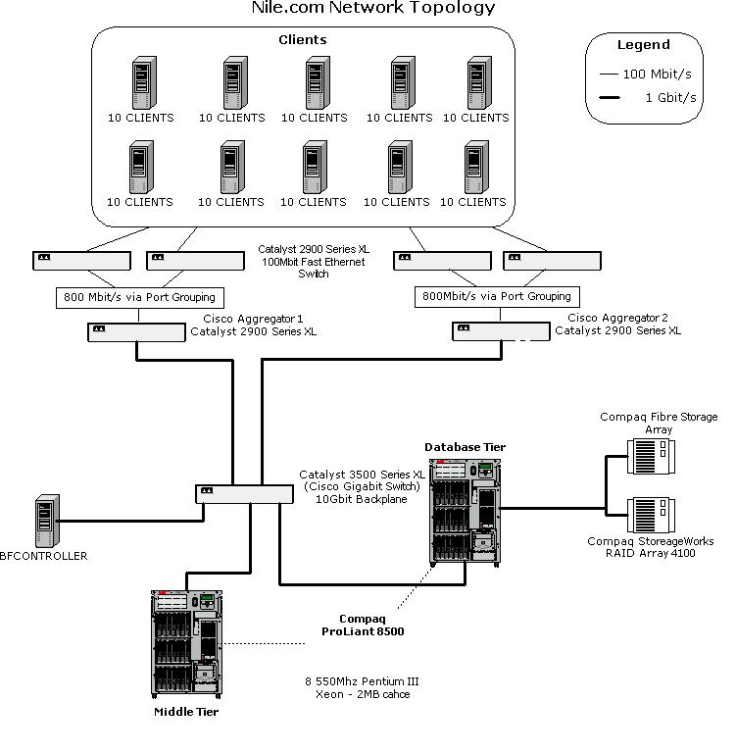
The Nile Benchmark Testing Hardware and Network
<P><A HREF="Nile2dotNET1.gif" target="_Top"><IMG SRC="Nile2dotNET1thumb.gif" ALT="Figure 1. Nile.com Network Topology. Click here to see larger image." BORDER=0></A></P>

The Microsoft .NET Implementation
The .NET implementation uses ASP.NET with inline C# code in Web Forms with middle-tier component logic isolated into a separate .NET assembly. The implementation uses an ADO.NET DataReader (as opposed to a DataSet) for optimal performance. This version uses the new .NET Managed Provider for SQL Server for data access (the System.Data.SqlClient class library). This C# implementation has the following additional characteristics:
- A logical three-tier implementation using .NET.
- ASP .NET pages activate .NET middle-tier components written in C#.
- Session state stored in the database.
- A cookie stores a client sessionID.
- ADO .NET DataReaders are used for all database logic.
- The performance impact of using ASP .NET dynamic output caching is illustrated as the mainline configuration, with the output cache turned off as a secondary configuration.
- Proper database coding techniques are used; database indexes are highly tuned and SPROCs are used for all SQL Server data access.

The ASP/COM+ Implementation
This implementation uses ASP (VBScript) pages to activate COM+ components written in Visual Basic 6.0. It has the following additional characteristics:
- A logical three-tier implementation.
- ASP pages activate COM+ middle-tier components written in VB6.
- ADO/OLE DB used for data access within COM+ components.
- Session state stored in the database.
- A cookie stores a client sessionID.
- ADO disconnected recordsets are used for all database logic.
- No output caching used since ASP does not natively support this feature.
- Proper database coding techniques are used; database indexes are highly tuned and SPROCs are used for all SQL Server data access.

The ISAPI/ATL Server Implementation
This implementation uses C++ to implement Nile as a high-performance ISAPI application. It has the following additional characteristics:
- C++ 7.0 ATL Server used to implement the application.
- OLE DB used for data access to SQL Server 2000.

- Session state stored in the database.
- A cookie stores a client sessionID.
- Implements dynamic output caching as the mainline configuration, with the output cache turned off as a secondary configuration.
- Proper database coding techniques are used; database indexes are highly tuned and SPROCs are used for all SQL Server data access.

The J2EE Java Server Pages Version
This implementation uses JSP pages in the form of precompiled servlets running within the latest version (as of 10/21/2001) of a leading J2EE-based application server. The implementation was created and tuned by an independent ISV expert with the J2EE product, and developed according to the precise vendor-published guidelines for building highly performant applications. It was implemented against one of the recommended, widely used RDBMS database packages the application server supports, using the recommended thin JDBC driver for this database. It has the following additional characteristics:
- Java Server Pages used to implement the application logic via precompiled servlets.
- Session state stored in the database.
- A cookie stores a client sessionID.
- Implements dynamic output caching as the mainline configuration, with the output cache turned off as a secondary configuration.
- Proper database coding techniques are used; database indexes are highly tuned and SPROCs are used for data access.

The J2EE Enterprise Java Beans Version
This implementation uses JSP pages to activate EJB components that encapsulate all middle tier business and data access logic. The EJBs are implemented as stateless session beans according to best practice guidelines of the application server tested. The implementation was created and tuned by an independent ISV expert with the J2EE product, and developed according to the precise vendor-published guidelines for building highly performant applications. It was implemented against one of the recommended, widely used RDBMS database packages the application server supports, using the recommended thin JDBC driver for this database. It has the following additional characteristics:

- A logical 3 tier implementation using J2EE
- Java Server Pages and EJBs used to implement the application logic.
- Session state stored in the database.
- A cookie stores a client sessionID.

- Implements dynamic output caching as the mainline configuration, with the output cache turned off as a secondary configuration.
- Proper database coding techniques are used; database indexes are highly tuned and SPROCs are used for data access.

The Tests
We used Benchmark Factory 2.5 from Quest Software to generate the load and measure the performance results. Benchmark Factory ships with precompiled scripts to test the Nile application and validate all returned pages for error. The scripts simulate a mix of six different user types performing a mix of transactions modeled after real-world application usage patterns. These scripts include a mix of user logins, user account creation, ad-hoc searching, adding items to the shopping cart, and placing orders. The load characteristics of Benchmark Factory are similar to those of Microsoft's own Web Application Stress Tool. We wanted to use a third party testing tool that is designed to work with both Microsoft and J2EE application servers. With this software, relatively few clients can easily put enormous stress on the system. To be safe, we used 100 client machines and ensured that the clients were never the bottleneck during the tests. In order to maximize the stress placed on the systems, we ran all tests with no think time, as did Doculabs in both its original Microsoft Windows NT&#174; 4.0 tests (as published in PC Week) and in the follow-up August 2000 retest of Windows 2000 Advanced Server as published in the MSDN Nile 1.0 Code Center sample application. Keep this in mind as you look at the results. One virtual "user" in the test actually equates to many more "real" users hitting the server, since real users have think time on every page. Doculabs has estimated that one user with no think time equates to at least ten real users with a normal user-delay between page requests. We ran varying user loads in the tests, monitoring not only page response rates, but also error rates to ensure no errors were being returned by the servers during the tests. We ran up to 750 virtual users with no think time, which was enough to put us beyond the peak throughput rates of all technologies tested, and fully saturated CPU utilization on the middle tier in all cases. Any customer can replicate the exact test by running the Benchmark Factory 2.5 software using the standard transaction mix for the Nile benchmark that ships with the software.

The Results

Throughput Table
Clients | ASP.NET  C#  Windows 2000  SQL Server 2000 |  |  | JSP  Major J2EE App Server  Linux 7.1  Major RDBMS |  |  |  | EJB  Major J2EE App Server  Linux 7.1  Major RDBMS |  |  | ASP/COM+  Visual Basic 6.0  Windows 2000  SQL Server 2000 |  |  | ISAPI  C++/ATL Server  Windows 2000  SQL Server 2000
 | 2CPU | 4CPU | 8CPU | 2CPU | 4CPU | 8CPU | 2CPU |  | 4CPU | 8CPU | 2CPU | 4CPU | 8CPU |  | 2CPU | 4CPU | 8CPU
1 | 25 | 27 | 27 | 71 | 79 | 89 | 64 |  | 67 | 53 | 42 | 45 | 44 |  | 250 | 259 | 258
25 | 663 | 661 | 661 | 834 | 1280 | 1395 | 619 |  | 890 | 890 | 469 | 874 | 993 |  | 1568 | 2043 | 2089
50 | 1301 | 1328 | 1328 | 828 | 1246 | 1393 | 647 |  | 859 | 900 | 462 | 857 | 1260 |  | 1633 | 2825 | 3190
100 | 1399 | 2661 | 2657 | 834 | 1230 | 1361 | 667 |  | 846 | 892 | 463 | 815 | 1243 |  | 1628 | 2847 | 3968
250 | 1387 | 2713 | 4004 | 803 | 1190 | 1330 | 638 |  | 834 | 860 | 464 | 844 | 1135 |  | 1629 | 2858 | 3989
750 | 1393 | 2643 | 3884 | 760 | 1178 | 1290 | 580 |  | 790 | 820 | 478 | 821 | 1129 |  | 1619 | 2867 | 3999

Note: Output caching is enabled for the search results page and the specials page for the J2EE implementations, the ASP.NET implementation, and the ATL Server implementation. ASP does not natively support output cache, so each ASP page is executed on every request.

Nile Benchmark Peak Throughput Chart 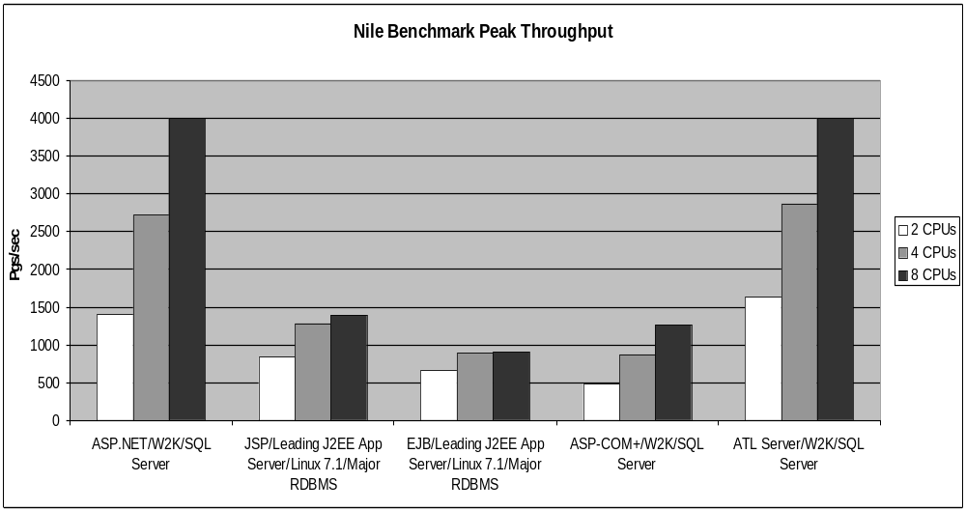

Throughput Curve: 2 CPU Compaq ProLiant 8500 Application Server
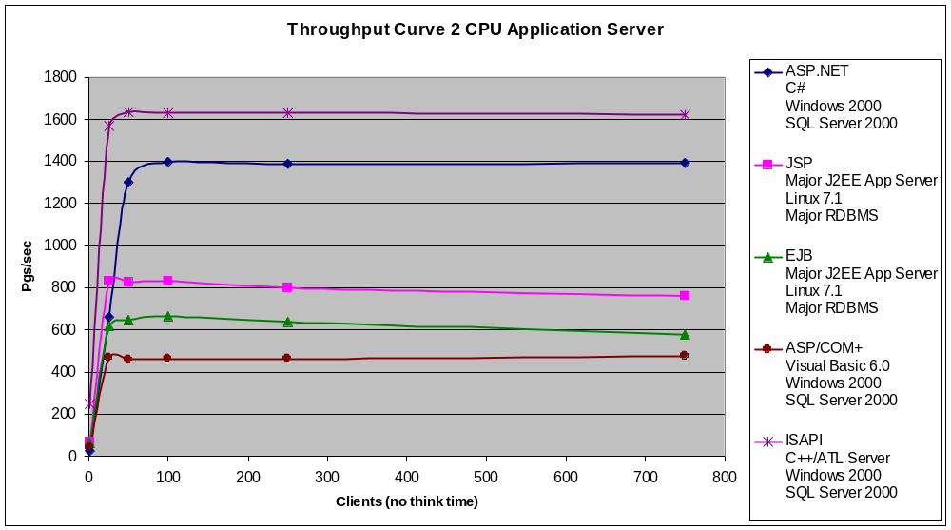

Throughput Curve: 4 CPU Compaq ProLiant 8500 Application Server
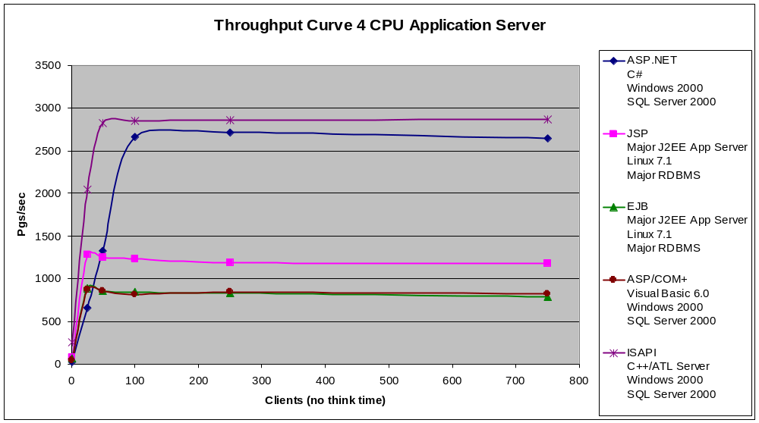

Throughput Curve: 8 CPU Compaq ProLiant 8500 Application Server
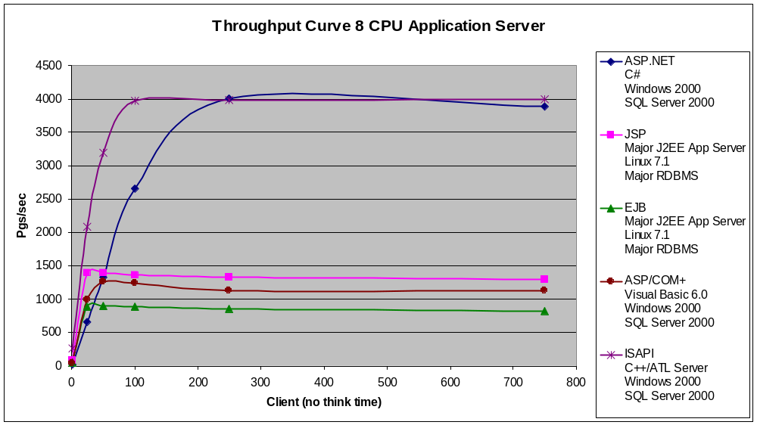

No Output Cache Results
The mainline tests shown implement the use of an output cache when possible given the technology. The use of an output cache on dynamic pages can greatly reduce the load on the middle tier and data tier, while increasing throughput overall. While not all pages can be cached, in the case of Nile the search results page and the specials page lend themselves to output caching assuming the products database is only updated periodically (for example once a day). We thought it would be useful, however, to also include baseline data for the applications running with no output cache enabled. This data is presented below, and indicates how good each technology is when executing each request on demand.

Throughput Table – No Output Cache
Clients | ASP.NET  C#  Windows 2000  SQL Server 2000 |  | JSP  Major J2EE App Server  Linux 7.1  Major RDBMS | EJB  Major J2EE App Server  Linux 7.1 Major RDBMS | ASP/COM+  Visual Basic 6.0  Windows 2000  SQL Server 2000 | ISAPI  C++/ATL Server  Windows 2000  SQL Server 2000
 | 8CPU | 8CPU |  | 8CPU | 8CPU | 8CPU
1 | 27 | 59 |  | 50 | 44 | 236
25 | 664 | 685 |  | 576 | 993 | 3061
50 | 1318 | 663 |  | 551 | 1260 | 3319
100 | 2527 | 662 |  | 593 | 1243 | 3341
250 | 3093 | 641 |  | 572 | 1135 | 3386
750 | 3037 | 610 |  | 548 | 1129 | 3398

Nile Benchmark Peak Throughput Chart
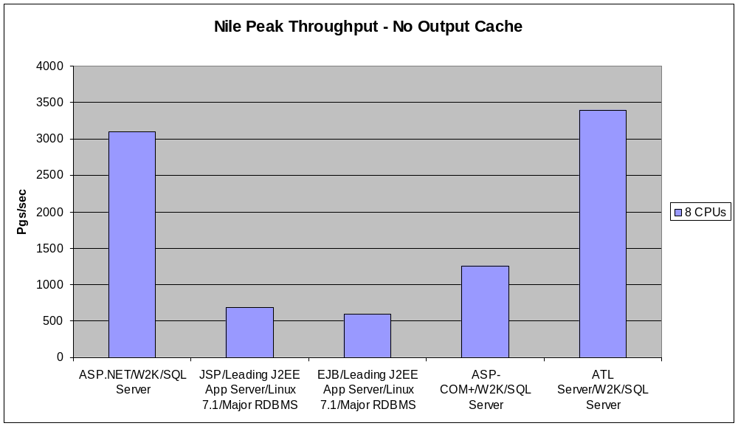

Nile Throughput Curve – No Output Cache, 8 CPU Application Server
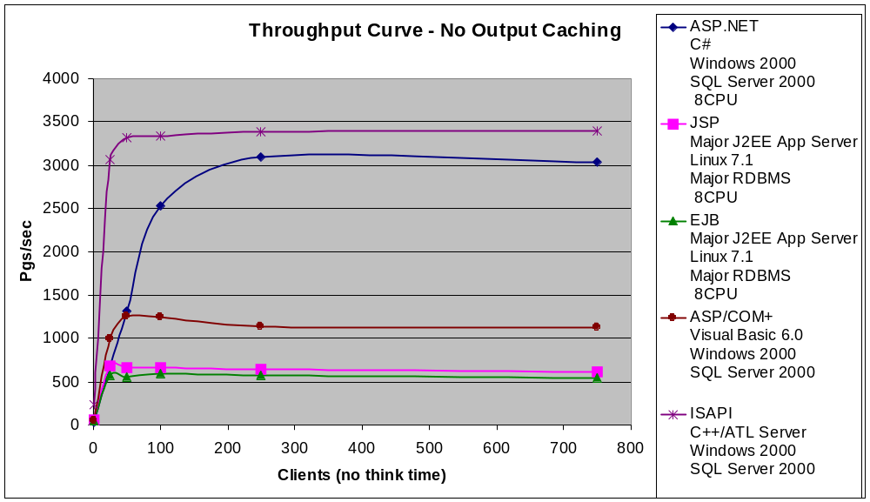

Conclusions
Performance and scalability are incredibly important considerations when choosing an application server technology. Customers need valid benchmark data in order to make informed decisions, and they need the source code and test scripts that will allow them to replicate the results themselves. A good benchmark must be based on a realistic application scenario that includes database connectivity, user state, and the use of dynamic server-side processing logic that typifies almost all real-world Web applications. The implementations tested should be tuned and optimized for the platform they were built on, to make the comparison fair. The Nile benchmark presented in this paper meets these criteria. The benchmark shows that the Nile application implemented using Microsoft ASP.NET outperforms the same application implemented using EJBs on a leading J2EE application server by 345% on an 8 CPU system when output caching is enabled for both products. It also shows that the Microsoft.NET version of Nile outperforms the EJB version of Nile on an 8 CPU system by over 421% when output caching is not used. Microsoft welcomes opportunities to participate in independently-conducted benchmark shootouts with competing Web application server technologies in the future as they arise.

Appendix 1: Nile Benchmark Source Code Downloads

We encourage customers to download the code for the following implementations of Nile to examine the code and test the benchmark themselves in their own environment. Simply visit http://www.gotdotnet.com/compare to download the source code to the following implementations of Nile, including complete setup instructions:

- ASP.NET written in C# (W2K)
- ASP and VB6 COM+ (W2K)
- ISAPI/ATL Server C++ (W2K)

The information contained in this document represents the current view of Microsoft Corporation on the issues discussed as of the date of publication. Because Microsoft must respond to changing market conditions, it should not be interpreted to be a commitment on the part of Microsoft, and Microsoft cannot guarantee the accuracy of any information presented after the date of publication.

This White Paper is for informational purposes only. MICROSOFT MAKES NO WARRANTIES, EXPRESS OR IMPLIED, AS TO THE INFORMATION IN THIS DOCUMENT.

Complying with all applicable copyright laws is the responsibility of the user. Without limiting the rights under copyright, no part of this document may be reproduced, stored in or introduced into a retrieval system, or transmitted in any form or by any means (electronic, mechanical, photocopying, recording, or otherwise), or for any purpose, without the express written permission of Microsoft Corporation.

Microsoft may have patents, patent applications, trademarks, copyrights, or other intellectual property rights covering subject matter in this document. Except as expressly provided in any written license agreement from Microsoft, the furnishing of this document does not give you any license to these patents, trademarks, copyrights, or other intellectual property.

© 2001 Microsoft Corporation. All rights reserved.

Microsoft, Visual Basic, Visual Studio.Net, Visual C++ and Windows are either registered trademarks or trademarks of Microsoft Corporation in the United States and/or other countries.

The names of actual companies and products mentioned herein may be the trademarks of their respective owners.

The most recent use of Nile was in a PC Magazine benchmark that appears in the May, 2001 issue of the publication. While IBM states in published documents that Websphere 4.0 demonstrated the best performance of all the products in this published review, PC Magazine did not test or evaluate Microsoft .NET in the review—instead testing just the Microsoft ASP/COM+ technology (since Microsoft .NET was still in beta testing at the time). While PC Magazine did benchmark an ASP/COM+ implementation of Nile, they chose to only publish the performance data for the J2EE application server products tested. Nevertheless, in this benchmark, PC Magazine does state that the Microsoft ASP/COM+ version of Nile against an Oracle® 8i database performed in-line with the best J2EE application server results, and showed even better results against SQL Server 2000. This paper extends the PC Magazine benchmark in the following ways: - Re-testing the optimized ASP/COM+ version of Nile in a more realistic, higher-end hardware and network configuration against SQL Server 2000, and showing the detailed performance results that do not appear in the PC Magazine issue. - Testing a new ASP.NET implementation of Nile based on the .NET Framework, as well as an ATL Server/C++ version of Nile to directly compare to the performance of the ASP/COM+ implementation, including the use of the new facilities for output caching with ASP.NET and ATL Server. - Testing a much more highly tuned version of a J2EE implementation of Nile than that tested by PC Magazine. For example, the J2EE implementation tested here was implemented using stateless session beans with optimized logic that mirrors the optimized logic of the Microsoft .NET, ASP/COM+ and ATL Server versions of Nile tested in the benchmark. - Publishing sources for the Nile implementations tested based on Microsoft technologies so that customers can examine the code and test these technologies for themselves.
We cannot disclose the name of the J2EE application server product tested because the license agreement of this product prevents users of these products from revealing benchmark results.
The EJB implementation was tested using the same J2EE application server as the pure-JSP version tested.
Note the J2EE application server vendor recommends avoiding the use of entity beans and the use of Container Managed Persistence (CMP) when building applications that require high performance.
Make sure to get the update that supports testing of ASP.NET Web forms. It includes an updated DLL for the Nile benchmark.
This implementation using COM+ is not indicative of the performance of COM+ applications in general. For example, COM+ implementations using C++ COM+ objects as opposed to VB 6.0 COM+ objects will in general exhibit higher performance. This is especially true if the C++/COM+ implementations use ISAPI as the activation layer vs. ASP, since ISAPI is faster than ASP. Also, the database communication technology will also impact performance; using C++ OLE DB template classes, or using ODBC direct calls to the database will exhibit higher performance than the use of ADO as tested here. The tradeoff is one of code complexity vs. runtime performance. The VB version tested here was implemented using the most commonly used MS RAD technologies (ASP, VB, ADO), and hence not implemented strictly for highest performance. Also, the fact that the ASP/COM+ version tested did not implement output caching has a huge impact on the relative performance vs. the other implementations in this table. While ASP itself does not support output caching, it is certainly possible to cache dynamic ASP/COM+ pages using third party products such as Microsoft Internet Security and Acceleration Server (ISA). These products were not used in this test, however.

