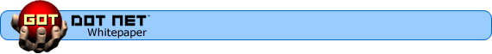

Sign up to receive e-mail announcements about the GotDotNet Workspaces Beta Program!

GotDotNet Workspaces
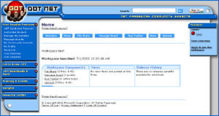

GotDotNet Workspaces ………………………………………………………………………. 1
Overview ……………………………………………………………………………………………. 1
Features …………………………………………………………………………………………….. 3
Status and timeline …………………………………………………………………………… 9
Further details ……………………………………………………………………………………. 10

Overview
GotDotNet Workspaces provides a dynamic online environment where professionals and students alike can collaborate on software projects without the barriers created by geographical or network boundaries.
Existing collaboration tools typically rely on all contributors having access to the same physical network, and often require set-up on each machine before they can be used. The GotDotNet Workspaces Web-based solution overcomes these limitations, allowing easy access from any Internet-connected computer.
The unique flexibility of GotDotNet Workspaces makes it the ideal collaboration tool for people who don’t share the same network — such as employees from different companies working on a joint project or students and faculty on multiple college campuses — and mobile users who may not always log on from the same computer. GotDotNet Workspaces is also a powerful tool for people in more traditional settings — inside the same company or on the same campus — who do not face those challenges. This flexible access also makes it easy for developers using GotDotNet Workspaces to enlist the help of non-developers, such as graphic designers or experts in other fields, for advice on specific aspects of their project.
Key features of GotDotNet Workspaces:
- Online source control enables multiple users to work concurrently on different areas of a project without compromising the work of their peers.
- The bug tracker allows users to record and monitor problem reports, work items, spec issues and project-related suggestions.
- Message boards provide a convenient online forum for project-related community discussions.
All features are integrated into the existing GotDotNet infrastructure and are accessed through a Web browser. Users are authenticated by their .NET Passport identification, which allows project administrators to control access to their Workspaces and protect their teams’ work. Workspaces can be designated as either public or private. In both cases, an administrator must grant a user membership in a specific Workspace before he or she can contribute to the project. Only members can view private Workspaces, whereas anyone can browse a public Workspace.
The GotDotNet Workspaces project is currently in a restricted alpha release with a small group of testers. A wider beta release will follow in September. When the final version is released next year, it will be freely available on the GotDotNet Web site for everyone to use.
Scenario: Sean, Alex and Amy have been friends since their sophomore year of high school, and they’ve always been crazy about computers. All three decided to major in computer science, and although they attend different colleges they keep in close touch via e-mail. The three friends are also dedicated gamers, and they’ve been talking for years about a role-playing game they would like to develop. Code-named “Magellan,” the game would be an expedition of adventure and discovery, based loosely on the famous explorer’s voyage around the world and his encounter with previously unknown cultures. When Sean heard about GotDotNet Workspaces, a Web-based collaboration tool that allows people on different networks to work on development projects, he decided the time had come for he and his friends to pursue their dream.

Features

Source control
The source control feature in GotDotNet Workspaces allows members to store their working files online. When Workspaces members want to modify a file, they use a check out/check in system that helps prevent errors and maintains the integrity of the files.
For example, if a Workspaces member needed to modify a particular file, he or she would simply check it out, make the changes, and check the changes back in to source control. Using this feature, different members can work on different parts of the project at the same time, knowing that their changes will not overwrite those of another contributor.
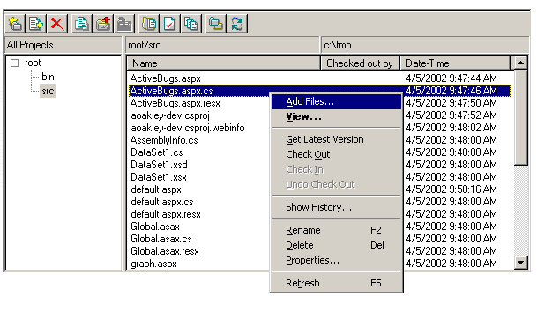

Scenario: Work on Magellan is progressing steadily. As with any development project, however, there are always many issues to resolve. Fortunately, GotDotNet Workspaces makes it easy to track and manage those tasks.

Sean assigns Amy a bug concerning a confusing section on one of the game’s Web pages. He wants a second opinion. Amy navigates to source control, selects the file in question, and clicks on the “Get Latest Version” icon. Since Amy has used the source control feature before, it downloads the latest copy of the file and knows exactly where to place it on her local machine.
After reading through the page, Amy decides it needs additional rewording to make it easier to understand. She also decides to include an image on the page. Back at source control, Amy uses the “check out” command to gain access to the file. From this point on, other team members can see that the file is being modified and are unable to make any changes to it. After Amy makes her changes, she returns to source control and performs a “check in” of the altered file. The new image file also must be added to source control, so Amy clicks the “add files” icon and selects the image file from her local machine. Moments later, Amy’s fellow developers can see the changes and the new image file.
A few days later while Amy is home visiting her parents, she receives e-mail from Alex pointing out a typo in her reworded text. Even though she is sitting at her parents’ home computer, Amy can log on to Workspaces and check out the file. Once the new change is made, Amy checks in the file as before, and the changes are instantly available to other developers on the team.

Bug tracker
The ability to track bugs and assign tasks is fundamental to every successful development project. The bug tracking system in GotDotNet Workspaces allows members to record and monitor the status of project-related bugs, and also provides a mechanism for storing and keeping track of member suggestions, feature requests and other work items.
Bugs can be designated by both severity and priority, based on their nature and their importance to the overall project, and then assigned to individual Workspace members. As the work progresses, any member can modify a bug to include more details or to adjust its priority.
The bug tracker feature provides a quick overview of the project’s status, including current bugs, outstanding requests and future work items.

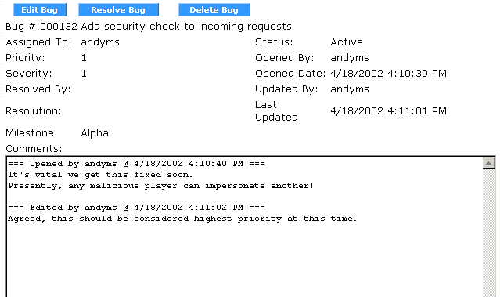

Scenario: Sean, Alex and Amy have enlisted several friends to help them with Magellan, so there is now a team of about 25 developers around the country working on the project, including a few who graduated a year or two earlier and are working at private companies. For a development project of any size, it is critical to have a reliable mechanism for tracking progress and work that has to be done.
While working on Magellan late one night in his dorm room, Alex realizes one of the features needs more work, but he doesn’t have time to stop what he’s doing to take care of the problem immediately. Instead, using the Workspaces bug tracker, he opens a work item, records the relevant details, and continues with his current task. As a result, the necessary changes will not be forgotten simply because Alex couldn’t handle them right away.
One weekend, the three friends decide to do a test run with Magellan. As they play, they encounter a series of bugs, which they record in the bug tracker. Sean has agreed to coordinate the efforts of different team members, and the bug tracker allows him to easily view all active work items. It also provides a central forum where Sean can assign bugs to the care of individual developers and follow issues through to resolution.

Message boards
The existing message board functionality on the GotDotNet Web site has been customized to provide Workspaces members with a convenient online forum for project-related discussions. This communication tool is more efficient than e-mail, because members can view an entire discussion thread at one time on a particular issue. In turn, the thread serves as a communal record for future reference as work on the project continues. Message boards also make it easier to review suggestions and feedback from non-developers who may be advising the team on various aspects of a project.

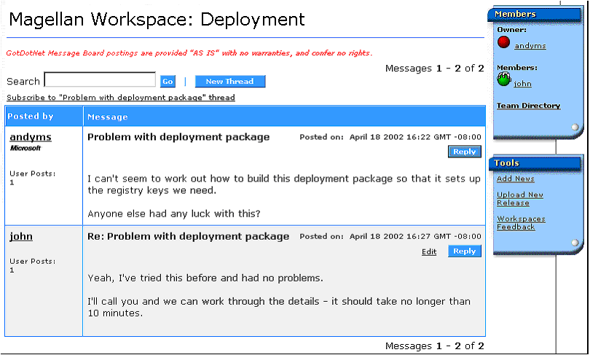

Scenario: As work on Magellan has progressed, many other students and faculty members have become interested in what the team is doing. GotDotNet Workspaces allows them to view the latest version of the project and offer comments and suggestions. Further, the team has recruited several advisors to help with various aspects of the project: history majors for historical accuracy; artists and graphic designers to help with costumes, settings, and the overall look and feel of the game; anthropology students to help them design different cultures for gamers to encounter, etc. The message boards support a wide-ranging discussion on various topics and allow the team to capture important contributions and suggestions from advisors.

News & release management
A project contributor (perhaps the project lead) can upload a current release package or executable and make it available to all project contributors and other Workspaces members. This way, Workspaces members always have access to the latest, stable version of a project. Members also have the option to post important developments, milestones and announcements concerning their projects.

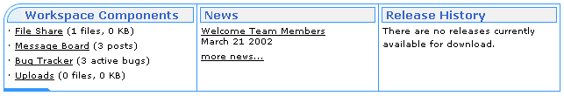

Scenario: Following a discussion on a Magellan Workspaces message board, everyone on the project team has agreed that the current code is stable, free of known bugs, and ready for a wider audience. With many feature requests in the bug tracker still waiting to be implemented, the team is eager to begin further development. Meanwhile, they want to start getting feedback from other gamers and developers.
Sean uses “Get Latest Version” to retrieve a current copy of the source code. He assembles the project on his machine, and then collects the source and compiled executable into a single zip file. Next, he brings up his Workspaces home page in a browser and navigates to the Release section. After choosing the option to upload a new release, he is prompted for the filename on the local machine. After uploading the file, Sean moves to the News section and follows the “Add News” link. After entering a title for the announcement, and a description of the project, the news item immediately appears both on the Workspaces home page and in the News section.
A student named Rob doesn’t know any of the Magellan team members, but he has heard about the new game being developed in a Workspace on GotDotNet. Intrigued, he heads over to the Workspaces directory and locates the Workspace for the Magellan project. On the Workspaces home page, the News release announcing Version 1.0 is immediately visible. Right next to the news item is a link to the zip file containing the new build. Within seconds, Rob has downloaded a stable release of the project code. After looking it over, he starts calling friends to see who wants to join him in trying out the new game.

Status and timeline
Several improvements and additions are planned before the final release, including an HTML-based interface to the source control component and more sophisticated bug tracking and management features.
The beta release is scheduled for September 2002 — more information is available at http://www.gotdotnet.com/community/workspaces/default.aspx — and a final version will be available on GotDotNet in 2003.

Further details
We welcome any comments on this document or the GotDotNet Workspaces project. Please send feedback to wksfeed@microsoft.com.

