An Overview of Microsoft Content Management Server 2002
June 2003
Patrick Gaul
proAxent solutions inc.
Applies to:
Microsoft Content Management Server 2002
Summary: An overview of Microsoft Content Management Server 2002, from both the subscriber and the site administrator perspective.

Contents

Introduction
Microsoft® Content Management Server 2002 (MCMS) is a comprehensive solution for managing the design and publication of content on a Web site. This article focuses on the MCMS infrastructure, covering a number of concepts that are helpful in understanding how to plan, build, maintain, and extend an MCMS site.
This article is intended as an introductory overview of MCMS. Comprehensive technical documentation on MCMS is included with the product (as an HTML help file) and is also available online at http://msdn.microsoft.com/library/en-us/getstrt/htm/cms_gs_getstarted_suzu.asp.

Overview
The central goal of Microsoft Content Management Server is to enable a simple and effective means of publishing and managing content on a Web site. The technology is applicable to virtually any kind of site, whether it is an intranet, extranet, or public site. It also provides a comprehensive mechanism for designing, developing, and managing a site. Additionally, the dynamic nature of MCMS provides an implicit methodology for managing functional aspects of the Web site such as navigation.
In working with MCMS, it is essential to understand the concept of dynamic content, and how MCMS deals with this content in real time. This understanding will form the foundation from which developers and site administrators will be able to work with the MCMS architecture to rapidly and effectively build highly functional sites.
This article does not present an exhaustive walk-through of MCMS, but rather is intended to expose the reader to some of the key concepts in the design and implementation of the product which will help establish a clearer understanding of this powerful technology.

Why Dynamic Content?
Many Web sites in existence today utilize static, file-based content. In many instances the content is authored directly within the published pages on the Web site, using standard Web design and authoring tools. As well, many content management products that use template-based layouts render pages as physical flat files with content embedded in-line with the template layouts; these files are generated during a publishing event. When a subscriber views the site, these files are browsed directly.
In the case of MCMS, content is accessed dynamically in real time, through the use of templates and the underlying Content Repository. The resulting pages are visually indistinguishable from flat file-based pages. What, then, are the reasons for using a dynamic content model over a flat file model?
There are a number of important issues that can be addressed through the use of dynamic content:
- Timeliness – Content should only appear in the time span for which it is relevant. Often, this relevance can be reduced down to a specific minute on a specific date. For example, if a corporate Web site is to contain content that is collateral to a scheduled corporate event, it may be required that the content not appear on the site until the precise moment that the event begins, and should “disappear” from the site at the event’s conclusion.
- Instant Reuse – Any discrete content element should have a single unique source. In the case of content that is reused (published) in multiple locations, an update to the source should be immediately reflected in all published locations, without the need for additional publishing events to take place.
- Access – Some sites require access by subscribers with varying access privileges. In many cases even the appearance of links to pages for which a given user does not have access is not acceptable. In such cases the lists must be automatically “filtered” according to the subscribers’ access rights.
- Context – In many instances, it is desirable for lists of content to reflect a particular topical context, and not simply be a fixed list. Perhaps it is a site requirement that the subscriber can set personal preferences for the categories of content to be displayed. Dynamic content which is “tagged” or “profiled” with metadata can be dynamically filtered according to these requirements.
- Content Integration – Advanced sites may require the integration of application data with Web publishing content. This is feasible only if the content is available as data, separate from its publishing layout. Dynamic content offers the opportunity to integrate with other applications in real time.
- Content Web Services - An increasingly popular requirement for many sites is the availability of content to be accessed in real time by other applications or independent Web sites. With MCMS, XML Web services can be built which expose its content for consumption by other platforms in real time; the dynamic nature of the content ensures that the most current content will always be available, and eliminates the need for asynchronous publishing events to occur in order to propagate this content to these services.

Content as Data
A distinguishing feature of MCMS is the role of content as a form of application data. An MCMS Web site is a dynamic, data-driven application, rather than a static file structure. This represents something of a paradigm shift in Web publishing, and it has important implications in the method of managing content. Accordingly, MCMS is designed to apply comprehensive workflow and versioning to this content.
In a conventional file-based site, content is inextricably linked to the published pages within the site. In order to version content, it is often the case that entire pages must be versioned or source-controlled. Content versioning tends to dictate different requirements than versioning of Web design components and application logic. With MCMS these different requirements are managed separately.
For design components, versioning is managed through source control (such as with Microsoft Visual SourceSafe), and are the responsibility of the Web design team. For content, revision histories are stored in the MCMS repository, and are the responsibility of the content authoring and management community.
Each approval event for a modified version of existing content results in the creation of a new revision history entry for a page. A comprehensive historical chronology of all content updates for each page is available within the MCMS content repository. Back-dated revisions can be browsed, compared with current or other back-dated revisions, and if required they may also be restored into current published status.
The workflow process in MCMS ensures that proper review and approval controls exist for the publication of new and revised versions of content.

What about Performance?
In any Web site that accesses data dynamically and generates resultant pages in real time, performance should always be an important consideration. To this end, MCMS is designed with a comprehensive range of features to allow extensive performance tuning and optimization, thus enabling highly scalable Web sites.
Caching is fundamental to the MCMS architecture. Whenever a resource is requested from the MCMS repository, it is first loaded into a file cache on the server. This cache is automatically managed by the server to ensure concurrence with updates in the repository. Subsequent accesses to cached content do not require database access.
In practice, the majority of database access for an MCMS site occurs shortly after the site becomes live following the start of IIS. All of the most frequently accessed objects typically become cached soon after this event, and database activity usually drops off dramatically within a relatively short time. In most cases, the underlying Microsoft SQL Server™ database for MCMS displays very little activity following this initial period.
Equally important is the availability of ASP.NET output caching. Rendered templates and embedded user Web controls or server controls can utilize the powerful range of caching features supplied by the Microsoft .NET Framework to optimize the performance of MCMS templates.
ASP.NET allows full page output caching, caching of individual control output, and programmatic caching of specific items. Also, this caching can be done for all users or can be done on a per-user basis. The caching method chosen should be determined by the needs of the site. For example, if the site makes use of varying user rights to determine the range of channels through MCMS user role definitions, then caching of dynamic output – such as navigation – may be done using individual per-user caching. And content that is highly volatile – in other words, it changes very frequently – may not be a good candidate for caching.
In employing caching, it is important to keep in mind that extensive use of this technique will result in higher levels of memory utilization. Site developers and administrators should monitor performance on the MCMS servers to track memory usage and ensure that caching does not over-stress the available memory on these systems.

Channels: The Site Hierarchy
An MCMS site is comprised of a hierarchy of objects as follows:
- Channels – A hierarchical tree that defines the overall schema or site map.
- Postings – The individual content “page views” within the channel hierarchy.
- Placeholders – The individual content objects to be rendered within a posting.
Together, this hierarchy of objects comprises the site schema. Figure 1 shows a simple site schema comprised of these object types:
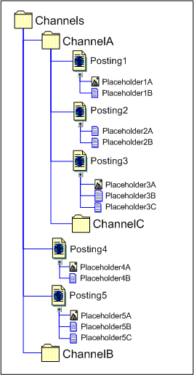
Figure 1. Channel/posting/placeholder hierarchy
In this hierarchy, an important general concept to understand is that the posting can be viewed as containing all information required to render a Web page: the page name, its URL, its content (in placeholders and/or custom properties), and the template used to physically render the page.
This structure has an analogy in a file-based Web site’s virtual directory structure. Channels are analogous to virtual directories, and postings to HTML or ASPX files. However, there is no parallel for placeholder objects – they contain dynamic data that originates in the MCMS Content Repository. Nor are they individually addressable by a URI – their rendered content is embedded within the postings contained on the site.
In MCMS, a posting can be accessed using several different URLs for each of its modes in the publication process. The site subscriber sees only one publishing mode: Published. Other publishing modes (Unpublished and Update) are available only to those roles in MCMS involved in content authoring, approval, and site development and administration. (A further publishing mode – Staging – arises only when the MCMS Site Stager is involved in rendering postings that employ ASP-mode templates; the Site Stager and this mode are not applicable to ASP.NET templates and will not be discussed in this document.)
Channels, like Postings (see next section) have associated properties. Many of these properties are standard, including publishing start and end times, display names, and other features. There are also custom properties, which are added by site developers and provide a means for developers and/or authors to store metadata specific to individual channels and postings. For example, a designer could add a custom property to a template called “Keywords” which could be employed to render a <META> tag of the same name in the HTML of the rendered page, with its value being the contents of the custom property as specified by the author in the posting. Or a custom property could be used to inform the template to alter some other aspect of its physical rendering of the page – for example, to render a page as XML instead of HTML.
It is important to note that while custom properties provide a general means of adding metadata to channels and postings, in general the use of these properties should be limited to the specific items in current context. In other words, a template should access the current channel or posting’s custom properties when rendering a specific channel item. Although the MCMS Publishing API contains the ability to search the entire MCMS site for channel items that have a specific value, such searches are not optimized for large sites. For example, although it may be tempting to use these properties as a mechanism for site personalization, a much more sophisticated and scalable approach would be to employ the Microsoft Solution for Internet Business (see http://www.microsoft.com/solutions/msib/), which leverages the advanced personalization capabilities of Microsoft Commerce Server 2002 for such purposes.

Postings: Published Instances
An MCMS posting corresponds to the page view that a subscriber receives in response to a request to the server. A posting represents a published instance of content. From the subscriber’s perspective, the resultant view is indistinguishable from a file-based page. Every posting employs a template to render its content.
When a subscriber requests a posting from an MCMS site, MCMS dynamically builds the resulting Web page using the posting’s associated template and content. (More about this later in the section on templates).
Postings have additional properties that are separate from the underlying content; for example, Start Date and Expiry Date are properties unique to each individual posting.
A posting’s published URL is derived from its context within the channel hierarchy. For example, the URL for “Posting3” in Figure 1 would be “http://<serveraddress>/ChannelA/Posting3.htm”. Note that the root channel (“Channels”) is not included in the URL. However, in an MCMS site the special URL “http://<serveraddress>/Channels” will access the MCMS root channel, rather than the root virtual directory of the Web site.

Connected Postings
The content for a particular posting may actually be shared with other postings; in MCMS, this is referred to as a connected posting. A collection of connected postings shares a single underlying source of content. Changes to that content can be made through any published instance to which an author has authoring rights; once the submitted changes are approved through the workflow process, all connected postings will immediately be affected. This eliminates the need to replicate or synchronize such changes across the site.
Each posting has an associated template; otherwise, there would be no means of rendering the content in each posting. However, it is not necessary for connected postings to all use the same template. Connected postings can access common content using different templates, as long as the templates themselves are connected.
Although connected postings share placeholder content, they do not share properties. For example, two connected postings may have different start and end times, and different custom property values.

Templates: Layout, Look and Feel
Templates form the basis for the overall design – the layouts, look, and feel – of the site. They are also responsible for all of the functional behaviors and possible integrations within the site. Navigation, for example, is a part of template design. Custom code to access applications and present forms to the user must be incorporated into MCMS templates.
Template design is the domain of site developers. Content managers do not require any knowledge of Web page design or functionality; they simply need to know which templates to use to publish their content.
In response to a subscriber’s page request, MCMS assembles a response in real time from a number of elements, by accessing content from the MCMS content repository and instantiating the various objects required by the template’s ASPX file (more on this later under the topic “How MCMS Requests Are Handled”).
As an example, examine the following schematic representation of a common HTML page layout:
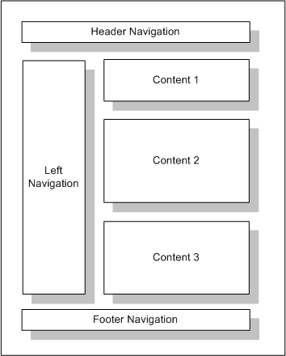
Figure 2. Sample Page Layout
To implement this layout in MCMS, the following items would be dynamically inserted into the rendered page:
- Header and Footer Navigation: These are usually ASP.Net user controls that render links to common items across the site (e.g. Help, About Us, Search, etc.).
- Left Navigation: This is usually created as an ASP.Net user control that displays navigation links depending on the current posting’s location within the site (i.e. navigational context). In most cases this navigation is built using text hyperlinks.
- Content: This layout has three separate content “blocks”, which may represent HTML, XML, images, or file attachments. In MCMS these blocks of content are provided by placeholder controls, the most granular content components within MCMS. Placeholders store content; placeholder controls render placeholder content in the locations on the templates where they were inserted during template design.
The template itself may contain other embedded (“boilerplate”) elements such as images, style sheets, additional HTML, and so on. These elements are usually referenced directly within the templates and are not stored in the MCMS repository (although it is possible to render other MCMS resources in a template through the use of the MCMS Publishing API).
As a more illustrative example, figure 3 shows a page contained in the WoodgroveNet sample site included with MCMS, with several areas of the page indicated as separate components:
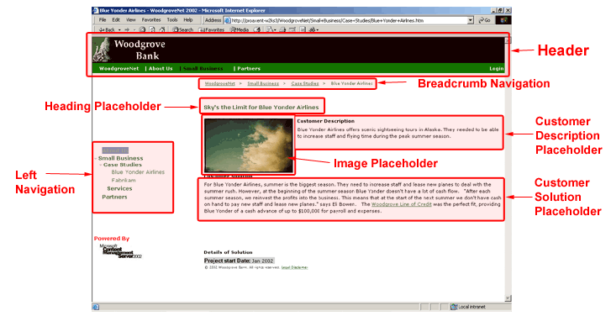
Figure 3. WoodgroveNet Page Layout
In Edit mode, each of the content areas appear as in Figure 4:
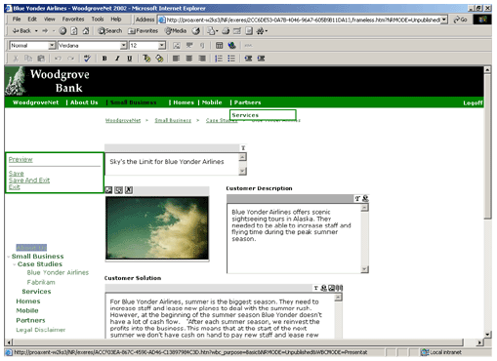
Figure 4. Page in Edit Mode
In the design of this layout using Microsoft Visual Studio® .NET, each of the elements of this page layout are implemented as controls, as shown in Figure 5:
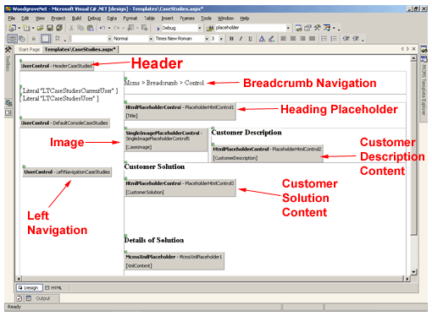
Figure 5. Template Design in Visual Studio .NET
MCMS site developers determine which elements on a particular template will be placeholder-based and which will be directly embedded in the template. The most common criterion for defining content as placeholder-based is that it must be maintainable by content authors. All non-placeholder items in the template must be maintained by the template designers.
Templates are comprised of two main components:
- A Template Gallery Item (TGI) – the definition of the template’s associated placeholder collection, stored in the MCMS repository. The TGI and the template gallery hierarchy are shown in the MCMS Web author template selection dialog when authors choose templates to create new pages.
- A Template Source File – an ASP or ASPX file residing in a Web application on the MCMS server. The template source file contains all programmatic elements within the template. The file system location of the source file is not important to content authors, as they do not usually navigate through this file structure. Navigation to templates is always done by traversing the template gallery structure.
Although each template has its own TGI, multiple templates can share common placeholders – this is how connected templates are implemented. Connected templates are a means of providing multiple alternate renderings using a common set of placeholder content. An example would be in creating alternate renderings for full-function desktop browsers versus those for mobile devices. In most cases, mobile device browsers offer limited functionality in the rendering of Web pages; for example, many mobile browsers do not support the Document Object Model, so embedded scripts that use the browser’s Document Object Model (DOM) to dynamically render HTML will not function in these environments. An MCMS site can be designed to provide simpler renderings of pages that are specifically optimized for the characteristics of such devices. A more exhaustive discussion of this scenario can be found in the article “Supporting Mobile Devices with Microsoft Content Management Server 2002”, available for download from the Microsoft Download Center at http://go.microsoft.com/fwlink/?LinkId=16161.
In designing a site, it is important for developers to strive for the minimum number of templates required to satisfy the requirements for the site. As much as possible, templates should be kept “generic” and flexible, to become adaptable to multiple scenarios. This helps in the manageability of the site.
For example, if you have a 10,000 page Web site that uses only 20 templates, a site-wide design change will likely be easily accomplished by a relatively small development effort. On the other hand, if you have implemented this site with 200 templates, the workload will be much more substantial.
In template development, a good practice to follow is to avoid “one-off” templates as much as possible. If it is possible to accommodate a specific requirement by adding selectable functionality to an existing template, in most cases this approach is preferred over the creation of a single template that will be used for a single posting.
From the content author’s perspective, templates are stored in galleries. Galleries form a means of grouping together templates according to their intended use, either by different groups of authors or by functionality. Site administrators must ensure that the required galleries are accessible by authors, editors, and subscribers to the site.

Resources: Commonly-Used Objects
In an MCMS context, resources are commonly-used objects, such as graphics or file attachments. There are two major types of resources:
- “Local” Resources – Resources associated with individual MCMS postings. These resources are not stored in the MCMS Resource Gallery structure, but rather are uniquely associated with their published postings. They are usually uploaded from a local source or network path into MCMS placeholders by authors. (It is possible to restrict this ability by placeholder.)
- Gallery Resources – MCMS contains a Resource Gallery structure to store resources which are intended to be used in many postings throughout the site. Examples of such resources would be corporate logos and common documents (such as Word or PowerPoint presentations).
Resources in MCMS are primarily intended for authoring. In general, resources (such as graphics) that are to be embedded permanently in templates should be stored in the same file system as the template files.

The Dual Nature of Templates
Templates in MCMS operate in two basic modes:
- Content Presentation – the template is the medium through which a posting’s content is rendered to subscribers browsing the site.
- Content Authoring – templates act as the content input and editing form.
(Of course, since templates are ASP.NET pages, they may also implement additional application logic that may be required by the Web site.)
This dual nature is important, as it enables the unique in-context and WYSIWYG nature of content editing in MCMS. To edit content on an MCMS site, an author navigates to the desired location, enters “Site Edit” mode, and creates or modifies the content at the appropriate location in the site. Thus, templates must be designed with this capability in mind. A template to be used for editing content at a minimum must have these MCMS Web Author features:
- The ability to switch between “Live” and “Edit” modes.
- Access to MCMS publishing functions via an “Edit Console”.
(In MCMS 2002 and Visual Studio .NET, the creation of a new MCMS Web Project includes a user control, DefaultConsole.ascx, which implements both of these features. This control may be inserted wherever appropriate in a template file.)
Templates that are to be used to publish individual sets of content must also have placeholder controls. In edit mode, these controls become form objects in the browser, containing the user-submitted content. In live mode, the content is simply rendered in-line within the template.
It is also possible to create templates that do not possess placeholder controls of their own; this is commonly done for templates which will display summaries of content originating in other locations (such as the postings in the current channel). However, even these templates must have the live/edit mode switch and the edit console if any of their properties are to be modifiable.
MCMS comes with sample implementations of these capabilities, and they are fully customizable. Refer to the MCMS documentation for more information.

The Importance of Context
Context is a central concept in MCMS. There are several aspects to context which must be understood in designing an MCMS site:
- Session Context – Each authenticated subscriber to the MCMS site has a unique session, which presents a consolidated view of the site according to that user’s access rights. Any channels for which the subscriber does not have access will not be included in their session context, and for all intents and purposes these unauthorized channels do not exist to the current subscriber. Even if the subscriber has the URLs to postings and channels to which they have no access, these objects cannot be accessed within that session; the subscriber would have to re-authenticate to MCMS using credentials which have appropriate privileges. Dynamic site navigation controls in MCMS templates will only render links to those channels included in the current session context.
- Navigational Context – As a subscriber navigates through the MCMS Web site, the session for that user maintains objects that correspond to the current posting and channel that the user is accessing. This is essential in developing navigation controls that present the current location context for any given posting or channel. Navigational context is used as a basis for creating controls that render navigational elements such as breadcrumb paths and channel/posting menus.
- Time – The channels and postings that a subscriber sees when browsing an MCMS Web site are dependent on the current time. For example, if a subscriber is browsing a channel that contains several postings that have not begun publication or have expired, links to those postings will not appear in navigation, nor will the postings be accessible even if the subscriber knows their URLs. All channels and postings visible to any subscriber must be in Published mode in order to be visible and accessible.
It is also important to note that context is automatic in MCMS. Navigation design is based on it, and designers can take advantage of it to build better navigation.

How is Content Stored?
Content in MCMS is stored internally – in the MCMS Content Repository – as Pages. Pages are collections of placeholders associated with one or more postings, which are in turn associated with templates and channels.
The maintenance of content in pages, separate from postings, is the mechanism that enables content sharing between connected postings. No single posting “owns” the content; it is accessible through any connected posting. And – provided the associated template is designed to allow editing – the shared content may be edited through any connected posting as well.
Content authors and designers never deal with MCMS pages directly; they are exclusively internal objects. (In versions of MCMS prior to 2002, pages were editable separately from postings, but limitations in that architecture resulted in the current implementation.) Site developers can, for most practical purposes, view content as being contained within postings. Indeed, the MCMS publishing API presents placeholder objects as collections contained within the posting object. In practice, in the vast majority of implementations each single source of content is associated with only a single posting, so the fact that the content is stored separately is of little consequence in these cases. However, it is important to understand that connected postings always share a single underlying source of content; an update to that content affects all connected postings.

How is Content Created?
In MCMS, content is usually created through the Web Author interface. The Web Author is comprised of a set of functional elements that transform a template into a content editing form.
As mentioned earlier (see “The Dual Nature of Templates”), templates through which content is to be created and modified must incorporate some basic MCMS Web Author functions (via an edit console) to allow an appropriately authorized content author to create and edit content.
The MCMS 2002 Help documentation contains a tutorial that will familiarize you with the MCMS Web Author interface.
Due to the comprehensive Publishing API included with MCMS, it is also possible to publish content automatically from custom application code. For this purpose, the Publishing API contains two different MCMS contexts: CmsHttpContext for Web browsing and authoring, and CmsApplicationContext for accessing MCMS content from a separate application.
For example, a Web site may have access to syndicated content that is to be published in MCMS. A custom application may be designed that will access this syndicated content and submit new pages to MCMS automatically. The programs used to post such pages do not require Web Author capability, and can publish content using templates that do not contain the Web author interface.

Workflow, User Roles, and Events
Given that MCMS is a dynamic, data-driven Web site management solution, it is essential that workflow processes exist to ensure that only approved content is published on the site. This is particularly important for extranets and public sites.
With conventional file-based Web sites, the content is usually embedded within the published pages, so the approval process for the publishing of content usually involves the input of members of the Web development team, as they are largely responsible for the final inclusion of new or updated content on the site.
However, with MCMS this paradigm is changed. The management and approval of content is placed under the control of the original content owners – the subject experts and knowledge workers who understand the content intimately. These content creators operate in several different user roles that participate in the content publishing process. A key advantage in MCMS is that the publishing process is completely separate from the site design and template development process.
MCMS includes a predefined, built-in workflow process that requires only the addition of users or user groups to take effect. The MCMS workflow process is also fully extensible; you may choose to modify it according to your own specific business requirements, or you can acquire third-party workflow design tools which will integrate directly with MCMS. The discussion in this article is limited to the default workflow model that is built in to MCMS.
The user roles available in MCMS are listed in the following table.
Table 1: MCMS User Roles.

User Role | Rights
Subscriber | Someone who browses the Web site. Different subscriber groups can be defined with different privileges for accessing various channels within the site.  Subscribers need access to the channels, template galleries, and resource galleries that comprise the content within the areas of the site that they are allowed to view.
Author | Someone who creates and maintains content. When a user is authenticated as an author, they are able to both browse the Web site and edit content in the portions of the site for which they are authorized. Through the use of Author Rights Groups, different authors may be allowed to create and maintain content in different areas of the site.  Like subscribers, they require access to channels, template galleries, and resource galleries.
Editor | Someone who reviews, updates, and approves or declines content. As with other roles, different groups of editors can be responsible for different parts of the site. Editors also have the privilege of authoring and immediately approving content in their designated channels.  Editors also require access to channels, template galleries, and resource galleries.
Moderator | Someone who reviews, updates, and or approves the properties of the postings in channels (for example, publishing start and end date/times). Moderators can approve or decline posting submissions to their appointed channels, but do not have responsibility over posting content.  Moderators also require access to channels, template galleries, and resource galleries.
Resource Manager | Someone who updates and maintains the content of one or more resource galleries.  Resource managers require access to resource galleries only.
Template Designer | Someone who designs templates.  Template designers require access to template galleries.
Channel Manager | Someone who has site administrative rights over a sub-section of the MCMS site.  Channel managers can perform all site management activities, including template design, content creation and approval, and rights administration for their select portions of the site.  Channel managers require access to channels, template galleries, and resource galleries.
MCMS Administrator | Someone who has full access to and control over an MCMS site. Administrators have full authority to perform any function in any location within an MCMS site.  Administrators have full access to all channels, template galleries, resource galleries, and User rights group administration. Only administrators can maintain or modify rights groups.

Publishing Workflow
The default workflow in effect for MCMS is as follows:
- An Author creates a new posting (or updates an existing one). When content is ready, the author submits the content for approval. If the posting’s channel is not edited (no editor is assigned to the channel) and not moderated (no moderator is assigned to the channel), the posting and its content are automatically approved.
- If an editor is assigned to the channel, an editor reviews the submitted content, makes any necessary changes, and either approves or declines the submitted content. If the editor declines the submission but makes no changes to it, the content returns back to the author’s production manager in a declined state (If the editor has made changes, it will reside in the editor’s production manager). If the posting’s channel is not moderated (i.e. no moderator is assigned to the channel), the posting is automatically approved. If a page was previously approved, and a new version of the page is waiting approval, the previously approved page will still be in published status on the site.
- If new content is submitted into a moderated channel, the Moderator must approve it before it is published. The moderator must also approve any changes that have been made to an existing posting’s properties. The moderator is not involved with subsequent changes to existing content if the posting properties have not been modified. It is important to note that changes to a previously published posting’s properties (in a moderated channel only) will remove it from publication until the moderator approves the change.
Every step in the MCMS publishing process may have an associated event which can be used to extend the publishing workflow. These events are registered in the Web application’s web.config file’s <httpmodules> section.
For example, consider a case where multiple editor approvals are required. The Microsoft.ContentManagement.Publishing.Events.PostingEventsModule could be registered with a name of CmsPosting, and a CmsPosting_Submitted event handler could be created in the global.asax file (or a custom HTTP Module could be created) that would introduce the required multiple-approval logic.
More detailed information on customizing the publishing workflow can be found in the MCMS 2002 Help documentation, which is also available online at http://msdn.microsoft.com/library/en-us/sitedevl/htm/cms_sd_ext_workflow_kyva.asp.

MCMS Architecture
MCMS is installed on a Windows Server environment (Microsoft Windows® 2000 Server or Microsoft Windows Server™ 2003) with IIS. The installation creates two ISAPI filters which are attached to the WWW service, and thus are in effect for all sites running under that server’s instance of IIS.
The MCMS Content Repository is stored in a Microsoft SQL Server database, which can reside on a separate platform.
The following figure illustrates the basic architecture of the MCMS 2002 environment:
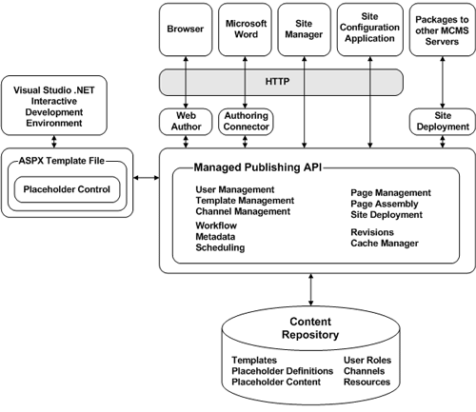
Figure 6. MCMS 2002 Architecture
For scalability, MCMS can be installed and configured to run in a multiple-server environment connecting to a common repository (which can itself be scaled for performance and reliability). Various deployment scenarios are covered in the MCMS documentation, which can be viewed online at http://msdn.microsoft.com/library/en-us/deploymt/htm/cms_de_deploy_hcte.asp.
Authoring and ongoing content management functions in MCMS 2002 are done through the Web Author, an interface accessible through the Internet Explorer browser. An alternative means of publishing content to MCMS is available through Microsoft Word 2002 and later using the MCMS Authoring Connector. A limited number of administrative tasks are done through the use of the MCMS Site Manager which – like the browser – uses HTTP as its communications protocol. Server-specific configuration parameters are also managed through the browser using the Server Configuration Application (SCA). As a general practice to enhance security, the SCA is configured for access from the local server only.

How MCMS Requests Are Handled when Browsing the Published Site
In MCMS 2002, page templates are actually ASP.NET pages. There is considerable documentation elsewhere on how HTTP requests and “postbacks” are handled in ASP.NET. In this discussion we will investigate how MCMS requests are handled differently from those for pages that exist in virtual directories on the server.
When an MCMS server receives a request, the Web Author Context is important. There are a total of seven Web author context modes:
- PresentationPublished – this is the mode in effect when a subscriber views a published page.
- PresentationUnPublished – this mode is accessible by the site’s content managers (authors, editors, channel managers, administrators), and represents the view of a modified page version which has not yet been approved.
- PresentationUnPublishedPreview – this is the mode that content managers see when they request a preview of an unpublished page.
- AuthoringNew – this mode is in effect while an author is creating a new posting.
- AuthoringReedit – this mode is in effect while an author is editing an existing posting.
- AuthoringPreview – this mode is in effect when an author requests a preview of a posting while in edit/update modes (i.e. AuthoringNew, AuthoringReedit).
- TemplatePreview – this mode takes effect when previewing a template without any posting content (e.g. from the template selection dialog).
For the purposes of this discussion, we’ll consider grouping these modes into two larger categories: Presentation, where the request is for the rendering of an MCMS object for browsing, or Authoring, where the user is appropriately authenticated for the modification of the site and is in the process of updating MCMS. Understanding the presentation modes is fundamental in understanding how the authoring mode works as well. (In the authoring modes, multiple requests are issued as the user progresses through the authoring process. For a discussion about how this mode differs from presentation mode, refer to the MCMS 2002 Help documentation topic “Authoring Mode Page Processing”, available online at http://msdn.microsoft.com/library/en-us/sitedevl/htm/cms_sd_dev_pageprocessing_mswj.asp.) In this article the discussion will be limited to presentation modes – specifically, to the PresentationPublished mode, which is the mode that site subscribers normally invoke when they browse the site.
The following diagram shows the path of a presentation mode HTTP GET request to an IIS server with MCMS installed:
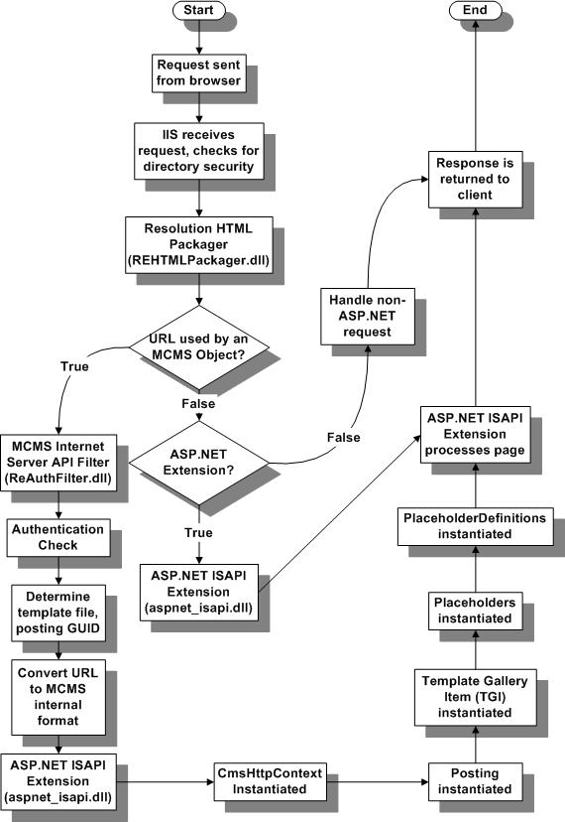
Figure 7. Presentation-Mode Handling of MCMS HTTP Request
The following text describes this process:
- In the first step in processing the request, the URL is checked by IIS to determine if it corresponds to a known virtual directory – and if so, that virtual directory’s properties are checked to determine whether authentication and/or SSL is required.
- The next step is to determine whether the requested URL corresponds to an MCMS object. This is performed by the “Resolution HTML Packager” ISAPI filter, installed in IIS (REHTMLPackager.dll). (Note: the name “Resolution” is a reference to an earlier generation of MCMS.) If the URL corresponds to that of an MCMS object, this object takes precedence and the request is passed to the next MCMS ISAPI Filter. Otherwise, subsequent processing is handled as it would be for any non-MCMS object in IIS.
- Assuming the request corresponds to an MCMS object – a channel, posting, or resource – the next step is handled by the MCMS Internet Server API (ISAPI) Filter (“Resolution Filter” – ReAuthFilt.dll). This filter performs an authentication check to determine the requesting user’s access rights and examines the URL to determine the MCMS object that corresponds to the request. In the case of a posting, the URL is further analyzed to determine the template ASPX file that is associated with the posting, and constructs a new URL for the posting based on this ASPX template; several query string parameters are appended which specify the mode of access to the posting (i.e. “Published”, “Unpublished”, etc.) as well as the globally unique identifier (GUID) of the posting. This newly-constructed URL is passed on to IIS for further processing.
- As the new URL references an ASPX Web form, IIS then forwards the request to the mapped ISAPI extension for ASP.NET files (aspnet_isapi.dll), where further authentication is performed in as well as any ASP.NET output cache processing.
- A CmsHttpContext object is instantiated, which sets the correct context for the requested object (e.g. what is the current channel, etc.)
- The required MCMS Posting object is instantiated, along with all associated properties of the posting. This posting object is obtained from the MCMS data repository, and is based on the GUID contained in the transformed URL described earlier.
- The Template object associated with the posting is instantiated. This object is distinct from the template ASPX file; it is the Template Gallery Item (TGI), obtained from the MCMS data repository, and contains template properties, placeholder and custom property definitions.
- The Placeholder objects associated with the template (if any) are instantiated and read from the repository, along with any stored contents for each placeholder.
- The PlaceholderDefinition objects contained within the TGI are instantiated, making available all information on the constraints placed on placeholder content.
- At this point, all of the required objects are instantiated to allow the ASP.NET ISAPI extension to fully process the code associated with the template ASPX file. All controls embedded in the template are executed (navigation, console, placeholder controls, etc.) and individually rendered, and the results are aggregated into a rendered page as an HTTP response.
- The response is sent back to the client.
In the simplest terms, it is possible to consider an MCMS page as an ASP.NET page with a number of objects instantiated (MCMS context, posting, etc.) prior to processing by the ASP.NET ISAPI extension. An important distinction here is that the only physical file objects are the template .ASPX file and any other file objects that it references (i.e., user control .ASCX files, images, style sheets, script files, etc.).
As discussed earlier (see “Channels: The Site Hierarchy”), the physical virtual directory structure does not form the basis for the site’s schema (i.e. the site map), but rather will reflect the organization of the functional elements of the site. For example, an MCMS site may be a composite of multiple Visual Studio .NET MCMS Web projects, each with their own application root and sub-folders containing the physical file objects that support their specific templates and other objects.

Building Templates
We have seen how templates form an essential component in the architecture of an MCMS site. They provide both the basic mechanism for rendering content as well as the primary means for authoring content.
Designing templates is fundamentally a two-phase process:
- TGI Definition – Define the template gallery container, gallery item, placeholder collections, custom properties, placeholder constraints, and associated physical template file. These definitions are stored in the MCMS Content Repository.
- Template File Design – Build the physical .ASPX file that corresponds to the TGI defined above. The physical layout and functionality of the page is designed here, including placeholder controls which bind to placeholder definitions in the TGI.
Visual Studio .NET integrates both of these design phases into a single integrated development environment (IDE). TGI definition and configuration is done through the use of the MCMS Template Explorer Window. Properties of the TGI are selected from this window, and placeholder definitions are managed through the Placeholder Definition Collection Editor dialog. These dialogs are all shown in the following figure:
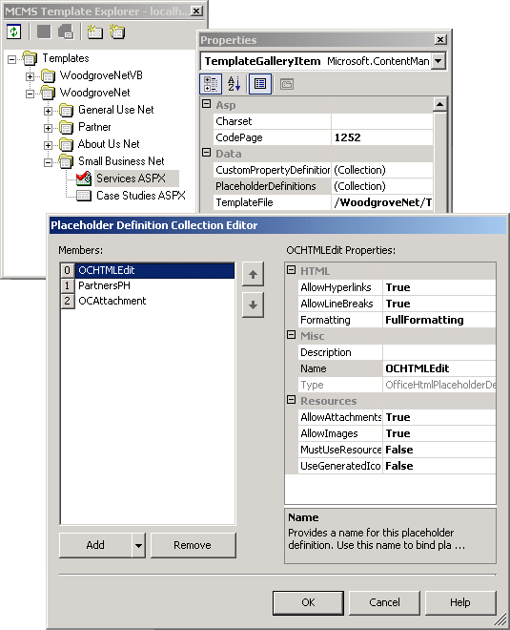
Figure 8. MCMS Template Explorer, Properties, and Placeholder Definitions
Through this interface the designer creates template galleries and their constituent TGIs. For each TGI, placeholder definitions are created through a dialog invoked from the Properties sheet for each item in the gallery. These definitions comprise the total placeholder collection available to a given template file through the use of placeholder controls.
MCMS template files are implemented as ASP.NET Web forms, so the design process is the same as with other Web forms, with the following additional elements:
- Placeholder controls are added to the Web form and bound to placeholder definitions from the associated TGI
- An editing console is added to the Web form (MCMS supplies a default “flat HTML” console, DefaultConsole.ascx, which can be customized or extended)
- Navigational elements are usually designed separately as user controls (.ascx files) and added to the template (e.g. breadcrumb path, channel navigation, etc.)
- Any manipulation of MCMS content is enabled through the placeholder controls
- The template’s code-behind layer is the programmatic interface for the template file. It can be employed to manipulate the handling of template objects – such as controlling the visibility of certain controls and/or content in different contexts, or integration of other information (such as data from another database) into the rendered page, to name only two examples.
As in the development of any ASP.NET Web application, custom controls can be built to perform custom actions; for example, a summary list control could render links and content excerpts from a collection of MCMS postings. As well, the MCMS placeholder architecture is designed for extensibility; the site developer can build custom placeholders and placeholder controls to suit a specific set of requirements.
The MCMS software includes sample controls (e.g. placeholder controls and navigation user controls) for many of these functions, and can serve as a basis for developing your own custom controls. Many other sample controls and custom placeholders submitted by MCMS users are available from www.gotdotnet.com.
The MCMS 2002 Help documentation includes a tutorial on building templates. This documentation is also available online at http://msdn.microsoft.com/library/en-us/tutorial/htm/cms_gs_tut_developer_zsrw.asp.

Where are the Files?
As discussed, MCMS is a data-driven content management solution, with some components (the physical template files and some related objects) stored in the file system. Having file-based template components has the advantage of being able to manage these Web application assets through source control, such as with Microsoft Visual SourceSafe®.
Despite the fact that the content itself is stored in the MCMS Content Repository (in a SQL Server database), in many (if not most) sites, the level of content volatility does not demand constant retrieval from a database. To optimize performance, content objects themselves are retrieved and stored in a dedicated MCMS cache structure. There are two elements to the MCMS cache:
- The Node Cache – this is a memory cache where content objects are stored such as postings, channels, template metadata, and channel objects.
- The Disk Cache – this is a file cache for resources extracted from the repository.
The sizes of these cache components are configurable via the MCMS Site Configuration Application (SCA).
Additionally, the site designer can employ the full functionality of ASP.NET Output Caching to store content ranging from page fragments, to controls, to complete rendered pages. The database administrator can configure the SQL Server Cache to optimize performance.
A good example of an item suitable for output caching would be a site map. In a large site with hundreds – or even thousands – of channels, it would be inefficient to dynamically traverse the entire channel structure each time a user wishes to browse the site map. The map should be generated only when there is a change to the underlying schema of the site. MCMS 2002 is integrated with the ASP.NET output caching architecture to ensure that underlying content changes can cause the flushing of dependent cache objects, such that the site map always represents the current schema.
This multiple-tier caching architecture allows extensive tuning to ensure that even a data-driven Web site can perform with high scalability.

Navigation
Perhaps the most technical activity early in the implementation of MCMS is in the development of navigation controls that will dynamically render links to MCMS channels and postings.
The sample WoodgroveNet sites available for MCMS provide good examples to use as a starting point in developing your own navigation controls. (WoodgroveNet, supplied on the MCMS software CD, is written in C#; you can download a Visual Basic .NET version – WoodgroveNetVB – at http://www.microsoft.com/downloads/details.aspx?FamilyID=d0bd546c-f2b2-4ed0-a209-54f3ee35322a&DisplayLang=en).
Most navigation controls work primarily with the Microsoft.ContentManagement.Publishing namespace. Navigation controls commonly perform the following functions:
- Get context. Instantiate the CmsHttpContext object.
- Establish current channel and posting objects: CmsHttpContext.Current.Channel and CmsHttpContext.Current.Posting.
- List sub-channels. Use the current channel object’s Channels property, which will return a collection of Channel items. For each member of the collection, render a hyperlink using the item’s Url and DisplayName properties.
- List postings in the current channel. Use the current channel object’s Postings property, which will return a collection of Posting items. For each member of the collection, render a hyperlink using the item’s Url and DisplayName properties.
Another common navigation control is a Breadcrumb control. This type of control recursively traverses upwards from the current posting to the root channel, displaying hyperlinks for each level’s Parent object. For a good example of a breadcrumb control, review the WoodgroveNet sample site mentioned above.

.NET and COM - ASP.NET and ASP
MCMS 2002 is capable of running in both ASP and ASP.NET mode. In ASP mode, placeholder controls must be manually registered in the templates – there are no visual design-time controls which can be dragged-and-dropped onto the ASP template.
A site upgrade to MCMS 2002 from MCMS 2001 will result in all templates being converted to ASP mode. The template files will be created with the required placeholder registrations embedded within the templates. The following block of code illustrates how a placeholder named “MainBodyContent” is registered in an ASP mode template:
<%
PlaceholderEmitter.Height = 100
PlaceholderEmitter.Width= 500
PlaceholderEmitter.Style = "font-family: " & chr(34) & "Verdana" & chr(34) & "; font-size: 10 pt; font-style: normal; font-weight: bold; font-variant: normal; color: #000000; background-color: #ffffff; text-align: left; text-decoration: none;"
PlaceholderEmitter.HtmlSrcCodeEditable = false
PlaceholderEmitter.Rows = 20
PlaceholderEmitter.Columns = 40
PlaceholderEmitter.Emit("MainBodyContent")
%>
If you are implementing MCMS on top of an existing ASP site that includes a substantial amount of application code, you may wish to implement some (if not most or all) of your templates in ASP mode, such that you may include existing ASP logic with little or no changes to your existing code.
However, if you are implementing ASP-mode templates, you should be aware of the following issues:
- All related template code must use the MCMS 2002 COM-Based Publishing API, which is largely unchanged from MCMS 2001. There are a number of new functional capabilities in MCMS 2002 which are available only through .NET; these capabilities cannot be utilized in ASP mode.
- ASP-mode support exists in MCMS 2002 primarily to enable a smooth transition from MCMS 2001, which was itself COM/ASP-based. All future enhancements to MCMS will be made using the .NET framework, and will not be available in the COM-based API.
- .NET controls cannot be embedded in ASP templates. Therefore, additional elements such as navigation must be coded either in VBScript or JScript and incorporated into your templates either in-line or through include files. A mixed-mode (both ASP and ASP.NET) MCMS site will therefore likely require some duplicate functional elements written for ASP and ASP.NET.
- The .NET publishing event model is not in effect for ASP-mode pages. Any extensions to the publishing model in ASP mode must be done through the use of workflow hooks. If you are maintaining a mixed-mode site, this means that any workflow modifications applicable to all templates (whether ASP or ASP.NET) must be implemented through both the ASP-mode workflow hooks and the ASP.NET publishing events.
- ASP.NET output caching is unavailable in ASP mode; however, HTML fragment caching is available in ASP mode through the NRContentCache object.
If you are starting a new site from scratch, it is recommended that you build it entirely using ASP.NET. If you are migrating from MCMS 2001, you can gradually convert your physical template files individually to .NET mode.

MCMS Publishing API Namespaces
A quick glance at the MCMS 2002 Developer’s Reference (included with the MCMS software or available online at http://msdn.microsoft.com/library/en-us/sitedevl/htm/cms_sd_ref_netclassintro_baft.asp) indicates that the .NET namespaces for MCMS 2002 are very extensive.
The following is a short summary of the main role for each namespace.
Table 2: MCMS 2002 .NET Namespaces

Namespace | Description
Microsoft.ContentManagement.Publishing
 | The core namespace in the MCMS Publishing API. This namespace contains the most commonly-accessed classes, such as channels, postings, templates, and so on. Site developers will work principally with this namespace when building navigation controls.
Microsoft.ContentManagement.Publishing.Events
 | Classes used when working with the publishing event model. For example, workflow customization code will work with classes in this namespace.
Microsoft.ContentManagement.Publishing.Extensions.Placeholders
 | The namespace containing the classes that define the different placeholder types shipped with MCMS 2002. Developers will reference classes in this namespace when dealing with the contents and/or properties associated with placeholders.
Microsoft.ContentManagement.Publishing.Extensions.Placeholders.Office
 | This namespace contains the placeholder classes used by the MCMS Authoring Connector, which allows authoring MCMS pages from Microsoft Word 2002 and later.
Microsoft.ContentManagement.Web
 | This namespace contains two classes intended for working with ASP.NET Web applications, including the CmsHttpApplication class, which implements the MCMS extensions to ASP.NET output caching.
Microsoft.ContentManagement.Web.Caching
 | This namespace contains classes for programmatically caching content in MCMS.
Microsoft.ContentManagement.Web.Security
 | This namespace contains classes to implement MCMS authentication.
Microsoft.ContentManagement.WebControls
 | This namespace contains classes that implement the placeholder controls, helper controls, and various other classes used in template files or their code-behind files.
Microsoft.ContentManagement.WebControls.ConsoleControls
 | This namespace implements MCMS Web Author actions and console controls.
Microsoft.ContentManagement.WebControls.Design
 | This namespace contains a class and an interface to implement the design-time “PlaceholderToBind” behavior of the placeholder control in the Visual Studio .NET IDE.

In addition to the .NET namespaces, there is the MCMS COM Object Reference, which will be familiar to earlier versions of MCMS. This reference is applicable to development work with ASP-mode MCMS templates. It too is included in the MCMS 2002 Help documentation or can be viewed online at http://msdn.microsoft.com/library/en-us/sitedevl/htm/cms_sd_ref_comobjintro_scqn.asp.

Site Deployment
In MCMS, the term Site Deployment specifically applies to the transport of packages of content between MCMS servers. There are two aspects to site deployment:
- The Site Deployment Export and Import dialogs in Site Manager.
Figure 9 shows an example of the export dialog. You can also store export and import Profiles, which can be accessed from scripts for automatic processing. This aspect of Site Deployment is usually used to create complete packages for transport between MCMS systems. It cannot produce incremental packages (i.e. containing only items which have changed), but can be used to create packages which contain only a subset of the site (for example, specific templates).
- The COM-based Site Deployment API (SDAPI).
You can use this API to selectively export and import content based on specific programmatic criteria.
This mechanism can be used for creating incremental packages of content; in other words, content that has changed since the last time an export package was created. Or you could create packages of exported content that meets some other specific business criteria, based explicitly on your own custom logic.
An important restriction of the SDAPI is that only objects that are bound to channels and/or postings can be exported through this method. Specifically, templates and resources which are not published in any postings cannot be exported using the SDAPI. Site Deployment Manager Export must be used for such objects. As such, SDAPI is not suitable for the creation of complete export packages, but rather for incremental or context-specific packages.
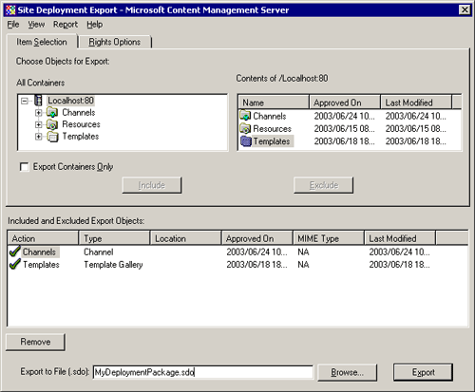
Figure 9. MCMS Site Deployment Export Dialog
Both methods create a Site Deployment Output (SDO) package. SDO packages are created using the same format as a CAB file, and contains XML documents and binary files that collectively comprise the content exported from MCMS.
SDO packages are completely portable between MCMS 2002 servers. (Please note that SDO packages are not accessible by MCMS 2001, nor are MCMS 2001 ROP packages accessible by MCMS 2002.)
It is essential to understand that SDO packages contain only content and schema from the MCMS content repository. File components such as template ASPX files are not included. These components must be deployed separately. The most effective means of doing this is to create a Web deployment project in Visual Studio .NET, and ensure that all objects to be included in the deployment package are defined as Embedded Resources in the objects’ Build Action property in the MCMS Web Project. The deployment project output will create a setup package which can be transported to the target server environment for execution.
For a more detailed discussion on Site Deployment, consult the MCMS 2002 Help documentation or access the information online at http://msdn.microsoft.com/library/en-us/deploymt/htm/cms_de_deploy_hcte.asp.

Beyond the Basics
With architecture as sophisticated as that of MCMS 2002, the possibilities for creating a dynamic Web site with sophisticated functionality and behavior are virtually limitless. Some important possibilities beyond the initial implementation of MCMS that you may wish to explore are:
- The Microsoft Solution for Internet Business (MSIB). This collaborative integration between MCMS and Microsoft Commerce Server 2002 enables a multitude of advanced capabilities.
A key aspect of the MSIB is the ability to profile content with metadata, which allows pre-built interrelationships between content on the site to automatically form collections of related content on the site. With this implementation there is no need to manually cross-reference content. Controls can be included in templates that will display links to related content automatically, in real time. And these relationships can be dynamically managed through a GUI, based on flexible business rules that require no programmatic work. In short, this capability allows content to find the user based on its context within the site.
Another important feature of MSIB is for sites which require online access to product and services information and catalogs. Catalog information can be supplemented by rich content published in MCMS; for example, a site may contain detailed product usage information, or third-party product reviews. Any content within MCMS that relates to a product can be connected with that product, and links to this content can appear on product pages.
Yet another powerful capability is to personalize the user experience on the MCMS site. Users can select their content preferences – anonymously or through registration – and have the site deliver content that is most relevant to their specifications. The business rules that define how content is targeted to these preferences can also be modified in real time.
MSIB also contains integrated search support for Microsoft SharePoint™ Portal Server. The inclusion of Microsoft SharePoint Portal Server can provide the additional functions of advanced search, document management, and collaboration functionality to the site.
With MSIB, all of these capabilities are augmented by analytic components to create a complete feedback process, where site managers can come to terms with how effectively content is being targeted and accessed by subscribers.
More information on MSIB is available at http://www.microsoft.com/solutions/msib/default.asp.
- Content Integration Pack for SharePoint Portal Server. Microsoft Content Integration Pack 2 for Content Management Server 2002 and SharePoint Portal Server 2001 consists of engineered code and documentation that enable customers to integrate MCMS 2002 and Microsoft SharePoint Portal Server 2001 so that users can combine the features of the two programs into an end-to-end solution for document publishing, search, and task management.
- Web Services. XML-based Web services offer tremendous potential for open integration between MCMS and other systems. For example, content authored and maintained in MCMS can be made available as syndicated content to other systems through Web services.
An article that discusses the use of Web services with MCMS in greater depth can be found at http://msdn.microsoft.com/library/en-us/dnmscms02/html/cms_2002webservices.asp.

Glossary
The following table lists a number of important terms used extensively throughout this article.
Table 3: Key MCMS Terms.

Term | Definition
Subscriber | Someone who browses the Web site. In MCMS, different subscriber groups can be defined with different privileges for accessing various channels within the site.
Channel | A sub-section of an MCMS Web site. The site map is built by defining a channel hierarchy. Channels may be visible or hidden; hidden channels are used to store postings that may be accessed from other locations in the site but not shown in navigation menus. Channels are the most granular element controlling site access in MCMS.
Page | The source collection of content placeholders for a specific Web page in the MCMS site. Each page has at least one associated posting (automatically created when the page is originally authored), but can have multiple “connected postings” located throughout the site.
Posting | A published instance of a page. Postings are contained within the channel hierarchy, and form the primary link between a site address (URL) and its associated content (page). Each posting is associated with both page content and a single template; these are assembled dynamically at browse-time.  Like channels, postings may be visible or hidden; hidden postings are used to store content that may be accessed from other locations in the site but not shown in navigation menus.
Connected posting | A posting that shares content with another posting. It is important to understand that for any given group of connected postings there is a single source of underlying content (page).
Template | The layout used to render and/or author pages in MCMS. Templates contain placeholders, which dynamically insert posting-specific content into the rendered MCMS page. Templates also normally contain dynamic navigation controls that form the basis of navigation in the Web site.  Each template is comprised of a Template Gallery Item (TGI) and an associated physical template file (either an ASPX or ASP file). All pages in an MCMS site are published using templates.  The template is the mechanism by which the site’s visual design (“look and feel”) is implemented, and also serves to keep these design elements completely separate from published content. In this way, a visual site redesign may be accomplished primarily through modifying templates alone.  Templates are most commonly used to render HTML, but may also be designed to render XML, WML, cHTML, or any other required rendering of content.  From the content author’s viewpoint, templates are stored in and selected from Template Galleries.
Resource | Commonly used content objects (such as graphic files) used by authors to include in their pages. Resources are stored in Resource Galleries or as “local” resources attached to individual postings.
Galleries | Containers which hold either templates or resources.
Template Gallery Item (TGI) | A collection of placeholder and/or custom property definitions associated with a specific template. The TGI also has an associated physical template file. TGIs are data objects stored in the MCMS repository.

The information contained in this document represents the current view of Microsoft Corporation on the issues discussed as of the date of publication. Because Microsoft must respond to changing market conditions, it should not be interpreted to be a commitment on the part of Microsoft, and Microsoft cannot guarantee the accuracy of any information presented after the date of publication.

This White Paper is for informational purposes only. MICROSOFT MAKES NO WARRANTIES, EXPRESS OR IMPLIED, AS TO THE INFORMATION IN THIS DOCUMENT.

Complying with all applicable copyright laws is the responsibility of the user. Without limiting the rights under copyright, no part of this document may be reproduced, stored in or introduced into a retrieval system, or transmitted in any form or by any means (electronic, mechanical, photocopying, recording, or otherwise), or for any purpose, without the express written permission of Microsoft Corporation.

Microsoft may have patents, patent applications, trademarks, copyrights, or other intellectual property rights covering subject matter in this document. Except as expressly provided in any written license agreement from Microsoft, the furnishing of this document does not give you any license to these patents, trademarks, copyrights, or other intellectual property.

© <2003> Microsoft Corporation. All rights reserved.

