407 Trip Calculator Instruction

1. **Source Code download**

Source code is available:

https://github.com/philipzhong222/TripCalculator

1. **Technology Used**

Java 8, Spring Boot, REST, JSON, Maven

1. **Application Function**

The application provides two functions:

1. Calculate trip cost;
2. Calculate cost based on vehicle type and direction
3. **How to Execute**

The application provides REST sever API. We can use REST client to call the APIs

**HTTP Method**:

GET

**URL**:

<http://localhost:8080/costoftrip>

**Request Parameter**:

*fromLocation*:

Name of from location, e.g. QEW

Required

*toLocation*:

Name of from location, e.g. Bronte Road

Required

*vehicleType*:

Vehicle type: light, heavy or multi

Optional. If vehicleType is provided, the API returns cost based on vehicle type

Otherwise, it will return cost of location distance

**Return**

Calculate trip cost --

*{*

*"distance": e.g. 6.062,*

*"cost": e.g. 1.52*

*}*

Calculate cost based on vehicle type and direction --

*{*

*"distance": e.g. 14.062,*

*"direction": e.g. "eastbound",*

*"kmRate": e.g. 54.30,*

*"tripCharge": e.g. 57.82*

*}*

1. **Example**
2. Get cost between QEW and Dundas Street

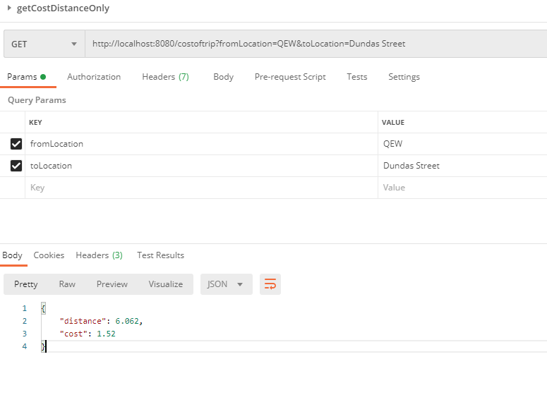

1. Get cost between Highway 400 and QEW

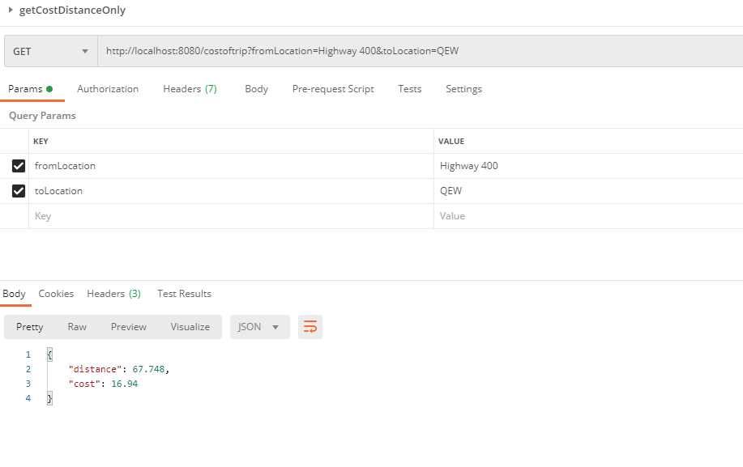

1. Input location doesn’t exist

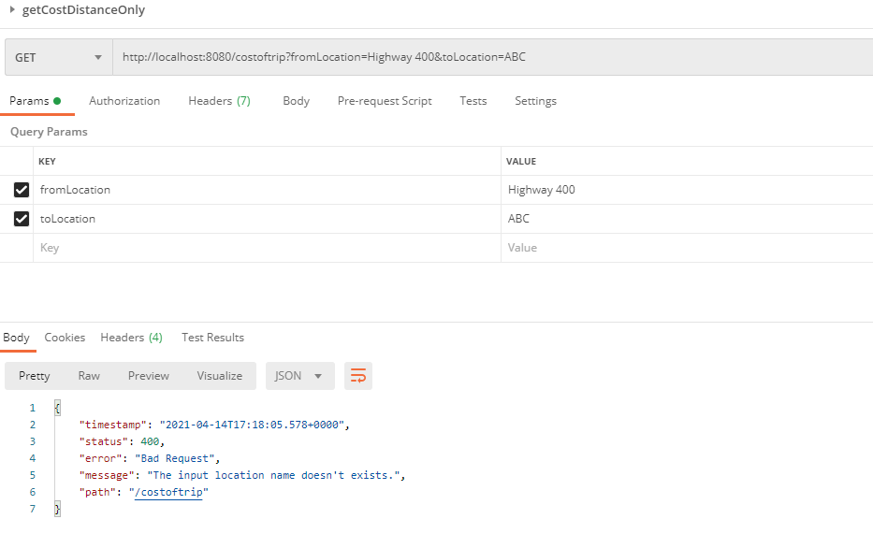

1. Get cost from Bronte Road to QEW for multi type vehicle

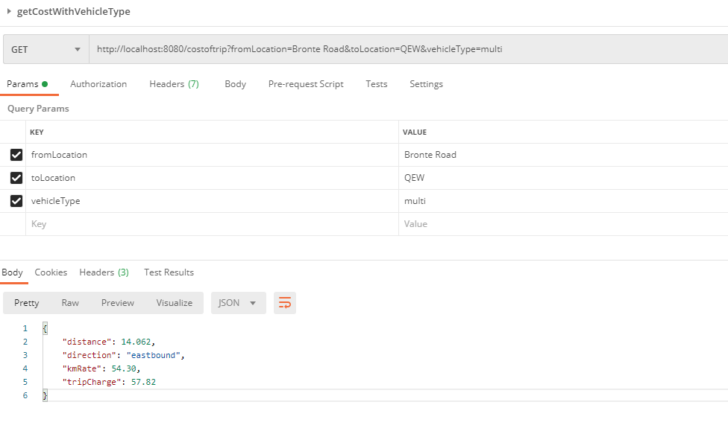

1. Get cost from QEW to Bronte Road for light vehicle

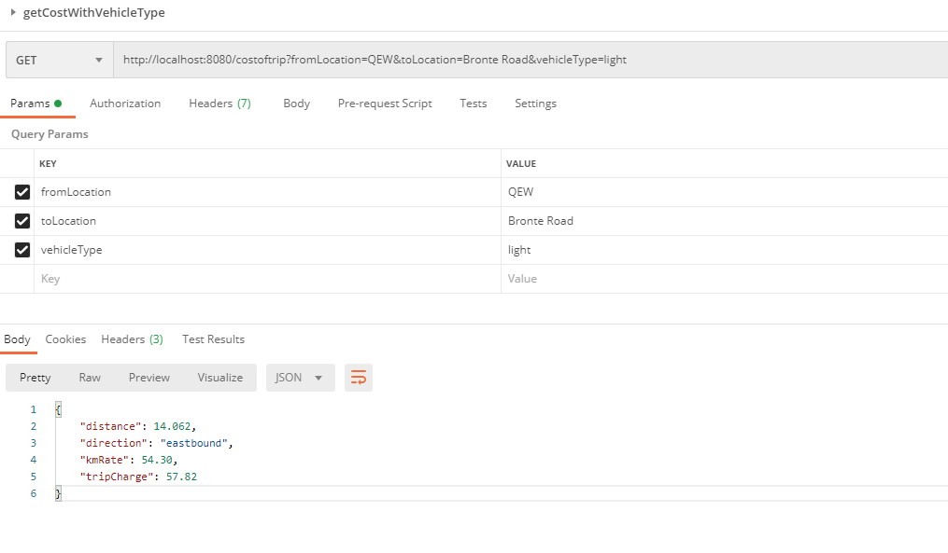

1. Get cost from QEW to Salem Road for heavy type vehicle

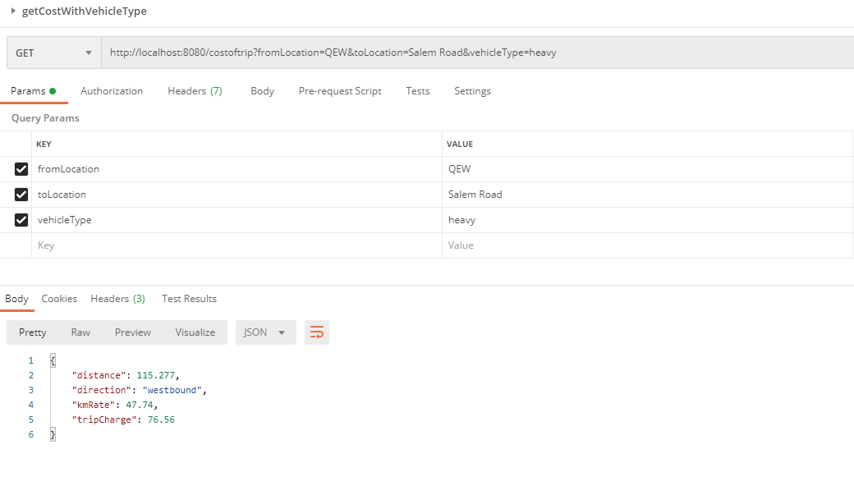

1. **Unit Test**

Junit Unit Test is included in the application. Please check source code:

*Com.etr.CostConfiguratorTest.java*

*Com.etr.TripCalculatorControllerTest*

When creating build with Maven, unit test will be triggered automatically.

1. **Source Code Structure**

